eTable 1. Sources of questionnaire items, LEGACY Girls Study, 2011 - 2015

Questionnaire items | Sources
Growth and Development
Signs of puberty and menses | Adapted from: Petersen AC, Crockett L, Richards M, Boxer A. A Self-Report Measure of Pubertal Status: Reliability, Validity, and Initial Norms. Journal of Youth and Adolescence 1988;17(5):117-133.
Tanner stage of breast and pubic hair development | Adapted from PhenX Toolkit: https://www.phenxtoolkit.org/index.php?pageLink=browse.protocoldetails&id=100101.
Current body size drawings | Adapted from PhenX Toolkit: https://www.phenxtoolkit.org/index.php?pageLink=browse.protocoldetails&id=20401.
Lifestyle Factors

Recent physical activity | Adapted from BCERP physical activity questionnaire: http://www.bcerc.org/index.htm.
Recent dietary intake | Block Kid Food Frequency Questionnaire: http://www.nutritionquest.com/company/our-research-questionnaires/.
Physical and Social Environment
Personal product use | Adapted from BCERP questionnaire: http://www.bcerc.org/index.htm.
Chemical exposures in home and community environment | Adapted from:  AVON questionnaire: Boyd A, Golding J, Macleod J, et al. Cohort Profile: the 'children of the 90s'--the index offspring of the Avon Longitudinal Study of Parents and Children. Int J Epidemiol 2013;42(1):111-27  BCERP questionnaire: http://www.bcerc.org/index.htm
Attitudes about daily life, place in society | Adapted from:  Lukwago SN, Kreuter MW, Bucholtz DC, Holt CL, Clark EM. Development and validation of brief scales to measure collectivism, religiosity, racial pride, and time orientation in urban African American women. Fam Community Health 2001;24(3):63-71.  Adler NE, Epel ES, Castellazzo G, Ickovics JR. Relationship of subjective and objective social status with psychological and physiological functioning: preliminary data in healthy white women. Health Psychol 2000;19(6):586-92.  Dahlberg LL, Toal SB, Swahn M, Behrens CB. Measuring Violence-Related Attitudes, Behaviors, and Influences Among Youths: A Compendium of Assessment Tools, 2nd ed. Atlanta, GA: Centers for Disease Control and Prevention, National Center for Injury Prevention and Control, 2005.  Goodman E, Adler NE, Kawachi I, et al. Adolescents' perceptions of social status: development and evaluation of a new indicator. Pediatrics 2001;108(2):E31.
Neighborhood
Neighborhood characteristics | Adapted from:  Sallis JF, Bowles HR, Bauman A, et al. Neighborhood environments and physical activity among adults in 11 countries. Am J Prev Med 2009;36(6):484-90.  Mota J, Almeida M, Santos P, Ribeiro JC. Perceived Neighborhood Environments and physical activity in adolescents. Prev Med 2005;41(5-6):834-6.  De Bourdeaudhuij I, Sallis JF, Saelens BE. Environmental correlates of physical activity in a sample of Belgian adults. Am J Health Promot. 2003;18(1):83-92.  U.S. Department of Health and Human Services, National Institutes of Health, National Heart, Lung and Blood Institute. Multi-Ethnic Study of Atherosclerosis (MESA), Neighborhood Section. www.mesa-nhlbi.org/.  BCERP questionnaire: http://www.bcerc.org/index.htm  http://activelivingresearch.org/sites/default/files/ActiveWhere_adolescent_survey.pdf.
Behavioral Questionnaire - mothers/  guardians | Adapted from:  Reynolds CR, Kamphaus RW. BASC™-2 Behavioral Assessment for Children Manual, Second Edition. 2 ed. Minneapolis, MN: Pearson, 2004.  Smith P, Perrin S, Dyregrov A, Yule W. Principal components analysis of the impact of event scale with children in war. Personality and Individual Differences 2003;34(2):315–322.  Shedlosky-Shoemaker R, Ngo TL, Ferketich AK, et al. Exploring perceptions of genetic testing: an examination of perceived accuracy over time. Patient Educ Couns 2010;78(1):34-9.  Kelly K, Leventhal H, Andrykowski M, et al. Using the common sense model to understand perceived cancer risk in individuals testing for BRCA1/2 mutations. Psychooncology 2005;14(1):34-48.  Miller IW, Kabacoff RI, Epstein NB, et al. The development of a clinical rating scale for the McMaster model of family functioning. Fam Process 1994;33(1):53-69.  Byles J, Byrne C, Boyle MH, Offord DR. Ontario Child Health Study: reliability and validity of the general functioning subscale of the McMaster Family Assessment Device. Fam Process 1988;27(1):97-104.  CDC. Centers for Disease Control and Prevention (CDC) Youth Risk Behavior Surveillance System Survey Questionnaire. Atlanta, Georgia: U.S. Department of Health and Human Services Centers for Disease Control and Prevention, 2007.  Zigmond AS, Snaith RP. The hospital anxiety and depression scale. Acta Psychiatr Scand 1983;67(6):361-70.  Horowitz M, Wilner N, Alvarez W. Impact of Event Scale: a measure of subjective stress. Psychosom Med 1979;41(3):209-18.
Behavioral Questionnaire – daughters ages ≥10 years | Adapted from:  Reynolds CR, Kamphaus RW. BASC™-2 Behavioral Assessment for Children Manual, Second Edition. 2 ed. Minneapolis, MN: Pearson, 2004.  Smith P, Perrin S, Dyregrov A, Yule W. Principal components analysis of the impact of event scale with children in war. Personality and Individual Differences 2003;34(2):315–322.  Kelly K, Leventhal H, Andrykowski M, et al. Using the common sense model to understand perceived cancer risk in individuals testing for BRCA1/2 mutations. Psychooncology 2005;14(1):34-48.  Miller IW, Kabacoff RI, Epstein NB, et al. The development of a clinical rating scale for the McMaster model of family functioning. Fam Process 1994;33(1):53-69.  Byles J, Byrne C, Boyle MH, Offord DR. Ontario Child Health Study: reliability and validity of the general functioning subscale of the McMaster Family Assessment Device. Fam Process 1988;27(1):97-104.  CDC. Centers for Disease Control and Prevention (CDC) Youth Risk Behavior Surveillance System Survey Questionnaire. Atlanta, Georgia: U.S. Department of Health and Human Services, Centers for Disease Control and Prevention, 2010.

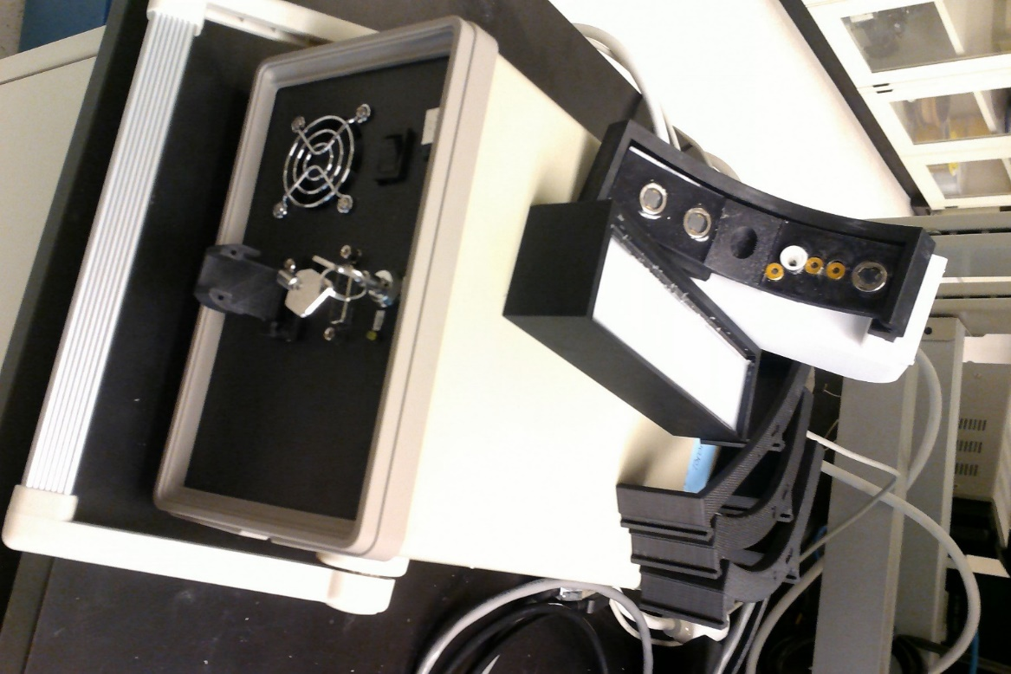eFigure 1. The LEGACY optical spectroscopy device comprises a light emitting source cone (A) emitting sequentially the light from 13 laser diodes (wavelength from 635 to 1050nm); and six photodetectors (B) which quantify the diffuse reflectance at known distances (from 10 to 75 mm) from the light emitting cone. The light responsivity of the device is calibrated daily using light scattering standards (C).
A
B
C
D
E
F

The changing curvature of the device is matched by 5 different preformed shapes (D) holding the light source and detectors at known distances on the curved surface. Light emission and detection quantification are maintained by the controller (E). To preclude unauthorized access to the light source the system is secured by a key switch (F).

For optical spectroscopy measurements, the source and reflectance detectors are held by the participant or a parent onto the breast, whereby the nipple is placed into the central depression below the light source.

Four different alignments are used for each breast, obtaining a total of 24 diffuse reflectance measurements of the breast as shown in eFigure 2. Sample calculations of the optically interrogated tissues are shown in eFigure 3.

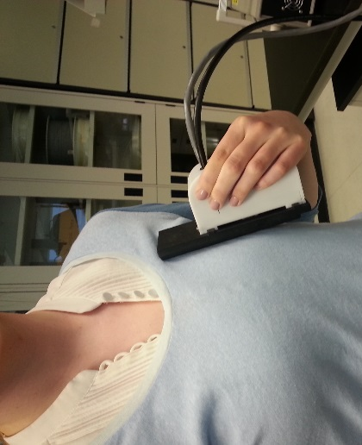
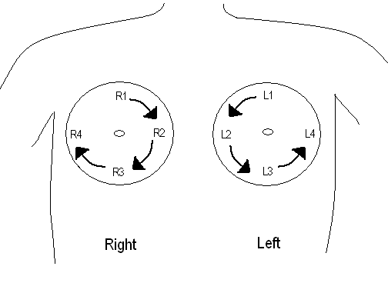
eFigure 2. The left shows the LEGACY optical spectroscopy device as it would be applied to breast in direct contact with the skin. The right shows the sequence of the diffuse reflectance measurements collected from each breast, covering 4 quadrants of each breast.

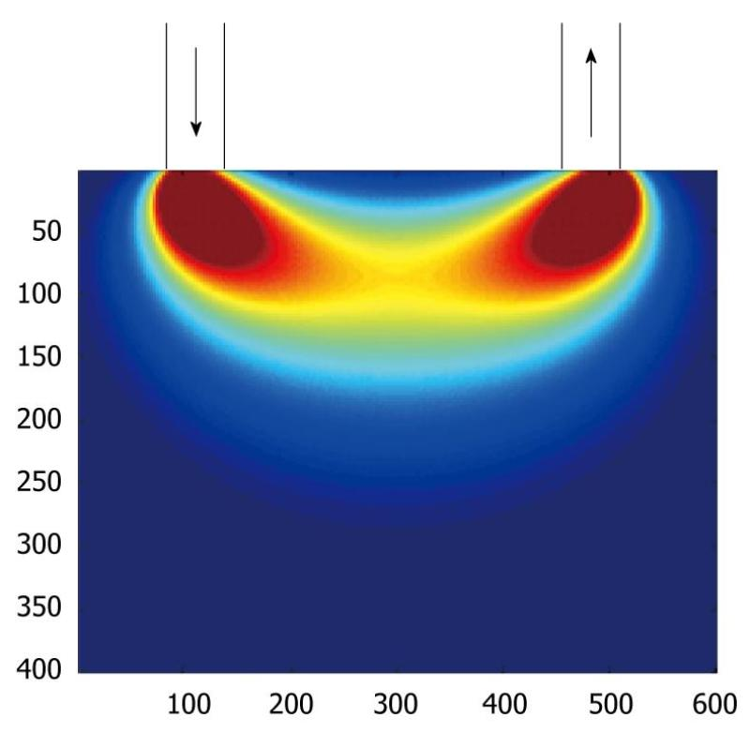
eFigure 3 shows the photon path density between a
source (left) and detector (right) separated by 40 mm. Red indicates high photon density and dark blue indicates very low photon density. As shown, the majority of the detected photons did not penetrate more than 10-15 mm into the tissue (size of simulation is 40mm by 60 mm). While a high photon density is noted in the 5 mm proximal to the source and the detector, the majority of the photon path density is beyond 5 mm depth and beyond the pigmented layers of the skin. Hence, the technology is independent of the skin type. One should note also that melanin mediated light absorption and scattering is greatly diminished beyond 700 nm.

