Supplemental Material: eAppendix 1
G-formula procedure
We estimate the effect of setting all unemployed person-years to employed throughout follow-up. We assume a set of cross-lagged relationships between the time-varying variables, allowing for mediation (Figure 1). Time-constant variables, when included in the analysis, are allowed to affect all time-varying variables at every time-point. To estimate the effect of our hypothetical intervention, we apply the parametric g-formula using the following steps:
- Randomly draw individuals from the data with replacement (n = 49,753).
- To the randomly drawn individuals (step 1), fit parametric models for covariates at time t as a function of covariate history at time t.
- Take observations from the first year of follow-up (from the step 1 sample) and using the models (step 2), predict observations for the second year of follow-up. Then use those (predicted) observations to predict observations in the next year, etc. until the end of follow-up.
- Save the predicted outcomes (from step 3) for antidepressant purchasing (AD purchasing) and the other variables for all simulated years (these represent the ‘natural course scenario’).
- Perform step 3 a second time, now setting all unemployed person-years at the first year of follow-up to employed. Whenever unemployment is predicted, set it to employed instead.
- Save the predicted outcomes (step 5) for AD purchasing and the other variables for all simulated years (these represent the ‘intervention scenario’).
- Monte Carlo error reduction: Perform steps 2 to 6 10 times and average AD purchasing values in both scenarios respectively over the simulations.
- Calculate the difference in AD purchasing between the natural course and intervention scenarios, and save this estimate.
- Bootstrap: Perform the steps 1-8 500 times. The distribution of effect estimates (step 7) is used to derive the mean effect and the 2.5 and 97.5% quantiles are used to determine 95% confidence intervals for the effect.
We perform the g-formula estimation with 3 different covariate sets, (Table 1). Covariate sets 2 and 3 follow our directed acyclic graph (DAG), as they include time-varying covariates (Figure 1). For all covariate sets, the models in step 2 are linear regression models, i.e. linear probability models are assumed for nominal variables. Linear models allow for the inclusion (and extraction) of individual fixed intercepts in a computationally efficient manner, compared to a g-formula with individual intercepts and non-linear (i.e. generalized linear) models. The covariate sets include interactions between employment status and sex, and between employment status and education. For binary and multinomial variables, the prediction steps (4 and 7) use predicted probabilities to draw values (0 or 1) from binomial and multinomial distributions, respectively. Note that the models with individual-level fixed effect intercepts have different effective sample sizes for each coefficient (Table 2). We produce population-averaged effect estimates by including the estimated individual-level fixed effect intercepts in the prediction steps (steps 4 and 7). Individual intercepts were estimated using the ‘plm’ package in R. Annotated R-code performing the g-formula for sets 2 and 3 is available in eAppendix 2 and 3.

Sensitivity analysis for unmeasured confounder strength
It has been recommended to investigate how strong a potential (unobserved) confounder would need to be in order to produce null estimates (Lin et al., 2015). In this study, we have measured the level of unobserved time-constant confounding through the estimation of individual-level intercepts. We therefore quantify the strength of their association with AD purchasing and unemployment, respectively, by comparing the 75% and 25% quantiles of these individual intercepts (from the multivariable models for AD purchasing and unemployment). To help interpret this sensitivity check, by comparison to a measured variables’ strength, we also estimate the 75% and 25% quantiles of personal income and multiply these values by the coefficient of personal income from the same models.

Results
Time-constant factors, as measured by comparing the 75% quantile of individual intercepts from the model for AD purchasing with the 25% quantile, are associated with a 3.3 percentage point increase in person-years with antidepressants. Comparing the same quantiles using individual intercepts from the model for unemployment showed that they are associated with a 7.8 percentage point increase. For comparison, the 75% and 25% quantiles for personal income are associated with a 0.2 percentage point increase in AD purchasing and a 1 percentage point increase in unemployment.

Discussion
As measured through the fixed effect intercepts, the relationship between unmeasured time-constant factors and both antidepressant purchasing and unemployment is very strong when compared to the coefficients of all other covariates in the multivariable models.
References
Lin SH, Young J, Logan R, Tchetgen Tchetgen EJ, VanderWeele TJ. Parametric Mediational g-Formula Approach to Mediation Analysis with Time-varying Exposures, Mediators, and Confounders. Epidemiology 2017;28(2):266-274.

Natural course to empirical data fit
Note that the y-axis varies in each graph.
Set 2: time-constant and time-varying covariates.
Set 3: time-varying covariates and individual-level fixed-effect intercepts.
Note that set 3 emulates the aggregate of individuals that change on all time-varying covariates, and therefore represents a population that is not represented well by the empirical data (as the empirical data below includes all individuals, including those that do not change on covariates); this issue was described in the paragraph on effect estimation in the main document. Therefore, the main comparisons should be between set 2 and the natural course.
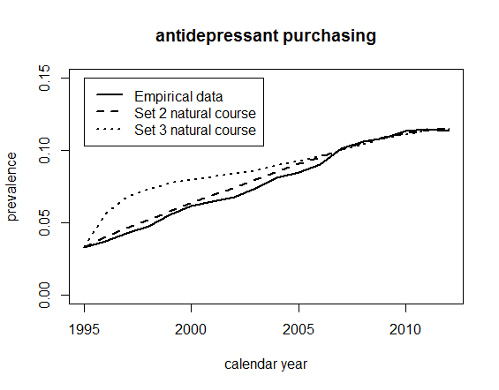
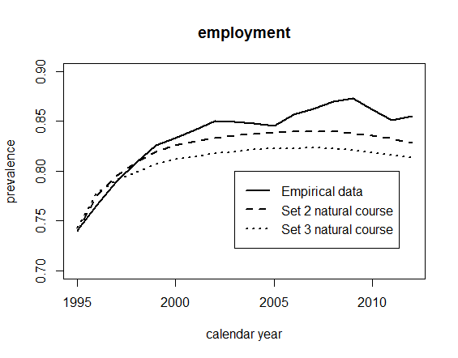
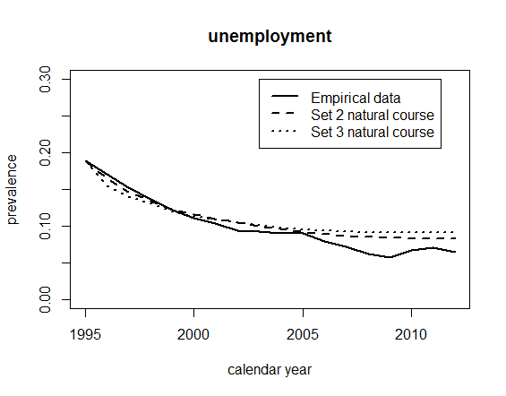
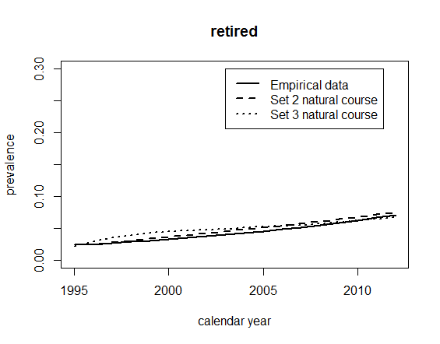
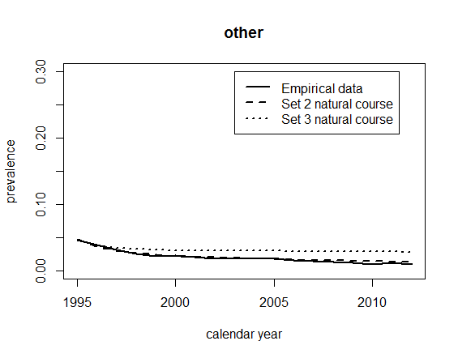
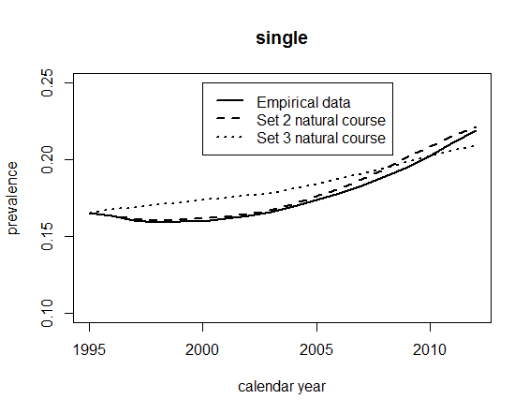
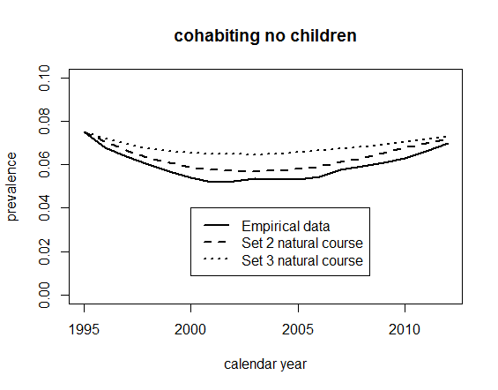

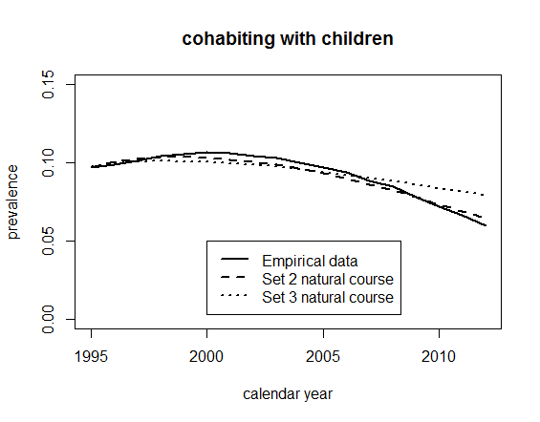
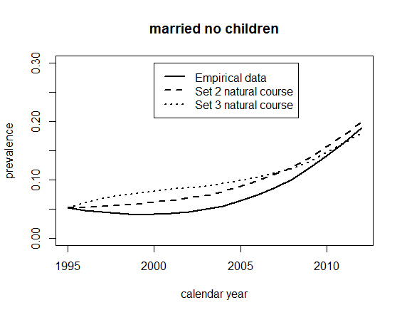

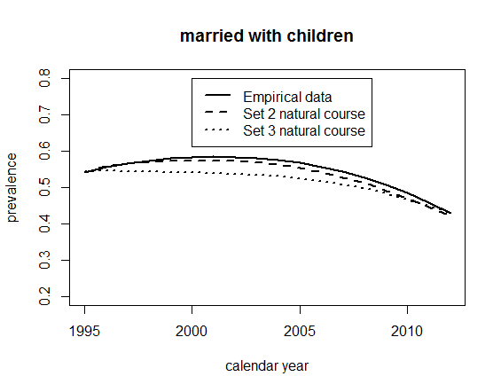
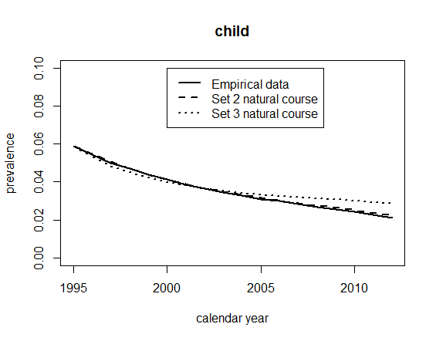

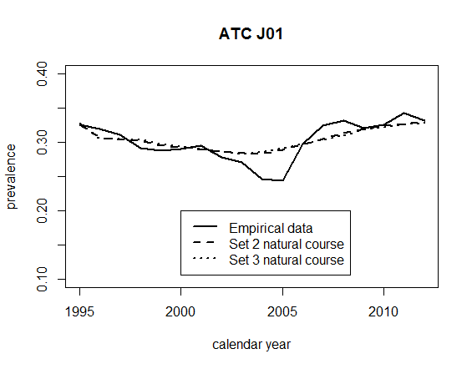
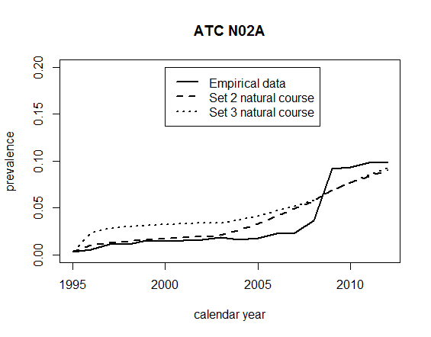

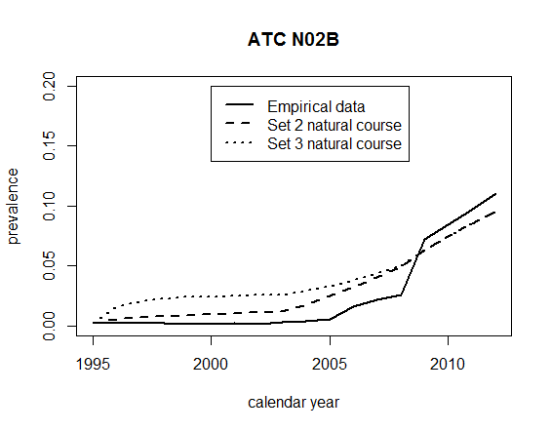
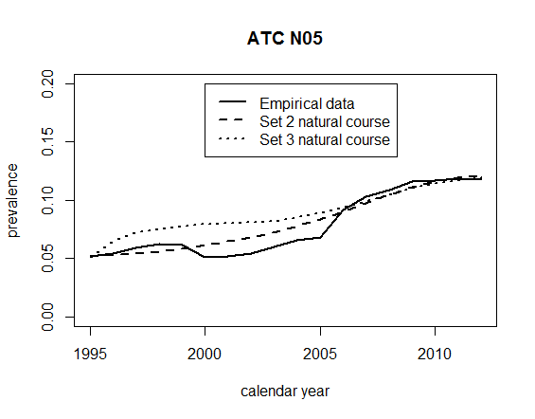
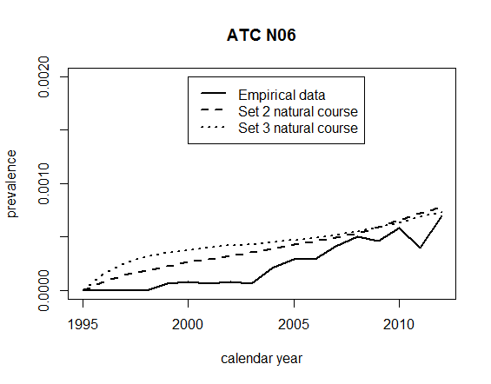
N06 excluding antidepressants (therefore an extremely small group: note the y-axis range).
