Supplemental Material
Air Pollution-Associated Changes in Biomarkers of Diabetes Risk

Katelyn M. Holliday,¹ Archana P. Lamichhane², Rahul Gondalia,³ James D. Stewart,³ Jamie Madrigano,⁴ Regina A. Shih,⁴ Jeff D. Yanosky,⁵ Duanping Liao,⁵ Gregory A. Wellenius,⁶ Eric A. Whitsel^{3, 7}
Author Affiliations:
- Department of Community and Family Medicine; Duke University; Durham, NC, USA
- Department of Nutrition; University of North Carolina at Chapel Hill; Chapel Hill, NC, USA
- Department of Epidemiology; University of North Carolina at Chapel Hill; Chapel Hill, NC, USA
- RAND Corporation; Washington D.C., USA
- Department of Public Health Sciences; Penn State University; Hershey, PA, USA
- Department of Epidemiology; Brown University; Providence, RI, USA
- Department of Medicine; University of North Carolina at Chapel Hill; Chapel Hill, NC, USA

Abbreviations. AV, annual visit; HOMA-IR, homeostasis model assessment-insulin resistance; NO_{x}, nitrogen oxides; PM₁₀ and PM_{2.5}, particulate matter ≤ 10 and ≤ 2.5 μm in diameter; SV, screening visit; TG:HDL-C, ratio of triglycerides to high-density lipoprotein cholesterol; TyG, triglycerides-glucose index. See main text for cited definitions.
Table S1. Unweighted demographic, behavioral, clinical, and contextual characteristics at screening
(1993-1998), Women’s Health Initiative Clinical Trials
Characteristics | Mean (SD) or %
Age, years | 62.2 (7.1)
Race/ethnicity (%) Non-Hispanic White | 52.1
Non-Hispanic Black | 24.9
Hispanic | 12.6
Others | 10.4
Less than college graduate (%) | 66.0
Area-level SES | -1.5 (5.6)
Examination season (%) Spring | 28.4
Summer | 26.2
Fall | 24.2
Winter | 21.2
Examination day on weekday (%) | 95.6
Family history of diabetes (%) | 36.0
Current smoker (%) | 8.9
Current alcohol use (%) | 51.8
Total energy expenditure, MET-hrs/week | 10.3 (13.0)
Body Mass Index, kg/m² | 29.2 (6.0)
Glucose, mg/dLª | 94.4 (10.3)
Insulin, uIU/mL | 11.3 (6.6)
HOMA-IR | 2.7 (1.8)
TG:HDL-C | 2.8 (2.3)
TyG | 8.7 (0.5)
PM₁₀ (μg/m³) 2-day ^{b} | 28.8 (11.2)
365-day ^{b} | 28.1 (3.8)
12-month ^{c} | 21.3 (5.3)
PM_{2.5} (μg/m³) 12-month ^{c} | 12.3 (3.1)
NO_{x} (ppb) 2-day ^{b} | 39.0 (30.0)
365-day ^{b} | 38.4 (16.4)
Note: CI, confidence interval; HOMA-IR, homeostatic model assessment of insulin resistance; MET, metabolic equivalent; NO_{x}, nitrous oxide; PM_{2.5}, particulate matter ≤2.5 μm in diameter; PM₁₀, particulate matter ≤10 μm in diameter; ppb, parts per billion; SES, socioeconomic status; TG:HDL-C, triglyceride to high-density lipoprotein cholesterol ratio; TyG, triglyceride-glucose index; uIU, micro international units
ª Excluded extremely low glucose values (<50 mg/dL, n=2)
^{b} Daily mean concentrations spatially estimated using national-scale, log normal, ordinary kriging
^{c} Monthly mean concentrations spatiotemporally estimated using generalized, additive mixed
models and land use regression

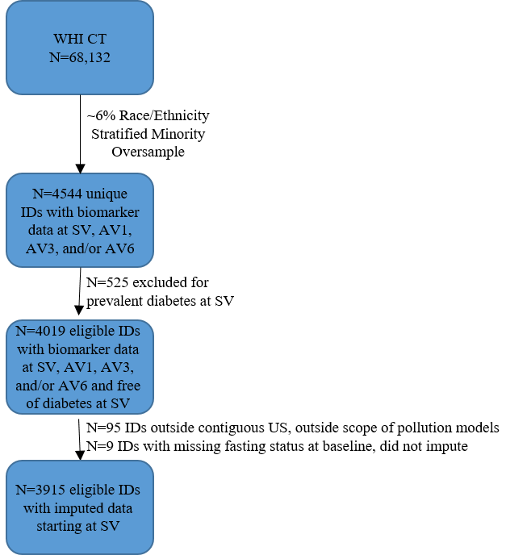
Figure S1. Flowchart of included participants
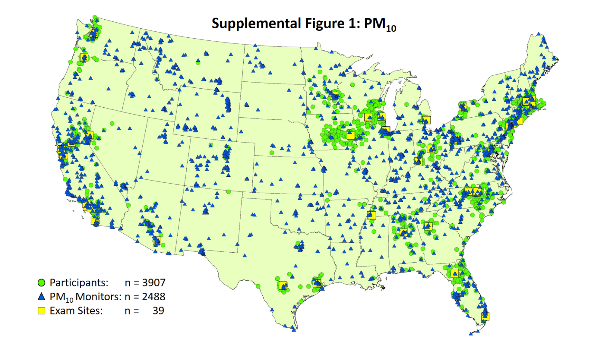
Figure S2. Map of geocoded addresses of non-diabetic participants, PM₁₀ air pollution monitors, and exam sites (1993–2004). Exam sites followed 60 to 187 sampled participants. Participant addresses were a median of 7.5 km away from the nearest PM₁₀ monitor.

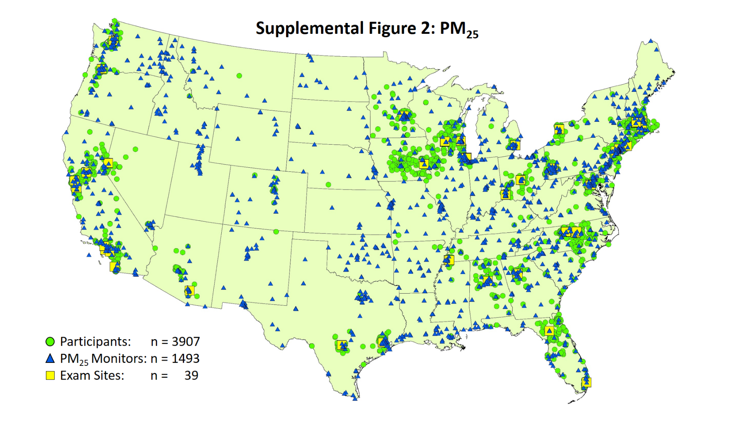
Figure S3. Map of geocoded addresses of non-diabetic participants, PM_{2.5} air pollution monitors, and exam sites (1993–2004). Exam sites followed 60 to 187 sampled participants. Participant addresses were a median of 7.4 km away from the nearest PM_{2.5} monitor.

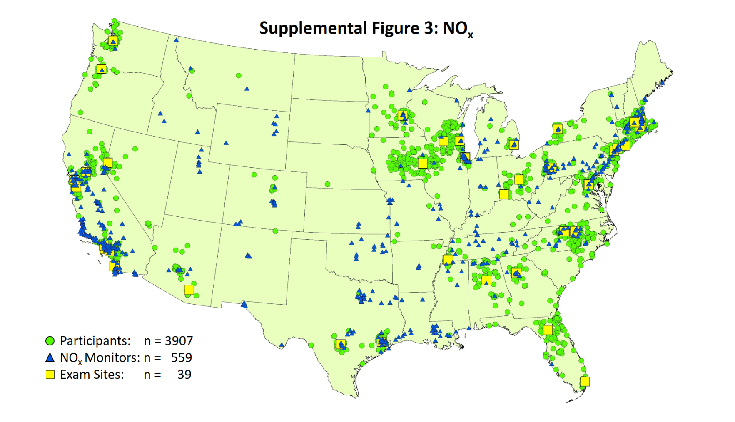
Figure S4. Map of geocoded addresses of non-diabetic participants, NO_{x} air pollution monitors, and exam sites (1993–2004). Exam sites followed 60 to 187 sampled participants. Participant addresses were a median of 15.0 km away from the nearest NO_{x} monitor.

Figure S5. Scatterplots of participant-specific glucose homeostasis measures (glucose; insulin; HOMA-IR; TG:HDL-C; TyG), mean air pollution concentrations (daily PM₁₀; monthly PM_{2.5}; daily NO_{x}), and daily mean meteorological measures (temperature; dew point; barometric pressure) with kernel-smoothed moving averages, by exam year (1993-2004), after excluding values ≥ 3 standard deviations from the mean. At the screening visit (pink) and annual visits 1, 3, or 6 (yellow; green; blue), mean (standard deviation) measures of glucose homeostasis, air pollution concentrations, and meteorological measures were:

Visit | Glucose  (mg/dl) |  | Insulin  (uIU/ml) |  | HOMA-IR |  | TG:HDL-C |  | TyG
SV | 94.3 | (10.3) | 11.3 | (6.6) | 2.7 | (1.8) | 2.8 | (2.2) | 8.7 | (0.5)
AV1 | 93.2 | (9.7) | 10.8 | (6.0) | 2.5 | (1.6) | 2.8 | (2.5) | 8.7 | (0.5)
AV3 | 92.7 | (10.5) | 12.0 | (6.8) | 2.8 | (1.8) | 2.8 | (2.3) | 8.7 | (0.5)
AV6 | 95.1 | (10.9) | 9.4 | (6.5) | 2.3 | (1.8) | 2.7 | (2.0) | 8.7 | (0.5)
Visit | PM₁₀  (ug/m³) |  | PM_{2.5}  (ug/m³) |  | NO_{x}  (ppb)
SV | 28.8 | (11.2) | 12.2 | (4.2) | 39.0 | (30.0)
AV1 | 28.1 | (10.9) | 12.9 | (4.7) | 37.2 | (29.9)
AV3 | 28.0 | (10.6) | 14.9 | (6.0) | 36.0 | (30.2)
AV6 | 27.0 | (10.5) | 14.7 | (6.0) | 32.1 | (25.7)
Visit | Temperature  (◦C) |  | Dewpoint  (◦C) |  | BarometricPressure  (kPa)
SV | 14.1 | (9.2) | 7.4 | (9.3) | 101.6 | (0.6)
AV1 | 14.5 | (9.3) | 8.0 | (9.3) | 101.6 | (0.6)
AV3 | 14.3 | (9.2) | 7.8 | (9.2) | 101.7 | (0.6)
AV6 | 14.5 | (9.2) | 8.1 | (9.3) | 101.7 | (0.5)

Table S2. Unadjusted percent change in biomarkers of diabetes risk (95% confidence interval) per unit increase in air pollution concentration (1993-2004), Women’s Health Initiative Clinical Trials
Measure | Fasting glucose |  | PM₁₀ ª |  |  | PM_{2.5} ª | NO_{x} ª
 |  | N | 2-day | 365-day | 12-month | 12-month | 2-day | 365-day
Fasting Glucose | All | 3915 | -0.1 (-0.4, 0.2) | -0.4 (-1.7, 1.0) | -0.4 (-1.4, 0.6) | -1.2 (-2.3, 0.0) | -0.2 (-0.6, 0.2) | -0.5 (-1.4, 0.3)
 | Normal | 2902 | 0.1 (-0.3, 0.4) | -0.7 (-1.9, 0.5) | -0.8 (-1.7, 0.1) | -1.2 (-2.3, -0.1) | -0.2 (-0.5, 0.2) | -0.5 (-1.2, 0.3)
 | Impaired | 1013 | 0.0 (-0.3, 0.3) | 0.0 (-1.3, 1.3) | -0.1 (-1.0, 0.9) | -0.1 (-1.2, 0.9) | 0.0 (-0.3, 0.3) | 0.0 (-0.5, 0.6)
Fasting Insulin | All | 3915 | -1.0 (-1.8, -0.2) | -1.5 (-5.9, 3.1) | 2.3 (-1.6, 6.5) | 2.9 (-1.9, 7.9) | -0.2 (-1.3, 0.9) | -2.3 ( -5.5, 0.9)
 | Normal | 2902 | -1.1. (-1.9, -0.2) | -3.5 (-7.9, 1.2) | 0.8 (-3.3, 4.9) | 2.5 (-2.3, 7.5) | -0.2 (-1.3, 0.9) | -2.5 (-6.1, 1.2)
 | Impaired | 1013 | -0.2 (-2.3, 1.9) | 3.9 (-2.6, 10.9) | 6.2 (0.4, 12.2) | 4.3 (-2.4, 11.5) | 0.4 (-1.8, 2.8) | -1.1 (-4.8, 2.7)
HOMA-IR | All | 3915 | -0.9 (-1.9,0.0) | -2.1. (-6.5, 2.6) | 0.6 (-3.1, 4.5) | 0.8 (-4.1, 5.9) | -0.4 (-1.8, 1.0) | -2.7 (-5.6, 0.3)
 | Normal | 2902 | -0.9 (-2.1, 0.3) | -5.0 (-9, -0.9) | -0.8 (-5.1, 3.6) | 0.8 (-4.0, 5.7) | -0.3 (-1.7, 1.1) | -2.2 (-5.7, 1.4)
 | Impaired | 1013 | 0.0 (-2.2, 2.3) | 5.5 (-3.0, 14.7) | 6.7 (0.4, 13.3) | 2.0 (-5.2, 9.7) | 0.0 (-2.6, 2.6) | -1.4 (-5.3, 2.6)
TG:HDL-C | All | 3915 | 0.1 (-0.9, 1.1) | 2.1. (-2.5, 7.0) | -1.4 (-5.7, 3.1) | 0.6 (-4.3, 5.6) | -0.8 (-1.8, 0.3) | -0.4 (-3.2, 2.5)
 | Normal | 2902 | -0.2 (-1.2, 0.9) | 0.7 (-3.8, 5.5) | -2.3 (-6.9, 2.5) | 0.9 (-4, 6.2) | -0.9 (-2.0, 0.2) | -0.6 (-3.4, 2.3)
 | Impaired | 1013 | 0.8 (-1.1, 2.7) | 5.1 (-3.6, 14.5) | 1.1 (-5.5, 8.1) | -0.1 (-7.3, 7.7) | -0.2 (-2.6, 2.3) | 0.4 (-3.9, 4.9)
TyG | All | 3915 | -0.1 (-1.0, 0.7) | 0.0 (-4.3, 4.6) | -2.8 (-6.6, 1.1) | 1.2 (-2.5, 5) | -0.5 (-1.4, 0.5) | -0.8 (-3.4, 1.9)
 | Normal | 2902 | -0.2 (-1.1, 0.6) | -0.8 (-5.1, 3.8) | -4.0 (-8.0, 0.2) | 1.2 (-2.7, 5.3) | -0.6 (-1.5, 0.3) | -0.8 (-3.6, 2.1)
 | Impaired | 1013 | 0.4 (-1.4, 2.1) | 2.6 (-4.5, 10.3) | 0.1 (-5.7, 6.3) | 1.4 (-4.6, 7.8) | 0.0 (-2.5, 2.6) | 0.1 (-3.7, 4.1)
Note: HOMA-IR, homeostatic model assessment of insulin resistance; NO_{x}, nitrous oxide; PM_{2.5}, particulate matter ≤2.5 μm in diameter; PM₁₀, particulate matter ≤10 μm in diameter; TG:HDL-C, triglyceride to high-density lipoprotein cholesterol ratio; TyG, triglyceride-glucose index.
ª PM: 10 ug/m³ increase; NO_{x}: IQR increase (2-day: 28.4 ppb; 365-day: 20.3 ppb)
^{b} P < 0.05
^{c} P_{interaction} < 0.05

Figure S6: Sketch of P-value function for associations between 12-month PM_{2.5} and biomarkers of diabetes risk.

Additional Acknowledgements
Program Office: (National Heart, Lung, and Blood Institute, Bethesda, Maryland) Jacques Rossouw, Shari Ludlam, Joan McGowan, Leslie Ford, and Nancy Geller

Clinical Coordinating Center: (Fred Hutchinson Cancer Research Center, Seattle, WA) Garnet Anderson, Ross Prentice, Andrea LaCroix, and Charles Kooperberg

Investigators and Academic Centers: (Brigham and Women's Hospital, Harvard Medical School, Boston, MA) JoAnn E. Manson; (MedStar Health Research Institute/Howard University, Washington, DC) Barbara V. Howard; (Stanford Prevention Research Center, Stanford, CA) Marcia L. Stefanick; (The Ohio State University, Columbus, OH) Rebecca Jackson; (University of Arizona, Tucson/Phoenix, AZ) Cynthia A. Thomson; (University at Buffalo, Buffalo, NY) Jean Wactawski-Wende; (University of Florida, Gainesville/Jacksonville, FL) Marian Limacher; (University of Iowa, Iowa City/Davenport, IA) Jennifer Robinson; (University of Pittsburgh, Pittsburgh, PA) Lewis Kuller; (Wake Forest University School of Medicine, Winston-Salem, NC) Sally Shumaker; (University of Nevada, Reno, NV) Robert Brunner

Women’s Health Initiative Memory Study: (Wake Forest University School of Medicine, Winston-Salem, NC) Mark Espeland

For a list of all the investigators who have contributed to WHI science, please visit: https://www.whi.org/researchers/Documents%20%20Write%20a%20Paper/WHI%20Investigator %20Long%20List.pdf

