eAppendix

eFigure 1. Number of inpatient diagnosis codes by month

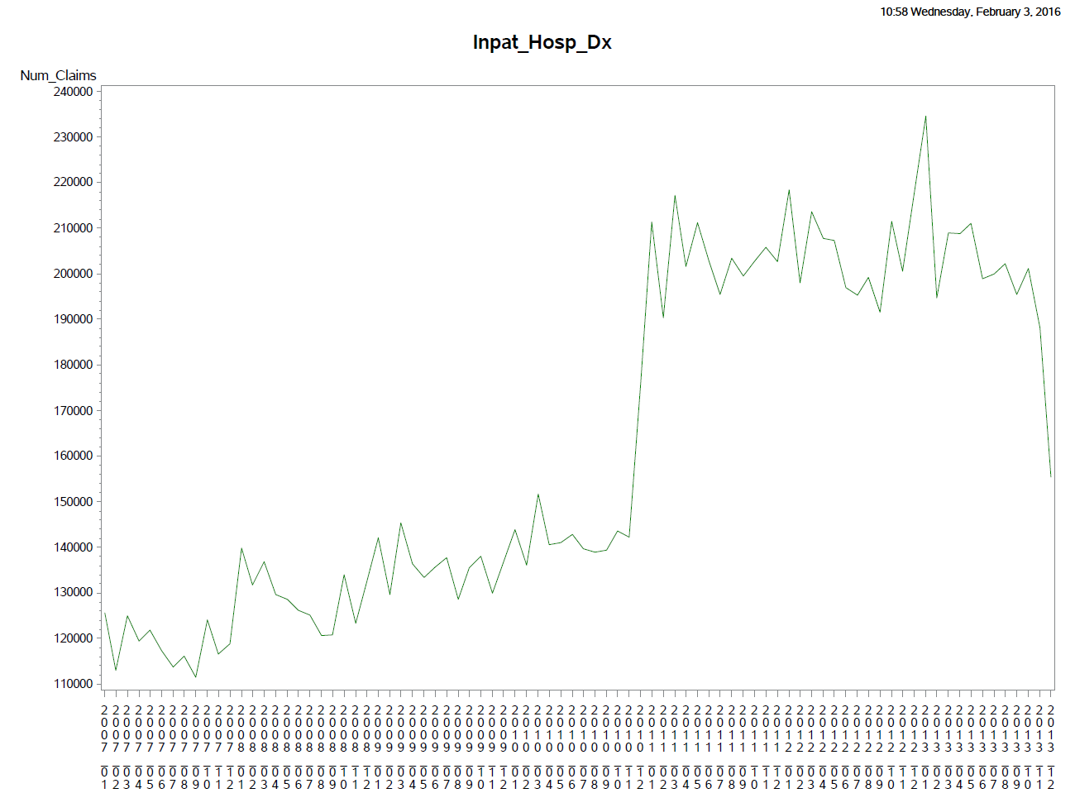

eFigure 2. Number of outpatient diagnosis codes by month

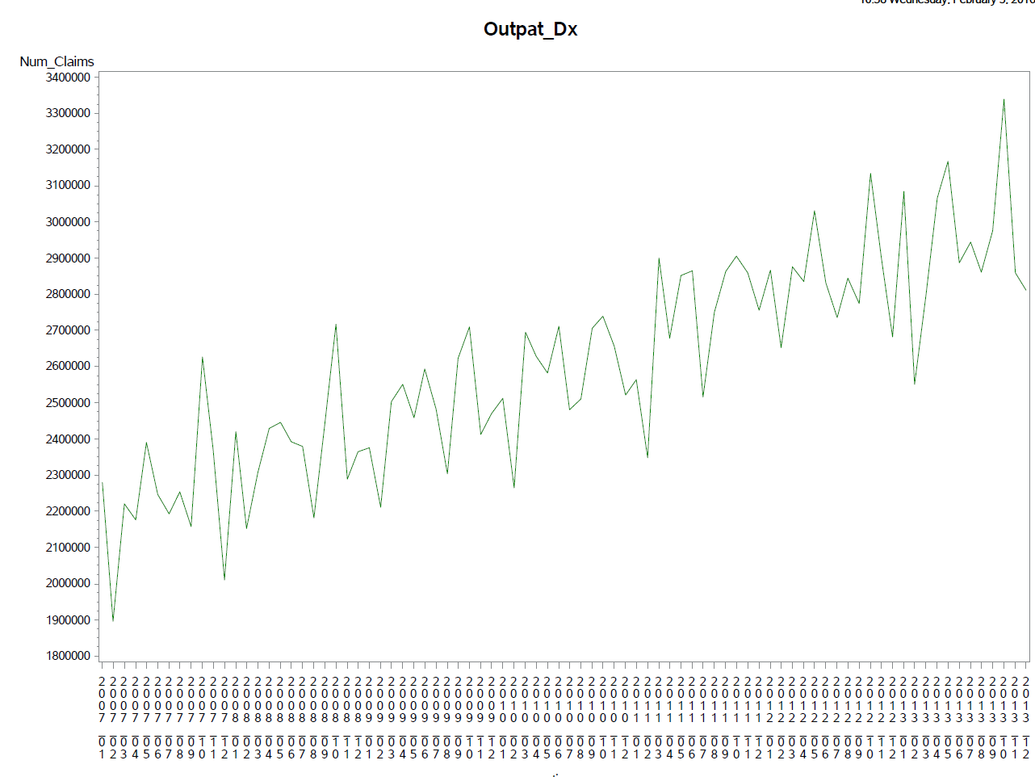

eTable 1. Covariates defined using inpatient diagnosis codes only

Outcome | Hospital Discharge Code(s) | Comments
Ischemic stroke | ICD-9 Dx 433.x1 Occlusion and stenosis of precerebral arteries with cerebral infarction  ICD-9 Dx 434.x1 Occlusion and stenosis of cerebral arteries with cerebral infarction | PPV 95.5% in commercially-insured population  Wahl PM, Rodgers K, Schneeweiss S, Gage BF, Butler J, Wilmer C, Nash M, Esper G, Gitlin N, Osborn N, Short LJ, Bohn RL. Validation of claims-based diagnostic and procedure codes for cardiovascular and gastrointestinal serious adverse events in a commercially insured population. Pharmcoepidemiol Drug Saf. 2010;19(6): 596-603.
Hemorrhagic stroke | As primary ICD-9 discharge diagnosis (Dx):  430.x Subarachnoid hemorrhage (SAH)  431.x Intracerebral hemorrhage (ICH) | Median PPV 96% (86% if all discharge diagnoses) for ICH based on 2 validation studies;  PPV 93% (80% if all discharge diagnoses) for SAH based on 2 validation studies  Andrade SE, Harrold LR, Tjia J, Cutrona SL, Saczynski JS, Dodd KS, Goldberg RJ, Gurwitz JH. A systematic review of validated methods for identifying cerebrovascular accident or transient ischemic attack using administrative data. Pharmcoepidemiol Drug Saf. 2012;21: 100-128.
Myocardial infarction (MI) | ICD-9 Dx 410.X (acute myocardial infarction) excluding 410.x2 (subsequent episode of care), as the principal (primary) or the next (secondary) diagnosis  AND  a length of stay (LOS) between 3-180 days, or death if LOS is < 3 days | PPV 94% in Medicare claims data  Kiyota Y, Schneeweiss S, Glynn RJ, Cannuscio CC, Avorn J, Solomon DH. Accuracy of Medicare claims-based diagnosis of acute myocardial infarction: estimating positive predictive value on the basis of review of hospital records. Am J Heart. 2004;148(1):99-104.
Deep vein thrombosis (DVT) | Validated algorithm:  ICD-9 451.1x (Phlebitis and thrombophlebitis of deep vessels of lower extremities)  ICD-9 451.2x (of lower extremities, unspecified)  ICD-9 451.81 (of Iliac vein)  ICD-9 451.9x (of unspecified site)  ICD-9 453.1x (thrombophlebitis migrans)  ICD-9 453.2x ( venous embolism and thrombosis of vena cava)  ICD-9 453.8x (venous embolism and thrombosis of other specified veins)  ICD-9 453.9x (venous embolism and thrombosis of unspecified site)  Not in the validated algorithm but will be included following Mini-Sentinel recommendation for VTE outcome:  ICD-9 453.40 (Venous embolism and thrombosis of unspecified deep vessels of lower extremity (includes DVT)  ICD-9 453.41 (Venous embolism and thrombosis of deep vessels of proximal lower extremity (includes femoral, iliac, popliteal, thigh, and upper leg)  ICD-9 453.42 (Venous embolism and thrombosis of deep vessels of distal lower extremity (includes calf, lower leg, peroneal, and tibia)  ICD-9 453.0 (Hepatic vein thrombosis) | Algorithm for Deep vein thrombosis (DVT): ICD-9 codes of 451.1, 451.2, 451.81, 451.9, 453.1, 453.2, 453.8, 453.9 [hospital discharge, any position] had PPV of 0.72 and specificity > 0.99 in Medicare population  Birman-Deych E, Waterman AD, Yan Y, Nilasena DS, Radford MJ, Gage BF. Accuracy of ICD-9-CM diagnosis codes for identifying cardiovascular and stroke risk factors. Med Care. 2005;43(5):480-485.
Pulmonary Embolism (PE) | ICD-9 415.1x (pulmonary embolism and infarction) | PPV of 72% in a community sample (45 YO and older)  Cushman M, Tsai AW, White RH, Heckbert SR, Rosamond WD, Enright P, Folsom AR. Deep vein thrombosis and pulmonary embolism in two cohorts: the longitudinal investigation of thromboembolism etiology. Am J Med. 2004;117(1): 19-25.
Major upper GI bleed | ICD-9 diagnoses:  531.0x (acute gastric ulcer with hemorrhage with/without obstruction)  531.2x (with hemorrhage and perforation with/without obstruction)  531.4x (chronic or unspecified gastric ulcer with hemorrhage with/without obstruction)  531.6x (with hemorrhage and perforation with/without obstruction)  532.0x (acute duodenal ulcer with hemorrhage with/without obstruction)  532.2x (with hemorrhage and perforation with/without obstruction)  532.4x (chronic or unspecified duodenal ulcer with hemorrhage with/without obstruction)  532.6x (with hemorrhage and perforation with/without obstruction)  533.0x (acute peptic ulcer of unspecified site with hemorrhage with/without obstruction)  533.2x (with hemorrhage and perforation with/without obstruction)  533.4x (chronic or unspecified peptic ulcer of unspecified site with hemorrhage with/without obstruction)  533.6x (with hemorrhage and perforation with/without obstruction),  534.0x (acute gastrojejunal ulcer with hemorrhage with/without obstruction)  534.2x (with hemorrhage and perforation with/without obstruction)  534.4x (chronic or unspecified gastrojejunal ulcer with hemorrhage with/without obstruction)  534.6x (with hemorrhage and perforation with/without obstruction)  578.0 (hematemesis) OR  ICD-9 procedure code 44.43 (endoscopic control of gastric or duodenal bleeding) OR  CPT code 43255 (upper gastrointestinal endoscopy including esophagus, stomach, and either the duodenum and/or jejunum as appropriate with control of bleeding, any method) | PPV of 87.8% in commercially-insured population  Wahl PM, Rodgers K, Schneeweiss S, Gage BF, Butler J, Wilmer C, Nash M, Esper G, Gitlin N, Osborn N, Short LJ, Bohn RL. Validation of claims-based diagnostic and procedure codes for cardiovascular and gastrointestinal serious adverse events in a commercially insured population. Pharmcoepidemiol Drug Saf. 2010;19(6): 596-603.

Hepatotoxicity | Inpatient ICD-9 diagnoses:  570.xx acute and subacute necrosis of liver  573.3x hepatitis unspecified (toxic)  572.2x hepatic coma (hepatic encephalopathy) | PPV of 83% (95% CI 72-91%) in patients hospitalized for acetaminophen overdose and who developed hepatotoxicity (ALT>1000 U/L)  Myers RP, Leung Y, Shaheen AA, Li B. Validation of ICD-9-CM/ICD-10 coding algorithms for the identification of patients with acetaminophen overdose and hepatotoxicity using administrative data. BMC Health Serv Res. 2007;7:159.
Hip Fracture | Hip fracture diagnosis during hospitalization (ICD-9: 820.xx, 733.14) + procedure code during hospitalization (ICD: 78.55, 79.05, 79.15, 79.25, 79.35, 79.65, CPT-4: 27230-27248) | Solomon DH, Rassen JA, Glynn RJ, Lee J, Levin R, Schneeweiss S. The Comparative Safety of Analgesics in Older Adults With Arthritis. Arch Intern Med. 2010;170(22):1968–1978.
Acute kidney injury based on claims | The following two ARF and ARF-D individually and then as a composite
ARF | Identify patients with inpatient codes for ARF by the presence of ICD-9CM codes 584.5x, 584.6x, 584.7x, 584.8x, or 584.9x in any of the listed diagnoses | Waikar SS, Wald R, Chertow GM, Curhan GC, Winkelmayer WC, Liangos O, Sosa MA, Jaber BL: Validity of ICD-9-CM Codes for Acute Renal Failure. J Am Soc Nephrol. 2006;17:1688-1694.
ARF-D | ARF-D can be identified by the additional presence of any of the following ICD-9CM codes for hemodialysis: procedure code 39.95 (hemodialysis) or diagnosis codes V45.1x (renal dialysis status), V56.0x (extracorporeal dialysis), or V56.1x (fitting and adjustment of dialysis catheter).

eTable 2. Covariates defined using inpatient or outpatient diagnosis codes

Covariate | Definition | Comments
Coronary Artery Disease (CAD) | ICD-9 Dx: 410.x-414.x, 429.2  V45.81
DVT | - ICD-9 : 451.xx, 453.xx
PE | ICD-9: 415.11, 415.12, 415.19
Atrial fibrillation/flutter | one ICD-9 diagnosis code of 427.3 (Atrial fibrillation/flutter), 427.31 (atrial fibrillation), 427.32 (Atrial flutter)
Hypertension | At least 1 Dx of ICD-9 codes 401.x – 405.x  OR  At least 1 dispensing of a CCB, ACEI, ARB, BB, a thiazide diuretic or a direct antihypertensive agent
Diabetes | At least 2 outpatient diagnoses of DM (ICD-9 250.X (diabetes)) OR 1 hospital discharge Dx of DM OR 1 diagnosis of DM plus an insulin or oral antidiabetic dispensing
Hyperlipidemia | ICD-9 272.0, 272.2, 272.4
Heart failure (CHF) | 1 inpatient or 2 outpatient claims with any of ICD-9 codes : 428.x, 398.91, 402.01, 402.11, 402.91, 404.01, 404.11, 404.91, 404.03, 404.13, 404.93 | Validated in Medicare algorithm:  Hospital discharge ICD-9 codes: 428.x, 398.91, 402.01, 402.11, 402.91, 404.01, 404.11, 404.91, 404.03, 404.13, 404.93  PPV 0.97, Spec. 0.97, Sens. 0.76¹
Hemorrhagic stroke | 1 inpatient or 2 outpatient claims with any of 430.x – 432.x,
Ischemic stroke | 1 inpatient or 2 outpatient claims with any of ICD-9 codes: 433.x, 434.x, 436.x, 437.1 | Differs from the outcome definition as higher sensitivity is preferred for covariates definition
COPD | 491.xx, 492.xx, or 496.xx
Pneumonia | 480.xx – 486.xx, 487.0x, 507.xx
Cancer | 140.x-195.x, 196.x-198.x, 199.x, 200.x-208.x, 230.x-234.x, 235.x-238.x, 239.x, excluding non-melanoma skin cancer ( = 173.xx), v10.xx
Acute MI | ICD-9 410
Peptic Ulcer Disease | Diseases of esophagus: 530.1x – 530.4x, 530.8x, 530.9x  Gastric ulcer: 531.x  Duodenal ulcer: 532.x  Peptic ulcer: 533.x  Acute gastritis: 535.0x  Other specified gastritis: 535.4x  Unspecified gastritis and gastroduodenitis: 535.5x  Duodenitis: 535.6x
Upper GI bleed | ICD-9 diagnosis: 531.0x, 531.2x, 531.4x, 531.6x  532.0x, 532.2x, 532.4x, 532.6x, 533.0x, 533.2x, 533.4x, 533.6x,  534.0x, 534.2x, 534.4x, 534.6x, 578.0 OR  ICD-9 procedure code 44.43 OR  CPT code 43255
Prior liver disease | ICD-9 diagnosis:  070.x viral hepatitis  571.x chronic liver disease and cirrhosis  572.x liver abscess and sequalae of chronic liver disease  573.x other disorders of liver  456.0 – 456.2x esophageal varices  155.0 primary cancer of liver  155.1 cancer of intrahepatic bile ducts  155.2 cancer of liver not specified as primary or secondary  576.8 cholestasis  ICD-9 procedure codes:  39.1 intra-abdominal venous shunt  42.91 ligation of esophageal varices
Chronic Kidney Disease | Acute renal disease (see below)  Chronic renal disease (see below)  Diabetic nephropathy (see below)  Hypertensive nephropathy (see below)  Miscellaneous Renal Insufficiency (see below)  Or ESRD (see below) | This definition of renal dysfunction is based on prior work^{3,4} and will be used for covariate adjustment. It is a combination of several diagnoses that are not well distinguished in claims databases.
Acute Renal Disease | 580.0, 580.4, 580.8, 580.9, 581.0, 581.1, 581.2, 581.2, 581.3, 581.8, 581.9, 584.6, 584.7, 584.8, 584.9
Chronic Renal Insufficiency | 582.x, 583.x, 585.x, 586.x, 587.x
Diabetic Nephropathy | 250.4, 250.40, 250.41,  250.42, 250.43
Hypertensive Nephropathy | 403.xx, 404.xx
Miscellaneous Renal Insufficiency | 274.10, 440.1, 442.1, 453.3,  581.xx, 593.xx, 753.0,  753.3, 866.00 866.01,  866.1
ESRD (with and without dialysis) | DIALYSIS  ICD-9 procedure:  39.95 hemodialysis  54.98 peritoneal dialysis  38.95 Venous catheterization for renal dialysis  39.27 Arteriovenostomy for renal dialysis  39.42 Revision of arteriovenous shunt for renal dialysis  39.43 Removal of arteriovenous shunt for renal dialysis  ICD-9 diagnoses:  V45.1 renal dialysis status  V56.0 extracorporeal dialysis  V56.8 peritoneal dialysis  CPT4:  90935 HEMODIALYSIS PROC W/SINGLE PHYSICIAN EVALUATION  90937 HEMODIALYSIS, REPEATED EVAL, W/WO REVISION DIALYSIS PRESCRIPTION  90940 HEMODIALYSIS ACCESS FLOW STUDY, BY INDICATOR DILUTION METHOD, HOOK UP; MEASUREMENT & DISCONNECTION  90945 DIALYSIS, OTHER THAN HEMODIALYSIS, SINGLE PHYSICIAN EVAL  90947 DIALYSIS PROCEDURE, OTHER THAN HEMODIALYSIS, REPEATED PHYSICIAN EVAL  90989 DIALYSIS TRAINING, PATIENT, W/HELPER WHERE APPLICABLE, ANY MODE, COMPLETED COURSE  90993 DIALYSIS TRAINING, PATIENT, W/HELPER WHERE APPLICABLE, ANY MODE, COURSE INCOMPLETE, PER SESSION  99512 HOME VISIT, HEMODIALYSIS  99559 HOME INFUSION, PERITONEAL DIALYSIS, PER VISIT  OR  RENAL TRANSPLANT  V42.0 Kidney transplant  55.6x Kidney transplant  996.81 Complication of transplanted kidney  CPT4:  50360 RENAL ALLOTRANSPLANTATION, IMPLANTATION, GRAFT; W/O DONOR & RECIPIENT NEPHRECTOMY  50365 RENAL ALLOTRANSPLANTATION, IMPLANTATION, GRAFT; W/RECIPIENT NEPHRECTOMY  50380 RENAL AUTOTRANSPLANTATION, REIMPLANTATION, KIDNEY  OR  RENAL ICD9-defined ESRD  585.5 ESKD with no mention of dialysis  585.6 ESKD on dialysis

Waikar SS, Wald R, Chertow GM, Curhan GC, Winkelmayer WC, Liangos O, Sosa MA, Jaber BL: Validity of ICD-9-CM Codes for Acute Renal Failure. J Am Soc Nephrol 2006; 17:1688-1694.

