eAppendix to the manuscript “Antenatal uterotonics as a risk factor for intrapartum stillbirth and first-day death in Haryana, India: a nested case-control study” by Mohan/Sommerfelt et al.

eFigure. Alternative DAG to explore the set of potential confounders that could be observed prior to or during delivery, and that could drive either care seeking behavior or response by care providers. The open ovals depict the covariates in the alternative model described in the manuscript. The “Quality of care provider” variable is unobserved, and is included only to illustrate that residual confounding could potentially be present through some unknown quality of the care provider not fully represented by the variables “Place of delivery” and “Skilled birth attendant”.
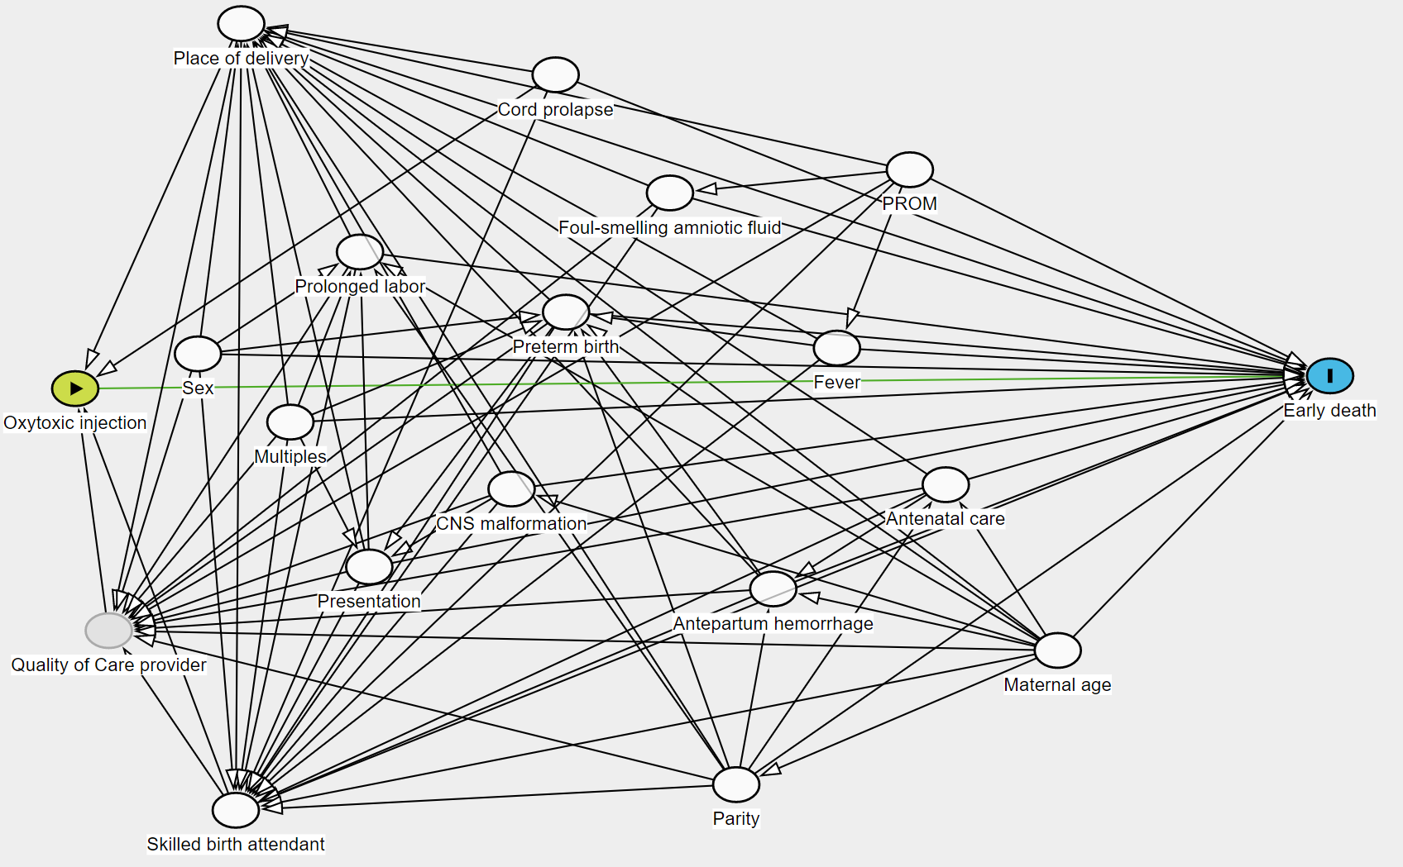

____________________________________________________________________________________
eTABLE. Antenatal administration of oxytocics, antenatal and intrapartum characteristics with their corresponding crude odds ratios (ORs) describing the association between early death versus late death in a nested case-control study in Haryana, India. The cases are intrapartum stillbirths and live-born babies who died within 24 hours of being born, the controls (late deaths) are neonates who died after their first week of life. The ORs are calculated from the non-missing values. Thus, antenatal oxytocic injections were recalled by mothers of 1,478 (74%) of the 1,997 (1478+519) cases and 199 (61.5%) of the 517 (318+199) controls, yielding a crude OR of (1,478/519)/(318/199) or 1.78. The 95% confidence intervals (95%CI) of the ORs were derived from logistic regression accounting for dependencies between individuals within each of the 18 population clusters.
 | Cases |  | Controls
 | n=2076 |  | n=532
Variable | Number (%) |  |  |  |  | OR (95%CI)
Oxytocic injection
Missing |  | 79 (3.8) |  | 15 (2.8)
No |  | 519 (25) |  | 199 (37) |  | 1
Yes |  | 1478 (71) |  | 318 (60) |  | 1.8 (1.5, 2.1)
Place of delivery
Missing |  | 2 (0.10) |  | 1 (0.19)
Government facility |  | 292 (14) |  | 70 (13) |  | 1
Private health facility |  | 830 (40) |  | 169 (32) |  | 1.2 (0.84, 1.6)
Home, including 13 in transport |  | 952 (46) |  | 292 (55) |  | 0.78 (0.56, 1.1)
Skilled birth attendant
Missing (%) |  | 0 (0) |  | 0 (0)
No |  | 863 (42) |  | 261 (49) |  | 1
Yes |  | 1213 (58) |  | 271 (51) |  | 1.4 (1.1, 1.7)
Maternal age
Missing |  | 0 (0) |  | 0 (0)
<20years |  | 281 (14) |  | 70 (13) |  | 1.0 (0.79, 1.3)
20, <35 years |  | 1693 (82) |  | 429 (81) |  | 1
> 35 years |  | 102 (4.9) |  | 33 (6.2) |  | 0.78 (0.55, 1.1)
Parity
Missing |  | 10 (0.48) |  | 2 (0.38)
Multiparous |  | 1300 (63) |  | 378 (71) |  | 1
Nulliparous |  | 766 (37) |  | 152 (29) |  | 1.5 (1.2, 1.7)
Multiples
Missing |  | 10 (0.48) |  | 2 (0.38)
Singleton |  | 1946 (94) |  | 484 (91) |  | 1
Twin or triplet |  | 120 (5.8) |  | 46 (8.6) |  | 0.65 (0.46, 0.91)
Antenatal care
Missing |  | 11 (0.53) |  | 3 (0.56)
No |  | 796 (38) |  | 238 (45) |  | 1
Yes |  | 1269 (61) |  | 291 (55) |  | 1.3 (1.1, 1.5)
Fever on the day delivery began
Missing |  | 11 (0.53) | 2 (0.38)
No |  | 1888 (91) | 497 (93) |  |  | 1
Yes |  | 177 (8.5) | 33 (6.2) |  |  | 1.4 (1.1, 1.9)
Antepartum hemorrhage
Missing |  | 0 (0) | 0 (0)
No |  | 1805 (87) | 478 (90) |  |  | 1
Yes |  | 271 (13) | 54 (10) |  |  | 1.3 (0.90, 2.0)
Prolonged Labour (≥12 hours in multiparous, ≥ 24 hours in primiparous)
Missing |  | 10 (0.48) | 2 (0.38)
No |  | 1707 (82) | 448 (84) |  |  | 1
Yes |  | 359 (17) | 82 (15) |  |  | 1.2 (0.82, 1.6)
Foul-smelling amniotic fluid
Missing (%)r |  | 37 (1.8) | 6 (1.1)
No |  | 1943 (94) | 504 (95) |  |  | 1
Yes |  | 96 (4.6) | 22 (4.1) |  |  | 1.1 (0.78, 1.6)
PROM (Prolonged rupture of membranes)
Missing (%) |  | 21 (1.0) | 6 (1.1)
No |  | 1844 (89) | 476 (90) |  | 1
Yes | 211 (10) |  | 50 (9.4) |  | 1.1 (0.82, 1.5)
Cord prolapse
Missing (%) |  | 34 (1.6) | 5 (0.94)
No |  | 2013 (97) | 524 (98) |  | 1
Yes | 29 (1.4) |  | 3 (0.56) |  | 2.5 (0.88, 7.2)
Presentation
Missing (%) |  | 136 (6.5) | 21 (3.9)
Vertex |  | 1617 (78) | 475 (89) |  | 1
Malpresentation |  | 323 (16) | 36 (6.8) |  | 2.6 (1.8, 3.8)
Type of delivery
Missing (%) |  | 10 (0.48) | 2 (0.38)
Spontaneous vaginal delivery |  | 1853 (89) | 494 (93) |  | 1
Assisted delivery |  | 213 (10) | 36 (6.8) |  | 1.6 (1.2, 2.1)
Sex assigned at birth
Missing (%) |  | 15 (0.72) | 3 (0.56)
Girl |  | 930 (45) | 269 (51) |  | 1
Boy |  | 1131 (54) | 260 (49) |  | 1.3 (1.1, 1.5)
Preterm birth
Missing (%) |  | 10 (0.48) | 2 (0.38)
Term or post term |  | 1908 (92) | 503 (95) |  | 1
Preterm (< 7 months) |  | 158 (7.6) | 27 (5.1) |  | 1.54 (1.0, 2.3)
CNS malformation
Missing (%) |  | 10 (0.48) | 2 (0.38)
No |  | 1968 (95) | 507 (95) |  | 1
Yes |  | 98 (4.7) | 23 (4.3) |  | 1.1 (0.70, 1.7)

OR=1 denotes reference category
____________________________________________________________________________________

