eAppendix – Supplementary Materials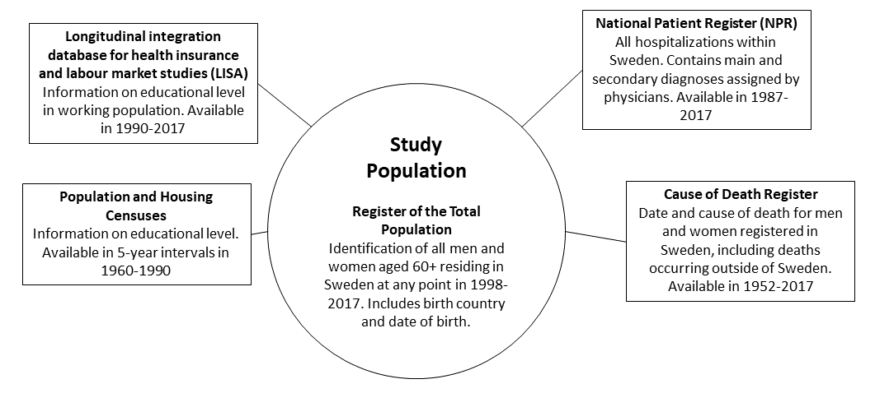
eFigure 1: Data sources linked through unique personal identification number assigned to each resident in Sweden.

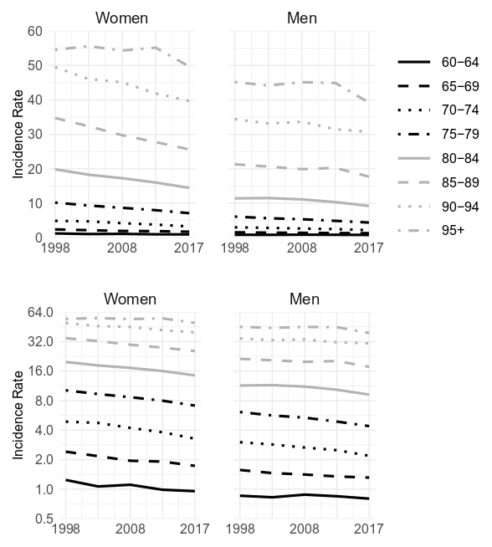
eFigure 2: Incidence rates of first hip fractures (rates per 1000 person-years) by age group among men and women 1998-2017. Top panels show incidence rates on a linear scale, bottom panels show incidence rates plotted on a logarithmic scale.

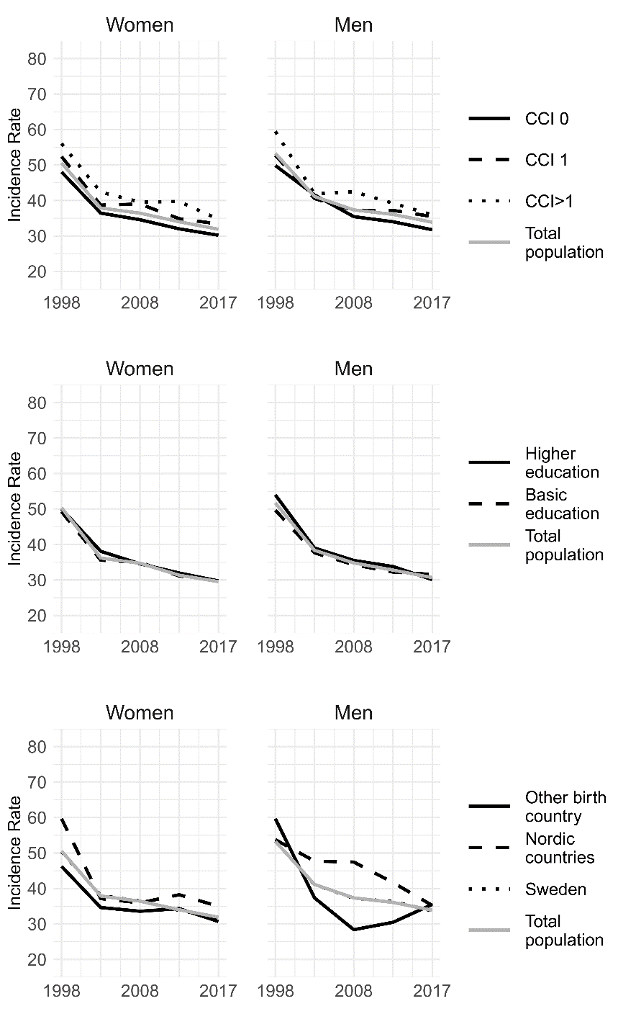
eFigure 3: Age-standardized incidence rates of recurrent hip fractures (rates per 1000 person-years) by comorbidity level, educational level, and birth country among men and women 1998-2017. CCI: Charlson comorbidity index score. Note: Incidence by educational level includes individuals up to age 90 only.

eTable 1: Age-standardized incidence of first hip fracture (rate per 1000 person-years), recurrent hip fracture (rate per 1000 person-years), and survival proportions with 95%-confidence intervals and relative trends between time periods1998-2001 and 2014-2017
 | Incidence of first hip fracture (rate per 1000 person-years, age-standardized)
 | Women |  |  | Men
 | 1998-2001 | 2014-2017 | Trend | 1998-2001 | 2014-2017 | Trend
Total population | 8.93 [8.84-9.01] | 6.57 [6.50-6.64] | -26.4% | 5.64 [5.55-5.72] | 4.57 [4.51-4.64] | -19.0%
Education*
Basic | 8.12 [8.01-8.24] | 6.23 [6.11-6.34] | -23.3% | 5.07 [4.94-5.19] | 4.32 [4.22-4.43] | -14.8%
Higher | 7.71 [7.52-7.90] | 5.56 [5.47-5.65] | -27.9% | 4.62 [4.46-4.78] | 3.65 [3.57-3.74] | -21.0%
Birth country
Sweden | 9.04 [8.95-9.13] | 6.73 [6.66-6.80] | -25.6% | 5.49 [5.41-5.58] | 4.65 [4.58-4.72] | -15.3%
Other Nordic | 9.23 [8.72-9.73] | 6.23 [5.95-6.51] | -32.5% | 5.94 [5.21-6.67] | 4.60 [4.24-4.95] | -22.6%
Other | 6.58 [6.20-6.97] | 4.72 [4.50-4.95] | -28.3% | 3.86 [3.44-4.27] | 3.32 [3.07-3.57] | -14.0%
CCI at fracture
0 | 7.65 [7.55-7.75] | 5.49 [5.41-5.57] | -28.2% | 4.35 [4.25-4.46] | 3.40 [3.32-3.48] | -21.8%
1 | 11.82 [11.59-12.06] | 7.95 [7.77-8.13] | -32.7% | 7.32 [7.12-7.53] | 5.03 [4.88-5.18] | -31.3%
2+ | 16.87 [16.29-17.46] | 11.76 [11.43-12.09] | -30.3% | 10.32 [9.92-10.71] | 8.37 [8.12-8.62] | -18.9%
*up to age 90
 | Incidence of recurrent hip fracture (rate per 1000 person-years, age-standardized)
 | Women |  |  | Men
 | 1998-2001 | 2014-2017 | Trend | 1998-2001 | 2014-2017 | Trend
Total population | 66.0 [63.9-68.0] | 34.3 [33.4-35.2] | -47.9% | 69.7 [65.7-76.6] | 37.3 [35.7-38.9] | -46.5%
Education*
Basic | 63.8 [61.0-66.7] | 32.6 [31.2-34.0] | -48.9% | 65.6 [60.2-70.9] | 34.6 [32.2-37.0] | -47.3%
Higher | 64.7 [59.8-69.5] | 31.6 [30.2-32.9] | -51.2% | 70.5 [61.9-79.1] | 34.0 [31.8-36.3] | -51.8%
Birth country
Sweden | 66.0 [63.9-68.2] | 34.1 [33.2-35.0] | -48.3% | 69.8 [65.7-73.8] | 37.2 [35.6-38.9] | -46.7%
Other Nordic | 70.2 [57.6-82.9] | 38.1 [33.9-42.1] | -45.7% | 66.8 [35.6-98.0] | 35.9 [27.3-44.6] | -46.3%
Other | 61.0 [48.8-73.2] | 33.8 [29.6-38.0] | -44.6% | 82.8 [40.1-125.6] | 37.9 [30.0-46.0] | -55.2%
CCI at fracture
0 | 60.6 [57.8-63.4] | 31.4 [30.2-32.5] | -48.2% | 64.2 [58.1-70.2] | 33.8 [31.3-36.3] | -47.4%
1 | 70.5 [66.6-74.4] | 36.0 [34.4-37.7] | -48.9% | 71.0 [64.2-77.8] | 38.9 [35.9-41.9] | -45.2%
2+ | 75.9 [70.5-81.4] | 39.7 [37.6-41.8] | -47.7% | 77.7 [69.1-86.2] | 40.8 [38.0-43.7] | -47.5%
*up to age 90
 | Proportion surviving 30 days
 | Women |  |  | Men
 | 1998-2001 | 2014-2017 |  | 1998-2001 | 2014-2017
Total population | 0.95 [0.94-0.96] | 0.94 [0.93-0.95] |  | 0.89 [0.88-0.90] | 0.88 [0.86-0.89]
Education*
Basic | 0.96 [0.95-0.97] | 0.95 [0.93-0.97] |  | 0.90 [0.88-0.92] | 0.89 [0.87-0.91]
Higher | 0.97 [0.94-0.99] | 0.96 [0.94-0.98] |  | 0.90 [0.87-0.93] | 0.91 [0.89-0.93]
Birth country*
Sweden | 0.95 [0.94-0.96] | 0.94 [0.93-0.95] |  | 0.89 [0.88-0.91] | 0.88 [0.86-0.89]
Other Nordic | 0.96 [0.91-1.00] | 0.93 [0.89-0.98] |  | 0.80 [0.69-0.92] | 0.87 [0.80-0.95]
Other | 0.96 [0.90-1.00] | 0.94 [0.89-0.99] |  | 0.90 [0.79-1.00] | 0.88 [0.81-0.95]
CCI at fracture
0 | 0.98 [0.97-0.99] | 0.98 [0.96-1.00] |  | 0.95 [0.92-0.97] | 0.96 [0.92-0.99]
1 | 0.95 [0.93-0.96] | 0.95 [0.93-0.97] |  | 0.89 [0.87-0.92] | 0.91 [0.88-0.93]
2+ | 0.90 [0.88-0.92] | 0.90 [0.88-0.92] |  | 0.82 [0.80-0.85] | 0.83 [0.81-0.85]
*up to age 90
 | Proportion surviving 365 days
 | Women |  |  | Men
 | 1998-2001 | 2014-2017 |  | 1998-2001 | 2014-2017
Total population | 0.79 [0.78-0.80] | 0.79 [0.78-0.80] |  | 0.64 [0.62-0.65] | 0.66 [0.64-0.67]
Education*
Basic | 0.82 [0.81-0.83] | 0.81 [0.79-0.83] |  | 0.67 [0.65-0.69] | 0.68 [0.66-0.71]
Higher | 0.83 [0.81-0.85] | 0.83 [0.82-0.85] |  | 0.68 [0.66-0.71] | 0.71 [0.69-0.73]
Birth country*
Sweden | 0.79 [0.78-0.80] | 0.79 [0.78-0.80] |  | 0.64 [0.63-0.65] | 0.66 [0.64-0.67]
Other Nordic | 0.79 [0.74-0.85] | 0.78 [0.73-0.82] |  | 0.54 [0.46-0.62] | 0.64 [0.57-0.71]
Other | 0.65 [0.63-0.66] | 0.67 [0.66-0.69] |  | 0.63 [0.55-0.72] | 0.66 [0.59-0.73]
CCI at fracture
0 | 0.87 [0.86-0.88] | 0.91 [0.89-0.93] |  | 0.77 [0.74-0.79] | 0.83 [0.79-0.86]
1 | 0.76 [0.75-0.78] | 0.80 [0.78-0.82] |  | 0.63 [0.61-0.66] | 0.70 [0.67-0.72]
2+ | 0.72 [0.67-0.77] | 0.78 [0.73-0.83] |  | 0.49 [0.47-0.51] | 0.57 [0.55-0.58]
*up to age 90

