eAPPENDIX

Section 1: Assumptions for variables – Calculation of baseline date

Calculation of the weight and weight change
We calculated theoretical weight and weight change measurements every year after the 1st measurement of bodyweight for each individual. We assumed linear trend and we censored observations of participants with >4 years without weight measurement.
The formula for the linear trend will be
$$w(t_{hyp})=\frac{\left(t_{hyp}-t_{0}\right)*\left[w\left(t_{1}\right)-w\left(t_{0}\right)\right]}{\left(t_{1}-t_{0}\right)}$$
where $w(t_{hyp})$ indicates the (hypothetical) bodyweight measurement at 1 or 2 years, calculated from previous and next bodyweight measurements [$w\left(t_{0}\right)$ and $w\left(t_{1}\right)$], i.e.
For $w(t_{hyp})$ at 1 year after baseline, we have that
$w\left(t_{0}\right)$= latest bodyweight measurement between baseline and 1 year after baseline,
$t_{0}$∈ [t_{baseline}, 1 year after baseline) and
$w\left(t_{1}\right)$= first bodyweight measurement 1 year after baseline, $t_{1}$ > 1 year after baseline

For $w(t_{hyp})$ at 2 years after baseline, we have that
$w\left(t_{0}\right)$= latest bodyweight measurement between baseline and 2 years after baseline,
$t_{0}$∈ [t_{baseline}, 2 years after baseline) and
$w\left(t_{1}\right)$= first bodyweight measurement 2 years after baseline, $t_{1}$ > 2 years after baseline
Below, we present a hypothetical participant, who measured her weight 4 times
1st bodyweight measurement at 30/6/99
2nd bodyweight measurement at 7/1/01
3rd bodyweight measurement at 25/4/02
4th bodyweight measurement at 4/7/07
For this individual, we assumed that she had the 1st bodyweight measurement at 30/6/99 was 84.8kg (this will be the baseline measurement). The 2nd (hypothetical this time) measurement will be at 30/6/00, 80.5kg and the other hypothetical measurement is 79.5 kg at 30/6/01. These 3 bodyweight measurement are represented in orange colour below. We censored the last observation from this individual, as her last measurement was >4 years after 25/4/02, so we did not assume linear trend between these 2 observations.
So the 1st weight change measurement will be (84.8 – 80.5)/ 80.5 ≈ –5.1%
Her 2nd weight change measurement will be (80.5– 79.5)/ 79.5≈ –1.2%

kg

85

80

75
30/6/99 30/6/00 7/1/01 30/6/01 25/4/02 4/7/07
Calculation of smoking status, physical activity and baseline date

We considered smoking status (in the main analysis) and physical activity (in the sensitivity analysis) as confounders in our study. We assumed that their last observation carries forward for 4 years, unless the participant has another measurement of these variables. We implemented complete-case analysis, requiring that all individuals should have observations of smoking status and physical activity (in the sensitivity analysis). For this reason, we created time “windows” within which could be the baseline of our hypothetical interventions.
The date of baseline for an individual was defined as the date of the first BMI and weight observations, in which we would have valid information on smoking status. For those individuals with information on both physical activity and smoking status, we selected as baseline date, the date of the first BMI and weight observations, in which they had information on both smoking status and physical activity.
Below, we present a hypothetical individual who had her 1st bodyweight measurement at 20/5/2003 and her 2nd at 30/6/2006 (she also had a few more after 2006). Given that she had her 1st smoking status record at 2004 and her 1st physical activity observation at 2005, we considered that the time “window” for her potential baseline would be between 7/1/2005 and 30/6/2008. So, her actual baseline in this example would be at 30/6/2006 (time of her 2nd bodyweight measurement).

1st Bodyweight Sm. Status Ph activity Bodyweight (BW) obs.
Obs (not baseline) Observation Observation (Baseline) BW obs BW obs

20/5/03 30/6/04 7/1/05 30/6/06 30/6/08 7/1/09

Section 2: Protocol of the target trials – protocol of the emulated trials

PROTOCOL OF THE TARGET TRIALS
Eligibility criteria
The trials would enrol healthy men and non-pregnant women aged 45-69 years old, from primary care practices in England registered between 1998 and 2016 who had not undergone bariatric surgery in the past and without any prevalent cardiovascular disease, diabetes, cancer (apart from non-melanoma skin cancer), severe mental diseases (acute stress, phobia, anxiety, schizophrenia, depression, bipolar disorder or affective disorder), major inflammatory diseases (systemic lupus erythematosus, rheumatoid arthritis, gout and ulcerative colitis), Parkinson’s disease, multiple sclerosis, renal disease and renal failure at baseline. Moreover, individuals who either die or develop one of the aforementioned chronic diseases or the outcome or women who become pregnant during the 1st year of the hypothetical interventions, would be excluded from the trials. The trials would be conducted separately among normal weight, overweight and obese individuals (see Table 1 and Figure 1). We would additionally consider these trials, stratified by sex (males and females) and age (<60 & ≥60 years old).
Treatment strategies
Individuals in the trials would be randomly assigned to the following two-year hypothetical weight change interventions
a) lose ≥3% & <20% of their weight each year or undergo bariatric surgery
b) maintain their weight, defined as weight change >-3% & <3% of bodyweight each year
c) gain ≥3% & <20% of their weight each year.
Under all three strategies, individuals would be allowed to deviate from their assigned weight change intervention after 2 years. From these trials, we considered women who became pregnant and individuals who developed chronic diseases during the 2nd year of follow up as a clinically allowable reason for deviating from assigned intervention; thus, these individuals will be allowed to deviate from their assigned intervention in the 2nd year. The chronic diseases considered as clinically allowable conditions to deviate from the intervention in these trials would be the following; diabetes, cancer (apart from non-melanoma skin cancer), dementia, severe mental diseases (acute stress, phobia, anxiety, depression, schizophrenia, bipolar disorder and affective disorder), chronic kidney disease, chronic obstructive pulmonary disease, HIV, major inflammatory diseases(systemic lupus erythematosus, rheumatoid arthritis, gout, and inflammatory bowel disease), Parkinson’s disease, multiple sclerosis and renal failure. When diabetes or non-melanoma skin cancer were the outcomes of interest (positive and negative control outcomes), we also considered CVD as a clinically allowable condition for deviating from the initial intervention. For more details, see table 1.
Treatment assignment
Individuals would be randomly assigned to a treatment strategy at baseline
Follow-up
Follow-up would start at randomization and would end at diagnosis of a cardiovascular event, death, loss to follow-up, 7 years after baseline, or 31st June 2016, whichever occurs first.
Endpoints
Primary endpoint;
Composite CVD outcome (CVD death, non-fatal Myocardial infarction, non-fatal stroke, hospitalisation from coronary heart disease and heart failure)
Secondary endpoints;
a) Composite CHD outcome (CHD death, non-fatal Myocardial infarction, hospitalisation from coronary heart disease)
b) fatal and non-fatal Myocardial infarction,
c) fatal and non-fatal stroke,
d) heart failure
e) CVD deaths
Causal contrasts
Per-protocol effect, defined as the effect of adhering to the assigned intervention for two years
Analysis plan
i. Data structure: Follow-up would be divided into one year periods in which the weight change intervention per year was recorded, along with information on confounders, CVD outcome (1:yes , 0:no), death (1:yes , 0:no) and loss to follow-up (1:yes , 0:no) recorded during each year.
ii. Outcome regression: Pooled logistic regression model would be used to estimate the hazard ratios of the hypothetical interventions and the cumulative incidence risk curves of each intervention.
iii. Emulating randomisation at baseline: Individuals would be randomised at baseline
iv. Dealing with non-adherence to intervention (for the per-protocol analysis):. Inverse probability of treatment weights (IPTW) would be used to adjust for time-fixed and time-dependent confounders. To estimate the per-protocol effect of these 2-year interventions, we would first break all the follow-up time of each individual into one-year periods. We would then have to account for all pre-and post-randomisation factors that were related to adherence for the first and the second year, using inverse probability for treatment weights (IPTW).
v. Dealing with loss to follow-up: Additional adjustment for pre- and post-randomisation prognostic factors of loss to follow-up would also be used through inverse probability of censoring weighting (IPCW), to estimate the effect of the interventions, had the participants remained uncensored during the follow-up. These analyses would be thus valid under missing at random, given the covariates used to model the censoring mechanism.
vi. Final calculation of IP weights: IPTW and IPCW would be multiplied at each time point. The final weight for each individual for a specific time would be taken as the product of his/her weights up until that time point. We would truncate weights >15 (which were higher than the 99th percentile of weights) and would set it to 15.
vii. Risk curves: We would additionally estimate absolute risks for CVD, CHD and diabetes by fitting the pooled logistic models that were mentioned above, including product terms between treatment and follow-up time (time, squared time and cubic time) to allow for time varying effects. The estimated parameters would be then used to calculate the cumulative incidence of CVD, CHD and diabetes (see details in the Appendix – section 3).
viii. Variance estimators: We would use robust variance estimators to calculate 95% CI for the hazard ratio estimates, and we would use non-parametric bootstrapping from 500 samples to obtain percentile-based 95% CI for the cumulative incidence estimates.

PROTOCOL OF THE EMULATED TRIALS
Eligibility criteria
Same as for the target trials plus the following modifications: i) all participants should have measurements of smoking status (important confounder), ii) while the target trial would apply eligibility criteria and assign treatment strategies at a unified time zero, our emulated trial applies the exclusion criteria from chronic diseases based on observing a 12-month baseline period iii) exclude individuals with an excess number of bodyweight measurements or clinical consultations in the 1st year (defined as ≥6 bodyweight measurements or with ≥12 primary care consultations), under the assumption that these individuals would be too unhealthy to participate in the study.
Treatment strategies
Same as for the target trials plus we excused individuals from following their assigned intervention if they have ≥12 clinical consultations or measured their bodyweight ≥6 times per year in the primary care‡ during the 2nd year.
Treatment assignment
Patients are classified into one of three weight change groups (maintenance, loss, or gain) based on their observed weight status. Randomization is emulated via adjustment for baseline covariates.
Follow-up
Same as for the target trials
Endpoints
Same as for the target trials plus
(i) Diabetes: used as a positive control outcome (i.e. it is expected that weight loss reduces and weight gain increases the risk of diabetes)
(ii) Non melanoma skin cancer – used as a negative control outcome (i.e. it is expected that no effect of weight loss or gain on non-melanoma skin cancer)
Causal contrasts
Observational analog of the per-protocol effects
Analysis plan
Pooled logistic regression models were used to estimate the hazard ratios of the hypothetical interventions and the cumulative incidence risk curves of each intervention, after dividing the 7-year follow-up time into one-year periods. Time of entry in the emulated trials was considered the date of the first BMI observations. Each time point corresponds to one-year duration of our interventions. To emulate randomisation in the baseline period, we adjusted for: age (in years), sex (man/woman), BMI (in kg/m²), prevalence of hypertension (yes/no), record of high LDL levels (before baseline; yes/no), use of diuretics before baseline (yes/no), family history of CVD (yes/no), hypertension during the 1st year (yes/no); high LDL levels during the 1st year (yes/no), use of diuretics during the 1st year (yes/no), smoking status during the 1st year (never, former and current), bodyweight measurements during the 1st year (categorical: 1, 2 and 3-5 measurements), clinical consultations during the 1st year (categorical: 1-2, 3-5, 6-8 and 9-11 consultations) and region (categorical; London, South West, South Central, South East, East, West Midlands, Central North and North West). Non-adherence occurred when individuals were observed to a particular weight change group in the first year but deviated from it in second year. IPTW were used to adjust for time-fixed and time-dependent confounders that were related to adherence in the 2nd year. To calculate the denominator of the IPTW, we used multinomial logistic regression models to model weight loss, maintenance and gain of the 2nd year, as a function of prognostic factors measured before baseline, during the 1st and the 2nd year of these interventions, along with the observed weight change intervention of the 1st year. These weights remained unchanged after the second year, because we were interested in the effect of interventions sustained over 2 years only. After calculating the IPTW for the received intervention in the second year, individuals were then censored during the 2nd year, if they deviate from their assigned intervention. Individuals who developed a chronic disease other than CVD during the 2nd year (and thus were allowed to deviate from their intervention) were assigned the weight of 1 across all time points. We remark that we used the non-stabilised IPTW, because the regime of the trials was dynamic (as there are clinically allowable reasons after which individuals were free to deviate from their initial intervention).
Additional adjustment for pre- and post-randomisation prognostic factors of loss to follow-up was also used through inverse probability of censoring weighting (IPCW), to estimate the effect of the interventions, had the participants remained uncensored during the follow-up. IPTW and IPCW specific to each time point were multiplied to create time specific weights. The final weight for each individual at a specific time was the cumulative product of his/her time-specific weights up until that time point. We truncated weights >15 (and higher than the 99th percentile of weights) and set them to 15.
We estimated incidence risk curves by fitting the weighted pooled logistic regression models, by additionally including product terms between intervention and follow-up time (linear, squared and cubic time) to allow for time varying effects (see Appendix–Section 3). These product terms were not included in the calculation of hazard ratios and hence this part of the analysis relied on the proportional hazard assumption. Finally, we used robust variance estimators to calculate 95% confidence intervals (CI) for the hazard ratio estimates, and non-parametric bootstrapping from 500 samples to obtain percentile-based 95% CI for the cumulative incidence estimates.

Section 3: Details on the statistical analysis

Disease models

To estimate the hazard ratios in all analyses, we used pooled logistic regression models. In these models, we use the following notation; t is the follow-up time (in years), A_{t,wl} denotes the value of the “weight loss intervention” between t and t+1, A_{t,wm} denotes the value of the “weight maintenance intervention” between t and t+1, A_{0,wg} and A_{t,wg} indicates the value of the “weight gain intervention” between t and t+1, L_{t} indicates a vector of covariates (number of weight measurements [categorical; 1: 1 meas, 2:2 meas., 3: 3-5 meas), number of clinical consultations (ordered; 1: 1-2 clinical cons., 2: 3-5 clinical cons., 3: 6-8 clinical cons, 4: 9-11 clinical cons), record of hypertension, record of high LDL measurement, use of diuretics] measured between t and t+1. Of note, L₀ (i.e. baseline confounders) additionally contains information on age (at baseline), sex, region, BMI (in kg/m² at baseline), prevalence of hypertension (at baseline – criteria; systolic blood pressure>140mmol/Hg or diastolic blood pressure>90mmol/Hg), record of high LDL measurement (before baseline), use of diuretics (before baseline), apart from the information of number of weight measurements, number of clinical consultations, record of hypertension, high LDL measurement and use of diuretics that occurred during the 1st year (i.e. between t=0 and t=1). Moreover, D_{t} indicates the values of the CVD outcome between t and t+1 and C_{t} denotes whether an individual was censored between t and t+1. The over-bars represent the previous history of a variable from the beginning of follow-up and the superscript T indicates a transpose of a vector of parameters.
Throughout our analyses, we censored the person-time when someone discontinued his/her initial treatment assignment, because we were interested in the per-protocol effect of our “interventions”. That is, we fit the model:
$logit\left[pr \left(D_{t+1}=1 | A_{0}, L_{0},{\overline{D}}_{t}=0, {\overline{C}}_{t+1}=0\right)\right]=β_{0,t}+β_{1}A_{0,wl}+β_{2}A_{0,wg}+ {β_{3}}^{T}L_{0}$ (S.1)
where ${\overline{C}}_{t+1}$ is the indicator for (artificial) censoring at time t+1, $β_{0,t}$ is a time-varying intercept, calculated as a constant plus a linear, a quadratic and a cubic term for time t. Moreover, $β_{1}$ and $β_{2}$ corresponds to the log hazard ratios for the weight loss and weight gain “interventions” respectively (compared to the weight maintenance “intervention”).

Models for IP weights
We were interested in the per-protocol effect of our “trails”, so we weighted our disease models with the inverse probability of treatment weights (IPTW). The IPTW correspond to the reciprocal of the probability that an individual adhered his/her observed weight change intervention given his past treatment and pre and post baseline prognostic factors history. We used the unstabilised version of IPTW because the regime of our trials was dynamic (if people were not healthy at year 1, they were free to deviate from their allocated intervention).

During the 1st year, individuals adhered to the initial intervention they were allocated (by default in our observational analog of the target trial), so the IPTW during the 1st year was 1 for all individuals (i.e. the probability that an individual adhered his/her observed weight change intervention was 1, the same for the inverse of this probability). For the 2nd year (i.e. year 1), we calculated the IPTW as follows.
The unstabilized inverse probability weights for each patient at year 1 (i.e. the 2nd year) are defined as
$${IPTW}_{1}=\frac{1}{f(A_{1}|A_{0}{,L}_{0}{,L}_{1}, {\overline{D}}_{1}=0 )}$$
As described elsewhere, (2, 3) we fit the multinomial logistic model
$logit\left[pr \left(A_{1}=j | A_{0}, L_{0},L_{1},{\overline{D}}_{1}=0\right)\right]=φ_{0}+φ_{1}A_{0}+φ_{2}^{T}L_{0}+ φ_{3}^{T}L_{1}$ (S.2)
to estimate $f(A_{1}|A_{0}{,L}_{0}{,L}_{1}, {\overline{D}}_{1}=0 )$, where j=1,2,3 is the “intervention” of interest.
To be consistent with the notation, we used previously in the outcome regression model,
if $A_{1}=1⇒A_{1,wl}=1,A_{1,wm}=0,A_{1,wg}=0$
if $A_{1}=2⇒A_{1,wl}=0,A_{1,wm}=1,A_{1,wg}=0$
if $A_{1}=3⇒A_{1,wl}=0,A_{1,wm}=0,A_{1,wg}=1$
If the participants develop a severe disease at year 1, then the participants are free to deviate from their intervention. These individuals will not be used in model (S.2), i.e. only healthy individuals contribute in the calculation of the probability of adhering to their intervention in year 1 [$f(A_{1}|A_{0}{,L}_{0}{,L}_{1}, {\overline{D}}_{1}=0 )$], and will have IPTW=1. Of note, we run this model before excluding the individuals who did not adhere to their allocated intervention during the 2nd year.
Moreover, from year 2 onwards, participants were free to deviate from their hypothetical weight change intervention, so the weights remained constant till the end of their follow-up.
We also took into consideration the potential bias due to loss to follow-up, by calculating the effect of an intervention, had the participants remained uncensored. To implement that, we additionally multiply IPTW calculated from (S.2) with the reciprocal of the probability of remaining uncensored
More specifically, we calculate the inverse of the probability of remaining uncensored at each time point
$${IPCW}_{t}=\prod_{k=0}^{t}{\frac{1}{f(C_{k+1}=0|A_{k},\overline{L_{k}},\overline{C_{k}}=0,\overline{D_{k+1}}=0)}}$$
by running the pooled logistic regression
$logit\left[pr \left(C_{t+1}=1 | A_{t},\overline{L_{t}}, C_{t}=0,\overline{D_{t+1}}=0\right)\right]=d_{0,t}+d_{1}A_{t,wl}+d_{2}A_{t,wg}+ {d_{3}}^{T}L_{0}+ {d_{4}}^{T}L_{t}$ (S.4)
to estimate$f(C_{k+1}=1|A_{k},\overline{L_{k}},\overline{C_{k}}=0,\overline{D_{k+1}}=0)$ at each time point. Then we calculate $f(C_{k+1}=0|A_{k},\overline{L_{k}},\overline{C_{k}}=0,\overline{D_{k+1}}=0)$ =1-$f(C_{k+1}=1|A_{k},\overline{L_{k}},\overline{C_{k}}=0,\overline{D_{k+1}}=0)$ at each time point and finally we multiply these probabilities through all time points, to estimate $\prod_{k=0}^{t}{f(C_{k+1}=0|A_{k},\overline{L_{k}},\overline{C_{k}}=0,\overline{D_{k+1}}=0)}$. Then the ${IPCW}_{t}$ is the reciprocal of this probability in each time point.

For IPCW, we used smoking status only for the 1st year (i.e. in the vector $L_{0}$). We didn’t use information from smoking status in the vector $L_{k}$, with k≥1, from follow-up, due to near positivity violations.
eTable 1: Example of the dataset from 3 hypothetical individuals;
ID | Date | Time (in years) | BW^{t}  Bodyweight measurement at t | WC^{t}= BW^{t+1}-BW^{t}  Weight change between t and t+1 | A^{t}  Hypothetical intervention between t and t+1 (1=weight loss,  2=weight maint.,  3=weight gain) | C^{t}  Censored between t and t+1 | C^{t+1}  Censored between t+1 and t+2 | D^{t}  Develop the CVD outcome between t and t+1 | D^{t+1}  Develop the CVD outcome between t+1 and t+2 | L^{t} (example)  N of Weight measurements (Confounder measured between t and t+1) | Severe disease  measured between t and t+1 (from table 1) | IPTW
1 | 5/5/2002 | 0 | 70 | -0.05 | 1 | 0 | 0 | 0 | 0 | 1 | 0 | 1
1 | 5/5/2003 | 1 | 66.5 | -0.098 | 1 | 0 | 1 | 0 | 0 | 2 | 0 | w1
1 | 5/5/2004 | 2 | 60 |  |  | 1 | . | 0 | 0 | 1 | 0 | w1
2 | 3/8/2001 | 0 | 50 | 0 | 2 | 0 | 0 | 0 | 0 | 1 | 0 | 1
2 | 3/8/2002 | 1 | 50 | 0.02 | 2 | 0 | 0 | 0 | 0 | 1 | 0 | w2
2 | 3/8/2003 | 2 | 51 | . | 2 | 0 | 0 | 0 | 0 | 2 | 0 | w2
2 | 3/8/2004 | 3 | . | . | 2 | 0 | 0 | 0 | 0 | 1 | 0 | w2
2 | 3/8/2005 | 4 | . | . | 2 | 0 | 0 | 0 | 0 | 2 | 0 | w2
2 | 3/8/2006 | 5 | . | . | 2 | 0 | 0 | 0 | 1 | 2 | 0 | w2
2 | 3/8/2007 | 6 | . | . | 2 | 0 | 0 | 1 | . | 1 | 0 | w2
3 | 9/6/2006 | 0 | 100 | -0.1 | 1 | 0 | 0 | 0 | 0 | 2 | 0 | 1
3 | 9/6/2007 | 1 | 90 | 0.11 | 1 | 0 | 1 | 0 | 0 | 1 | 1 | 1
3 | 9/6/2008 | 2 | 100 | . | 1 | 1 | . | 0 | 0 | 1 | 1 | 1
Participant 1 was censored at 7/8/2004, participant 2 developed CVD at 10/11/2007 and participant 3 was censored at 12/10/2008
Description of eTable 1

Participant ID=1 was allocated in the weight loss arm (she lost ≥3% of her bodyweight at year 0 and year 1). She was censored at 7/8/2004, during the 3rd year, so this was recorded in her year 2 raw in C^{t} and in her year 1 in C^{t+1}. We subsequently delete any observations from this participant from time 2 onwards (orange line).
Participant ID=2 was allocated in the weight maintenance arm (her bodyweight change was <3 % at year 0 and year 1). She remained in the weight maintenance arm from year 2 onwards, even if she has no other measures of bodyweight, as after the completion of 2 years, people are free to deviate from their intervention. She developed the CVD outcome during the 7th year (10/11/2007).
Participant ID=3 was allocated in the weight loss arm (she lost ≥3% of her bodyweight at year 0). She developed cancer (which is included in the set of the severe chronic diseases described in the paper, so she was free to deviate from her intervention) during the 2nd year of follow-up, at 11/12/2007. Even if at time 1 (i.e. during the second year) she gained weight, he remained in the weight reduction arm. Her IPTW is 1 (because she developed cancer at year 1). She was censored during her 3rd year, so we subsequently deleted any observations from this participant from time 2 onwards.

Risk curves

After calculating the IPTW from (S.2), we fitted a (weighted) pooled logistic regression model as the one described in the beginning of section 1 in (S.1), with the only difference being that we add product terms with a linear, a quadratic and a cubic term for time t in the variables for weight loss and weight gain “intervention” at baseline. In other words, we adjusted for the joint distribution of confounders at baseline, as well as from the 1st year of follow-up ($L_{0}$) and additionally added product terms with a linear, a quadratic and a cubic term for time t to the weight interventions. More specifically, the model we fitted is
$$logit\left[pr \left(D_{t+1}=1 | A_{0}, L_{0},{\overline{D}}_{t}=0, {\overline{C}}_{t+1}=0\right)\right]=$$
${=c}_{0,t}+c_{1}A_{0,wl}+c_{2}A_{0,wg}+ c_{3}A_{0,wl}*t+c_{4}A_{0,wg}*t+c_{5}A_{0,wl}*t^{2}+c_{6}A_{0,wg}*t^{2}+ {c_{7}}^{T}L_{0}$ (S.3)
Then, we created a dataset with all the time points under each “treatment”, by copying each subject 3 times (one copy for every arm). We predicted the probability of the events from the (S.3) at each time point t and then we calculated probabilities that the participants remained free from the CVDs [S(t)=1-pr(D(t)=1)] for each person each year under all 3 “interventions”. We then multiplied these probabilities (i.e. of remaining free from the outcome) through time t. Finally, we averaged the adjusted time-to-event curves over all subjects, so we obtained marginal time-to-event curves under each “intervention”. Finally, we calculate the risk at each time point, by subtracting the marginal time-to-event probabilities from one.

Sensitivity analyses

- Including physical activity, index of multiple deprivation or ethnicity
We implement complete case analyses, requiring from all individuals to have measurements of physical activity or ethnicity at baseline. We assume in the calculation of the time “windows” of physical activity and smoking status that the last observation carries forward for at most 4 years.

- Impact of pre-clinical diseases
To take into consideration the impact of potential bias due to preclinic diseases, we assume that a chronic disease occurred one, two or three years before it was recorded during the follow-up time and we check whether our results remain the same in this sensitivity analysis. The set of chronic diseases we considered for this sensitivity analysis was: diabetes, cancer (apart from non-melanoma skin cancer), dementia, severe mental diseases (acute stress, phobia, anxiety, depression, schizophrenia, bipolar disorder and affective disorder), chronic kidney disease, chronic obstructive pulmonary disease, HIV, major inflammatory diseases(systemic lupus erythematosus, rheumatoid arthritis, gout, and inflammatory bowel disease), Parkinson’s disease, multiple sclerosis and renal failure

Section 4 – Extra results

eFigure 1: Hazard ratios of the per-protocol analysis emulated (two-year) interventions on cardiovascular diseases in normal weight individuals, using pooled logistic regression, by age group and sex
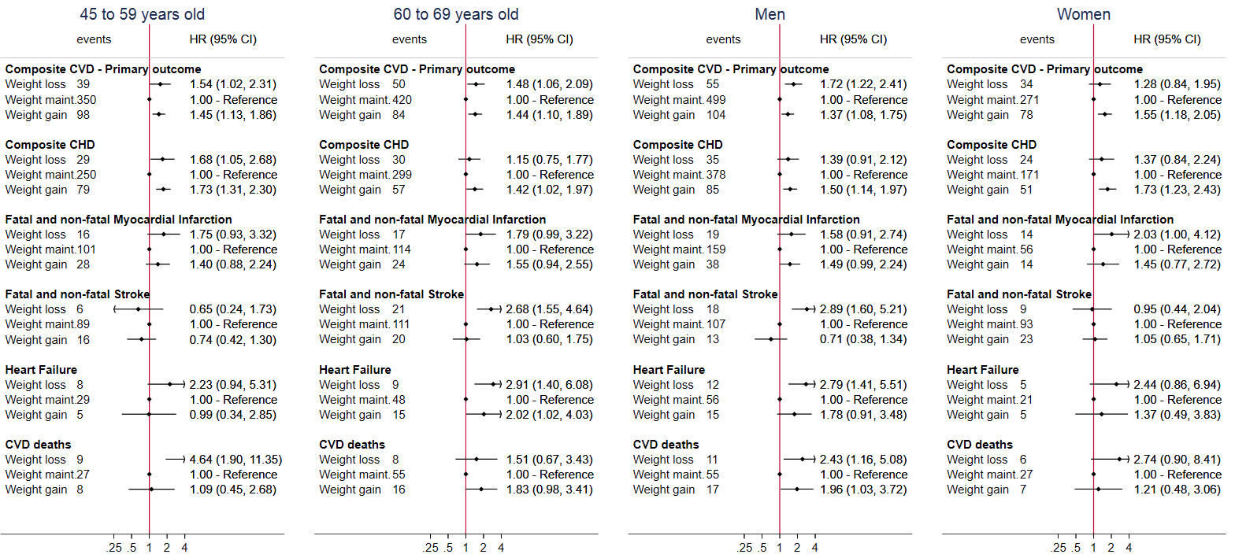

eFigure 2; Hazard ratios of the per-protocol effect of the emulated interventions on the composite CVD outcome in normal weight, overweight and obese individuals. Sensitivity analysis includes further adjustment for index of multiple deprivation, ethnicity or physical activity

eFigure 3; Hazard ratios of the per-protocol effect of the emulated interventions on the secondary CVD outcomes in normal weight, overweight and obese individuals after assuming that a set of chronic diseasesª occurred two years prior to the recorded date
ªSet of chronic diseases consists of: diabetes, cancer (apart from non-melanoma skin cancer), dementia, severe mental diseases (acute stress, phobia, anxiety, depression, schizophrenia, bipolar disorder and affective disorder), chronic kidney disease, chronic obstructive pulmonary disease, HIV, major inflammatory diseases(systemic lupus erythematosus, rheumatoid arthritis, gout, and inflammatory bowel disease), Parkinson’s disease, multiple sclerosis and renal failure

eFigure 4: Hazard ratios of the per-protocol analysis emulated (two-year) interventions on cardiovascular diseases in overweight individuals, using pooled logistic regression, by age group and sex
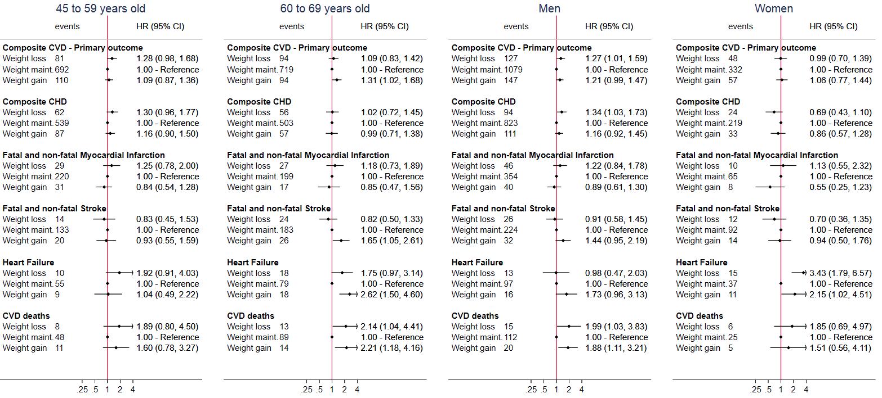

eFigure 5: Hazard ratios of the per-protocol analysis emulated (two-year) interventions on cardiovascular diseases in obese individuals, using pooled logistic regression, by age group and sex
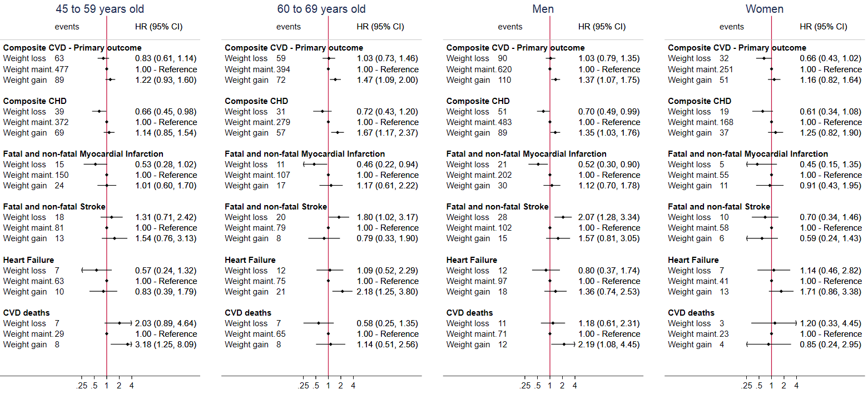

eFigure 6: Estimated hazard ratios (upper panel) and cumulative incidence curves¶ (lower panel) for diabetes (i.e. positive control outcome) under hypothetical weight change interventions, by BMI group
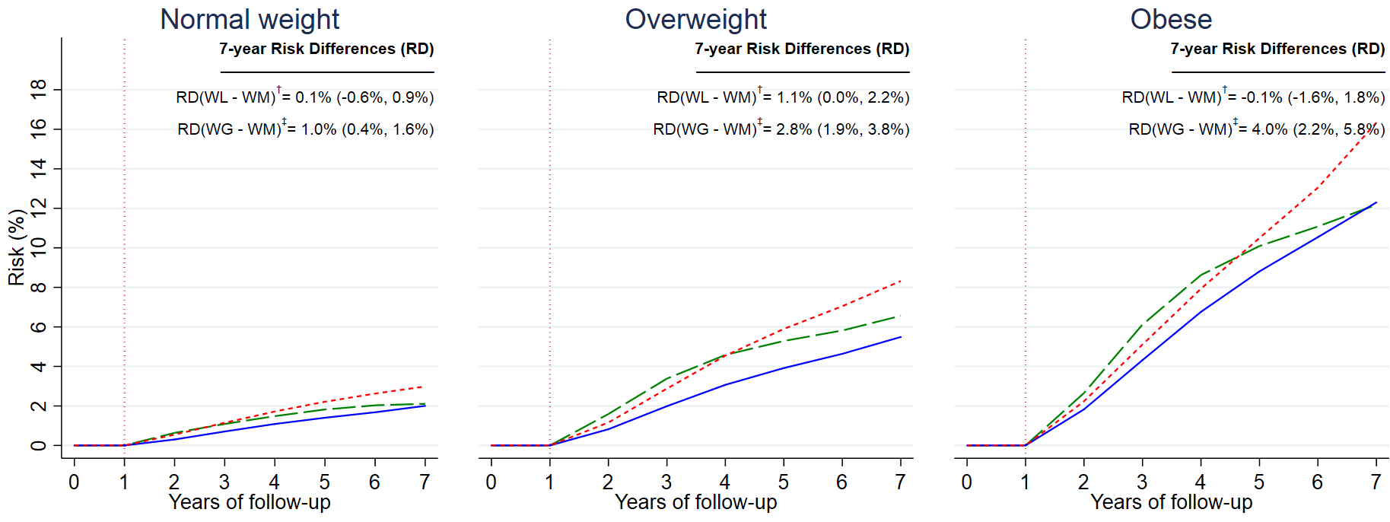
¶For the technical details for the estimation of the cumulative risk curves, see Appendix (Section 3)
†RD(WL - WM): Risk Difference (Weight loss intervention - Weight maintenance intervention)
‡RD(WG - WM): Risk Difference (Weight gain intervention - Weight maintenance intervention)
Individual were free of diabetes during the 1st year of the intervention (see vertical dotted line at year 1).
We excluded all individuals who developed the outcome during the 1st year, to avoid problems of reverse causation

eFigure 7: Estimated hazard ratios for non-melanoma skin cancer (i.e. negative control outcome) under hypothetical weight change interventions, by BMI group and overall

eFigure 8; Estimated hazard ratios for cardiovascular diseases comparing hypothetical weight change interventions, using pooled logistic regression, using different cutoffs for the weight gain (3-10% gain per year) and loss (3-10% loss per year) arms.
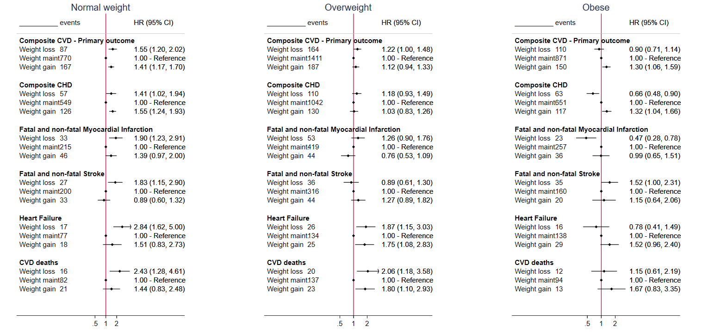

eFigure 9: Estimated hazard ratios for cardiovascular diseases comparing hypothetical weight change interventions, using pooled logistic regression after additionally adjusting for calendar year.

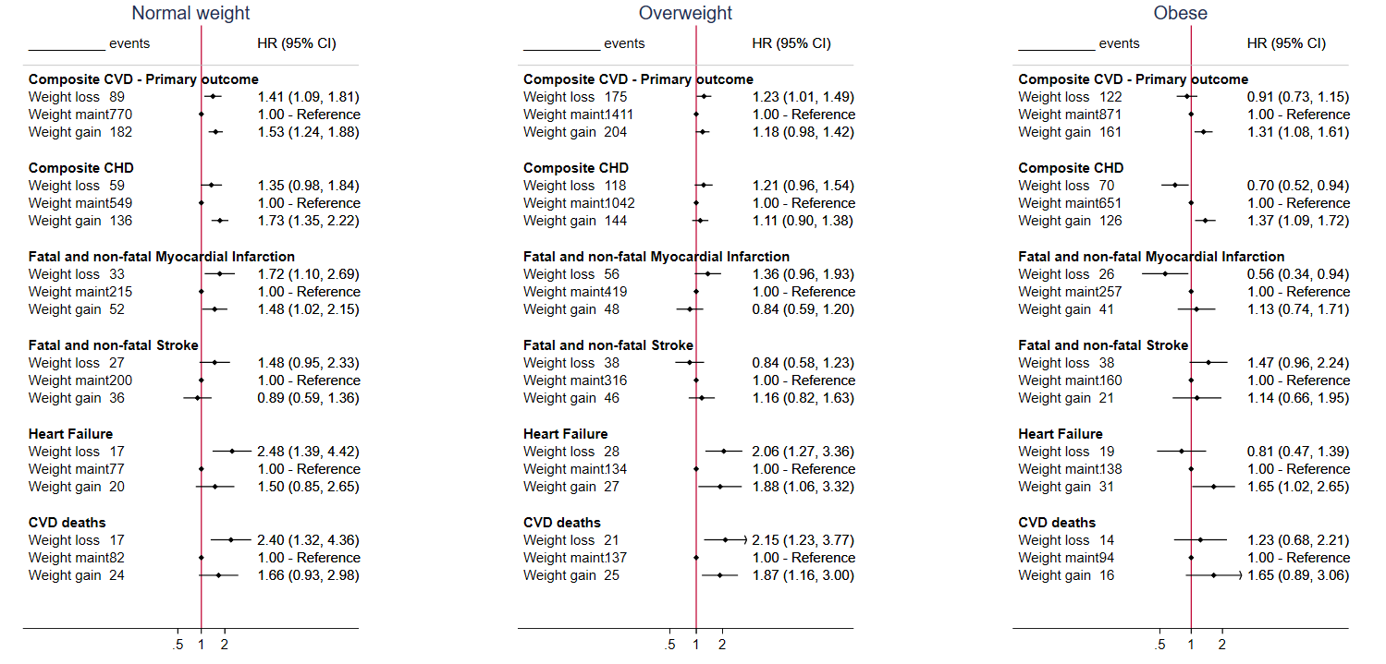

eFigure 10: Estimated hazard ratios for cardiovascular diseases comparing hypothetical weight change interventions, using pooled logistic regression in the obese non-smokers
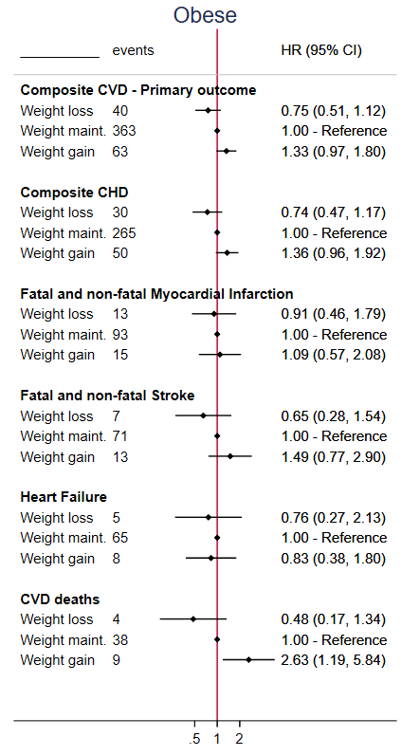

Section 5 – Codelists used for the outcome definition

- Primary outcome: Composite CVD

The primary outcome (composite CVD) consists of

i. myocardial infarction,
ii. stable angina (hospitalization),
iii. unstable angina (hospitalization),
iv. other CHD (hospitalization),
v. heart failure (hospitalization),
vi. stroke
vii. CVD deaths

- Myocardial infarction
- Self-reported from primary care (CPRD)
- ICD-10 codes from Hospital Episodes Statistics (HES)

ICD10 code | Interpretation
I252 | Old myocardial infarction
I21 | Acute myocardial infarction
I22 | Subsequent myocardial infarction
I23 | Certain current complications following acute myocardial infarction
I241 | Dressler's syndrome

- OPSC codes from Hospital Episodes Statistics (HES)

OPSC code | Interpretation
K50.2 | Percutaneous transluminal coronary thrombolysis using streptokinase
K50.3 | Percutaneous transluminal injection of therapeutic substance into coronary artery NEC

- ICD-10 codes from ONS

ONS ICD10 | Interpretation
I21 | Acute myocardial infarction
I22 | Subsequent myocardial infarction
I23 | Certain current complications following acute myocardial infarction

- ICD-9 codes from ONS
ICD9 code | Interpretation
410 | Acute myocardial infarction
4110 | Other acute and subacute forms of ischemic heart disease ; Postmyocardial infarction syndrome
4297 | Ill-defined descriptions and complications of heart disease ; Certain sequelae of myocardial infarction, not elsewhere classified

- Stable Angina (hospitalization)
a. ICD-10 codes from Hospital Episodes Statistics (HES)
ICD10 code | Interpretation
I201 | Angina pectoris with documented spasm
I208 | Other forms of angina pectoris
I209 | Angina pectoris, unspecified

b. OPSC codes from Hospital Episodes Statistics (HES)

OPCS code | Interpretation
K40 | Saphenous vein graft replacement of coronary artery
K40.1 | Saphenous vein graft replacement of one coronary artery
K40.2 | Saphenous vein graft replacement of two coronary arteries
K40.3 | Saphenous vein graft replacement of three coronary arteries
K40.4 | Saphenous vein graft replacement of four or more coronary arteries
K40.8 | Other specified saphenous vein graft replacement of coronary artery
K40.9 | Unspecified saphenous vein graft replacement of coronary artery
K41 | Other autograft replacement of coronary artery
K41.1 | Autograft replacement of one coronary artery NEC
K41.2 | Autograft replacement of two coronary arteries NEC
K41.3 | Autograft replacement of three coronary arteries NEC
K41.4 | Autograft replacement of four or more coronary arteries NEC
K41.8 | Other specified other autograft replacement of coronary artery
K41.9 | Unspecified other autograft replacement of coronary artery
K42 | Allograft replacement of coronary artery
K42.1 | Allograft replacement of one coronary artery
K42.2 | Allograft replacement of two coronary arteries
K42.3 | Allograft replacement of three coronary arteries
K42.4 | Allograft replacement of four or more coronary arteries
K42.8 | Other specified allograft replacement of coronary artery
K42.9 | Unspecified allograft replacement of coronary artery
K43 | Prosthetic replacement of coronary artery
K43.1 | Prosthetic replacement of one coronary artery
K43.2 | Prosthetic replacement of two coronary arteries
K43.3 | Prosthetic replacement of three coronary arteries
K43.4 | Prosthetic replacement of four or more coronary arteries
K43.8 | Other specified prosthetic replacement of coronary artery
K43.9 | Unspecified prosthetic replacement of coronary artery
K44 | Other replacement of coronary artery
K44.1 | Replacement of coronary arteries using multiple methods
K44.8 | Other specified other replacement of coronary artery
K44.9 | Unspecified other replacement of coronary artery
K45 | Connection of thoracic artery to coronary artery
K45.1 | Double anastomosis of mammary arteries to coronary arteries
K45.2 | Double anastomosis of thoracic arteries to coronary arteries NEC
K45.3 | Anastomosis of mammary artery to left anterior descending coronary artery
K45.4 | Anastomosis of mammary artery to coronary artery NEC
K45.5 | Anastomosis of thoracic artery to coronary artery NEC
K45.8 | Other specified connection of thoracic artery to coronary artery
K45.9 | Unspecified connection of thoracic artery to coronary artery
K46 | Other bypass of coronary artery
K46.1 | Double implantation of mammary arteries into heart
K46.2 | Double implantation of thoracic arteries into heart NEC
K46.3 | Implantation of mammary artery into heart NEC
K46.4 | Implantation of thoracic artery into heart NEC
K46.8 | Other specified other bypass of coronary artery
K46.9 | Unspecified other bypass of coronary artery
K44.2 | Revision of replacement of coronary artery
K45.6 | Revision of connection of thoracic artery to coronary artery
K46.5 | Revision of implantation of thoracic artery into heart

- Unstable Angina (hospitalization)
- ICD-10 codes from Hospital Episodes Statistics (HES)
ICD10 code | Interpretation
I240 | Coronary thrombosis not resulting in myocardial infarction
I248 | Other forms of acute ischaemic heart disease
I249 | Acute ischaemic heart disease, unspecified
I200 | Unstable angina

- Other CHD (hospitalization)
a. ICD-10 codes from Hospital Episodes Statistics (HES)
ICD10 code | Interpretation
I250 | Atherosclerotic cardiovascular disease, so described
I251 | Atherosclerotic heart disease
I253 | Aneurysm of heart
I254 | Coronary artery aneurysm
I255 | Ischaemic cardiomyopathy
I256 | Silent myocardial ischaemia
I258 | Other forms of chronic ischaemic heart disease
I259 | Chronic ischaemic heart disease, unspecified

- ICD-10 codes from ONS
ONS ICD10 | Interpretation
I20 | Angina pectoris
I21 | Acute myocardial infarction
I22 | Subsequent myocardial infarction
I23 | Certain current complications following acute myocardial infarction
I24 | Other acute ischaemic heart diseases
I25 | Chronic ischaemic heart disease

- ICD-9 codes from ONS
ONS ICD9 | Interpretation
410 | Acute myocardial infarction
411 | Other acute and subacute forms of ischemic heart disease
412 | Old myocardial infarction
413 | Angina pectoris
414 | Other forms of chronic ischemic heart disease
4292 | Ill-defined descriptions and complications of heart disease ; Cardiovascular disease, unspecified
4295 | Ill-defined descriptions and complications of heart disease ; Rupture of chordae tendineae
4296 | Ill-defined descriptions and complications of heart disease ; Rupture of papillary muscle
4297 | Ill-defined descriptions and complications of heart disease ; Certain sequelae of myocardial infarction, not elsewhere classified

- Heart failure (hospitalization)
a. ICD-10 codes from Hospital Episodes Statistics (HES)
ICD10 | Interpretation
I50.0 | Congestive heart failure
I50.1 | Left ventricular heart failure
I50.9 | Heart failure, unspecified
I11.0 | Hypertensive heart disease with (congestive) heart failure
I13.0 | Hypertensive heart and renal disease with (congestive) heart failure
I32.2 | Hypertensive heart and renal disease with both (congestive) heart failure and renal failure

- ICD-10 codes from ONS
ICD10 | Interpretation
I50.0 | Congestive heart failure
I50.1 | Left ventricular heart failure
I50.9 | Heart failure, unspecified
I11.0 | Hypertensive heart disease with (congestive) heart failure
I13.0 | Hypertensive heart and renal disease with (congestive) heart failure
I32.2 | Hypertensive heart and renal disease with both (congestive) heart failure and renal failure

- ICD-9 codes from ONS
ICD9 | Interpretation
428 | Congestive heart failure, unspecified
428.1 | Left heart failure
428.9 | Heart failure, unspecified

- Stroke
- Self-reported from primary care (CPRD)
- ICD-10 codes from Hospital Episodes Statistics (HES)
ICD10 code | Interpretation
I690 | Sequelae of subarachnoid haemorrhage
I61 | Intracerebral haemorrhage
I60 | Subarachnoid haemorrhage
I620 | Subdural haemorrhage (acute)(nontraumatic)
I621 | Nontraumatic extradural haemorrhage
I629 | Intracranial haemorrhage (nontraumatic), unspecified
I693 | Sequelae of cerebral infarction
I63 | Cerebral infarction
I690 | Sequelae of subarachnoid haemorrhage
I61 | Intracerebral haemorrhage
I60 | Subarachnoid haemorrhage
I620 | Subdural haemorrhage (acute)(nontraumatic)
I621 | Nontraumatic extradural haemorrhage
I629 | Intracranial haemorrhage (nontraumatic), unspecified
I691 | Sequelae of intracerebral haemorrhage
I692 | Sequelae of other nontraumatic intracranial haemorrhage
I694 | Sequelae of stroke, not specified as haemorrhage or infarction
I698 | Sequelae of other and unspecified cerebrovascular diseases
G463 | Brain stem stroke syndrome
G464 | Cerebellar stroke syndrome
G465 | Pure motor lacunar syndrome
G466 | Pure sensory lacunar syndrome
G467 | Other lacunar syndromes
I64 | Stroke, not specified as haemorrhage or infarction

- ICD-10 codes from ONS
ONS ICD10 code | Interpretation
I690 | Sequelae of subarachnoid haemorrhage
I61 | Intracerebral haemorrhage
I60 | Subarachnoid haemorrhage
I620 | Subdural haemorrhage (acute)(nontraumatic)
I621 | Nontraumatic extradural haemorrhage
I629 | Intracranial haemorrhage (nontraumatic), unspecified
I693 | Sequelae of cerebral infarction
I63 | Cerebral infarction
I690 | Sequelae of subarachnoid haemorrhage
I61 | Intracerebral haemorrhage
I60 | Subarachnoid haemorrhage
I620 | Subdural haemorrhage (acute)(nontraumatic)
I621 | Nontraumatic extradural haemorrhage
I629 | Intracranial haemorrhage (nontraumatic), unspecified
I694 | Sequelae of stroke, not specified as haemorrhage or infarction
I698 | Sequelae of other and unspecified cerebrovascular diseases
I64 | Stroke, not specified as haemorrhage or infarction
I672 | Cerebral atherosclerosis
I679 | Cerebrovascular disease, unspecified

- ICD-9 codes from ONS
ICD9 code | Interpretation
431 | Intracerebral hemorrhage
430 | Subarachnoid hemorrhage
4321 | Other and unspecified intracranial hemorrhage ; Subdural hemorrhage
4320 | Other and unspecified intracranial hemorrhage ; Nontraumatic extradural hemorrhage
4329 | Other and unspecified intracranial hemorrhage ; Unspecified intracranial hemorrhage
433 | Occlusion and stenosis of precerebral arteries
434 | Occlusion of cerebral arteries
431 | Intracerebral hemorrhage
430 | Subarachnoid hemorrhage
4321 | Other and unspecified intracranial hemorrhage ; Subdural hemorrhage
4320 | Other and unspecified intracranial hemorrhage ; Nontraumatic extradural hemorrhage
4329 | Other and unspecified intracranial hemorrhage ; Unspecified intracranial hemorrhage
436 | Acute, but ill-defined, cerebrovascular disease
4370 | Other and ill-defined cerebrovascular disease ; Cerebral atherosclerosis
4379 | Other and ill-defined cerebrovascular disease ; Unspecified

- CVD deaths

- ICD-10 codes from ONS: All “I” codes

- Secondary outcome: Composite CHD

Composite CHD consists of

i. myocardial infarction,
ii. stable angina (hospitalization),
iii. unstable angina (hospitalization),
iv. other CHD (hospitalization),

Section 6 – Definition of baseline period, when the exposure is weight change

eFigure 11: Directed acyclic graph (DAG) for the effect of weight change on CVD in observational studies.
C₀ C₁

W₀ W₁ O

0 1st year Time

The confounders at time 0 (enrolment) C₀ and at 1st year C₁ (variables which simultaneously associated with weight at either time and CVD) need to be controlled for. Weight change is only observed at the 1st year, i.e. when we can measure W₁-W₀. In other words, for standard levels of initial weight W₀, weight loss or maintenance can be observed only from W₁. From this DAG, it is clear that we should adjust for both C₀ and C₁. If we do not control for C₀, we leave open the backdoor pathway
W₁<--C₀--> O open. In the same fashion, if we do not control for C₁, we leave open the backdoor pathway W₁<--C₁--> O open.

In this analysis, we face the problem of immortal time bias as a result of all individuals needing to survive and remain healthy till the first year of follow up, to be included in the study. Unlike other examples, in which the problem of immortal time bias can be tackled through cloning (or through randomly assigning the individual to one of the strategies), this technique cannot be applied in paradigms regarding BMI/weight change, because individuals should be compatible with only one hypothetical intervention at enrolment, so that they end up either losing, maintaining or gaining weight..

Even if we cloned individuals at enrolment and then censor them at the 1st year, this would not make any difference. During the 1st year, all individuals have zero risk of developing the outcome, because we excluded individuals who
- developed a chronic disease, so that we can focus on healthy weight change and
- developed the outcome, so that we tackle reverse causation

