Supplementary material to:
A spatial joint analysis of metal constituents of ambient particulate matter and mortality in England.

Table S1: Description of LUR models for Copper(Cu),Iron (Fe) and Zinc(Zn), both PM₁₀ and PM_{2.5} fractions for the Oxford and London region.
 | LUR model | R² | R² LOOCV* | RMSE LOOCV* (ng/m3) | N¹ | Mean Conc [range] (ng/m3)
PM₁₀Cu | -0.3 +1.4E-05*TRAFLOAD25 +3.4E-04*ROADLENGTH1000 | 0.96 | 0.95 | 3.50 | 20 | 19 [4.1-79]
PM_{2.5}Cu | 0.9 +5.3E-08*HLDRES5000 +1.8E-05*TRAFMAJOR+1.9E-02*ROADLENGTH25 +1.2E-02*MAJORROADLENGTH50 | 0.84 | 0.79 | 0.71 | 19 | 4.4 [1.4 - 6.7]
PM₁₀Fe | 191.4 +5.8E-04*POP5000 +4.0E-04*TRAFLOAD25 | 0.95 | 0.95 | 95.44 | 20 | 521 [134-1999]
PM_{2.5}Fe | 37.4 +8.5E-05*POP5000 +1.3E-02*HEAVYTRAFMAJOR +3.3E-02*INTMAJORINVDIST | 0.94 | 0.92 | 19.69 | 20 | 111 [26-355]
PM₁₀Zn | 14.6 +1.1E-07*HLDRES5000 +5.3E-01*HEAVYINTINVDIST2 +1.3E-06*HEAVYTRAFLOAD500 | 0.80 | 0.77 | 3.69 | 20 | 23 [12-45]
PM_{2.5}Zn | 10.0 +2.1E-05*HHOLD5000 +4.9E-05*TRAFMAJOR+2.7E+02*DISTINVMAJOR2 | 0.70 | 0.63 | 2.19 | 20 | 15 [8.1-22]

¹Number of sites
*Leave One Out Cross-Validation

Table S2. Correlation between the particle metals (PM).
 | PM₁₀ Copper | PM₁₀ Iron | PM₁₀ Zinc | PM_{2.5} Iron | PM_{2.5} Copper
PM₁₀ Copper | 1
PM₁₀ Iron | 0.85 | 1
PM₁₀ Zinc | 0.85 | 0.92 | 1
PM_{2.5} Iron | 0.82 | 0.91 | 0.93 | 1
PM_{2.5} Copper | 0.75 | 0.89 | 0.90 | 0.88 | 1

Table S3: Pearson Correlation between the adjusted annual mean concentrations of PM-metals and the adjusted annual mean PM concentrations (PM_{2.5} and PM₁₀).

N=1533 |  | PM_{2.5} CU | PM_{2.5} FE | PM₁₀ CU | PM₁₀ FE | PM₁₀ ZN | PM_{2.5} | PM₁₀
PM_{2.5} | Correlation | 0.86 | 0.89 | 0.89 | 0.89 | 0.73 | 1.00 | 0.92
PM₁₀ | Correlation | 0.82 | 0.87 | 0.86 | 0.88 | 0.74 | 0.92 | 1.00
All the correlation significant at p< 0.001

Table S4. Variance partition coefficients (VPC) between the fixed effects, the spatial random effect, and the effect related to the mixture of particle metals (PM).

 | PM₁₀ |  |  | PM_{2.5}
 | Fixed effects | Spatial effects | PM | Fixed effects | Spatial effects | PM
Cardiovascular mortality | 36.5 | 48.5 | 10.5 | 36.4 | 55.2 | 8.3
Respiratory mortality | 31.3 | 60.6 | 8.1 | 29.9 | 61.6 | 8.5
Lung cancer incidence | 51.1 | 47.0 | 1.9 | 51.6 | 47.2 | 1.2

Figure 1. Maps of the metal exposures population weighted by ward. Contains National Statistics data © Crown copyright and database right 2018; Contains OS data © Crown copyright and database right 2018. All rights reserved.

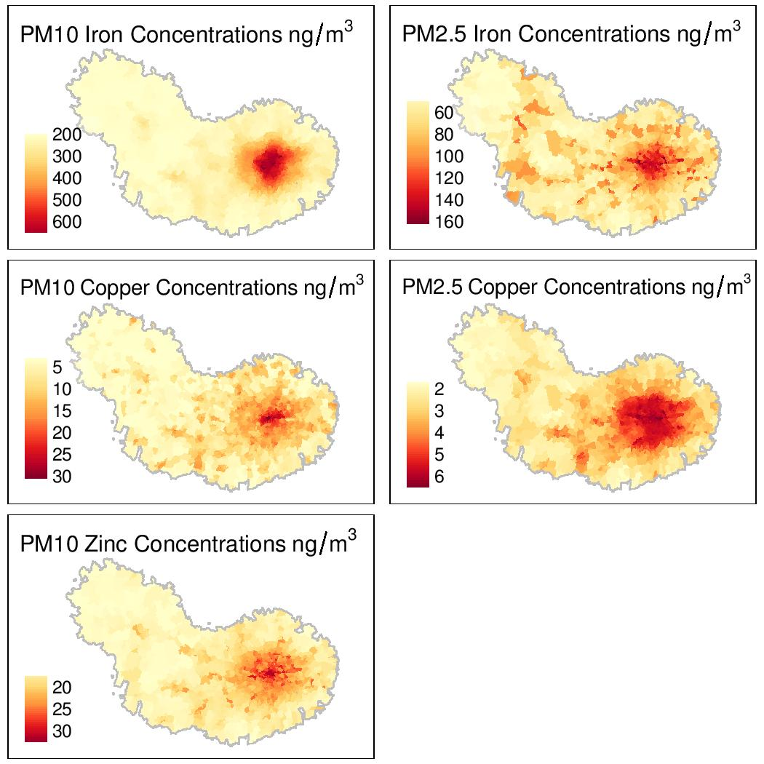

Figure 2. Maps of the confounders in quintiles: proportion of Asian people, proportion of white people, modified index of multiple deprivations, and tobacco spends. Contains National Statistics data © Crown copyright and database right 2018; Contains OS data © Crown copyright and database right 2018. All rights reserved.

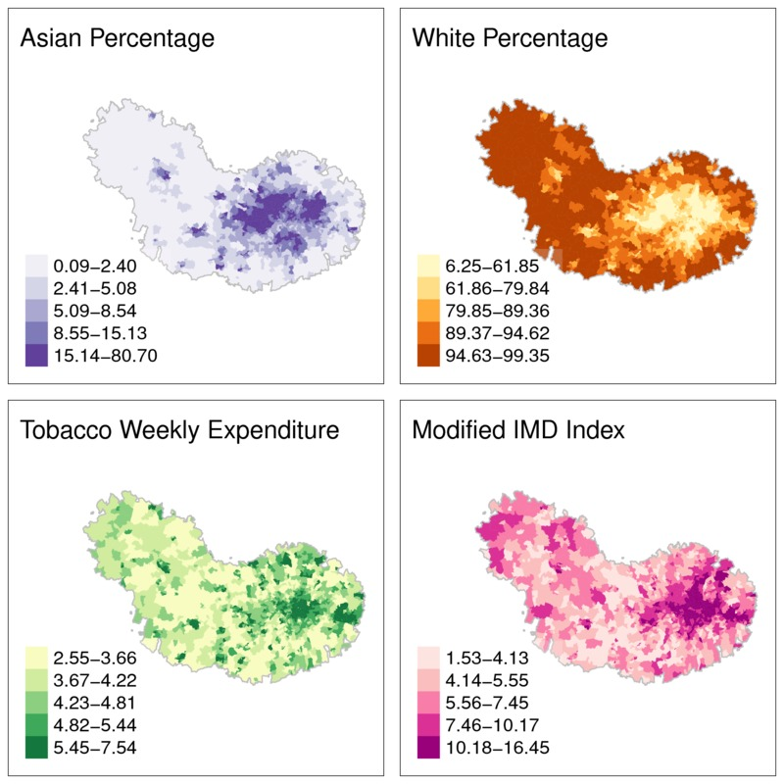

Figure 3. Cardiovascular mortality for PM₁₀, from top left the map of cluster location and the boxplot indicated the risk distribution associated within each cluster and the distribution of metals in the clusters, and the line represents the average metal value for the overall area.
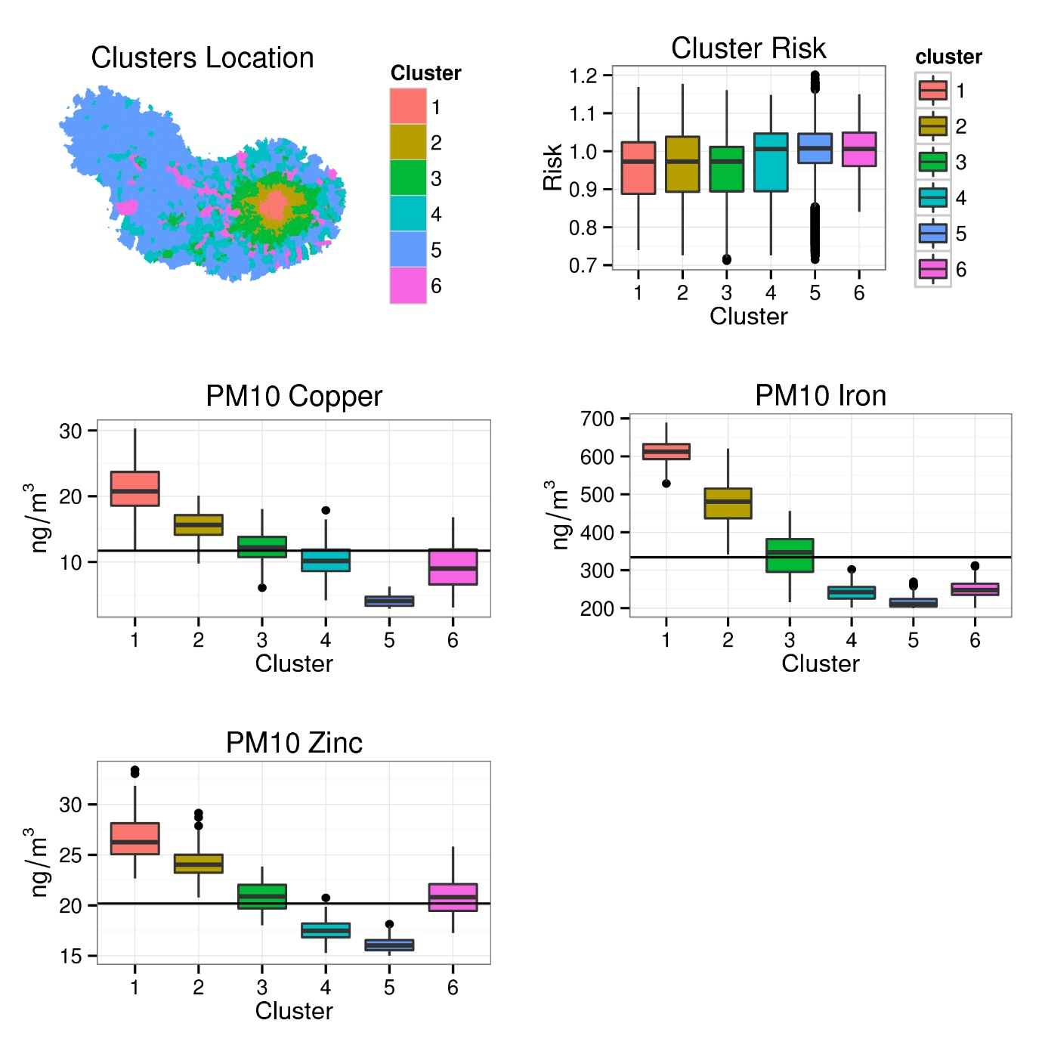

Figure 4. Respiratory Mortality PM₁₀ from top left the map of cluster location and the boxplot indicated the risk distribution associated within each cluster and the distribution of metals in the clusters.
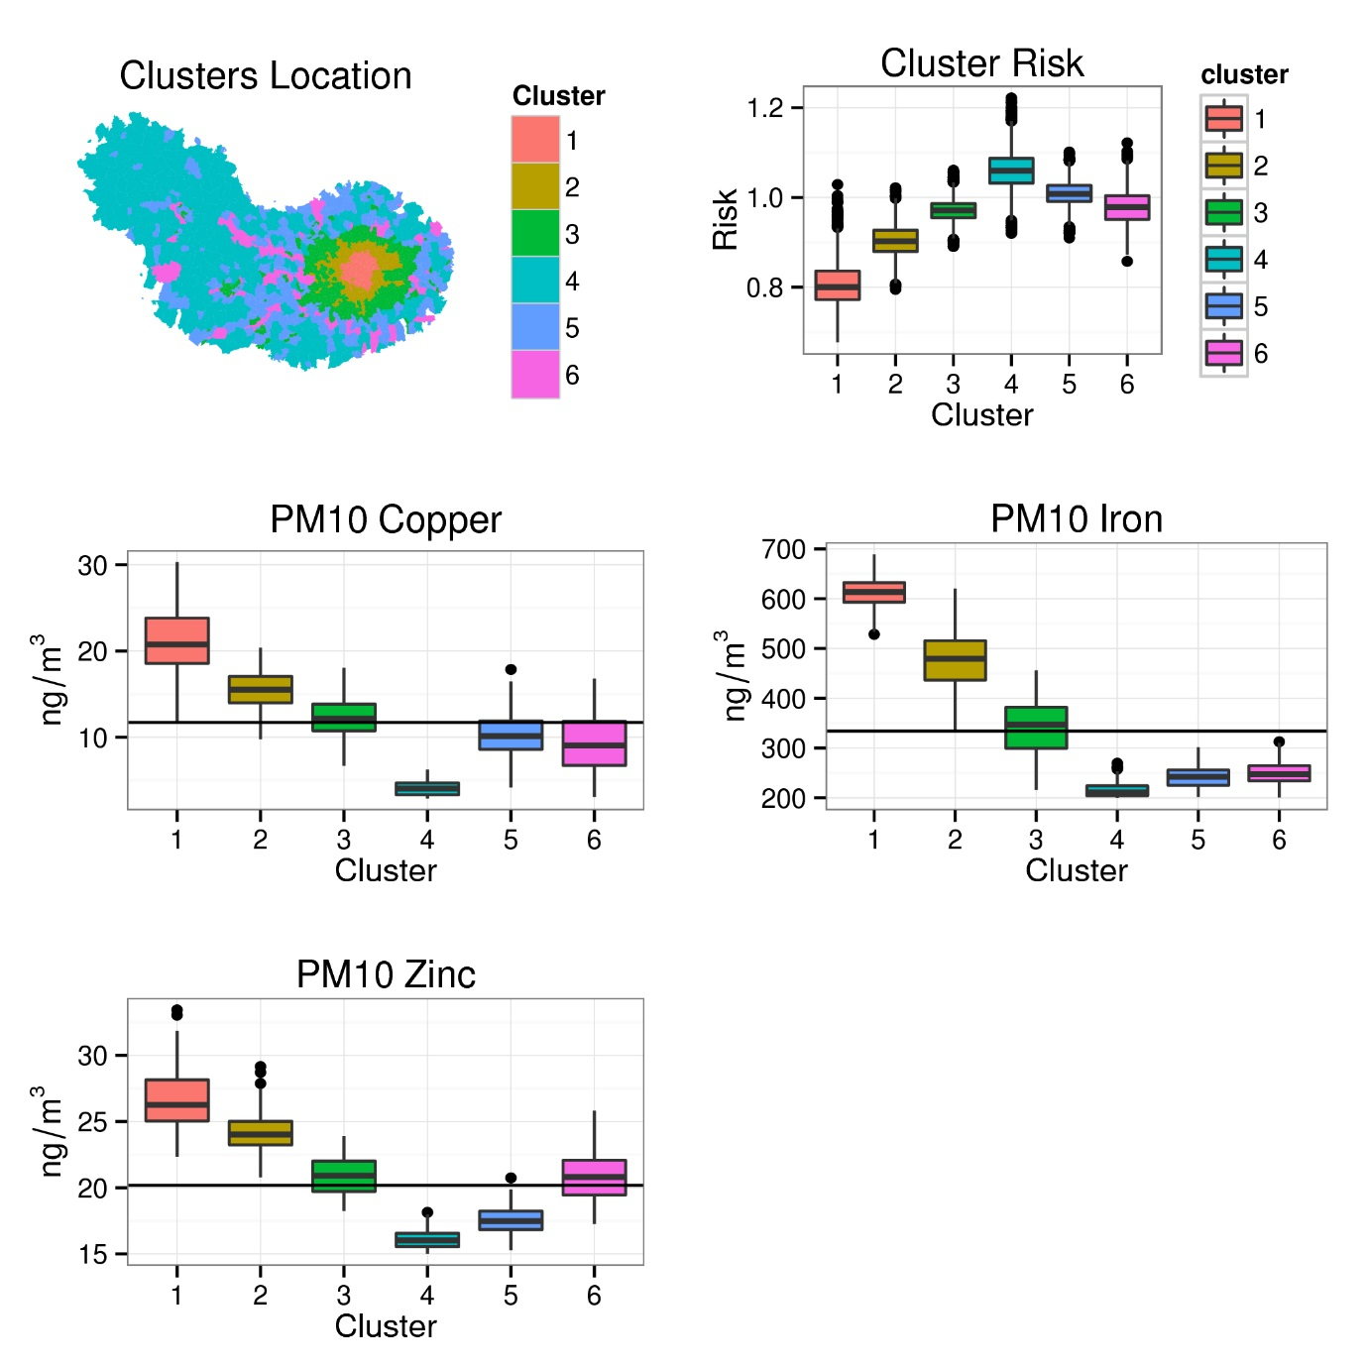

Figure 5. Lung Cancer for PM_{2.5} from top left the map of cluster location and the boxplot indicated the risk distribution associated within each cluster and the distribution of metals in the clusters.
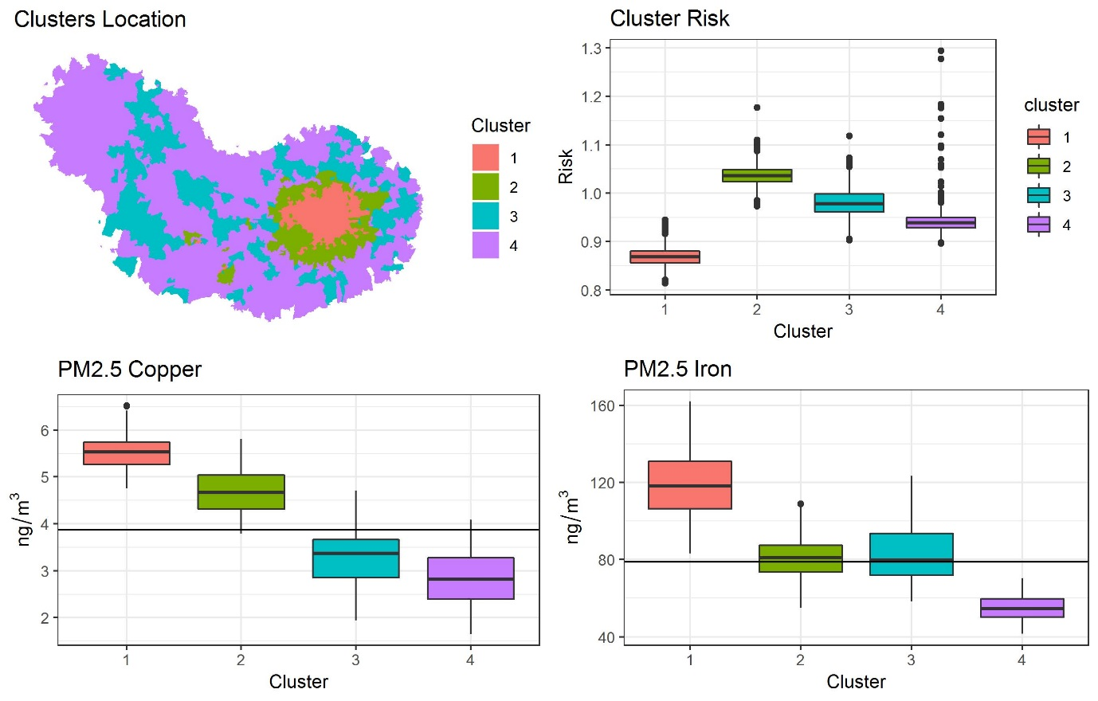

Figure 6. Lung Cancer for PM₁₀ from top left the map of cluster location and the boxplot indicated the risk distribution associated within each cluster and the distribution of metals in the clusters, and the line represents the average metal value for the overall area.
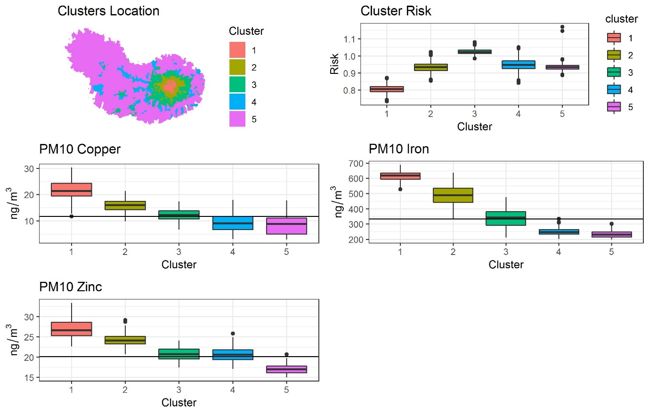

Figure 7. The study area compromising London and Oxford split in the 1533 wards, an English Census area classification (primary unit of the English electoral geography).
