**eFigure 1. Gestational age at delivery distributed across average ambient PM2.5 levels during the third trimester for each outcome percentile group**

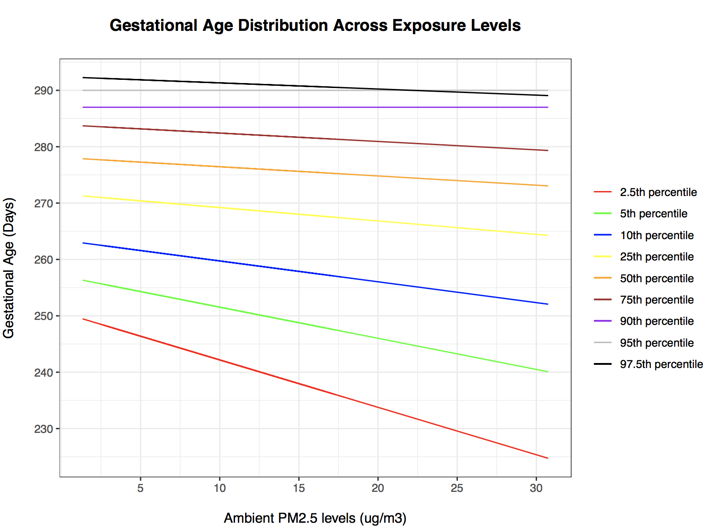

**eFigure 2. Probability density distribution for model residuals from propensity score model of inverse probability weighing (IPW) process at third trimester (Trim 3) exposure levels**



**eFigure 3. Covariate balance plot for covariates adjusted in propensity score models of inverse probability weighting (IPW) process using absolute standardized differences (ASD)**



ASD less than 0.1, by convention, indicates good removing of confounding effect by that covariate. Abbreviations means: cigdpp, cigarette smoked per day prior to pregnancy; ctmi, census tract median household income level; ctpd, census tract population density; ctrace, census tract black race proportion; kotck_0, Kotelchuck index level 0; kotck_1, Kotelchuck index level 1; kotck_2, Kotelchuck index level 2; kotck_3, Kotelchuck index level 3; kotck_4, Kotelchuck index level 4; m_edu_1, maternal education level less than high school; m_edu_2, maternal education level high school and general education degrees; m_edu_3, maternal education level some college degree; m_edu_4, maternal education level bachelor’s degree; m_edu_5, maternal education level more than bachelor’s degree; mage, maternal age; married, maternal marital status; mrace_1, maternal race white; mrace_2, maternal race black; mrace_3, maternal race Asian or pacific islands origin; mrace_4, maternal race native American; mrace_5, maternal race other races with no missing information; mrace_6, maternal race missing/refused to tell/unknown; pncgov, prenatal care paid by government; rf_lung, maternal lung disease; rf_card, maternal cardiac disease; rf_db_other, maternal non-gestational diabetes; rf_hbp_chronic, maternal chronic hypertension; rf_cervix, incomplete cervix; maternal previous infant with birth defects; rf_prev_4kg, maternal previous infant over 4000 grams; rf_prev_sga, maternal previous SGA infant (small for gestational age); rf_renal, maternal renal disease; rf_rh_sens, maternal rH sensitization; rf_sickle, maternal sickle cell; season_con_num_1, season of conception spring; season_con_num_2, season of conception summer; season_con_num_3, season of conception fall; season_con_num_4, season of conception winter; sex, infant’s sex.

**eFigure 4. Directed Acyclic Graph (DAG) Supporting the Adjustment for Maternal Risk Factors for Gestational Age (GA)**

**Figures/eFigure%204.pdf**

U for unmeasured or other uncontrolled covariates, including pollution from other sources (water, soil), temperature, other meteorological variables, greenness, etc. that are associated with ambient particulate air pollution and maternal risk factors for gestational age (maternal diseases and previous birth conditions as described in the main text).

**eTable 1. Time Trend of Annual Ambient PM2.5 Levels and Average Population Gestational Age in Massachusetts Birth Registry Cohort (2001-2015)**

|  |  |  |
| --- | --- | --- |
| year | annual pm2.5 (μg/m3) | average GA (d) |
| 2001 | 11.8 | 276 |
| 2002 | 10.6 | 276 |
| 2003 | 10.4 | 276 |
| 2004 | 9.8 | 276 |
| 2005 | 10.5 | 275 |
| 2006 | 9.3 | 275 |
| 2007 | 9.7 | 275 |
| 2008 | 9.1 | 276 |
| 2009 | 8.4 | 276 |
| 2010 | 7.8 | 276 |
| 2011 | 8.4 | 276 |
| 2012 | 7.5 | 276 |
| 2013 | 7.6 | 276 |
| 2014 | 6.5 | 276 |
| 2015 | 6.3 | 276 |

**eTable 2. Gestational Age Change (days) per 5 μg/m3 Increase in PM2.5 Levels of Third Trimester (Adding Paternal Factors, Adding First and Second Trimester PM2.5 Levels)**

|  |  |  |  |  |  |  |  |
| --- | --- | --- | --- | --- | --- | --- | --- |
| **Percentile** | **2.5th** | **10th** | **25th** | **50th** | **75th** | **90th** | **97.5th** |
| **+ Paternal Factors** | -4.3(-5.0, -3.5) | -1.9 (-2.2, -1.6) | -1.2 (-1.4, -0.99) | -0.82 (-0.92, -0.72) | -0.75 (-0.95, -0.55) | 0.00 (-0.10, 0.10) | -0.55 (-0.94, -0.16) |
| **+ Trim1, Trim2 PM2.5** | -3.4 (-4.5, -2.3) | -1.6 (-2.0, -1.2) | -1.2 (-1.4, -1.0) | -0.93 (-1.0, -0.83) | -0.83 (-1.0, -0.63) | -0.79 (-1.2, -0.40) | -0.73 (-1.2, -0.24) |

Point estimates (95% Confidence Interval) for each percentile are reported here.

+ Paternal Factors, adjusted for individual covariates, contextual variables, season of conception and calendar year described in Methods section plus father’s age and father’s race.

+ Trim1, Trim2 PM2.5, adjusted for individual covariates, contextual variables, season of conception and calendar year described in Methods section plus Trim1 (first trimester) and Trim2 (second trimester) PM2.5 levels.

**eTable 3. Time Window Specific Gestational Age Change (days) per 5 μg/m3 Increase in PM2.5 Levels with Different Temperature Adjustment (2004-2015)**

|  |  |  |  |  |  |  |  |
| --- | --- | --- | --- | --- | --- | --- | --- |
| **Percentile** | **2.5th** | **10th** | **25th** | **50th** | **75th** | **90th** | **97.5th** |
| **First Trimester** | | | | | | | |
| **No temp** | 0.00 (-0.59, 0.59) | 0.00 (-0.29, 0.29) | 0.00 (-0.20, 0.20) | 0.00 (-0.20, 0.20) | 0.00 (0.00, 0.00) | 0.00 (0.00, 0.00) | 0.00 (-0.10, 0.10) |
| **Temp trim1** | 0.00 (-0.78, 0.78) | 0.00 (-0.29, 0.29) | 0.00 (-0.20, 0.20) | 0.00 (-0.20, 0.20) | 0.00 (0.00, 0.00) | 0.00 (0.00, 0.00) | 0.00 (0.00, 0.00) |
| **Second Trimester** | | | | | | | |
| **No temp** | 0.00 (-0.78, 0.78) | 0.00 (-0.39, 0.39) | -0.64 (-0.94, -0.35) | 0.00 (-0.20, 0.20) | 0.00 (0.00, 0.00) | 0.00 (0.00, 0.00) | 0.00 (-0.10, 0.10) |
| **Temp trim2** | 0.00 (-0.78, 0.78) | 0.00 (0.39, 0.39) | -0.64 (-0.94, -0.35) | 0.00 (-0.20, 0.20) | 0.00 (0.00, 0.00) | 0.00 (0.00, 0.00) | 0.00 (-0.10, 0.10) |
| **Temp trim12** | 0.00 (-0.78, 0.78) | 0.00 (-0.39, 0.39) | -0.63 (-0.92, -0.34) | 0.00 (-0.20, 0.20) | 0.00 (0.00, 0.00) | 0.00 (0.00, 0.00) | 0.00 (-0.10, 0.10) |
| **Third Trimester** | | | | | | | |
| **No temp** | -2.2 (-2.9, -1.5) | -1.2 (-1.5, -0.92) | 0.00 (-0.10, 0.10) | 0.00 (-0.10, 0.10) | 0.00 (-0.10, 0.10) | -0.68 (-0.97, -0.38) | 0.00 (-0.39, 0.39) |
| **Temp trim3** | -2.0 (-2.7, -1.4) | -1.1 (-1.4, -0.80) | 0.00 (-0.10, 0.10) | 0.00 (-0.10, 0.10) | 0.00 (-0.10, 0.10) | -0.66 (-0.95, -0.36) | 0.00 (-0.39, 0.39) |
| **Temp trim123** | -2.4 (-3.1, -1.6) | -1.3 (-1.6, -1.0) | -0.76 (-0.96, -0.57) | 0.00 (-0.10, 0.10) | 0.00 (-0.10, 0.10) | -0.67 (-0.96, -0.37) | 0.00 (-0.39, 0.39) |
| **Last Month** | | | | | | | |
| **No temp** | -8.0 (-8.9, -7.1) | -3.8 (-4.1, -3.5) | -2.1 (-2.3, -1.9) | -1.1 (-1.2, -1.0) | -0.62 (-0.72, -0.52) | -0.62 (-0.91, -0.33) | -0.51 (-0.90, -0.12) |
| **Temp last month** | -7.7 (-8.7, -6.7) | -3.6 (-3.9, -3.3) | -2.0 (-2.2, -1.8) | -1.0 (-1.1, -0.90) | -0.57 (-0.67, -0.47) | -0.60 (-0.89, -0.31) | -0.50 (-0.89, -0.11) |

Point estimates (95% Confidence Interval) for each percentile are reported here.

Each time window effect estimates are for neonates with information on that time window.

Adjusted for at least individual covariates, contextual variables, season of conception and calendar year described in Methods section.

No temp, without temperature adjustment.

Temp trim1, additionally adjusting for first trimester temperature exposure.

Temp trim2, additionally adjusting for second trimester temperature exposure.

Temp trim2, additionally adjusting for third trimester temperature exposure.

Temp trim12, additionally adjusting for first and second trimester temperature exposure.

Temp trim123, additionally adjusting first, second and third trimester temperature exposure.

Temp last month, additionally adjusting for last month average temperature exposure.