Supplemental Material

Supplemental Table 1. Prevalence distribution of experiencing neurologic symptoms most or all of the time in the previous 30 days (n=21,467).
Supplemental Table 2. Distributions of average PM_{2.5} and ozone exposure metrics (n=21,467).
Supplemental Table 3. Spearman rank correlations among 30- and 7-day PM_{2.5} and ozone average exposure metrics (n=21,467).
Supplemental Table 4. Associations between average PM_{2.5} levels (quartiles of 30- and 7-day concentrations) and neurologic symptoms (n=21,467).
Supplemental Table 5. Associations between average ozone levels (quartiles of 30- and 7-day concentrations) and neurologic symptoms (n=21,467).
Supplemental Table 6. Associations between 30-day average criteria air pollutant levels and neurologic symptoms stratified by smoking status (n=21,467).
Supplemental Table 7. Associations between 30-day average criteria air pollutant levels and neurologic symptoms stratified by season (n=21,467).
Supplemental Table 8. Associations between 30-day average criteria air pollutant levels and neurologic symptoms stratified by sex (n=21,467).
Supplemental Table 9. Associations between 30-day average criteria air pollutant levels and neurologic symptoms stratified by age group (n=21,467).
Supplemental Table 10. Associations between 30-day average criteria air pollutant levels and neurologic symptoms stratified by ADI (n=21,467).
Supplemental Table 11. Associations between 30-day average criteria air pollutant levels and neurologic symptoms stratified by race (n=21,467).

Supplemental Figure 1. Directed Acyclic Graph of the theoretical relationship between exposure to PM_{2.5} and ozone and neurologic symptoms.
Supplemental Figure 2. Associations between 30-day average criteria air pollutant levels and neurologic symptoms stratified by smoking status (n=21,467).
Supplemental Figure 3. Associations between 30-day average criteria air pollutant levels and neurologic symptoms stratified by season (n=21,467).
Supplemental Figure 4. Associations between 30-day average criteria air pollutant levels and neurologic symptoms stratified by sex (n=21,467).
Supplemental Figure 5. Associations between 30-day average criteria air pollutant levels and neurologic symptoms stratified by age group (n=21,467).
Supplemental Figure 6. Associations between 30-day average criteria air pollutant levels and neurologic symptoms stratified by ADI (n=21,467).
Supplemental Figure 7. Associations between 30-day average criteria air pollutant levels and neurologic symptoms stratified by race (n=21,467).
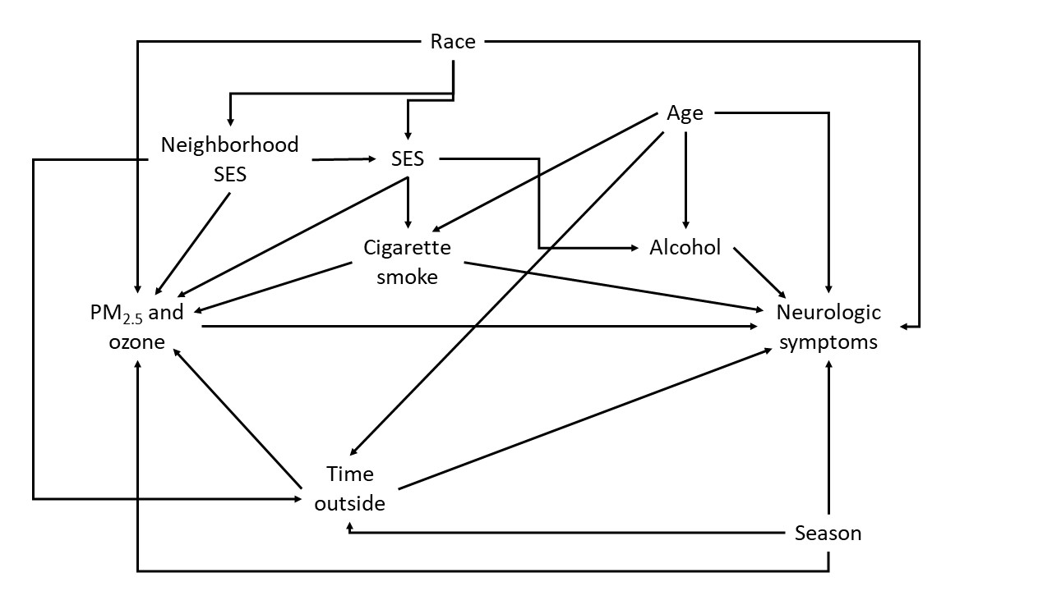
Supplemental Figure 1. Directed Acyclic Graph of the theoretical relationship between exposure to PM_{2.5} and ozone and neurologic symptoms.
Supplemental Table 1. Prevalence distribution of experiencing neurologic symptoms most or all of the time in the previous 30 days (n=21,467).
Endpoint | N | %
Any neurologic symptom | 6479 | 30.18
Any CNS symptom | 4723 | 22
Multiple CNS symptoms | 2062 | 9.61
Dizzy/lightheadedness | 1517 | 7.07
Nausea | 1058 | 4.93
Headache | 3094 | 14.41
Sweat heavily for no reason | 1955 | 9.11
Heart palpitations | 742 | 3.46
Any PNS symptom | 4187 | 19.5
Multiple PNS symptoms | 2587 | 12.05
Tingling in extremities | 2874 | 13.39
Numbness in extremities | 2662 | 12.4
Blurred/distorted vision | 1731 | 8.06
Stumbled while walking | 780 | 3.63

Supplemental Table 2. Distributions of average PM_{2.5} and ozone exposure metrics (n=21,467).
Average exposure metric | Mean | Min | 25th percentile | Median | 75th percentile | IQR | Max
30-day ozone (ppb) | 40.1 | 20.7 | 35.0 | 39.5 | 45.2 | 10.2 | 68.9
7-day ozone (ppb) | 40.2 | 18.0 | 33.9 | 38.8 | 45.9 | 12.0 | 81.7
30-day PM_{2.5} (μg/m³) | 8.6 | 3.2 | 7.5 | 8.4 | 9.5 | 2.0 | 19.4
7-day PM_{2.5} (μg/m³) | 8.5 | 2.5 | 6.9 | 8.1 | 9.6 | 2.7 | 34.1

Supplemental Table 3. Spearman rank correlations among 30- and 7-day PM_{2.5} and ozone average exposure metrics (n=21,467).¹
 | 7-day PM_{2.5} | 30-day ozone | 7-day ozone
30-day PM_{2.5} | 0.59 | 0.41 | 0.22
7-day PM_{2.5} |  | 0.25 | 0.46
30-day ozone |  |  | 0.74
¹For all pairwise correlation coefficients, p-value is < 0.0001.

Supplemental Table 4. Associations between average PM_{2.5} levels (quartiles of 30- and 7-day concentrations) and neurologic symptoms (n=21,467).
 |  | 30-day average PM_{2.5} |  |  |  |  |  | 7-day average PM_{2.5}
 |  | Covariate-adjusted¹ |  |  | Covariate and  ozone-adjusted² |  |  | Covariate-adjusted¹ |  |  | Covariate and  ozone-adjusted³
Outcome | Exposure | PR | 95% CI | p-trend | PR | 95% CI | p-trend | PR | 95% CI | p-trend | PR | 95% CI | p-trend
Any neuro | Q2 | 1.02 | (0.97, 1.08) | 0.002 | 1.02 | (0.97, 1.08) | 0.002 | 1.02 | (0.97, 1.07) | 0.85 | 1.01 | (0.96, 1.06) | 0.38
 | Q3 | 1.09 | (1.04, 1.15) |  | 1.09 | (1.03, 1.15) |  | 1.05 | (1.00, 1.10) |  | 1.04 | (0.98, 1.09)
 | Q4 | 1.16 | (1.10, 1.22) |  | 1.16 | (1.09, 1.23) |  | 1.02 | (0.97, 1.07) |  | 1.00 | (0.94, 1.06)
Any CNS | Q2 | 1.05 | (0.98, 1.12) | 0.02 | 1.05 | (0.99, 1.13) | 0.01 | 1.04 | (0.97, 1.10) | 0.23 | 1.03 | (0.97, 1.09) | 0.57
 | Q3 | 1.17 | (1.10, 1.24) |  | 1.17 | (1.10, 1.25) |  | 1.05 | (0.99, 1.11) |  | 1.04 | (0.97, 1.10)
 | Q4 | 1.22 | (1.14, 1.30) |  | 1.23 | (1.14, 1.32) |  | 1.06 | (1.00, 1.13) |  | 1.04 | (0.97, 1.11)
Multiple CNS | Q2 | 1.07 | (0.96, 1.19) | <.0001 | 1.10 | (0.99, 1.22) | <.0001 | 1.16 | (1.05, 1.27) | 0.13 | 1.17 | (1.06, 1.29) | 0.05
 | Q3 | 1.19 | (1.08, 1.32) |  | 1.24 | (1.12, 1.37) |  | 1.05 | (0.96, 1.16) |  | 1.08 | (0.97, 1.19)
 | Q4 | 1.36 | (1.23, 1.50) |  | 1.44 | (1.29, 1.61) |  | 1.13 | (1.03, 1.24) |  | 1.17 | (1.05, 1.30)
Any PNS | Q2 | 1.03 | (0.96, 1.11) | 0.001 | 1.03 | (0.96, 1.11) | 0.001 | 1.02 | (0.95, 1.09) | 0.89 | 1.00 | (0.94, 1.07) | 0.50
 | Q3 | 1.08 | (1.01, 1.16) |  | 1.08 | (1.01, 1.17) |  | 1.07 | (1.00, 1.14) |  | 1.05 | (0.98, 1.12)
 | Q4 | 1.19 | (1.11, 1.27) |  | 1.19 | (1.10, 1.29) |  | 1.04 | (0.97, 1.11) |  | 1.00 | (0.93, 1.08)
Multiple PNS | Q2 | 1.07 | (0.97, 1.17) | 0.004 | 1.07 | (0.97, 1.17) | 0.007 | 1.00 | (0.91, 1.09) | 0.40 | 0.98 | (0.90, 1.07) | 0.80
 | Q3 | 1.12 | (1.02, 1.23) |  | 1.11 | (1.01, 1.23) |  | 1.04 | (0.96, 1.14) |  | 1.01 | (0.92, 1.10)
 | Q4 | 1.24 | (1.13, 1.36) |  | 1.23 | (1.11, 1.36) |  | 1.05 | (0.96, 1.14) |  | 0.99 | (0.89, 1.09)
¹Adjusted for age, sex, season, race, employment status, alcohol status, smoking status, education, income, and ADI
²Adjusted as in (¹) and additionally adjusted for quartiles of 30-day average ozone concentration
³Adjusted as in (¹) and additionally adjusted for quartiles of 7-day average ozone concentration

Supplemental Table 5. Associations between average ozone levels (quartiles of 30- and 7-day concentrations) and neurologic symptoms (n=21,467).
 |  | 30-day average ozone |  |  |  |  |  | 7-day average ozone
 |  | Covariate-adjusted¹ |  |  | Covariate and  PM_{2.5}-adjusted² |  |  | Covariate-adjusted¹ |  |  | Covariate and  PM_{2.5}-adjusted³
Outcome | Exposure | PR | 95% CI | p-trend | PR | 95% CI | p-trend | PR | 95% CI | p-trend | PR | 95% CI | p-trend
Any neuro | Q2 | 1.07 | (1.01, 1.13) | 0.02 | 1.05 | (1.00, 1.11) | 0.89 | 1.04 | (0.99, 1.10) | 0.10 | 1.04 | (0.99, 1.10) | 0.19
 | Q3 | 1.04 | (0.98, 1.11) |  | 1.00 | (0.93, 1.06) |  | 1.03 | (0.98, 1.09) |  | 1.03 | (0.97, 1.09)
 | Q4 | 1.09 | (1.02, 1.16) |  | 1.01 | (0.95, 1.08) |  | 1.06 | (1.01, 1.12) |  | 1.06 | (0.99, 1.13)
Any CNS | Q2 | 1.09 | (1.02, 1.17) | 0.12 | 1.08 | (1.01, 1.15) | 0.20 | 1.09 | (1.03, 1.16) | 0.20 | 1.09 | (1.03, 1.16) | 0.62
 | Q3 | 1.09 | (1.01, 1.18) |  | 1.03 | (0.96, 1.11) |  | 1.06 | (0.99, 1.13) |  | 1.04 | (0.98, 1.12)
 | Q4 | 1.11 | (1.03, 1.19) |  | 1.00 | (0.93, 1.08) |  | 1.09 | (1.02, 1.16) |  | 1.06 | (0.98, 1.14)
Multiple CNS | Q2 | 1.08 | (0.97, 1.19) | 0.91 | 1.05 | (0.95, 1.17) | 0.003 | 1.12 | (1.03, 1.23) | 0.35 | 1.11 | (1.02, 1.22) | 0.04
 | Q3 | 1.06 | (0.94, 1.18) |  | 0.97 | (0.86, 1.09) |  | 1.04 | (0.94, 1.14) |  | 1.00 | (0.91, 1.11)
 | Q4 | 1.05 | (0.94, 1.18) |  | 0.89 | (0.79, 1.00) |  | 1.02 | (0.92, 1.13) |  | 0.95 | (0.85, 1.06)
Any PNS | Q2 | 1.04 | (0.96, 1.12) | 0.02 | 1.03 | (0.95, 1.11) | 0.77 | 1.03 | (0.97, 1.11) | 0.008 | 1.03 | (0.96, 1.10) | 0.03
 | Q3 | 1.02 | (0.94. 1.11) |  | 0.98 | (0.89, 1.06) |  | 1.01 | (0.94, 1.09) |  | 1.01 | (0.94, 1.09)
 | Q4 | 1.09 | (1.01, 1.19) |  | 1.01 | (0.92, 1.10) |  | 1.10 | (1.02, 1.18) |  | 1.09 | (1.00, 1.19)
Multiple PNS | Q2 | 1.03 | (0.93, 1.13) | 0.01 | 1.01 | (0.92, 1.12) | 0.55 | 1.06 | (0.97, 1.16) | 0.003 | 1.06 | (0.97, 1.16) | 0.006
 | Q3 | 1.04 | (0.93, 1.16) |  | 0.99 | (0.88, 1.11) |  | 1.04 | (0.94, 1.15) |  | 1.04 | (0.94, 1.15)
 | Q4 | 1.12 | (1.01, 1.26) |  | 1.02 | (0.91, 1.15) |  | 1.16 | (1.05, 1.28) |  | 1.17 | (1.04, 1.30)
¹Adjusted for age, sex, season, race, employment status, alcohol status, smoking status, education, income, and ADI
²Adjusted as in (¹) and additionally adjusted for quartiles of 30-day average PM_{2.5} concentration
³Adjusted as in (¹) and additionally adjusted for quartiles of 7-day average PM_{2.5} concentration
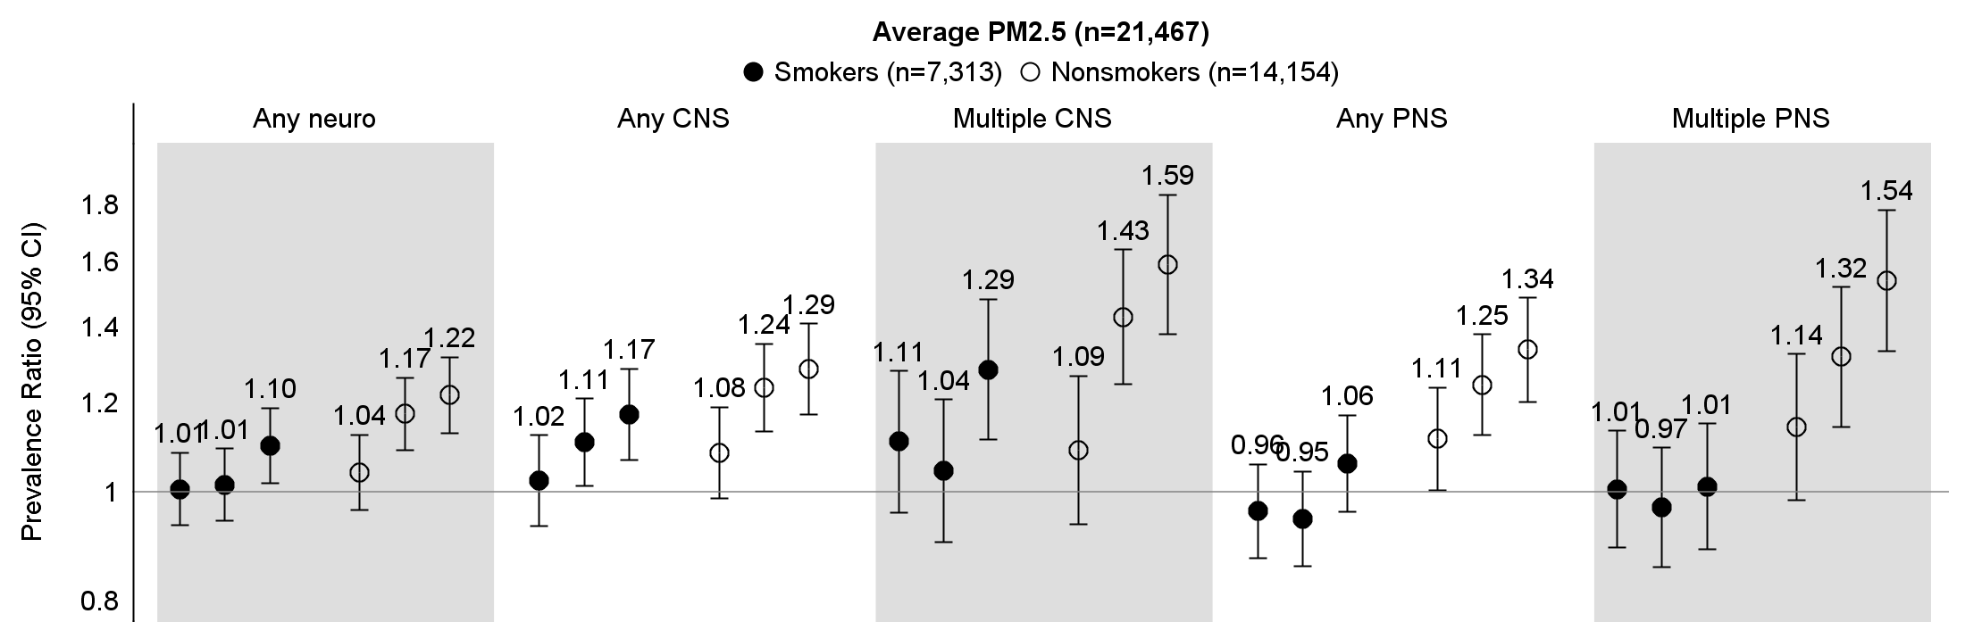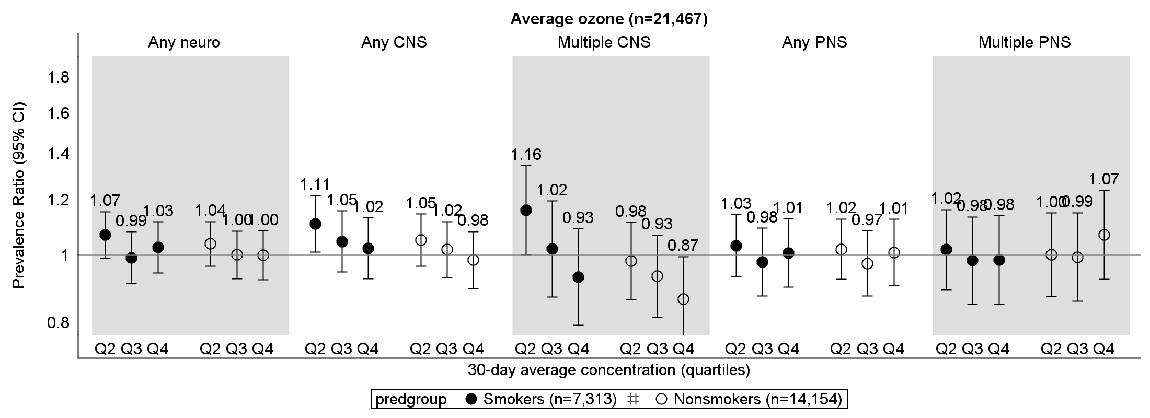
Supplemental Figure 2. Associations between 30-day average criteria air pollutant levels and neurologic symptoms stratified by smoking status. Estimates are generated from co-pollutant models (including both PM_{2.5} and ozone: quartiles of 30-day average concentrations) with a product interaction term between the main exposure (PM_{2.5} or ozone) and smoking status, and adjusted for age, sex, season, race, employment status, alcohol status, smoking status, education, income, and ADI.
Supplemental Table 6 (accompanies Supplemental Figure 1). Associations between 30-day average criteria air pollutant levels and neurologic symptoms stratified by smoking status (n=21,467).
 |  | 30-day average PM_{2.5} |  |  |  |  | 30-day average ozone
 |  | Nonsmokers |  | Smokers |  |  | Nonsmokers |  | Smokers
Outcome | Level | PR | 95% CI | PR | 95% CI | p-interaction | PR | 95% CI | PR | 95% CI | p- interaction
Any neuro | Q2 | 1.04 | (0.96, 1.12) | 1.01 | (0.93, 1.08) | 0.02 | 1.04 | (0.97, 1.12) | 1.07 | (0.99, 1.16) | 0.83
 | Q3 | 1.17 | (1.09, 1.26) | 1.01 | (0.94, 1.09) |  | 1.00 | (0.92, 1.08) | 0.99 | (0.91, 1.08)
 | Q4 | 1.22 | (1.13, 1.32) | 1.10 | (1.02, 1.19) |  | 1.00 | (0.92, 1.08) | 1.03 | (0.94, 1.12)
Any CNS | Q2 | 1.08 | (0.99, 1.19) | 1.02 | (0.93, 1.12) | 0.3 | 1.05 | (0.96, 1.15) | 1.11 | (1.01, 1.22) | 0.84
 | Q3 | 1.24 | (1.13, 1.35) | 1.11 | (1.01, 1.21) |  | 1.02 | (0.93, 1.12) | 1.05 | (0.95, 1.16)
 | Q4 | 1.29 | (1.17, 1.41) | 1.17 | (1.07, 1.29) |  | 0.98 | (0.90, 1.08) | 1.02 | (0.92, 1.13)
Multiple CNS | Q2 | 1.09 | (0.94, 1.27) | 1.11 | (0.96, 1.28) | 0.0003 | 0.98 | (0.86, 1.11) | 1.16 | (1.00, 1.35) | 0.35
 | Q3 | 1.43 | (1.25, 1.64) | 1.04 | (0.90, 1.21) |  | 0.93 | (0.81, 1.07) | 1.02 | (0.87, 1.20)
 | Q4 | 1.59 | (1.38, 1.84) | 1.29 | (1.11, 1.48) |  | 0.87 | (0.75, 1.00) | 0.93 | (0.79, 1.09)
Any PNS | Q2 | 1.11 | (1.00, 1.24) | 0.96 | (0.87, 1.06) | 0.0004 | 1.02 | (0.92, 1.13) | 1.03 | (0.93, 1.14) | 1.0
 | Q3 | 1.25 | (1.13, 1.38) | 0.95 | (0.86, 1.04) |  | 0.97 | (0.87, 1.08) | 0.98 | (0.87, 1.09)
 | Q4 | 1.34 | (1.20, 1.49) | 1.06 | (0.96, 1.17) |  | 1.01 | (0.90, 1.13) | 1.01 | (0.90, 1.13)
Multiple PNS | Q2 | 1.14 | (0.98, 1.33) | 1.01 | (0.89, 1.13) | <.0001 | 1.00 | (0.87, 1.15) | 1.02 | (0.89, 1.16) | 0.63
 | Q3 | 1.32 | (1.14, 1.52) | 0.97 | (0.86, 1.10) |  | 0.99 | (0.86, 1.15) | 0.98 | (0.85, 1.13)
 | Q4 | 1.54 | (1.33, 1.78) | 1.01 | (0.89, 1.15) |  | 1.07 | (0.92, 1.24) | 0.98 | (0.85, 1.14)
Estimates are generated from co-pollutant models (including both PM_{2.5} and ozone: quartiles of 30-day average concentrations) with a product interaction term between the main exposure (PM_{2.5} or ozone) and smoking status, and adjusted for age, sex, season, race, employment status, alcohol status, smoking status, education, income, and ADI.
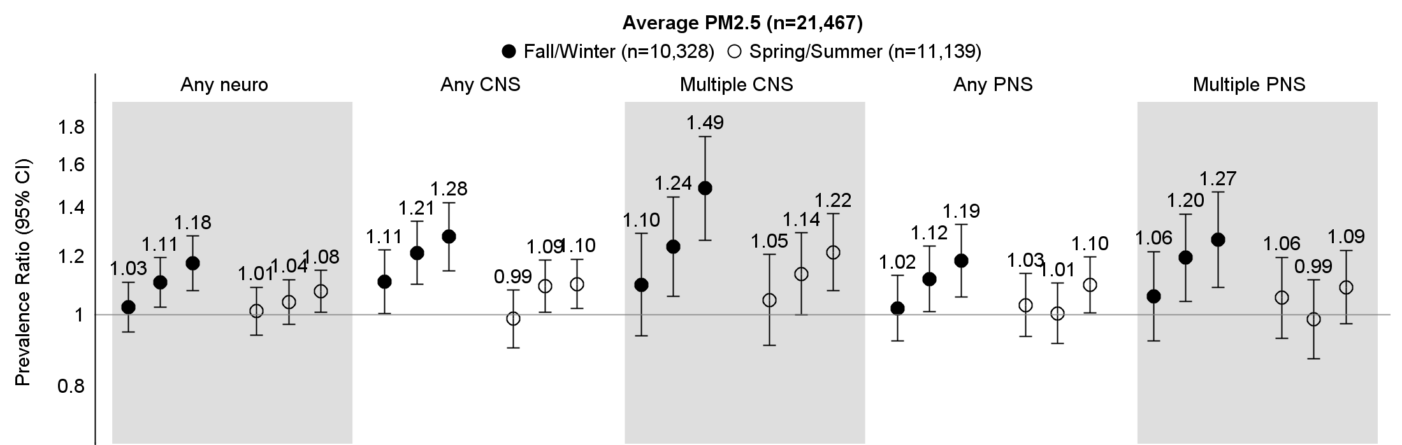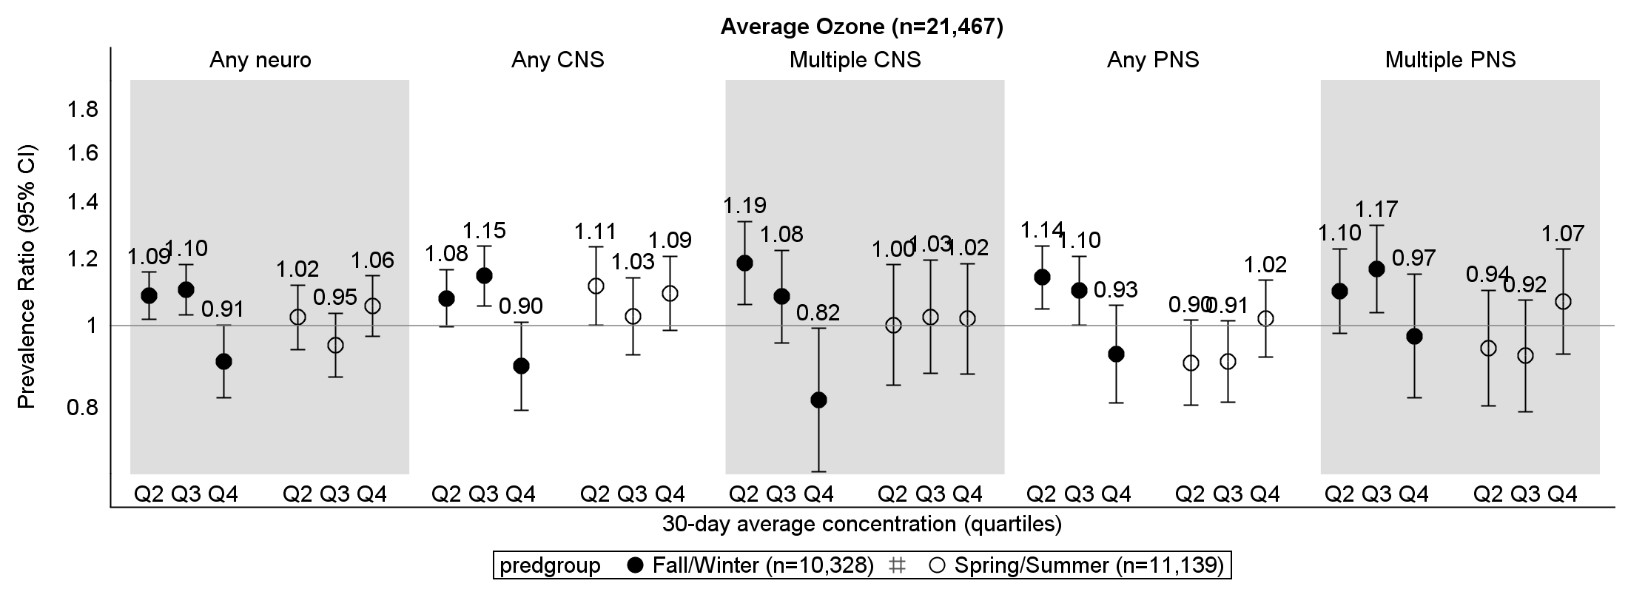
Supplemental Figure 3. Associations between 30-day average criteria air pollutant levels and neurologic symptoms stratified by season. Estimates are generated from co-pollutant models (including both PM_{2.5} and ozone: quartiles of 30-day average concentrations) with a product interaction term between the main exposure (PM_{2.5} or ozone) and season (spring/summer or fall/winter), and adjusted for age, sex, individual season, race, employment status, alcohol status, smoking status, education, income, and ADI.
Supplemental Table 7 (accompanies Supplemental Figure 2). Associations between 30-day average criteria air pollutant levels and neurologic symptoms stratified by season (n=21,467).
 |  | 30-day average PM_{2.5} |  |  |  |  | 30-day average ozone
 |  | Fall/Winter |  | Spring/Summer |  |  | Fall/Winter |  | Spring/Summer
Outcome | Level | PR | 95% CI | PR | 95% CI | p-interaction | PR | 95% CI | PR | 95% CI | p-interaction
Any neuro | Q2 | 1.03 | (0.95, 1.11) | 1.01 | (0.94, 1.09) | 0.29 | 1.09 | (1.02, 1.16) | 1.02 | (0.94, 1.12) | <.0001
 | Q3 | 1.11 | (1.03, 1.20) | 1.04 | (0.97, 1.12) |  | 1.10 | (1.03, 1.18) | 0.95 | (0.87, 1.03)
 | Q4 | 1.18 | (1.08, 1.28) | 1.08 | (1.01, 1.15) |  | 0.91 | (0.82, 1.00) | 1.06 | (0.97, 1.15)
Any CNS | Q2 | 1.11 | (1.00, 1.23) | 0.99 | (0.90, 1.08) | 0.14 | 1.08 | (1.00, 1.17) | 1.11 | (1.00, 1.24) | 0.0001
 | Q3 | 1.21 | (1.10, 1.34) | 1.09 | (1.01, 1.19) |  | 1.15 | (1.06, 1.24) | 1.03 | (0.92, 1.14)
 | Q4 | 1.28 | (1.15, 1.42) | 1.1 | (1.02, 1.19) |  | 0.9 | (0.79, 1.01) | 1.09 | (0.99, 1.21)
Multiple CNS | Q2 | 1.1 | (0.94, 1.29) | 1.05 | (0.91, 1.21) | 0.15 | 1.19 | (1.06, 1.33) | 1 | (0.85, 1.18) | 0.003
 | Q3 | 1.24 | (1.06, 1.45) | 1.14 | (1.00, 1.29) |  | 1.08 | (0.95, 1.23) | 1.03 | (0.88, 1.20)
 | Q4 | 1.49 | (1.26, 1.75) | 1.22 | (1.08, 1.37) |  | 0.82 | (0.67, 0.99) | 1.02 | (0.88, 1.18)
Any PNS | Q2 | 1.02 | (0.92, 1.13) | 1.03 | (0.94, 1.14) | 0.23 | 1.14 | (1.05, 1.24) | 0.9 | (0.81, 1.02) | <.0001
 | Q3 | 1.12 | (1.01, 1.24) | 1.01 | (0.92, 1.10) |  | 1.1 | (1.00, 1.21) | 0.91 | (0.81, 1.01)
 | Q4 | 1.19 | (1.06, 1.33) | 1.1 | (1.01, 1.20) |  | 0.93 | (0.81, 1.06) | 1.02 | (0.92, 1.13)
Multiple PNS | Q2 | 1.06 | (0.92, 1.22) | 1.06 | (0.93, 1.20) | 0.06 | 1.1 | (0.98, 1.23) | 0.94 | (0.80, 1.10) | 0.003
 | Q3 | 1.2 | (1.04, 1.37) | 0.99 | (0.87, 1.12) |  | 1.17 | (1.04, 1.32) | 0.92 | (0.79, 1.07)
 | Q4 | 1.27 | (1.09, 1.47) | 1.09 | (0.97, 1.22) |  | 0.97 | (0.82, 1.15) | 1.07 | (0.93, 1.23)
Estimates are generated from co-pollutant models (including both PM_{2.5} and ozone: quartiles of 30-day average concentrations) with a product interaction term between the main exposure (PM_{2.5} or ozone) and season (spring/summer or fall/winter), and adjusted for age, sex, individual season, race, employment status, alcohol status, smoking status, education, income, and ADI.

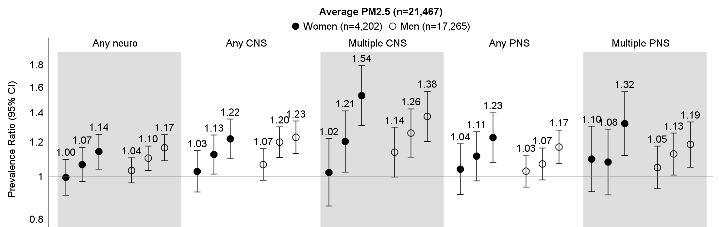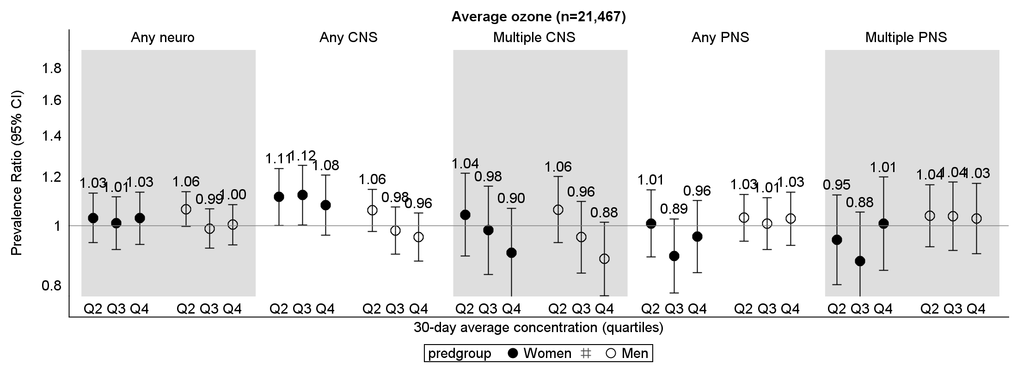
Supplemental Figure 4. Associations between 30-day average criteria air pollutant levels and neurologic symptoms stratified by sex. Estimates are generated from co-pollutant models (including both PM_{2.5} and ozone: quartiles of 30-day average concentrations) with a product interaction term between the main exposure (PM_{2.5} or ozone) and sex, and adjusted for age, sex, season, race, employment status, alcohol status, smoking status, education, income, and ADI.
Supplemental Table 8 (accompanies Supplemental Figure 3). Associations between 30-day average criteria air pollutant levels and neurologic symptoms stratified by sex (n=21,467).
 |  | 30-day average PM_{2.5} |  |  |  |  | 30-day average ozone
 |  | Men |  | Women |  |  | Men |  | Women
Outcome | Level | PR | 95% CI | PR | 95% CI | p-interaction | PR | 95% CI | PR | 95% CI | p-interaction
Any neuro | Q2 | 1.04 | (0.97, 1.11) | 1 | (0.91, 1.10) | 0.92 | 1.06 | (1.00, 1.14) | 1.03 | (0.94, 1.13) | 0.68
 | Q3 | 1.07 | (1.03, 1.18) | 1.07 | (0.98, 1.17) |  | 0.99 | (0.92, 1.07) | 1.01 | (0.92, 1.11)
 | Q4 | 1.14 | (1.09, 1.25) | 1.14 | (1.04, 1.25) |  | 1 | (0.93, 1.08) | 1.03 | (0.93, 1.13)
Any CNS | Q2 | 1.07 | (0.98, 1.16) | 1.03 | (0.92, 1.15) | 0.68 | 1.06 | (0.98, 1.15) | 1.11 | (1.00, 1.24) | 0.12
 | Q3 | 1.2 | (1.11, 1.30) | 1.13 | (1.02, 1.25) |  | 0.98 | (0.90, 1.07) | 1.12 | (1.00, 1.25)
 | Q4 | 1.23 | (1.13, 1.34) | 1.22 | (1.10, 1.36) |  | 0.96 | (0.88, 1.05) | 1.08 | (0.97, 1.21)
Multiple CNS | Q2 | 1.14 | (1.00, 1.30) | 1.02 | (0.86, 1.22) | 0.07 | 1.06 | (0.94, 1.20) | 1.04 | (0.89, 1.22) | 0.95
 | Q3 | 1.26 | (1.11, 1.43) | 1.21 | (1.03, 1.42) |  | 0.96 | (0.84, 1.10) | 0.98 | (0.83, 1.16)
 | Q4 | 1.38 | (1.21, 1.57) | 1.54 | (1.31, 1.80) |  | 0.88 | (0.77, 1.01) | 0.9 | (0.77, 1.07)
Any PNS | Q2 | 1.03 | (0.95, 1.12) | 1.04 | (0.91, 1.19) | 0.89 | 1.03 | (0.94, 1.13) | 1.01 | (0.89, 1.14) | 0.38
 | Q3 | 1.07 | (0.99, 1.17) | 1.11 | (0.98, 1.27) |  | 1.01 | (0.92, 1.11) | 0.89 | (0.78, 1.03)
 | Q4 | 1.17 | (1.07, 1.28) | 1.23 | (1.08, 1.40) |  | 1.03 | (0.93, 1.13) | 0.96 | (0.84, 1.10)
Multiple PNS | Q2 | 1.05 | (0.94, 1.18) | 1.1 | (0.92, 1.31) | 0.34 | 1.04 | (0.92, 1.17) | 0.95 | (0.80, 1.12) | 0.28
 | Q3 | 1.13 | (1.01, 1.26) | 1.08 | (0.91, 1.29) |  | 1.04 | (0.91, 1.18) | 0.88 | (0.73, 1.05)
 | Q4 | 1.19 | (1.05, 1.33) | 1.32 | (1.12, 1.57) |  | 1.03 | (0.90, 1.17) | 1.01 | (0.85, 1.20)
Estimates are generated from co-pollutant models (including both PM_{2.5} and ozone: quartiles of 30-day average concentrations) with a product interaction term between the main exposure (PM_{2.5} or ozone) and sex, and adjusted for age, sex, season, race, employment status, alcohol status, smoking status, education, income, and ADI.

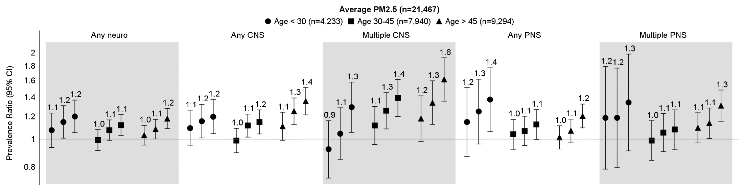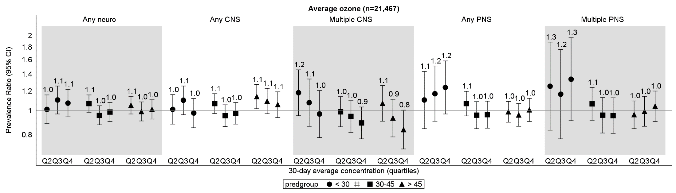
Supplemental Figure 5. Associations between 30-day average criteria air pollutant levels and neurologic symptoms stratified by age group. Estimates are generated from co-pollutant models (including both PM_{2.5} and ozone: quartiles of 30-day average concentrations) with a product interaction term between the main exposure (PM_{2.5} or ozone) and age group, and adjusted for age group, sex, season, race, employment status, alcohol status, smoking status, education, income, and ADI.

Supplemental Table 9 (accompanies Supplemental Figure 4). Associations between 30-day average criteria air pollutant levels and neurologic symptoms stratified by age group (n=21,467).
 |  |  | Age <30 |  | Age 30-45 |  | Age >45 |  | p-interaction
Exposure | Outcome | Level | PR | 95% CI | PR | 95% CI | PR | 95% CI
PM2.5 | Any neuro | Q2 | 1.08 | (0.94, 1.23) | 0.99 | (0.91, 1.08) | 1.03 | (0.95, 1.12) | 0.91
 |  | Q3 | 1.15 | (1.01, 1.31) | 1.08 | (0.99, 1.17) | 1.08 | (1.00, 1.17)
 |  | Q4 | 1.2 | (1.05, 1.37) | 1.12 | (1.03, 1.22) | 1.12 | (1.09, 1.28)
 | Any CNS | Q2 | 1.09 | (0.95, 1.26) | 0.99 | (0.90, 1.09) | 1.11 | (0.99, 1.24) | 0.29
 |  | Q3 | 1.16 | (1.01, 1.32) | 1.12 | (1.02, 1.22) | 1.23 | (1.12, 1.39)
 |  | Q4 | 1.2 | (1.04, 1.38) | 1.15 | (1.04, 1.27) | 1.36 | (1.22, 1.52)
 | Multiple CNS | Q2 | 0.92 | (0.73, 1.16) | 1.12 | (0.96, 1.30) | 1.18 | (0.98, 1.42) | 0.42
 |  | Q3 | 1.05 | (0.85, 1.29) | 1.26 | (1.09, 1.46) | 1.34 | (1.13, 1.60)
 |  | Q4 | 1.29 | (1.06, 1.58) | 1.39 | (1.20, 1.62) | 1.62 | (1.36, 1.92)
 | Any PNS | Q2 | 1.15 | (0.87, 1.51) | 1.04 | (0.92, 1.17) | 1.01 | (0.92, 1.11) | 0.69
 |  | Q3 | 1.25 | (0.96, 1.62) | 1.07 | (0.95, 1.20) | 1.07 | (0.98, 1.18)
 |  | Q4 | 1.37 | (1.06, 1.78) | 1.13 | (1.00, 1.27) | 1.21 | (1.10, 1.33)
 | Multiple PNS | Q2 | 1.19 | (0.79, 1.79) | 0.99 | (0.84, 1.16) | 1.1 | (0.97, 1.24) | 0.57
 |  | Q3 | 1.19 | (0.80, 1.77) | 1.05 | (0.90, 1.23) | 1.14 | (1.01, 1.28)
 |  | Q4 | 1.34 | (0.91, 1.98) | 1.08 | (0.92, 1.27) | 1.31 | (1.16, 1.48)
Ozone | Any neuro | Q2 | 1.01 | (0.89, 1.16) | 1.07 | (0.99, 1.16) | 1.05 | (0.97, 1.14) | 0.21
 |  | Q3 | 1.1 | (0.97, 1.26) | 0.96 | (0.88, 1.05) | 0.99 | (0.91, 1.08)
 |  | Q4 | 1.07 | (0.94, 1.22) | 0.99 | (0.91, 1.08) | 1.01 | (0.93, 1.11)
 | Any CNS | Q2 | 1.01 | (0.88, 1.16) | 1.07 | (0.98, 1.17) | 1.14 | (1.02, 1.27) | 0.14
 |  | Q3 | 1.1 | (0.97, 1.26) | 0.96 | (0.86, 1.06) | 1.09 | (0.97, 1.23)
 |  | Q4 | 0.98 | (0.86, 1.12) | 0.98 | (0.88, 1.08) | 1.06 | (0.94, 1.19)
 | Multiple CNS | Q2 | 1.18 | (0.96, 1.46) | 0.99 | (0.86, 1.14) | 1.07 | (0.91, 1.26) | 0.68
 |  | Q3 | 1.08 | (0.87, 1.34) | 0.95 | (0.82, 1.10) | 0.93 | (0.78, 1.11)
 |  | Q4 | 0.97 | (0.78, 1.21) | 0.89 | (0.77, 1.04) | 0.84 | (0.70, 1.01)
 | Any PNS | Q2 | 1.1 | (0.85, 1.44) | 1.07 | (0.95, 1.20) | 0.99 | (0.90, 1.09) | 0.27
 |  | Q3 | 1.17 | (0.91, 1.51) | 0.96 | (0.85, 1.09) | 0.96 | (0.87, 1.07)
 |  | Q4 | 1.24 | (0.97, 1.59) | 0.96 | (0.85, 1.09) | 1.01 | (0.91, 1.12)
 | Multiple PNS | Q2 | 1.26 | (0.84, 1.89) | 1.07 | (0.92, 1.24) | 0.96 | (0.85, 1.10) | 0.33
 |  | Q3 | 1.17 | (0.77, 1.76) | 0.96 | (0.81, 1.13) | 1 | (0.87, 1.14)
 |  | Q4 | 1.34 | (0.91, 1.96) | 0.96 | (0.81, 1.13) | 1.04 | (0.91, 1.20)

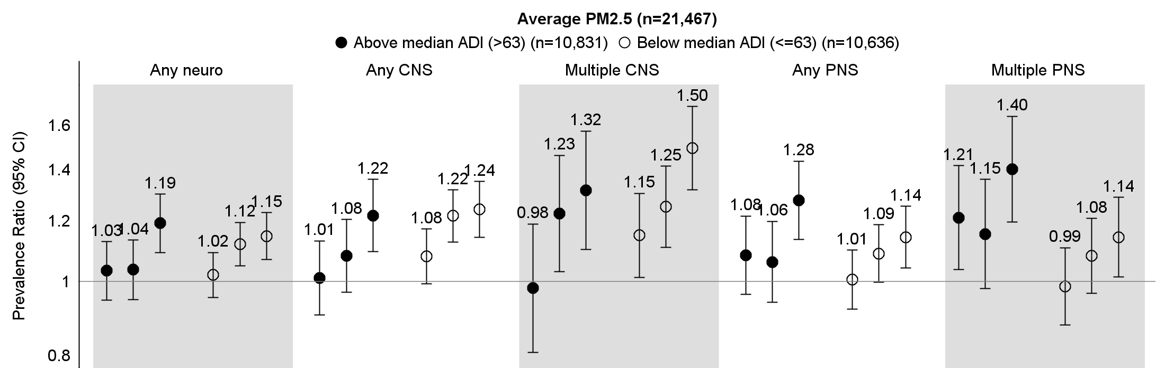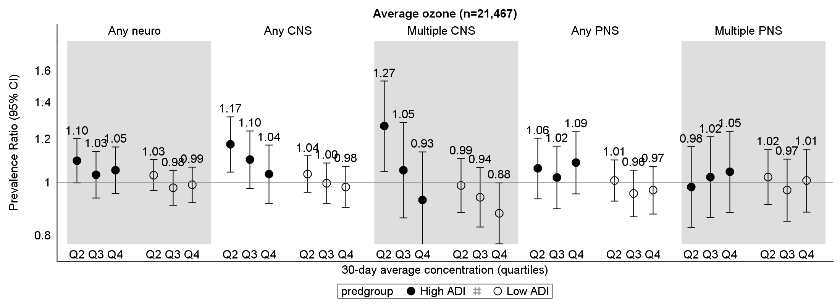
Supplemental Figure 6. Associations between 30-day average criteria air pollutant levels and neurologic symptoms stratified by ADI (cohort median=63). Estimates are generated from co-pollutant models (including both PM_{2.5} and ozone: quartiles of 30-day average concentrations) with a product interaction term between the main exposure (PM_{2.5} or ozone) and ADI relative to the median (high vs low), and adjusted for age, sex, season, race, employment status, alcohol status, smoking status, education, income, and ADI.
Supplemental Table 10 (accompanies Supplemental Figure 5). Associations between 30-day average criteria air pollutant levels and neurologic symptoms stratified by ADI (n=21,467).
 |  | 30-day average PM_{2.5} |  |  |  |  | 30-day average ozone
 |  | High ADI |  | Low ADI |  | p-interaction | High ADI |  | Low ADI |  | p-interaction
Outcome | Level | PR | 95% CI | PR | 95% CI |  | PR | 95% CI | PR | 95% CI
Any neuro | Q2 | 1.03 | (0.95, 1.13) | 1.02 | (0.95, 1.09) | 0.13 | 1.1 | (1.00, 1.20) | 1.03 | (0.97, 1.10) | 0.64
 | Q3 | 1.04 | (0.95, 1.13) | 1.12 | (1.05, 1.20) |  | 1.03 | (0.94, 1.14) | 0.98 | (0.91, 1.05)
 | Q4 | 1.19 | (1.09, 1.30) | 1.15 | (1.07, 1.23) |  | 1.05 | (0.95, 1.16) | 0.99 | (0.92, 1.07)
Any CNS | Q2 | 1.01 | (0.90, 1.13) | 1.08 | (0.99, 1.17) | 0.22 | 1.17 | (1.04, 1.32) | 1.04 | (0.96, 1.12) | 0.27
 | Q3 | 1.08 | (0.97, 1.21) | 1.22 | (1.13, 1.32) |  | 1.1 | (0.98, 1.24) | 1 | (0.92, 1.09)
 | Q4 | 1.22 | (1.10, 1.36) | 1.24 | (1.14, 1.35) |  | 1.04 | (0.92, 1.17) | 0.98 | (0.90, 1.07)
Multiple CNS | Q2 | 0.98 | (0.81, 1.19) | 1.15 | (1.01, 1.30) | 0.35 | 1.27 | (1.05, 1.53) | 0.99 | (0.88, 1.11) | 0.09
 | Q3 | 1.23 | (1.03, 1.46) | 1.25 | (1.11, 1.42) |  | 1.05 | (0.86, 1.29) | 0.94 | (0.83, 1.07)
 | Q4 | 1.32 | (1.10, 1.57) | 1.5 | (1.32, 1.70) |  | 0.93 | (0.76, 1.14) | 0.88 | (0.77, 1.00)
Any PNS | Q2 | 1.08 | (0.96, 1.22) | 1.01 | (0.92, 1.10) | 0.16 | 1.06 | (0.93, 1.20) | 1.01 | (0.92, 1.10) | 0.43
 | Q3 | 1.06 | (0.94, 1.20) | 1.09 | (1.00, 1.19) |  | 1.02 | (0.89, 1.17) | 0.96 | (0.87, 1.05)
 | Q4 | 1.28 | (1.14, 1.44) | 1.14 | (1.04, 1.25) |  | 1.09 | (0.95, 1.24) | 0.97 | (0.88, 1.07)
Multiple PNS | Q2 | 1.21 | (1.04, 1.42) | 0.99 | (0.88, 1.11) | 0.06 | 0.98 | (0.83, 1.16) | 1.02 | (0.91, 1.15) | 0.74
 | Q3 | 1.15 | (0.98, 1.36) | 1.08 | (0.97, 1.21) |  | 1.02 | (0.86, 1.21) | 0.97 | (0.85, 1.10)
 | Q4 | 1.4 | (1.20, 1.65) | 1.14 | (1.01, 1.29) |  | 1.05 | (0.88, 1.24) | 1.01 | (0.88, 1.15)
Estimates are generated from co-pollutant models (including both PM_{2.5} and ozone: quartiles of 30-day average concentrations) with a product interaction term between the main exposure (PM_{2.5} or ozone) and ADI relative to the median (63) (high vs low), and adjusted for age, sex, season, race, employment status, alcohol status, smoking status, education, income, and ADI (relative to the median).
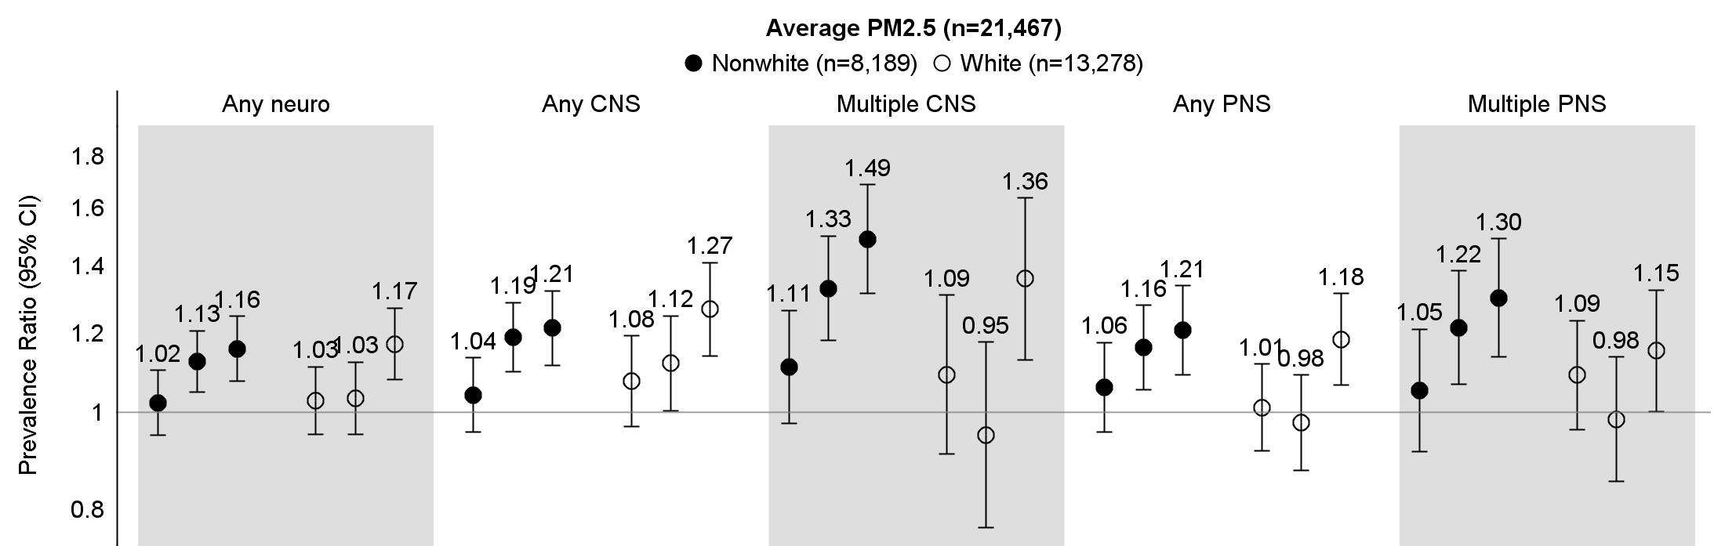 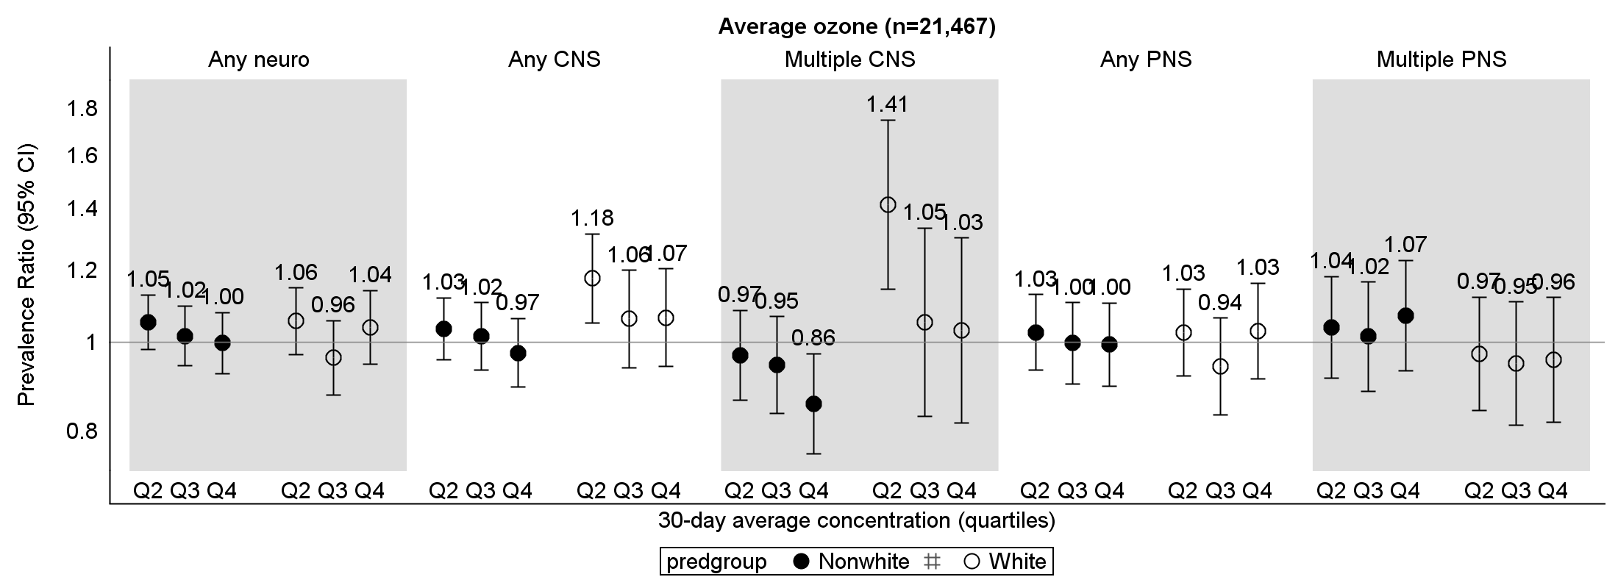 Supplemental Figure 7. Associations between 30-day average criteria air pollutant levels and neurologic symptoms stratified by race. Estimates are generated from co-pollutant models (including both PM_{2.5} and ozone: quartiles of 30-day maximum concentrations) with a product interaction term between the main exposure (PM_{2.5} or ozone) and race (nonwhite vs white), and adjusted for age, sex, season, race, employment status, alcohol status, smoking status, education, income, and ADI.
Supplemental Table 11 (accompanies Supplemental Figure 6). Associations between 30-day average criteria air pollutant levels and neurologic symptoms stratified by race (n=21,467).
 |  | 30-day average PM_{2.5} |  |  |  |  | 30-day average ozone
 |  | Nonwhite |  | White |  | p-interaction | Nonwhite |  | White |  | p-interaction
Outcome | Level | PR | 95% CI | PR | 95% CI |  | PR | 95% CI | PR | 95% CI
Any neuro | Q2 | 1.02 | (0.95, 1.10) | 1.03 | (0.95, 1.11) | 0.19 | 1.05 | (0.98, 1.13) | 1.06 | (0.97, 1.15) | 0.29
 | Q3 | 1.13 | (1.05, 1.21) | 1.03 | (0.95, 1.12) |  | 1.02 | (0.94, 1.10) | 0.96 | (0.88, 1.06)
 | Q4 | 1.16 | (1.08, 1.25) | 1.17 | (1.08, 1.27) |  | 1.00 | (0.93, 1.08) | 1.04 | (0.95, 1.14)
Any CNS | Q2 | 1.04 | (0.96, 1.13) | 1.08 | (0.97, 1.19) | 0.34 | 1.03 | (0.96, 1.12) | 1.18 | (1.05, 1.32) | 0.24
 | Q3 | 1.19 | (1.10, 1.29) | 1.12 | (1.00, 1.25) |  | 1.02 | (0.93, 1.11) | 1.06 | (0.94, 1.20)
 | Q4 | 1.21 | (1.12, 1.32) | 1.27 | (1.14, 1.41) |  | 0.97 | (0.89, 1.06) | 1.07 | (0.94, 1.20)
Multiple CNS | Q2 | 1.11 | (0.98, 1.27) | 1.09 | (0.91, 1.31) | 0.01 | 0.97 | (0.87, 1.08) | 1.41 | (1.14, 1.75) | 0.006
 | Q3 | 1.33 | (1.18, 1.50) | 0.95 | (0.77, 1.18) |  | 0.95 | (0.84, 1.07) | 1.05 | (0.83, 1.33)
 | Q4 | 1.49 | (1.32, 1.69) | 1.36 | (1.13, 1.64) |  | 0.86 | (0.76, 0.97) | 1.03 | (0.82, 1.30)
Any PNS | Q2 | 1.06 | (0.96, 1.17) | 1.01 | (0.92, 1.12) | 0.06 | 1.03 | (0.93, 1.13) | 1.03 | (0.92, 1.14) | 0.55
 | Q3 | 1.16 | (1.05, 1.28) | 0.98 | (0.88, 1.09) |  | 1.00 | (0.90, 1.11) | 0.94 | (0.83, 1.06)
 | Q4 | 1.21 | (1.09, 1.34) | 1.18 | (1.07, 1.31) |  | 1.00 | (0.90, 1.10) | 1.03 | (0.91, 1.16)
Multiple PNS | Q2 | 1.05 | (0.91, 1.21) | 1.09 | (0.96, 1.24) | 0.03 | 1.04 | (0.91, 1.18) | 0.97 | (0.84, 1.12) | 0.66
 | Q3 | 1.22 | (1.07, 1.38) | 0.98 | (0.85, 1.14) |  | 1.02 | (0.89, 1.16) | 0.95 | (0.81, 1.11)
 | Q4 | 1.30 | (1.14, 1.49) | 1.15 | (1.00, 1.33) |  | 1.07 | (0.93, 1.23)) | 0.96 | (0.82, 1.12)
Estimates are generated from co-pollutant models (including both PM_{2.5} and ozone: quartiles of 30-day maximum concentrations) with a product interaction term between the main exposure (PM_{2.5} or ozone) and race (nonwhite vs white), and adjusted for age, sex, season, race, employment status, alcohol status, smoking status, education, income, and ADI.

