Supplemental Table 1. ICD-9 and ICD-10 codes used to identify cause-specific emergency department visits.
Outcome | ICD-9 Codes | ICD-10 Codes
All Cardiovascular Diseases | All ICD-9 codes listed below | All ICD-10 codes listed below
Hypertension | 401-405 | I10-I15
Ischemic Heart Disease | 410-414 | I20-I25
Dysrhythmia | 427 | I46-I49
Congestive Heart Failure | 428 | I50
Stroke | 433-437 | G45, I63-I67
Peripheral Vascular Disease | 440-447 | I70-I79
Myocardial Infarction | 410 | I21-I22

Supplemental Table 2. Three-day distributed lag associations between grouped grasses, trees, and weed pollen concentrations and CVD emergency department visits during 1993-2018.

 | Group Grasses | Group Trees | Group Weeds
All Cardiovascular diseases | 0.992 (0.987, 0.997) | 0.996 (0.991, 1.001) | 0.999 (0.994, 1.005)
Hypertension | 0.990 (0.978, 1.002) | 0.990 (0.980, 0.999) | 1.003 (0.996, 1.010)
Ischemic heart disease | 0.971 (0.951, 0.992) | 1.001 (0.987, 1.014) | 0.991 (0.976, 1.007)
Myocardial infarction | 0.984 (0.956, 1.013) | 1.004 (0.985, 1.022) | 0.991 (0.976, 1.007)
Congestive heart failure | 0.988 (0.959, 1.017) | 1.006 (0.993, 1.020) | 0.987, 0.972, 1.003)
Periphreal Heart Disease | 0.990 (0.925, 1.059) | 1.011 (0.965, 1.058) | 1.014 (0.975, 1.054)
Stroke | 0.983 (0.962, 1.005) | 0.989 (0.975, 1.003) | 1.000 (0.988, 1.013)
Dysrhythmia | 0.990 (0.971, 1.010) | 0.999 (0.987, 1.012) | 1.002 (0.991, 1.013)

Supplemental Figure 1. Day-of-year mean cardiovascular disease emergency department visits and mean pollen concentrations (grains/m³) by taxa in Atlanta over the 26-year study period. Dashed lines indicate the seasonal period included for each taxa-specific analysis.
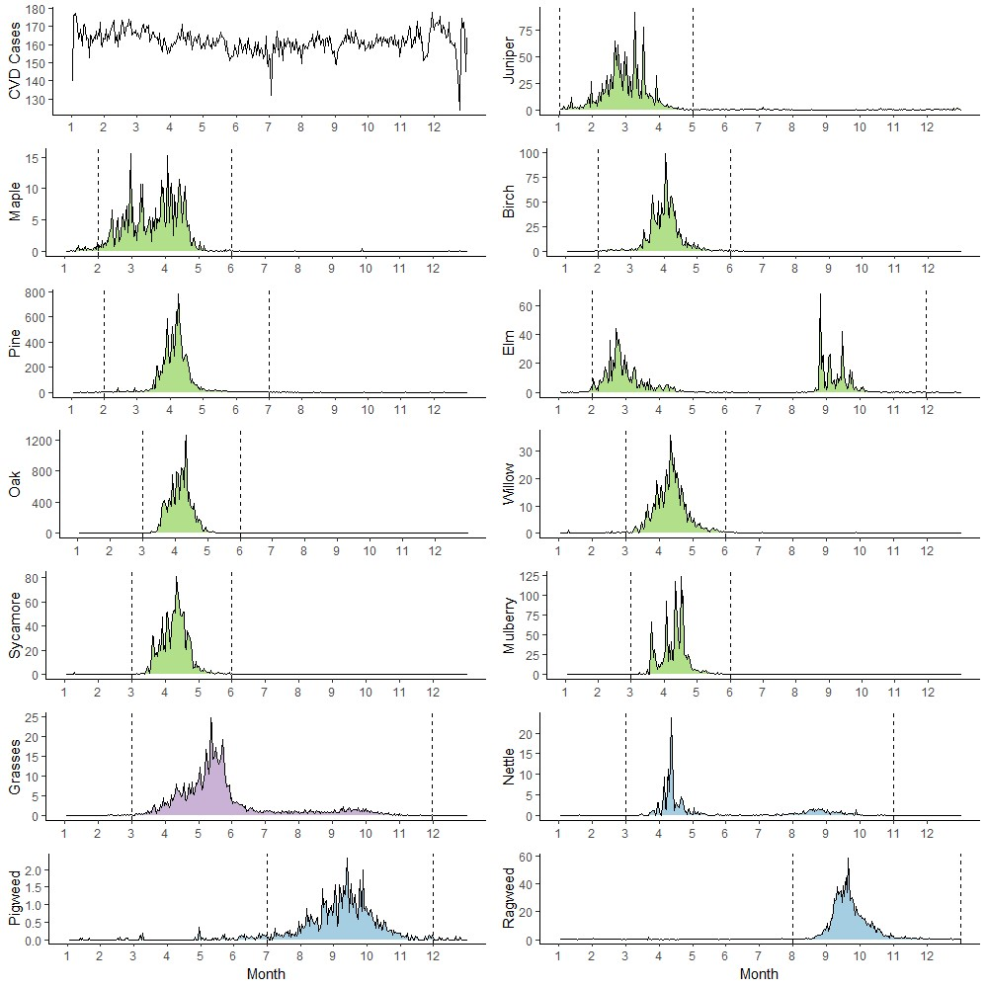

Supplemental Figure 2. Spearman correlations among pollen taxa concentrations, air pollution, and meteorological factors.
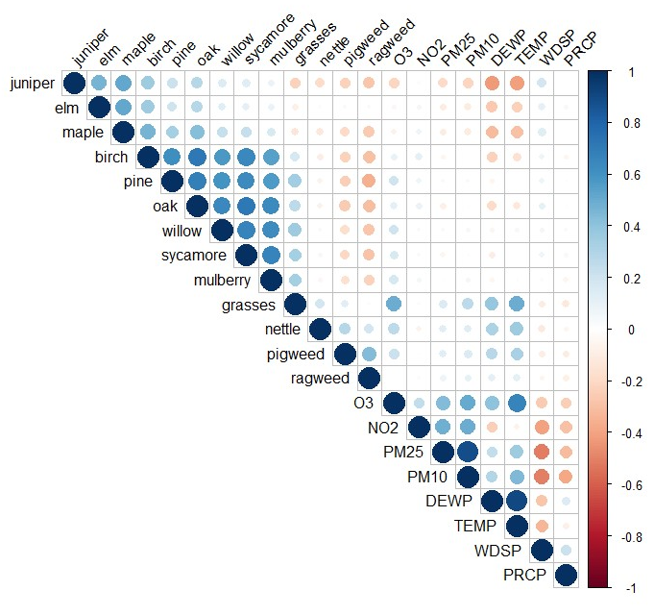

Supplemental Figure 3. Nonlinear exposure response curves (0-99th percentile) for all cardiovascular disease emergency department visits and grouped trees, weeds, and grasses. Dashed lines indicate the 5th, 50th, and 95th percentiles for within-season pollen concentrations.
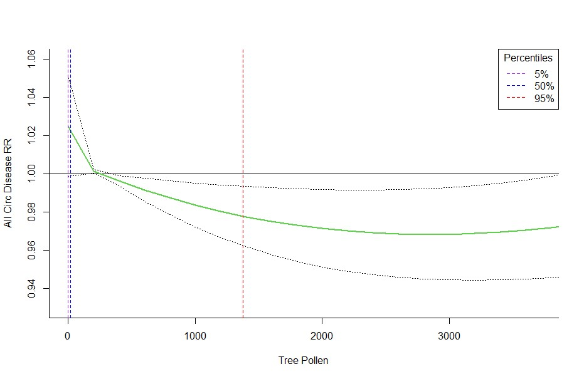
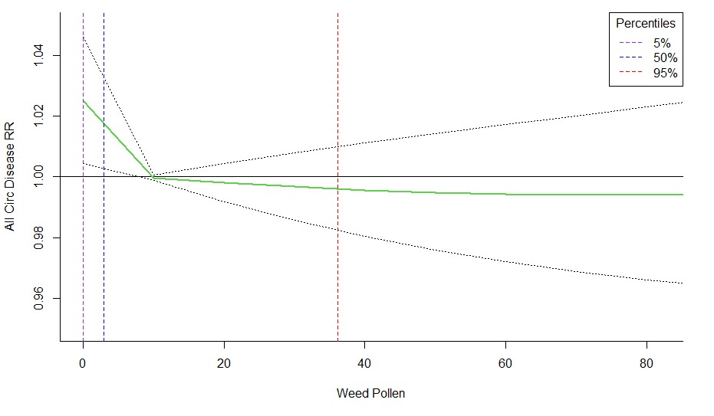
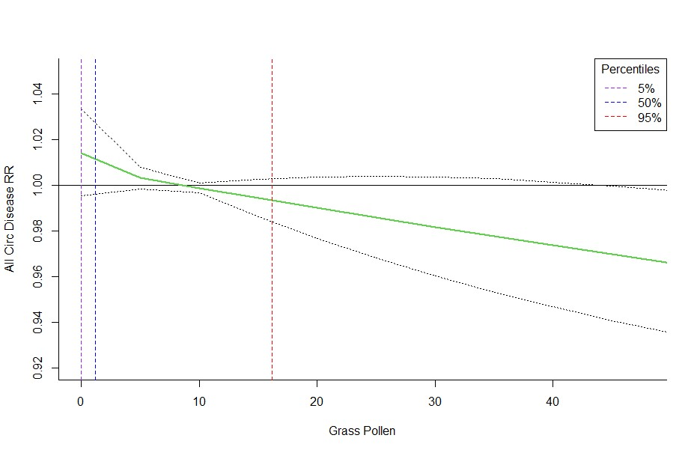
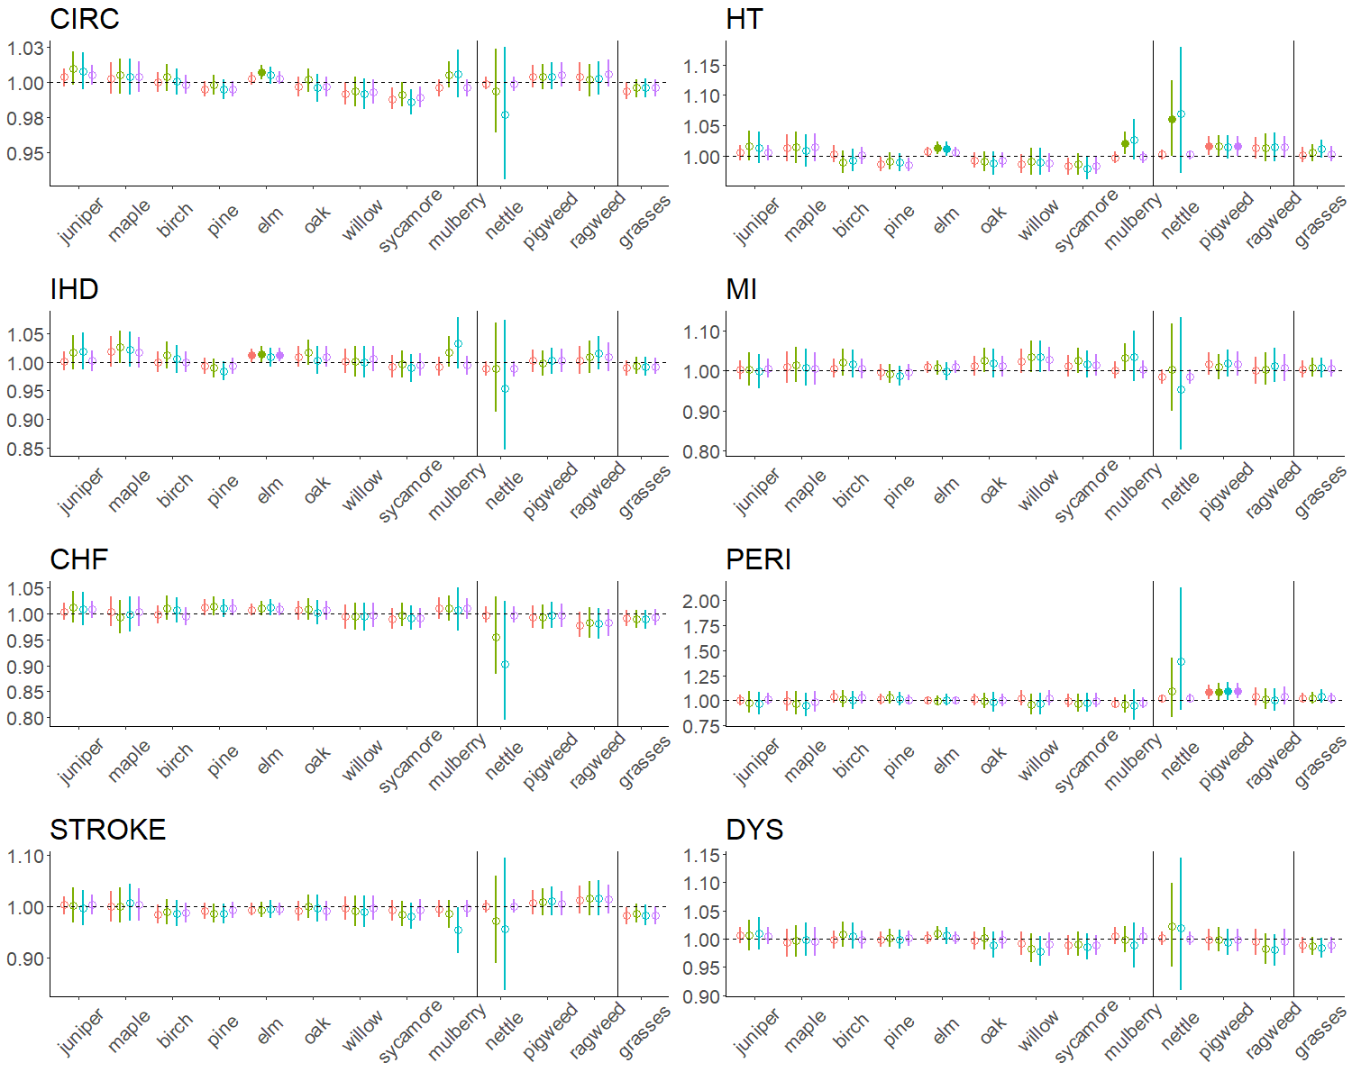
Supplemental Figure 4. Rate ratios for cardiovascular disease ED visits per standard deviation increase in taxa-specific pollen, controlling for ambient air pollutants (NO₂, PM₁₀, ozone) in the models one at a time. Statistical significance is based on a type I error rate of 0.05.

