Air Pollution, Traffic Noise, Greenness, and Temperature and the Risk of Incident Type 2 Diabetes: Results from the KORA Cohort Study
Mahnaz Badpa^{1,2}, Alexandra Schneider¹, Lars Schwettmann^{3,4}, Barbara Thorand^{1,5}, Kathrin Wolf^{1,*}, Annette Peters^{1,2,5,*}
¹ Institute of Epidemiology, Helmholtz Zentrum München, German Research Center for Environmental Health, Munich, Germany
² Institute for Medical Information Processing, Biometry and Epidemiology (IBE), Faculty of Medicine, Pettenkofer School of Public Health, LMU Munich, Munich, Germany
³ Institute of Health Economics and Health Care Management, Helmholtz Zentrum München, Munich, Germany
⁴ Department of Health Services Research, School of Medicine and Health Sciences, Carl von Ossietzky University of Oldenburg, Oldenburg, Germany
⁵ German Center for Diabetes Research (DZD), Partner München-Neuherberg, Neuherberg, Germany
* Shared last authorship

All participants (N=9,116)
N_{S3}=4,856; N_{S4}=4,260

Withdrawal consent (N=80)
N_{S3}=68; N_{S4}=12

Unknown diabetes type and unknown age (N=32)*
N_{S3}=32; N_{S4}=0

Lost to follow-up (N=521)
N_{S3}=302; N_{S4}=219

Unavailable residential addresses (N=270)
N_{S3}=252; N_{S4}=18

Missing values in covariates in the main model (N=128)
N_{S3}= 78; N_{S4}=50

Incident T2D analyses (N=7,736)
N_{S3}=3,964; N_{S4}=3,772

Prevalent T2D at baseline (N=349)
N_{S3}=160; N_{S4}=189

Figure S1. Flow chart of the exclusion process.
* Participants with unknown diabetes type but age of onset ≥35 years (N=77) were included as T2D cases.

Text S1. Assessment of incident T2D
The incidence of T2D was assessed using written follow-up questionnaires sent to all S3 participants in 1997/98 and 2002/03, and to all S3 and S4 participants in 2008/09 and 2016. Furthermore, all S3 participants were invited to a follow-up examination in 2004/05 and all S4 participants were invited to a follow-up examination in 2006/08 and 2013/14. Self-reported incident T2D status at the first above-mentioned occasion and the date of diagnosis were validated by a questionnaire mailed to the treating physician or medical chart review. Only participants for whom the treating physician clearly reported a diagnosis of T2D or for whom a diagnosis of T2D was mentioned in the medical records or who reported taking antidiabetic medication at any follow-up time point were classified as incident cases.

Text S2. Definitions of covariates
Body mass index (BMI) was calculated as weight divided by height squared. Alcohol intake was quantified as the daily consumption of grams (g) of alcohol. Education levels were determined by considering the duration of education and vocational training, resulting in three groups: low (≤ 9 years), middle (10-11 years), and high (≥ 12 years). Physical activity was categorized based on the time spent on physical exercise into inactive (< 1 h of physical activity per week in either summer or winter) and active (≥ 1 h of physical activity per week) levels. Dietary score was based on participants' responses to a food-frequency questionnaire, which assessed the frequency of consumption for 24 food groups. The score was calculated by assigning points (0, 1, or 2) to each food based on German Nutrition Society (DGE) recommendations, resulting in a sum score ranging from 0 to 27, where higher scores indicated better compliance with DGE guidelines. Cardiovascular diseases were defined as presence of hypertension (blood pressure ≥ 140/90 mmHg or use of hypertensive medication) or a history of self-reported myocardial infarction, or stroke. Height, weight, waist circumference, and cholesterol level were measured at the study center by trained personnel following international standard protocols. Waist circumference was measured at the minimum abdominal girth, with precision to the nearest 0.1 cm. Body weight and height were measured while participants were wearing light clothing, with precision to the nearest 0.1 kg and 0.5 cm, respectively.¹
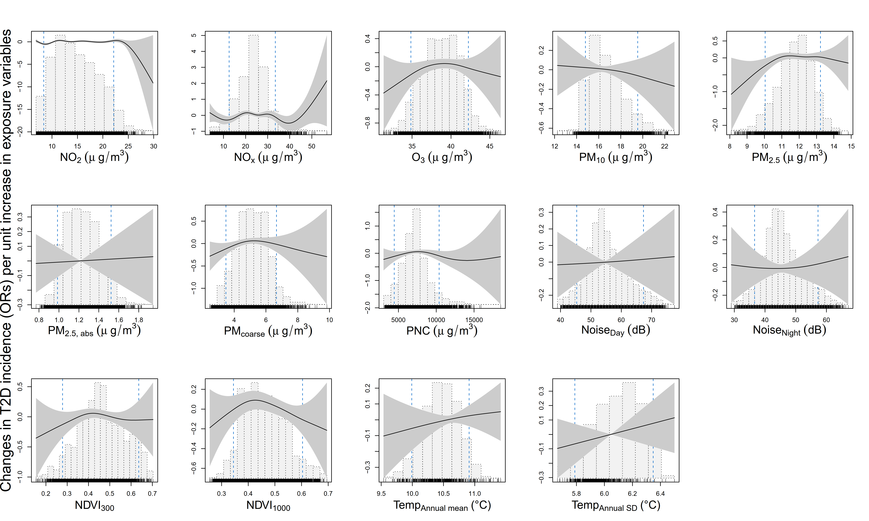
Figure S2. Thin plate regression splines (solid black line) with 95% confidence bands (dark shaded) based on main models (adjusted for age, sex, subcohort indicator, BMI, smoking status, alcohol consumption, education level, physical activity, and dietary score). Gray bars show the distribution of the exposure variables.
T2D: type 2 diabetes; OR: adds ratio; IQR: interquartile range; NO₂: nitrogen dioxide; NO_{x}: nitrogen oxide; O₃: ozone; PM₁₀: particulate matter with an aerodynamic diameter ≤10 μm; PM_{2.5}: particulate matter with an aerodynamic diameter ≤2.5 μm; PM_{2.5, abs:} PM_{2·5} absorbance; PM_{coarse}: particulate matter with an aerodynamic diameter of 2.5–10 μm; PNC: particle number concentration; Temp: temperature; SD: standard deviation; NDVI: normalized difference vegetation index.

xvdfdr
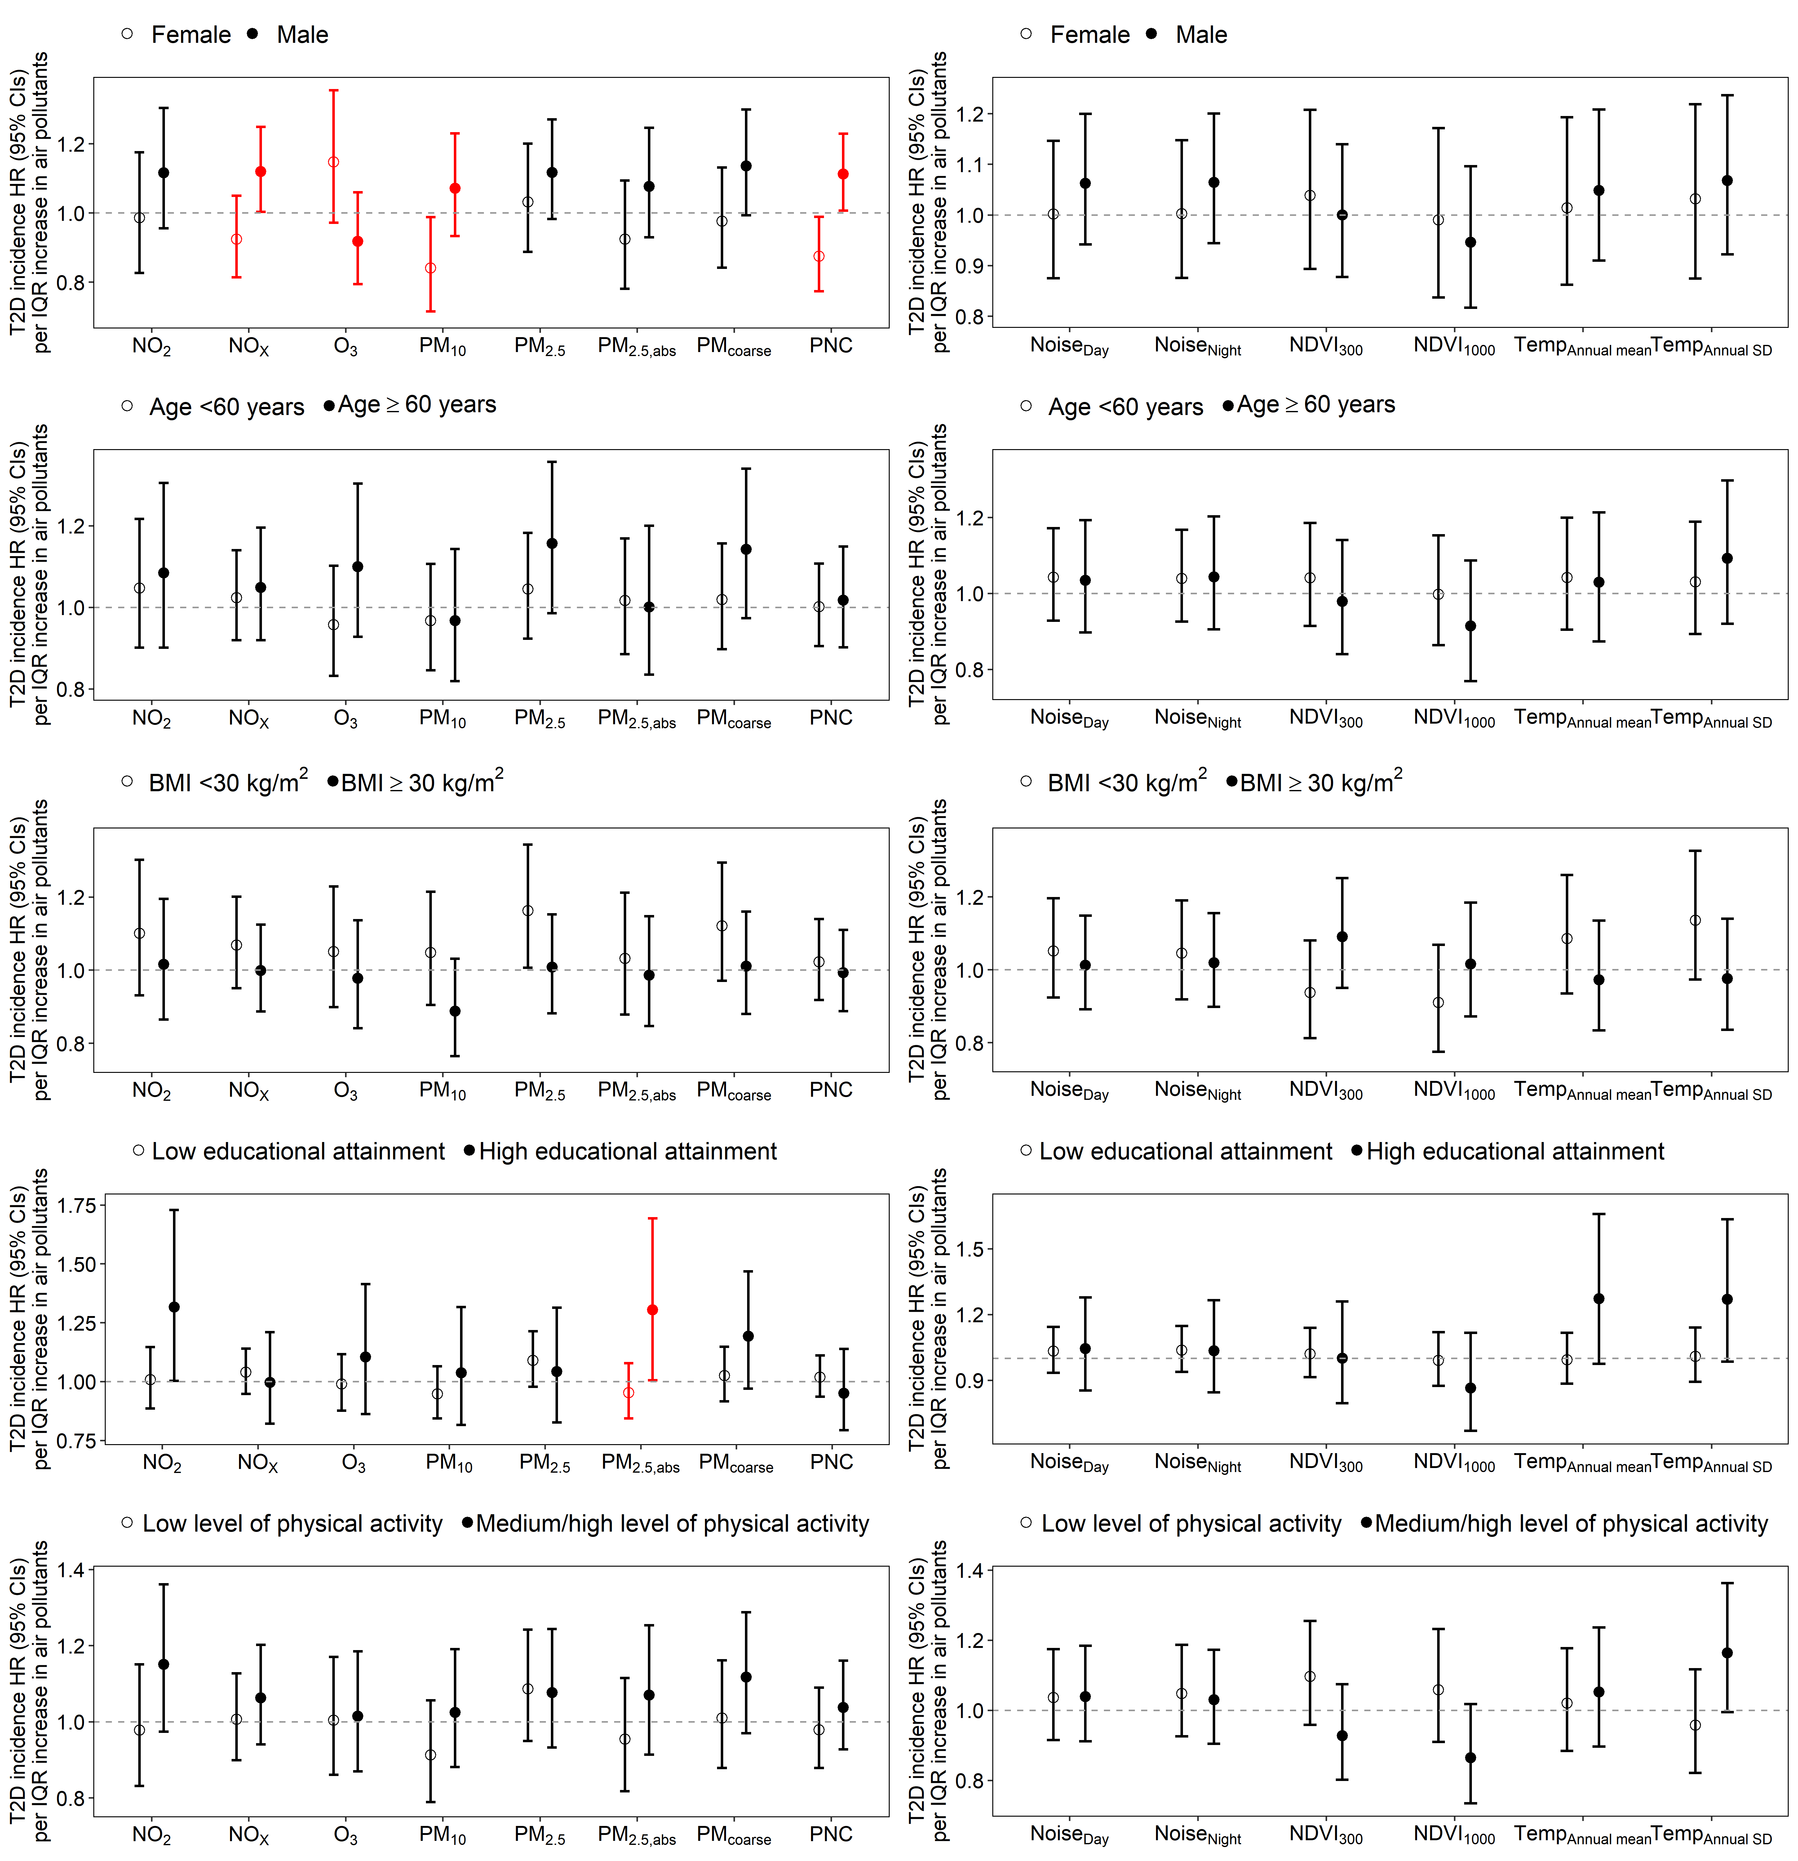
b)
a)
Figure S3. Effect modification: Hazard ratios (95% CIs) for the associations between air pollutants (a) and environmental exposures (b), with the risks of incident T2D by sex, age, obesity, educational attainment, and physical activity.
Panels show effect modification by sex (female: N=3,926, male: N=3,810), age (age < 60 years: N=5,654, age ≥ 60 years: N=2,082), obesity (30 < kg/m²: N=6,070, ≥ 30 kg/m²: N=1,666), educational status (high: N=6,617, low: N=1,119), and physical activity (inactive: N=4,886, active: N=2,850). Error bars in red indicate significant differences in effect estimates between subgroups (p_{interaction} < 0.05).
Models are adjusted for age, sex, subcohort indicator, BMI, smoking status, alcohol consumption, education level, physical activity, and healthy eating score.
T2D: type 2 diabetes; HR: hazard ratio; IQR: interquartile range; NO₂: nitrogen dioxide; NO_{x}: nitrogen oxide; O₃: ozone; PM₁₀: particulate matter with an aerodynamic diameter ≤10 μm; PM_{2.5}: particulate matter with an aerodynamic diameter ≤2.5 μm; PM_{2.5, abs:} PM_{2·5} absorbance; PM_{coarse}: particulate matter with an aerodynamic diameter of 2.5–10 μm; PNC: particle number concentration; Temp: temperature; SD: standard deviation; NDVI: normalized difference vegetation index.
HRs are expressed per IQR increase for each exposure variable. The IQRs were as follows: NO₂: 7.0 μg/m³, NO_{X}: 8.1 μg/m³, O₃: 3.6 μg/m³, PM₁₀: 2.2 μg/m³, PM_{2.5}: 1.3 μg/m³, PM_{2.5,abs}: 0.3 10⁻⁵/m, PM_{coarse}: 1.4 μg/m³, PNC: 1.9 10³/cm³, Noise_{Day}: 8.2 dB, Noise_{Night}: 7.9 dB, NDVI₃₀₀:0.12, NDVI₁₀₀₀: 0.14, Temp_{mean}: 0.6 °C, Temp_{SD}: 0.2 °C.
NDVI values below 0 were excluded since they represent water or bare rocks.

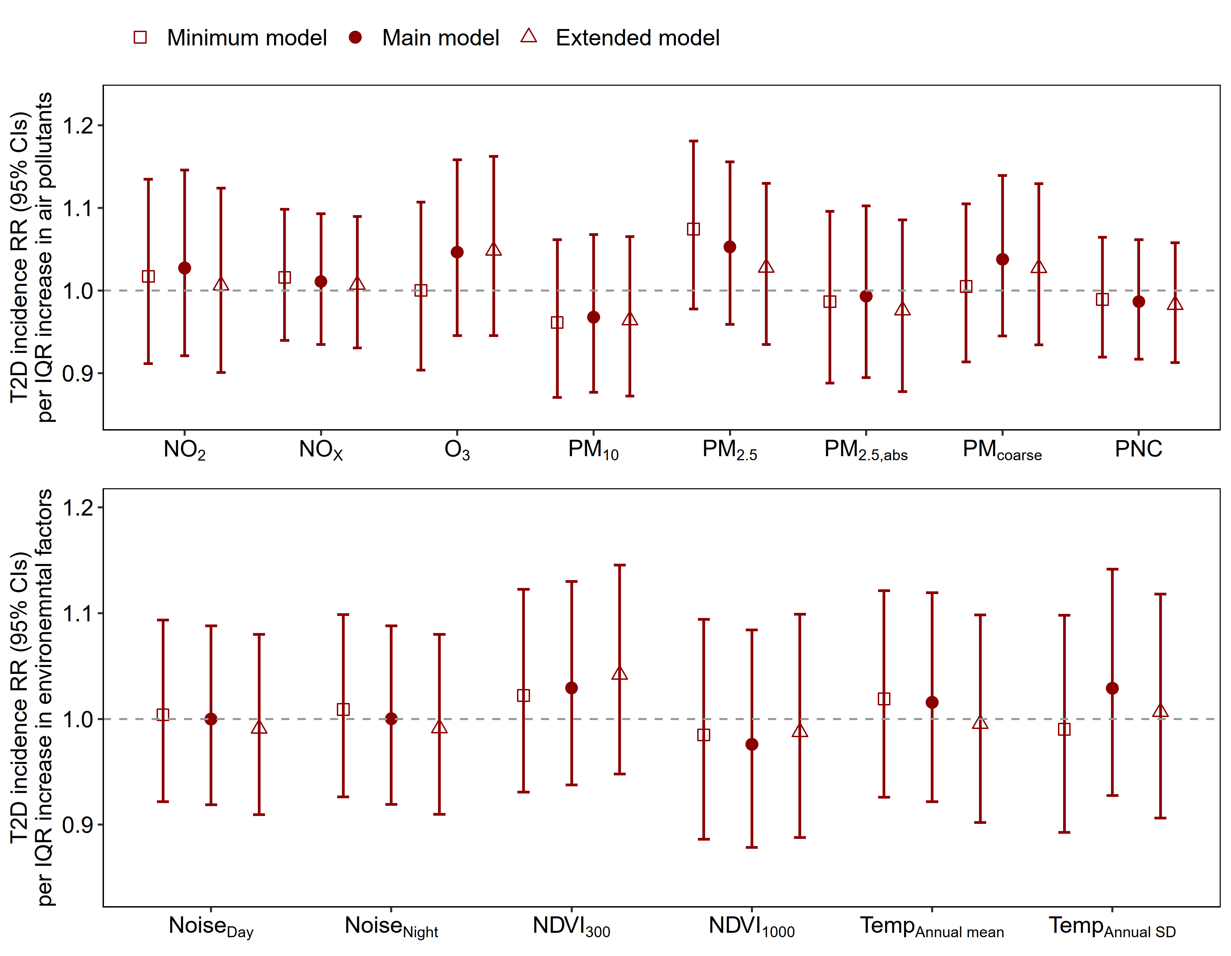
Figure S4. Poisson regression: Risk ratios and 95% CIs for the associations between environmental factors, and the risks of incident T2D. Minimum model included age and sex, and subcohort indicator. Main model was further adjusted for BMI, smoking status, alcohol consumption, education level, physical activity, and healthy eating score. Extended model additionally included cardiovascular diseases, waist-hip ratio, and cholesterol level.
T2D: type 2 diabetes; RR: risk ratio; IQR: interquartile range; NO₂: nitrogen dioxide; NO_{x}: nitrogen oxide; O₃: ozone; PM₁₀: particulate matter with an aerodynamic diameter ≤10 μm; PM_{2.5}: particulate matter with an aerodynamic diameter ≤2.5 μm; PM_{2.5, abs:} PM_{2·5} absorbance; PM_{coarse}: particulate matter with an aerodynamic diameter of 2.5–10 μm; PNC: particle number concentration; Temp: temperature; SD: standard deviation; NDVI: normalized difference vegetation index.
RRs are expressed per IQR increase for each exposure variable. The IQRs were as follows: NO₂: 7.0 μg/m³, NO_{X}: 8.1 μg/m³, O₃: 3.6 μg/m³, PM₁₀: 2.2 μg/m³, PM_{2.5}: 1.3 μg/m³, PM_{2.5,abs}: 0.3 10⁻⁵/m, PM_{coarse}: 1.4 μg/m³, PNC: 1.9 10³/cm³, Noise_{Day}: 8.2 dB, Noise_{Night}: 7.9 dB, NDVI₃₀₀:0.12, NDVI₁₀₀₀: 0.14, Temp_{annual} _{mean}: 0.6 °C, Temp_{annual} _{SD}: 0.2 °C.
NDVI values below 0 were excluded since they represent water or bare rocks.
Note: Minimum and main models were based on data for 7,768 participants. In extended models we excluded 142 participants with missing clinical information, resulting in 7,626 participants.

a)
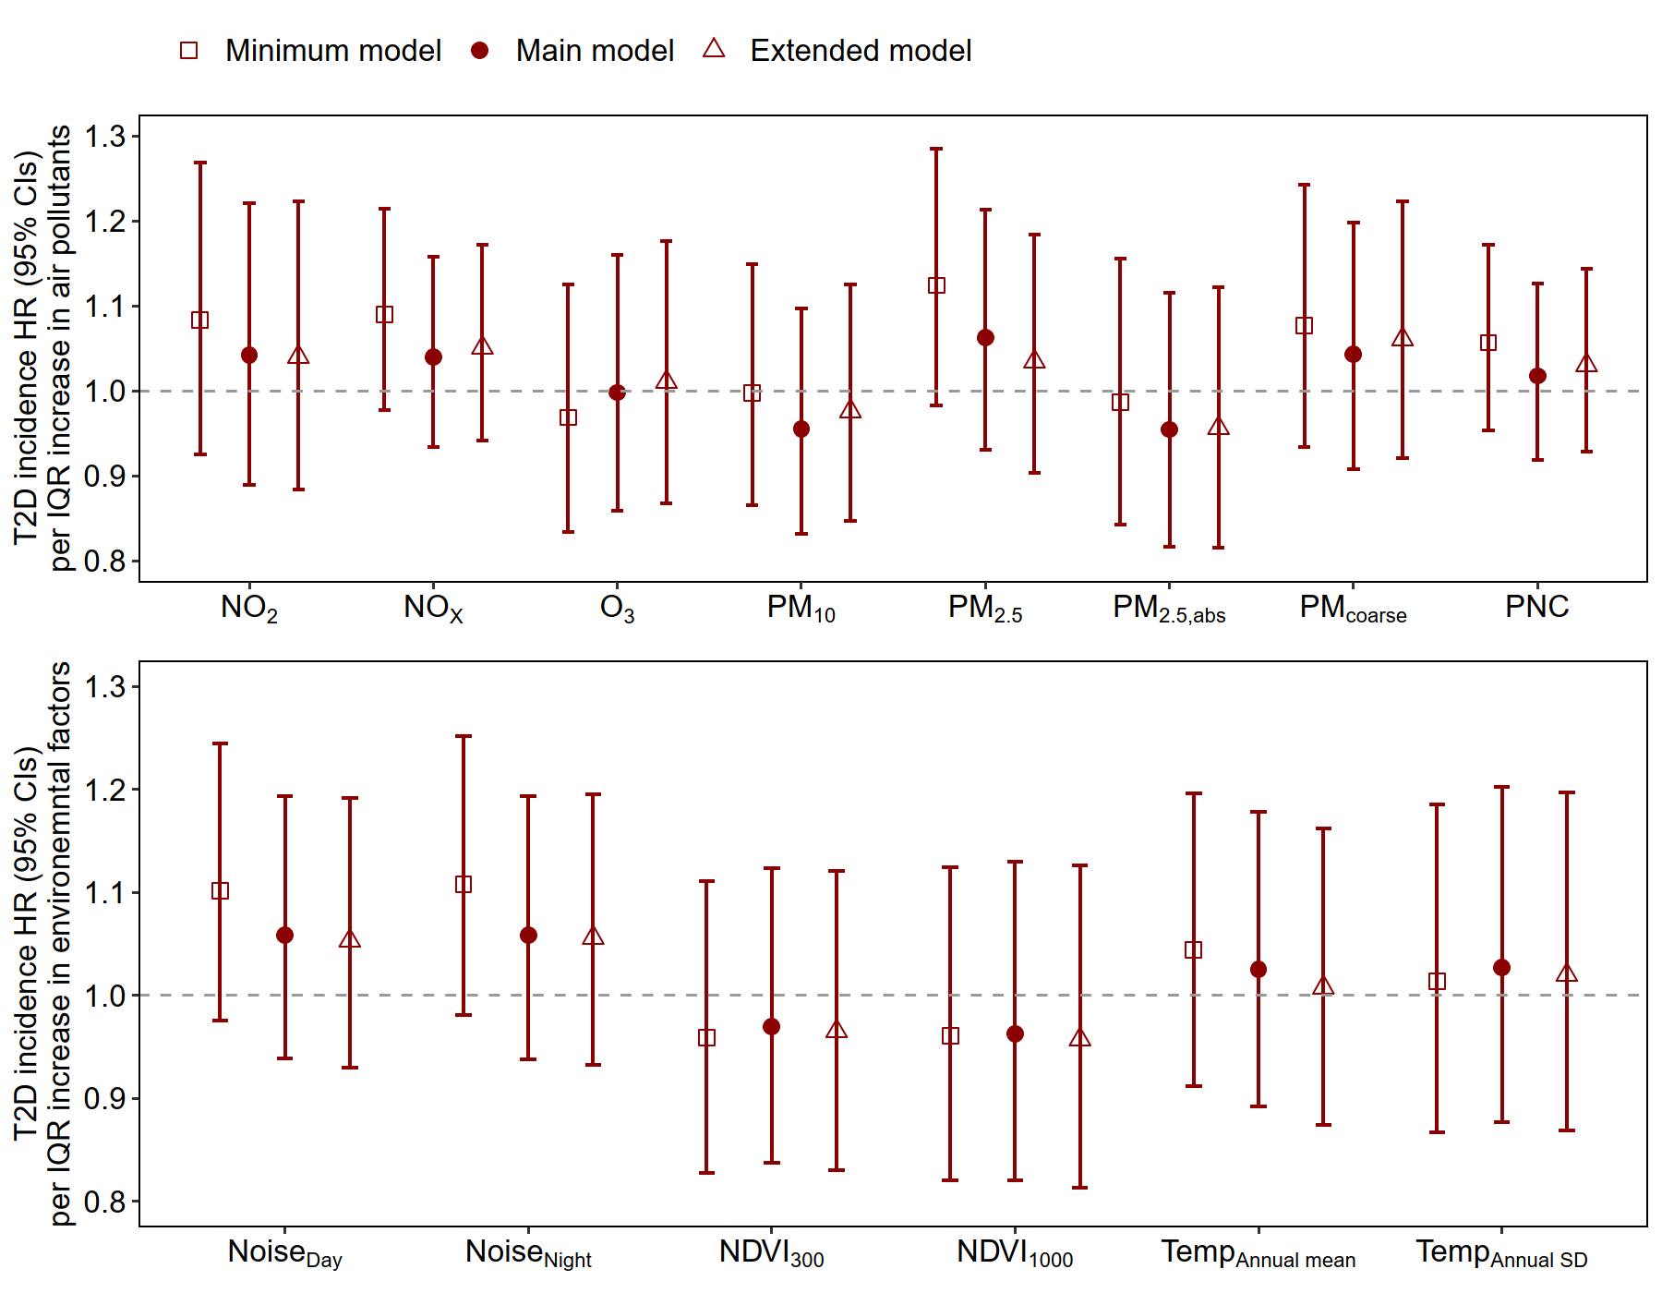
b)
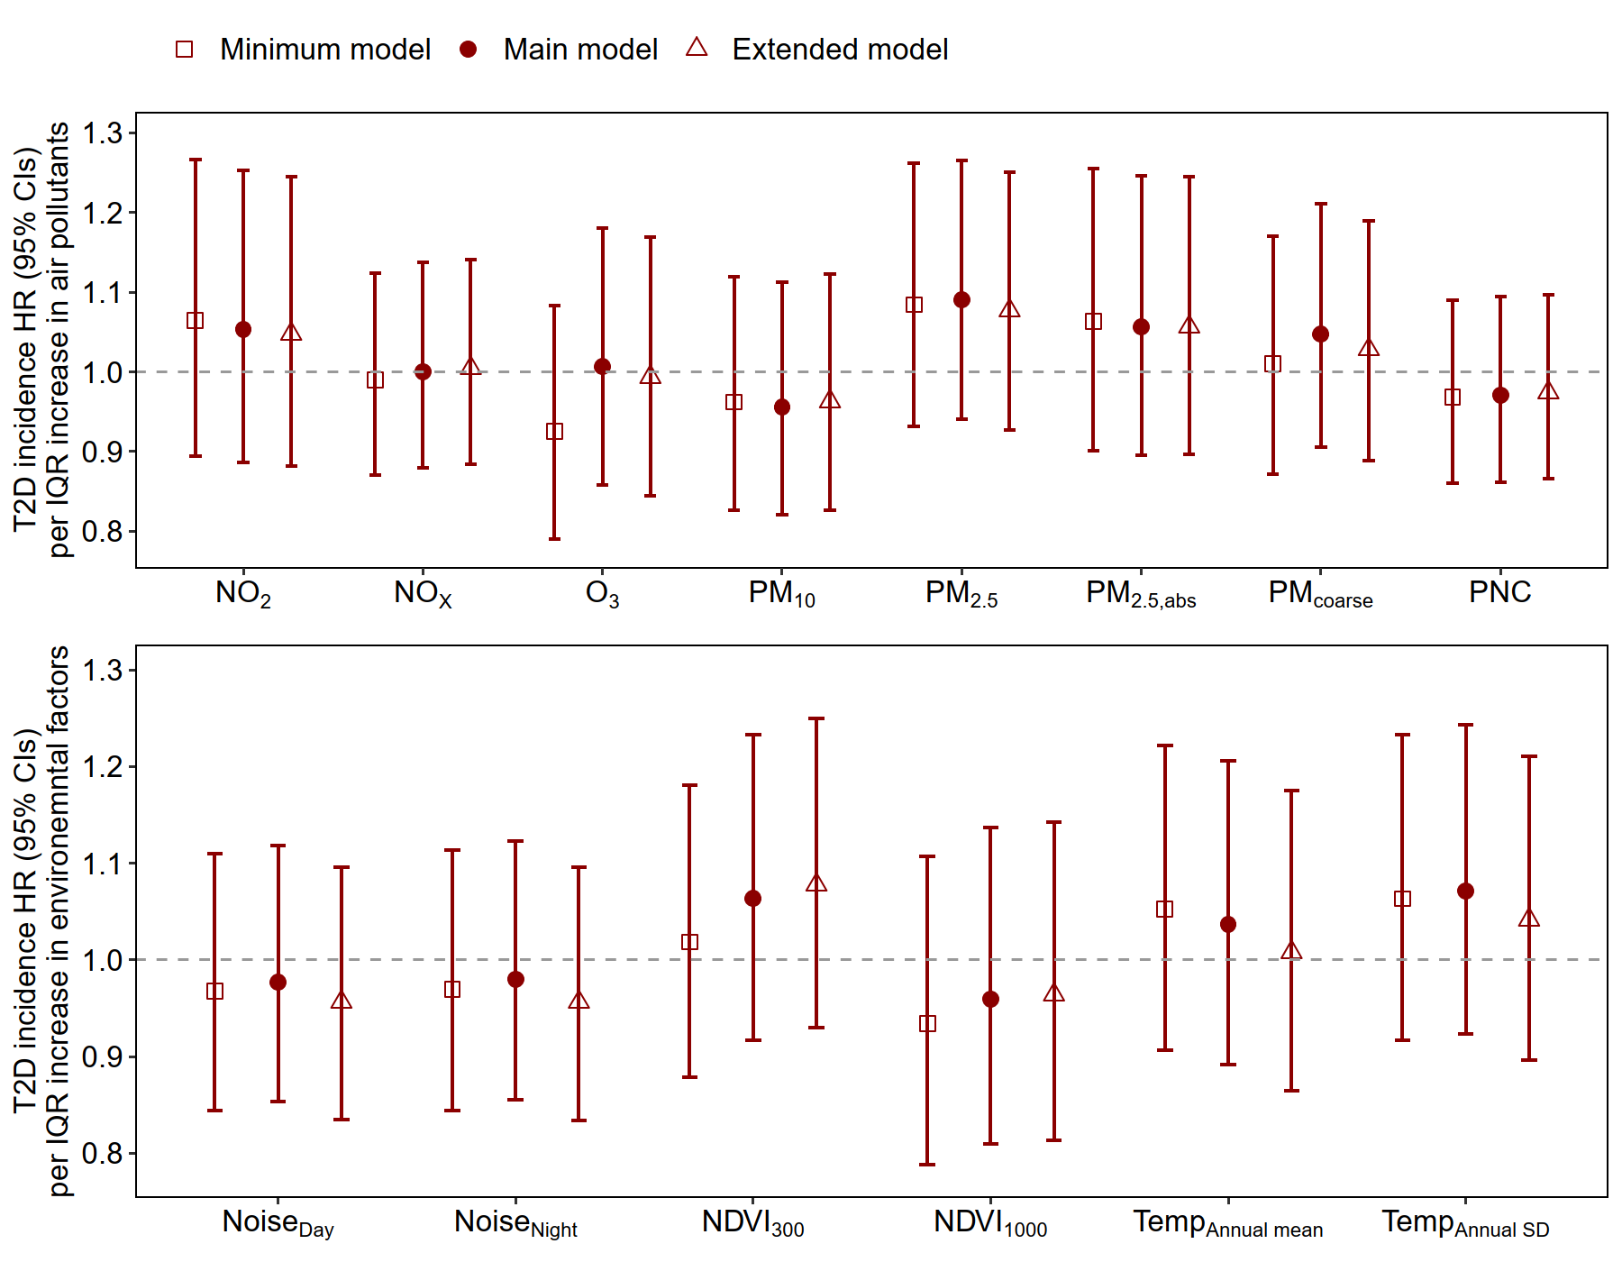
Figure S5. Stratified analysis: Hazard ratios and 95% CIs for the associations between environmental factors, and the risks of incident T2D, using KORA S3 (a) and KORA S4 (b) data. Minimum model included age and sex, and subcohort indicator. Main model was further adjusted for BMI, smoking status, alcohol consumption, education level, physical activity, and healthy eating score. Extended model additionally included cardiovascular diseases, waist-hip ratio, and cholesterol level.
T2D: type 2 diabetes; HR: hazard ratio; IQR: interquartile range; NO₂: nitrogen dioxide; NO_{x}: nitrogen oxide; O₃: ozone; PM₁₀: particulate matter with an aerodynamic diameter ≤10 μm; PM_{2.5}: particulate matter with an aerodynamic diameter ≤2.5 μm; PM_{2.5, abs:} PM_{2·5} absorbance; PM_{coarse}: particulate matter with an aerodynamic diameter of 2.5–10 μm; PNC: particle number concentration; Temp: temperature; SD: standard deviation; NDVI: normalized difference vegetation index.
HRs are expressed per IQR increase for each exposure variable. The IQRs in S3 dataset were as follows: NO₂: 6.9 μg/m³, NO_{X}: 7.6 μg/m³, O₃: 3.6 μg/m³, PM₁₀: 2.2 μg/m³, PM_{2.5}: 1.3 μg/m³, PM_{2.5,abs}: 0.3 10⁻⁵/m, PM_{coarse}: 1.5 μg/m³, PNC: 1.9 10³/cm³, Noise_{Day}: 8.2 dB, Noise_{Night}: 8.0 dB, NDVI₃₀₀:0.13, NDVI₁₀₀₀: 0.14, Temperature_{Annaul mean}: 0.5 °C, Temperature_{Annual SD}: 0.2 °C.
The IQRs in S4 dataset were as follows: NO₂: 7.2 μg/m³, NO_{X}: 8.5 μg/m³, O₃: 3.6 μg/m³, PM₁₀: 2.1 μg/m³, PM_{2.5}: 1.4 μg/m³, PM_{2.5,abs}: 0.3 10⁻⁵/m, PM_{coarse}: 1.4 μg/m³, PNC: 1.9 10³/cm³, Noise_{Day}: 8.1 dB, Noise_{Night}: 7.9 dB, NDVI₃₀₀:0.12, NDVI₁₀₀₀: 0.15, Temperature_{Annaul mean}: 0.6 °C, Temperature_{Annual SD}: 0.2 °C.
NDVI values below 0 were excluded since they represent water or bare rocks.
Note: Minimum and main models were based on data for 3,964participants in S3 and 3,772 in S4 For the extended models, we excluded 107 participants from the S3 dataset and 35 participants from the S4 dataset due to missing clinical information, resulting in 3,857 participants in S3 and 3,737 in S4.

References
1. Rathmann W, Haastert B, Icks A, et al. High prevalence of undiagnosed diabetes mellitus in Southern Germany: target populations for efficient screening. The KORA survey 2000. Diabetologia. 2003;46:182-189.

