Supplemental Table S1. Pooling of selected Texas counties into new observational units due to low birth counts during the period 2003-2017.
New observational unit | Included counties
1 | Hartley, Oldham
2 | Lipscomb, Roberts
3 | Armstrong, Briscoe, Donley
4 | Hall, Motley
5 | Baylor, Cottle, Foard, Hardeman
6 | Shackelford, Throckmorton
7 | Dickens, Haskell, King
8 | Fisher, Kent, Stonewall
9 | Borden, Martin
10 | Loving, Winkler
11 | Culberson, Jeff Davis
12 | Reagan, Upton
13 | Irion, Schleicher
14 | Coke, Glasscock, Sterling
15 | Terrell, Crockett
16 | Edwards, Real
17 | Concho, Menard
18 | La Salle, McMullen
19 | Brooks, Kenedy

Supplemental Figure S1. Directed acyclic graph illustrating the proposed causal relationship between drinking water source and birth defects prevalence. Minimum sufficient adjustment set for estimating the total effect of drinking water source on birth defects prevalence includes maternal age at delivery, educational attainment, county of residence, race, and ethnicity.

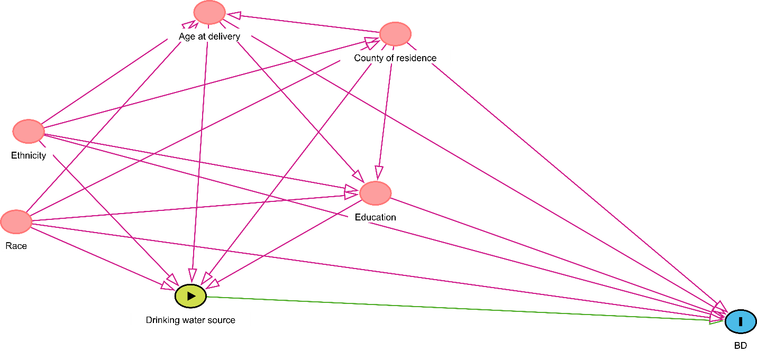
Supplemental Figure S2. Map of nineteen new observational units created by pooling Texas counties with <25 annual livebirths at any time during the period 2003-2017. New pooled observational units are shown in blue; counties that implemented direct potable reuse water treatment in 2013 are shown in gray.
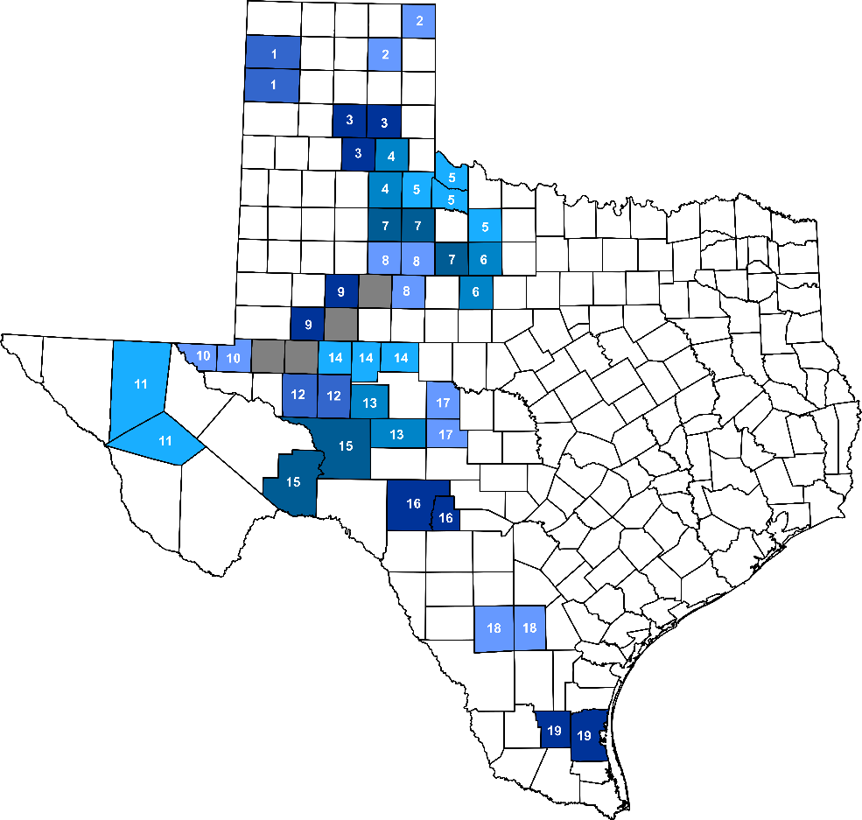

Supplemental Figure S3. Average treatment effect in the treated (ATT) estimates in the treated units (red) and 1,000 in-place placebo studies. Placebo studies, in which direct potable reuse implementation was assumed to have occurred in four randomly chosen counties, were performed in order to derive an empirical distribution of ATT estimates against which the estimated effect in the treated units could be compared.
