Supplemental Content
A randomized, double-blind, crossover intervention study of traffic-related air pollution (TRAP) and airway inflammation in healthy adults

Table of Content
Table S1: Monitoring equipment and parameters 2
Text S1: The powered air purifying respirator (PAPR) 3
Figure S1: Participant with PAPR 4
Table S2: FE_{NO} over time and intervention modes (ppb) 5
Figure S2: FE_{NO} levels for different intervention modes and measurement time points 6
Table S3: ΔFE_{NO} over time and intervention modes (ppb) 7
Table S4: Summary statistics for exposure variables during wearing different intervention modes 8
Figure S3: Mixed model results after controlling for roadside pollutant concentrations or meteorology 9
Figure S4: Variation of baseline FE_{NO} level across participants 10
Figure S5: Change (and 95% CIs) in ΔFE_{NO} from baseline by intervention mode relative to the sham mode for the mean of all post-exposure FE_{NO} measurements and for each time point before and after excluding baseline FE_{NO} outliers. 11

Table S1: Monitoring equipment and parameters
Instrument | Company | Type | Pollutants
DustTrak | TSI, USA | DustTrak 8520 | PM_{2.5}
Q-Trak | TSI, USA | TSI 8552 | Temp and RH
Aeroqual | Aeroqual. Inc, New Zealand | Series 500 | NO₂
Micro Aeth | Aethlabs, USA | AE51 | BC
In this study, we monitored the real time data of PM_{2.5}, NO₂, black carbon, temperature and relative humidity (RH). The monitoring instrument information is shown in Supplement Table S1.

Text S1: The powered air purifying respirator (PAPR)
The intervention used in this study is comprised of headtop (face mask), PAPR (OptimAir 3000, MSA, USA), filters (for particles and organic gas), connecting hoses, belts, NiMH battery and charger. The system can deliver 130L/min airflow and is typically used in occupational settings whenever long-term clean filtered air is needed.
The PAPR meets requirements of the EN12941 TH3 class. Maximum inward leakage is less than 0.2%. For particle filter, maximum particle filter penetration is less than 0.2%. Also, the gas filter in this study is effective against organic gases and vapors with a boiling point higher than 65ºC (volatile organic compounds), certain inorganic gases and vapors (Cl₂, H₂S, HCN, etc.), sulfur dioxide or other acidic gases and vapors, and ammonium or organic ammonium derivatives. The battery life is more than 8hr with the particle filter and more than 4hr with the combination filter (both particle and organic gas filter).

Figure S1: Participant with PAPR
Pictured in Fig. S1 is a participant wearing a PAPR.

Table S2: FE_{NO} over time and intervention modes (ppb)
Baseline (p=0.22)
 | Sham |  | PM |  | PMG |  | N95
25th | 9.0 |  | 12.0 |  | 12.0 |  | 11.0
50th | 13.0 |  | 14.0 |  | 15.0 |  | 14.0
Mean | 13.2 |  | 13.8 |  | 15.6 |  | 15.1
75th | 15.3 |  | 16.0 |  | 18.0 |  | 18.0
After exposure (p=0.78)
 | Sham |  | PM |  | PMG |  | N95
25th | 8.8 |  | 10.0 |  | 9.8 |  | 10.8
50th | 12.0 |  | 13.0 |  | 13.0 |  | 13.5
Mean | 12.9 |  | 13.3 |  | 13.5 |  | 14.2
75th | 15.0 |  | 16.0 |  | 16.0 |  | 17.5
1 hr after exposure (p=0.68)
 | Sham |  | PM |  | PMG |  | N95
25th | 11.0 |  | 11.0 |  | 11.8 |  | 12.0
50th | 14.0 |  | 14.0 |  | 13.0 |  | 14.5
Mean | 15.3 |  | 15.7 |  | 14.9 |  | 16.6
75th | 18.3 |  | 20.0 |  | 17.0 |  | 22.3
2 hr after exposure (p=0.89)
 | Sham |  | PM |  | PMG |  | N95
25th | 11.5 |  | 12.0 |  | 11.0 |  | 12.0
50th | 15.0 |  | 15.0 |  | 14.0 |  | 15.0
Mean | 16.1 |  | 15.2 |  | 15.4 |  | 16.2
75th | 19.0 |  | 18.0 |  | 19.3 |  | 18.8
4 hr after exposure (p=0.80)
 | Sham |  | PM |  | PMG |  | N95
25th | 12.8 |  | 15.0 |  | 12.0 |  | 13.5
50th | 15.5 |  | 18.0 |  | 16.0 |  | 16.0
Mean | 17.2 |  | 18.2 |  | 16.6 |  | 18.0
75th | 21.3 |  | 20.0 |  | 22.0 |  | 24.0
6 hr after exposure (p=0.96)
 | Sham |  | PM |  | PMG |  | N95
25th | 13.0 |  | 12.0 |  | 11.8 |  | 12.0
50th | 15.0 |  | 16.0 |  | 15.5 |  | 16.0
Mean | 16.4 |  | 16.7 |  | 15.9 |  | 16.5
75th | 20.0 |  | 21.0 |  | 18.3 |  | 21.0

Figure S2: FE_{NO} levels for different intervention modes and measurement time points
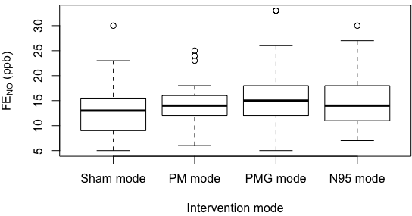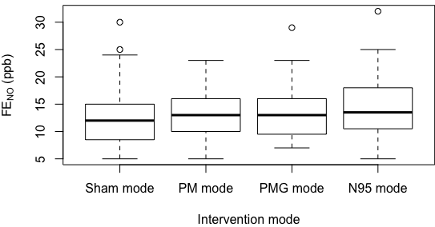
FE_{NO} (ppb)
FE_{NO} (ppb)
(a) FE_{NO} level before exposure (baseline) (b) FE_{NO} level immediately post exposure
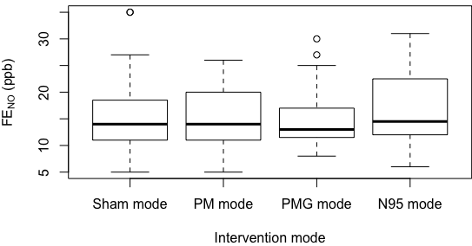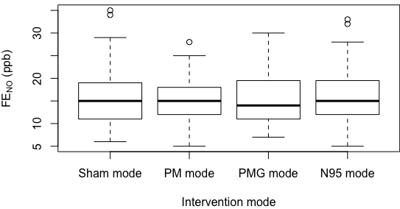
FE_{NO} (ppb)
FE_{NO} (ppb)
(c) FE_{NO} level 1 hr post exposure (d) FE_{NO} level 2 hr post exposure
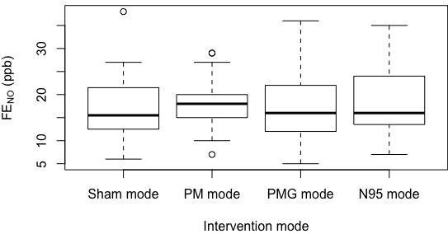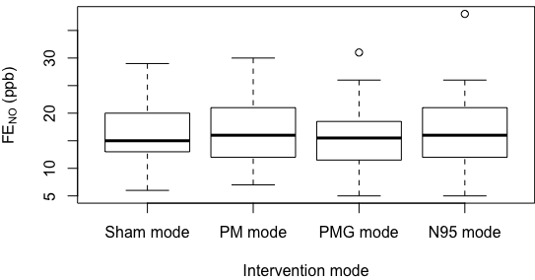
FE_{NO} (ppb)
FE_{NO} (ppb)
(e) FE_{NO} level 4 hr post exposure (f) FE_{NO} level 6 hr post exposure

Table S3: ΔFE_{NO} over time and intervention modes (ppb)
ΔFE_{NO} mean post exposure (p=0.03)*
 | Sham |  | PM |  | PMG |  | N95
25th | -0.3 |  | 0.6 |  | -1.8 |  | -1.5
50th | 2.3 |  | 1.8 |  | 1.0 |  | 1.7
Mean | 2.3 |  | 2.0 |  | -0.2 |  | 1.2
75th | 4.2 |  | 3.6 |  | 2.5 |  | 3.3
ΔFE_{NO} immediately post exposure (p=0.26)
 | Sham |  | PM |  | PMG |  | N95
25th | -2.0 |  | -2.0 |  | -4.0 |  | -3.3
50th | -0.5 |  | -1.0 |  | -2.0 |  | -1.0
Mean | -0.3 |  | -0.5 |  | -2.0 |  | -0.9
75th | 2.0 |  | 2.0 |  | 0.0 |  | 2.0
ΔFE_{NO} 1-hr post exposure (p=0.03)
 | Sham |  | PM |  | PMG |  | N95
25th | 0.0 |  | 0.0 |  | -3.0 |  | -2.0
50th | 2.0 |  | 1.0 |  | 1.0 |  | 1.5
Mean | 2.1 |  | 1.9 |  | -0.7 |  | 1.5
75th | 4.0 |  | 4.0 |  | 2.0 |  | 3.0
ΔFE_{NO} 2-hr post exposure (p=0.06)
 | Sham |  | PM |  | PMG |  | N95
25th | 0.0 |  | -1.0 |  | -2.0 |  | -1.0
50th | 2.0 |  | 2.0 |  | -1.0 |  | 1.0
Mean | 2.9 |  | 1.3 |  | -0.1 |  | 1.1
75th | 6.0 |  | 4.0 |  | 2.0 |  | 3.0
ΔFE_{NO} 4-hr post exposure (p=0.06)
 | Sham |  | PM |  | PMG |  | N95
25th | 0.8 |  | 2.0 |  | -2.0 |  | -1.0
50th | 3.5 |  | 4.0 |  | 1.0 |  | 3.0
Mean | 4.0 |  | 4.4 |  | 1.3 |  | 3.1
75th | 7.3 |  | 7.0 |  | 4.0 |  | 6.5
ΔFE_{NO} 6-hr post exposure (p=0.23)
 | Sham |  | PM |  | PMG |  | N95
25th | 0.3 |  | 0.0 |  | -2.0 |  | -2.0
50th | 3.0 |  | 2.0 |  | 0.0 |  | 1.5
Mean | 3.1 |  | 2.9 |  | 0.6 |  | 1.4
75th | 6.0 |  | 5.0 |  | 5.0 |  | 4.0
* figures in bold showed significant at the level of 0.05

Table S4: Summary statistics for exposure variables during wearing different intervention modes
NO₂ (μg/m³) (p=0.12)
 | Sham |  | PM |  | PMG |  | N95
25th | 66.0 |  | 66.0 |  | 66.1 |  | 68.0
50th | 71.5 |  | 70.5 |  | 73.0 |  | 74.0
Mean | 73.7 |  | 70.0 |  | 75.7 |  | 76.4
75th | 80.0 |  | 79.0 |  | 87.9 |  | 81.5
PM_{2.5} (μg/m³) (p=0.11)
 | Sham |  | PM |  | PMG |  | N95
25th | 79.8 |  | 78.0 |  | 62.3 |  | 52.3
50th | 165.0 |  | 191.0 |  | 122.5 |  | 81.0
Mean | 169.2 |  | 182.3 |  | 177.1 |  | 119.0
75th | 215.8 |  | 257.0 |  | 256.2 |  | 163.5
BC (μg/m³) (p=0.53)
 | Sham |  | PM |  | PMG |  | N95
25th | 5.6 |  | 5.2 |  | 4.0 |  | 4.6
50th | 7.2 |  | 10.1 |  | 6.3 |  | 6.2
Mean | 9.1 |  | 8.8 |  | 7.7 |  | 7.6
75th | 13.0 |  | 13.4 |  | 11.2 |  | 10.6
Relative humidity (%) (p=0.07)
 | Sham |  | PM |  | PMG |  | N95
25th | 29.6 |  | 38.9 |  | 31.4 |  | 25.5
50th | 40.5 |  | 48.5 |  | 48.1 |  | 33.1
Mean | 43.2 |  | 51.5 |  | 48.0 |  | 40.4
75th | 58.4 |  | 66.5 |  | 64.1 |  | 58.6
Temperature (ºC) (p=0.38)
 | Sham |  | PM |  | PMG |  | N95
25th | -0.9 |  | -0.5 |  | -0.5 |  | -2.0
50th | 1.5 |  | 0.5 |  | 0.30 |  | 0.7
Mean | 3.7 |  | 2.2 |  | 1.9 |  | 3.4
75th | 9.6 |  | 6.3 |  | 4.6 |  | 9.2

Figure S3: Mixed model results after controlling for roadside pollutant concentrations or meteorology
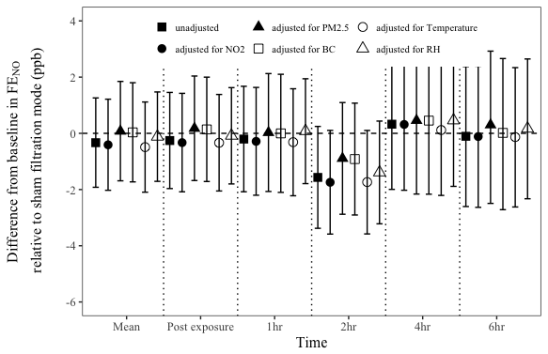
Difference from baseline in FE_{NO} (ppb)
relative to sham filtration mode

(a) PM mode vs. Sham mode
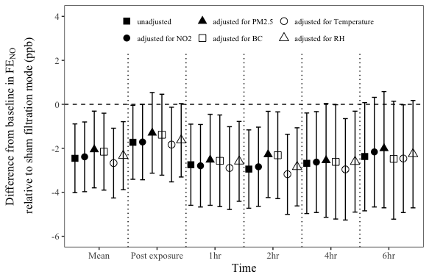
Difference from baseline in FE_{NO} (ppb)
relative to sham filtration mode

(b) PMG mode vs. Sham mode
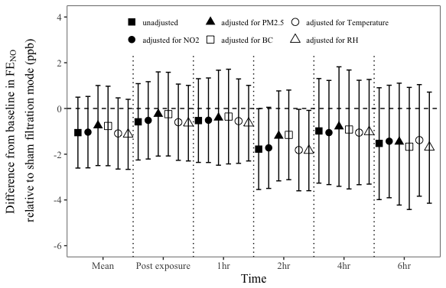
Difference from baseline in FE_{NO} (ppb)
relative to sham filtration mode

(c) N95 mode vs. Sham mode
Change (and 95% CIs) in ΔFE_{NO} from baseline by intervention mode relative to the sham mode for the mean of all post-exposure FE_{NO} measurements and for each time point with or without adjustment for air pollutants and meteorology.

Figure S4: Variation of baseline FE_{NO} level across participants
General speaking, the baseline FE_{NO} level should be in a narrow variation range for every participant. So we characterized the trend of each participant in FE_{NO} baseline level over four intervention modes in Figure S4; participant #3, #6, #31 and #34 experienced very high FE_{NO} levels in a some mode. We retained these higher values in our primary model, but excluded them in a sensitivity analysis.

Figure S5: Change (and 95% CIs) in ΔFE_{NO} from baseline by intervention mode relative to the sham mode for the mean of all post-exposure FE_{NO} measurements and for each time point before and after excluding baseline FE_{NO} outliers.
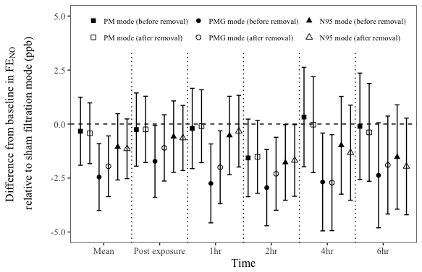
Difference from baseline in FE_{NO} (ppb)
relative to sham filtration mode

