**Supplemental Material**

**Comparison of temperature-mortality associations estimated using different exposure metrics**

Kate R. Weinberger, Keith R. Spangler, Antonella Zanobetti, Joel D. Schwartz, Gregory A. Wellenius

**Table of Contents**

**Table S1:** Characteristics of the 113 study counties, 1987-2006, including the name of the weather station, the median and range of daily temperature values as measured at the weather station and as estimated using PRISM, the correlation between daily temperature values from the weather station and from PRISM, and the total number of deaths.

**Figure S1:** Exposure-response curves for the association between temperature and mortality estimated using station versus PRISM temperatures in each of 113 counties.

**Figure S2:** Distribution of the differences between the log(RR) for the 21-day cumulative association between temperature and mortality as estimated using PRISM versus station temperature in each of 113 counties. In each county, days with missing values in the station temperature time series were assigned missing values in the corresponding PRISM temperature time series. Comparisons in each county are made at a constant value of temperature.

**Figure S3:** Scatterplot of relative risks (RR) for the 21-day cumulative association between daily mean temperature and mortality modeled using temperature observations from weather stations (x-axis) versus population-weighted temperature estimates from PRISM (y-axis) in each of 113 study counties. Comparisons in each county are made at a constant percentile of temperature.

**Figure S4:** Distribution of the difference between the log(RR) for the 21-day cumulative association between temperature and mortality as estimated using PRISM versus station temperature in each of 113 counties. Comparisons in each county are made at constant percentiles of temperature.

**Table S1:** Characteristics of the 113 study counties, 1987-2006, including the name of the weather station, the median and range of daily temperature values as measured at the weather station and as estimated using PRISM, the correlation between daily temperature values from the weather station and from PRISM, and the total number of deaths.

|  |  |  |  |  |  |  |
| --- | --- | --- | --- | --- | --- | --- |
| **County** | **State** | **Weather station name** | **Median (range) temperature, station**  **[°C]** | **Median (range) temperature, PRISM**  **[°C]** | **Pearson correlation coefficient a** | **Deaths**  **[n]** |
| Jefferson | AL | Birmingham International Airport | 18.3 (-13.1, 32.4) | 17.8 (-13.3, 31.1) | 0.989 | 131193 |
| Madison | AL | Huntsville International/C.T. Jones Field Airport | 17.2 (-16.2, 31.4) | 16.2 (-16.3, 30.2) | 0.990 | 35001 |
| Mobile | AL | Mobile Regional Airport | 20.5 (-9.2, 31.6) | 20.3 (-9.2, 32.5) | 0.986 | 66920 |
| Montgomery | AL | Montgomery Rgnl (Dannelly Fd) Airport | 19.4 (-10.1, 31.3) | 19.3 (-9.2, 31.6) | 0.987 | 36904 |
| Maricopa | AZ | Phoenix Sky Harbor International Airport | 24.2 (2.8, 41.5) | 22.6 (1.6, 38.9) | 0.993 | 362167 |
| Pima | AZ | Tucson International Airport | 21.6 (-1.3, 38.0) | 20.8 (-0.8, 36.8) | 0.988 | 122171 |
| Fresno | CA | Fresno Yosemite International Airport | 17.6 (-3.0, 37.9) | 17.4 (-2.8, 35.9) | 0.997 | 96300 |
| Kern | CA | Meadows Field Airport | 18.0 (-2.8, 36.6) | 17.5 (-3.0, 35.0) | 0.994 | 82411 |
| Los Angeles | CA | Los Angeles International Airport | 17.1 (5.7, 29.8) | 18.3 (4.6, 32.9) | 0.946 | 1125678 |
| San Diego | CA | San Diego International Airport | 17.3 (7.2, 28.9) | 17.5 (5.4, 31.7) | 0.967 | 341963 |
| San Mateo | CA | San Francisco International Airport | 14.1 (0.0, 28.4) | 14.6 (0.0, 30.2) | 0.965 | 90851 |
| El Paso | CO | City of Colorado Springs Municipal Airport | 9.9 (-26.4, 28.3) | 9.3 (-22.9, 26.6) | 0.983 | 48003 |
| Hartford | CT | Bradley International Airport | 10.7 (-18.1, 31.3) | 10.2 (-19.7, 31.6) | 0.989 | 145539 |
| New Castle | DE | Wilmington New Castle | 12.9 (-18.0, 32.0) | 12.8 (-15.6, 31.1) | 0.987 | 70134 |
| Alachua | FL | Gainesville Regional | 21.4 (-4.9, 30.7) | 21.8 (-6.0, 31.7) | 0.976 | 25610 |
| Duval | FL | Jacksonville International Airport | 21.2 (-2.8, 31.1) | 21.9 (-4.8, 32.6) | 0.976 | 114174 |
| Hillsborough | FL | Tampa International Airport | 23.7 (-0.6, 31.2) | 23.6 (-0.7, 30.7) | 0.979 | 146585 |
| Leon | FL | Tallahassee Regional Airport | 20.8 (-5.0, 32.2) | 20.8 (-6.4, 31.3) | 0.975 | 24196 |
| Orange | FL | Orlando International Airport | 23.2 (-1.9, 31.5) | 23.5 (-1.2, 31.7) | 0.979 | 103731 |
| Palm Beach | FL | Palm Beach International Airport | 24.9 (1.0, 30.5) | 24.7 (3.8, 30.6) | 0.972 | 218076 |
| Volusia | FL | Dayton Beach International | 22.6 (-2.4, 30.8) | 22.7 (-1.8, 31.3) | 0.972 | 99689 |
| Bibb | GA | Middle Georgia Regional Airport | 18.7 (-6.1, 31.3) | 18.5 (-7.2, 31.8) | 0.983 | 30202 |
| Chatham | GA | Savannah/Hilton Head International Airport | 19.9 (-7.2, 32.0) | 20.2 (-5.0, 32.7) | 0.977 | 39467 |
| Clayton | GA | Hartsfield-Jackson Atlanta International Airport | 17.9 (-10.8, 32.1) | 17.1 (-10.3, 30.9) | 0.988 | 20983 |
| Muscogee | GA | Columbus Metro Airport | 19.4 (-7.5, 32.8) | 19.0 (-8.5, 32.3) | 0.985 | 31465 |
| Richmond | GA | Augusta Regional at Bush Field Airport | 18.2 (-6.0, 32.5) | 18.3 (-6.6, 32.6) | 0.978 | 34063 |
| Polk | IA | Des Moines International Airport | 11.3 (-26.9, 32.4) | 10.6 (-29.7, 31.9) | 0.994 | 49908 |
| Cook | IL | Chicago O'Hare International Airport | 10.7 (-26.6, 32.9) | 10.9 (-26.5, 33.7) | 0.993 | 854591 |
| Peoria | IL | Greater Peoria Regional Airport | 12.1 (-25.9, 32.3) | 11.5 (-26.1, 31.7) | 0.993 | 32892 |
| Rock Island | IL | Quad City International Airport | 11.5 (-27.9, 32.3) | 11.0 (-28.2, 31.7) | 0.993 | 27193 |
| Sangamon | IL | Abraham Lincoln Capital Airport | 12.8 (-24.0, 32.5) | 12.5 (-25.3, 31.1) | 0.992 | 32599 |
| Allen | IN | Fort Wayne International Airport | 11.0 (-24.6, 32.2) | 10.7 (-26.2, 31.2) | 0.989 | 46508 |
| Marion | IN | Indianapolis International Airport | 12.8 (-25.5, 32.3) | 12.2 (-27.8, 31.4) | 0.991 | 136632 |
| St. Joseph | IN | South Bend Regional Airport | 10.6 (-25.2, 31.8) | 10.2 (-26.5, 31.9) | 0.991 | 44317 |
| Vanderburgh | IN | Evansville Regional Airport | 14.6 (-23.2, 32.3) | 14.3 (-22.6, 31.3) | 0.991 | 34235 |
| Sedgwick | KS | Wichita Eisenhower National | 14.5 (-22.2, 34.3) | 14.2 (-23.1, 33.6) | 0.992 | 63095 |
| Shawnee | KS | Philip Billard Municipal Airport | 13.6 (-26.1, 34.2) | 13.3 (-25.5, 33.6) | 0.992 | 29366 |
| Fayette | KY | Blue Grass Airport | 14.1 (-23.4, 31.6) | 13.9 (-23.2, 30.9) | 0.988 | 33833 |
| Jefferson | KY | Louisville International-Standiford Field Airport | 15.2 (-21.6, 33.8) | 14.5 (-24.2, 32.5) | 0.989 | 127367 |
| Caddo | LA | Shreveport Regional Airport | 19.7 (-10.7, 33.9) | 19.3 (-11.5, 33.3) | 0.990 | 47106 |
| Calcasieu | LA | Lake Charles Regional Airport | 21.2 (-7.4, 32.1) | 21.2 (-8.5, 32.8) | 0.984 | 29031 |
| East Baton Rouge | LA | Baton Rouge Metropolitan Airport | 21.0 (-9.0, 31.5) | 20.8 (-10.1, 31.7) | 0.985 | 55759 |
| Jefferson | LA | Louis Armstrong New Orleans International Airport | 21.9 (-7.7, 31.3) | 22.1 (-8.5, 32.5) | 0.987 | 70395 |
| Suffolk | MA | Logan International Airpot | 10.7 (-16.9, 31.7) | 10.6 (-18.1, 31.3) | 0.984 | 107616 |
| Anne Arundel | MD | Baltimore-Washington International Airport | 13.6 (-17.5, 32.7) | 13.6 (-15.3, 31.8) | 0.987 | 58567 |
| Cumberland | ME | Portland International Jetport | 8.3 (-20.8, 29.3) | 7.9 (-22.4, 28.5) | 0.987 | 42150 |
| Genesee | MI | Bishop International Airport | 9.4 (-23.9, 30.4) | 8.9 (-24.0, 30.0) | 0.989 | 69320 |
| Kent | MI | Gerald R. Ford International Airport | 9.5 (-23.0, 31.5) | 8.8 (-23.7, 30.0) | 0.991 | 72262 |
| Muskegon | MI | Muskegon County Airport | 9.2 (-20.6, 29.8) | 8.9 (-21.8, 29.9) | 0.988 | 28304 |
| Wayne | MI | Detroit Metro Wayne County Airport | 10.6 (-24.0, 31.0) | 10.3 (-23.2, 31.7) | 0.989 | 379383 |
| Hennepin | MN | Minneapolis-St Paul International Airport | 9.0 (-31.1, 33.4) | 8.6 (-32.4, 32.3) | 0.990 | 145774 |
| Olmsted | MN | Rochester International Airport | 8.1 (-31.1, 30.6) | 7.9 (-32.9, 31.5) | 0.993 | 13338 |
| St. Louis | MN | Duluth International Airport | 5.1 (-33.0, 28.2) | 4.9 (-34.4, 28.5) | 0.989 | 40692 |
| Greene | MO | Springfield-Branson Regional Airport | 14.5 (-22.5, 32.2) | 13.9 (-22.1, 31.2) | 0.992 | 40010 |
| St. Louis | MO | Lambert-St Louis International Airport | 15.0 (-23.0, 33.7) | 14.4 (-23.3, 32.6) | 0.994 | 172356 |
| Buncombe | NC | Asheville Regional Airport | 13.8 (-14.3, 27.1) | 13.3 (-16.0, 26.7) | 0.983 | 37929 |
| Guilford | NC | Piedmont Triad International Airport | 15.4 (-13.1, 30.9) | 15.3 (-12.7, 30.6) | 0.990 | 60781 |
| Mecklenburg | NC | Charlotte/Douglas International Airport | 16.9 (-9.8, 32.0) | 16.3 (-9.9, 30.4) | 0.988 | 76352 |
| Wake | NC | Raleigh-Durham International Airport | 16.3 (-12.8, 31.7) | 16.0 (-12.3, 31.4) | 0.988 | 54584 |
| Cass | ND | Jector International Airport | 6.9 (-32.6, 33.5) | 6.6 (-35.1, 32.9) | 0.993 | 13155 |
| Douglas | NE | Eppley Airfield | 11.6 (-27.1, 33.1) | 11.3 (-27.8, 32.3) | 0.993 | 65214 |
| Rockingham | NH | Concord Municipal Airport | 8.5 (-22.4, 29.6) | 8.9 (-20.1, 29.8) | 0.988 | 28138 |
| Atlantic | NJ | Atlantic City International Airport | 12.4 (-16.8, 32.0) | 12.5 (-16.3, 31.3) | 0.985 | 45195 |
| Union | NJ | Newark Liberty International Airport | 13.2 (-16.4, 34.2) | 12.3 (-16.4, 32.2) | 0.988 | 88130 |
| Bernalillo | NM | Albuquerque International Sunport Airport | 14.6 (-13.7, 32.7) | 13.3 (-16.0, 29.6) | 0.989 | 67913 |
| Washoe | NV | Reno/Tahoe International Airport | 11.3 (-19.1, 31.0) | 10.8 (-18.3, 30.4) | 0.987 | 42410 |
| Erie | NY | Buffalo Niagara International Airport | 9.6 (-20.3, 29.0) | 9.1 (-21.3, 29.2) | 0.990 | 192328 |
| Monroe | NY | Greater Rochester International Airport | 9.5 (-20.8, 30.2) | 9.5 (-21.0, 30.3) | 0.990 | 115891 |
| Onondaga | NY | Syracuse Hancock International Airport | 9.6 (-22.1, 30.3) | 9.2 (-23.1, 30.3) | 0.988 | 76718 |
| Queens | NY | LaGuardia Airport | 13.1 (-16.2, 34.1) | 12.6 (-15.8, 32.6) | 0.990 | 325198 |
| Cuyahoga | OH | Cleveland-Hopkins International Airport | 11.2 (-23.6, 31.9) | 10.9 (-25.0, 29.9) | 0.990 | 286237 |
| Franklin | OH | Port Columbus International Airport | 12.5 (-23.9, 31.6) | 12.1 (-26.9, 30.6) | 0.991 | 146157 |
| Lucas | OH | Toledo Express Airport | 10.9 (-23.4, 31.9) | 10.7 (-25.4, 31.8) | 0.989 | 83473 |
| Montgomery | OH | J.M. Cox Dayton International Airport | 12.2 (-25.9, 31.6) | 12.3 (-26.1, 31.8) | 0.992 | 99176 |
| Summit | OH | Akron-Canton Regional Airport | 10.9 (-25.5, 30.9) | 10.7 (-25.9, 29.9) | 0.989 | 97882 |
| Trumbull | OH | Youngstown-Warren Regional Airport | 10.6 (-25.0, 30.4) | 10.3 (-25.2, 28.9) | 0.990 | 42467 |
| Oklahoma | OK | Will Rogers World Airport | 16.7 (-18.1, 34.5) | 16.5 (-18.5, 34.7) | 0.990 | 109473 |
| Tulsa | OK | Tulsa International Airport | 17.0 (-18.0, 34.7) | 16.2 (-19.2, 33.8) | 0.991 | 87974 |
| Jackson | OR | Rogue Valley International-Medford Airport | 12.1 (-13.5, 32.5) | 11.4 (-14.3, 30.5) | 0.985 | 31172 |
| Lane | OR | Mahlon Sweet field Airport | 11.2 (-11.6, 29.2) | 11.3 (-11.4, 28.5) | 0.984 | 48837 |
| Multnomah | OR | Portland International Airport | 12.0 (-11.3, 29.6) | 11.6 (-11.5, 28.4) | 0.991 | 104965 |
| Allegheny | PA | Pittsburgh International Airport | 12.0 (-24.2, 30.9) | 11.7 (-23.2, 29.4) | 0.985 | 288301 |
| Delaware | PA | Philadelphia International Airport | 13.6 (-17.8, 33.0) | 13.0 (-16.2, 31.7) | 0.988 | 106004 |
| Erie | PA | Erie International/T. Ridge Field Airport | 10.5 (-23.2, 29.8) | 9.8 (-24.0, 28.9) | 0.988 | 49941 |
| Lehigh | PA | Lehigh Valley International Airport | 11.5 (-20.0, 31.7) | 11.1 (-19.3, 30.5) | 0.990 | 56174 |
| Luzerne | PA | Wilkes-Barre/Scranton International Airport | 10.6 (-21.7, 31.0) | 9.9 (-21.7, 29.1) | 0.989 | 82904 |
| Kent | RI | Theodore F. Green Airport | 11.0 (-16.9, 31.3) | 10.6 (-17.4, 30.4) | 0.986 | 30157 |
| Charleston | SC | Charleston Air Force Base/International Airport | 19.6 (-7.5, 33.3) | 19.7 (-5.8, 32.5) | 0.980 | 45917 |
| Lexington | SC | Columbia Metropolitan Airport | 18.5 (-6.8, 32.5) | 17.9 (-7.5, 31.5) | 0.984 | 26469 |
| Spartanburg | SC | Greenville-Spartanburg International Airport | 16.5 (-9.8, 31.6) | 16.1 (-9.4, 30.3) | 0.987 | 42823 |
| Davidson | TN | Nashville International Airport | 16.5 (-19.9, 32.3) | 15.4 (-19.6, 31.2) | 0.989 | 89291 |
| Hamilton | TN | Lovell Field Airport | 16.7 (-12.6, 32.2) | 16.0 (-13.8, 30.0) | 0.985 | 55395 |
| Shelby | TN | Memphis International Airport | 18.3 (-16.6, 34.2) | 17.3 (-16.8, 32.5) | 0.991 | 139220 |
| Bexar | TX | San Antonio International Airport | 22.0 (-8.0, 34.1) | 21.9 (-9.6, 33.8) | 0.986 | 172399 |
| Cameron | TX | Brownsville/South Padre Island International Airport | 24.3 (-4.7, 31.5) | 24.8 (-5.3, 32.8) | 0.980 | 33410 |
| Dallas | TX | Dallas/Fort Worth International Airport | 19.9 (-12.7, 36.3) | 19.5 (-13.2, 34.9) | 0.990 | 239678 |
| El Paso | TX | El Paso International Airport | 19.5 (-10.6, 36.9) | 18.7 (-6.1, 35.2) | 0.977 | 68105 |
| Harris | TX | George Bush Intercontinental Airport | 21.9 (-8.9, 32.7) | 22.1 (-9.1, 33.2) | 0.981 | 339203 |
| Jefferson | TX | Southeast Texas Regional Airport | 21.6 (-7.1, 31.8) | 21.4 (-8.3, 33.0) | 0.984 | 46557 |
| Lubbock | TX | Lubbock International Airport | 16.7 (-15.2, 34.8) | 16.5 (-14.8, 33.4) | 0.991 | 32805 |
| Nueces | TX | Corpus Christi International Airport | 23.5 (-6.3, 33.0) | 23.8 (-6.8, 32.9) | 0.980 | 42508 |
| Salt Lake | UT | Salt Lake City International Airport | 11.3 (-19.6, 32.6) | 11.0 (-21.0, 31.2) | 0.989 | 83035 |
| Arlington | VA | Ronald Reagan Washington National Airport | 14.6 (-16.4, 33.8) | 13.9 (-15.1, 32.1) | 0.989 | 19425 |
| Fairfax | VA | Washington Dulles International Airport | 13.3 (-17.4, 31.9) | 13.5 (-15.8, 31.7) | 0.988 | 66427 |
| Henrico | VA | Richmond International Airport | 15.2 (-14.5, 32.6) | 14.5 (-14.1, 31.3) | 0.986 | 39706 |
| Norfolk | VA | Norfolk International Airport | 16.4 (-12.2, 32.8) | 16.2 (-11.9, 33.0) | 0.984 | 39950 |
| Chittenden | VT | Burlington International Airport | 8.6 (-26.6, 30.8) | 7.9 (-28.1, 29.8) | 0.988 | 15875 |
| King | WA | Seattle-Tacoma International Airport | 10.9 (-10.2, 28.1) | 11.0 (-10.0, 26.9) | 0.992 | 206685 |
| Spokane | WA | Spokane International Airport | 8.4 (-23.1, 31.0) | 8.5 (-20.8, 29.8) | 0.996 | 63078 |
| Brown | WI | Austin Straubel International Airport | 8.1 (-30.1, 32.2) | 7.6 (-30.8, 30.5) | 0.990 | 27490 |
| Dane | WI | Dane County Regional-Truax Field Airport | 9.2 (-29.0, 32.4) | 8.7 (-30.5, 31.4) | 0.991 | 44908 |
| Milwaukee | WI | General Mitchell International Airport | 9.1 (-26.9, 33.1) | 9.1 (-28.9, 33.8) | 0.987 | 166814 |
| Kanawha | WV | Yeager Airport | 13.9 (-19.8, 31.1) | 13.2 (-21.8, 29.5) | 0.989 | 44807 |

**a** Between daily mean temperature measured at the weather station and the population-weighted daily mean temperature estimate derived from PRISM

**Figure S1:** Exposure-response curves for the association between temperature and mortality estimated using station versus PRISM temperatures in each of 113 counties. Dashed black lines are placed at the 1st and 99th percentiles of the weather station temperature distribution.





















**Figure S2:** Distribution of the differences between the log(RR) for the 21-day cumulative association between temperature and mortality as estimated using PRISM versus station temperature in each of 113 counties. In each county, days with missing values in the station temperature time series were assigned missing values in the corresponding PRISM temperature time series. Comparisons in each county are made at a constant value of temperature.

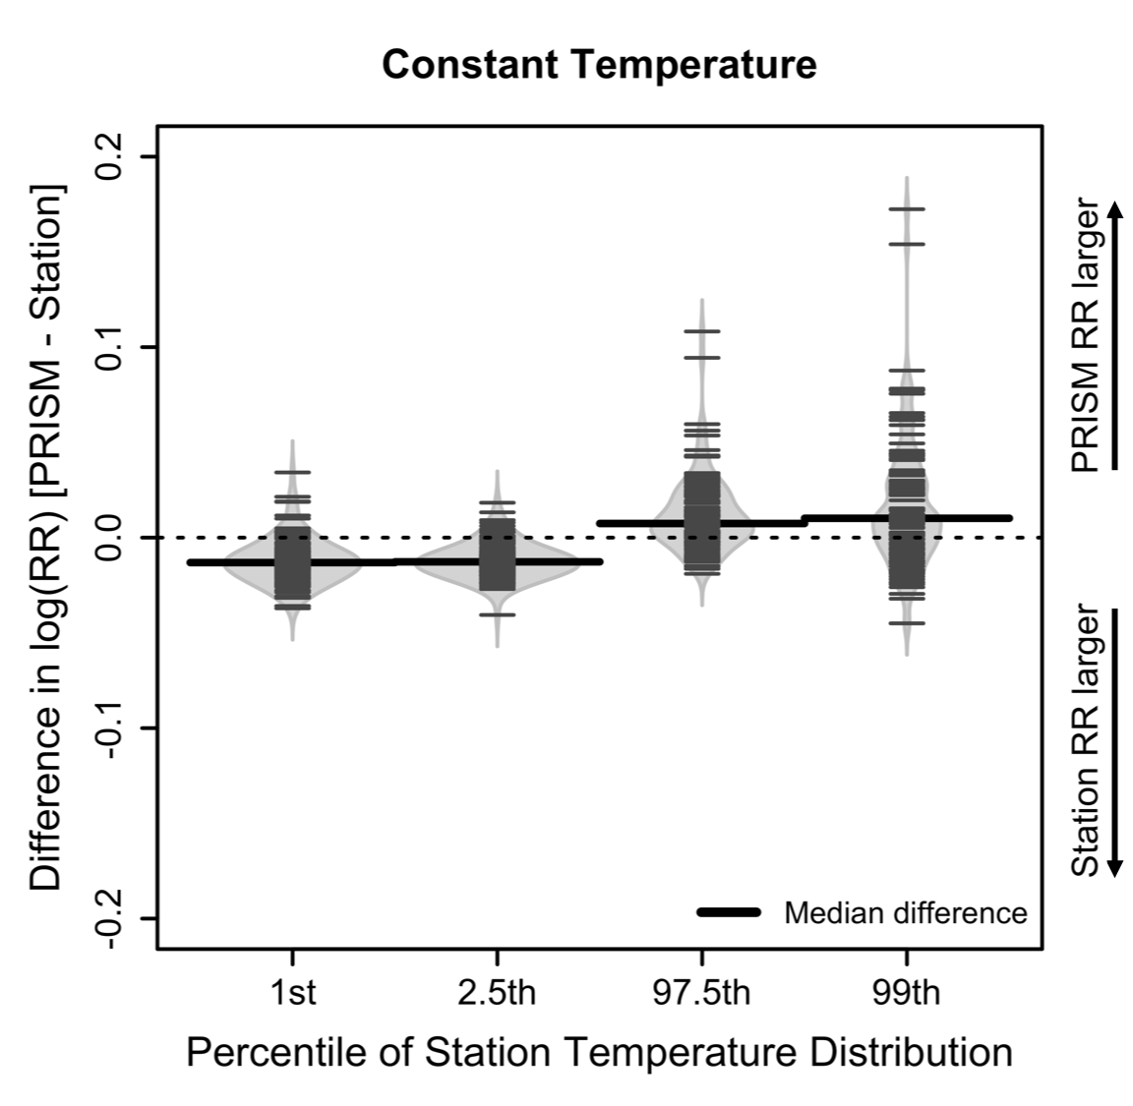

**Figure S3:** Scatterplot of relative risks (RR) for the 21-day cumulative association between daily mean temperature and mortality modeled using temperature observations from weather stations (x-axis) versus population-weighted temperature estimates from PRISM (y-axis) in each of 113 study counties. Comparisons are made at a constant percentile of temperature. Specifically, for each county, the percentile for which associations are plotted is held constant across exposure datasets (i.e., the 99th percentile of each county’s weather station temperature distribution for the station curve vs. the 99th percentile of each county’s PRISM distribution for the PRISM curve).



**Figure S4:** Distribution of the difference between the log(RR) for the 21-day cumulative association between temperature and mortality as estimated using PRISM versus station temperature in each of 113 counties. Comparisons are made at constant percentiles of temperature. Specifically, in each county, differences are calculated for the log(RR) at four percentiles of temperature (i.e., the 1st, 2.5th, 97.5th, and 99th percentiles of the county-specific weather station distribution and the 1st, 2.5th, 97.5th, and 99th percentiles of the PRISM temperature distribution) versus the minimum mortality temperature. Differences are calculated such counties where the PRISM curve yields a larger estimate of the temperature-mortality association receive a positive value.

