Supplemental Material For: Associations of parental preconception and prenatal urinary bisphenol A and paraben concentrations with child behavior
Authors: Julianne Skarha, Carmen Messerlian, David Bellinger, Lidia Minguez-Alarcon, Megan E. Romano, Jennifer B. Ford, Paige L. Williams, Antonia M. Calafat, Russ Hauser, Joseph M. Braun for the Environment and Reproductive Health (EARTH) Study
Contents
Supplemental Table 1: Comparison of baseline characteristics of the study sample to the original EARTH cohort 2
Supplemental Table 2: Distribution of specific gravity standardized preconception urinary phenol concentrations in women and men in the EARTH study 3
Supplemental Table 3: Pearson's correlation coefficients between parental urinary
bisphenol A and ∑paraben concentrations 4
Supplemental Table 4: Adjusted mean differences in the BASC-2 behavioral symptoms index, internalizing, and externalizing problems T-Scores stratified by child sex with log_{e}-unit increase in maternal and paternal preconception and maternal pregnancy urinary bisphenol A and ∑paraben concentrations 5
Supplemental Table 5: Adjusted difference in the BASC-2 behavioral symptoms index, internalizing, and externalizing problems T-Scores among children younger than 6 years old per ln-unit increase in maternal and paternal preconception and maternal prenatal urinary bisphenol A and ∑paraben concentrations 6
Supplemental Table 6: Adjusted difference in the BASC-2 behavioral symptoms
index, internalizing, and externalizing problems T-Scores among singleton children with
log_{e}-unit increase in maternal and paternal preconception and maternal pregnancy
urinary bisphenol A and ∑paraben concentrations 7
Supplemental Table 7: Adjusted difference in the BASC-2 behavioral symptoms index, internalizing, and externalizing problems T-Scores among children with a gestation > 37 weeks with log_{e}-unit increase in maternal and paternal preconception urinary bisphenol A and ∑paraben concentrations 8
Supplemental Table 8: Difference in externalizing problems t-score with log_{e}-unit increase in maternal preconception urinary BPA concentration 9
Supplemental Table 9: Adjusted difference in the BASC-2 behavioral symptoms index, internalizing, and externalizing problems T-Scores among children per ln-unit increase in maternal and paternal preconception and maternal prenatal urinary bisphenol A and ∑paraben concentrations 10
Supplemental Figure 1: Simplified Directed Acyclic Graph (DAG) for the association
of urinary BPA and ∑paraben metabolite concentrations with neurobehavior in children 11
Supplemental Figure 2: Adjusted differences in the BASC-2 behavioral symptoms index, internalizing, and externalizing problems T-Scores with log_{e}-unit increase in maternal and paternal preconception and maternal prenatal urinary bisphenol A concentrations 12 Supplemental Figure 3: Adjusted differences in the BASC-2 behavioral symptoms index, internalizing, and externalizing problems T-Scores with log_{e}-unit increase in maternal and paternal preconception and maternal prenatal urinary ∑paraben concentrations 13
Supplemental Figure 4: Adjusted differences in the BASC-2 behavioral symptoms index, internalizing, and externalizing T-Scores with ln-unit increase in maternal prenatal urinary BPA and ∑paraben concentrations 14
Supplemental Table 1: Baseline characteristics of the study participants and the original EARTH Study cohort

 |  | Mothers |  | Fathers
Parental Characteristic |  | Study sample | All EARTH participants | Study sample | All EARTH participants
 |  | N = 127 | N=799 | N = 93 | N=487
Mean Age (years) |  | 34.8 | 34.7 | 35.9 | 36.6
Race Percent (%)
 | White | 92 | 81 | 94 | 86
 | Asian | 6 | 9 | 4 | 7
 | Other | 2 | 10 | 2 | 7
Mean BMI |  | 23.8 | 24.6 | 27.1 | 27.5
Education Percent (%)
 | < College | 2 | 8 | 11 | 11
 | College Graduate | 36 | 29 | 29 | 28
 | Graduate Degree | 57 | 49 | 41 | 41
 | Missing | 5 | 14 | 19 | 20
Smoking Status Percent (%)
 | Never | 72 | 73 | 76 | 67
 | Former/Current | 28 | 27 | 24 | 33
Supplemental Table 2: Distribution of specific gravity standardized preconception and prenatal urinary phenol concentrations in women and men in the EARTH study

Phenol | Sample type | Sample Size (N) | LOD (μg/L) | % detect | SG-standardized GM (μg/L) | SG- standardized median (μg/L) | 25th - 75th (μg/L)
BPA | father preconception | 97 | 0.4 | 81 | 1.7 | 1.7 | 0.9 - 2.7
 | mother preconception | 126 | 0.4 | 58 | 1.3 | 1.2 | 0.9 - 1.8
 | mother prenatal | 121 | 0.4 | 62 | 1.3 | 1.2 | 0.8 – 1.8
Butyl Paraben | father preconception | 93 | 0.1 | 22 | 0.4 | 0.2 | 0.1 - 0.6
 | mother preconception | 119 | 0.1 | 55 | 1.8 | 1.2 | 0.5 - 6.9
 | mother prenatal | 121 | 0.1 | 46 | 0.9 | 0.7 | 0.3 – 2.5
Methyl Paraben | father preconception | 93 | 1.0 | 100 | 28 | 21 | 11 – 55
 | mother preconception | 119 | 1.0 | 99 | 150 | 156 | 72 – 347
 | mother prenatal | 121 | 1.0 | 100 | 106 | 112 | 43 - 267
Propyl Paraben | father preconception | 93 | 0.1 | 85 | 3.4 | 2.9 | 0.8 - 9.1
 | mother preconception | 119 | 0.1 | 93 | 30 | 31 | 14 - 89
 | mother prenatal | 121 | 0.1 | 99 | 19 | 19 | 6.9 - 64
∑Paraben | father preconception | 93 | N/A | N/A | 34 | 25 | 4.2 – 68
 | mother preconception | 119 | N/A | N/A | 190 | 189 | 99 - 449
 | mother prenatal | 121 | N/A | N/A | 131 | 141 | 51 - 353

Supplemental Table 3: Spearman correlation coefficients between parental urinary bisphenol A and ∑paraben concentrations before conception among women and men in the EARTH study

 |  | BPA (r) |  |  | ∑Paraben (r)
 |  | Maternal Preconception | Maternal Prenatal | Paternal Preconception | Maternal Preconception | Maternal Prenatal | Paternal Preconception
BPA (r) | Maternal Preconception | -
 | Maternal Prenatal | 0.27 | -
 | Paternal Preconception | 0.21 | 0.13 | -
∑Paraben (r) | Maternal Preconception | 0.10 | 0.17 | 0.06 | -
 | Maternal Prenatal | 0.03 | 0.15 | -0.06 | 0.54 | -
 | Paternal Preconception | -0.05 | -0.28 | -0.08 | 0.11 | 0.02 | -

Supplemental Table 4: Adjusted mean differences in the BASC-2 behavioral symptoms index, internalizing, and externalizing problems T-Scores stratified by child sex with log_{e}-unit increase in maternal and paternal preconception and maternal prenatal urinary bisphenol A and ∑paraben concentrations^{a,b}

 | BPA (μg/L) |  |  |  |  | ∑Paraben (μg/L)
 | N | Girls  Beta (95% CI) | N | Boys  Beta (95% CI) | EMM p-value | N | Girls  Beta (95% CI) | N | Boys  Beta (95% CI) | EMM p-value
Behavioral symptoms index
Maternal preconception | 73 | 0.5 (-2.3, 3.7) | 79 | 1.6 (-1.3, 4.5) | 0.82 | 71 | 0.1 (-1.5, 1.7) | 73 | -0.6 (-1.7, 0.5) | 0.50
Paternal preconception | 56 | -1.2 (-4.4, 2.1) | 58 | -3.6 (-8.0, 0.9) | 0.76 | 55 | -0.7 (-2.3, 0.9) | 55 | -1.9 (-4.7, 0.8) | 0.44
Maternal prenatal | 70 | -0.4 (-2.3, 1.5) | 75 | -2.3 (-4.6, -0.1) | 0.41 | 70 | 0.3 (-1.0, 1.6) | 75 | 0.1 (-1.5, 1.7) | 0.88
Internalizing problems
Maternal preconception | 72 | 0.8 (-2.8, 4.3) | 79 | 2.8 (-1.2, 6.8) | 0.78 | 70 | 0.6 (-1.5, 2.8) | 73 | -0.3 (-1.7, 1.1) | 0.46
Paternal preconception | 55 | -2.5 (-5.3, 0.4) | 57 | 1.1 (-1.4, 3.6) | 0.34 | 54 | -0.2 (-1.6, 1.2) | 54 | 0.5 (-1.6, 2.5) | 0.62
Maternal prenatal | 69 | -3.0 (-6.4, 0.4) | 75 | -0.3 (-2.7, 2.0) | 0.54 | 69 | -0.6 (-1.8, 0.7) | 75 | -0.5 (-2.2, 1.3) | 0.91
Externalizing problems
Maternal preconception | 74 | 0.6 (-2.3, 3.4) | 80 | 1.7 (-1.2, 4.5) | 0.79 | 72 | -0.3 (-1.9, 1.4) | 74 | -0.5 (-1.7, 0.7) | 0.82
Paternal preconception | 56 | 0.3 (-2.4, 3.0) | 58 | -0.5 (-2.9, 1.9) | 0.81 | 55 | -1.6 (-3.0, -0.2) | 55 | -1.0 (-3.0, 1.1) | 0.62
Maternal prenatal | 71 | -0.3 (-2.7, 2.0) | 76 | -2.4 (-4.3, -0.4) | 0.41 | 71 | -0.3 (-1.6, 1.0) | 76 | 0.0 (-1.4, 1.4) | 0.78

ªAdjusted for maternal or paternal age, smoking status, and race
^{b}Effect Measure Modification (EMM) p-values were calculated using a two-sample z-test with beta coefficients and variances from the sex-stratified models to determine sex-specific differences

Supplemental Table 5: Adjusted difference in the BASC-2 behavioral symptoms index, internalizing, and externalizing problems T-Scores among children younger than 6 years old per ln-unit increase in maternal and paternal preconception and maternal prenatal urinary bisphenol A and ∑paraben concentrationsª

 | N | BPA (μg/L)  Beta (95% CI) | N | ∑Paraben (μg/L)  Beta (95% CI)
Behavioral symptoms index
Maternal preconception | 127 | 1.1 (-1.5, 3.8) | 127 | -0.2 (-1.2, 0.9)
Paternal preconception | 93 | -1.8 (-4.0, 0.4) | 93 | -1.0 (-2.6, 0.5)
Maternal prenatal | 121 | -1.4 (-3.0, 0.2) | 121 | 0.1 (-1.0, 1.1)
Internalizing problems
Maternal preconception | 126 | 2.4 (-0.3, 5.1) | 126 | 0.0 (-1.2, 1.1)
Paternal preconception | 91 | -1.0 (-3.0, 1.0) | 91 | -0.3 (-1.7, 1.1)
Maternal prenatal | 120 | -0.2 (-1.9, 1.5) | 120 | -0.2 (-1.4, 1.0)
Externalizing problems
Maternal preconception | 129 | 1.2 (-1.3, 3.6) | 129 | -0.3 (-1.5, 0.8)
Paternal preconception | 93 | -1.1 (-3.1, 0.8) | 93 | -1.5 (-3.2, 0.1)
Maternal prenatal | 123 | -1.1 (-2.7, 0.5) | 123 | -0.2 (-1.2, 0.9)

ªAdjusted for maternal or paternal age, smoking status, and race
Supplemental Table 6: Adjusted difference in the BASC-2 behavioral symptoms index, internalizing, and externalizing problems T-Scores among singleton children per ln-unit increase in maternal and paternal preconception and maternal prenatal urinary bisphenol A and ∑paraben concentrationsª

 | N | BPA (μg/L)  Beta (95% CI) | N | ∑Paraben (μg/L)  Beta (95% CI)
Behavioral symptoms index
Maternal preconception | 101 | 1.8 (-0.9, 4.5) | 95 | -0.3 (-1.6, 1.0)
Paternal preconception | 75 | -1.4 (-3.8, 1.0) | 71 | -0.9 (-2.4, 0.5)
Maternal prenatal | 98 | -0.6 (-2.8, 1.6) | 98 | -0.2 (-1.4, 1.0)
Internalizing problems
Maternal preconception | 101 | 1.0 (-1.8, 3.8) | 95 | -0.5 (-1.9, 0.8)
Paternal preconception | 75 | -0.9 (-3.3, 1.4) | 71 | -0.1 (-1.5, 1.4)
Maternal prenatal | 98 | -0.7 (-3.0, 1.6) | 98 | -0.6 (-1.8, 0.7)
Externalizing problems
Maternal preconception | 101 | 2.3 (-0.5, 5.2) | 95 | -0.3 (-1.7, 1.1)
Paternal preconception | 75 | -0.7 (-3.2, 1.7) | 71 | -1.5 (-3.0, -0.0)
Maternal prenatal | 98 | -0.5 (-2.9, 1.8) | 98 | -0.5 (-1.7, 0.8)

ªAdjusted for maternal or paternal age, smoking status, and race

Supplemental Table 7: Adjusted difference in the BASC-2 behavioral symptoms index, internalizing, and externalizing problems T-Scores among children with a gestation > 37 weeks per ln-unit increase in maternal and paternal preconception and maternal prenatal urinary bisphenol A and ∑paraben concentrationsª

 | N | BPA (μg/L)  Beta (95% CI) | N | ∑Paraben (μg/L)  Beta (95% CI)
Behavioral symptoms index
Maternal preconception | 117 | 1.9 (-0.6, 4.4) | 109 | -0.5 (-1.4, 0.5)
Paternal preconception | 82 | -0.5 (-2.6, 1.6) | 79 | 0.1 (-0.9, 1.2)
Maternal prenatal | 111 | -1.0 (-2.5, 0.5) | 111 | -0.6 (-1.7, 0.5)
Internalizing problems
Maternal preconception | 117 | 1.5 (-1.2, 4.2) | 109 | -0.5 (-1.7, 0.7)
Paternal preconception | 82 | 0.4 (-1.3, 2.1) | 79 | 0.4 (-1.0, 1.8)
Maternal prenatal | 111 | -0.5 (-2.4, 1.4) | 111 | -0.6 (-1.8, 0.6)
Externalizing problems
Maternal preconception | 117 | 2.1 (-0.1, 4.3) | 109 | -0.7 (-1.8, 0.4)
Paternal preconception | 82 | -0.2 (-2.1, 1.7) | 79 | -0.6 (-1.8, 0.5)
Maternal prenatal | 111 | -0.8 (-2.2, 0.6) | 111 | -0.9 (-1.9, 0.1)

ªAdjusted for maternal or paternal age, smoking status, and race

Among… | Adjustments | N | Beta (95% CI)
All children | Unadjusted | 154 | 1.4 (-0.7, 3.5)
All children | maternal age, race, and smoking | 154 | 1.2 (-0.9, 3.4)
Singletons | maternal age, race, and smoking | 101 | 2.3 (-0.5, 5.2)
Children born term | maternal age, race, and smoking | 117 | 2.1 (-0.1, 4.3)
Singleton children born term | maternal age, race, and smoking | 87 | 2.6 (0.1, 5.2)
All children | maternal age, race, smoking, and education | 121 | 1.8 (-0.2, 3.8)
Singletons | maternal age, race, smoking, and education | 113 | 2.9 (0.8, 5.0)
Children born term | maternal age, race, smoking, and education | 97 | 3.5 (1.1, 5.8)
Singleton children born term | maternal age, race, smoking, and education | 83 | 3.7 (1.2, 6.1)
Supplemental Table 8: Difference in externalizing problems t-score per ln-unit increase in maternal preconception urinary BPA concentration

*-Term defined as >37 weeks gestation

Supplemental Table 9: Adjusted difference in the BASC-2 behavioral symptoms index, internalizing, and externalizing problems T-Scores among children per ln-unit increase in maternal and paternal preconception and maternal prenatal urinary bisphenol A and ∑paraben concentrations

 | Fully Adjusted model: Adjusted for maternal or paternal age, smoking status, and race |  |  |  | Adjusted for maternal or paternal age, smoking status, race, and respective partner’s chemical preconception concentration |  |  |  | Adjusted for maternal or paternal age, smoking status, race, and person respective other chemical concentration
 | N | BPA (μg/L)  Beta (95% CI) | N | ∑Paraben (μg/L)  Beta (95% CI) | N | BPA (μg/L)  Beta (95% CI) | N | ∑Paraben (μg/L)  Beta (95% CI) | N | BPA (μg/L)  Beta (95% CI) | N | ∑Paraben (μg/L)  Beta (95% CI)
Behavioral symptoms index
Maternal preconception | 152 | 1.0 (-1.4, 3.3) | 144 | -0.3 (-1.3, 0.7) | 110 | 1.0 (-1.9, 3.9) | 105 | 0.7 (-0.7, 2.1) | 144 | 1.3 (-1.2, 3.8) | 144 | -0.3 (-1.3, 0.7)
Paternal preconception | 114 | -1.2 (-3.2, 0.8) | 110 | -0.6 (-1.8, 0.6) | 110 | -1.1 (-3.1, 0.9) | 105 | -0.4 (-1.6, 0.8) | 110 | -1.4 (-3.5, 0.7) | 110 | -1.2 (-2.5, 0.1)
Maternal prenatal | 145 | -1.5 (-3.0, 0.0) | 145 | 0.1 (-0.9, 1.1) |  | N/A |  | N/A | 145 | -1.5 (-3, 0) | 145 | 0.2 (-0.7, 1.1)
Internalizing problems
Maternal preconception | 151 | 1.1 (-1.4, 3.6) | 142 | -0.3 (-1.4, 0.8) | 108 | 0.6 (-2.9, 4.1) | 103 | 0.6 (-0.8, 2) | 143 | 1.9 (-0.7, 4.5) | 143 | -0.3 (-1.4, 0.8)
Paternal preconception | 112 | -0.6 (-2.4, 1.2) | 108 | 0.0 (-1.2, 1.2) | 108 | -0.4 (-2.2, 1.4) | 103 | 0.1 (-1.1, 1.3) | 108 | -0.6 (-2.6, 1.4) | 108 | 0 (-1.2, 1.2)
Maternal prenatal | 144 | -1.0 (-2.7, 0.7) | 144 | -0.5 (-1.5, 0.5) |  | N/A |  | N/A | 144 | 0.9 (-0.8, 2.6) | 144 | -0.4 (-1.4, 0.6)
Externalizing problems
Maternal preconception | 154 | 1.2 (-0.9, 3.4) | 146 | -0.4 (-1.5, 0.7) | 110 | 0.5 (-2, 3) | 105 | 0.2 (-1.3, 1.7) | 146 | 1.6 (-0.7, 3.9) | 146 | -0.5 (-1.6, 0.6)
Paternal preconception | 114 | -0.5 (-2.3, 1.2) | 110 | -1.2 (-2.5, 0.1) | 110 | -0.4 (-2.1, 1.3) | 105 | -1.1 (-2.3, 0.1) | 110 | -1.2 (-2.5, 0.1) | 110 | -0.7 (-1.9, 0.5)
Maternal prenatal | 147 | -1.2 (-2.6, 0.2) | 147 | -0.2 (-1.1, 0.7) |  | N/A |  | N/A | 147 | -1.1 (-2.6, 0.4) | 147 | -0.1 (-1, 0.8)

Supplemental Figure 1: Simplified Directed Acyclic Graph (DAG) for the association of urinary BPA and ∑paraben metabolite concentrations with neurobehavior in children
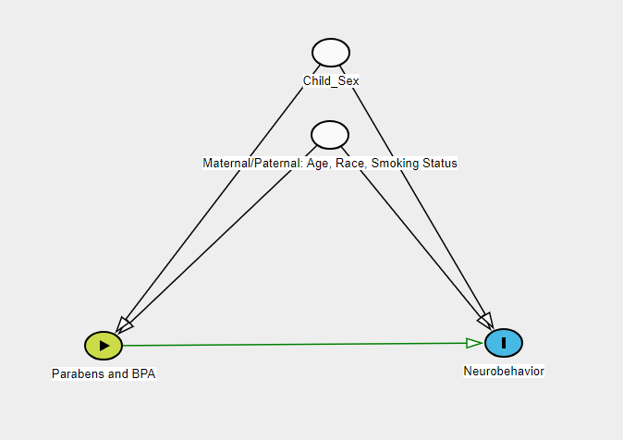

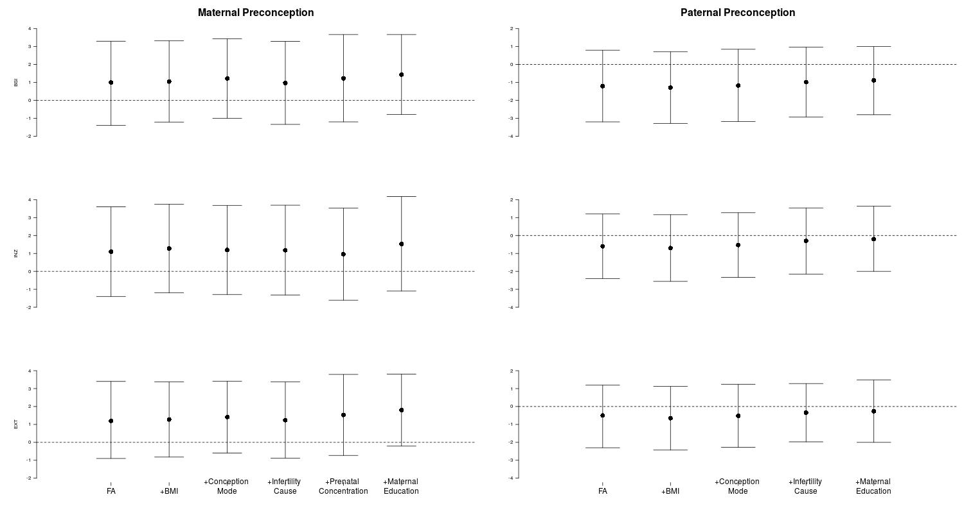
Supplemental Figure 2: Adjusted differences in the BASC-2 behavioral symptoms index, internalizing, and externalizing T-Scores with ln-unit increase in maternal and paternal preconception urinary bisphenol A concentrationsª
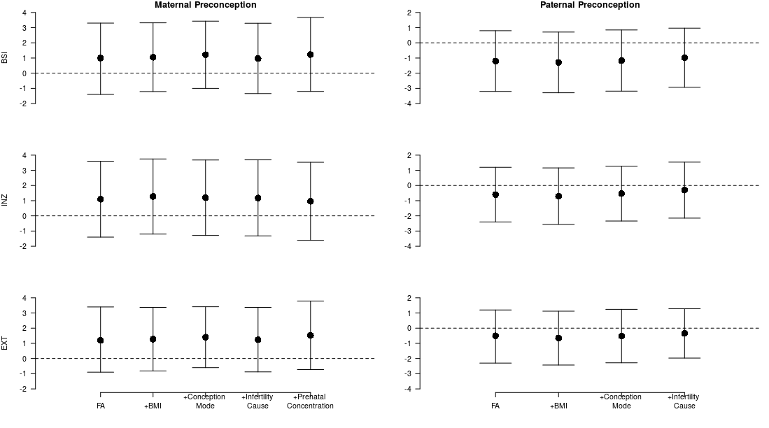

ªFA is the fully adjusted model which included maternal or paternal age, smoking status, and race.

Supplemental Figure 3: Adjusted differences in the BASC-2 behavioral symptoms index, internalizing, and externalizing T-Scores with ln-unit increase in maternal and paternal preconception urinary ∑paraben concentrationsª
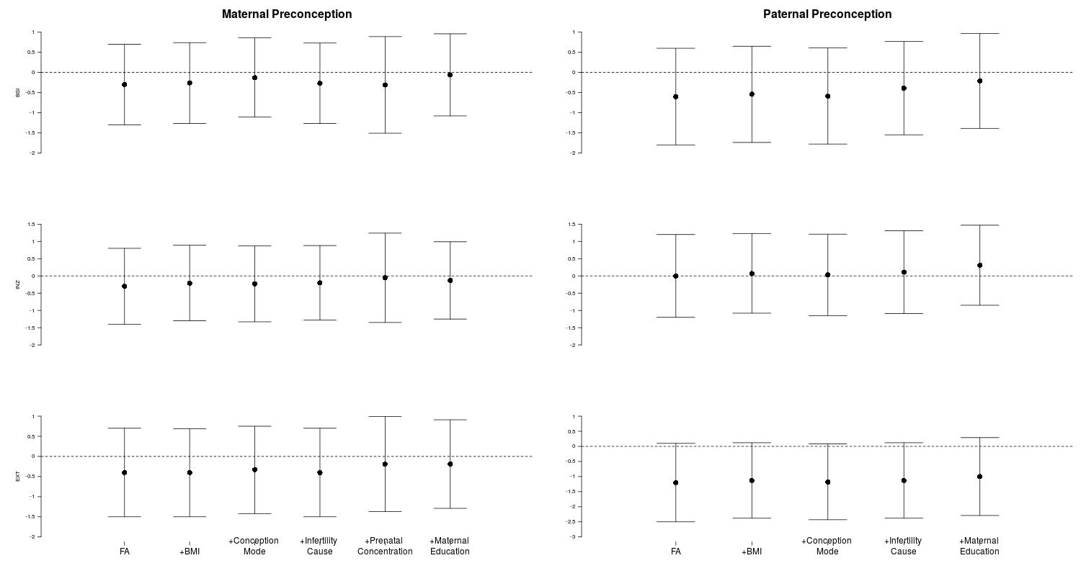
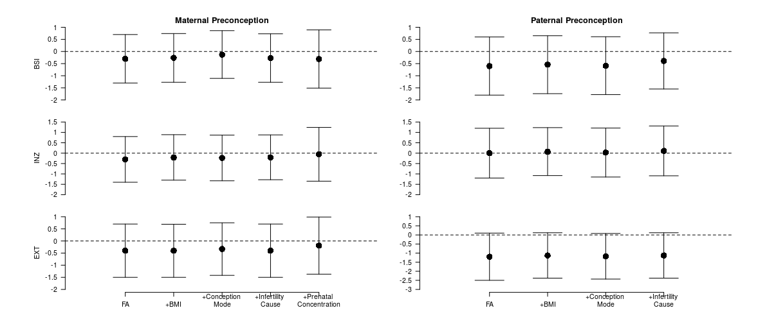
ªFA is the fully adjusted model which included maternal or paternal age, smoking status, and race

Supplemental Figure 4: Adjusted differences in the BASC-2 behavioral symptoms index, internalizing, and externalizing T-Scores with ln-unit increase in maternal prenatal urinary BPA and ∑paraben concentrationsª
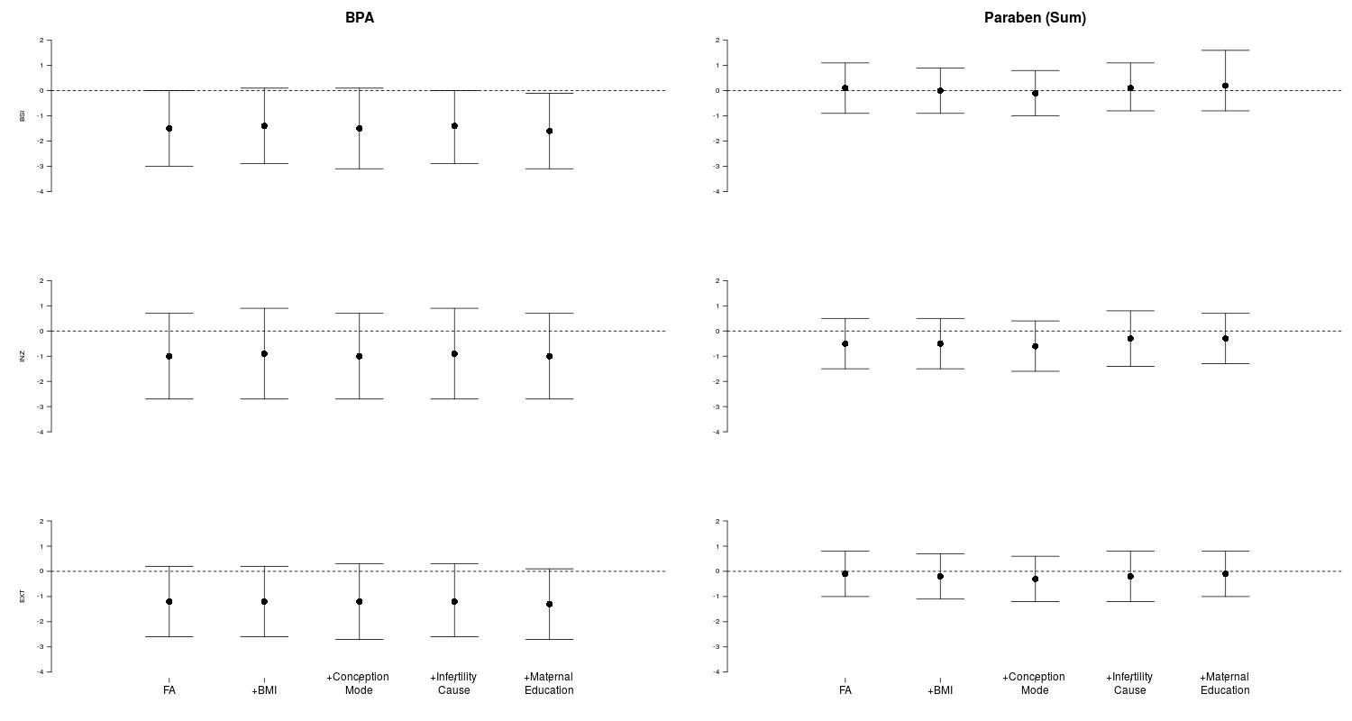

ªFA is the fully adjusted model which included maternal or paternal age, smoking status, and race

