Supplemental Material

Table S1. NHANES participants with serum perfluorinated compounds (PFAS) levels above the detection limit (%).
PFAS measured in serum (ng/mL) |  | Overall adult population | Men over 50 years old | Postmenopausal women
 |  | n=499 | n=115 | n=117
Name | Acronym | Percentage | Percentage | Percentage
Linear perfluorooctanoate | n-PFOA | 99 | 99 | 99
Branched isomers of perfluorooctanoate | Sb-PFOA | 16 | 20 | 14
Linear perfluorooctane sulfonate (PFOS) | n-PFOS | 99 | 98 | 99
Monomethyl branched isomers of PFOS | Sm-PFOS | 98 | 97 | 99
Perfluorohexane sulfonic acid | PFHxS | 99 | 99 | 100
2-(N-Methyl-PFOSA) acetic acid | Me-PFOSA-AcOH | 47 | 55 | 49
Pefluorodecanoic acid | PFDeA | 86 | 87 | 91
Perfluorobutane sulfonic acid | PFBuS | 1 | 1 | 2
Perfluoroheptanoic acid | PFHpA | 12 | 15 | 15
Perfluorononanoic acid | PFNA | 98 | 97 | 99
Perfluoroundecanoic acid | PFUA | 56 | 58 | 51
Perflurododecanoic acid | PFDoA | 22 | 20 | 21

Table S2. BWQS regression results. Coefficient estimates of the association between the perfluorinated compound (PFAS) mixture and mineral density in lumbar spine, total femur, and femur neck and estimates of mixture weights (percentages, rescaled between 0 and 1) for the mixture components in the overall adult population, men over 50 years old, and postmenopausal women. All analyses were adjusted for race/ethnicity, age, sex, physical activity, poverty-income ratio, and smoking status.
Parameter | Lumbar spine mineral density |  |  |  | Total femur mineral density |  |  |  | Femur neck mineral density
 | Estimate | 95% CrI | $$\hat{R}$$ |  | Estimate | 95% CrI | $$\hat{R}$$ |  | Estimate | 95% CrI | $$\hat{R}$$
Overall adult population (n = 499)
beta1 (BWQS index) | -0.004 | (-0.04, 0.042) | 1.00 |  | 0.002 | (-0.040, 0.046) | 1.00 |  | 0.005 | (-0.030, 0.044) | 1.00
PFAS weight for
n-PFOA | 0.124 | ( 0.003, 0.414) | 1.00 |  | 0.121 | ( 0.004, 0.397) | 1.00 |  | 0.117 | ( 0.003, 0.390) | 1.00
n-PFOS | 0.117 | ( 0.003, 0.389) | 1.00 |  | 0.119 | ( 0.003, 0.381) | 1.00 |  | 0.118 | ( 0.003, 0.379) | 1.00
Sm-PFOS | 0.129 | ( 0.005, 0.413) | 1.00 |  | 0.130 | ( 0.004, 0.447) | 1.00 |  | 0.127 | ( 0.004, 0.431) | 1.00
PFHxS | 0.133 | ( 0.003, 0.431) | 1.00 |  | 0.123 | ( 0.003, 0.390) | 1.00 |  | 0.125 | ( 0.004, 0.408) | 1.00
Me-PFOSA-AcOH | 0.134 | ( 0.003, 0.462) | 1.00 |  | 0.153 | ( 0.003, 0.508) | 1.00 |  | 0.162 | ( 0.005, 0.533) | 1.00
PFDeA | 0.120 | ( 0.004, 0.404) | 1.00 |  | 0.122 | ( 0.005, 0.393) | 1.00 |  | 0.116 | ( 0.004, 0.398) | 1.00
PFNA | 0.124 | ( 0.004, 0.421) | 1.00 |  | 0.117 | ( 0.002, 0.392) | 1.00 |  | 0.111 | ( 0.003, 0.375) | 1.00
PFUA | 0.119 | ( 0.003, 0.376) | 1.00 |  | 0.116 | ( 0.003, 0.364) | 1.00 |  | 0.124 | ( 0.003, 0.390) | 1.00
Men over 50 years old (n = 115)
beta1 (BWQS index) | 0.012 | (-0.050, 0.077) | 1.00 |  | 0.014 | (-0.040, 0.070) | 1.00 |  | 0.016 | (-0.037, 0.071) | 1.00
PFAS weight for
n-PFOA | 0.140 | ( 0.004, 0.432) | 1.00 |  | 0.128 | ( 0.005, 0.406) | 1.00 |  | 0.135 | ( 0.004, 0.412) | 1.00
n-PFOS | 0.110 | ( 0.004, 0.393) | 1.00 |  | 0.114 | ( 0.004, 0.388) | 1.00 |  | 0.112 | ( 0.004, 0.352) | 1.00
Sm-PFOS | 0.132 | ( 0.004, 0.434) | 1.00 |  | 0.133 | ( 0.005, 0.429) | 1.00 |  | 0.131 | ( 0.006, 0.413) | 1.00
PFHxS | 0.139 | ( 0.005, 0.431) | 1.00 |  | 0.132 | ( 0.003, 0.438) | 1.00 |  | 0.137 | ( 0.005, 0.426) | 1.00
Me-PFOSA-AcOH | 0.124 | ( 0.004, 0.392) | 1.00 |  | 0.136 | ( 0.004, 0.439) | 1.00 |  | 0.133 | ( 0.004, 0.433) | 1.00
PFDeA | 0.119 | ( 0.004, 0.400) | 1.00 |  | 0.123 | ( 0.003, 0.401) | 1.00 |  | 0.113 | ( 0.004, 0.394) | 1.00
PFNA | 0.120 | ( 0.005, 0.379) | 1.00 |  | 0.120 | ( 0.003, 0.405) | 1.00 |  | 0.124 | ( 0.004, 0.415) | 1.00
PFUA | 0.115 | ( 0.002, 0.409) | 1.00 |  | 0.114 | ( 0.002, 0.399) | 1.00 |  | 0.115 | ( 0.002, 0.378) | 1.00
Postmenopausal women (n = 117)
beta1 (BWQS index) | 0.000 | (-0.080, 0.081) | 1.00 |  | 0.020 | (-0.044, 0.082) | 1.00 |  | 0.024 | (-0.031, 0.078) | 1.00
PFAS weight for
n-PFOA | 0.124 | ( 0.002, 0.417) | 1.00 |  | 0.138 | ( 0.005, 0.436) | 1.00 |  | 0.137 | ( 0.003, 0.421) | 1.00
n-PFOS | 0.122 | ( 0.004, 0.409) | 1.00 |  | 0.110 | ( 0.002, 0.367) | 1.00 |  | 0.115 | ( 0.004, 0.405) | 1.00
Sm-PFOS | 0.123 | ( 0.004, 0.394) | 1.00 |  | 0.109 | ( 0.003, 0.371) | 1.00 |  | 0.105 | ( 0.003, 0.364) | 1.00
PFHxS | 0.127 | ( 0.005, 0.421) | 1.00 |  | 0.117 | ( 0.003, 0.369) | 1.00 |  | 0.119 | ( 0.004, 0.365) | 1.00
Me-PFOSA-AcOH | 0.127 | ( 0.005, 0.414) | 1.00 |  | 0.125 | ( 0.003, 0.386) | 1.00 |  | 0.125 | ( 0.005, 0.399) | 1.00
PFDeA | 0.125 | ( 0.004, 0.416) | 1.00 |  | 0.130 | ( 0.004, 0.394) | 1.00 |  | 0.128 | ( 0.004, 0.394) | 1.00
PFNA | 0.124 | ( 0.004, 0.438) | 1.00 |  | 0.143 | ( 0.003, 0.446) | 1.00 |  | 0.148 | ( 0.006, 0.447) | 1.00
PFUA | 0.127 | ( 0.004, 0.389) | 1.00 |  | 0.129 | ( 0.004, 0.429) | 1.00 |  | 0.123 | ( 0.003, 0.389) | 1.00
95% CrI: 95% credible interval, $\hat{R}$: potential scale-reduction statistic.
Table S3. WQS Results. Coefficient estimates of the association between the perfluorinated compound (PFAS) mixture and mineral density in lumbar spine, total femur, and femur neck and estimates of weights for mixture components in the overall adult population (N = 499). All analyses were adjusted for race/ethnicity, age, sex, physical activity, poverty-income ratio, and smoking status.
Outcome | Estimate | 95% CI |  | Weight estimates
 |  |  |  | n-PFOA | n-PFOS | Sm-PFOS | PFHxS | Me-PFOSA-AcOH | PFDeA | PFNA | PFUA
Lumbar spine | -0.009 | (-0.0482; 0.0302) |  | 0.01 | 0.05 | 0.26 | 0.31 | 0.08 | 0.05 | 0.18 | 0.06
Total femur | -0.013 | (-0.0522; 0.0262) |  | 0.03 | 0.06 | 0.53 | 0.11 | 0.08 | 0.03 | 0.11 | 0.05
Femur neck | -0.004 | (-0.0432; 0.0352) |  | 0.05 | 0.07 | 0.46 | 0.11 | 0.06 | 0.07 | 0.14 | 0.03
95% CI: 95% Confidence Interval

Table S4. R² for the BWQS and WQS regressions in the overall adult population.
R² | Lumbar spine | Total femur | Femur neck
BWQS | 0.8508 | 0.8365 | 0.8154
WQSª | 0.8598 | 0.8492 | 0.8185
ª The WQS regression requires splitting the original dataset into training and validation sets. In the training set WQS estimates the weights, while in the validation set WQS estimates the mixture-outcome coefficient given the estimated weights. The R² for the WQS regression was computed in the validation set of data.

Table S5. Bayesian Linear Regression results. Coefficient estimates of the association between each perfluorinated compound (PFAS) and mineral density in lumbar spine, total femur, and femur neck in the overall adult population (n = 499). All analyses were adjusted for race/ethnicity, age, sex, physical activity, poverty-income ratio, and smoking status.
PFAS | Lumbar spine mineral density |  |  | Total femur mineral density |  |  | Femur neck mineral density
 | Estimate | 95% CrI |  | Estimate | 95% CrI |  | Estimate | 95% CrI
n-PFOA | 0.004 | (-0.008, 0.016) |  | 0.008 | (-0.004, 0.019) |  | 0.005 | (-0.005, 0.015)
n-PFOS | -0.002 | (-0.005, 0.002) |  | 0.001 | (-0.003, 0.004) |  | 0.000 | (-0.003, 0.003)
Sm-PFOS | -0.020 | (-0.030, -0.009) |  | -0.013 | (-0.023, -0.003) |  | -0.013 | (-0.022, -0.004)
PFHxS | 0.008 | (-0.005, 0.020) |  | 0.008 | (-0.004, 0.020) |  | 0.010 | (-0.001, 0.020)
Me-PFOSA-AcOH | -0.005 | (-0.058, 0.048) |  | 0.041 | (-0.009, 0.090) |  | 0.037 | (-0.007, 0.081)
PFDeA | 0.002 | (-0.015, 0.020) |  | 0.006 | (-0.010, 0.023) |  | 0.004 | (-0.010, 0.019)
PFNA | 0.011 | (-0.017, 0.038) |  | 0.037 | (0.011, 0.062) |  | 0.028 | (0.005, 0.050)
PFUA | 0.001 | (-0.011, 0.013) |  | 0.002 | (-0.009, 0.013) |  | 0.001 | (-0.009, 0.011)
95% CrI = 95% credible interval. See Table S1 for PFAS acronyms.

Table S6 BWQS regression combining PFOS isomers. Coefficient estimates of the association between the perfluorinated compound (PFAS) mixture and mineral density in lumbar spine, total femur, and femur neck and estimates of mixture weights for the mixture components in the overall adult population, men over 50 years old, and postmenopausal women. All analyses were adjusted for race/ethnicity, age, sex, physical activity, poverty-income ratio, and smoking status.

PFAS exposure | Lumbar spine |  |  | Total femur |  |  | Femur neck
 | Estimate | 95% CrI |  | Estimate | 95% CrI |  | Estimate | 95% CrI
beta1 (BWQS index) | 0.000 | (-0.04; 0.04) |  | 0.010 | (-0.03; 0.06) |  | 0.011 | (-0.02; 0.05)
n-PFOA | 0.142 | (0.01; 0.44) |  | 0.137 | (0.00; 0.44) |  | 0.132 | (0.00; 0.43)
PFOS | 0.140 | (0.00; 0.46) |  | 0.125 | (0.00; 0.45) |  | 0.128 | (0.00; 0.43)
PFHxS | 0.139 | (0.00; 0.46) |  | 0.134 | (0.00; 0.46) |  | 0.131 | (0.00; 0.43)
Me-PFOSA-AcOH | 0.164 | (0.01; 0.55) |  | 0.208 | (0.00; 0.61) |  | 0.221 | (0.01; 0.60)
PFDeA | 0.144 | (0.00; 0.46) |  | 0.134 | (0.00; 0.43) |  | 0.127 | (0.00; 0.42)
PFNA | 0.135 | (0.00; 0.45) |  | 0.130 | (0.00; 0.43) |  | 0.129 | (0.00; 0.43)
PFUA | 0.136 | (0.01; 0.45) |  | 0.132 | (0.01; 0.44) |  | 0.131 | (0.00; 0.42)

95% CrI = 95% credible interval.

Table S7 BWQS regression on postmenopausal women from the 2009-2010 NHANES cycle. Coefficient estimates of the association between the perfluorinated compound (PFAS) mixture and mineral density in lumbar spine, total femur, and femur neck and estimates of mixture weights for the mixture components in the postmenopausal women. All analyses were adjusted for race/ethnicity, age, sex, body mass index, blood lead levels, dietary intake, physical activity, poverty-income ratio, and smoking status.

PFAS exposure | Lumbar spine |  |  | Total femur |  |  | Femur neck
 | Estimate | 95% CrI |  | Estimate | 95% CrI |  | Estimate | 95% CrI
beta1 (BWQS index) | 0.015 | (-0.029; 0.060) |  | -0.004 | (-0.036; 0.027) |  | -0.011 | (-0.04; 0.019)
PFOA | 0.248 | (0.009; 0.693) |  | 0.244 | (0.009; 0.681) |  | 0.246 | (0.009; 0.689)
PFOS | 0.242 | (0.007; 0.691) |  | 0.271 | (0.007; 0.745) |  | 0.298 | (0.010; 0.751)
PFHxS | 0.266 | (0.013; 0.692) |  | 0.241 | (0.009; 0.691) |  | 0.225 | (0.008; 0.666)
PFNA | 0.244 | (0.010; 0.688) |  | 0.245 | (0.010; 0.682) |  | 0.231 | (0.006; 0.667)
95% CrI = 95% credible interval.

Figure S1: Correlation between serum perfluorinated compounds (PFAS) in men over 50 years old, and in postmenopausal women.
Color and shape of each ellipse reflect the correlation between two compounds.

B) Post-menopausal women
A) Men over 50 years old
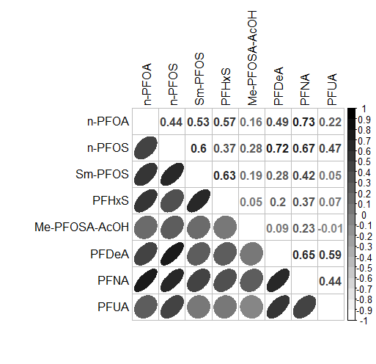
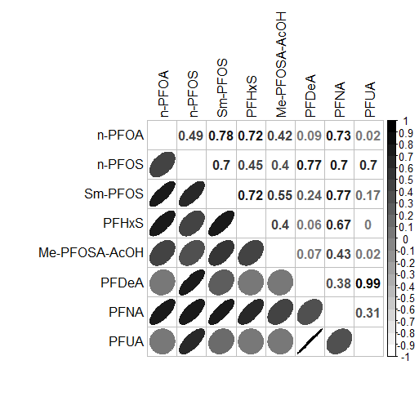
Figure S2. Estimates of the association between perfluorinated compound (PFAS) mixture and mineral density in A) lumbar spine, B) total femur, and C) femur neck, by using weighted quantile sum regression, assuming a negative association between the mixture and the outcomes, in the overall adult (≥20 years) population (n = 499). All analyses were adjusted for race/ethnicity, age, sex, physical activity, poverty-income ratio, and smoking status.

Figure S3. Estimates of the association between individual perfluorinated compounds (PFAS) and mineral density in lumbar spine, total femur, and femur neck by using Bayesian linear regressions. All analyses were adjusted for race/ethnicity, age, sex, physical activity, poverty-income ratio, and smoking status. Size and color of each bubble represent the magnitude and direction, respectively, of the association.
F.NECK = femur neck bone mineral density; FEMUR = total femur bone mineral density; SPINE = lumbar spine mineral density.

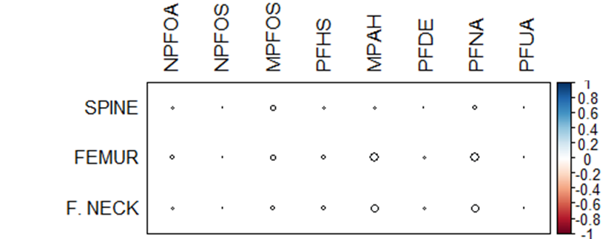

Figure S4: Estimates of the 1) association between bone mineral density and the perfluorinated compound (PFAS) mixture for men over 50 years old and estimates of 2) mixture composition: weights (percentage rescaled between 0 to 1) with 95% credible intervals for each mixture component in A) lumbar spine, B) total femur, and C) femur neck.
BMD = bone mineral density adjusted for race/ethnicity, age, sex, physical activity, poverty-income ratio, and smoking status.
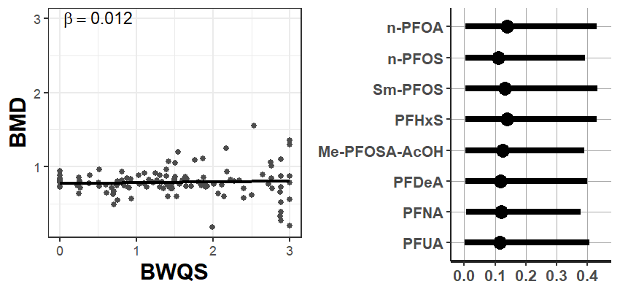
- Estimated association
- Mixture composition
- Mixture composition
- Lumbar spine

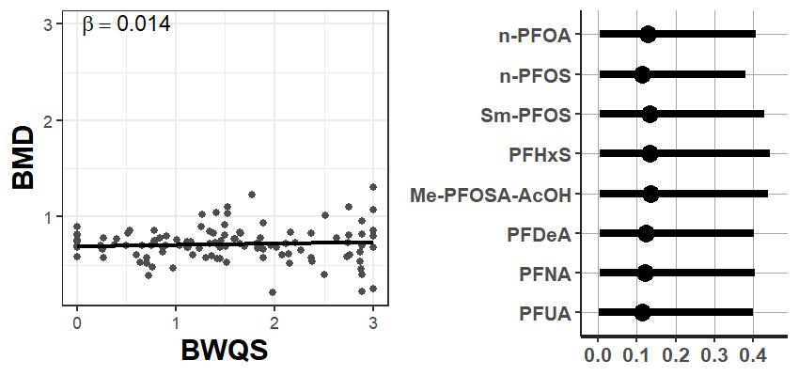
- Estimated association
- Total femur

- Mixture composition
- Estimated association
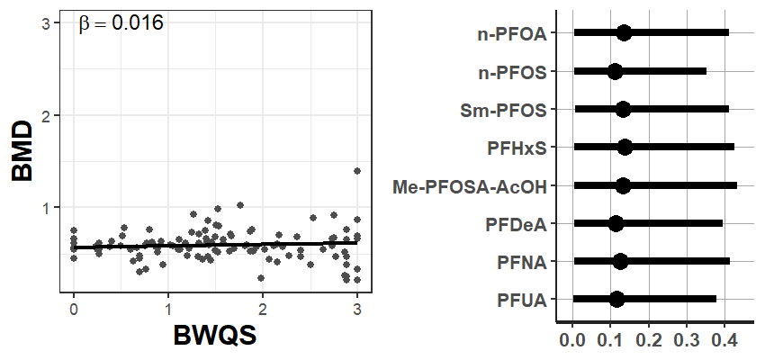
- Femur neck

Figure S5: Estimates of the 1) association between bone mineral density and the perfluorinated compound (PFAS) mixture for post-menopausal women and estimates of 2) mixture composition: weights (percentage rescaled between 0 to 1) with 95% credible intervals for each mixture component in A) lumbar spine, B) femur neck, and C) total femur.
BMD = bone mineral density adjusted for race/ethnicity, age, sex, physical activity, poverty-income ratio, and smoking status.
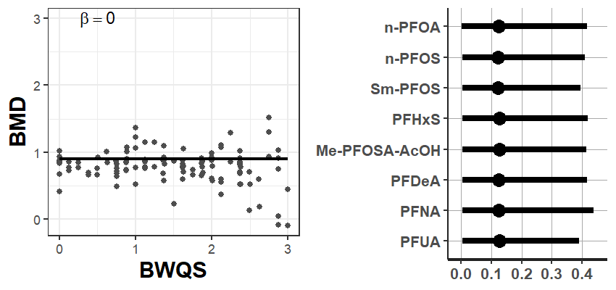
- Estimated association
- Mixture composition
- Estimated association
- Mixture composition
- Lumbar Spine

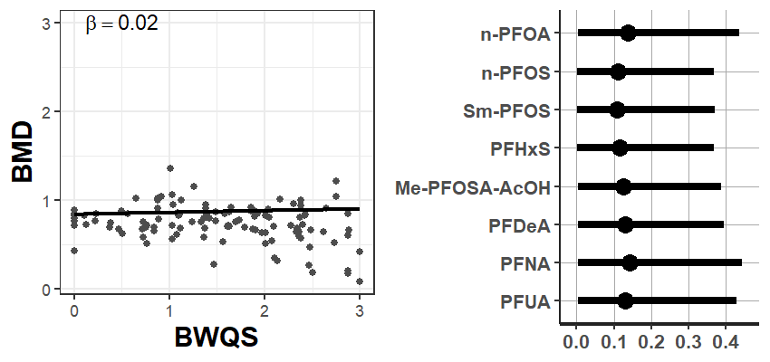
B) Total Femur

- Mixture composition
1)Estimated association
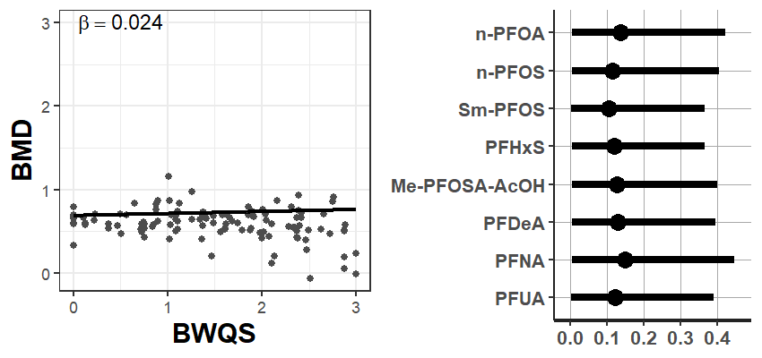
- Femur Neck

Figure S6: Including PFASs detected in at least 60% of samples. Estimates of the 1) association between bone mineral density and the perfluorinated compound (PFAS) mixture in the overall population and estimates of 2) mixture composition: weights (percentage rescaled between 0 to 1) with 95% credible intervals for each mixture component in A) lumbar spine, B) total femur, and C) femur neck.
BMD = bone mineral density adjusted for race/ethnicity, age, sex, physical activity, poverty-income ratio, and smoking status.
- Estimated association
- Mixture composition
- Estimated association
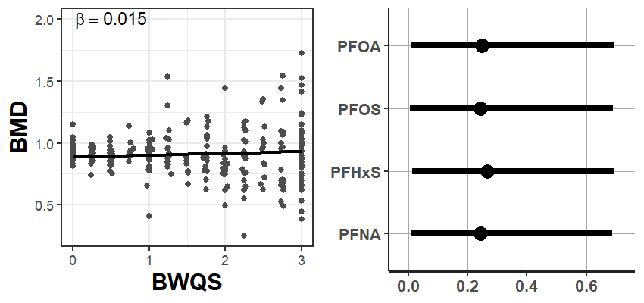
- Lumbar Spine
- Mixture composition
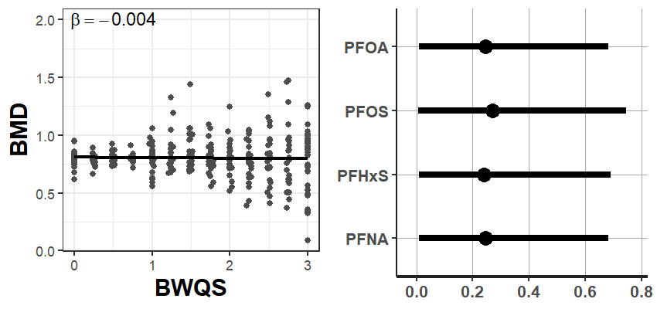
- Total Femur
- Mixture composition
- Estimated association
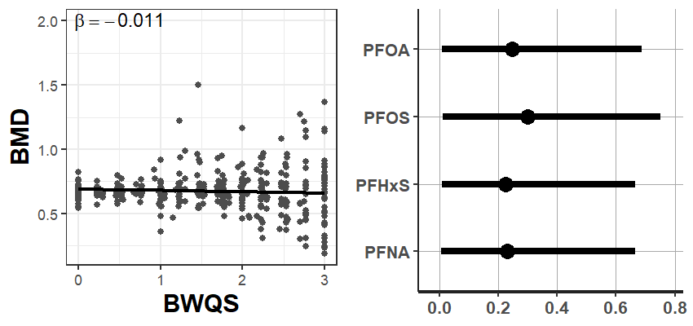
- Femur Neck

Figure S7: Excluding women on hormonal replacement therapy and with further dietary adjustment. Estimates of the 1) association between bone mineral density and the perfluorinated compound (PFAS) mixture in the overall population and estimates of 2) mixture composition: weights (percentage rescaled between 0 to 1) with 95% credible intervals for each mixture component in A) lumbar spine, B) total femur, and C) femur neck.
BMD = bone mineral density adjusted for race/ethnicity, age, sex, physical activity, poverty-income ratio, and smoking status, calcium and vitamins (D & K) intake.
- Mixture composition
- Estimated association
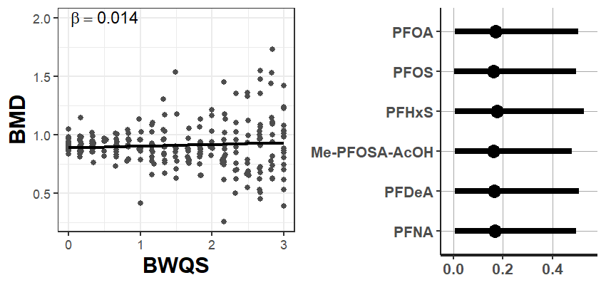
- Estimated association
- Mixture composition
- Lumbar Spine

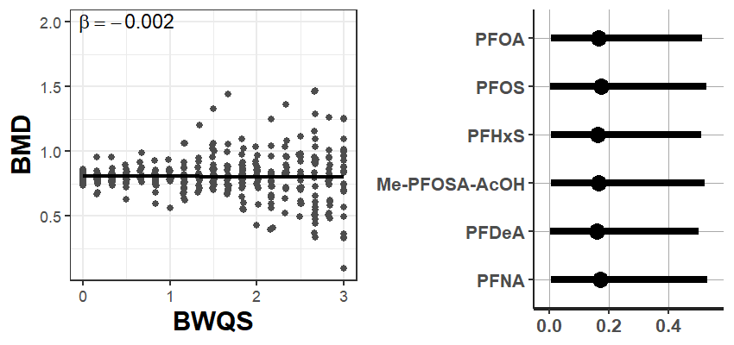
- Estimated association
- Mixture composition
- Total Femur

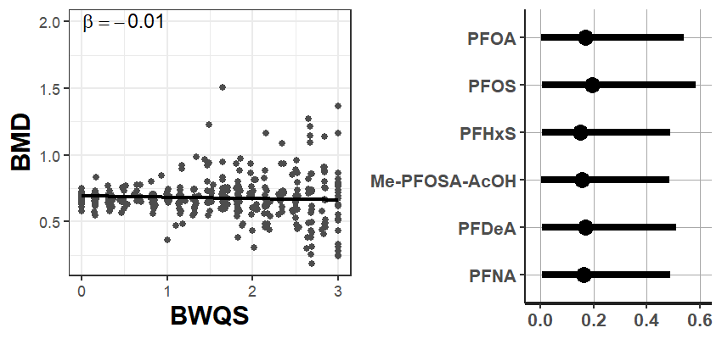
C) Femur Neck

Simulated data
To validate the Bayesian WQS (BWQS) approach, we tested three different simulated scenarios based on 1000 observations from a multivariate normal distribution. Each scenario had a different correlation structure among mixture components, different weights, and different associations with the outcome. The endpoint variable was assumed to be continuous for scenarios A and B, while binary for scenario C.

A) In the first scenario, we employed the BWQS regression, assuming that all components of the mixture jointly had a positive association with a continuous outcome (β₁ = 0.8) but that each contributed differently to the mixture w = (0.5, 0.2, 0.2, 0.05, 0.05). We simulated five mixture components from a multivariate normal distribution with a mean vector μ = (0,0,0,1,3) and the following covariance matrix:
Σ = [1.0000 0.6500 0.4225 1.2675 0.4225;
0.6500 1.0000 0.4225 1.2675 0.4225;
0.4225 0.4225 1.0000 1.2675 0.4225;
1.2675 1.2675 1.2675 9.0000 1.9500;
0.4225 0.4225 0.4225 1.9500 1.0000].
The correlation structure was low to moderate among the mixture components, as previously described for real data (Figure S8). We then computed quartiles for each mixture component, and we generated the continuous outcome variable Y from a normal distribution with a standard deviation of σ = 1.

B) In the second scenario, we simulated a strong correlation between the mixture components (Figure S9) with a multivariate normal distribution with a mean vector μ = (0,0,0,1,3) and the following covariance matrix:
Σ= [ 1.0000 0.8500 0.7225 2.1675 0.7225
0.8500 1.0000 0.7225 2.1675 0.7225
0.7225 0.7225 1.0000 2.1675 0.7225
2.1675 2.1675 2.1675 9.0000 2.5500
0.7225 0.7225 0.7225 2.5500 1.0000 ]
We assumed the set of weights to be w = (0.05,0.15,0.70,0.05,0.05) and intercept and slope coefficients to be β₀ = 2 and β₁ = 0.8, respectively.

C) In the last scenario data (Figure S10), we simulated a binary outcome positively associated (β₁ = 2) with a mixture of five components, but with only one component driving the mixture w = (0.01, 0.96, 0.01, 0.01, 0.01). Data were drawn from a multivariate normal distribution with a mean vector μ = (0,0,0,1,3) and the following covariance matrix:
Σ= [ [1.00 0.60 0.36 1.08 0.36
0.60 1.00 0.36 1.08 0.36
0.36 0.36 1.00 1.08 0.36
1.08 1.08 1.08 9.00 1.80
0.36 0.36 0.36 1.80 1.00 ]

Results from simulated data showed slight discrepancies between estimated and predefined values across scenarios (Figures S8-S10). BWQS estimates were within the 95% credible intervals in all scenarios, independently of the correlation structure, the set of weights for the mixture components, and the outcome variable (binary or continuous).

Figures
Figure S8: BWQS with a continuous outcome. A) Correlation matrix among co-occurring variables; B) weights for each component of the mixture; C) coefficients (intercept and slope) and model uncertainty (sigma) for the linear association of the mixture with the continuous outcome Y. Red dots indicate the true values.
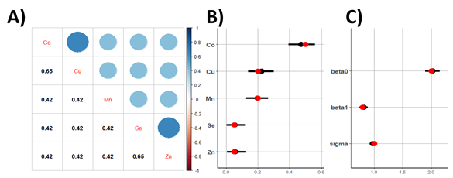

Figure S9: BWQS with a strong correlation among mixture components and a continuous outcome. A) Correlation matrix among co-occurring variables; B) weights for each component of the mixture; C) coefficients (intercept and slope) and model uncertainty (sigma) for the linear association of the mixture with the continuous outcome Y. Red dots indicate the true values.
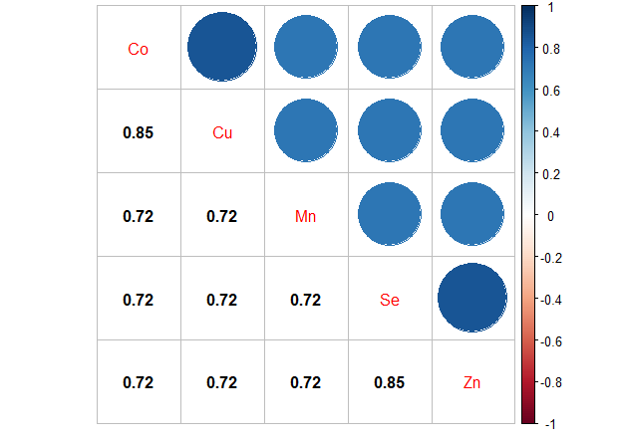
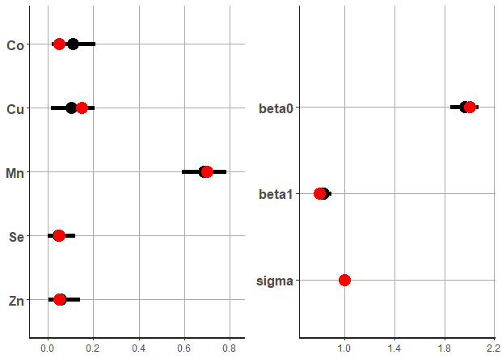
A)
B)
C)

Figure S10: BWQS with extreme weights for the mixture components and a binary outcome. A) Correlation matrix among co-occurring variables; B) weights for each component of the mixture; C) coefficients (intercept and slope) for the association of the mixture with the binary outcome Y. Red dots indicate the true values.
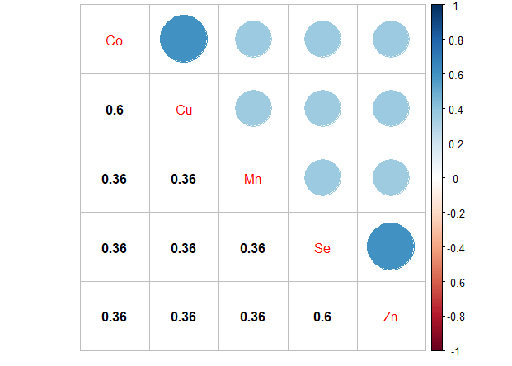
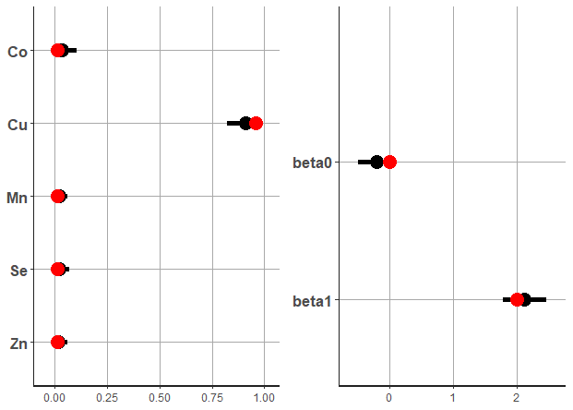
A)
B)
C)

