**Supplemental Figure 1.**  Directed acyclic graph for the association between metals and age at menopause.

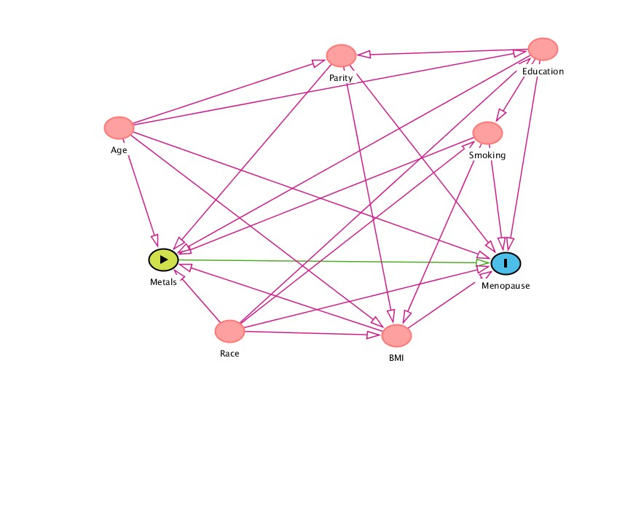

**Supplemental Figure 2.** Spearman correlation matrix of toenail metal concentrations.



**Supplemental Figure 3**. Mixture weights for each metal in the non-essential metal mixture in relation to age at menopause.



**Supplemental Figure 4.** Weights for each metal in the essential metal mixture in relation to age at menopause. 

**Supplemental Figure 5.** Quantile g-computation to estimate absolute risk of menopause with overall metal mixture, where the probability of remaining pre-menopausal by age is given for the highest and lowest quartiles of exposure and the average over all quartiles of exposure. All estimates are averaged over the sample distribution of BMI, smoking, race/ethnicity, and parity.



**Supplemental Table 1**. Range and quartile cut points (µg/g) for toenail metal concentrations

|  |  |  |  |  |  |
| --- | --- | --- | --- | --- | --- |
|  | Percentile | | | | |
|  | Min | 25.00 | 50.00 | 75.00 | Max |
| Antimony | 0.00 | 0.01 | 0.02 | 0.03 | 4.99 |
| Arsenic | 0.00 | 0.04 | 0.05 | 0.07 | 6.12 |
| Cadmium | 0.00 | 0.00 | 0.01 | 0.01 | 0.94 |
| Chromium | 0.00 | 0.12 | 0.23 | 0.49 | 23.99 |
| Cobalt | 0.00 | 0.00 | 0.01 | 0.01 | 0.76 |
| Copper | 1.57 | 3.12 | 3.68 | 4.47 | 22.55 |
| Iron | 2.55 | 7.94 | 11.79 | 19.30 | 384.75 |
| Lead | 0.00 | 0.06 | 0.11 | 0.22 | 12.27 |
| Mercury | 0.00 | 0.04 | 0.10 | 0.20 | 1.78 |
| Magnesium | 0.00 | 0.11 | 0.19 | 0.37 | 20.64 |
| Molybdenum | 0.00 | 0.00 | 0.01 | 0.01 | 1.11 |
| Nickel | 0.00 | 0.14 | 0.35 | 1.11 | 276.16 |
| Selenium | 0.15 | 0.86 | 0.95 | 1.06 | 3.99 |
| Tin | 0.00 | 0.05 | 0.08 | 0.14 | 2.69 |
| Vanadium | 0.00 | 0.01 | 0.01 | 0.03 | 0.36 |
| Zinc | 62.22 | 91.85 | 103.58 | 115.79 | 950.00 |

**Supplemental Table 2.** Hazard ratios (HRs) and 95% confidence intervals (95% CIs) for a quartile increase in each metal, holding all others constant in quantile g-computation.

|  |  |
| --- | --- |
|  | **HR (95% CI)** |
| **Antimony** | 1.02 (0.92,1.13) |
| **Arsenic** | 1.01 (0.90,1.14) |
| **Cadmium** | 1.05 (0.92,1.19) |
| **Chromium** | 0.92 (0.83,1.03) |
| **Cobalt** | 1.11 (0.97,1.28) |
| **Copper** | 0.96 (0.86,1.06) |
| **Iron** | 0.95 (0.82,1.09) |
| **Lead** | 0.99 (0.87,1.12) |
| **Mercury** | 0.97 (0.88,1.07) |
| **Magnesium** | 1.00 (0.87,1.16) |
| **Molybdenum** | 1.03 (0.92,1.15) |
| **Nickel** | 0.92 (0.82,1.02) |
| **Selenium** | 0.98 (0.88,1.08) |
| **Tin** | 0.98 (0.88,1.09) |
| **Vanadium** | 0.95 (0.84,1.09) |
| **Zinc** | 0.97 (0.87,1.08) |

**Supplemental Table 3.** Hazard ratios (HRs) and 95% confidence intervals (95% CIs) for the association between the overall metal mixture and age at menopause when iron is excluded.

|  |  |
| --- | --- |
| Metals | HR (95% CI) |
| All | 0.81 (0.64,1.02) |
| Exclude iron | 0.83 (0.65,1.05) |

**Supplemental Table 4.** Hazard ratios (HRs) and 95% confidence intervals (95% CIs) for the association between the overall metal mixture and age at menopause when restricting based on age at baseline.

|  |  |  |
| --- | --- | --- |
| Metals | Include only1 | HR (95% CI) |
| All | All | 0.81 (0.64,1.02) |
| All | < Median | 0.78 (0.48,1.25) |
| All | > Median | 0.85 (0.65,1.11) |
| All | < 90th percentile | 0.76 (0.59,0.99) |
| All | > 90th percentile | 1.62 (0.83,3.15) |
| Non-essential only | < 90th percentile | 0.96 (0.60,1.54) |
| Essential only | < 90th percentile | 0.85 (0.52,1.40) |
| 1Restrict by age at baseline: median = 44.3, 90th percentile = 49.95 | | |

**Supplemental Table 5.** Hazard ratios (HRs) and 95% confidence intervals (95% CIs) for the association between the overall metal mixture and age at menopause when using varying number of quantiles.

|  |  |
| --- | --- |
| # quantiles | HR (95% CI) |
| 2 | 0.79 (0.60,1.04) |
| 3 | 0.77 (0.60,0.97) |
| 4 | 0.81 (0.64,1.02) |
| 5 | 0.83 (0.66,1.04) |
| 6 | 0.80 (0.64,1.01) |
| 7 | 0.83 (0.66,1.04) |
| 8 | 0.83 (0.66,1.04) |
| 9 | 0.81 (0.65,1.02) |
| 10 | 0.82 (0.66,1.03) |
| 11 | 0.83 (0.66,1.04) |
| 12 | 0.82 (0.65,1.03) |
| 13 | 0.83 (0.66,1.04) |
| 14 | 0.83 (0.66,1.03) |
| 15 | 0.82 (0.66,1.02) |
| 16 | 0.82 (0.66,1.03) |
| 17 | 0.82 (0.66,1.03) |
| 18 | 0.82 (0.65,1.02) |
| 19 | 0.82 (0.65,1.02) |
| 20 | 0.82 (0.66,1.03) |

**Supplemental Table 6.** Association between the overall mixture effect and age at menopause allowing for non-linearity

|  |  |
| --- | --- |
| Parameter | beta (95% CI) |
| All metals, main term | -0.45 (-1.59, 0.70) |
| All metals, quadratic term | 0.08 (-0.30, 0.46) |