Tidal volume challenge to predict fluid responsiveness in operating room: a prospective trial on neurosurgical patients.

Antonio Messina, MD, PhD¹; Claudia Montagnini, MD²; Gianmaria Cammarota MD, PhD²; Silvia De Rosa, MD, MS, FCCN ³; Fabiana Giuliani, MD², Lara Muratore, MD², Francesco Della Corte², MD; Paolo Navalesi, MD, FERS⁴; Maurizio Cecconi, MD, FRCA, FICM¹.

¹IRCCS Humanitas, Humanitas University, Milano, Italy; ²Anesthesia and Intensive Care Medicine, Maggiore della Carità University Hospital, Novara, Italy; ³Department of Anesthesiology and Intensive Care, San Bortolo Hospital, Vicenza, Italy; ⁴Anesthesia and Intensive Care, Department of Medical and Surgical Sciences, Magna Graecia University, Catanzaro, Italy.

Supplemental Digital Content

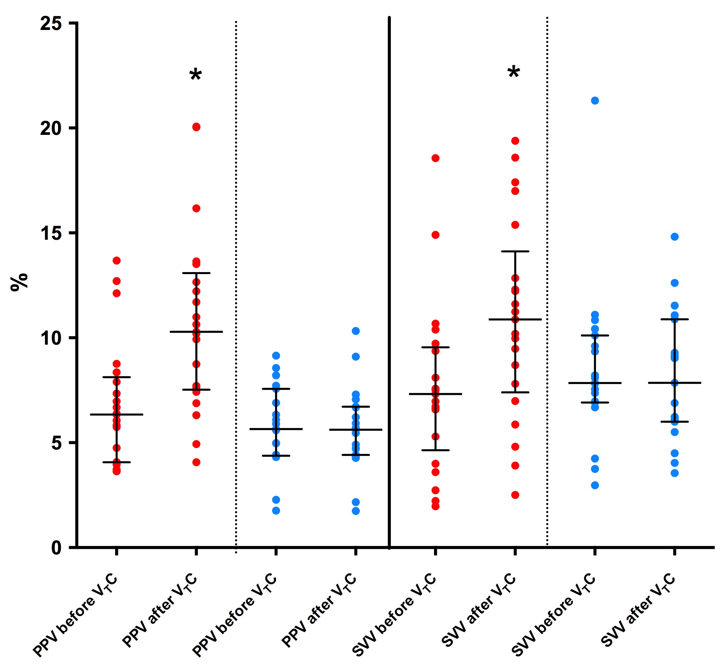

Supplemental Figure 1. Alligned dot plots of changes of pulse pressure variation (PPV) and stroke volume variation (SVV) after tidal volume challenge (V_{T}C) in responders (red circles) and non-responders (blue circles). Median (IQR) values of each subgroup are depicted through black lines. In responders, V_{T}C increased PPV increased from 6.3% (4.0-8.1) to 10.3% (7.5-13.8) (p < 0.0001) and SVV from 7.3% (4.6-9.6) to 9.9% (6.4-13.7) (p < 0.0001).

