Supplementary Figure 1 Measurement of the oral odor using Halitosis Detector.
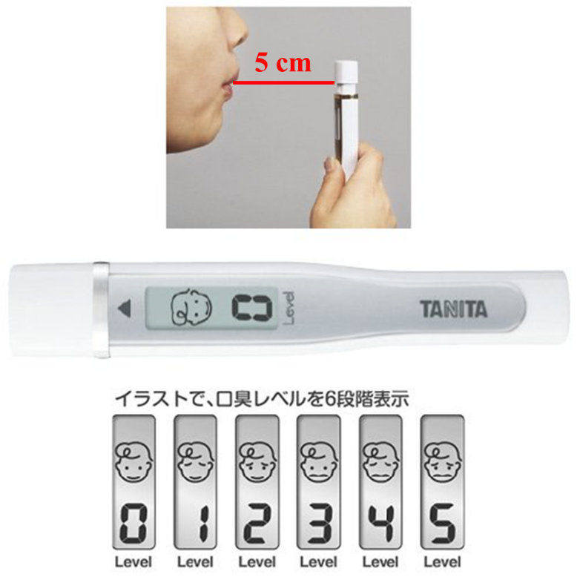
Notes: The anesthesiologist asked the patients to exhale to the Halitosis Detector to measure the oral odor (score ≤5) prior to induction of anesthesia, according to the manufacturer’s instructions.

Supplementary Figure 2 Comparison of different laryngoscope blades
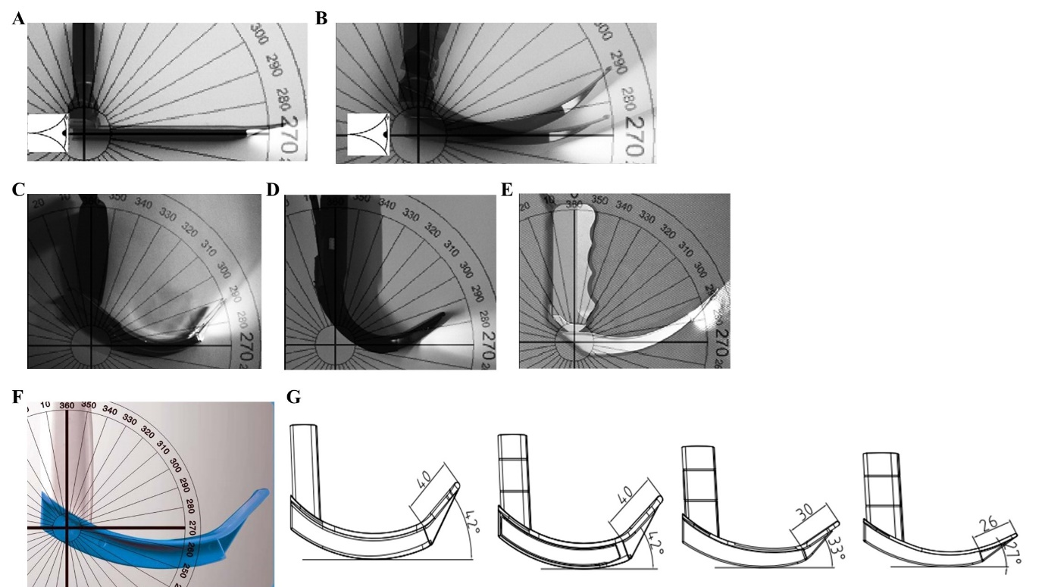
Notes: A: Miller blade; B: Macintosh blade; C: McGrath blade; D: GlideScope blade; E: C-MAC blade; F: UE videolaryngoscope blade; G: Different sizes of UE videolaryngoscope blade

Supplementary Figure 3 Glottis exposure with direct and video laryngoscopes.
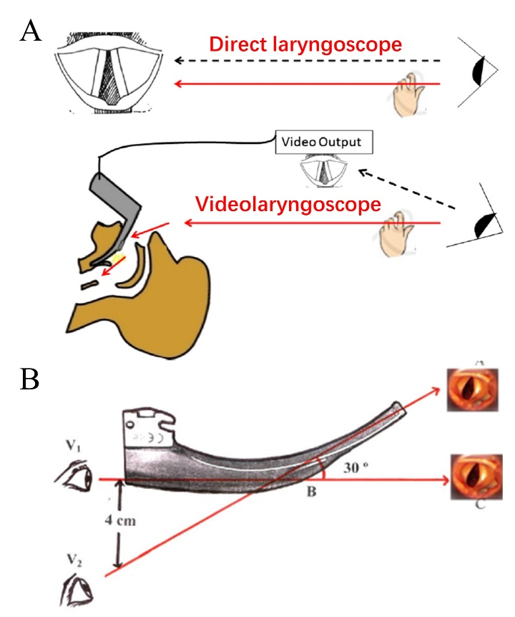
Notes: A: Glottis exposure with direct and video laryngoscopes. B: Different angles when intubating with direct and video laryngoscopes.

