Appendix 4.

Forrest plots of the main results conducted by RevMan.

Adults

USG IJV

1. Overall Success

RCTs
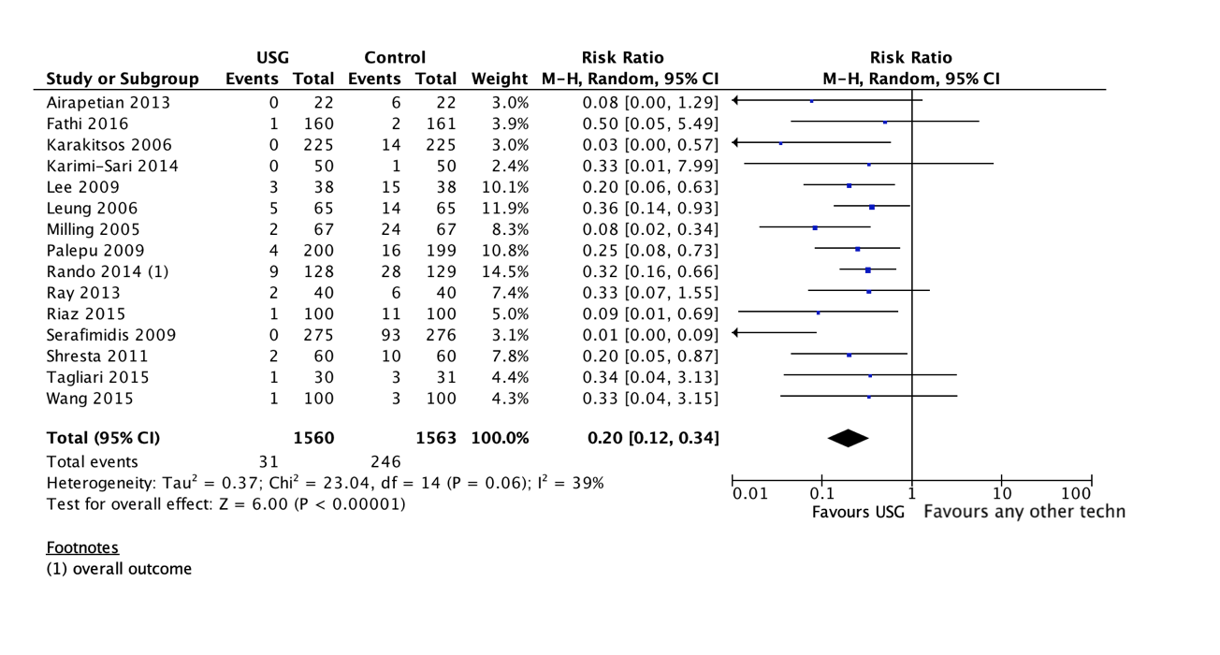

2. Overall Complications

RCTs
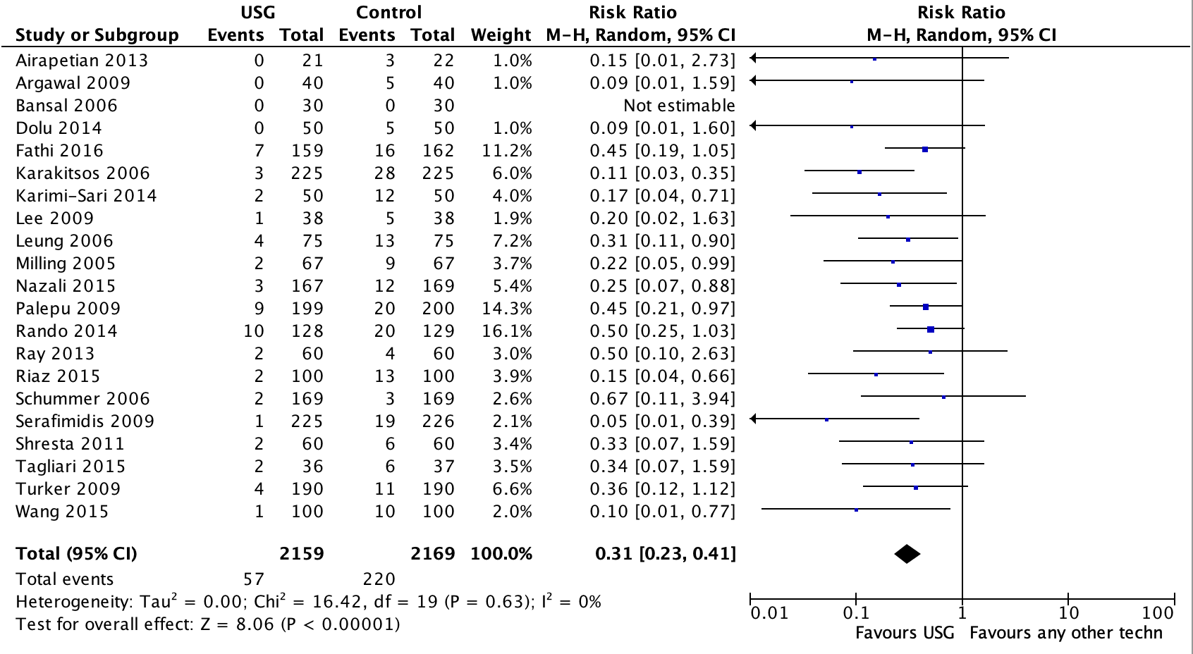

3. First Time Success

RCTs
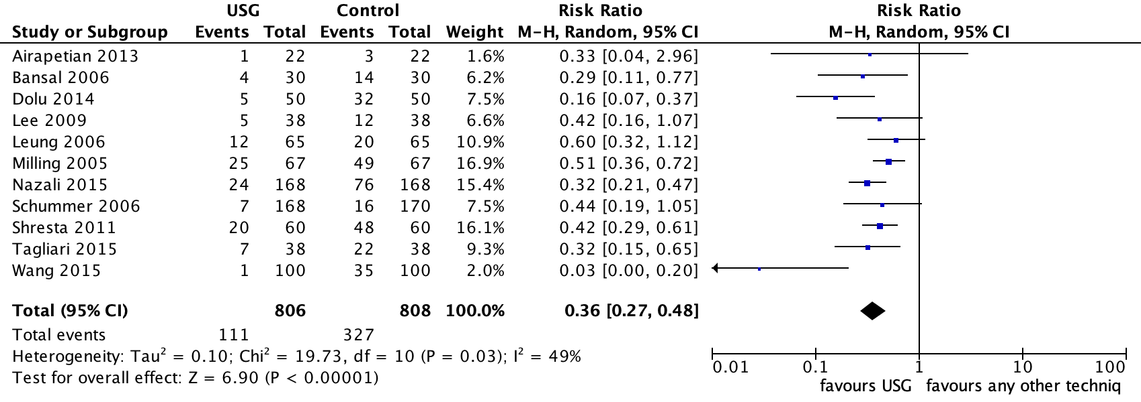

4. Time to Success

RCTs
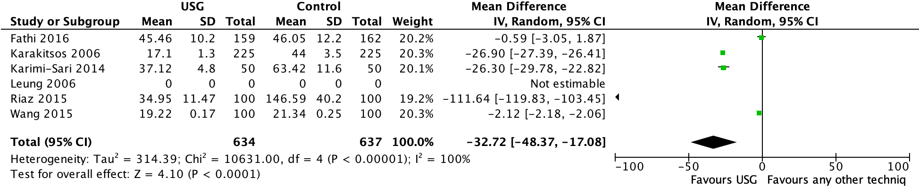

5. Time to Successful Cannulation

RCTs
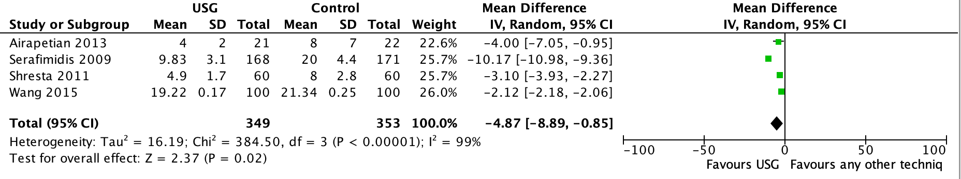

USG Subclavian vein

1. Overall success
RCTs
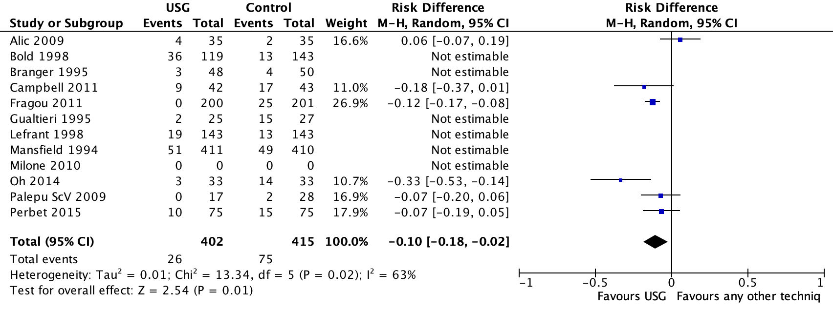

2. Overall complications
RCTs

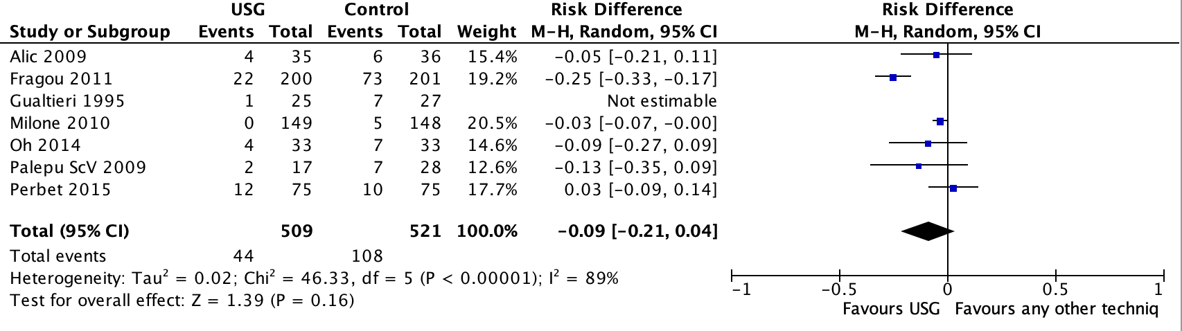

USG Axillary vein

Overall complications

RCTs
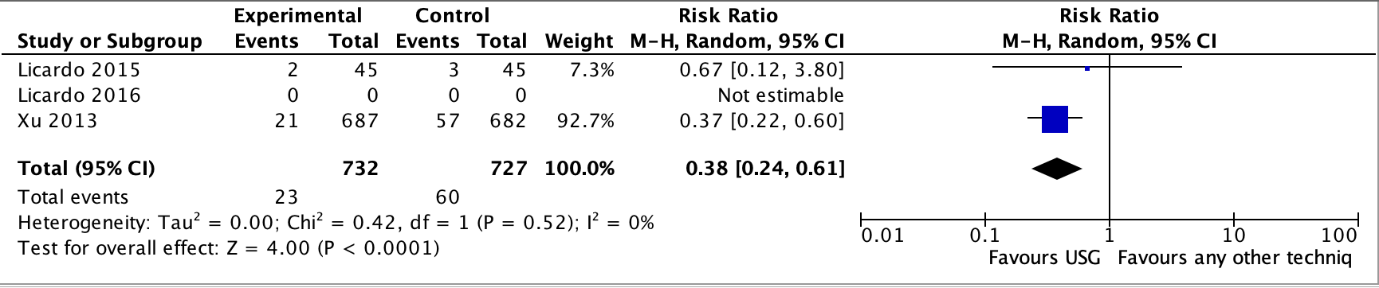

USG Femoral Vein (FV) Puncture

- Overall Success

Observational Prospective Studies

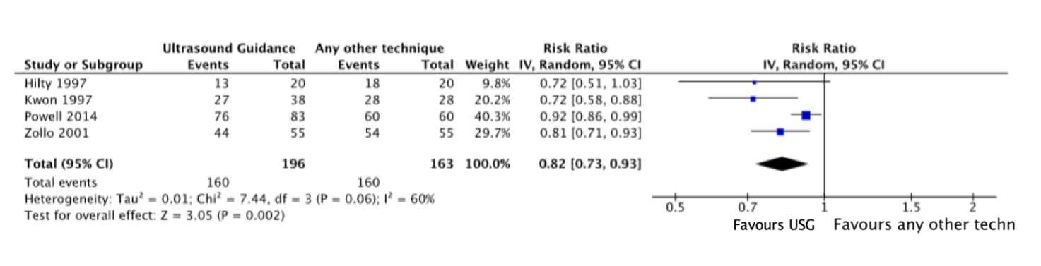

RCTs
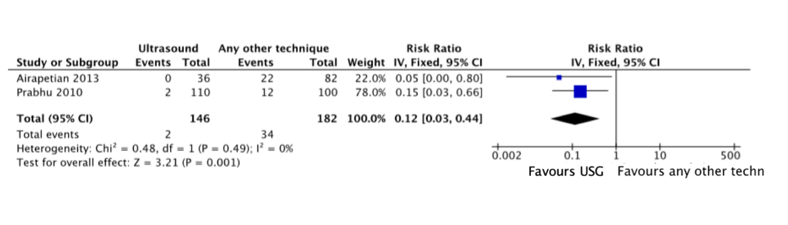
2. Overall Complications
Observational Prospective Studies
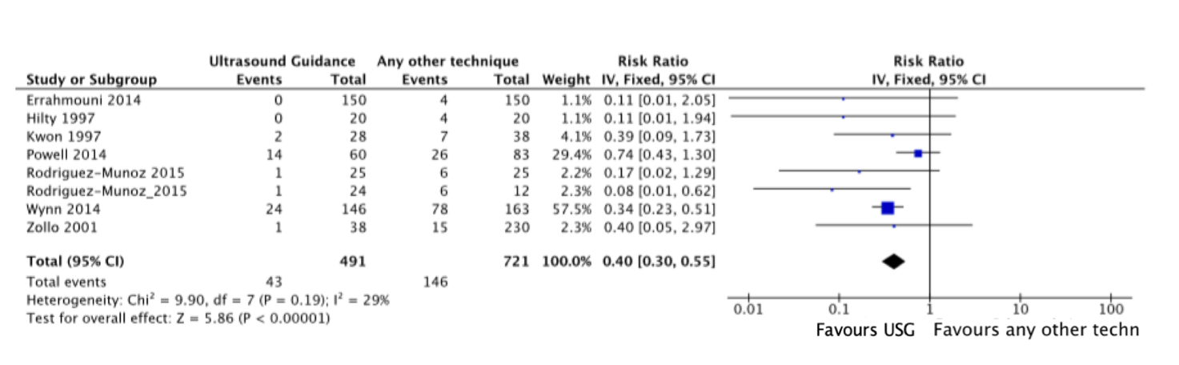

RCTs
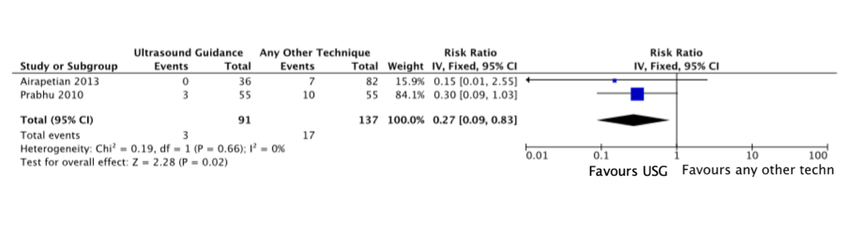

3. Time to Successful Cannulation
Observational Prospective Studies
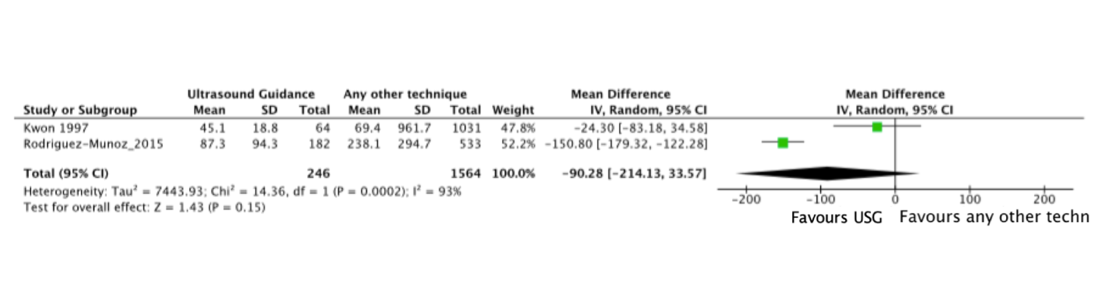
RCTs
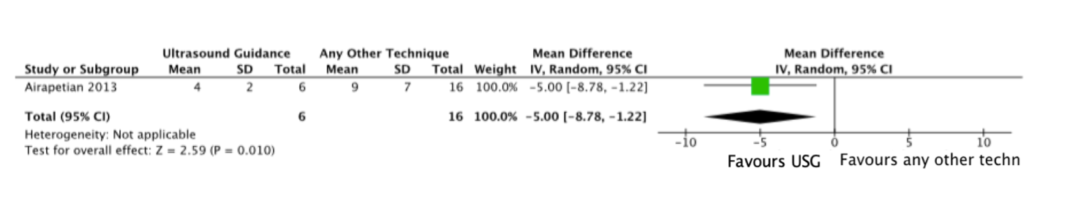

4. Number of Attempts
Observational Prospective Studies
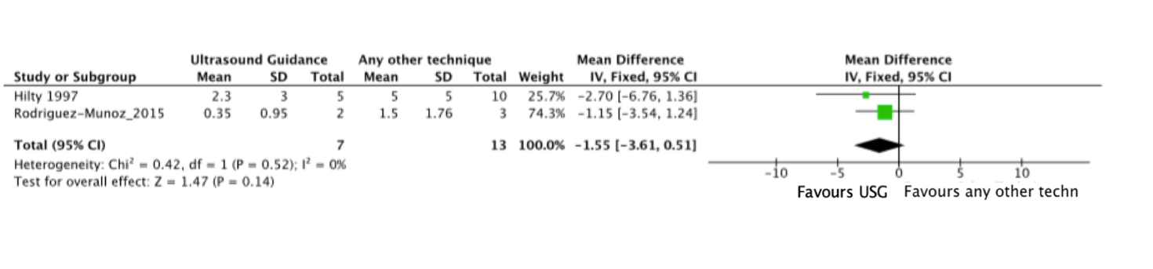

RCTs
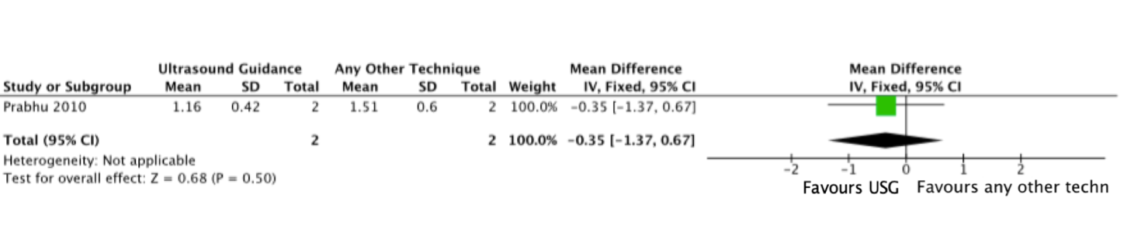

USG Peripheral Vein Puncture

- Overall Success
Observational Prospective Studies
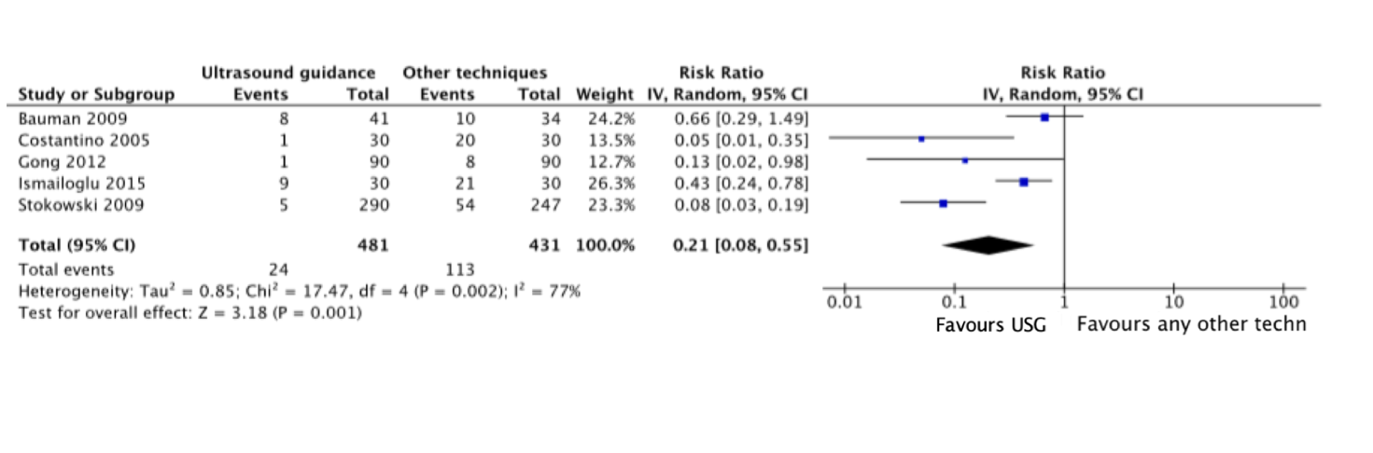

RCTs
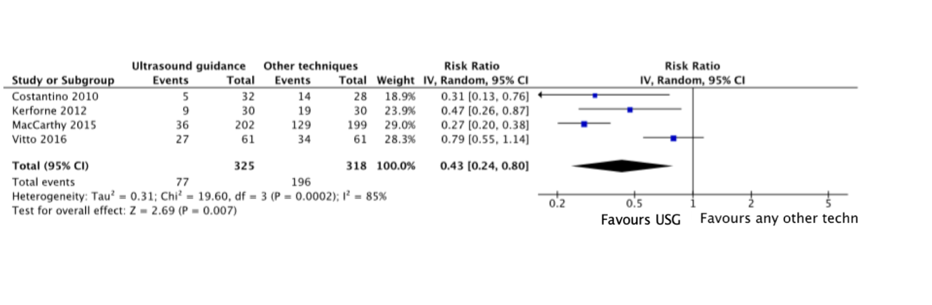

2. Overall Complications
Observational Prospective Studies

RCTs
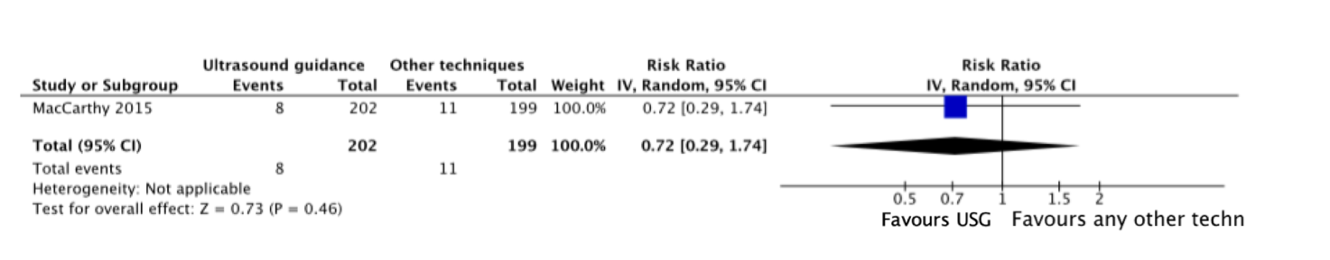

3. Time to Successful Cannulation
Observational Prospective Studies
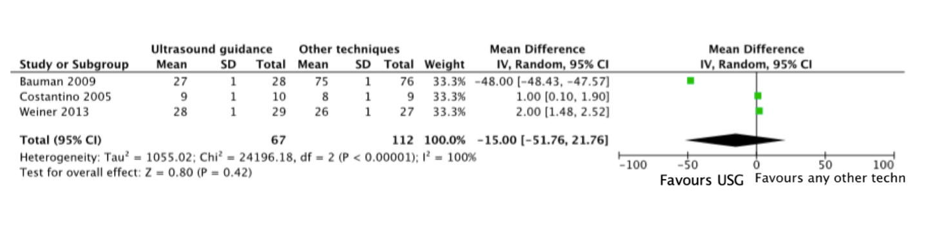

RCTs
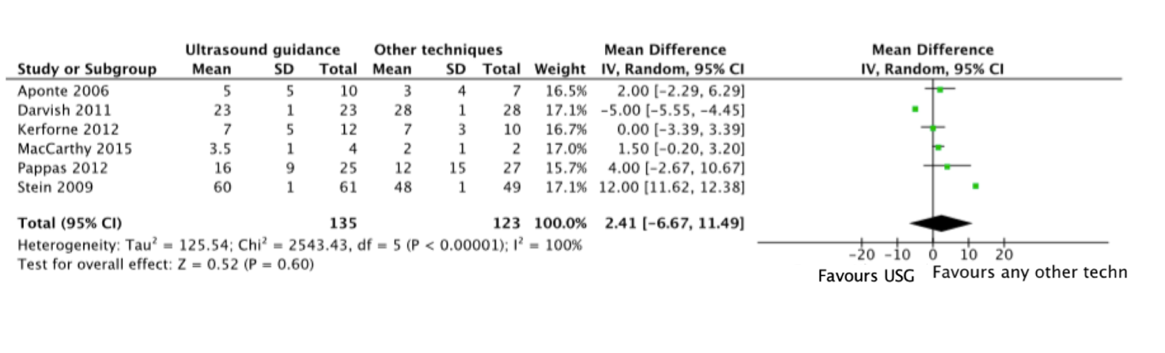

USG Long-Term-Vascular Access Devices

1. Catheter-related thrombosis
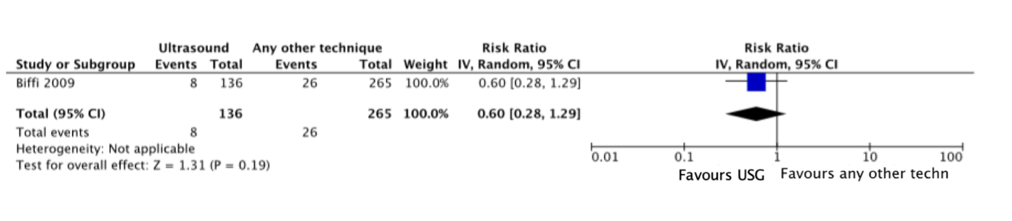
2. Pinch-off syndrome
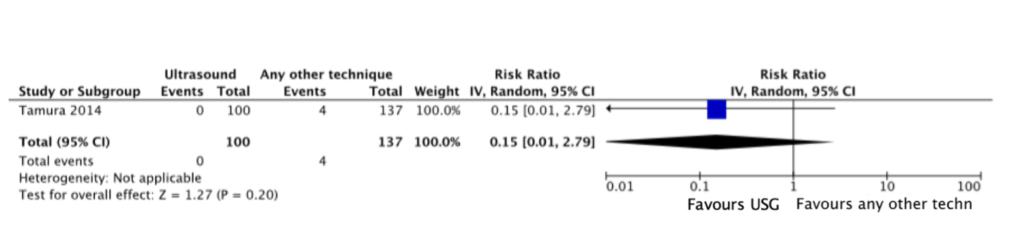
3. Early and Immediate Complications
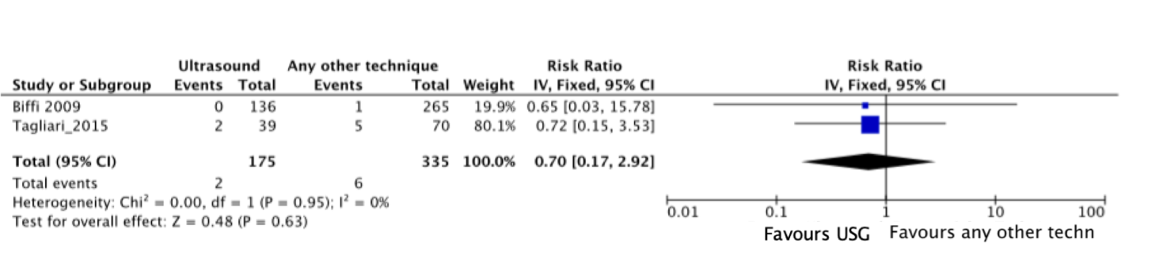

USG Arterial Cannulation

- Radial Artery

1. Overall Success
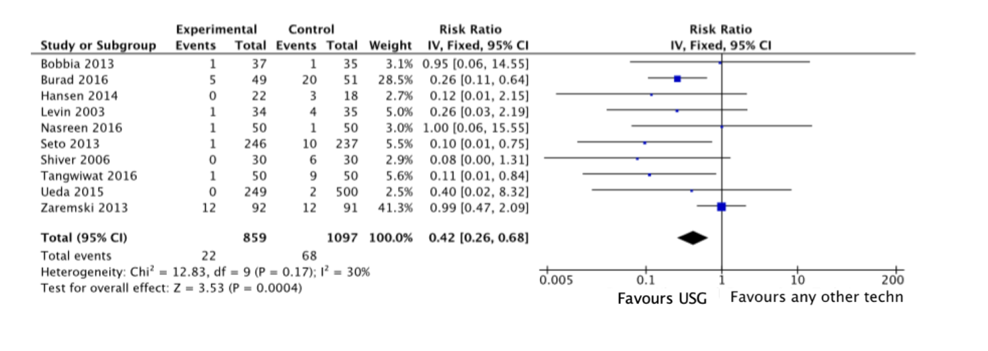

2. Overall Complications
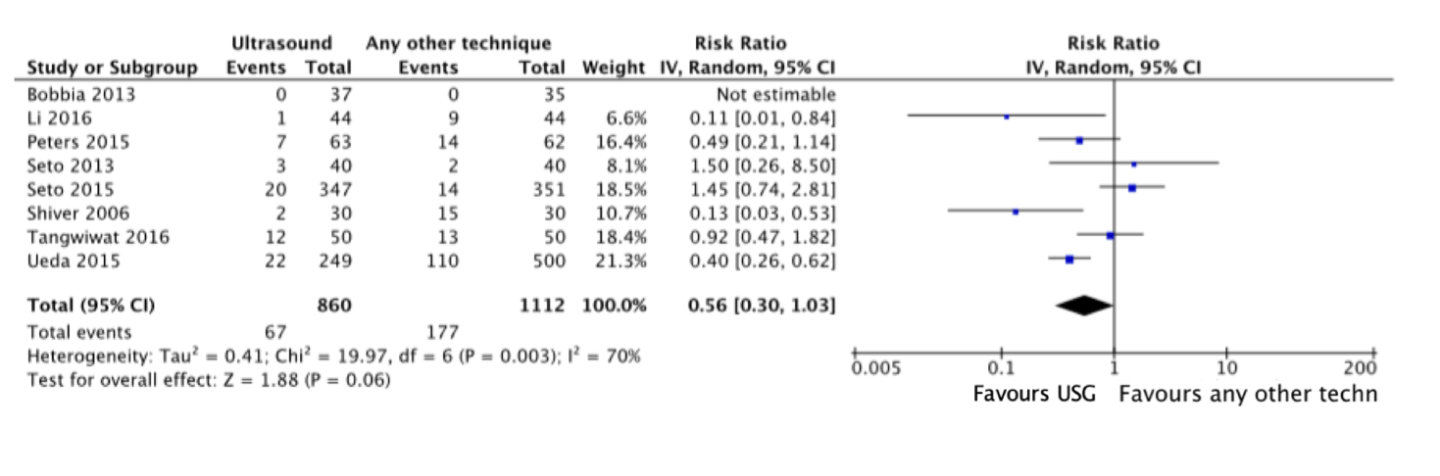

3. First Time Successful cannulation
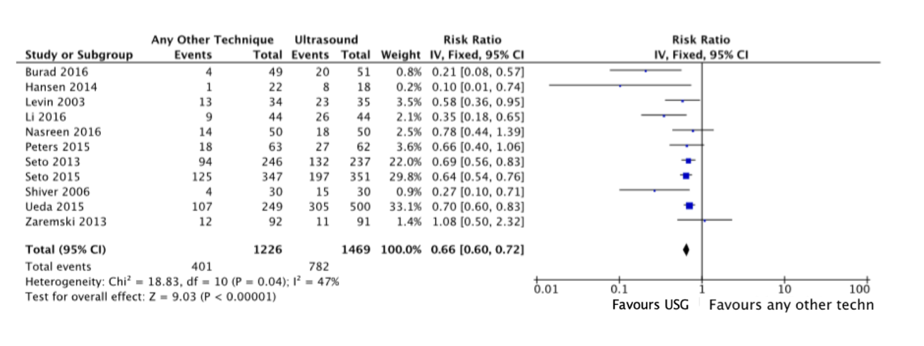

4. Time to Successful cannulation
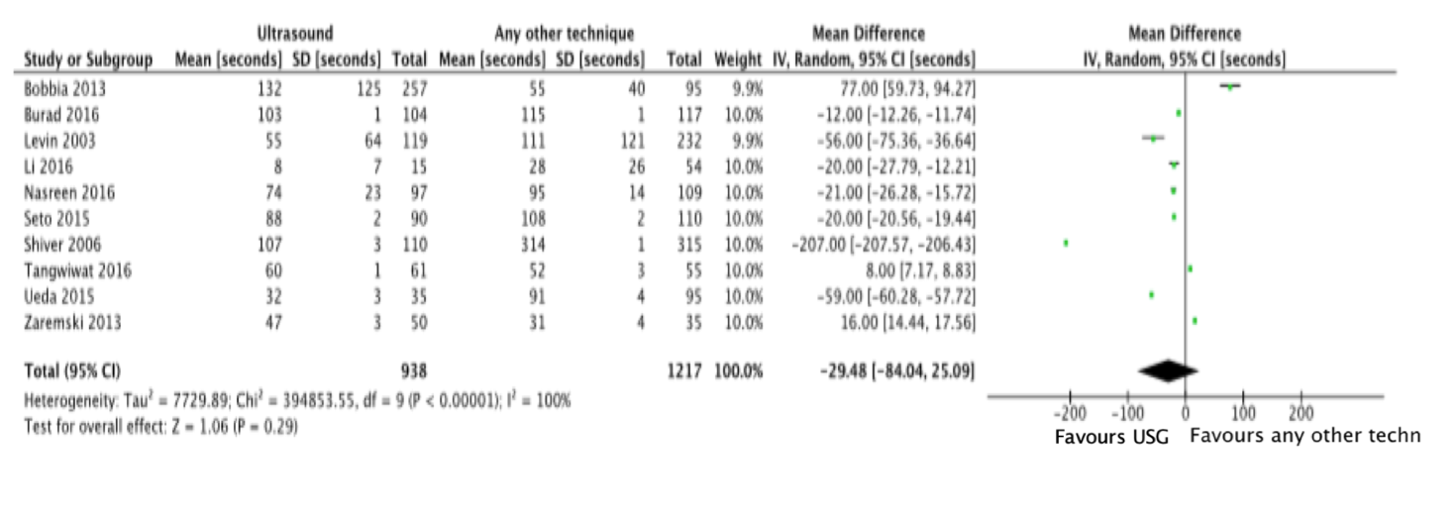

- Femoral Artery

- Overall Success

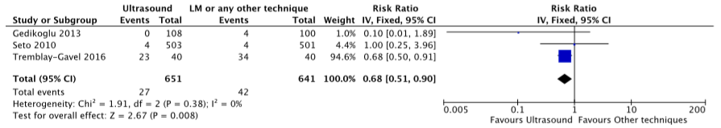

2. Overall Complications

3. First Time Successful Cannulation
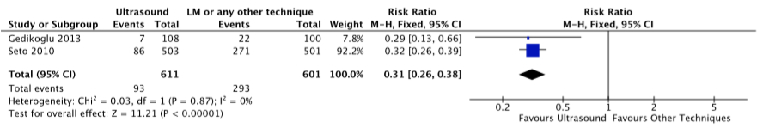

4. Time to successful cannulation

US for Tip Location and Tip Navigation

Accuracy

Time to Diagnosis

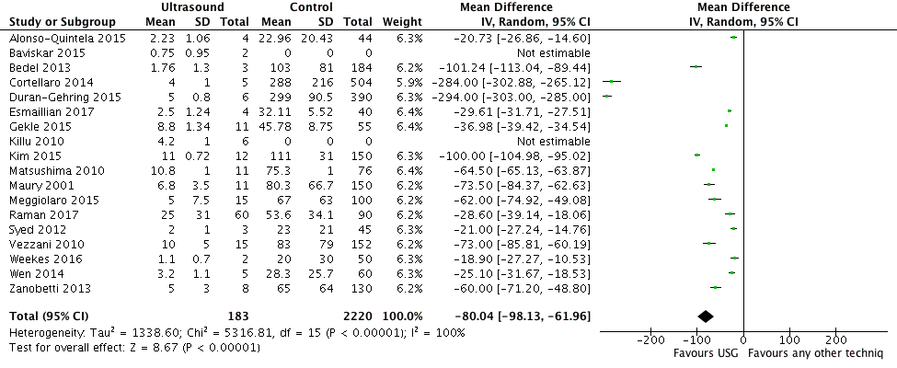

Sensitivity and Specificity
- CEUS + TTE: Forest Plot

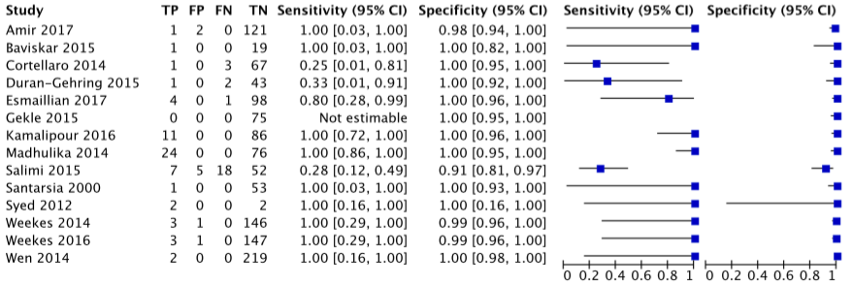
- CEUS + TTE: ROC
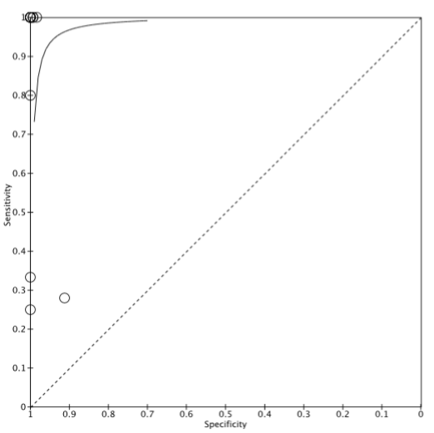

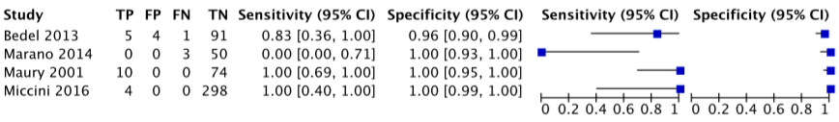
- Vascular US + TTE: Forest Plot

- Vascular US + TTE: SROC
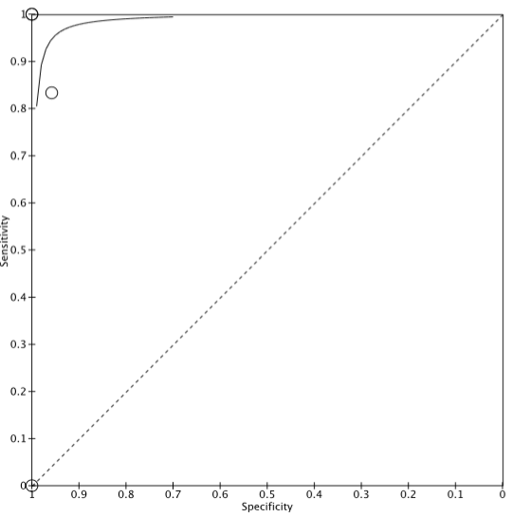

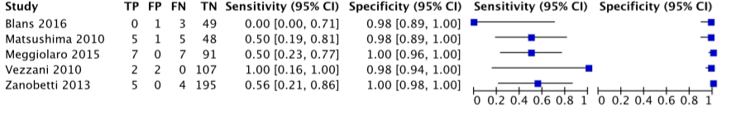
- Vascular US + TTE + CEUS: Forest Plot
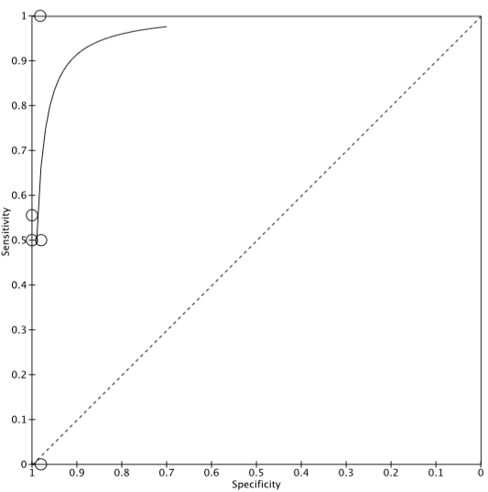

- Vascular US + TTE + CEUS: SROC

- Supra-clavicular US: Forest Plot

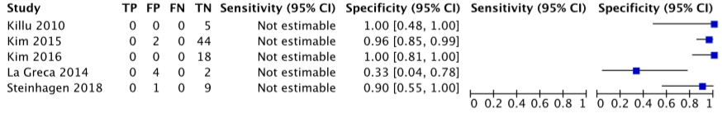
- Supra-clavicular US: SROC
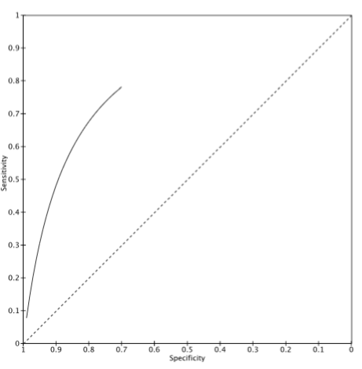

US Tip Location in Pediatrics: Forest Plot

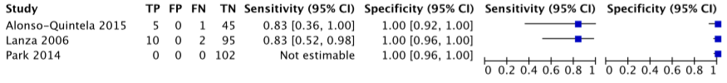

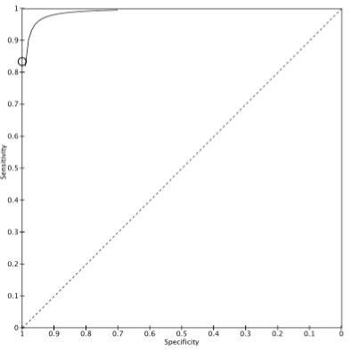
- US Tip Location in Pediatrics: SROC

US for Early Diagnosis of Central Veins Puncture Complications

Accuracy

Time to diagnosis
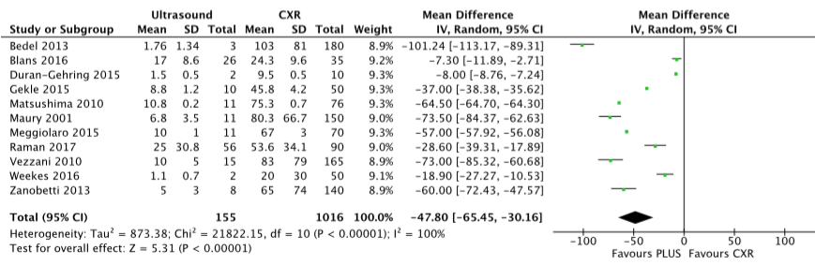

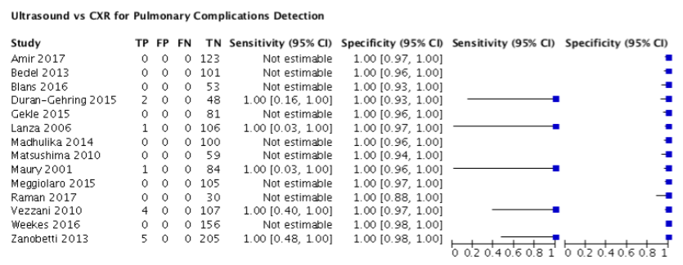
Sensitivity and Specificity

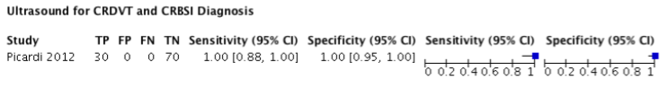

US for Pulmonary Complications Detection: SROC

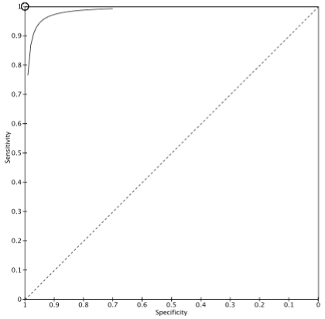

PEDIATRIC

USG Internal Jugular Vein

1. Overall Success
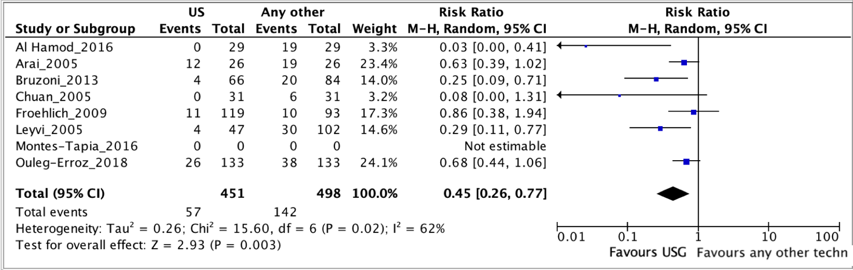

2. Overall Complications
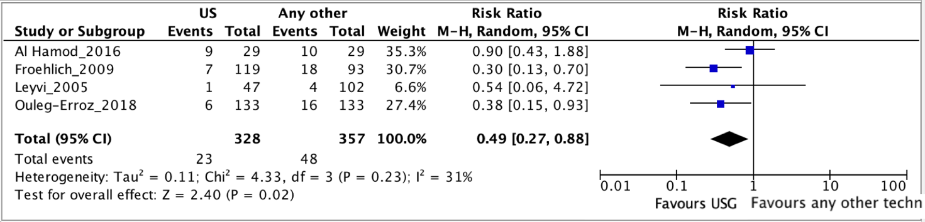

3. Time to Success
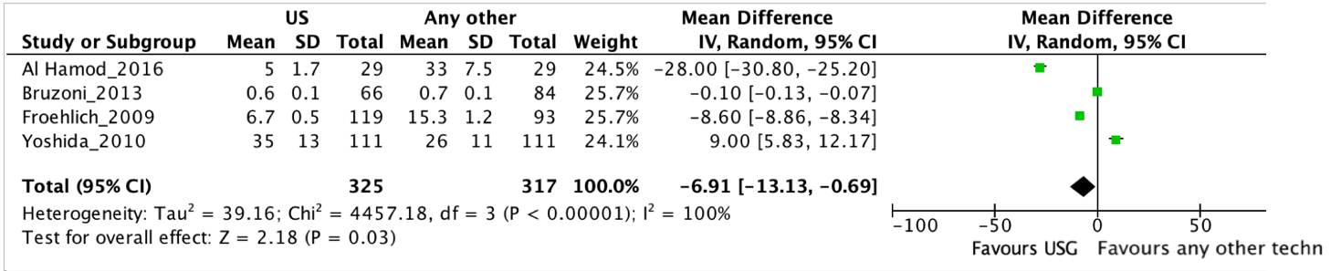

USG Femorally inserted central catheters

1. Overall success
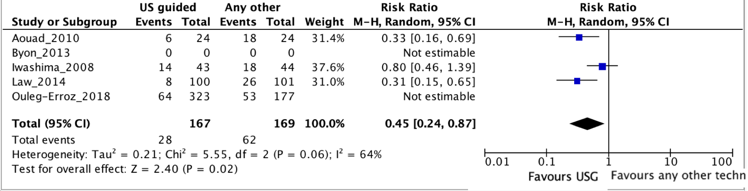

2. Overall Complications
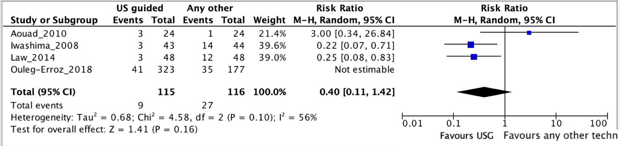

- Time to Success

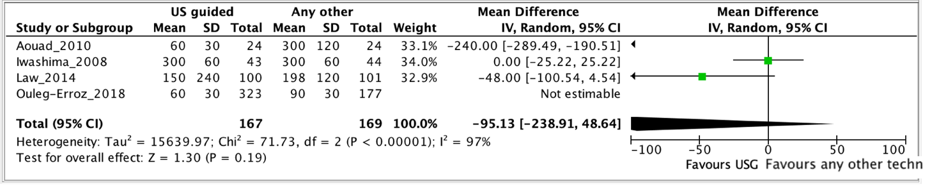

USG ARTERIAL

1. Overall success

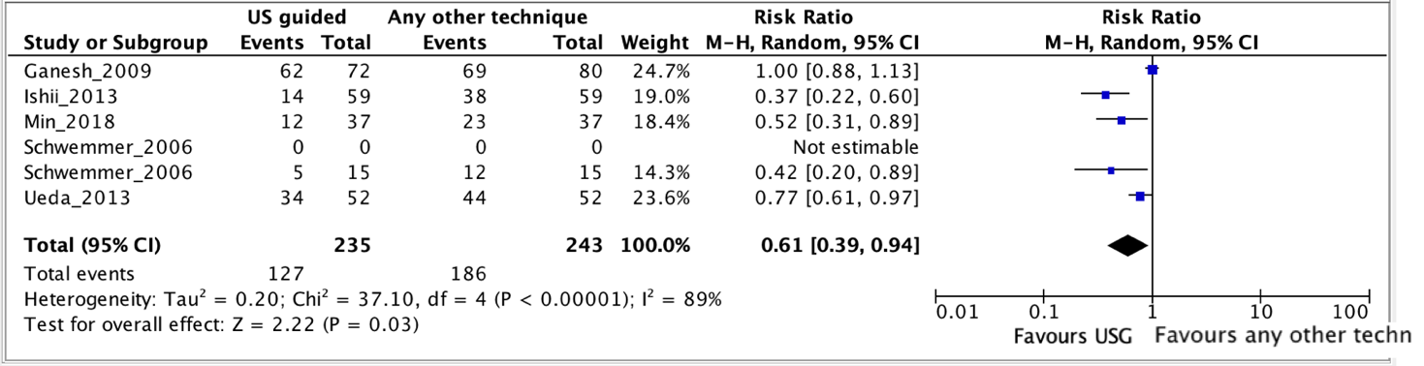

USG PERIPHERAL LINE

- Overall success

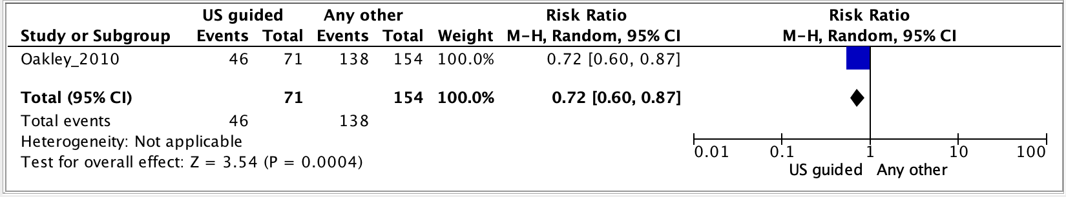

2. Time to Success

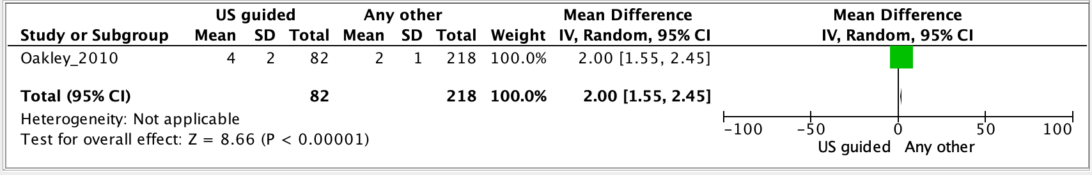

USG Subclavian Vein, Brachiocephalic Vein, Axillary Vein

- Overall success

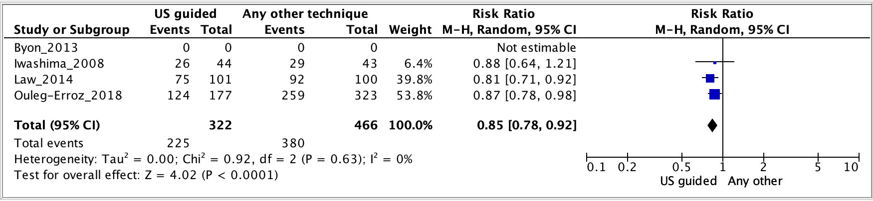

2. Overall Complications

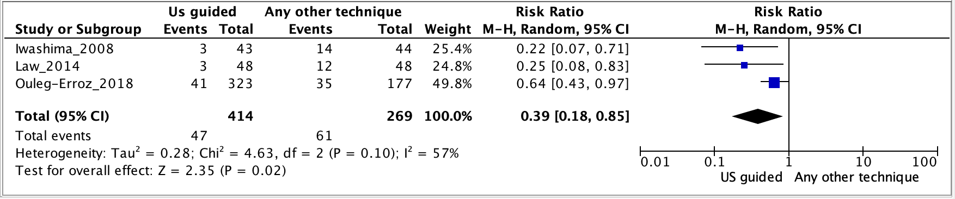

3. Time to Success

