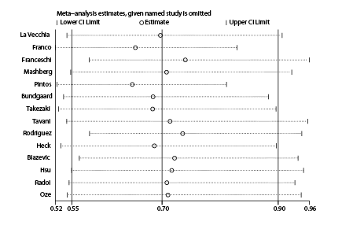
Fig. S1. Sensitivity analysis for high versus low coffee intake and oral cavity cancer risk from case-control studies

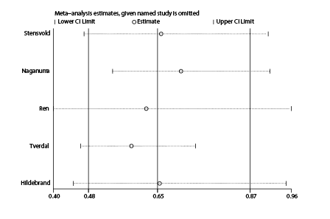
Fig. S2. Sensitivity analysis for high versus low coffee intake and oral cavity cancer risk from cohort studies

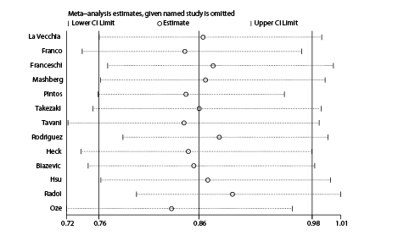
Fig. S3. Sensitivity analysis for intermediate versus low coffee intake and oral cavity cancer risk from case-control studies

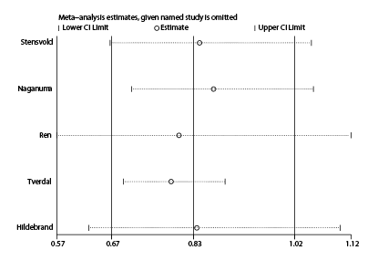
Fig. S4. Sensitivity analysis for intermediate versus low coffee intake and oral cavity cancer risk from cohort studies

