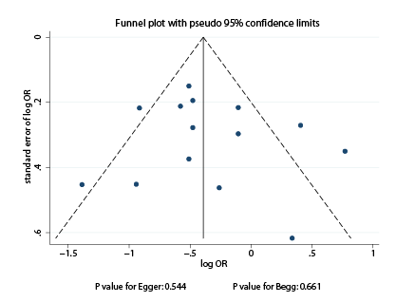
Fig. S1. Funnel plot for high versus low coffee intake and oral cavity cancer risk from case-control studies

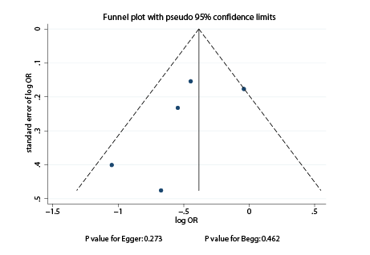
Fig. S2. Funnel plot for high versus low coffee intake and oral cavity cancer risk from cohort studies

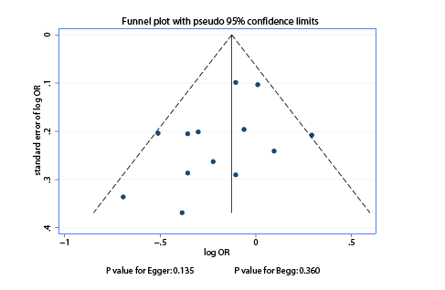
Fig. S3. Funnel plot for intermediate versus low coffee intake and oral cavity cancer risk from case-control studies

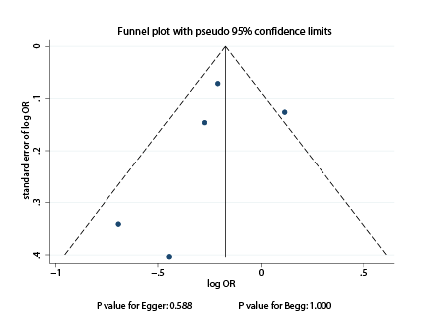
Fig. S4. Funnel plot for intermediate versus low coffee intake and oral cavity cancer risk from cohort studies

