Figure S1

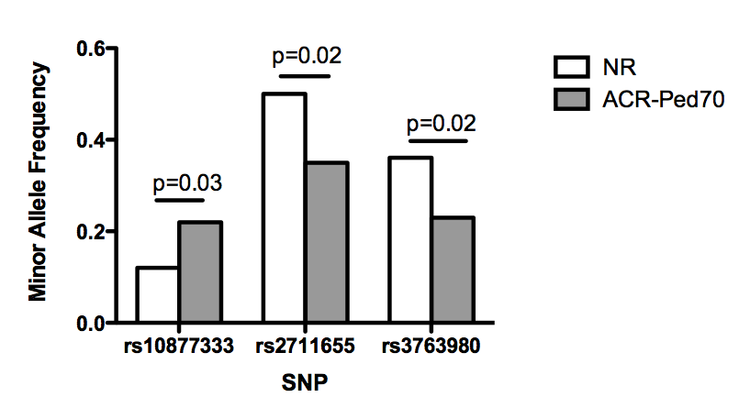
Figure S1: Frequency of minor allele in MTX responders (ACR-Ped70) and non-responders (NR) for the three significant SNPs in SLC16A7 gene.

