SUPPLEMENTAL MATERIAL
Genotyping and Imputation
In the exploratory PGx analysis, DNA samples were genotyped using the Illumina Omni1 Quad array (Studies BEL110751/BLISS-76/HGS-C1056 and BEL110752/BLISS-52/HGS-C1057) or the Affymetrix Axiom Biobank array with GSK custom content (Study BEL112341) through service agreements with Expression Analysis (Durham, NC) and BioStorage Technologies (BST) (Piscataway, NJ), respectively. The genome-wide array data were used to impute gene dosages as follows: For each array, genotypes were aligned to the reference strand and phased by chromosome using sequence and genotype data to estimate haplotypes and unobserved genotypes with MaCH v1.0.18.c [1]. The phased haplotypes were used to impute genotype dosages using the 1000 Genomes Project reference haplotypes (phase1_release_v3.20101123 without singletons) and the minimac 2012-11-16 release [2]. Standard quality control exclusions were applied.
In the confirmatory PGx analysis, we obtained approval from the Human Genetic Resources Administration of China to include DNA samples from Chinese patients. As our research objective was to confirm or refute the preliminary associations observed in the ANO3 gene region, rs293983 genotypes were generated using a TaqMan® SNP genotyping assay (ThermoFisher Scientific, Waltham, MA) through service agreements with BST or Shanghai Biosciences Corporation (Shanghai, China). Genotypes from Chinese patients were exported to the US for analysis.
REFERENCES FOR SUPPLEMENTAL MATERIALS
- Li Y, Willer CJ, Sanna S, Abecasis GR. Genotype imputation. Annual Review Genomics and Human Genetics 2009; 10: 387-406.
- Howie B, Fuchsberger C, Stephens M, Marchini J, Abecasis GR. Fast and accurate genotype imputation in genome -wide association studies through pre-phasing. Nature Genetics 2012; 44: 955-959.

Supplemental Figure 1: Manhattan plots
1A: Study BEL110751 and BEL110752
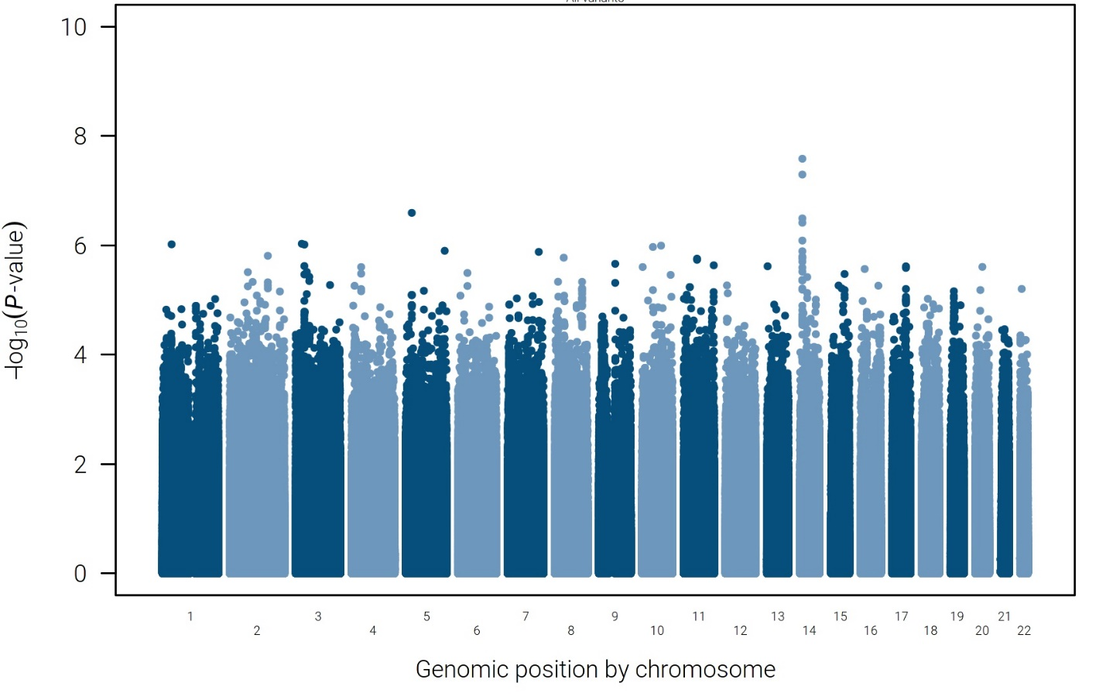
1B: Study BEL112341
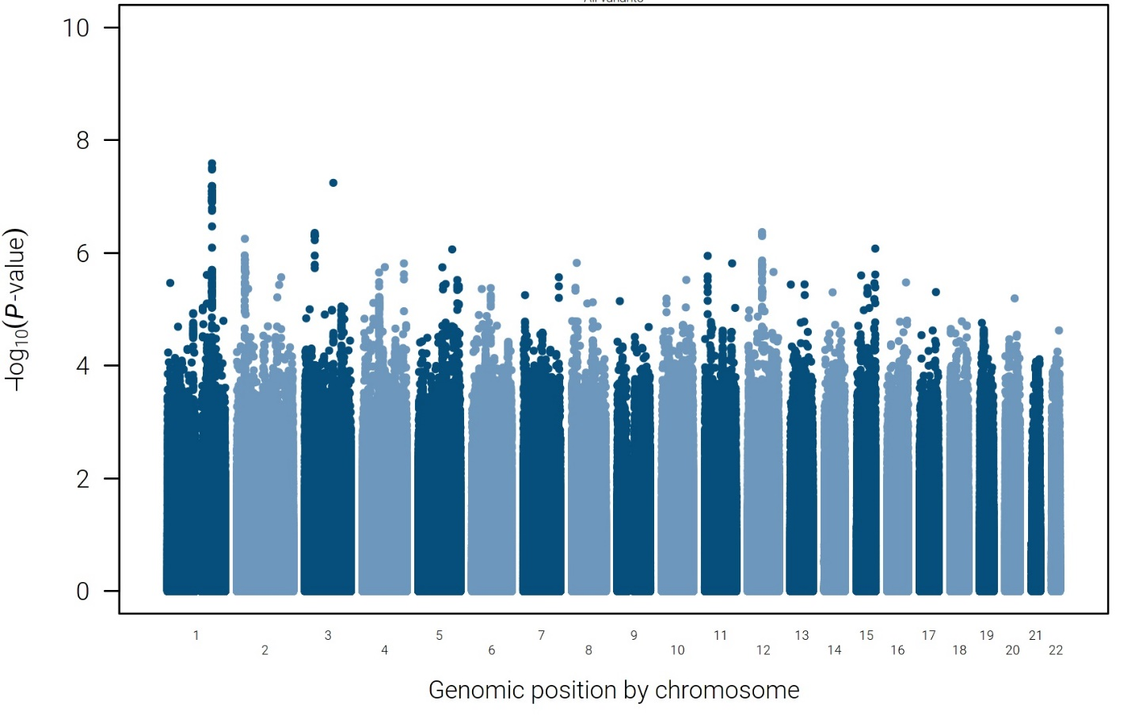
1C: Meta-analysis of BEL110751/BEL110752 and BEL112341
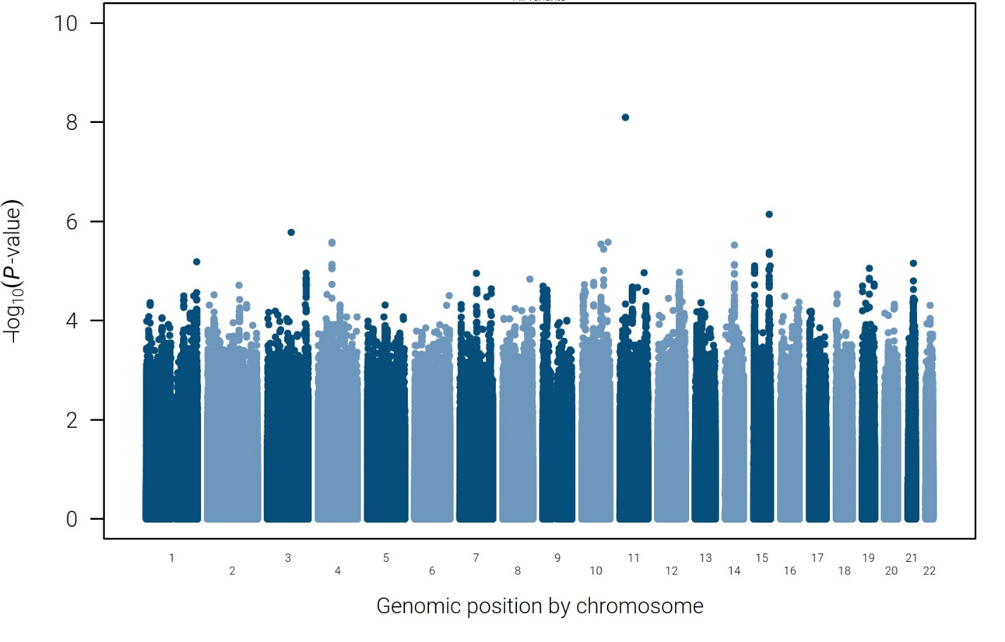

Supplemental Figure 2: Q-Q plots for the combined BEL110751 and BEL110752 studies and Study BEL112341
2A: Q-Q plots for Studies BEL110751 and BEL110752
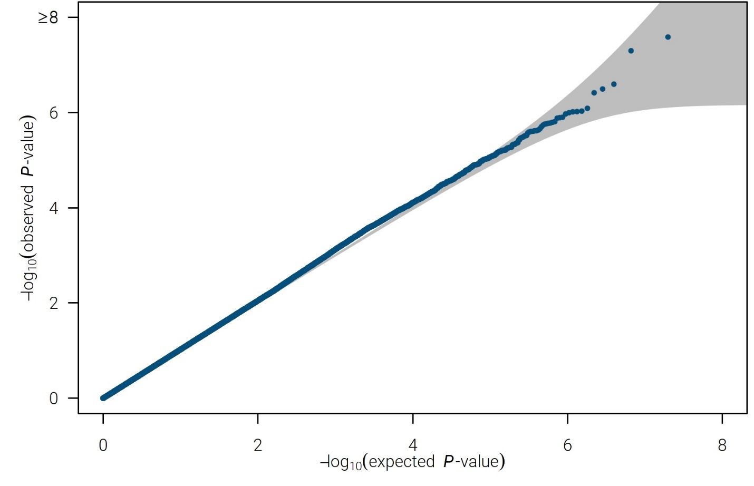
2B: Q-Q plot for BEL112341
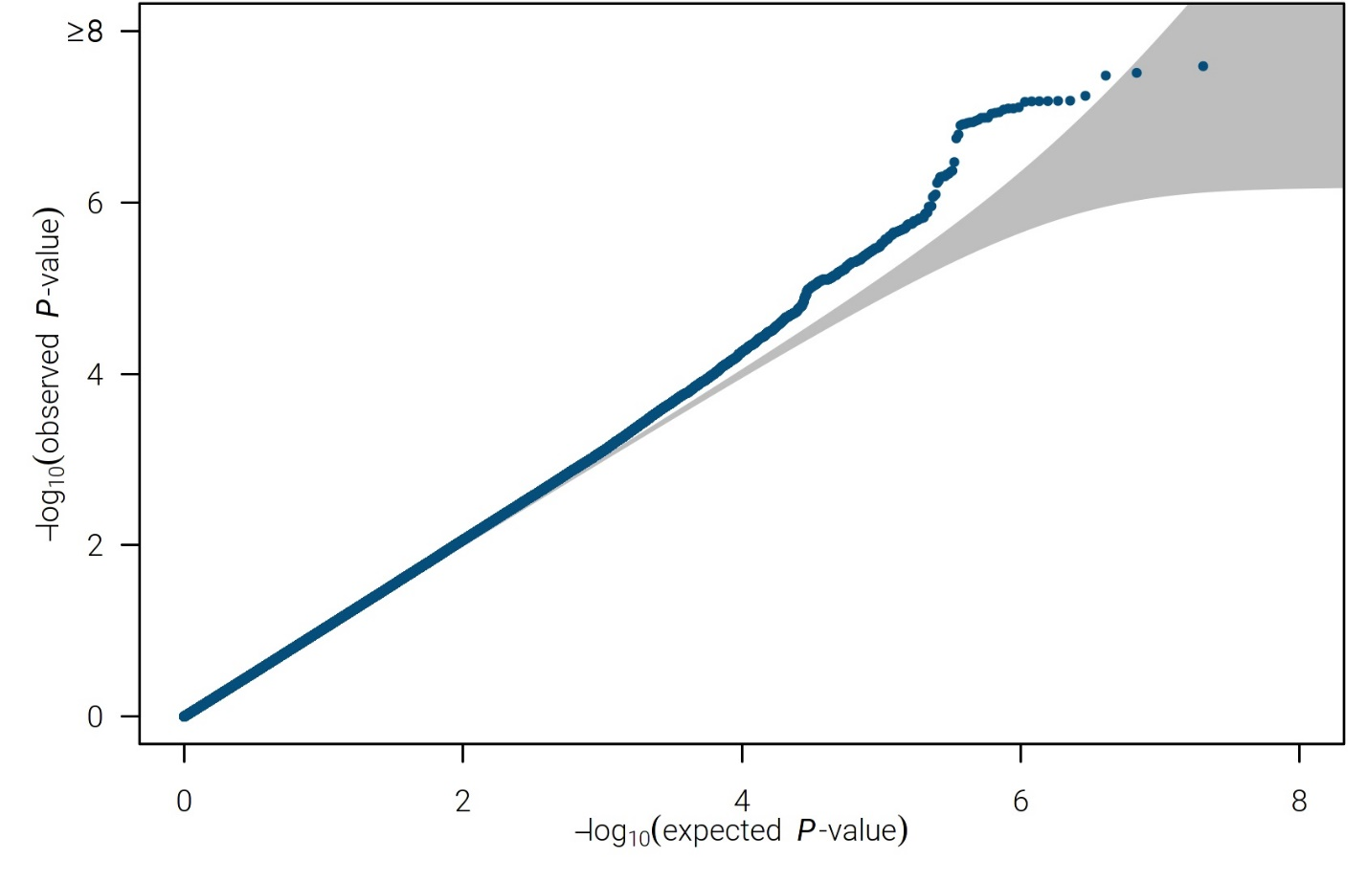

2C: Q-Q plot for Studies BEL110751, BEL110752 and BEL112341
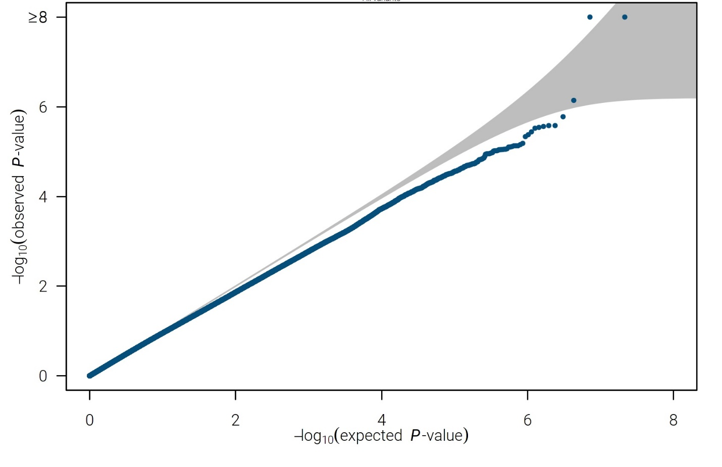

Supplemental Figure 3: Principal Components Analysis (PCA) plots for the combined BEL110751 and BEL110752 studies and Study BEL112341
3A: PCA plot for Studies BEL110751 and BEL110752
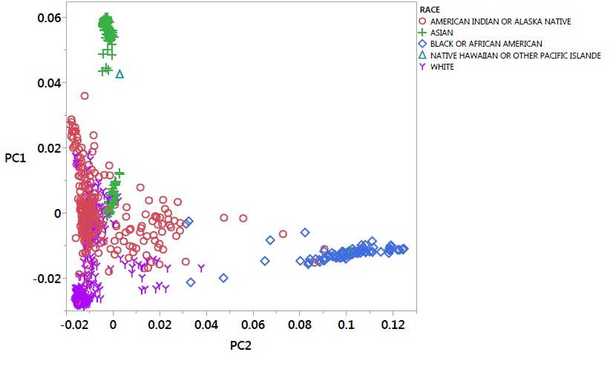
3B: PCA plot for BEL112341
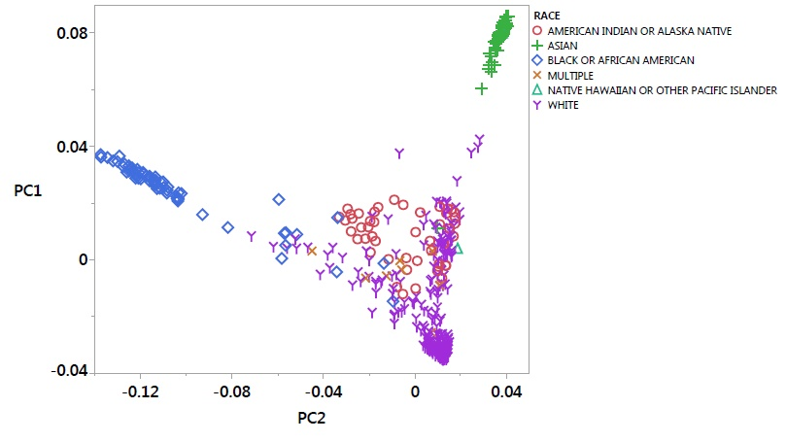

Supplemental TABLE 1: Analysis of candidate gene variants and belimumab efficacy in two populations (BEL110751/BEL110752 and BEL112341) that comprised the exploratory meta-analysis populations
Gene | Variation | Allele1 | Min Freq Allele1¹ | Max Freq Allele1¹ | Effect Estimate (SE)² | P-value | Direction³
BLK | rs13277113 | A | 0.42 | 0.48 | 0.08 (0.12) | 0.51 | +-
FCGR2A | rs1801274 | A | 0.51 | 0.52 | 0.05 (0.11) | 0.64 | -+
FCGR3A | rs396991 | A | 0.75 | 0.75 | -0.14(0.19) | 0.47 | --
HLA-DQB1 | *02:01 | *02:01 | 0.15 | 0.13 | 0.11(0.17) | 0.52 | ++
 | *06:02 | *06:02 | 0.14 | 0.09 | 0.01(0.19) | 0.96 | +-
HLA-DRB1 | *03:01 | *03:01 | 0.14 | 0.13 | 0.15(0.17) | 0.39 | ++
 | *15:01 | *15:01 | 0.14 | 0.10 | -0.15(0.18) | 0.39 | --
IL6 | rs1800796 | C | 0.20 | 0.27 | -0.18 (0.16) | 0.25 | --
MSH5 | rs2075789 | T | 0.11 | 0.15 | 0.18 (0.18) | 0.31 | ++
TLR5 | rs5744168 | A | 0.03 | 0.04 | 0.16 (0.35) | 0.65 | +-
TNFSF13 | rs3803800 | A | 0.34 | 0.37 | 0.10 (0.12) | 0.42 | ++
TNFRSF1B | rs1061622 | T | 0.78 | 0.81 | -0.07 (0.14) | 0.62 | -+
 | rs1041569 | A | 0.84 | 0.87 | 0.23(0.17) | 0.19 | ++
 | rs3759467 | T | 0.76 | 0.77 | -0.13(0.15) | 0.38 | -+
 | rs9514828 | T | 0.36 | 0.37 | 0.04(0.12) | 0.71 | -+
Post-hoc analysis
TNFSF13B (BAFF) | rs200748895 | Deletion | 0.029 | 0.033 | 0.07 (0.37) | 0.84 | -+
- Min-max freq(uency) represents the allele frequencies in the two populations that comprise the exploratory meta-analysis population
- The sign of the effect estimate indicates whether reduced efficacy (negative effect estimate) or improved efficacy (positive effect estimate) is observed with carriage of allele1.
- Direction of effect for each study, with one '+' or '-' per study [e.g., improved efficacy (positive effect estimate) denoted by the plus sign and reduced efficacy (negative effect estimate) denoted by the minus sign]. If “direction” is -/+ or +/-, this indicates that opposite effects were observed in the two populations

https://clinicaltrials.gov Study NCT00410384
https://clinicaltrials.gov Study NCT00424476
https://clinicaltrials.gov Study NCT01484496

