Appendix A: Expanded Methods

Study Integrity
The study Oversight Committee (see Acknowledgements for member names and affiliations) was created in February 2009 to help assure continuing study independence and integrity. Committee composition was designed to represent the obstetrics and genetics academic community, with expertise in both clinical and laboratory aspects of prenatal testing and molecular genetic methods. The Committee met with the study Co-Principal Investigators (GEP, JAC), either in person or by phone, an average of three times a year during 2009 and 2010, and completed its mission and held its last conference call with the end of active study enrollment in February 2011. Committee members chose not to sign confidentiality agreements with the study sponsor (Sequenom) so that they would not have knowledge of proprietary methods or results and did not directly interact with Sequenom personnel during the course of the study. Oversight Committee input was essential in implementing 1) secure methods in coding and selecting samples for testing, 2) the interim check on test results, and 3) rules to maintain separation between the study sponsor and coordinating center and recruitment site activities.

Inspections of each Enrollment Site by a study co-Principal Investigator (GEP, JAC) or Coordinator (EK) involved an on-site visit to review and evaluate adherence to procedures, examine the working space and resources, validate submitted data and answer questions about the study’s aims, methods and timelines. Summaries of each inspection were generated, signed by the particular study PI and Enrollment Site PI, and copies containing no patient identifiers or data were sent to the study sponsor. Enrollment Sites did not contact the study sponsor directly and had a proportion of samples tested by an independent laboratory.

Procedures were also put in place to ensure that raw data could not be changed without detection, and that all raw results could be reanalyzed by the independent laboratory. Blinding of diagnostic test results was accomplished on two levels. Within the Coordinating Center, samples and demographic information were stored in Rhode Island, while outcome data were stored at a second branch of the Coordinating Center (in Maine), for merging with demographic data at the appropriate time. None of this information was accessible from remote locations as the server was not connected to the internet.

Coordinating Center
The Coordinating Center (Women & Infants Hospital [WIH]) had overall responsibility for the study. Responsibilities included implementing and adhering to the study design, recruiting and establishing communications with Enrollment Sites, maintaining the secure study database and website, collecting and verifying patient data, maintaining the processed plasma sample bank, and organizing and utilizing the Oversight Committee. The Center was located at two sites, one in Standish, ME, where computerized data were held under the supervision of a Co-PI (GEP) and a study coordinator (EK), and one in Providence, RI (JAC), where samples were received from the Enrollment sites, stored at -80°C, and shipped to the testing laboratories as needed, and where administrative and supply support for the Enrollment Sites was located. The study was administered by WIH according to Federal guidelines. A non-disclosure agreement was signed between WIH and the study sponsor, allowing the Co-PIs access to interim data and research results throughout the study.

Enrollment Sites
Sites were preferentially sought that offered services to large numbers of patients, integrated screening, or first trimester diagnostic testing. The 27 participating Enrollment Sites (Appendix) provided diagnostic testing for Down syndrome (or other autosomal aneuploidies) in the late first and/or early second trimester. All had the capacity to collect, process, store and ship plasma samples according to a stringent protocol. The sites secured institutional review board (or equivalent) approval, and obtained informed consent of each woman who enrolled in the study. Sites could choose whether or not to offer $20 gift cards (or equivalent) to participating women.

Laboratory Sites
The Sequenom Center for Molecular Medicine in San Diego (SCMM-SD) is CLIA-certified as a high complexity molecular genetics laboratory. The laboratory has two Illumina HiSeq 2000 Next Generation Sequencers, both of which were used in this study. The Orphan Disease Testing Center at the University of California, Los Angeles School of Medicine (UCLA), also a CLIA-certified high complexity genetics laboratory, had one Illumina HiSeq 2000 platform during this study. UCLA collaborated with SCMM-SD in performing massively parallel sequencing of blinded study samples and provided clinical interpretations according to a standardized written protocol, updated for use on the Illumina HiSeq 2000 platform, created at SCMM-SD.

Study population
Information about pregnant women who were scheduled for diagnostic testing was reviewed at each Enrollment Site to identify those with a high risk for aneuploidy according to study criteria, and whose fetuses were 21 weeks’ 6 days gestation or less. High risk was defined as being screen positive for Down syndrome or other trisomy by serum and/or ultrasound testing, maternal age of 38 years or more at delivery (during the early part of the study this was set at 40 years or older), or a family history of aneuploidy. Women who qualified were informed about the study by genetic counselors or physicians and provided signed informed consent if they chose to participate. Each woman’s signature and full consent form were stored locally. Selected demographic and pregnancy-related information was obtained on a standardized form, along with at least two (and up to five) 10 mL purple top tubes of venous blood, drawn prior to the diagnostic procedure. Participants were identified only by a study code on the data forms and on the processed plasma tubes. Pregnancies with multiple gestations and existing fetal deaths were eligible, provided that diagnostic testing was planned for all fetuses.

Power analysis
The study was intended to determine whether existing practice should change. Therefore, a high level of confidence was needed in estimating both the detection rate (proportion of Down syndrome pregnancies with a positive test, or sensitivity) and the false positive rate (proportion of unaffected pregnancies with a positive test, or 1-specificity). Under the assumption of no false negatives, sufficient cases should be included to have at least 80% power to find the detection rate significantly higher than 98%. Analyzing 200 cases would provide 90% power to reject this lower limit. For each of these cases, seven euploid pregnancies (controls) would be selected to ensure reasonable confidence in the false positive rate.

Sample/data collection
Plasma samples were drawn prior to amniocentesis or chorionic villus sampling and processed according to a previously published protocol (Erich et al., 2010). Briefly, 10 mL plasma tubes (EDTA-containing, purple top) were centrifuged at 2,500 x g for 10 minutes at 4°C, the plasma pooled in a 50 mL centrifuge tube, and centrifuged at 15,500 x g for 10 minutes at 4°C. The plasma was then transferred to two or more 15 mL conical tubes, 4 mL per tube, with the last tube containing any residual volume. These tubes were either placed in a -70°C or colder freezer for longer term storage at the Enrollment Site or at -20°C for no more than 24 hours prior to shipment on dry ice for 1 to 2 day delivery to the Coordinating Center. If stored at -80°C, samples were shipped in batches on dry ice, usually on a monthly basis, for 1 to 2 day delivery to the Coordinating Center. All plasma tubes were identified using a pre-printed bar coded label with the site-specific study ID affixed. Quick International Courier, Inc., was used for international shipments to ensure proper tracking, maintenance of dry ice in packages, and delivery.

For data collection, a standardized multipart form included a pre-printed bar-coded study label, collection date, gestational age, maternal age, weight, race and ethnicity, indication for the procedure, number of fetuses, fetal sex, sample draw date and time, number of tubes drawn, time received in the laboratory, and time placed in the freezer. One copy was retained at the site, while the other was shipped with the samples to the Coordinating Center. To obtain karyotype information, an electronic request form was generated for each woman that requested procedure date, gestational age, procedure (e.g., amniocentesis, CVS), diagnostic test (e.g., karyotype, qfPCR), the interpreted test result (as well as fetal sex), and sufficient space to include results for additional fetuses and comments.

For both the processed plasma tubes and the data forms, participants were identified only by a study code.

Selection of samples for analysis
Selection criteria included access to a full 4 mL processed sample, woman’s age at least 18 years and no, or limited, important data missing. The last few enrolled cases from the late first trimester (<14 weeks’ gestation) and the early second trimester (15-22 weeks’ gestation) were not included because the target of 100 cases per trimester had been reached with a reasonable cushion. Matching was based on gestational age, maternal race, maternal ethnicity, Enrollment Site, and time in the freezer. Samples were shipped in dry ice for processing and testing, only after the laboratory developed test (LDT) had been through final internal validation, a publication submitted, and the Oversight Committee was satisfied. In select circumstances (e.g., broken aliquot, failed extraction), a second aliquot could be requested. The number of second aliquots and indications for sending was tracked.

Laboratory testing

Library preparation The extracted circulating cell-free (ccf) DNA was used for library preparation without further fragmentation or size selection, because ccf DNA is already fragmented naturally, having an average length of approximately 160 base pairs. Fifty-five μL of DNA eluent was stored at 4°C in low-binding Eppendorf tubes following extraction until the library preparation began. Storage times ranged from 24 to 72 hours. The library preparation was carried out according to the Illumina manufacturer’s specifications, with some modifications as noted herein. Enzymes and buffers were sourced from Enzymatics, MA (End Repair Mix –LC; dNTP Mix (25mM each); Exo(-) Klenow polymerase; 10X Blue Buffer; 100mM dATP; T4 DNA Ligase; 2X Rapid Ligation Buffer) and New England Biolabs, MA (Phusion PCR MM). Adapter oligonucleotides, indexing oligonucleotides, and PCR primers were obtained from Illumina Inc, CA.

Library preparation was initiated by taking 40μL of ccf DNA for end repair, retaining 15μL for FQA Quality Control (QC). End repair of the sample was performed with a final concentration of 1X End Repair buffer, 24.5μM each dNTPs, and 1μL of End Repair enzyme mix. The end repair reaction was carried out at room temperature for 30 minutes and the products were cleaned with Qiagen Qiaquick columns, eluting in 36μL of elution buffer (EB). 3’ mono-adenylation of the end repaired sample was performed by mixing it with a final concentration of 1X Blue Buffer, 192μM dATP, and 5U of Exo(-) Klenow Polymerase. The reaction was incubated at 37°C for 30 minutes and cleaned up with Qiagen MinElute columns, eluting the products in 14 μL of EB. Adapters were ligated to the fragments by incubating for 10 minutes at room temperature with 1X Rapid Ligation buffer, 48.3 nM Index PE Adapter Oligos, and 600U T4 DNA Ligase. The ligation reaction was cleaned up with QiaQuick columns, and the sample eluted in 23 μL of EB. The adapter modified sample was enriched by amplifying with a high-fidelity polymerase. The entire 23 μL eluent of each sample was mixed with 1X Phusion MM, Illumina PE 1.0 and 2.0 primers, and 1 of 12 index primers for a total PCR reaction volume of 50 μL. The sample was amplified in a 0.65-mL PCR tube using an AB GeneAmp PCR System 9700 thermal cycler. The PCR conditions were an initial denaturation at 98°C for 30 seconds, 15 cycles of denaturation at 98°C for 10 seconds, annealing at 65°C for 30 seconds, and extension at 72°C for 30 seconds. A final extension at 72°C for 5 minutes was followed by a 4°C hold. The PCR products were cleaned with MinElute columns and the libraries eluted in 17 μL of EB.

Quality control of sequencing library (LabChip GX) The libraries were quantified via electrophoretic separation on a microfluidics platform. Each library was diluted 1:100 and analyzed in triplicate using the Caliper LabChip GX instrument with HT DNA 1K LabChip, v2 and HiSens Reagent kit (Caliper Life Sciences, Hopkinton, MA). Concentrations were calculated by Caliper LabChip GX software v2.2 using smear analysis from 200-400bp.

Clustering and sequencing Clustering and sequencing was performed according to standard Illumina protocols. Individual libraries were normalized to a 2 nM concentration and then clustered in 4-plex format to a final flow cell loading concentration of 1.2 pM per sample or 4.8 pM per flow cell lane. The cBOT instrument and v4 Single-Read cBOT reagent kits were used. Thirty-six cycles of single-read multiplexed sequencing was performed on the HiSeq 2000 using v1 HiSeq Sequencing Reagent kits and supplemental Multiplex Sequencing Primer kits. Image analysis and base calling were performed with Illumina’s RTA1.7/HCS1.1 software. Sequences were aligned to the UCSC hg19 human reference genome (non repeat-masked) using CASAVA version 1.6.

Data analysis For classification of samples chromosome 21 trisomic versus disomic, we applied a method similar to the one used in Chiu et. al. and Ehrich et. al. Unlike the methods used for those studies, the classification applied in our study was done in an “on-line” fashion to simulate clinical practice – that is, samples were called as soon as one flow cell was processed. This “on-line” version of the classification predictions used all the data associated with a flow cell in order to establish a standardized chromosomal representation (so called `flow cell-robust z-scores', a.k.a. `FC-robust z-scores'), by using robust estimates of the location and scale of the chromosome representation. With denoting the chromosomal representation for chromosome ,
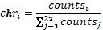

where are the number of aligned reads on chromosome , the equation of the FC-robust chrosome z-score for sample associated with the chromosome is

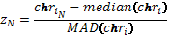

Here we have used a normalized form of the median absolute deviation for a robust estimate of the scale,

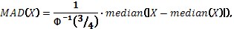

with the multiplicative constant chosen to approximate the standard deviation of a normally distributed random variable. The classification rule was to call samples trisomic with respect to chromosome 21 if and disomic otherwise.

Filtering repeat regions and GC normalization In the human genome, the repeated genomic sequences which can be inferred with the current detection methods represent up to half of the whole genome. These repetitive regions can take the forms of simple repeats, or tandem repeats (e.g, satellite, minisatellite, microsatellite DNA mostly found at centromeres and telomeres of chromosomes), or segmental duplications and interspersed repeats (e.g., SINES, LINES, DNA transposons). The size of such duplication can range from few basepairs, to hundreds of basepairs, and all the way up to 10-300 kilobasepairs. The repetitive nature of these regions is believed to be a source of variance in the PCR amplification step that is present in some of the next-generation sequencing techniques (such as Massively Parallel Shotgun Sequencing).

In order to evaluate the impact of reads mapped to such repetitive regions on the classification accuracy, we analyzed all samples with or without such reads included in the tabulation of chromosomal representation. For efficient computational processing, the reference genome used for the alignment of the short reads was not a `repeat-masked’ version but rather one that included such repetitive regions. Post-alignment, we deployed a filtering procedure based on the information contained in the Repeat Library 20090604 (http://www.repeatmasker.org). For Repeat-Mask-aware classification, only reads which do not overlap with the repeated regions were then considered for the estimation of chromosomal representation.

It has been observed previously that the different GC content of the genomic sequence will lead to different amplification efficiency in the PCR step. This leads to a biased sampling of the original genomic material. In order to compensate for this bias, the counts for each 50Kb bin were summarized and further normalized with respect to the bin-specific GC content by using a LOESS technique similar to the one described in Alkan et. al. The filtered counts normalized with respect to the estimated GC bias were then used for the calculation of chromosomal representation.

The above-describe procedures of read filtering and count normalization were not used for the “on-line” classification of chromosome 21 ploidy but were used as part of a subsequent analysis and data sets for all samples were delivered by SCMM to the Coordinating Center prior to un-blinding. The chromosome representation calculated after applying both the filtering with respect to the Repeat Mask as well as the GC normalization procedures are referred to in ths study as ‘GC-adjusted chromosome representation’, z-scores calculated from such chromosome representation are referred to as ‘GC-adjusted z-scores’..

The SCMM-SD laboratory performed all of the steps for all 1,640 samples. The UCLA laboratory received library preparations for about 40% of these samples, and then completed the testing protocol. For one set of samples (1 plate; 3 flow cells; approx 69 samples) containing seven Down syndrome cases and controls, separate 4 mL processed plasma samples were shipped to both the SCMM-SD and UCLA laboratories and the entire LDT was performed in duplicate. For any sample having test results from both laboratories, the result from SCMM-SD was considered the primary result.

Appendix B On-line eTable and eFigures

Table of eTables

eTable B1. More complete information about the six misclassifications by MPSS testing 50
eTable B2. Comparison of the final MPSS interpretations for 79 Down syndrome and 526 euploid samples tested at two laboratories 59
eTable B3. Comparison of published studies reporting the clinical validity of
massively parallel shotgun sequencing of maternal plasma and Down syndrome 66
Table of eFigures

Introduction: DNA fetal fraction figures 13
eFigure B1. DNA fetal fraction by time to freezer 14
eFigure B2. DNA fetal fraction by hemolysis 15
eFigure B3. DNA fetal fraction by geographic region 16
eFigure B4. DNA fetal fraction by indication for diagnostic testing 17
eFigure B5. DNA fetal fraction by enrollment site 18
eFigure B6. DNA fetal fraction by gestational age 19
eFigure B7. DNA fetal fraction by maternal age 20
eFigure B8. DNA fetal fraction by maternal weight 21
eFigure B9. DNA fetal fraction by maternal vaginal bleeding 22
eFigure B10. DNA fetal fraction by maternal race 23
eFigure B11. DNA fetal fraction by Caucasian ethnicity 24
eFigure B12. DNA fetal fraction by fetal sex 25
eFigure B13. DNA fetal fraction by freezer storage time 26
eFigure B14. DNA fetal fraction by library concentration 27
eFigure B15. DNA fetal fraction by matched sequence reads 28
eFigure B16. DNA fetal fraction by pregnancy outcome 29

Introduction: Chromosome 21 and assay variability 30
eFigure B17. Chromosome 21 percent by flow cell 31
eFigure B18. Chromosome 21 percent by plate 32
eFigure B19. Chromosome 21 percent by instrument 33

Introduction: Chromosome 21 z-score figures 34
eFigure B20. Chromosome 21 z-scores by time to freezer 35
eFigure B21. Chromosome 21 z-scores by hemolysis 36
eFigure B22. Chromosome 21 z-scores by geographic region 37
eFigure B23. Chromosome 21 z-scores by indication for diagnostic testing 38
eFigure B24. Chromosome 21 z-scores by enrollment site 39
eFigure B25. Chromosome 21 z-scores by gestational age 40
eFigure B26. Chromosome 21 z-scores by maternal age 41
eFigure B27. Chromosome 21 z-scores by maternal weight 42
eFigure B28. Chromosome 21 z-scores by maternal vaginal bleeding 43
eFigure B29. Chromosome 21 z-scores by maternal race 44
eFigure B30. Chromosome 21 z-scores by Caucasian ethnicity 45
eFigure B31. Chromosome 21 z-scores by fetal sex 46
eFigure B32. Chromosome 21 z-scores by freezer storage time 47
eFigure B33. Chromosome 21 z-scores by library concentration 48
eFigure B34. Chromosome 21 z-scores by matched sequence reads 49

eFigure B35. MPSS testing turn-around time (TAT) 51
eFigure B36. Flow diagram showing reasons for the initial MPSS testing failures along with subsequent testing results on a second aliquot from the same woman 53

eFigure B37. Comparison of Chromosome 21 percent from two laboratories 54
eFigure B38. Comparison of Chromosome 21 z-score from two laboratories 56
eFigure B39. Comparison of MPSS results for 7 Down syndrome and 46 euploid samples tested at two laboratory sites 57-59

eFigure B40. Medical and financial costs associated with using MPSS as an intermediate step between screening and diagnostic testing for Down syndrome 60-61
eFigure B41. Impact of adjusting Chromosome 21 percent for GC content and plate
variability 62-63
eFigure B42. Impact of adjusting Chromosome 21 z-score for GC content and
plate variability 64
General Background for eFigures B1 to B16 (potential covariates of fetal fraction)

This set of eFigures includes the fetal fractions (percentage of fetally derived free circulating DNA) for all 212 Down syndrome pregnancies and 1,484 euploid pregnancies. In order to improve visibility of the data, categorical data were ‘dithered’ to the left and right of the labeled tick mark. All of the pregnancies studied were viable at time of sampling, and all were verified singleton pregnancies with diagnostic test results available (e.g., karyotype). Since the fetal fraction test results were available prior to sequencing, they were used to determine sample adequacy. Acceptable fetal fractions were between 4% and 50%, inclusive (horizontal thin dashed lines). In clinical practice, samples outside of this range may be considered unacceptable for sequencing. The overall median fetal fraction of 14.0% (geometric mean 13.4%, arithmetic mean 15.0%) is shown in the eFigures as a thin solid horizontal line. If the fetal fraction is lower than 4%, it becomes difficult to resolve the small difference between circulating DNA from Down syndrome and euploid pregnancies. Higher levels indicate potential problems with sample handling. The distribution of fetal fractions is right-skewed. For this reason, the presentation and analysis is after a logarithmic transformation. For covariates explored using regression analyses, only the regression line is shown if results do not reach statistical significance. Otherwise, 95% prediction limits are shown, as well.

The most important covariate is maternal weight. At average weights of 100 and 250 pounds, the expected fetal fractions are 17.8% and 7.3%, respectively. This maternal weight effect is the likely explanation for the small but significant effects found for fetal fraction versus maternal race (Figure B10) and ethnicity (Figure B11). Time from sample draw to freezer storage (Figure B1) also has a significant effect on fetal fraction, with longer times resulting in slightly lower fetal fractions. This effect is, however, much smaller than for maternal weight. The remaining associations are generally small, and usually non-significant.

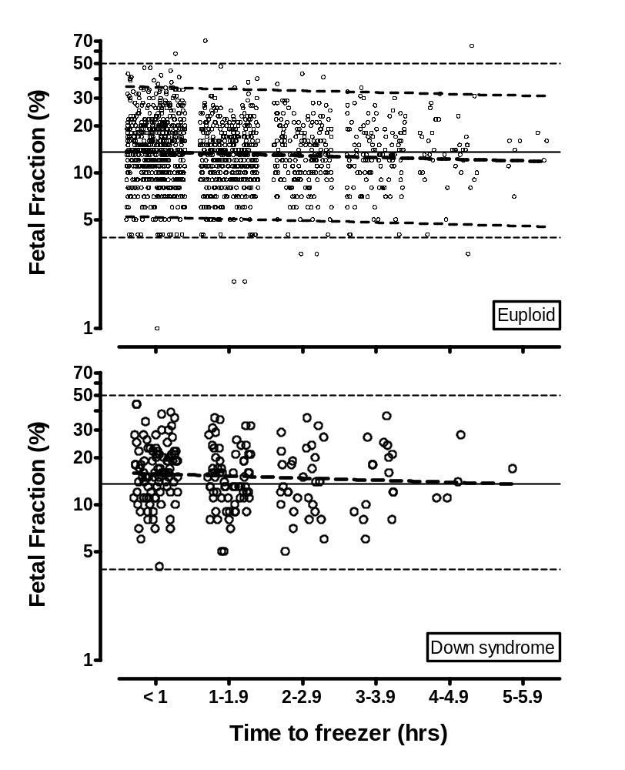
eFigure B1. DNA fetal fraction by time to freezer. The top Figure (Euploid pregnancies) shows the fetal fraction by time between sample draw and freezer storage. Linear regression shows a significant negative slope (thick dashed line, with 95% prediction limits shown by thin dashed lines, p = 0.023, slope = -0.011). Although a similar effect is seen for Down syndrome pregnancies (lower Figure), it is not significant (p = 0.30, slope = -0.013). Using the results of the analysis for euploid pregnancies, the expected fetal fractions for 1, 2, 3, 4 and 5 hours to freezer would be 13.5%, 13.2%, 12.8%, 12.5% and 12.2%, respectively.

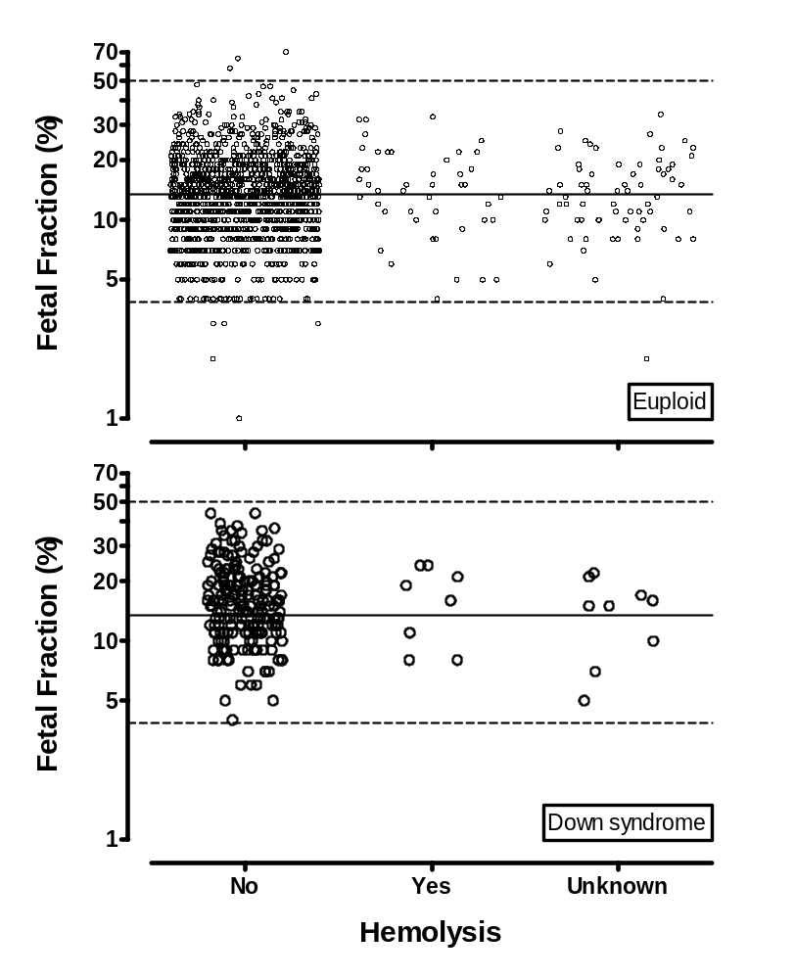
eFigure B2. DNA fetal fraction by hemolysis. Sample hemolysis status was evaluated by the Enrollment site prior to freezing. A standard scheme of None, Slight, Moderate and Gross was used. None and Slight were subsequently grouped into a ‘No’ category, with Moderate and Gross grouped into a ‘Yes’ category. The top Figure (Euploid pregnancies) shows the percent fetal fraction stratified by hemolysis among euploid pregnancies. There was no significant difference in fetal fraction for those with hemolysis (mean = 13.2% and 13.6% for No and Yes, respectively, t = -0.46, p = 0.64). The bottom Figure presents the same analysis among the Down syndrome pregnancies and shows little if any difference for those with hemolysis (mean = 15.4% and 15.0%, respectively, t = 0.14, p = 0.89).
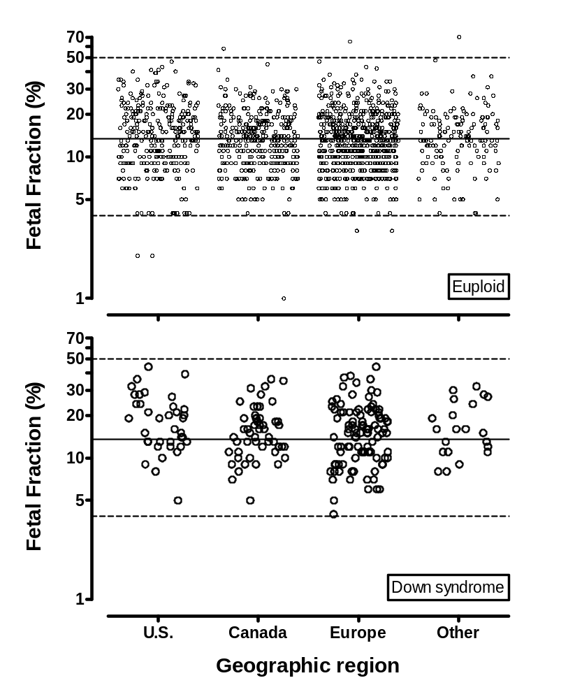
eFigure B3. DNA fetal fraction by geographic region. The top Figure (Euploid pregnancies) shows the percent fetal fraction, stratified by geographic region. There is no significant relationship (mean fetal fractions of 13.9%, 13.1%, 12.8% and 13.4%, from left to right, ANOVA F = 1.93, p = 0.12). The bottom Figure presents the same analysis among the Down syndrome pregnancies (mean fetal fractions of 17.4%, 15.0%, 14.5% and 15.9%, from left to right, ANOVA F= 1.45, p= 0.23).

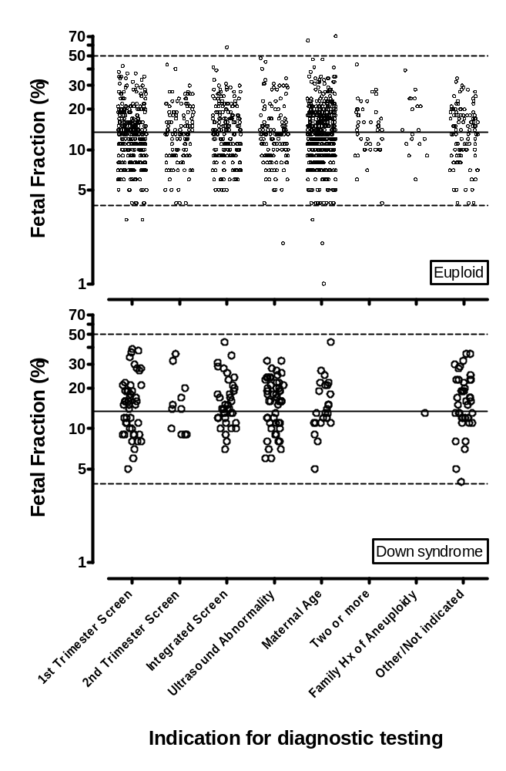
eFigure B4. DNA fetal fraction by indication for diagnostic testing. The top Figure (Euploid pregnancies) shows the percent fetal fraction stratified by indication for diagnostic testing. There is no significant association (mean fetal fractions of 13.0%, 13.2%, 13.4%, 12.7%, 13.1%, 14.1%, 15.6%, and 13.3%, from left to right, ANOVA F = 0.61, p = 0.75). The bottom Figure presents the same analysis among the Down syndrome pregnancies, again showing no association (mean fetal fractions of 14.9%, 15.0%, 15.6%, 15.3%, 14.8%, NA, 13.0%, and 15.7%, from left to right, ANOVA F=0.11, p=0.99).
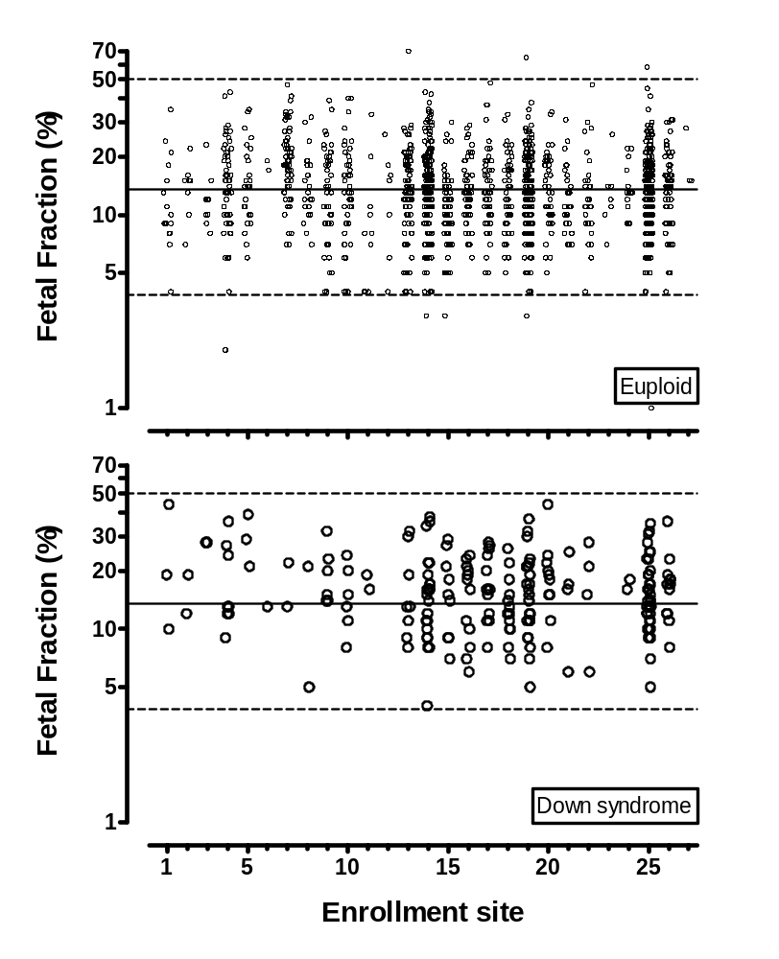
eFigure B5. DNA fetal fraction by Enrollment site. The top Figure (Euploid pregnancies) shows the percent fetal fraction stratified by Enrollment site. For Enrollment sites with at least 50 samples, there is a significant difference (mean fetal fractions range from 10.2% to 18.7%, ANOVA F = 5.59, p < 0.0001). The bottom Figure presents the same analysis among the Down syndrome pregnancies and does not find differences (mean fetal fractions range from 12.7% to 16.9%, ANOVA F = 0.35, p = 0.97). This is not explained by different maternal weights (see Figure B8), as the average weight in the five Enrollment Sites with the highest fetal fractions was 151 pounds compared to 150 pounds in the six Sites with the lower fetal fractions.

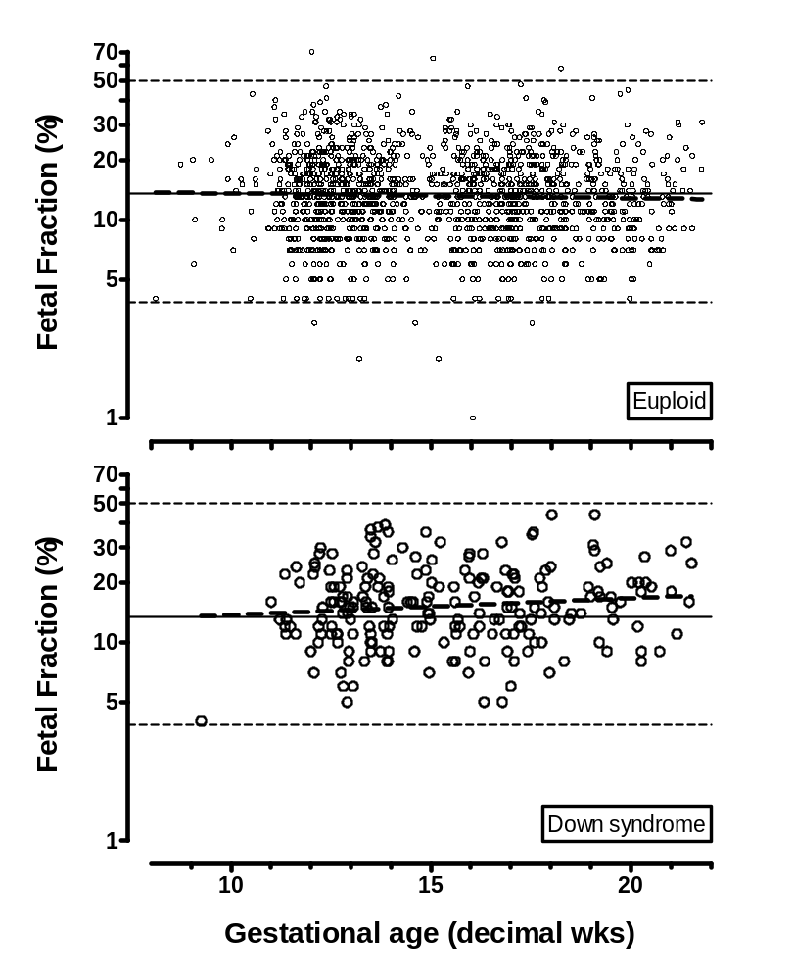
eFigure B6. DNA fetal fraction by gestational age. The x-axis shows the gestational age at the time of sample draw. The top Figure (Euploid pregnancies) shows the fetal fraction by gestational age. Linear regression did not find a significant relationship (thick dashed line, p = 0.23, slope = -0.0024). An analysis of Down syndrome pregnancies (bottom Figure) found a similar result, (p = 0.10, slope = 0.0084).

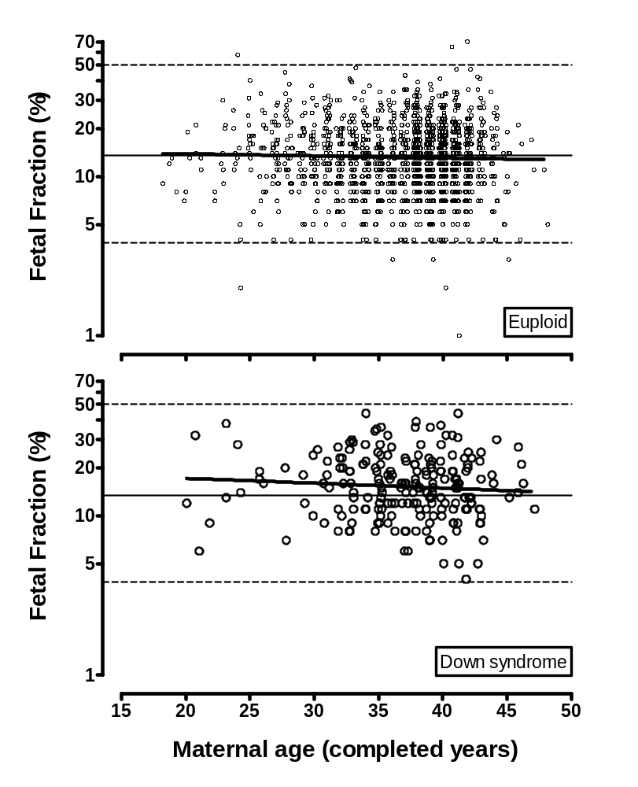
eFigure B7. DNA fetal fraction by maternal age. The x-axis shows the maternal age at the estimated delivery date. The top Figure (Euploid pregnancies) shows the fetal fraction by maternal age. Linear regression did not find a significant relationship (thick dashed line, p = 0.23, slope = -0.0013). An analysis of Down syndrome pregnancies (bottom Figure) found a similar result (p = 0.26, slope = -0.0031).

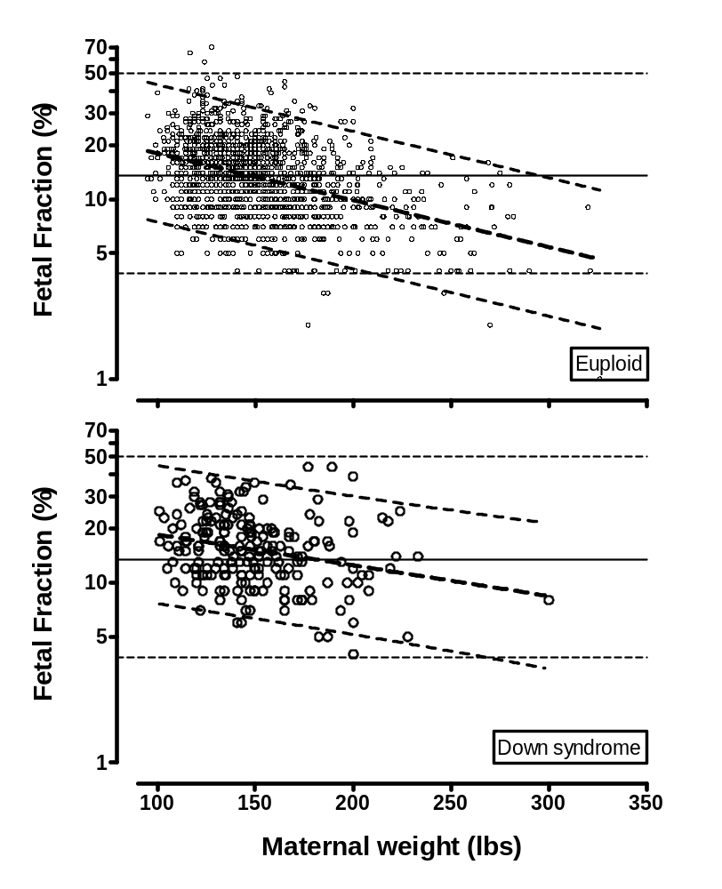
eFigure B8. DNA fetal fraction by maternal weight. The x-axis shows maternal weight in pounds at the time of sample draw. The top Figure (Euploid pregnancies) shows the fetal fraction by maternal weight from euploid pregnancies. Linear regression found a significant relationship (thick dashed line, with 95% predication limits shown by thin dashed lines, p < 0.0001, slope = -0.0026). A similar result (bottom Figure) was found for the Down syndrome pregnancies (p = 0.0002, slope = -0.0017). Using the euploid results as an example, women weighing 100, 150, 200, 250 and 300 pounds would be expected to have average fetal fractions of 17.8%, 13.2%, 9.8%, 7.3% and 5.4%, respectively.

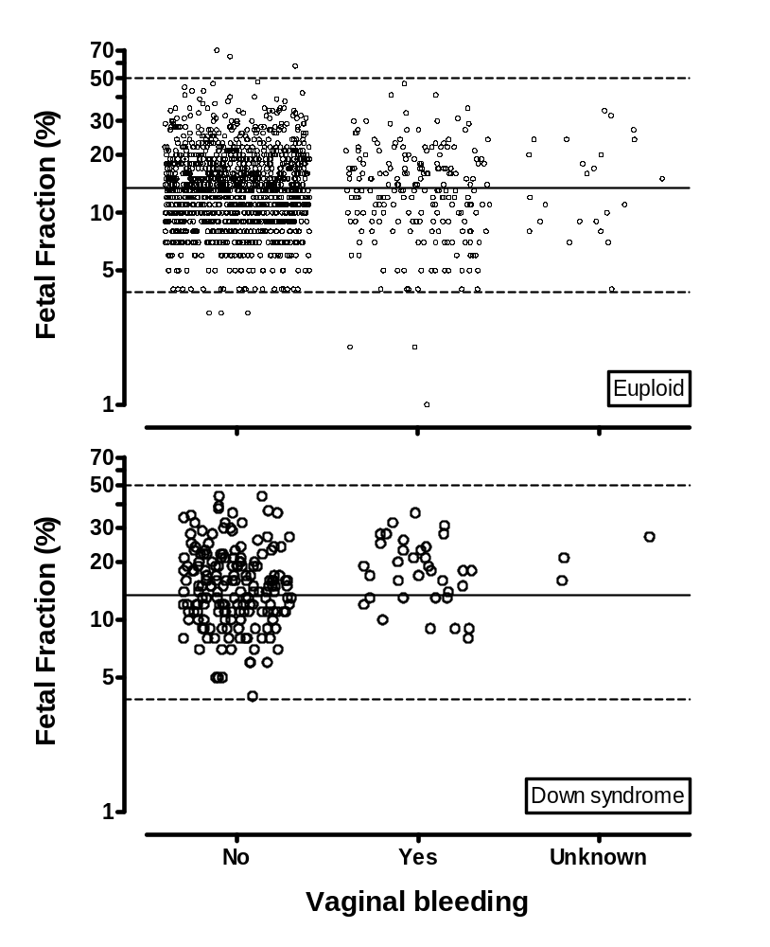
eFigure B9. DNA fetal fraction by self-reported maternal vaginal bleeding. The top Figure (Euploid pregnancies) shows the percent fetal fraction, stratified by vaginal bleeding. There is a slight, but significant, decrease in fetal fraction for those reporting bleeding (mean = 13.3% and 12.3% for No and Yes, respectively, t = 2.04, p = 0.04). The bottom Figure presents the same analysis among the Down syndrome pregnancies and finds a significant increase for those reporting bleeding (mean = 14.7% and 17.6%, respectively, t = -2.07, p = 0.04).

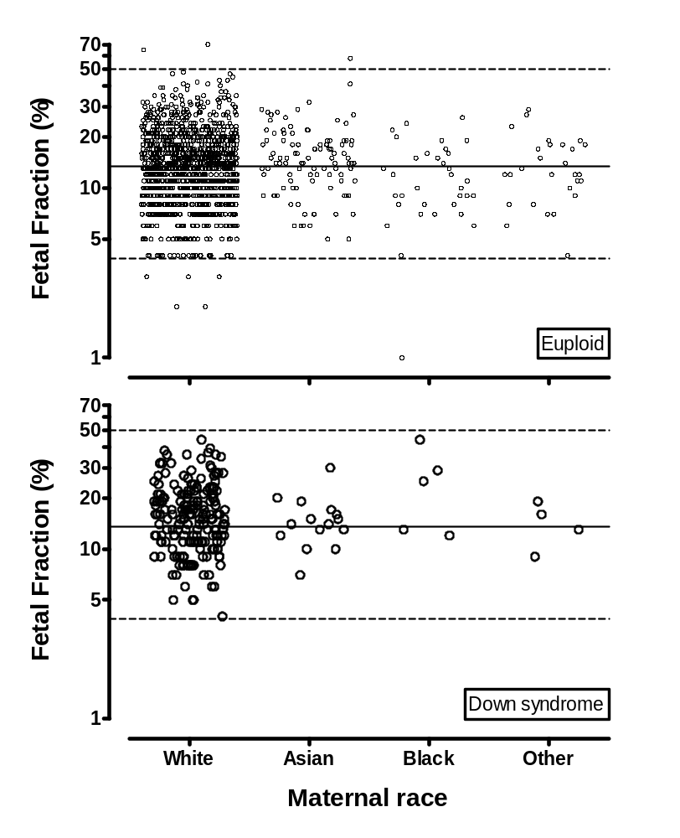
eFigure B10. DNA fetal fraction by maternal race. The top Figure (Euploid pregnancies) shows the percent fetal fraction, stratified by maternal race. There is a significant effect (mean fetal fractions of 13.2%, 14.4%, 10.5% and 12.6%, from left to right, ANOVA F = 3.71, p = 0.011). The bottom Figure presents the same analysis among the Down syndrome pregnancies and does not find a significant effect or similar pattern (mean fetal fractions of 15.2%, 14.2%, 21.8% and 13.7%, from left to right, ANOVA F= 1.20, p= 0.31). This is likely to be confounded by maternal weight, as the average weight in mothers of euploid pregnancies is 152, 138, 182 and 157 pounds, in White, Asian, Black and Other races, respectively.

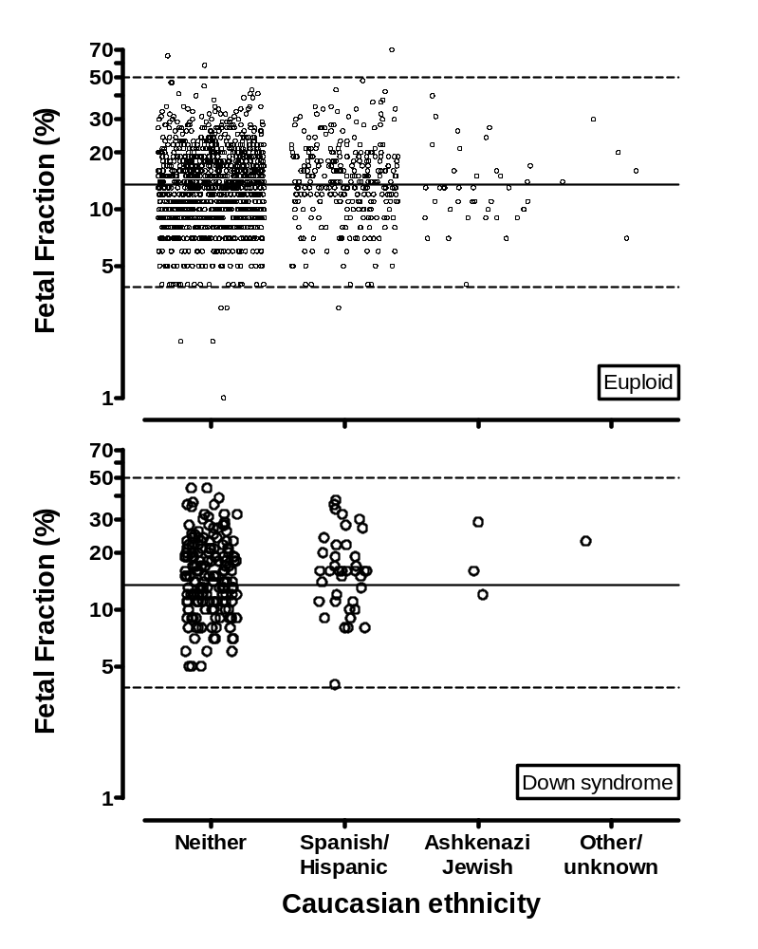
eFigure B11. DNA fetal fraction by Caucasian ethnicity. The top Figure (Euploid pregnancies) shows the percent fetal fraction, stratified by Caucasian ethnicity. There is a significant effect (mean fetal fractions in the three main categories of 12.9%, 14.1%, 12.7%, from left to right, ANOVA F = 3.78, p = 0.023). The bottom Figure presents the same analysis among the Down syndrome pregnancies and does not show a significant effect (mean fetal fractions of 15.1%, 15.6% and 17.7%, from left to right, ANOVA F= 0.27, p= 0.77). This may be confounded by maternal weight, as the average weights in mothers of euploid pregnancies are 154, 144 and 148 pounds, for Spanish / Hispanic, Ashkenazi Jewish and Other / unknown, respectively.

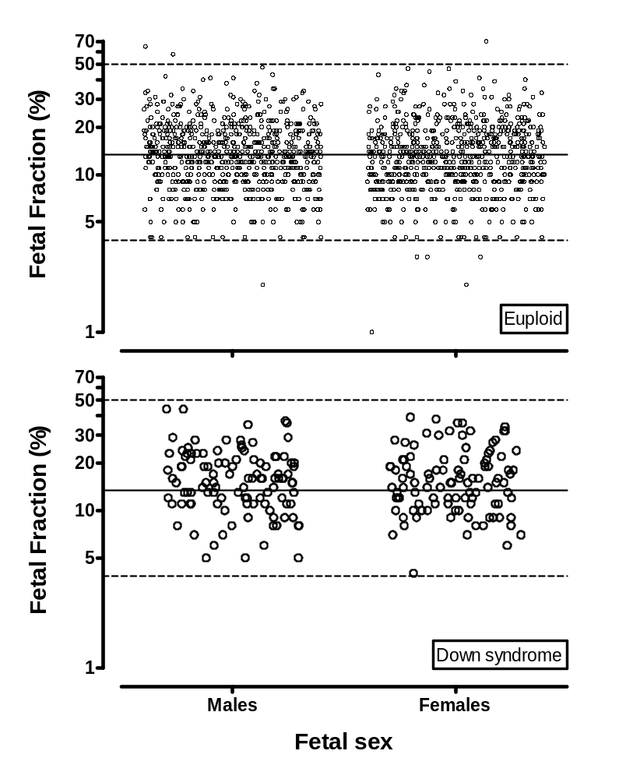
eFigure B12. DNA fetal fraction by fetal sex. The top Figure (Euploid pregnancies) shows the percent fetal fraction stratified by fetal sex. There is no difference in fetal fraction between male and female fetuses (mean of 13.4% and 12.9%, respectively, t = 1.68, p=0.094). The bottom Figure presents the same analysis among the Down syndrome pregnancies that found nearly identical levels (mean = 15.2% and 15.3%, respectively, t = -0.05, p = 0.96).

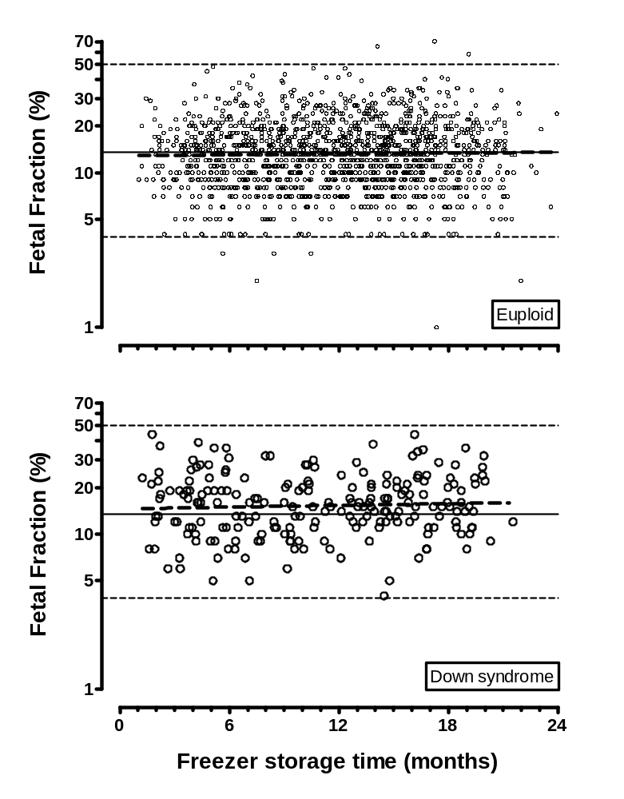
eFigure B13. DNA fetal fraction by freezer storage time. The top Figure (Euploid pregnancies) shows the fetal fraction by freezer storage time in months. Linear regression did not find a significant slope (thick dashed line, p = 0.40, slope = 0.000031). Similar results were seen among Down syndrome pregnancies (lower Figure, p = 0.46, slope = 0.000061).

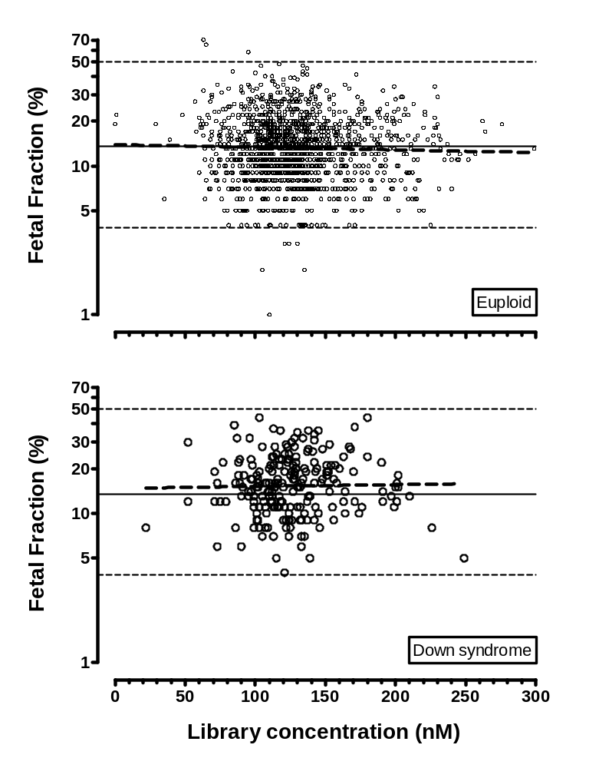
eFigure B14. DNA fetal fractions by library concentration. The top Figure (Euploid pregnancies) shows the fetal fraction versus library concentration. Linear regression finds a non-significant negative slope (thick dashed line, p = 0.25, slope = -0.00018). A non-significant, but positive slope is seen among Down syndrome pregnancies (lower Figure, p = 0.78, slope = 0.00012).

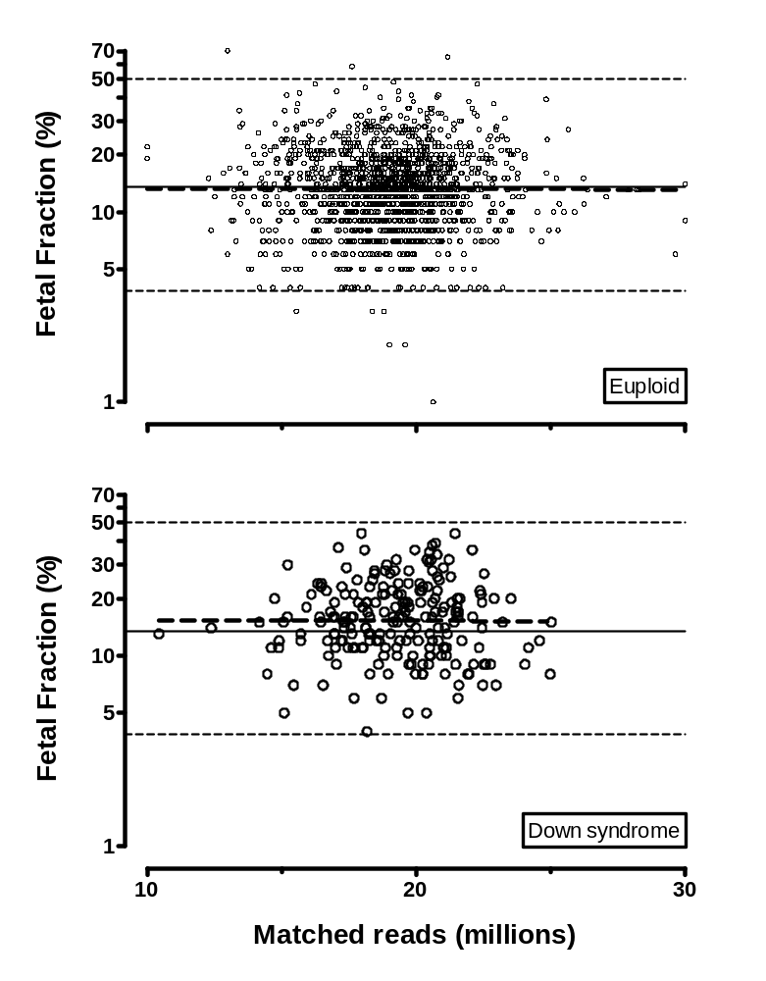
eFigure B15. DNA fetal fraction by matched sequence reads. The top Figure (Euploid pregnancies) shows the fetal fraction by millions of matched DNA sequences. Linear regression finds a non-significant negative slope (thick dashed line, p = 0.93, slope = -0.00022). A similar effect is seen for Down syndrome pregnancies (lower Figure, p = 0.97, slope = -0.00019).

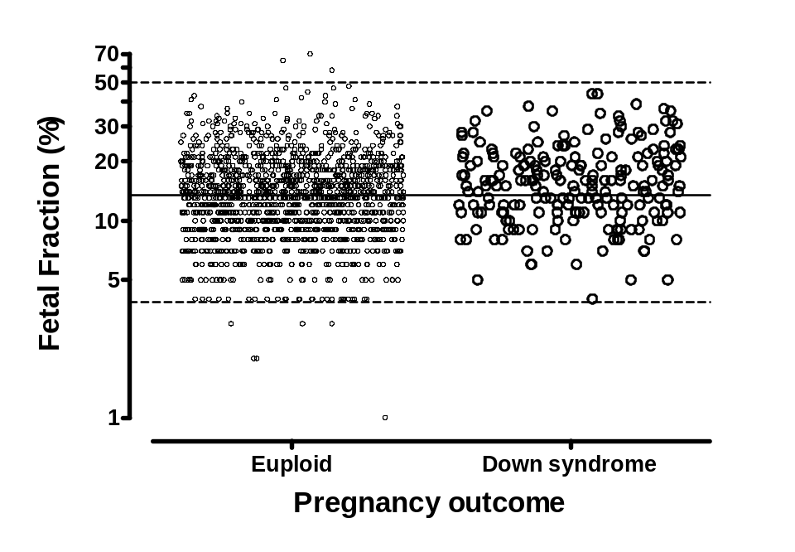
eFigure B16. DNA fetal fraction by pregnancy outcome. The Figure shows the fetal fraction stratified by whether the outcome was a euploid or Down syndrome pregnancy. Down syndrome pregnancies have a higher fetal fraction that is statistically significant (mean 15.2% versus 13.2%, t = -4.11, p<0.0001). If this were to be used as a screening test for Down syndrome, then at false positive rates of 5% and 10%, the corresponding detection rates would be 9.0% and 17.5%, respectively. These correspond to a cumulative odds ratio of about 1.8.

Introduction: Chromosome 21 and assay variability

These figures summarize the relationships between the chromosome 21 percent and assay variability. In general, samples from four patients are quad-plexed in a single flow cell lane, and with four lanes, this equates to 32 patients. In general, however, only 30 patients were run, with other positions holding controls. 92 patients were processed together in 96 well plates. Each plate was run on 3 flow cells. Generally, 7 plates of data were grouped together to form a batch. Each batch contained the allotted samples in random order. Thus, cases and controls within a batch were not necessarily run on the sample plate or flow cell. Running cases and controls together can under-estimate total variance in matched analyses. All 212 Down syndrome and all but 13 of the 1,484 euploid results are shown. If a sample initially failed, but the second result was successful, that second result is shown. Those samples that failed to produce a useable result on the repeated sample as well are not shown. All of the pregnancies studied were viable at the time of sampling, and all were verified singleton pregnancies with diagnostic test results available (e.g., karyotype).

Figure B17 shows C21% results by flow cell. Generally, 20 to 25 euploid and 2 to 7 Down syndrome pregnancies are shown for each. In some instances (e.g., a flow cell with repeats), the numbers are much smaller. Flow cell-to-flow cell changes in the mean level can be seen. Also, there is a clear tendency for early flow cells to be above the euploid mean of 1.355%, while the later flow cells tend to be lower. There is no difference in the standard deviations of the euploid results among flow cells.

Figure B18 shows the same results, but by plate. The same tendencies can be seen in this figure that were evident in B17. The reduction in overall variance is somewhat less when accounting for plate-to-plate differences compared to flow cell-to-flow cell. However, once plate differences are accounted for, there is no significant effect for flow cell differences. As seen in B17, there is no difference in the standard deviations of the euploid results among plates.

Figure B19 examines the effect of HiSeq 2000 machine 2 versus 3. There is no systematic difference in C21% results from the two machines.
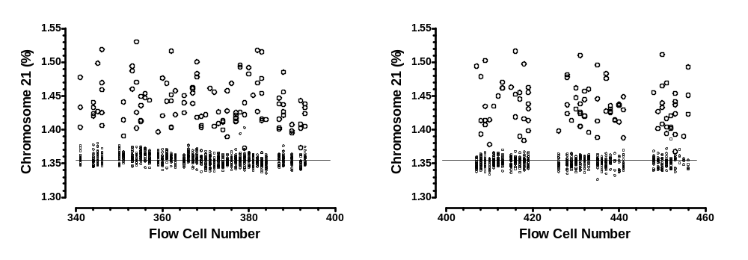
eFigure B17. Chromosome 21 percent by flow cell. The percentage of chromosome 21 matched reads divided by the total autosomal reads is plotted for both euploid (small circles) and Down syndrome (larger circles) by the flow cell number (x-axis). Each flow cell can test 32 samples (in quad-plex), resulting in 28 to 30 patient samples along with control samples (not all patient samples run in each flow cell are included in this report). Overall, 76 flow cells contained data relevant to the current study, including testing of additional aliquots. Flow cells were consecutively numbered, and missing flow cells were used for other studies, including testing at the independent laboratory. A reference line is drawn at 1.355%, the overall average fetal fraction for the euploid samples. Flow cell to flow cell variability in mean levels can be seen (ANOVA, F = 4.93, p < 0.001), but the standard deviation is constant (F = 1.1, p = 0.31).
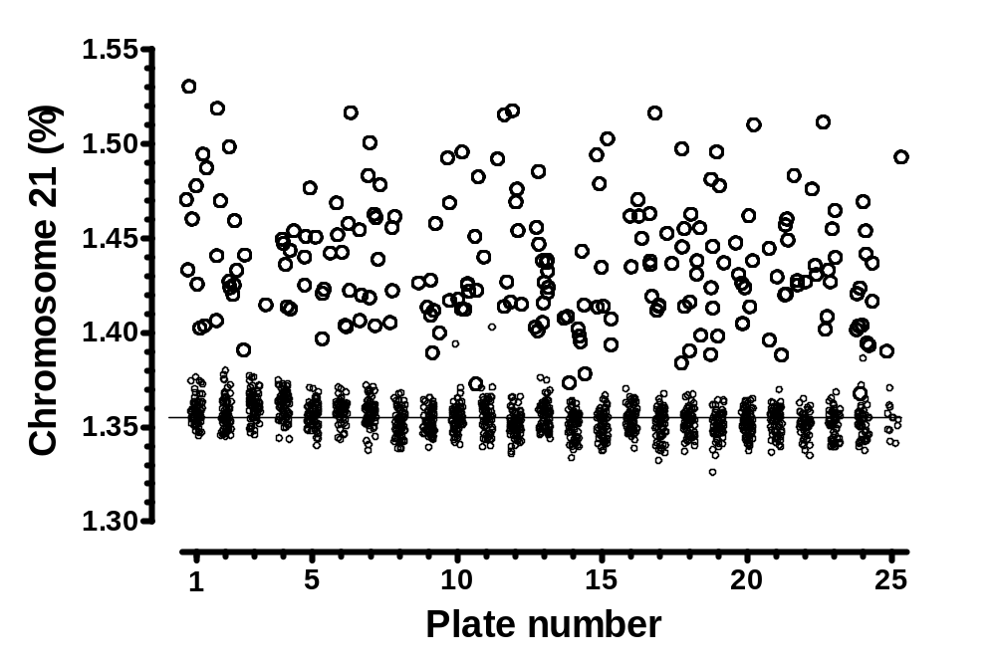
eFigure B18. Chromosome 21 percent by plate. This Figure contains the same data as Figure B17, but the data are stratified by plate rather than flow cell. Processing is performed in 96 well plates. The processed samples from one plate are then run on three flow cells. The reference line is at 1.355%. Plate to plate variability in mean levels can be seen (ANOVA, F=13.5, p < 0.001), but the standard deviation is constant (F = 1.2, p = 0.23).

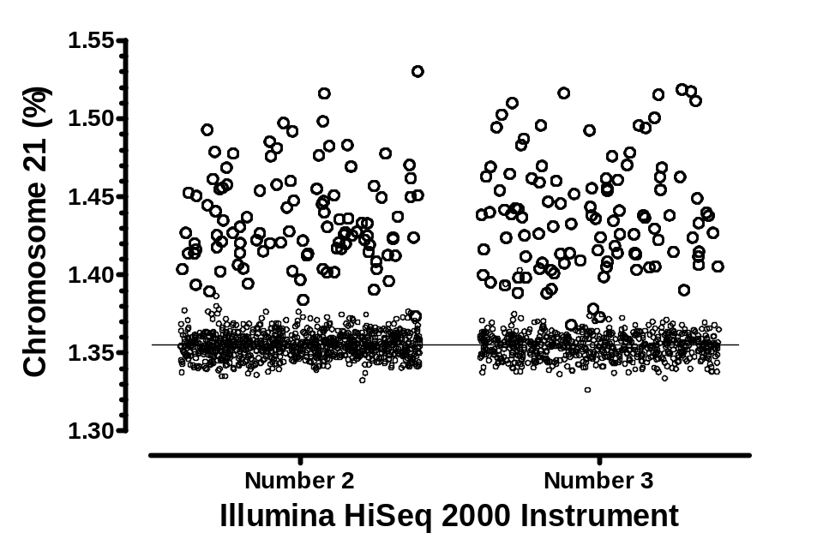
eFigure B19. Chromosome 21 percent by instrument. This Figure contains the same data as Figure B17 and B18, but the data are stratified according to which Illumina instrument was used for sequencing. 42 and 34 plates were processed on Number 2 and Number 3, respectively. The reference line is at 1.355%. There is no difference in the chromosome 21 percent by instrument in Euploid (means of 1.355 and 1.354, respectively, t = 2.0, p = 0.16) or Down syndrome pregnancies (means of 1.436 and 1.438, respectively, t = 0.32, p=0.57).

Introduction: Chromosome 21 z-score figures

These figures summarize 15 potential covariates versus the clinically reported chromosome 21 z-score. All 212 Down syndrome and all but 13 euploid results are shown. For those samples that failed to produce a useable result on the first aliquot, but were successful on the second, the second result is plotted. Only the 13 samples that failed to produce a useable result after testing of a duplicate sample are not plotted. All of the pregnancies studied were viable at the time of sampling, and all were verified singleton pregnancies with diagnostic test results available (e.g., karyotype). One Down syndrome sample had a z-score slightly over 25, but is plotted at 24.9. The range of euploid samples is between -3 and +3. These ranges are indicated by horizontal thin dashed lines. Among cases, the cut-off level of 3 is shown as a thin dashed line. The distribution of z-scores is right-skewed in cases, but Gaussian in controls. The data, however, are still plotted on a linear scale. Regression analysis in cases was after a logarithmic transformation. For covariates explored using regression analyses, only the regression line is shown if the results do not reach statistical significance. Otherwise, 95% prediction limits are shown as well.

By far the most important covariate is maternal weight, but the effect is far greater among Down syndrome pregnancies. The positive association with gestational age is significant in cases. This effect is, however, much smaller than that seen for maternal weight. The remaining associations are generally small, and usually non-significant.

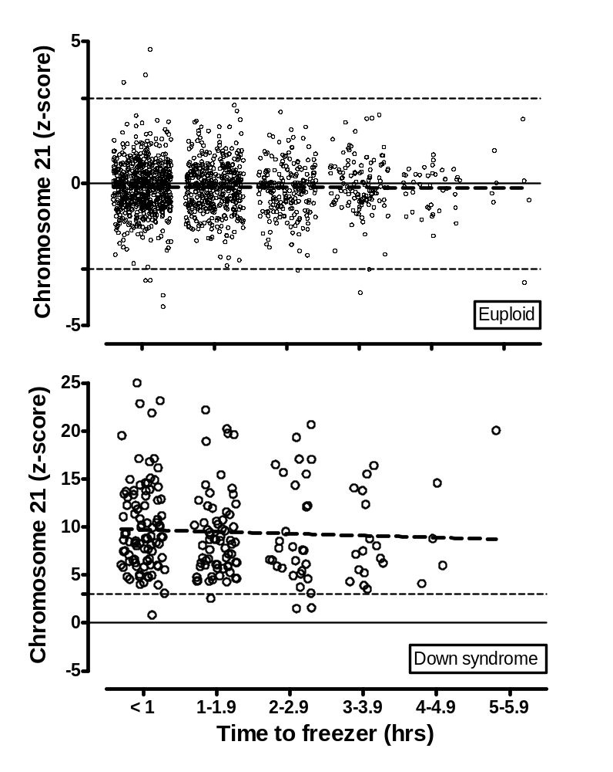
eFigure B20. Chromosome 21 z-score by time to freezer. All samples selected for testing were processed and stored in the freezer within six hours of collection. The top Figure (Euploid pregnancies), shows the chromosome 21 z-score by time from sample draw to freezer storage. Linear regression does not find a significant relationship for either the euploid or Down syndrome pregnancies (p = 0.90, slope = -0.0025; and p = 0.50, slope = -0.20, respectively).

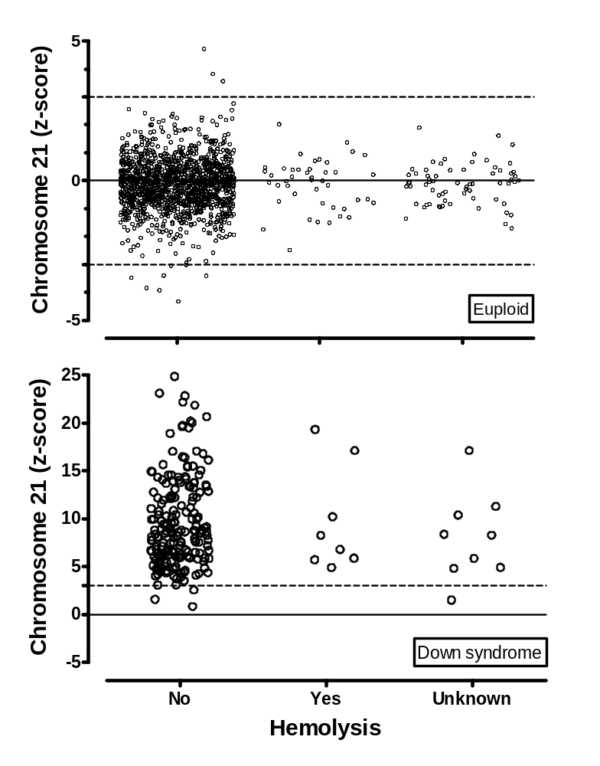
eFigure B21. Chromosome 21 z-score by hemolysis. Sample hemolysis status was evaluated by the Enrollment site prior to freezing. A standard scheme of None, Slight, Moderate and Gross was used. None and Slight were subsequently grouped into a ‘No’ category, with Moderate and Gross grouped into a ‘Yes’ category. The top Figure (Euploid pregnancies) shows chromosome 21 z-score by hemolysis status. There was no significant difference in the z-score after stratification by hemolysis status for either group (t = -0.01, p = 0.99 and t = -0.12, p = 0.90 for euploid and Down syndrome pregnancies, respectively).

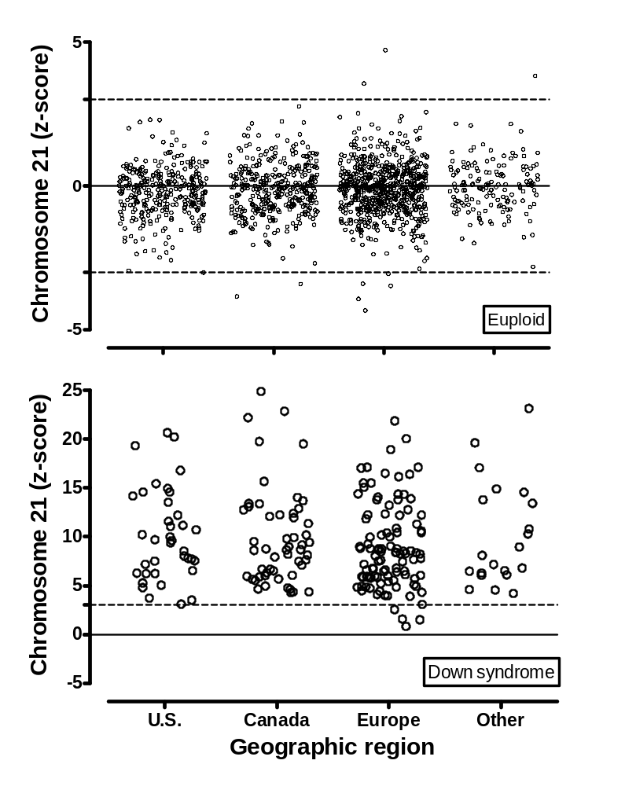
eFigure B22. Chromosome 21 z-score by geographic region. The top Figure (Euploid pregnancies) shows the z-score stratified by geographic region. There is no significant relationship (mean z-scores of -0.22, -0.14, -0.12 and -0.01, from left to right, ANOVA F = 1.84, p = 0.14). The bottom Figure presents the same analysis among the Down syndrome pregnancies and also does not show a significant effect (mean z-scores of 10.1, 9.9, 8.9 and 10.2, from left to right, ANOVA F= 1.00, p= 0.39).
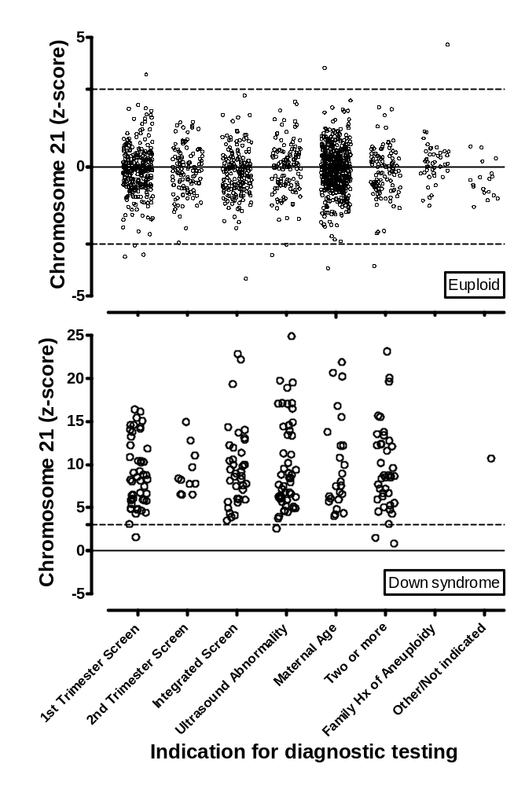
eFigure B23. Chromosome 21 z-score by indication for diagnostic testing. The top Figure (euploid pregnancies) shows the z-score stratified by indication for diagnostic testing. There is a slight but significant effect (mean z-scores of -0.15, -0.14, -0.24, -0.05, -0.11, 0.20, -0.52 and -0.20, from left to right, ANOVA F = 2.02, p = 0.049). The bottom Figure presents the same analysis among the Down syndrome pregnancies showing no significant effect (mean z-scores of 8.9, 9.1, 9.7, 9.8, 10.0, n/a, 10.7 and 9.5, from left to right, ANOVA F = 0.25, p = 0.96).

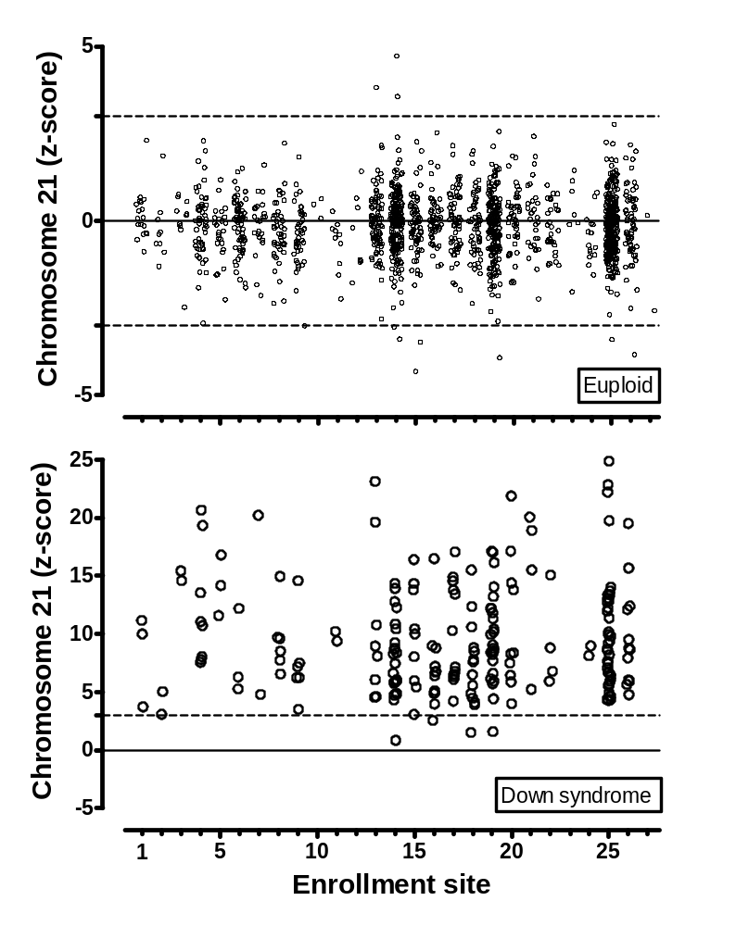
eFigure B24. Chromosome 21 z-score by Enrollment site. The top Figure (Euploid pregnancies) shows the z-score stratified by Enrollment site. For Enrollment sites with at least 50 samples, there is no effect (mean z-scores range from -0.21 to 0.02, ANOVA F = 0.57, p = 0.84). The bottom Figure presents the same analysis among the Down syndrome pregnancies and also does not show a significant effect (mean z-scores range from 6.90 to 12.34, ANOVA F=1.45, p=0.16).

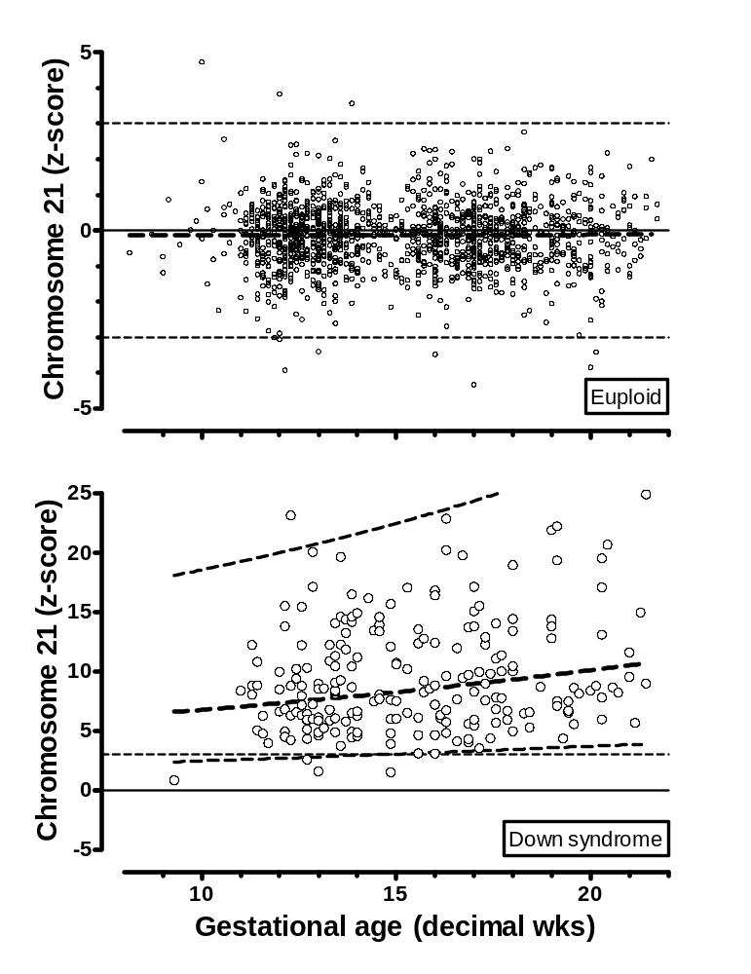
eFigure B25. Chromosome 21 z-score by gestational age. The x-axis shows the gestational age at the time of sample draw. The top Figure (Euploid pregnancies) shows the z-score by gestational age. Linear regression did not find a significant relationship (p = 0.79, slope = 0.0023). An analysis of Down syndrome pregnancies found a significant positive association with gestational age. (p=0.0023, slope = 0.017 on the log of the z-score).

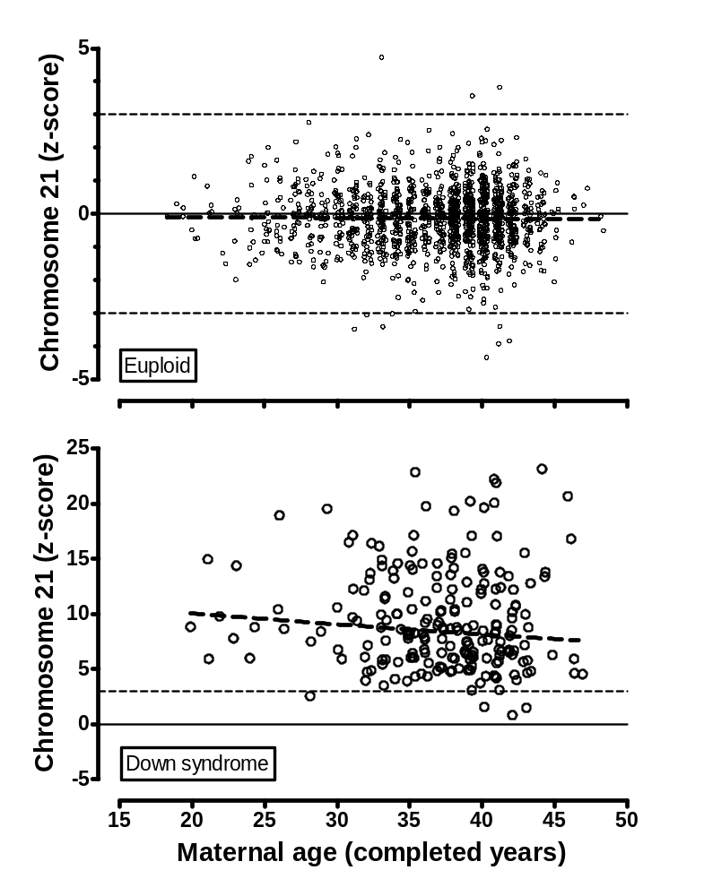
eFigure B26. Chromosome 21 z-score by maternal age. The x-axis shows the maternal age at the estimated delivery date. The top Figure (Euploid pregnancies) shows the z-score by maternal age. Linear regression did not find a significant relationship (thick dashed line, p = 0.62, slope = -0.0023. An analysis of Down syndrome pregnancies (bottom Figure) found a similar result (p=0.14, slope = -0.0046).

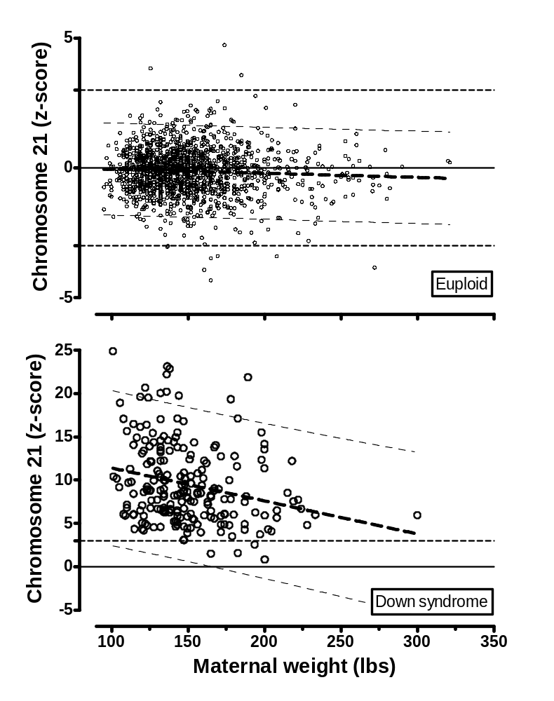
eFigure B27. Chromosome 21 z-score by maternal weight. The x-axis shows the maternal weight in pounds at the time of sample draw. The top Figure (Euploid pregnancies) shows the z-score by maternal weight for samples for euploid pregnancies. Linear regression found a significant negative slope (thick dashed line, with 95% prediction limits shown by thin dashed lines, p = 0.029, slope = -0.0016). A similar, but much larger, effect is seen for Down syndrome pregnancies (lower Figure, p = 0.0003, slope = -0.038). This latter effect is likely due to the maternal weight effect on fetal fraction (Figure B8).

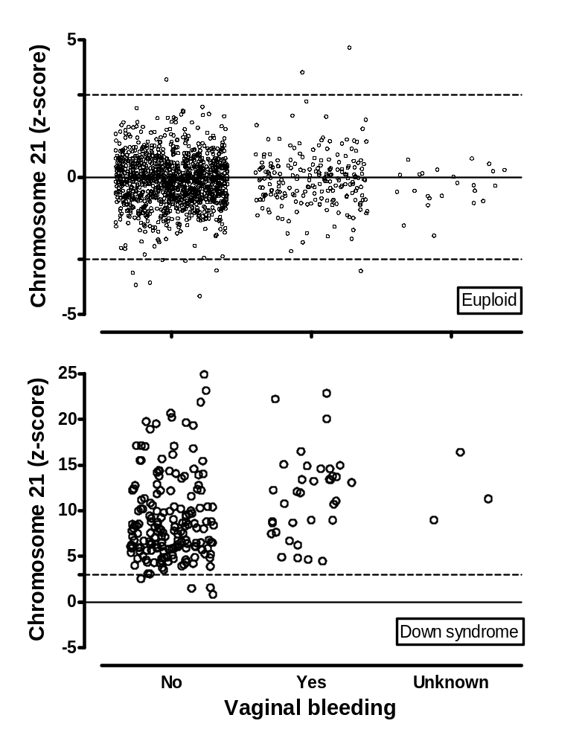
eFigure B28. Chromosome 21 z-score by self-reported maternal vaginal bleeding. The top Figure (Euploid pregnancies) shows the z-scores stratified by reported vaginal bleeding. There is no significant difference in z-scores by bleeding status (mean = -0.14 and -0.09, for No and Yes, respectively, t = -0.65, p = 0.52). The bottom Figure presents the same analysis among the Down syndrome pregnancies which shows a significant increase for those reporting bleeding (mean = 9.03 and 11.70, respectively, t = -3.14, p = 0.0019).

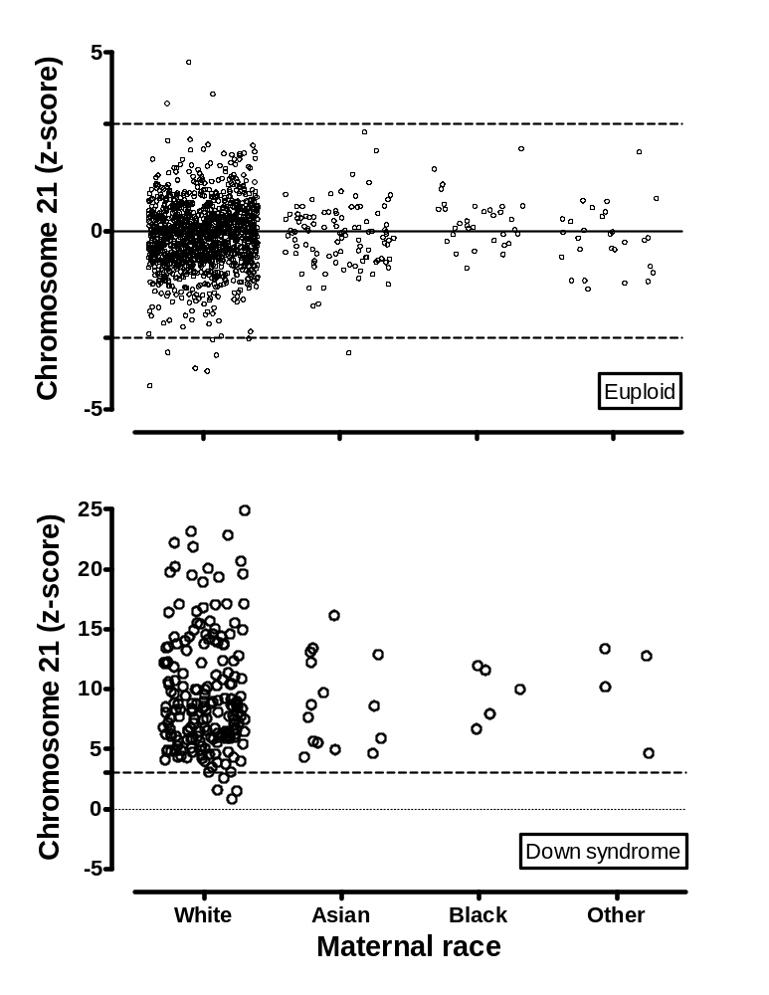
eFigure B29. Chromosome 21 z-score by maternal race. The top Figure (Euploid pregnancies) shows the z-score stratified by maternal race. There is no significant effect (mean z-scores of -0.14, -0.15, 0.28 and -0.21, from left to right; ANOVA F = 2.44, p = 0.063). The bottom Figure presents the same analysis among the Down syndrome pregnancies and also shows no effect (mean z-scores of 9.55, 8.90, 9.63 and 10.24, from left to right, ANOVA F = 0.12, p= 0.95).

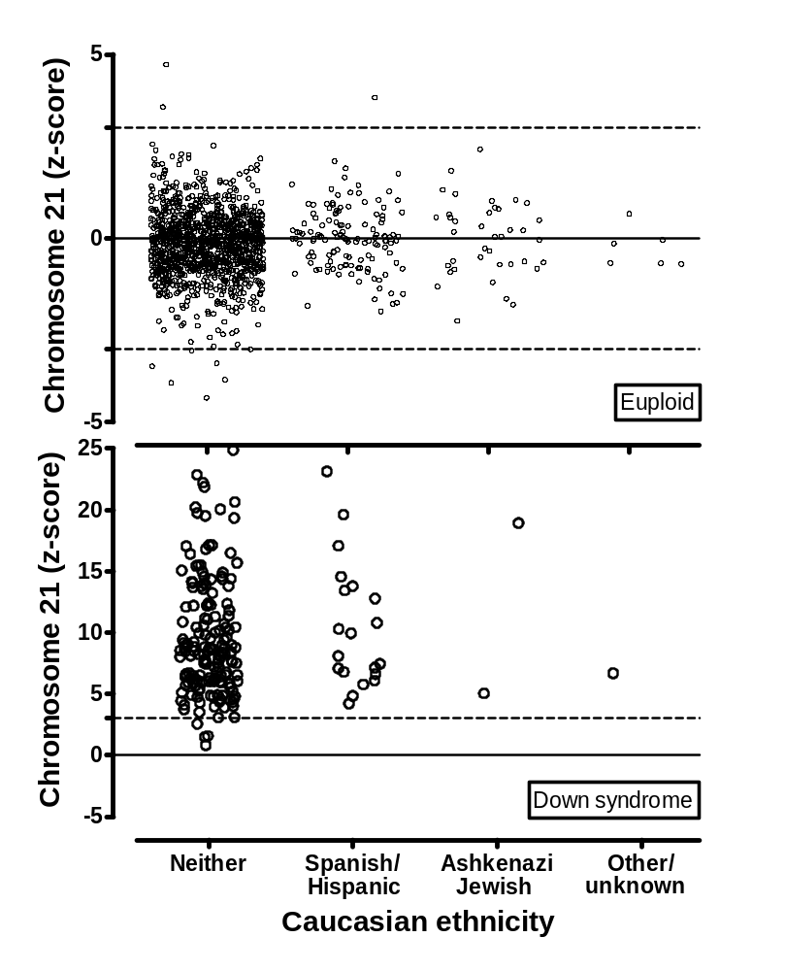
eFigure B30. Chromosome 21 z-score by Caucasian ethnicity. The top Figure (Euploid pregnancies) shows the z-score stratified by Caucasian ethnicity. There is no significant effect (mean z-scores of -0.16, -0.06 and 0.00, from left to right, ANOVA F = 1.70, p = 0.18). The bottom Figure presents the same analysis among the Down syndrome pregnancies and also does not show an effect (mean z-scores of 9.5, 9.4 and 11.9, from left to right, ANOVA F= 0.38, p= 0.68).

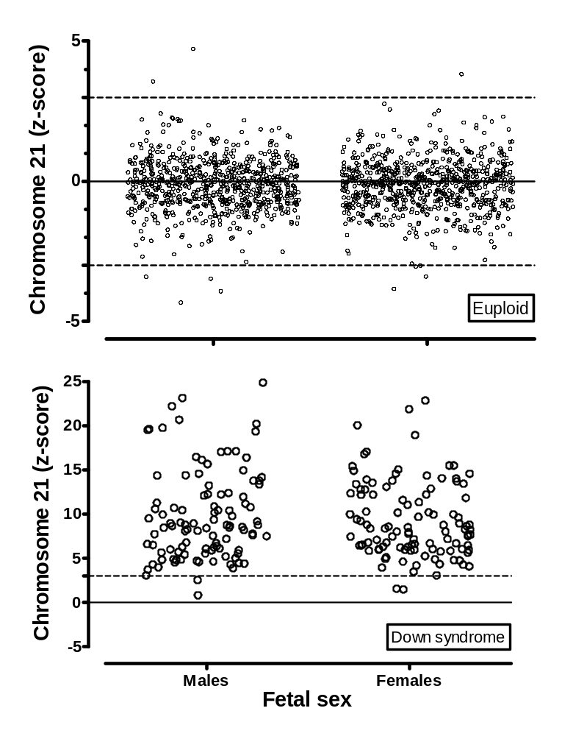
eFigure B31. Chromosome 21 z-score by fetal sex. The top Figure (Euploid pregnancies) shows the z-scores stratified by fetal sex. There is no difference in z-score between males and females (mean = -0.13 and mean = -0.13, respectively, t = -0.04, p=0.97). The bottom Figure presents the same analysis among the Down syndrome pregnancies, again showing no significant effect (mean = 9.25 and mean = 9.80, respectively, t = -0.85, p=0.39).

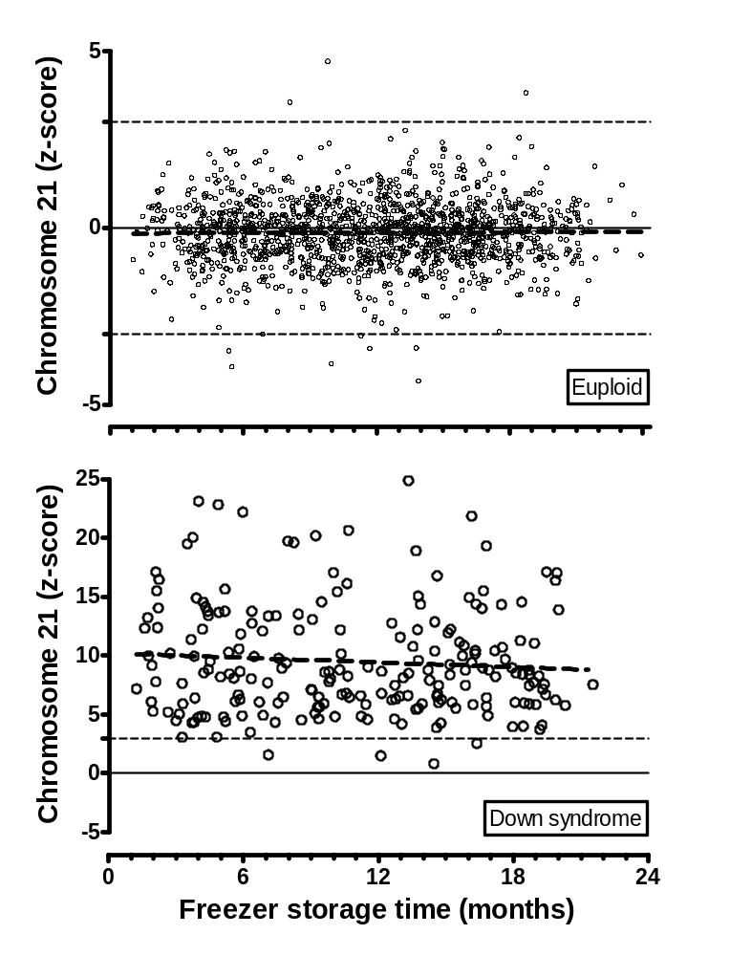
eFigure B32. Chromosome 21 z-score by freezer storage time. The x-axis shows the freezer storage time in months. The top Figure (Euploid pregnancies) shows the z-scores by freezer storage time. Linear regression did not find a significant slope (thick dashed line, p = 0.72, slope = 0.000057). Similar results were seen for Down syndrome pregnancies (lower Figure, p = 0.25, slope = -0.0022).

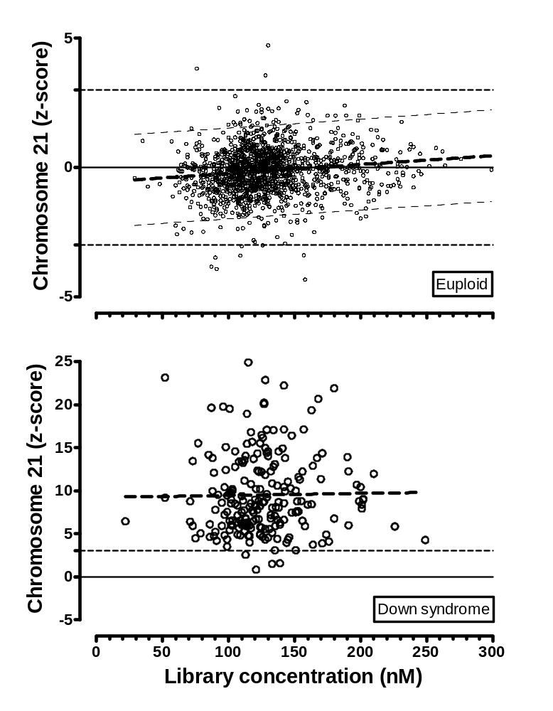
eFigure B33. Chromosome 21 z-score by library concentration. The top Figure (Euploid pregnancies) shows the z-score versus DNA library concentration. Linear regression shows a statistically significant positive slope (thick dashed line, with 95% predication limits shown by thin dashed lines, p < 0.0001, slope = 0.0034). A similar but non-significant effect is seen for Down syndrome pregnancies (lower Figure, p = 0.82, slope = 0.0024).

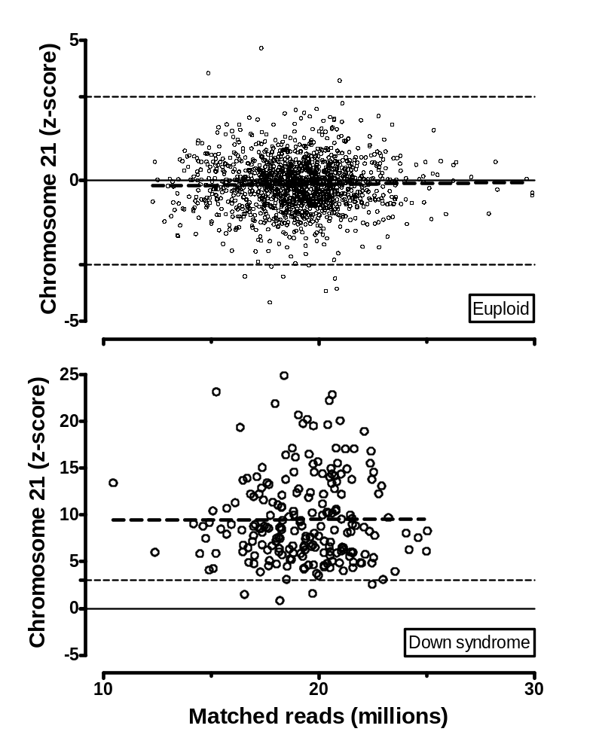
eFigure B34. Chromosome 21 z-score by matched sequence reads. The top Figure (Euploid pregnancies) shows the z-score by millions of matched DNA sequences. Linear regression finds a non-significant positive slope (thick dashed line, p = 0.47, slope = 0.0072). A similar effect is seen for Down syndrome pregnancies (lower Figure, p = 0.94, slope = 0.0099).

eTable B1. More complete information for the six misclassifications by MPSS testing
 | ID = 162 | ID = 167 | ID = 371 | ID = 22 | ID = 221 | ID = 249
T21 z-score | +0.83 | +1.50 | +1.57 | +3.82 | +4.72 | +3.56
MPSS interpretation | Not DS | Not DS | Not DS | DS | DS | DS
Karyotype | 47, XX +21 | 47, XY +21 | 47, XY +21 | 46, XY | 46, XX | 46, XX
Confirmation | Karyotype confirmed | Confirmed at autopsy | Confirmed by provider | Confirmed “healthy boy” | Confirmed “healthy girl” | Confirmed “healthy girl”
 | False Neg | False Neg | False Neg | False Pos | False Pos | False Pos
Gestational age (wks) | 9.2 | 14.6 | 13.0 | 12.1 | 10.0 | 13.6
Maternal age (yrs) | 42 | 43 | 40 | 41 | 33 | 39
Maternal Weight (lbs) | 200 | 165 | 182 | 125 | 174 | 185
Race/Ethnicity | White | White | White | White, Hispanic | White | White
Bleeding | No | No | No | Yes | Yes | No
Referral Reason | Mat age and  hx aneuploidy | Mat age and integrated screen | First trimester screen | Maternal age 38 or older | Mat age and  hx aneuploidy | First trimester screen
Processing Time (hrs) | 1 | 3 | 3 | 1 | 1 | 1
Sample volume (mL) | 4.0 | 4.0 | 3.8 | 3.9 | 4.0 | 4.0
Hemolysis | Slight | NR | None | None | Slight | Slight
Fetal Fraction (%) | 4 | 7 | 5 | 19 | 24 | 11
Note | 1st sample failed - low fetal DNA |  |  | 1st sample failed - high fetal DNA

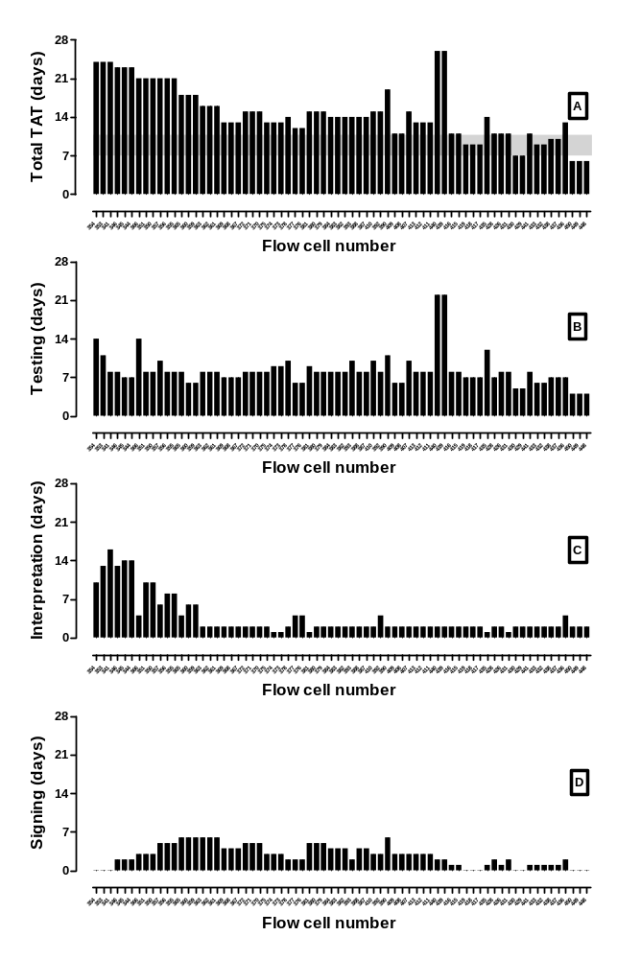
eFigure B35. MPSS testing turn-around time (TAT). Figure A shows the total turn-around time (TAT) in days (y-axis) by flow cell (x-axis) for the entire process of massively parallel shotgun sequencing. The target TAT of 7 to 10 days is shown by the gray rectangle. The next three Figures show the components of total turn-around time: B) time from sample thaw to end of the sequencing run, C) from the end of the sequencing run to computer interpretation and D) from computer interpretation to clinical sign-out. For the first third of flow cells processed, total TAT was dominated by the computer interpretation time due to modifications made in the algorithm prior to clinical sign-out described in our publication. The process of clinical sign-out improved over time. Two flow cells (about two-thirds of the way through the study) needed to be completely re-sequenced and this resulted in an increased TAT. During the last 20 flow cells, the TAT was within the 10 day target for 18 (90%). The TATs in a true clinical setting may be somewhat better, based on two potential improvements: in the current study, samples were not processed over the weekend, and a dedicated clinician was not always available for sign-out on a given day. About 5% of samples were repeated, roughly doubling the TAT for those samples.

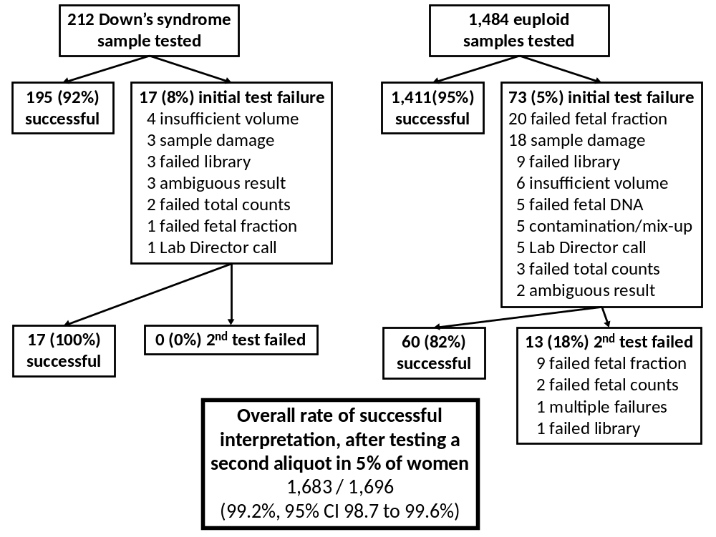
eFigure B36. Flow diagram showing reasons for the initial MPSS testing failures along with subsequent testing results on a second aliquot from the same woman. The left side of the flow chart shows the rate of successful interpretation (92%) as well as the reasons for test failures among the 212 samples from Down syndrome pregnancies. Repeat testing of a new aliquot from these 17 women resulted in 100% of samples having a successful interpretation. The analysis is repeated on the right side for the 1,484 euploid pregnancies tested. A total of 13 samples were considered test failures, even after a second aliquot was tested. Overall, the success rate in performing MPSS was 99.2%, with 5% of initial samples needing a second aliquot.

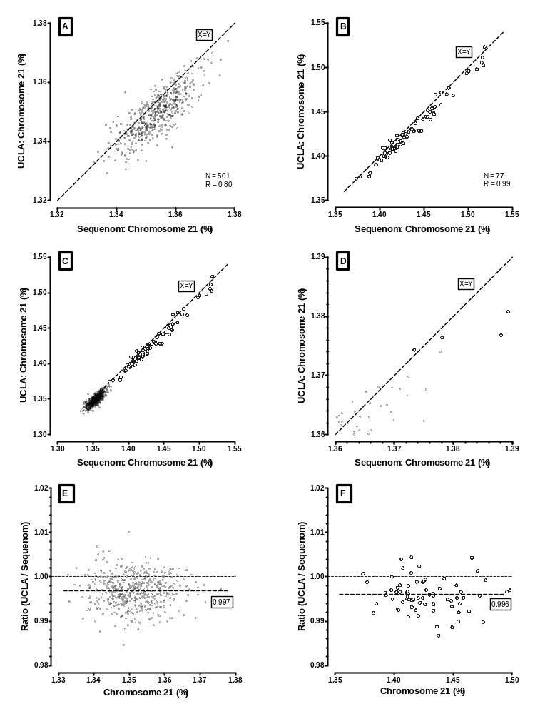
eFigure B37. Comparison of chromosome 21 percent from two laboratories. A total of 605 samples processed and tested at the Sequenom Center for Molecular Medicine (SCMM) were subsequently frozen and shipped to the Orphan Disease Testing Laboratory at UCLA for independent testing. Only the samples successfully run at both sites are shown. Figure A shows a scatterplot of the chromosome 21 percent (C21%) from both SCMM (x-axis) and UCLA (y-axis) for 501 euploid samples. Figure B shows the same comparison for the 77 Down syndrome samples. Correlation was high for both groups. Figure C shows both the euploid and Down syndrome test results from both laboratories in full scale. Figure D is a close-up of these same data in the area of overlap. Figure E shows a Bland-Altman plot of the mean C21% (X-axis) versus the ratio of the UCLA/SCMM results in the euploid samples. Figure F shows the same data in the Down syndrome samples. Not shown on any of the Figures are the 27 samples which one (or both) laboratories reported a test failure.
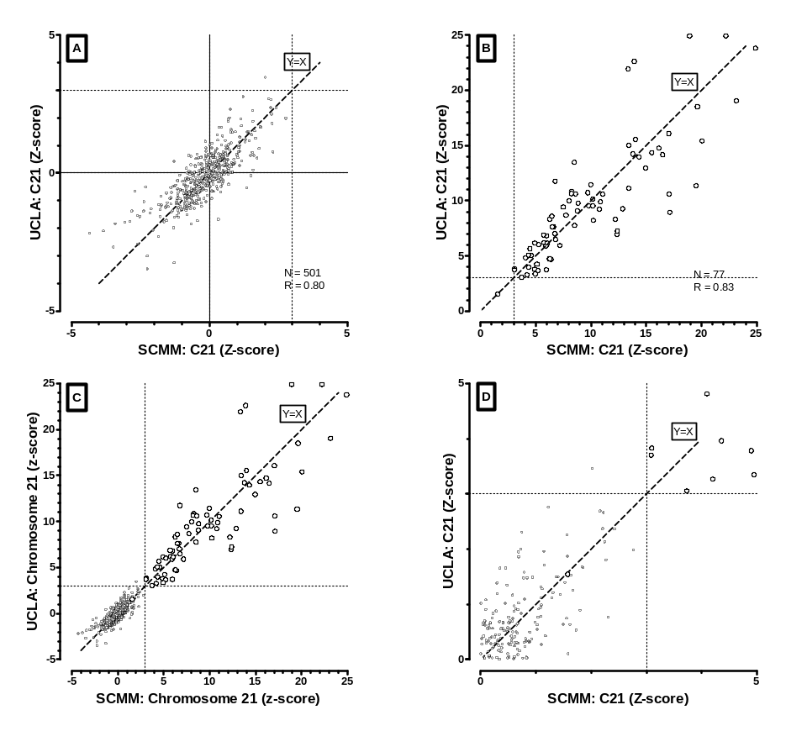
eFigure B38. Comparison of chromosome 21 z-score from two laboratories. A total of 605 samples processed and tested at the Sequenom Center for Molecular Medicine (SCMM) were subsequently frozen and shipped to the Orphan Disease Testing Laboratory at UCLA for independent testing. Only the samples successfully run at both sites are shown. Figure A shows a scatterplot of the chromosome 21 z-score from both SCMM (x-axis) and from UCLA (y-axis) for 501 euploid samples. Figure B shows the same comparison for the 77 Down syndrome samples. Correlation was high for both groups. Figures C shows both the euploid and Down syndrome test results from both laboratories in full scale. Figure D is a close-up of that same data in the area of overlap.

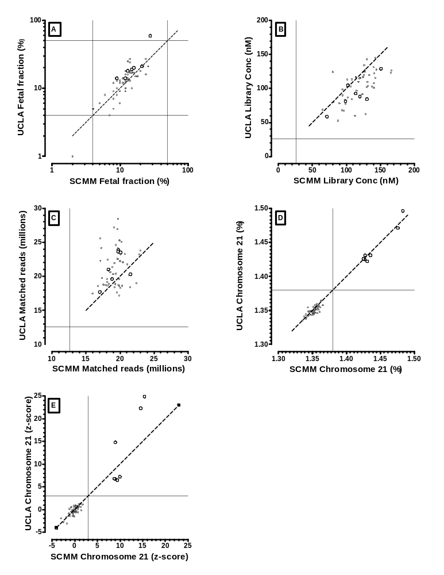
eFigure B39. Comparison of MPSS results for 7 Down syndrome and 46 euploid samples tested at two laboratory sites. Each testing site received an original 4 mL plasma sample from the Coordinating Center. Sequenom performed the fetal fraction testing for both sites. Otherwise, all processing, testing and interpretation was performed independently, according to an established set of standard operating protocols. One sample had a low fetal fraction at both sites (Figure A) and was considered a failure at both sites. Two other samples had a technical failure at UCLA and are not included in these plots. UCLA’s protocol did not require re-testing or requesting an additional aliquot. Among the remaining 53 samples, the DNA library concentration (Figure B) and matched DNA sequence reads (Figure C) were similar in the two groups and within quality parameters (horizontal and vertical lines). The resulting chromosome 21% in case and control pregnancies were well separated, and highly correlated (Figure D). The thin line is set at 1.38%. Figure E shows the chromosome 21 results expressed as a z-score. Again, the case and control pregnancies are well separated and highly correlated. The thin line is set at a z-score of +3. This corresponds to a detection rate of 100% and false positive rate of 0% for both sites. Failure rates are 1 of 56 for Sequenom and 3 of 56 for UCLA.

eTable B2. Comparison of the final MPSS interpretations for 79 Down syndrome and 526 euploid samples tested at two laboratories

 | SCMM
 | Down syndrome |  |  |  | Euploid
UCLA | True Positive | False Negative | Failure |  | True Negative | False Positive | Failure | Totals
Down syndrome
True Pos | 76 | 0 | 1 |  |  |  |  | 77
False Neg | 0 | 1 | 1 |  |  |  |  | 2
Test failure | 0 | 0 | 0 |  |  |  |  | 0
Euploid
True Neg |  |  |  |  | 500 | 0 | 4 | 504
False Pos |  |  |  |  | 1 | 0 | 0 | 1
Test Failure |  |  |  |  | 2 | 0 | 19 | 21
Totals | 76 | 1 | 2 |  | 503 | 0 | 23 | 605

Mixed libraries for 605 samples were prepared at Sequenom Center for Molecular Medicine (SCMM), tested, frozen, and then shipped to the independent UCLA laboratory for retesting. Detection and false positive rates at SCMM (98.7% and 0%, respectively), were slightly, but not significantly, better than those at UCLA (97.5% and 0.2%, respectively). However, failure rates were slightly, but not significantly, lower at UCLA versus SCMM (0% and 2.5% in Down syndrome; 3.9% and 4.4% in euploid pregnancies, respectively).
100,000
Screen positive women
3,000
Down syndrome
97,000
Euploid
2,958
MPSS +
42
MPSS -
198
MPSS +
96,026
MPSS -
776
Failure
Diagnostic test costs with full uptake ($K) 2,958 42 198 96,026 776 100,000
MPSS reduced diagnostic test costs ($K) 2,958 0 198 0 776 3,932
Potential savings ($K) 0 42 0 96,026 0 96,068

Cases not detected with MPSS 0 42 0 0 0 42

Per person available for MPSS ($) $960 ($96,068,000 / 100,000)
Marginal cost per missed case ($) $2,287,000 ($96,068,000 / 42)

Odds of affected given positive results 15:1 (2,958 : 198) with failures excluded
Odds of affected given negative results 1:2,300 (42 : 96,026) with failures excluded

Procedure-related losses (full uptake) 500 (100,000 / 200)
Procedure-related losses (MPSS) 20 ([2,958 + 198 + 776] / 200) with failures included
Avoidable losses with MPSS 480 (500 – 20)

Loss per Down detected (full uptake) 1:6 (500 : 3,000)
Loss per Down detected (MPSS) 1:150 ( 24 : 2,958)

eFigure B40. Medical and financial costs associated with using massively parallel shotgun sequencing (MPSS) as an intermediate step between screening and diagnostic testing for Down syndrome. Assumptions include: detection and false positive rates for MPSS testing of 98.6% and 0.2%, respectively. The test failure rate among euploid pregnancies is 0.8%. The prevalence of Down syndrome in the screen positive population is 1:32 (3%) and the procedure-related loss rate is 1:200 (0.5%). Costs of diagnostic testing are set to an even $1,000¹. The flow chart shows the results of MPSS testing in a population of 100,000 high risk women. The first row shows the diagnostic testing costs (in thousands of dollars) assuming full uptake for all women. The second row shows those same costs, assuming that all women have MPSS testing and only those with positive tests (or failures) go on for diagnostic testing. The third row shows the potential savings, and the fourth row shows the number of Down syndrome cases missed by MPSS testing. The fifth row contains the per-person dollars available for MPSS testing, under the assumption that the potential savings can all be used for this purpose. The sixth row shows the marginal costs of detecting the 42 missed cases. The next two rows show predictive values. The last five rows show the procedure-related losses under each assumption, the avoidable losses of unaffected pregnancies with MPSS testing, and the procedure-related losses per Downs’ syndrome pregnancy.

¹ Medicare 2011 reimbursements:
amniocentesis / karyotyping
59000 (amniocentesis, diagnostic) $273.73 $86.18 $359.91
76815 Ultrasound, pregnant uterus, limited $68.00 $32.61 $100.61
76946 Ultrasound guidance for amniocentesis - $19.30 $19.30
88235 Tissue culture $207.22 - $207.22
88269 Chromosome analysis $234.06 - $234.06
88292 Cytogenetic and molecular interpretation - $30.32 $30.32
88280 Chromosome analysis; additional karyotype $35.32 - $35.32
Total $818.32 $168.41 $986.73

CVS / karyotyping
59015 CVS any method $273.73 $141.03 $414.76
88172 Cytopathology, fine needle aspiration $18.74 $30.89 $49.63
Other codes (76815,76946,88235,88269,88282,88280) as above
Total $837.06 $269.99 $1,107.05
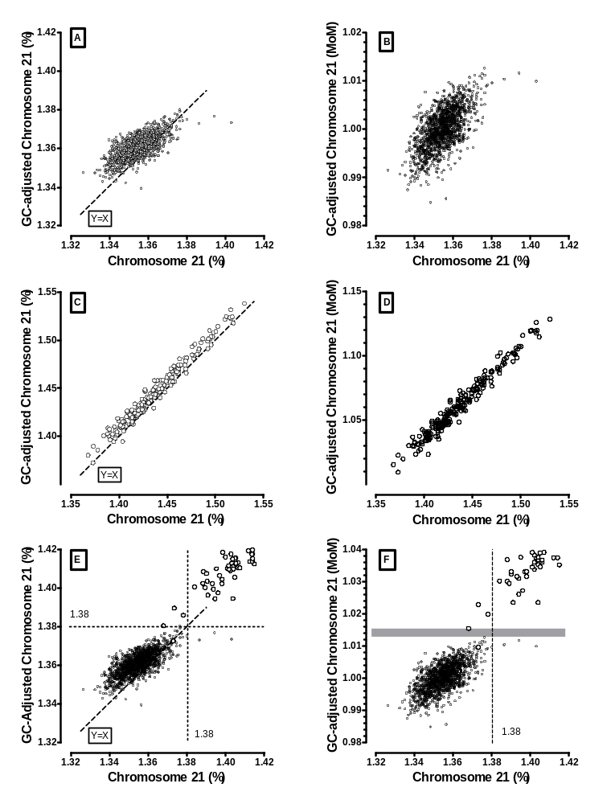
eFigure B41. Impact of adjusting Chromosome 21 percent (C21%) for GC content and for changes in plate means. Figure A shows C21% before (x-axis) and after (y-axis) GC adjustment in euploid samples, while Figure B also accounts for plate to plate differences by converting GC-adjusted C21% results to multiples of the plate median (MoM). Figures C and D show the same analysis for test results from pregnancies with Down syndrome. In both sets of Figures, the GC adjustment reduced the presence of high (and low) outliers among the euploid pregnancies, while reducing the spread of data. Figures E and F show the same two adjustments, but with both euploid and Down syndrome samples in the same Figures. These Figures focus on the area of overlap, so not all Down syndrome samples are shown. Without any adjustments (x-axis), a cut-off of 1.38% (vertical line) results in four false negatives and three false positive results. With GC adjustment (Figure E, y-axis), two of the four false negatives and all three false positive results are resolved using the same cut-off of 1.38% (horizontal line). However, one of the false negative results and a new false positive result are on the cut-off line. The remaining fourth false negative is still negative. By adding the plate adjustment to create the MoM (Figure F, y-axis), all three false positives and three of four false negatives are potentially resolved by any cut-off falling within the grey zone horizontal rectangle. The one false negative, however, remains.
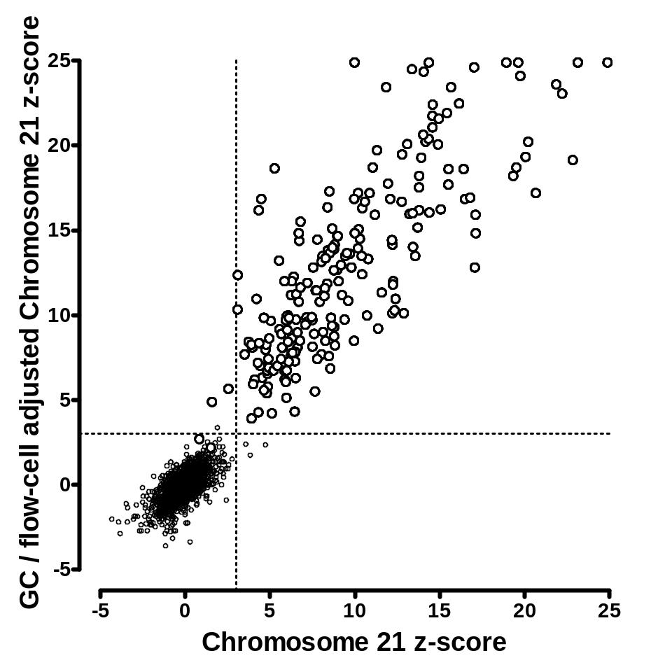
eFigure 42. Impact of adjusting Chromosome 21 z-score for GC content and plate variability. The original chromosome 21 z-score is shown on the x-axis. These results are based on a flow cell specific adjustment for processing variability. The results on the y-axis are also adjusted for GC base content and repeat masked. Results are shown for 1,471 euploid (small open circles) and 212 Down syndrome cases (large open circles). The use of chromosome 21 z-scores adjusted for GC content and flow-cell variability leads to the resolution of two false negative and the three original false positives using the z-score cut-off 3 (equivalent to the ‘on-line’ calling algorithm). However, one new false positive is generated. This figure is comparable to the data on Figure B41F.
eTable B3. Comparison of published studies reporting the clinical validity of massively parallel sequencing of maternal plasma and Down syndrome.

Characteristics | Current Study | Ehrich 2011 | Chiu 2011 | Sehnert 2011
Multiplexing | 4-plex | 4-plex | 2-plex¹ | NR
Down syndrome (N) | 212 | 39 | 86 | 13
Euploid / non-Down syndrome | 1,484 | 410 | 146 | 34
Illumina Platform | HiSeq 2000 | GAIIx | GAIIx | GAIIx
Performed in CLIA laboratory | Yes | No | No | No
Simulate Practice? | Yes | No | No | No
Flow cells | 76 | >15 | > 16 | NR
Study Population | N Amer, S Amer, Europe, Australia | US | Hong Kong, Netherlands, UK | US
Gestational age in weeks (mean, range) | 15 (8 – 22) | 16 (8 – 36) | 13 (NR) | 15 (10-28)
Trimester 1st/2nd (%) | 50/50 | NR | 88/12 | 58/42
Failures (n/N, %) | 13/1696 (<1) | 18/467 (3.9) | 11/764 ( 1.4) | 0/47
Detection Rate (%) | 209/ 212 (98.6) | 39/39 (100) | 86/86 (100) | 13/13 (100)
False Positive rate (%) | 3/1471 ( 0.2) | 1/410 ( 0.2) | 3/146 ( 2.1) | 0/34 ( 0)
Throughput (samples / week) | 250 | NR | NR | NR
Required volume | >3.5 mL | > 3.5 mL | >2 mL | ~4 mL³
Available 2nd sample | Yes | No | No | Yes
Fetal fraction estimated | All | All | Males only | NR
Turn-around time² (days) | 8.8⁴ | 10⁵ | NR | NR

¹ Report also included 8-plex, but only the results for 2-plex are shown
² from start of processing to sequencing completion (does not include alignment or sign-out)
³ Authors state, “plasma from a single [10 mL] blood tube was sufficient for sequencing”
⁴ Mean of last 20 flow cells [32 samples each]
⁵ Authors state, “each batch [96 samples] required approximately 10 days from DNA extraction to the final sequencing result”

