Supplemental Digital Content
Search Strategies (Last updated January 25, 2022)
Contents
Database: Ovid MEDLINE(R) and In-Process, In-Data-Review & Other Non-Indexed Citations <1946 to January 24, 2022> 2
Database: Embase Classic+Embase <1947 to 2022 January 24> 4
Database: APA PsycInfo <1806 to January Week 3 2022> 6
Database: EBSCO CINAHL (1937 – January 25, 2022) 8
Database: Web of Science (1900 – January 25, 2022) 11
Grey Literature Searches 12

Database: Ovid MEDLINE(R) and In-Process, In-Data-Review & Other Non-Indexed Citations <1946 to January 24, 2022>
Date Searched: January 25, 2022

Search Strategy:
--------------------------------------------------------------------------------
1 exp aged/ (3357053)
2 Geriatrics/ (30886)
3 elder*.mp. (291892)
4 seniors.mp. (8192)
5 "senior citizen*".mp. (1598)
6 old* adult*.mp. (99319)
7 aged population*.mp. (3127)
8 geriatric*.mp. (111182)
9 old* people.mp. (37302)
10 old* person*.mp. (13735)
11 baby boomer*.mp. (1377)
12 or/1-11 (3492925)
13 exp inflammatory bowel diseases/ (88869)
14 inflammatory bowel disease*.mp. (59961)
15 ulcerative colitis.mp. (43686)
16 crohn* disease.mp. (59564)
17 crohn* enteritis.mp. (18)
18 granulomatous colitis.mp. (376)
19 granulomatous enteritis.mp. (192)
20 ileocolitis.mp. (437)
21 regional enteritis.mp. (892)
22 terminal ileitis.mp. (478)
23 regional ileitis.mp. (287)
24 colitis gravis.mp. (7)
25 idiopathic proctocolitis.mp. (32)
26 or/13-25 (122391)
27 exp patient satisfaction/ (96400)
28 exp patient-centered care/ (22755)
29 exp physician-patient relations/ (75131)
30 patient reported outcome measures/ (10570)
31 exp patients/ (73941)
32 feedback/ (31621)
33 exp Attitude/ (616076)
34 Perception/ (40538)
35 or/32-34 (676767)
36 31 and 35 (12339)
37 (patient* adj3 feedback).mp. (3599)
38 (patient* adj3 experience*).mp. (139843)
39 (patient* adj3 perception*).mp. (19588)
40 (patient* adj3 perceiv*).mp. (12273)
41 (patient* adj3 satisf*).mp. (131735)
42 patient reported experience measure*.mp. (221)
43 PREM.mp. (283)
44 patient reported outcome measure*.mp. (15724)
45 PROM.mp. (3741)
46 (patient* adj3 expectation*).mp. (8945)
47 patient* care experience*.mp. (303)
48 patient* preferenc*.mp. (20720)
49 patient* critique*.mp. (7)
50 (patient* adj3 critici*).mp. (247)
51 (patient* adj3 interpretation*).mp. (3312)
52 (patient* adj3 opinion*).mp. (4245)
53 (patient* adj3 judgement*).mp. (535)
54 (patient* adj3 judgment*).mp. (1198)
55 (patient* adj3 view*).mp. (12147)
56 (patient* adj3 reaction*).mp. (14769)
57 (patient* adj3 observation*).mp. (25414)
58 (patient* adj3 rating*).mp. (6967)
59 (patient* adj3 feeling*).mp. (2886)
60 (patient* adj3 impression*).mp. (2758)
61 (patient* adj3 thought*).mp. (4822)
62 (patient* adj3 insight*).mp. (3944)
63 (patient* adj3 involve*).mp. (50465)
64 (patient* adj3 choice*).mp. (17218)
65 (patient* adj3 dissatisf*).mp. (3148)
66 (patient* adj3 engage*).mp. (9782)
67 (patient* adj3 knowl*).mp. (15502)
68 (patient* adj3 voice*).mp. (3394)
69 (patient* adj3 accept*).mp. (74477)
70 (patient* adj3 assessment*).mp. (56148)
71 (patient* adj3 comment*).mp. (1917)
72 27 or 28 or 29 or 30 or 36 or 37 or 38 or 39 or 40 or 41 or 42 or 43 or 44 or 45 or 46 or 47 or 48 or 49 or 50 or 51 or 52 or 53 or 54 or 55 or 56 or 57 or 58 or 59 or 60 or 61 or 62 or 63 or 64 or 65 or 66 or 67 or 68 or 69 or 70 or 71 (665364)
73 12 and 26 and 72 (1118)
74 (2021* or 2022*).dt,ez,da. (2113550)
75 73 and 74 (57)

***************************

Database: Embase Classic+Embase <1947 to 2022 January 24>

Date Searched: January 25, 2022

Search Strategy:
--------------------------------------------------------------------------------
1 exp aged/ (3479799)
2 Geriatrics/ (40424)
3 elder*.mp. (663050)
4 seniors.mp. (11464)
5 "senior citizen*".mp. (2183)
6 old* adult*.mp. (130413)
7 aged population*.mp. (4381)
8 geriatric*.mp. (170377)
9 old* people.mp. (50612)
10 old* person*.mp. (19393)
11 baby boomer*.mp. (2093)
12 or/1-11 (3679362)
13 exp inflammatory bowel disease/ (179513)
14 inflammatory bowel disease*.mp. (105190)
15 ulcerative colitis.mp. (96829)
16 crohn* disease.mp. (114161)
17 crohn* enteritis.mp. (37)
18 granulomatous colitis.mp. (690)
19 granulomatous enteritis.mp. (220)
20 ileocolitis.mp. (780)
21 regional enteritis.mp. (1329)
22 terminal ileitis.mp. (764)
23 regional ileitis.mp. (457)
24 colitis gravis.mp. (8)
25 idiopathic proctocolitis.mp. (47)
26 or/13-25 (213833)
27 exp patient satisfaction/ (152895)
28 exp doctor patient relation/ (6321)
29 patient-reported outcome/ (36573)
30 exp patient/ (3144160)
31 feedback system/ (90378)
32 exp Attitude/ (862965)
33 Perception/ (142670)
34 or/31-33 (1068365)
35 30 and 34 (105873)
36 (patient* adj3 feedback).mp. (7240)
37 (patient* adj3 experience*).mp. (238134)
38 (patient* adj3 perception*).mp. (29738)
39 (patient* adj3 perceiv*).mp. (18871)
40 (patient* adj3 satisf*).mp. (198146)
41 patient reported experience measure*.mp. (390)
42 PREM.mp. (549)
43 patient reported outcome measure*.mp. (12324)
44 PROM.mp. (6525)
45 (patient* adj3 expectation*).mp. (13509)
46 patient* care experience*.mp. (457)
47 patient* preferenc*.mp. (33804)
48 patient* critique*.mp. (13)
49 (patient* adj3 critici*).mp. (382)
50 (patient* adj3 interpretation*).mp. (5808)
51 (patient* adj3 opinion*).mp. (7002)
52 (patient* adj3 judgement*).mp. (877)
53 (patient* adj3 judgment*).mp. (1699)
54 (patient* adj3 view*).mp. (19013)
55 (patient* adj3 reaction*).mp. (26380)
56 (patient* adj3 observation*).mp. (48518)
57 (patient* adj3 rating*).mp. (9991)
58 (patient* adj3 feeling*).mp. (5345)
59 (patient* adj3 impression*).mp. (5502)
60 (patient* adj3 thought*).mp. (8392)
61 (patient* adj3 insight*).mp. (6968)
62 (patient* adj3 involve*).mp. (84578)
63 (patient* adj3 choice*).mp. (27937)
64 (patient* adj3 dissatisf*).mp. (4673)
65 (patient* adj3 engage*).mp. (15890)
66 (patient* adj3 knowl*).mp. (25302)
67 (patient* adj3 voice*).mp. (5023)
68 (patient* adj3 accept*).mp. (39397)
69 (patient* adj3 assessment*).mp. (115120)
70 (patient* adj3 comment*).mp. (3800)
71 27 or 28 or 29 (191912)
72 or/35-70 (962710)
73 71 or 72 (986904)
74 12 and 26 and 73 (1447)
75 limit 74 to dc=20210118-20220125 (131)

Database: APA PsycInfo <1806 to January Week 3 2022>
Date searched: January 25, 2022

Search Strategy:
--------------------------------------------------------------------------------
1 exp elder care/ (5445)
2 exp aging/ (82729)
3 exp older adulthood/ (8970)
4 Geriatrics/ (12195)
5 elder*.mp. (80792)
6 seniors.mp. (7998)
7 "senior citizen*".mp. (1163)
8 old* adult*.mp. (65311)
9 aged population*.mp. (779)
10 geriatric*.mp. (48490)
11 old* people.mp. (17219)
12 old* person*.mp. (7674)
13 baby boomer*.mp. (1793)
14 or/1-13 (202825)
15 exp colitis/ (480)
16 exp colon disorders/ (4578)
17 inflammatory bowel disease*.mp. (1107)
18 ulcerative colitis.mp. (704)
19 crohn* disease.mp. (719)
20 crohn* enteritis.mp. (0)
21 granulomatous colitis.mp. (0)
22 granulomatous enteritis.mp. (0)
23 ileocolitis.mp. (1)
24 regional enteritis.mp. (10)
25 terminal ileitis.mp. (0)
26 regional ileitis.mp. (7)
27 colitis gravis.mp. (0)
28 idiopathic proctocolitis.mp. (0)
29 or/15-28 (5420)
30 exp client satisfaction/ (5982)
31 exp client centered therapy/ (3512)
32 patient reported outcome measures/ (462)
33 exp patients/ (102243)
34 feedback/ (19721)
35 exp Attitude/ (0)
36 Perception/ (23385)
37 or/34-36 (43003)
38 33 and 37 (383)
39 patient reported experience measure*.mp. (44)
40 PREM.mp. (51)
41 patient reported outcome measure*.mp. (1476)
42 PROM.mp. (370)
43 patient* care experience*.mp. (78)
44 patient* preferenc*.mp. (4110)
45 patient* critique*.mp. (8)
46 patient*.mp. (828937)
47 (feedback or experience* or perception* or perceiv* or satisf* or expectation* or interpretation* or opinion* or judgement* or judgment* or view* or reaction* or observation* or rating* or feeling* or impression* or thought* or insight* or involve* or choice* or dissatisf* or engage* or knowl* or voice* or accept* or assessment* or comment*).mp. (3253190)
48 46 and 47 (558125)
49 30 or 31 or 32 or 38 or 39 or 40 or 41 or 42 or 43 or 44 or 45 or 48 (562816)
50 14 and 29 and 49 (73)

Database: EBSCO CINAHL (1937 – January 25, 2022)

Date searched: January 25, 2022

Search strategy:
Search ID | Search Terms | Actions
S76 | S74 AND S75 | 109
S75 | ZD (2021* OR 2022* OR "in process") | 1,064,591
S74 | S12 AND S26 AND S73 | 902
S73 | S27 OR S28 OR S29 OR S30 OR S36 OR S37 OR S38 OR S39 OR S40 OR S41 OR S42 OR S43 OR S44 OR S45 OR S46 OR S47 OR S48 OR S49 OR S50 OR S51 OR S52 OR S53 OR S54 OR S55 OR S56 OR S57 OR S58 OR S59 OR S60 OR S61 OR S62 OR S63 OR S64 OR S65 OR S66 OR S67 OR S68 OR S69 OR S70 OR S71 OR S72 | Auto-run
S72 | patient* AND comment* | Auto-run
S71 | patient* AND assessment* | Auto-run
S70 | patient* AND accept* | Auto-run
S69 | patient* AND voice* | Auto-run
S68 | patient* AND knowl* | Auto-run
S67 | patient* AND engage* | Auto-run
S66 | patient* AND dissatisf* | Auto-run
S65 | patient* AND choice* | Auto-run
S64 | patient* AND involve* | Auto-run
S63 | patient* AND insight* | Auto-run
S62 | patient* AND thought* | Auto-run
S61 | patient* AND impression* | Auto-run
S60 | patient* AND feeling* | Auto-run
S59 | patient* AND rating* | Auto-run
S58 | patient* AND observation* | Auto-run
S57 | patient* AND reaction* | Auto-run
S56 | patient* AND view* | Auto-run
S55 | patient* AND judgment* | Auto-run
S54 | patient* AND judgement* | Auto-run
S53 | patient* AND opinion* | Auto-run
S52 | patient* AND interpretation* | Auto-run
S51 | patient* AND interpretation* | Auto-run
S50 | patient* AND critici* | Auto-run
S49 | patient* critique* | Auto-run
S48 | patient* preferenc* | Auto-run
S47 | patient* care experience* | Auto-run
S46 | patient* AND expectation* | Auto-run
S45 | PROM | Auto-run
S44 | patient reported outcome measure* | Auto-run
S43 | PREM | Auto-run
S42 | patient reported experience measure* | Auto-run
S41 | patient* AND satisf* | Auto-run
S40 | patient* AND perceiv* | Auto-run
S39 | patient* AND perception* | Auto-run
S38 | patient* AND experience* | Auto-run
S37 | patient* AND feedback | Auto-run
S36 | S31 AND S35 | Auto-run
S35 | S32 OR S33 OR S34 | Auto-run
S34 | (MH "Perception+") | Auto-run
S33 | (MH "Attitude+") | Auto-run
S32 | (MH "Feedback") | Auto-run
S31 | (MH "Patients+") | Auto-run
S30 | (MH "Patient-Reported Outcomes+") | Auto-run
S29 | (MH "Professional-Patient Relations+") | Auto-run
S28 | (MH "Patient Centered Care") | Auto-run
S27 | (MH "Patient Satisfaction+") | Auto-run
S26 | S13 OR S14 OR S15 OR S16 OR S17 OR S18 OR S19 OR S20 OR S21 OR S22 OR S23 OR S24 OR S25 | Auto-run
S25 | idiopathic proctocolitis | Auto-run
S24 | colitis gravis | Auto-run
S23 | regional ileitis | Auto-run
S22 | terminal ileitis | Auto-run
S21 | regional enteritis | Auto-run
S20 | ileocolitis | Auto-run
S19 | granulomatous enteritis | Auto-run
S18 | granulomatous colitis | Auto-run
S17 | crohn* enteritis | Auto-run
S16 | crohn* disease | Auto-run
S15 | ulcerative colitis | Auto-run
S14 | inflammatory bowel disease* | Auto-run
S13 | (MH "Inflammatory Bowel Diseases+") | Auto-run
S12 | S1 OR S2 OR S3 OR S4 OR S5 OR S6 OR S7 OR S8 OR S9 OR S10 OR S11 | Auto-run
S11 | baby boomer* | Auto-run
S10 | old* person* | Auto-run
S9 | old* people | Auto-run
S8 | geriatric* | Auto-run
S7 | aged population* | Auto-run
S6 | old* adult* | Auto-run
S5 | "senior citizen*" | Auto-run
S4 | seniors | Auto-run
S3 | elder* | Auto-run
S2 | (MH "Geriatrics") | Auto-run
S1 | (MH "Aged+") | Auto-run

Database: Web of Science (1900 – January 25, 2022)

Date Searched January 25, 2022

Search Strategy:
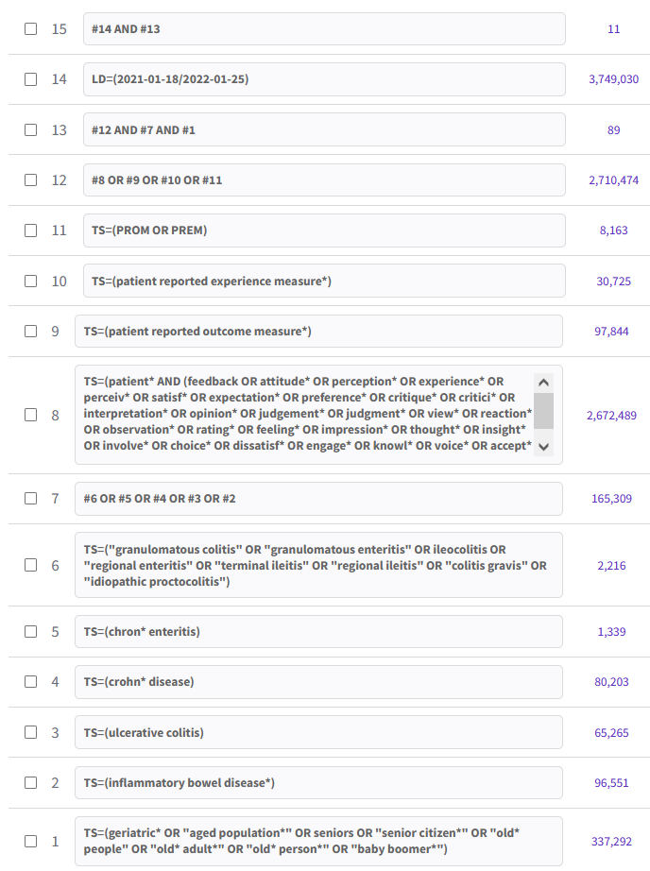

Grey Literature Searches

Sources:
- Crohns and Colitis Australia https://www.crohnsandcolitis.com.au/
- Crohn’s and Colitis Canada https://crohnsandcolitis.ca/
- Canadian Digestive Health Foundation https://cdhf.ca/
- Crohn’s and Colitis UK https://www.crohnsandcolitis.org.uk/
- Crohn’s and Colitis Foundation USA https://www.crohnscolitisfoundation.org/

Date Searched:
Jan 28, 2022

Search Strategy:

Copy and paste into Google:
(geriatric* OR "aged population*" OR seniors OR "senior citizen*" OR "old* people" OR "old* adult*" OR "old* person*" OR "baby boomer*") site:[paste website address here one search at a time]

Example:

(geriatric* OR "aged population*" OR seniors OR "senior citizen*" OR "old* people" OR "old* adult*" OR "old* person*" OR "baby boomer*") site:https://crohnsandcolitis.ca/

Number of results found across all sources:

- Crohn’s and Colitis Canada
  - (geriatric* OR "aged population*" OR seniors OR "senior citizen*" OR "old* people" OR "old* adult*" OR "old* person*" OR "baby boomer*") site:https://crohnsandcolitis.ca/
  - Crohn’s and Colitis Canada https://crohnsandcolitis.ca/ - 0 results
- Crohns and Colitis Australia
  - (geriatric* OR "aged population*" OR seniors OR "senior citizen*" OR "old* people" OR "old* adult*" OR "old* person*" OR "baby boomer*") site:https://www.crohnsandcolitis.com.au/
  - Crohns and Colitis Australia - 0 results
- Canadian Digestive Health Foundation
  - (geriatric* OR "aged population*" OR seniors OR "senior citizen*" OR "old* people" OR "old* adult*" OR "old* person*" OR "baby boomer*") site:https://cdhf.ca/
  - Canadian Digestive Health Foundation – 0 results
- Crohn’s and Colitis UK
  - (geriatric* OR "aged population*" OR seniors OR "senior citizen*" OR "old* people" OR "old* adult*" OR "old* person*" OR "baby boomer*") site:https://www.crohnsandcolitis.org.uk/
  - Crohns and Colitis UK - 0 results
- Crohn’s and Colitis Foundation USA
  - (geriatric* OR "aged population*" OR seniors OR "senior citizen*" OR "old* people" OR "old* adult*" OR "old* person*" OR "baby boomer*") site:https://www.crohnscolitisfoundation.org/
  - Crohn’s and Colitis Foundation USA - 0 results

