STAR Skin Tear Classification System

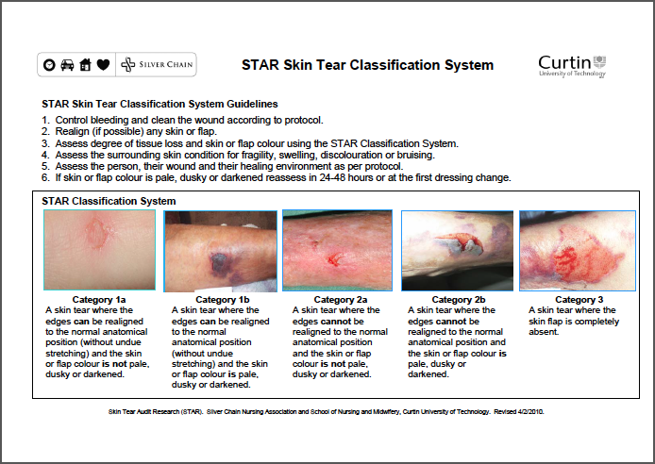
Reprinted with permission (2012).

