- Supplementary material (online only) −

Reference intervals for local arterial stiffness. Part A: carotid artery

Lian Engelen, JelleBossuyt, Isabel Ferreira, Luc van Bortel, Koen D. Reesink, Patrick Segers,Coen D. Stehouwer, Stéphane Laurent, Pierre Boutouyrieon behalf of the Reference Values for Arterial Measurements Collaboration

Table S1: Contributing centres (in order of decreasing number of participating individuals) and respective carotid properties measurement techniques used
Total n | Healthy subpopulation n |  | Centre | Study name/acronym | Echotracking system | Anatomical location* | (Local) PP measurement | MAP calculation for local PP
4,892 | - |  | Rotterdam (NL) | Rotterdam Study | WTS | Centred at 1 cm | Brachial PP | -
4,772 | 1,053 | 810  193  50 | Paris-HEGP (F) | PPS3 (n=3,762)  HEGP studies (n=622)  CASHMERE (n=388) | ART.LABª  WTS^{b}  WTS | Centred at 1 cm  Centred at 2 cm  Centred at 2 cm | Distension waveforms  Carotid tonometry/brachial PP (338/281) Carotid tonometry | Distension waveforms  Radial tonometry  Radial tonometry
3,423 | 14 | 14  - | Utrecht (NL) | SMART (n=3,296)  Whistler Cardio (n=127) | WTS  ART.LAB | Centred at 2 cm  Centred at 1 cm | Brachial PP  Brachial PP | -  -
2,027 | 742 |  | Ghent (BE) | ASKLEPIOS | Echopac | 1-2 cm | Carotid tonometry | Brachial tonometry
1,597 | 279 | 45  192  42 | Maastricht/Amsterdam (NL) | Hoorn study (n=717)  AGAHLS (n=406)  CODAM 1 (n=474) | WTS  WTS  WTS | Centred at 1 cm  Centred at 1 cm  1-2 cm | Distension waveforms  Distension waveforms  Brachial PP | Distension waveforms  Distension waveforms  -
1,367 | 340 |  | Leuven (BE) | FLEMENGHO | WTS | Centred at 2 cm | Carotid tonometry | Maximal oscillometry
854 | 398 |  | Shanghai (CN) | Ningbo Working place | ART.LAB | 0-1 cm | Radial tonometry^{f} | Constant
664 | 157 | 36  121 | Pisa (I) | CATOD (n=369)  Other (n=295) | Carotid Studio^{e} | Centred at 1 cm | Carotid tonometry  Carotid tonometry | Radial tonometry  Radial tonometry/Constant (241/54)
570 | 74 |  | Mannheim (D) | MIPH Industrial Cohort Study | ART.LAB | Centred at 1 cm | Brachial PP | -
472 | 83 |  | Vilnius (LT) | LitHir | ART.LAB | Centred at 1 cm | Carotid tonometry/brachial PP (249/223) | Radial tonometry
355 | 10 |  | Antwerp (BE) |  | WTS | Centred at 2 cm | Brachial PP | -
307 | 65 |  | São Paulo (BR) | CHEST-BR, GeneHy | WTS | Centred at 1 cm | Brachial PP | -
300 | 31 |  | Nancy (F) | ARTEOS study | WTS | Centred at 2 cm | Brachial PP | -
248 | 70 |  | Bern (CH) |  | ART.LAB | Centred at 1 cm | Carotid tonometry | Brachial tonometry
223 | 29 |  | Milano (I) |  | ART.LAB | Centred at 2 cm | Radial tonometry | Constant
222 | 43 |  | Maastricht-VitaK (NL) |  | ART.LAB | Centred at 2 cm | Brachial PP | -
176 | 126 |  | Budapest (H) |  | ART.LAB | Centred at 1 cm | Carotid tonometry | Radial tonometry
136 | 36 |  | Rouen (F) |  | ART.LAB | Centred at 1 cm | Carotid tonometry | Radial tonometry
121 | 2 |  | Paris-Foch (F) |  | ART.LAB | Centred at 1 cm | Carotid tonometry | Maximal oscillometry
100 | 49 | 49 | Maastricht/Leuven (NL/BE) | Migraine | WTS | 1-2 cm | Carotid tonometry | Brachial tonometry
85 | - |  | Gdansk (PL) | CareNorth | ART.LAB | Centred at 1 cm | Carotid tonometry | Constant (MAP=SBP+1/3*PP)
43 | - |  | Pilsen (CZ) | SAS study | ART.LAB | Centred at 1 cm | Brachial PP | -
32 | - |  | Québec (CDN) |  | ART.LAB | Centred at 1 cm | Carotid tonometry | Radial tonometry
21 | - |  | Montreal (CDN) |  | ART.LAB | Centred at 1 cm | Carotid tonometry | Brachial tonometry
*Anatomical location of the measurement is expressed as distance (in cm) proximal to the carotid bifurcation;ªART.LABechotracking system (ESAOTE, Maastricht, the Netherlands); ^{b}Wall Track System [WTS (former version of ART.LAB), ESAOTE, Maastricht, the Netherlands]²⁴; ^{c}Vivid-7 US system (GE Vingmed Ultrasound, Horten, Norway) with Echopac post-processing; ^{d}Aloka SSD-650 US system (Aloka, Tokyo, Japan) with post-processing in dedicated software (M’ATHS, Metris, France)⁴⁹; ^{e}Carotid Studio (Institute of Clinical Physiology, National Research Council, Pisa, Italy)²⁵; ^{f}Radial tonometry plus transfer function (Sphygmocor, Atcor Medical, Australia).

Table S2: Calibration factors for carotid diameter and distension values as obtained with different measurement devices and locations
 | Carotid diameter |  |  |  | Carotid distension
 | β | 95% CI | p |  | β | 95% CI | p
Echotracking system [reference=ART.LAB* (n=6,841)]
Wall Track system (n=13,176) | 0.220 | 0.191; 0.250 | <0.001 |  | 0.019 | 0.014; 0.024 | <0.001
Vivid-7 (n=2,027) | 0.191 | 0.109; 0.273 | <0.001 |  | 0.185 | 0.172; 0.198 | <0.001
Carotid studio (n=664) | -0.082 | -0.149; -0.015 | 0.016 |  | 0.113 | 0.102; 0.123 | <0.001
Anatomical location [reference=centred at 1 cm** (n=12,528)]
0-1 cm (n=854) | 0.910 | 0.849; 0.970 | <0.001 |  | -0.015 | -0.024; -0.005 | 0.002
1-2 cm (n=2,601) | -0.068 | -0.139; 0.003 | 0.062 |  | -0.115 | -0.126; -0.103 | <0.001
Centred at 2 cm (n=6,725) | -0.125 | -0.155; -0.095 | <0.001 |  | 0.004 | -0.001; 0.009 | 0.105
Regression coefficients β represent the mean difference in carotid artery diameter (in mm) or distension (in mm) when using each of the echotracking systems, and/or anatomical locations vs. the reference one (as indicated above) at mean levels of age, sex, MAP, total-HDL cholesterol ratio, smoking, diabetes, BMI, history of CVD, and use of BP- and/or lipid-lowering medication in the total reference population (n=22,812).
*In contrast to the Wall Track system, Vivid-7 and Carotid Studio, which select a single M-line, ART.LAB takes measures over an arterial width of >10 mm, comprising multiple M-lines, which may yield considerably more precise measurements.
**Anatomical location is expressed as distance (in cm) proximal to the carotid bifurcation.
On the basis of this equation, to rescale diameter values obtained by, for instance, the Wall Track System (WTS) to values of
ART.LAB (i.e. to the values presented in the paper), 0.220 mm needs to be subtracted from the original WTS values. Likewise, if values were obtained at 0-1 cm proximal to the carotid bifurcation, then to rescale these to values of measurements centred at 1 cm proximal to the carotid bifurcation (i.e. to the values presented in the paper), 0.910 mm needs to be subtracted from the original 0-1 cm values.

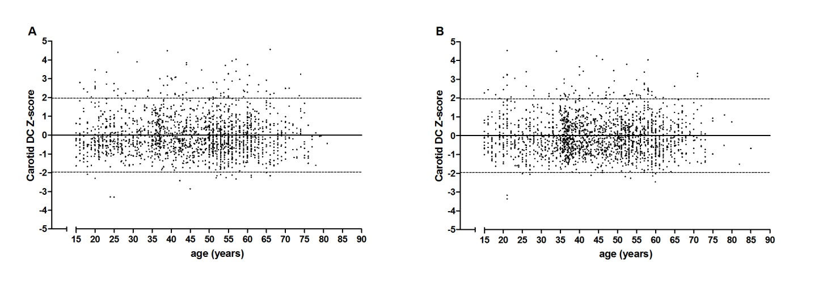
Figure S1: Scatter plot of carotid DC Z-scores by age, showing the mean (horizontal line) and +/- 1.96 SD (dotted lines), from the fitted model for carotid DC data for men (A) and women (B)

Results S1:
Age- and sex-specific reference intervals for carotid PWV in the healthy subpopulation
The best fitting FPs’ powers (p, q, …) for the mean_{PWV} curves were p=1 for both men andwomen and for the SD_{PWV} curves were p=1 for men and p=2women. Accordingly, the equations derived on the basis of the estimated coefficients were, for men:
- Mean_{PWV}(in m/s)= 3.914 + 0.069*age [eq. 7]
- SD_{PWV}(in m/s) = 0.317 + 0.017*age [eq. 8]
and, for women:
- Mean_{PWV}(in m/s) = 3.310 + 0.080*age [eq. 9]
- SD_{PWV}(in m/s) = 0.624 + 0.021*(age/10)² [eq. 10]

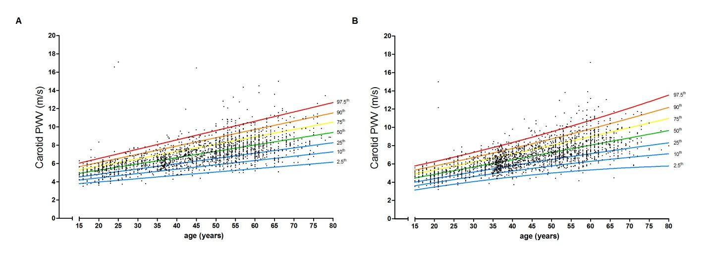Figure S2: Age-specific percentiles of carotid PWV in the healthy subpopulation. A, men; B, women.

Table S3: Age- and sex-specific percentiles of carotid PWV (in m/s) in the healthy subpopulation
 |  | percentiles
 | Age (years) | 2.5th | 10th | 25th | 50th | 75th | 90th | 97.5th
Men (n=1,724) | 20 | 4.0 | 4.5 | 4.9 | 5.3 | 5.7 | 6.1 | 6.6
 | 30 | 4.4 | 4.9 | 5.4 | 6.0 | 6.5 | 7.0 | 7.6
 | 40 | 4.7 | 5.4 | 6.0 | 6.7 | 7.3 | 7.9 | 8.6
 | 50 | 5.1 | 5.9 | 6.6 | 7.4 | 8.1 | 8.8 | 9.6
 | 60 | 5.5 | 6.4 | 7.2 | 8.1 | 8.9 | 9.7 | 10.7
 | 70 | 5.8 | 6.8 | 7.7 | 8.7 | 9.8 | 10.7 | 11.7
Women (n=1,877) | 20 | 3.5 | 4.0 | 4.4 | 4.9 | 5.4 | 5.8 | 6.3
 | 30 | 4.1 | 4.7 | 5.2 | 5.7 | 6.3 | 6.8 | 7.3
 | 40 | 4.6 | 5.3 | 5.9 | 6.5 | 7.2 | 7.7 | 8.4
 | 50 | 5.1 | 5.8 | 6.5 | 7.3 | 8.1 | 8.8 | 9.6
 | 60 | 5.4 | 6.3 | 7.2 | 8.1 | 9.0 | 9.9 | 10.8
 | 70 | 5.7 | 6.8 | 7.8 | 8.9 | 10.0 | 11.0 | 12.1
Results S2:
Age- and sex-specific reference intervals for carotid diameter in the healthy subpopulation
The best fitting FPs’ powers (p, q, …) for the mean_{diameter} curves were p=-2 q=-2 for men and p=0.5 for women and for the SD_{diameter} curves were p=3 for men and p=3 women. Accordingly, the equations derived on the basis of the estimated coefficients were, for men:
- Mean_{diameter}(in mm)= 7.661 + 0.087*(age/10)⁻² – 8.250*(age/10)⁻²*ln(age/10) [eq. 11]
- SD_{diameter}(in mm) = 0.514 + 0.001*(age/10)³ [eq. 12]
and, for women:
- Mean_{diameter}(in mm) = 4.783 + 0.780*(age/10)^{0.5} [eq. 13]
- SD_{diameter}(in mm) = 0.555 + 0.001*(age/10)³ [eq. 14]

Age- and sex-specific reference intervals for carotid distension in the healthy subpopulation
The best fitting FPs’ powers (p, q, …) for the mean_{distension} curves were p=0 for men and p=-0.5 for women and for the SD_{distension} curves were p=-2 for men and p=-1 women. Accordingly, the equations derived on the basis of the estimated coefficients were, for men:
- Mean_{distension}(mm)= 0.962 - 0.326*ln(age/10) [eq. 15]
- SD_{distension}(in mm) = 0.118 + 0.221*(age/10)⁻² [eq. 16]
and, for women:
- Mean_{distension}(in mm) = -0.137 + 1.163*(age/10)^{-0.5} [eq. 17]
- SD_{distension}(in mm) = 0.089 + 0.114*(age/10)⁻¹ [eq. 18]

Age- and sex-specific reference intervals for brachial PP in the healthy subpopulation
The best fitting FPs’ powers (p, q, …) for the mean_{PP} curves were p=3 q=3 for men and p=-2 q=-0.5 for women and for the SD_{PP} curves were p=1 for men and p=1 women. Accordingly, the equations derived on the basis of the estimated coefficients were, for men:
- Mean_{PP}(in mm Hg)= 53.64 - 0.133*(age/10)³ + 0.067*(age/10)³ * ln(age/10) [eq. 19]
- SD_{PP}(in mm Hg) = 9.940 - 0.035*age [eq. 20]
and, for women:
- Mean_{PP}(in mm Hg) = 72.83 + 55.88*(age/10)⁻² - 59.22*(age/10)^{-0.5} [eq. 21]
- SD_{PP}(in mm Hg) = 6.266 + 0.052*age [eq. 22]
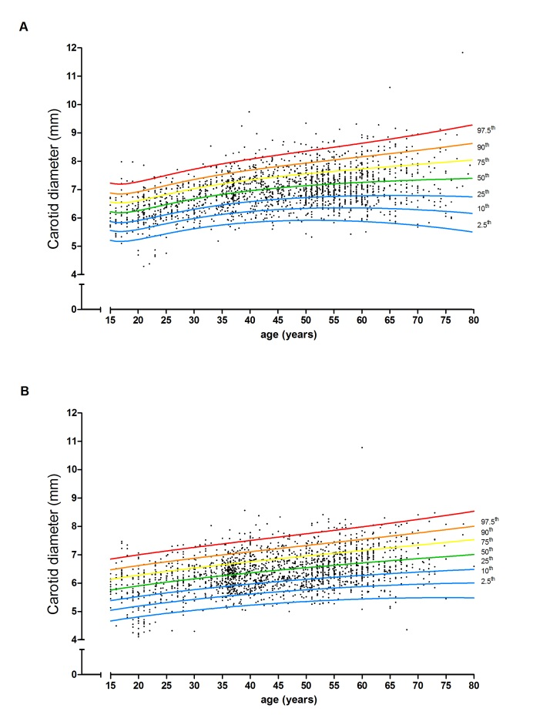 | 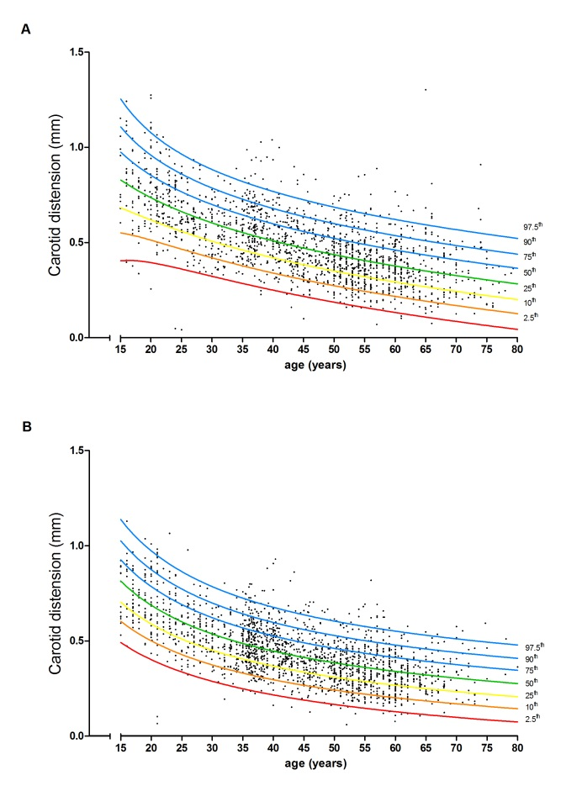 | 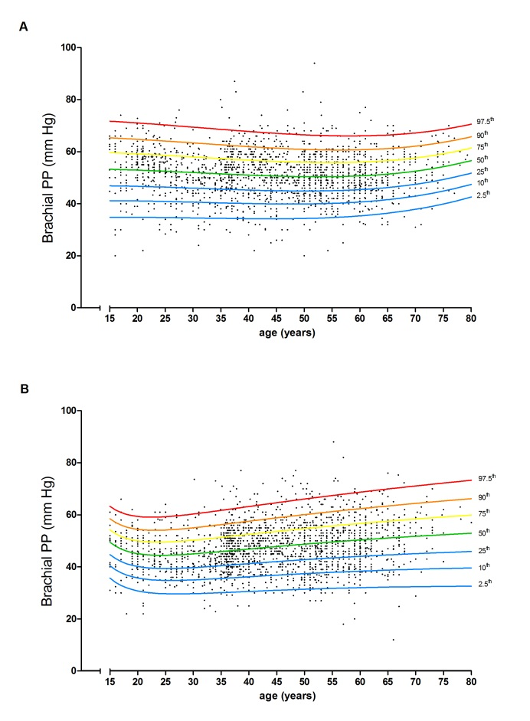
Figure S3: Age-specific percentiles of carotid diameter in the healthy subpopulation. A, men; B, women. | Figure S4: Age-specific percentiles of carotid distension in the healthy subpopulation. A, men; B, women. | Figure S5: Age-specific percentiles of brachial pulse pressure in the healthy subpopulation. A, men; B, women.

Methods S1:
Calibration between different techniques to determine local carotid pulse pressure
Different methods to determine local carotid PP were used. First, carotid distension waveforms were obtained and rescaled using brachial distension waveforms (n=4,807). Second, carotid tonometry was performed and the obtained pressures were rescaled with brachial MAP calculated using brachial tonometry (n=2,276), radial tonometry (n=1,857), maximal oscillometry (n=1,384) or the equation MAP=DBP+1/3*PP (n=125). Third, radial tonometry was performed to obtain carotid pressures using a transfer function (Sphygmocor, Atcor Medical, Australia; n=1,009) (Supplemental material, Table S1).
Similar to the calibration analyses for diameter and distension as described in the main manuscript, we performed multiple linear regression analyses that included dummy variables for each method (with carotid distension waveforms + brachial distension waveforms as reference) as independent determinants of carotid PP. These analyses were conducted in all individuals that had any measurement of local carotid PP (n=11,458; i.e. individuals with brachial PP only were excluded) and included adjustments for all CV-RFs, history of CVD and use of BP- and/or lipid-lowering medication. The regression coefficients (β) for the dummy variables hereby obtained were used as ‘calibration factors’ to rescale individual carotid PP values to the reference technique (Table S4). We used these rescaled carotid PP values in all further analyses.

Table S4: Calibration factors for local carotid pulse pressure values as obtained with different methods
 | Local carotid PP
 | β | 95% CI | p
Carotid tonometry + brachial tonometry | 7.2 | 6.5; 7.8 | <0.001
Carotid tonometry + radial tonometry | 0.4 | -0.2; 1.1 | 0.218
Carotid tonometry + maximal oscillometry | 2.1 | 1.3; 2.8 | <0.001
Carotid tonometry + constant | -0.4 | -2.5; 1.6 | 0.687
Radial tonometry + transfer function | -5.6 | -6.4; -4.8 | <0.001
Regression coefficients β represent the mean difference in local carotid pulse pressure (in mm Hg) when using each of the local PP measurement techniques vs. the reference one (carotid distension waveforms + brachial distension waveforms) at mean levels of age, sex, MAP, heart rate, total-HDL cholesterol ratio, BMI, history of CVD, and use of BP- and/or lipid-lowering medication only in individuals in whom a measure of local carotid PP was performed (n=11,458).
On the basis of this equation, to rescale local carotid PP values obtained by for instance radial tonometry + transfer function to values of carotid distension waveforms + brachial distension waveforms (i.e. to the values presented in the Supplemental material), to the original radial tonometry + transfer function values 5.6 mm Hg needs to be added.

Results S3:
Age- and sex-specific reference intervals for carotid DC (calculated using local carotid PP) in the healthy subpopulation
The best fitting FPs’ powers (p, q, …) for the mean_{DC} curves were p=-0.5 for men and p=-2 q=-2 for women and for the SD_{DC} curves were p=-2 for both men and women. Accordingly, the equations derived on the basis of the estimated coefficients were, for men:
- Mean_{DC}(in 10⁻³*kPa⁻¹)= -17.38 + 89.86*(age/10)^{-0.5} [eq. 23]
- SD_{DC}(in 10⁻³*kPa⁻¹) = 5.293 + 41.40*(age/10)⁻² [eq. 24]
and, for women:
- Mean_{DC}(in 10⁻³*kPa⁻¹) = 8.391 + 122.3*(age/10)⁻² + 143.4*(age/10)⁻² * ln(age/10) [eq. 25]
- SD_{DC}(in 10⁻³*kPa⁻¹) = 3.033 + 101.1*(age/10)⁻² [eq. 26]

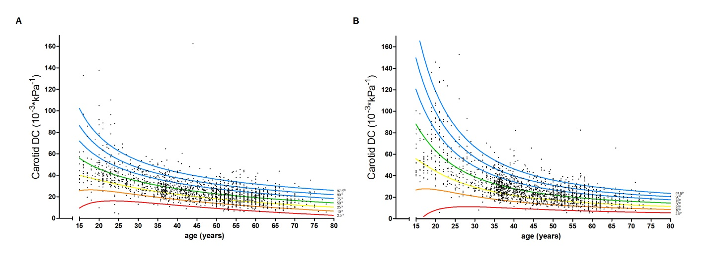
Figure S6: Age-specific percentiles of carotid DC calculated with local carotid PP in the healthy subpopulation. A, men; B, women.

Table S5: Age- and sex-specific percentiles of carotid DC (in 10⁻³*kPa⁻¹) calculated with local carotid PP in the healthy subpopulation
 |  | percentiles
 | Age (years) | 2.5th | 10th | 25th | 50th | 75th | 90th | 97.5th
Men (n=1,532) | 20 | 15.5 | 26.1 | 35.6 | 46.2 | 56.7 | 66.2 | 76.8
 | 30 | 15.1 | 21.8 | 27.8 | 34.5 | 41.2 | 47.2 | 53.9
 | 40 | 12.1 | 17.5 | 22.2 | 27.6 | 32.9 | 37.6 | 43.0
 | 50 | 9.2 | 13.9 | 18.1 | 22.8 | 27.5 | 31.7 | 36.4
 | 60 | 6.7 | 11.1 | 15.0 | 19.3 | 23.7 | 27.6 | 31.9
 | 70 | 4.6 | 8.7 | 12.4 | 16.6 | 20.7 | 24.4 | 28.6
Women (n=1,591) | 20 | 8.3 | 27.6 | 44.7 | 63.8 | 82.9 | 100.0 | 119.3
 | 30 | 11.5 | 21.2 | 29.9 | 39.5 | 49.1 | 57.7 | 67.4
 | 40 | 10.1 | 16.5 | 22.1 | 28.5 | 34.8 | 40.4 | 46.8
 | 50 | 8.6 | 13.5 | 17.7 | 22.5 | 27.3 | 31.6 | 36.4
 | 60 | 7.5 | 11.4 | 15.0 | 18.9 | 22.9 | 26.4 | 30.4
 | 70 | 6.6 | 10.1 | 13.1 | 16.6 | 20.0 | 23.1 | 26.6

Table S6:Associations between known cardiovascular risk factors and carotid DC Z-scores calculated using local pulse pressure in the reference subpopulations in men
 |  | Subpopulation without CVD |  |  |  |  |  |  |  | Subpopulation with CVD  (n=596)
 |  | without treatmentª  (n=4,458) |  |  |  | withtreatmentª  (n=1,117)
Risk factor | Model | ß | 95%CI | P-value |  | ß | 95%CI | P-value |  | ß | 95%CI | P-value
Mean arterial pressure (10 mm Hg)^{b} | 1 | -0.263 | -0.290; -0.235 | <0.001 |  | -0.353 | -0.403; -0.303 | <0.001 |  | -0.290 | -0.350; -0.231 | <0.001
 | 2 | - | - | - |  | - | - | - |  | - | - | -
 | 3 | -0.221 | -0.250; -0.191 | <0.001 |  | -0.331 | -0.382; -0.280 | <0.001 |  | -0.251 | -0.313; -0.190 | <0.001
Smoking
Previous smoking (vs. never smoking) | 1 | -0.083 | -0.156; -0.011 | 0.024 |  | -0.054 | -0.193; 0.086 | 0.452 |  | -0.230 | -0.402; -0.057 | 0.009
 | 2 | 0.006 | -0.064; 0.077 | 0.856 |  | -0.018 | -0.147; 0.111 | 0.785 |  | -0.147 | -0.309; 0.015 | 0.074
 | 3 | 0.025 | -0.045; 0.095 | 0.481 |  | -0.007 | -0.136; 0.122 | 0.913 |  | -0.094 | --0.255; 0.067 | 0.252
Current smoking (vs. never smoking) | 1 | -0.016 | -0.102; 0.070 | 0.713 |  | -0.053 | -0.233; 0.127 | 0.562 |  | -0.184 | -0.420; 0.052 | 0.127
 | 2 | 0.022 | -0.061; 0.105 | 0.607 |  | -0.054 | -0.221; 0.112 | 0.524 |  | -0.129 | -0.350; 0.092 | 0.254
 | 3 | 0.040 | -0.044; 0.124 | 0.351 |  | -0.030 | -0.197; 0.137 | 0.728 |  | -0.064 | -0.285; 0.157 | 0.570
Diabetes (yes) | 1 | -0.437 | -0.682; -0.193 | <0.001 |  | -0.246 | -0.406; -0.085 | 0.003 |  | -0.612 | -0.822; -0.402 | <0.001
 | 2 | -0.269 | -0.505; -0.033 | 0.025 |  | -0.174 | -0.323; -0.025 | 0.022 |  | -0.445 | -0.646; -0.244 | <0.001
 | 3 | -0.208 | -0.444; 0.028 | 0.084 |  | -0.144 | -0.295; 0.007 | 0.062 |  | -0.447 | -0.706; -0.188 | 0.001
Total-to-HDL cholesterol ratio (unit) | 1 | -0.094 | -0.135; -0.052 | <0.001 |  | -0.052 | -0.140; 0.036 | 0.196 |  | -0.137 | -0.203; -0.072 | <0.001
 | 2 | -0.063 | -0.106; -0.019 | 0.009 |  | -0.038 | -0.103; 0.027 | 0.207 |  | -0.110 | -0.170; -0.051 | <0.001
 | 3 | -0.039 | -0.087; 0.009 | 0.098 |  | -0.033 | -0.089; 0.023 | 0.215 |  | -0.100 | -0.161; -0.039 | 0.001
Body mass index (kg/m²) | 1 | -0.062 | -0.072; -0.053 | <0.001 |  | -0.046 | -0.062; -0.030 | <0.001 |  | -0.039 | -0.061; -0.017 | 0.001
 | 2 | -0.038 | -0.047; -0.028 | <0.001 |  | -0.027 | -0.042; -0.012 | <0.001 |  | -0.020 | -0.041; 0.001 | 0.062
 | 3 | -0.032 | -0.043; -0.021 | <0.001 |  | -0.022 | -0.038; -0.006 | 0.007 |  | -0.004 | -0.027; 0.018 | 0.707
Use of BP-lowering medication (yes) | 1 | - | - | - |  | - | - | - |  | -0.213 | -0.373; -0.053 | 0.009
 | 2 | - | - | - |  | - | - | - |  | -0.086 | -0.238; 0.066 | 0.267
 | 3 | - | - | - |  | - | - | - |  | -0.032 | -0.191; 0.127 | 0.694
Use of lipid-lowering medication (yes) | 1 | - | - | - |  | - | - | - |  | 0.034 | -0.056; 0.124 | 0.707
 | 2 | - | - | - |  | - | - | - |  | -0.024 | -0.189; 0.140 | 0.772
 | 3 | - | - | - |  | - | - | - |  | 0.019 | -0.153; 0.192 | 0.826
Use of glucose-lowering medication (yes) | 1 | - | - | - |  | - | - | - |  | -0.403 | -0.719; -0.086 | 0.013
 | 2 | - | - | - |  | - | - | - |  | -0.320 | -0.615; -0.024 | 0.034
 | 3 | - | - | - |  | - | - | - |  | 0.093 | -0.277; 0.463 | 0.623
The regression coefficient ß represents the increase in carotid DC (in SD from the healthy population mean among men of the same age) per unit increase in each risk factor. Model 1: unadjusted; Model 2: adjusted for MAP; Model 3: adjusted for MAP and all other risk factors.ªBP-, lipid- and glucose-lowering treatment; ^{b}mean arterial pressure was calculated by DBP+0.4*PP.

Table S7:Associations between known cardiovascular risk factors and carotid DC Z-scores calculated using local pulse pressure in the reference subpopulations in women
 |  | Subpopulation without CVD |  |  |  |  |  |  |  | Subpopulation with CVD  (n=630)
 |  | without treatmentª  (n=3,716) |  |  |  | withtreatmentª  (n=941)
Risk factor | Model | ß | 95%CI | P-value |  | ß | 95%CI | P-value |  | ß | 95%CI | P-value
Mean arterial pressure (10 mm Hg)^{b} | 1 | -0.296 | -0.324; -0.269 | <0.001 |  | -0.355 | -0.408; -0.302 | <0.001 |  | -0.448 | -0.520; -0.375 | <0.001
 | 2 | - | - | - |  | - | - | - |  | - | - | -
 | 3 | -0.277 | -0.308; -0.246 | <0.001 |  | -0.334 | -0.388; -0.280 | <0.001 |  | -0.364 | -0.440; -0.288 | <0.001
Smoking
Previous smoking (vs. never smoking) | 1 | -0.004 | -0.097; 0.089 | 0.932 |  | 0.046 | -0.157; 0.250 | 0.657 |  | -0.214 | -0.453; 0.024 | 0.078
 | 2 | 0.009 | -0.079; 0.098 | 0.834 |  | 0.026 | -0.161; 0.213 | 0.786 |  | -0.136 | -0.352; 0.080 | 0.218
 | 3 | 0.017 | -0.071; 0.106 | 0.700 |  | 0.030 | -0.157; 0.217 | 0.751 |  | -0.156 | -0.369; 0.056 | 0.149
Current smoking (vs. never smoking) | 1 | 0.104 | 0.004; 0.203 | 0.041 |  | 0.194 | -0.027; 0.416 | 0.085 |  | 0.461 | 0.143; 0.780 | 0.005
 | 2 | 0.073 | -0.022; 0.167 | 0.131 |  | 0.051 | -0.153; 0.256 | 0.623 |  | 0.393 | 0.105; 0.682 | 0.008
 | 3 | 0.078 | -0.016; 0.173 | 0.105 |  | 0.042 | -0.161; 0.246 | 0.684 |  | 0.333 | 0.049; 0.618 | 0.022
Diabetes (yes) | 1 | -0.419 | -0.949; 0.110 | 0.113 |  | -0.303 | -0.499; -0.108 | 0.002 |  | -1.059 | -1.345; -0.773 | <0.001
 | 2 | -0.130 | -0.579; 0.319 | 0.556 |  | -0.232 | -0.413; -0.051 | 0.012 |  | -0.691 | -0.963; -0.419 | <0.001
 | 3 | -0.050 | -0.503; 0.403 | 0.822 |  | -0.178 | -0.362; 0.006 | 0.058 |  | -0.686 | -1.015; -0.357 | <0.001
Total-to-HDL cholesterol ratio (unit) | 1 | -0.102 | -0.148; -0.057 | <0.001 |  | -0.088 | -0.147; -0.028 | 0.004 |  | -0.037 | -0.126; 0.052 | 0.418
 | 2 | -0.052 | -0.098; -0.006 | 0.028 |  | -0.040 | -0.095; 0.014 | 0.146 |  | -0.011 | -0.092; 0.069 | 0.781
 | 3 | -0.043 | -0.093; 0.006 | 0.084 |  | -0.010 | -0.069; 0.048 | 0.726 |  | 0.053 | -0.032; 0.137 | 0.223
Body mass index (kg/m²) | 1 | -0.042 | -0.051; -0.033 | <0.001 |  | -0.040 | -0.054; -0.026 | <0.001 |  | -0.078 | -0.101; -0.054 | <0.001
 | 2 | -0.015 | -0.024; -0.006 | 0.002 |  | -0.024 | -0.037; -0.011 | <0.001 |  | -0.042 | -0.064; -0.019 | <0.001
 | 3 | -0.011 | -0.021; -0.001 | 0.037 |  | -0.021 | -0.035; -0.006 | 0.006 |  | -0.032 | -0.057; -0.007 | 0.011
Use of BP-lowering medication (yes) | 1 | - | - | - |  | - | - | - |  | -0.572 | -0.789; -0.355 | <0.001
 | 2 | - | - | - |  | - | - | - |  | -0.303 | -0.507; -0.098 | 0.004
 | 3 | - | - | - |  | - | - | - |  | -0.127 | -0.345; 0.090 | 0.252
Use of lipid-lowering medication (yes) | 1 | - | - | - |  | - | - | - |  | -0.193 | -0.483; 0.097 | 0.192
 | 2 | - | - | - |  | - | - | - |  | -0.043 | -0.306; 0.220 | 0.750
 | 3 | - | - | - |  | - | - | - |  | 0.024 | -0.244; 0.291 | 0.863
Use of glucose-lowering medication (yes) | 1 | - | - | - |  | - | - | - |  | -0.656 | -1.178; -0.135 | 0.014
 | 2 | - | - | - |  | - | - | - |  | -0.326 | -0.801; 0.149 | 0.179
 | 3 | - | - | - |  | - | - | - |  | 0.404 | -0.137; 0.945 | 0.144
The regression coefficient ß represents the increase in carotid DC (in SD from the healthy population mean among women of the same age) per unit increase in each risk factor. Model 1: unadjusted; Model 2: adjusted for MAP; Model 3: adjusted for MAP and all other risk factors.ªBP-, lipid- and glucose-lowering treatment; ^{b}mean arterial pressure was calculated by DBP+0.4*PP.
Results S3:
Age- and sex-specific reference intervals for carotid DC in the healthy subpopulation used in part B: the femoral artery
The best fitting FPs’ powers (p, q, …) for the mean_{DC} curves were p=-2 q=-2 for men and p=0 for women and for the SD_{DC} curves were p=1 for both men and women. Accordingly, the equations derived on the basis of the estimated coefficients were, for men:
- Mean_{DC}(in 10⁻³*kPa⁻¹)= 4.875 - 11.47*(age/10)⁻² + 222.5*(age/10)⁻²*ln(age/10) [eq. 27]
- SD_{DC}(in 10⁻³*kPa⁻¹) = 11.47 - 0.119*age [eq. 28]
and, for women:
- Mean_{DC}(in 10⁻³*kPa⁻¹) = 58.85 - 24.37*ln(age/10) [eq. 29]
- SD_{DC}(in 10⁻³*kPa⁻¹) = 12.12 - 0.128*age [eq. 30]

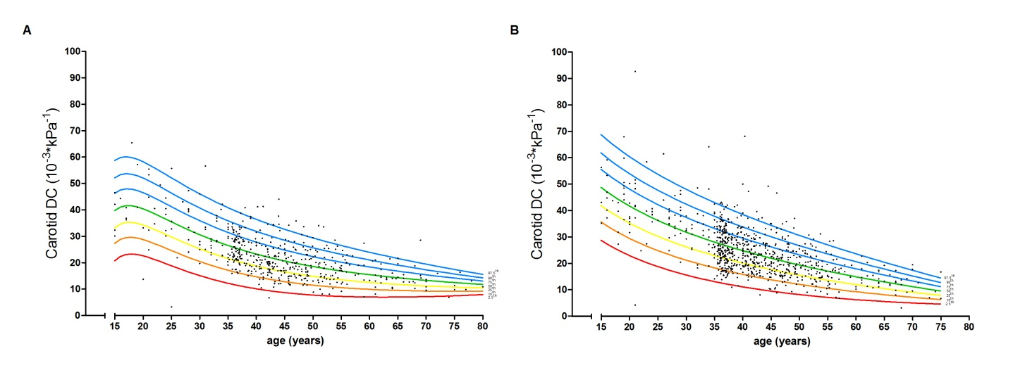
Figure S7: Age-specific percentiles of carotid DC in the subpopulation used in part B: the femoral artery. A, men; B, women.

Table S8: Age- and sex-specific percentiles of carotid DC (in 10⁻³*kPa⁻¹) in the healthy subpopulation used in part B: the femoral artery
 |  | percentiles
 | Age (years) | 2.5th | 10th | 25th | 50th | 75th | 90th | 97.5th
Men (n=488) | 20 | 22,7 | 28,9 | 34,4 | 0,6 | 46,7 | 52,2 | 58,4
 | 30 | 15,3 | 20,6 | 25,4 | 30,8 | 36,1 | 40,9 | 46,2
 | 40 | 10,3 | 14,8 | 18,9 | 23,4 | 28,0 | 32,0 | 36,6
 | 50 | 7,9 | 11,7 | 15,0 | 18,7 | 22,5 | 25,8 | 29,6
 | 60 | 7,1 | 10,1 | 12,7 | 15,6 | 18,6 | 21,2 | 24,1
 | 70 | 7,3 | 9,5 | 11,4 | 13,5 | 15,6 | 17,5 | 19,6
Women (n=775) | 20 | 23,2 | 29,7 | 35,5 | 42,0 | 48,4 | 54,2 | 60,7
 | 30 | 15,8 | 21,5 | 26,5 | 32,1 | 37,7 | 42,7 | 48,3
 | 40 | 11,3 | 16,1 | 20,3 | 25,1 | 29,8 | 34,0 | 38,8
 | 50 | 8,4 | 12,3 | 15,8 | 19,6 | 23,5 | 26,9 | 30,8
 | 60 | 6,5 | 9,5 | 12,2 | 15,2 | 18,2 | 20,9 | 23,9
 | 70 | 5,2 | 7,4 | 9,3 | 11,4 | 13,6 | 15,5 | 17,6

Table S9:Associations between known cardiovascular risk factors and carotid DC Z-scores in the reference subpopulations used in part B: the femoral artery in men
 |  | Subpopulation without CVD |  |  |  |  |  |  |  | Subpopulation with CVD  (n=262)
 |  | without treatmentª  (n=1,672) |  |  |  | withtreatmentª  (n=268)
Risk factor | Model | ß | 95%CI | P-value |  | ß | 95%CI | P-value |  | ß | 95%CI | P-value
Mean arterial pressure (10 mm Hg)^{b} | 1 | -0.318 | -0.363; -0.274 | <0.001 |  | -0.392 | -0.487; -0.297 | <0.001 |  | -0.190 | -0.261; -0.119 | <0.001
 | 2 | - | - | - |  | - | - | - |  | - | - | -
 | 3 | -0.274 | -0.321; -0.228 | <0.001 |  | -0.360 | -0.458; -0.262 | <0.001 |  | -0.152 | -0.226; -0.077 | <0.001
Smoking
Previous smoking(vs. never smoking) | 1 | -0.045 | -0.160; 0.071 | 0.448 |  | -0.050 | -0.328; 0.228 | 0.724 |  | -0.286 | -0.530; 0.042 | 0.022
 | 2 | 0.065 | -0.045; 0.176 | 0.247 |  | 0.024 | -0.227; 0.275 | 0.850 |  | -0.228 | -0.463; 0.006 | 0.056
 | 3 | 0.092 | -0.019; 0.203 | 0.103 |  | 0.086 | -0.164; 0.337 | 0.501 |  | -0.189 | -0.425; 0.048 | 0.118
Current smoking (vs. never smoking) | 1 | 0.246 | 0.123; 0.369 | <0.001 |  | 0.123 | -0.231; 0.477 | 0.495 |  | -0.179 | -0.468; 0.109 | 0.222
 | 2 | 0.249 | 0.132; 0.366 | <0.001 |  | 0.066 | -0.253; 0.385 | 0.685 |  | -0.202 | -0.477; 0.074 | 0.151
 | 3 | 0.250 | 0.133; 0.367 | <0.001 |  | 0.129 | -0.188; 0.447 | 0.424 |  | -0.201 | -0.476; 0.074 | 0.153
Diabetes (yes) | 1 | -0.549 | -0.865; -0.234 | 0.001 |  | -0.574 | -0.867; -0.281 | <0.001 |  | -0.381 | -0.575; -0.187 | <0.001
 | 2 | -0.310 | -0.611; -0.010 | 0.043 |  | -0.437 | -0.704; -0.170 | 0.001 |  | -0.303 | -0.493; -0.114 | 0.002
 | 3 | -0.259 | -0.558; 0.040 | 0.089 |  | -0.423 | -0.696; -0.151 | 0.002 |  | -0.272 | -0.496; -0.047 | 0.018
Total-to-HDL cholesterol ratio (unit) | 1 | -0.055 | -0.096; -0.013 | 0.010 |  | -0.083 | -0.186; 0.020 | 0.111 |  | -0.055 | -0.138; 0.028 | 0.192
 | 2 | -0.022 | -0.061; 0.017 | 0.265 |  | -0.048 | -0.136; 0.040 | 0.283 |  | -0.039 | -0.114; 0.035 | 0.292
 | 3 | -0.002 | -0.043; 0.038 | 0.904 |  | -0.025 | -0.116; 0.067 | 0.591 |  | -0.011 | -0.087; 0.064 | 0.766
Body mass index (kg/m²) | 1 | -0.064 | -0.079; -0.050 | <0.001 |  | -0.047 | -0.084; -0.010 | 0.012 |  | -0.046 | -0.074; -0.018 | 0.001
 | 2 | -0.037 | -0.052; -0.022 | <0.001 |  | -0.014 | -0.048; 0.020 | 0.416 |  | -0.036 | -0.063; -0.009 | 0.008
 | 3 | -0.034 | -0.050; -0.019 | <0.001 |  | -0.009 | -0.044; 0.025 | 0.597 |  | -0.029 | -0.058; 0.000 | 0.047
Use of BP-lowering medication (yes) | 1 | - | - | - |  | - | - | - |  | -0.192 | -0.374; -0.010 | 0.039
 | 2 | - | - | - |  | - | - | - |  | -0.131 | -0.307; 0.045 | 0.143
 | 3 | - | - | - |  | - | - | - |  | -0.118 | -0.301; 0.066 | 0.209
Use of lipid-lowering medication (yes) | 1 | - | - | - |  | - | - | - |  | 0.078 | -0.127; 0.282 | 0.457
 | 2 | - | - | - |  | - | - | - |  | 0.014 | -0.183; 0.211 | 0.890
 | 3 | - | - | - |  | - | - | - |  | 0.093 | -0.114; 0.301 | 0.378
Use of glucose-lowering medication (yes) | 1 | - | - | - |  | - | - | - |  | -0.196 | -0.495; 0.104 | 0.201
 | 2 | - | - | - |  | - | - | - |  | -0.232 | -0.518; 0.053 | 0.111
 | 3 | - | - | - |  | - | - | - |  | 0.048 | -0.285; 0.381 | 0.776
The regression coefficient ß represents the increase in carotid DC (in SD from the healthy population mean among men of the same age) per unit increase in each risk factor. Model 1: unadjusted; Model 2: adjusted for MAP; Model 3: adjusted for MAP and all other risk factors.ªBP-, lipid- and glucose-lowering treatment; ^{b}mean arterial pressure was calculated by DBP+0.4*PP.

Table S10:Associations between known cardiovascular risk factors and carotid DC Z-scores in the reference subpopulations used in part B: the femoral artery in women
 |  | Subpopulation without CVD |  |  |  |  |  |  |  | Subpopulation with CVD  (n=199)
 |  | without treatmentª  (n=1,709) |  |  |  | withtreatmentª  (n=278)
Risk factor | Model | ß | 95%CI | P-value |  | ß | 95%CI | P-value |  | ß | 95%CI | P-value
Mean arterial pressure (10 mm Hg)^{b} | 1 | -0.294 | -0.313; -0.274 | <0.001 |  | -0.270 | -0.351; -0.190 | <0.001 |  | -0.267 | -0.361; -0.173 | <0.001
 | 2 | - | - | - |  | - | - | - |  | - | - | -
 | 3 | -0.279 | -0.320; -0.238 | <0.001 |  | -0.250 | -0.332; -0.168 | <0.001 |  | -0.229 | -0.328; -0.131 | <0.001
Smoking
Previous smoking (vs. non-smoking) | 1 | 0.054 | -0.061; 0.170 | 0.358 |  | 0.076 | -0.185; 0.337 | 0.570 |  | 0.092 | -0.182; 0.366 | 0.511
 | 2 | 0.052 | -0.058; 0.161 | 0.355 |  | 0.060 | -0.184; 0.304 | 0.629 |  | 0.112 | -0.144; 0.367 | 0.391
 | 3 | 0.057 | -0.053; 0.166 | 0.312 |  | 0.059 | -0.190; 0.390 | 0.466 |  | 0.119 | -0.139; 0.377 | 0.368
Current smoking (vs. non-smoking) | 1 | 0.251 | 0.130; 0.371 | <0.001 |  | 0.401 | 0.106; 0.696 | 0.008 |  | 0.242 | -0.148; 0.633 | 0.224
 | 2 | 0.171 | 0.056; 0.285 | 0.003 |  | 0.288 | 0.010; 0.566 | 0.042 |  | 0.218 | -0.146; 0.583 | 0.240
 | 3 | 0.184 | 0.067; 0.301 | 0.002 |  | 0.266 | -0.016; 0.548 | 0.065 |  | 0.163 | -0.203; 0.530 | 0.382
Diabetes (yes) | 1 | -0.398 | -0.904; 0.106 | 0.117 |  | -0.298 | -0.574; -0.023 | 0.034 |  | -0.066 | -0.907; -0.409 | <0.001
 | 2 | -0.126 | -0.559; 0.307 | 0.561 |  | -0.190 | -0.452; 0.071 | 0.153 |  | -0.538 | -0.779; -0.297 | <0.001
 | 3 | -0.096 | -0.548; 0.356 | 0.669 |  | -0.189 | -0.456; 0.077 | 0.163 |  | -0.531 | -0.806; -0.256 | <0.001
Total-to-HDL cholesterol ratio (unit) | 1 | -0.087 | -0.149; -0.025 | 0.007 |  | 0.000 | -0.108; 0.109 | 0.995 |  | -0.034 | -0.127; 0.059 | 0.476
 | 2 | -0.029 | -0.090; 0.032 | 0.341 |  | 0.018 | -0.079; 0.116 | 0.708 |  | -0.035 | -0.122; 0.053 | 0.441
 | 3 | -0.033 | -0.102; 0.035 | 0.324 |  | 0.041 | -0.064; 0.146 | 0.439 |  | -0.006 | -0.100; 0.088 | 0.897
Body mass index (kg/m²) | 1 | -0.037 | -0.050; -0.025 | <0.001 |  | -0.024 | -0.036; -0.012 | 0.049 |  | -0.022 | -0.053; 0.008 | 0.147
 | 2 | -0.006 | -0.019; 0.006 | 0.322 |  | -0.013 | -0.036; 0.010 | 0.264 |  | 0.000 | -0.030; 0.029 | 0.991
 | 3 | -0.003 | -0.017; 0.011 | 0.680 |  | -0.011 | -0.036; 0.014 | 0.380 |  | 0.011 | -0.019; 0.041 | 0.470
Use of BP-lowering medication (yes) | 1 | - | - | - |  | - | - | - |  | -0.347 | -0.591; -0.103 | 0.005
 | 2 | - | - | - |  | - | - | - |  | -0.192 | -0.431; 0.046 | 0.114
 | 3 | - | - | - |  | - | - | - |  | -0.076 | -0.339; 0.186 | 0.570
Use of lipid-lowering medication (yes) | 1 | - | - | - |  | - | - | - |  | -0.052 | -0.351; 0.248 | 0.735
 | 2 | - | - | - |  | - | - | - |  | -0.005 | -0.285; 0.275 | 0.972
 | 3 | - | - | - |  | - | - | - |  | -0.036 | -0.327; 0.255 | 0.807
Use of glucose-lowering medication (yes) | 1 | - | - | - |  | - | - | - |  | -0.559 | -1.118;-0.000 | 0.050
 | 2 | - | - | - |  | - | - | - |  | -0.269 | -0.805; 0.266 | 0.324
 | 3 | - | - | - |  | - | - | - |  | 0.085 | -0.325; 0.495 | 0.761
The regression coefficient ß represents the increase in carotid DC (in SD from the healthy population mean among women of the same age) per unit increase in each risk factor. Model 1: unadjusted; Model 2: adjusted for MAP; Model 3: adjusted for MAP and all other risk factors.ªBP-, lipid- and glucose-lowering treatment; ^{b}mean arterial pressure was calculated by DBP+0.4*PP.
Table S11: Funding of the included datasets
Centre | Origin of funding
Rotterdam (the Netherlands) | The Rotterdam Study is funded by the Erasmus Medical Center and the Erasmus University, Rotterdam, Netherlands Organization for the Health Research and Development (ZonMw), the Research Institute for Diseases in the Elderly (RIDE), The Netherlands Heart Foundation, the Ministry of Education, Culture and Science, the Ministry for Health, Welfare and Sports, the European Commission (DG XII), and the Municipality of Rotterdam. Maryam Kavousi is supported by the AXA Research Fund. Oscar H. Franco works in ErasmusAGE, a center for aging research across the life course funded by Nestlé Nutrition (Nestec Ltd.); Metagenics Inc.; and AXA. Nestlé Nutrition (Nestec Ltd.); Metagenics Inc.; and AXA had no role in design and conduct of the study; collection, management, analysis, and interpretation of the data; and preparation, review or approval of the manuscript.
Paris-HEGP/APHP-St Antoine Hospital (France) | HEGP studies: PHRC-APHP 2003 [AOM 03023P030439], INSERM [ANR-05-PCOD-004-01; Grants 2008-2011]; APHP-St Antoine Hospital, CASHMERE study: Pfizer [NCT00163163]; PPS3 study: French Foundation for Research in Hypertension [0607-10], Institute for Research in Public Health [grant 2008], grants from the Paris area, France [CCODIM 2009-2013].
Utrecht (the Netherlands) | The SMART study was made possible by a grant from the University Medical Center Utrecht (UMCU, the Netherlands) and the echotracking measurements were made possible by a grant from the Netherlands Organization for Scientific Research (NOW) [904-61-154]; The WHISTLER birth cohort was supported with a grant from the Netherlands Organization for Health Research and Development (2100.0095), WHISTLER-Cardio was supported with an unrestricted strategic grant from the UMCU, the Netherlands.
Ghent (Belgium) | Funded by Research Foundation – Flanders [FWO; FWO G.0427.03, FWO G.0838.10N and 3G013109]
Maastricht/ Amsterdam (the Netherlands) | Hoorn study: Dutch Diabetes Research Foundation [DFN 98901], the Dutch Organization for Scientific Research (NWO) [940-35-034) and The Netherlands Heart Foundation (NHS) [98154]; Amsterdam Growth and Health Longitundinal Study (AGAHLS): Dutch Prevention Fund (ZON) and NHS [2006T050 to I.F.]; CODAM: Netherlands Organization for Scientific Research [940-35-034], the Dutch Diabetes Research Foundation [98.901] and NHS [2006T050 to I.F.].
Leuven (Belgium) | The European Union ([IC15-CT98-0329-EPOGH, LSHM-CT-2006-037093 InGeniousHyperCare, HEALTH-F4-2007-201550 HyperGenes, HEALTH-F7-2011- 278249 EU-MASCARA] and the European Research Council Advanced Researcher Grant [294713 EPLORE]), the FondsvoorWetenschappelijkOnderzoekVlaanderen, Ministry of the Flemish Community, Brussels, Belgium [G.0575.06 and G.0734.09], and the KatholiekeUniversiteit Leuven, Belgium [OT/00/25 and OT/05/49] supported the Studies Coordinating Centre (Leuven, Belgium).
Shanghai (China) | The Ningbo workplace study: The National Natural Science Foundation of China [30871360, 30871081, and 81170245], the Ministry of Science and Technology [2006BAI01A03], the Shanghai Commissions of Science and Technology [07JC14047 and 06QA14043] and Education [07ZZ32 and 08SG20], and the Shanghai Shenkang Hospital Development Centre [SHDC12007318]
Pisa (Italy) | -
Mannheim (Germany) | The Mannheim Study was funded by an internal grant from the Mannheim Medical Faculty, Heidelberg University
Vilnius (Lithuania) | This research was funded by the European Social Fund under the Global Grant measure [VP1-3.1-SMM-07-K-03-041]
Antwerp (Belgium) | -
São Paulo (Brazil) | FundaçãoZerbini, Instituto do Coração  FAPESP, Fundação de Amapro a Pesquisa do Estado de São Paulo
Nancy (France) | ERA study: FRM [DCV-2007-0409250]; ARTEOS study: University of Nancy [CPRC 2005].
Bern (Switzerland) | Swiss National Foundation [SNF 32003B_134946/1]
Milano (Italy) | Funded by the Italian Ministry of University, MIUR (RBFR08YVUL_002, FIRB, Futuro in Ricerca)
Maastricht-VitaK (the Netherlands) | -
Budapest (Hungary) | -
Rouen (France) | -
Paris-Foch (France) | -
Maastricht/Leuven (the Netherlands/Belgium) | -
Gdansk (Poland) | Polish Norwegian Research Found, Norway Grants, CareNorth Project, PNRF - A213
Pilsen (Czech Republic) | Charles University Research Fund [P36]
Québec (Canada) | Canadian Institutes of Health Research
Montreal (Canada) | -

Appendix
Table A1: Author list and participating centres/studies
Centre | Authors | Affiliations
Rotterdam (NL) | Francesco US Mattace-Raso^{1,2}, Albert Hofman¹, Oscar H Franco¹, Maryam Kavousi¹, Frank J.A. van Rooij¹ | ¹Dept. Epidemiology, ²Dept. Internal Medicine; both Erasmus University Medical Center Rotterdam, the Netherlands
Paris-HEGP/APHP-St Antoine (F) | Pierre Boutouyrie^{1,2,3,4}, Stéphane Laurent^{1,2,3,4}, Xavier Jouven^{1,2,3}, Jean-Philippe Empana^{1,2,3}, Erwan Bozec^{1,2,3,4}, Hakim Khettab^{1,2,3,4}, Tabassome Simon^{5,6}, Bruno Pannier⁷ | ¹Université Paris Descartes; ²INSERM U970; ³Sorbonne Paris cité; ⁴Dept. Pharmacology, Hôpital Européen Georges Pompidou; ⁵Université Pierre et Marie Curie-Paris 06; ⁶APHP, Dept. Pharmacology, Saint Antoine University Hospital; ⁷Institut Prévention Santé; all Paris, France
Utrecht (NL) | Michiel L. Bots¹, Diederick E. Grobbee¹, Cuno S. Uiterwaal¹, Annemieke Evelein¹, Yolanda van der Graaf¹, Frank L.J. Visseren² | ¹Julius Center for Health Sciences and Primary Care, ² Dept. Vascular Medicine; all University Medical Center Utrecht, Utrecht, the Netherlands
Ghent (BE) | Ernst Rietzschel^{1,2}, Patrick Segers³, Luc Van Bortel⁴, Dirk De Bacquer², Caroline Van daele¹, Marc De Buyzere¹ | ¹Dept. Cardiovascular Disease, Ghent University Hospital, ²Dept. Public Health, ³IBiTech – bioMMeda, ⁴Heymans Institute of Pharmacology; all Ghent University, Ghent, Belgium
Maastricht/ Amsterdam (NL) | Coen Stehouwer (Hoorn, AGAHLS, CODAM)¹, Isabel Ferreira (AGAHLS, CODAM)^{1,2}, Jacqueline Dekker (Hoorn)³, Giel Nijpels (Hoorn)³, Jos Twisk (AGAHLS)³, Yvo Smulders (AGAHLS)⁴, Casper Schalkwijk (CODAM)¹, Marleen van Greevenbroek (CODAM)¹, Carla van der Kallen (CODAM)¹, Roel van de Laar (CODAM)¹, Edith Feskens (CODAM)⁵ | ¹Dept. Internal Medicine and School for Cardiovascular Diseases (CARIM), ²Dept. Clinical Epidemiology and Health Technology Assessment and School for Public Health and Primary Care (CAPHRI); all Maastricht University Medical Center, Maastricht, the Netherlands; ³Dept. Epidemiology and Biostatistics and EMGO Institute for Health and Care Research, ⁴Dept. Internal Medicine and Institute of Cardiovascular Research; all VU University Medical Center, Amsterdam, the Netherlands; ⁵Division of Human Nutrition, Wageningen University, the Netherlands
Leuven (BE) | Jan Staessen^{1,2}, Lutgarde Thijs¹, Tatyana Kouznetsova¹, Yu Jin¹, Yanping Liu¹ | ¹Studies Coordinating Centre, Division of Hypertension and Cardiovascular Rehabilitation, Dept. Cardiovascular Diseases, University of Leuven, Leuven, Belgium, ²Dept. Epidemiology, Maastricht Uiversity Medical Centre, Maastricht, the Netherlands,
Shanghai (CN) | Jiguang Wang¹, Yan Li¹ | ¹Centre for Epidemiological Studies and Clinical Trials, The Shanghai Institute of Hypertension, Ruijin Hospital, Shanghai Jiaotong University School of Medicine, Shanghai, China
Pisa (I) | Elisabetta Bianchini¹, Lorenzo Ghiadoni², Rosa Maria Bruno², Lorenza Pratali¹, Stefano Taddei² | ¹Institute of Clinical Physiology, National Research Council, ²Dept. Internal Medicine, University of Pisa; all Pisa, Italy
Mannheim (D) | Joachim Fischer¹, Darcey Terris², Marc Jarczok¹, Maren Thole¹ | ¹Mannheim Institute of Public Health, Social and Preventive Medicine, Medical Faculty Mannheim, Heidelberg University, Germany; ²Center for Family Research, University of Georgia, Athens, Georgia, USA
Vilnius (LT) | Ligita Ryliskyte^{1,2}, Aleksandras Laucevicius^{1,2}, Kristina Ryliskiene^{3,4}, Jurgita Kuzmickiene^{3,4} | ¹Dept. Cardiovascular Medicine, Vilnius University Hospital Santariskiu Klinikos, ²Clinic of Cardiac and Vascular Diseases, Faculty of Medicine, Vilnius University, ³Dept. Neurology, Vilnius University Hospital Santariskiu Klinikos, ⁴Clinic of Neurology and Neurosurgery, Faculty of Medicine, Vilnius University; all Vilnius, Lithuania
Antwerp (BE) | Hilde Heuten¹, Inge Goovaerts¹, Guy Ennekens¹, Christiaan Vrints¹ | ¹Dept. Cardiology, University Hospital of Antwerp, Edegem, Belgium
São Paulo (BR) | Elaine C Tolezani¹, Valéria Hong¹, Luiz Bortolotto¹ | ¹Hypertension Unit, Heart Institute, University of São Paulo Medical School, São Paulo, Brazil
Nancy (F) | Athanase Benetos^{1,2,3}, Carlos Labat^{1,2,3}, Patrick Lacolley^{1,2,3} | ¹INSERM U1116, Faculté de Médecine, Vandoeuvre-les-Nancy, France; ²Université de Lorraine, Nancy, France; ³Centre Hospitalier Universitaire de Nancy, Department of Geriatrics, Nancy, France
Bern (CH) | Stefano F Rimoldi¹, Fabian Stucki¹, Damian Hutter¹, Emrush Rexhaj¹, Francesco Faita², Claudio Sartori¹, Urs Scherrer^{1,3}, Yves Allemann¹ | ¹Dept. Cardiology, University Hospital of Bern, Bern, Switzerland, ²Institute of Clinical Physiology, National Research Council, Pisa, Italy, ³Facultad de Ciencias, Dept. de Biología, Universidad de Tarapacá, Arica, Chile
Milano (I) | Cristina Giannattasio^{1,2}, Stefano Nava¹, Alessandro Maloberti¹, Paolo Meani² | ¹Dept. of Science of Health, Milano-Bicocca University, ²Cardiologia IV, Department A. De Gasperis, Niguarda Ca Granda Hospital; all Milano, Italy
Maastricht-VitaK (NL) | Cees Vermeer¹, Marjo Knapen¹, Nadja Drummen¹ | ¹VitaK, Maastricht University, Maastricht, the Netherlands
Budapest (H) | Márk Kollai¹, Alexandra Pintér¹, Tamás Horváth¹ | ¹Institute of Human Physiology and Clinical Experimental Research, Faculty of Medicine, Semmelweis University, Budapest, Hungary
Rouen (F) | Christian Thuillez^{1,2,3}, Robinson Joannidès^{1,2,3}, Jérémy Bellien^{1,2,3} | ¹University of Rouen, ²INSERM U1096, ³Dept. Pharmacology, CHU-Hopitaux de Rouen; all Rouen, France
Paris-Foch (F) | Michel Delahousse¹, Alexandre Karras¹ | ¹Dept. Nephrology, Hôpital Foch, Suresnes, France
Maastricht/Leuven (NL/BE) | Floris Vanmolkot¹, Jan de Hoon² | ¹Dept. of Internal Medicine, Maastricht University Medical Center, Maastricht, the Netherlands; ²Center for Clinical Pharmacology, University Hospital Leuven, Leuven, Belgium
Gdansk (PL) | Krzysztof Narkiewicz¹, Anna Szyndler¹, Michał Hoffmann¹, Robert Nowak¹, Katarzyna Polonis¹ | ¹Hypertension Unit, Dept. Hypertension and Diabetology, Medical University of Gdansk, Gdansk, Poland
Pilsen (CZ) | Jan Filipovský¹ | Dept. Internal Medicine II, Charles University Medical Faculty, Pilsen, Czech Republic
Québec (CDN) | Mohsen Agharazii¹ | ¹Dept. Medicine, Université Laval, Québec City, Canada
Montreal (CDN) | Marie Briet¹ | ¹Dept. Medicine, Jewish General Hospital, Montréal, Canada
BE, Belgium; BR, Brazil; CDN, Canada; CH, Switzerland; CN, China; CZ, Czech Republic; D, Germany; F, France; H, Hungary; I, Italy; LT, Lithuania; N, Norway; NL, the Netherlands; PL, Poland.

