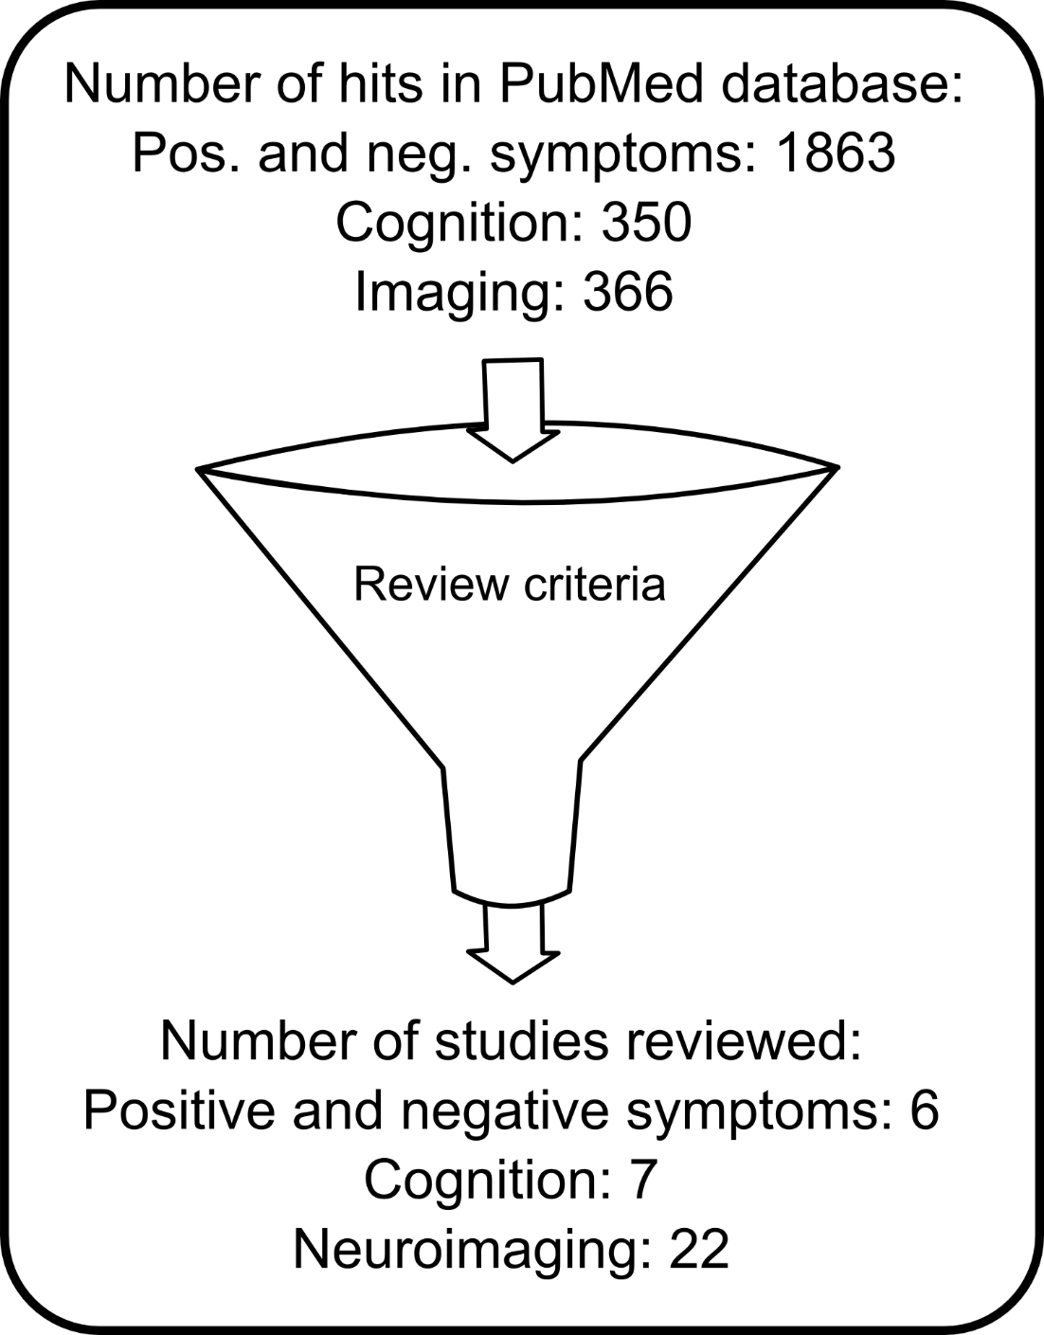
Supplemental Figure 1. Graphical illustration of study selection in the present review. When stringent criteria are applied, the number of database hits is considerably reduced (see also text and Supplemental Table 1). Studies investigating more than one aspect (e.g., imaging and symptomatology) are included only once in this overview according to the focus of the research (bottom).

