Supplementary methods

Cytogenetic analysis
Cytogenetic analysis was performed on chromosome suspensions from bone marrow cells, prepared according to standard laboratory techniques. Q-banding by Quinacrine mustard dihydrochloride (Merck KGaA, Darmstadt, Germany) was used. Metaphases images were acquired by Metafer automated slide scanning platform (magnification 63x) (Metasystems GmbH, Altlussheim, Germany). At least 20 metaphases were analyzed by using the Ikaros (MetaSystems) karyotyping system; definition of a clone and karyotype designation was according to ISCN 2016.
Western blot
5 million cells were seeded in absence or presence of trametinib for 4 hours. Then cells were harvested, washed once in PBS at 4°C, and resuspended in 100μL Laemmli buffer supplemented with 10% β-mercaptoethanol (Sigma). Lysates were denatured at 99°C for 20 min and then used for electrophoresis. Equal volumes (30μL) were loaded on 10% sodium dodecyl sulfate polyacrylamide gel electrophoresis (SDS-PAGE), transferred to nitrocellulose membrane Hybond ECL (GE Healthcare Life Science), and incubated overnight at 4°C with primary antibody (1:1000 dilution in bovine serum albumin [BSA] 2.5%, Roche). Secondary horseradish peroxidase-conjugated anti-rabbit antibodies (1:2000) was incubated for 1 hour at room temperature and then bands were visualized by chemiluminescence ECL (Thermo Scientific) as recommended by the manufacturer. Phospho-p44/42 MAPK (Erk1/2) (Thr202/Tyr204) and p44/42 MAPK (Erk1/2) antibodies were purchased from Cell Signaling Technology, anti-actin and anti-rabbit antibodies were from Sigma, and Bio-Rad, respectively.
Batch effect correction for RNA-sequencing data
Due to the improvements of sequencing technology and sample preparations over the years, technical variations (batch effects) in RNA-sequencing data can exist and lead to misleading findings. To verify the presence of any batch effect in our data, we performed principal component analysis (PCA) in order to visualize the first two principal components for our cohort of 43 samples with RNA-sequencing data. This highlighted a batch effect between samples sequenced earlier in the study versus the ones sequenced more recently (Supplementary Figure 1). Thus, we performed batch effect correction using ComBat ¹. We used the R implementation of the method provided in the sva R package (version 3.32.1) to remove any technical artefact (Supplementary Figure 2).

References
1. Johnson WE, Li C, Rabinovic A. Adjusting batch effects in microarray expression data using empirical Bayes methods. Biostatistics. 2007;8(1):118-127.

Supplementary Figure 1: Principal Component Analysis pre-batch correction. Visualization of the first two dimensions by PCA analysis shows two clearly separated clusters correlating with time of sequencing; namely early and late sequenced samples grouped together in two distinct clusters.

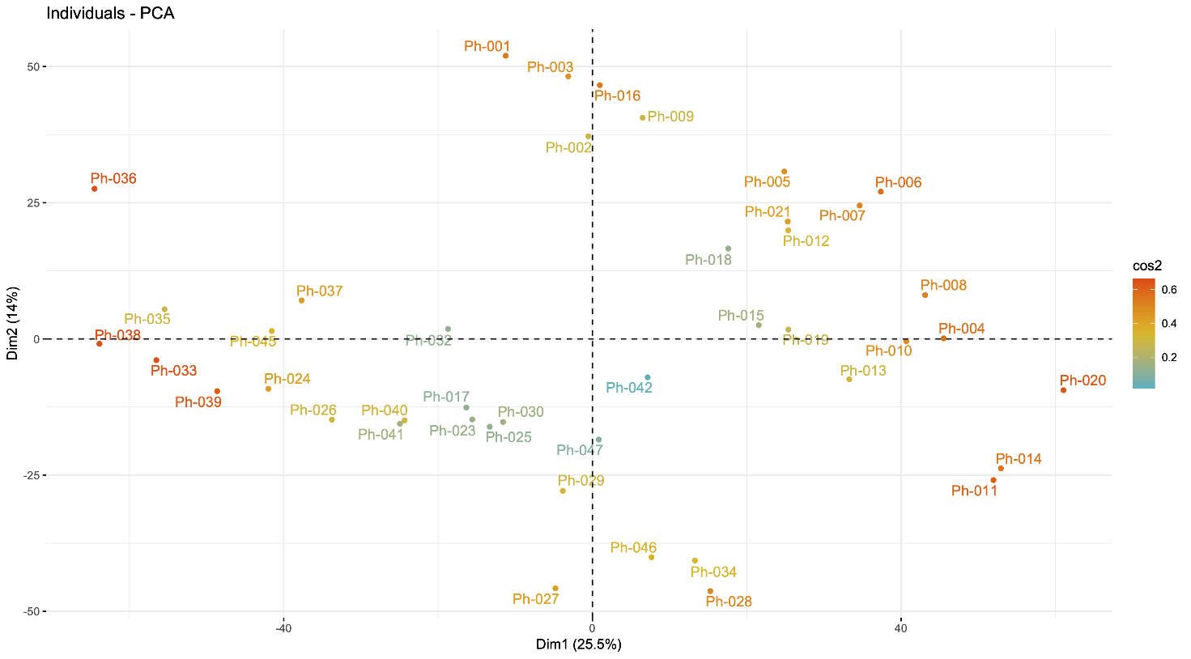

Supplementary Figure 2: Principal Component Analysis post-batch correction. Visualization of the first two dimensions by PCA analysis after batch correction shows the elimination of any artefactual cluster associated to time of sequencing.

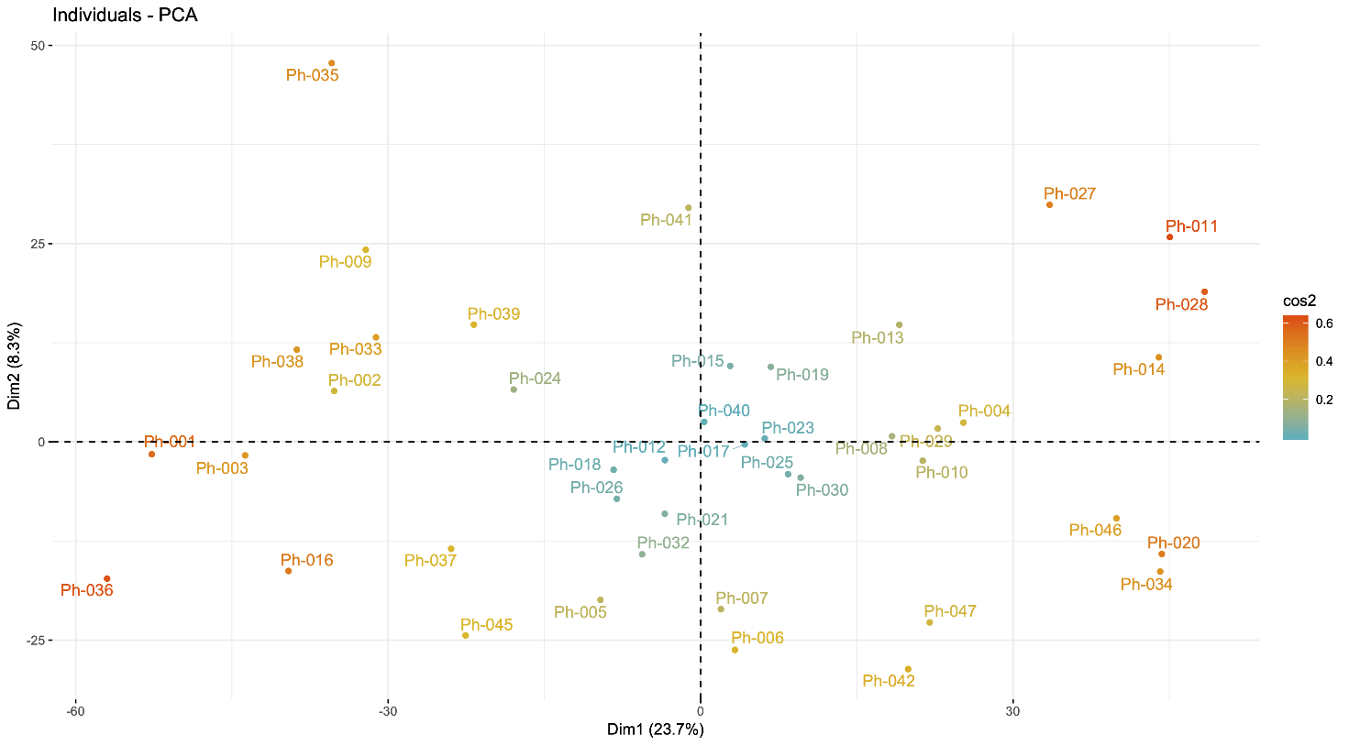

Supplementary Figure 3: Estimation of best number of clusters. Assessment of the optimal number of clusters as described in Ramazzotti D. et al. Nat Commun. 2018;9(1):4453. The two metrics intuitevely provide a measure of the recomemmed number of clusters, where lower values represent better solution.

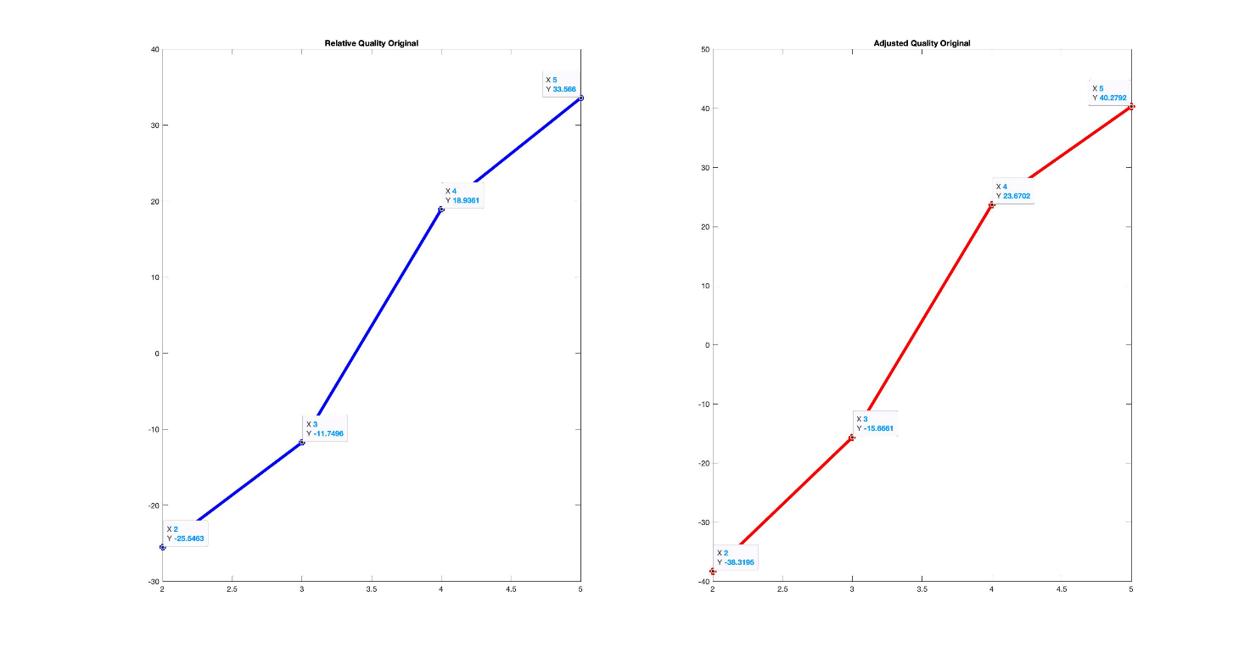

Supplementary Figure 4: Allelic imbalance analysis. Allelic imbalance analysis of CMLPh-019 exome using CEQer reveals that CBL homozygosity is caused by a somatic uniparental disomy event occurring in the telomeric region of the long arm of chromosome 11. SUD=Somatic Uniparental Disomy.

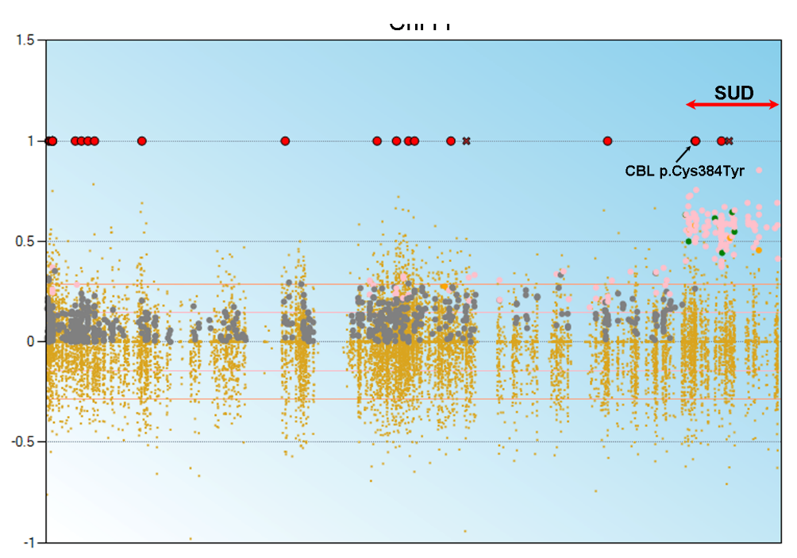

Supplementary Figure 5: Western blot analysis. Anti p-ERK and ERK western blot analysis on patient CMLPh-042 cell lysates from bone marrow sample treated/untreated with 10nM trametinib for 4 hours. Gel loading was normalized using total H3.

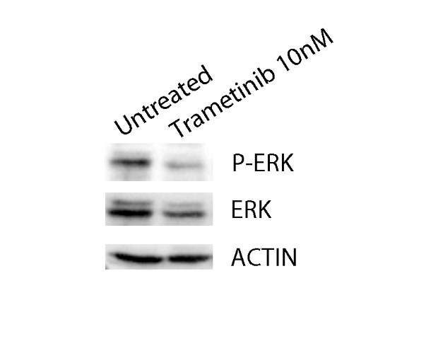

Supplementary Figure 6: Cytogenetic analysis of patient CMLPh-042. A) Karyotype from a metaphase at diagnosis. B) Karyotype from a metaphase at relapse. The arrow indicates isocromosome 17q. C) Copy number plot of chromosome 17 at relapse. Loss of 17p (deleted region in green), which includes p53 locus is shown. The arrow highlights p53 locus.

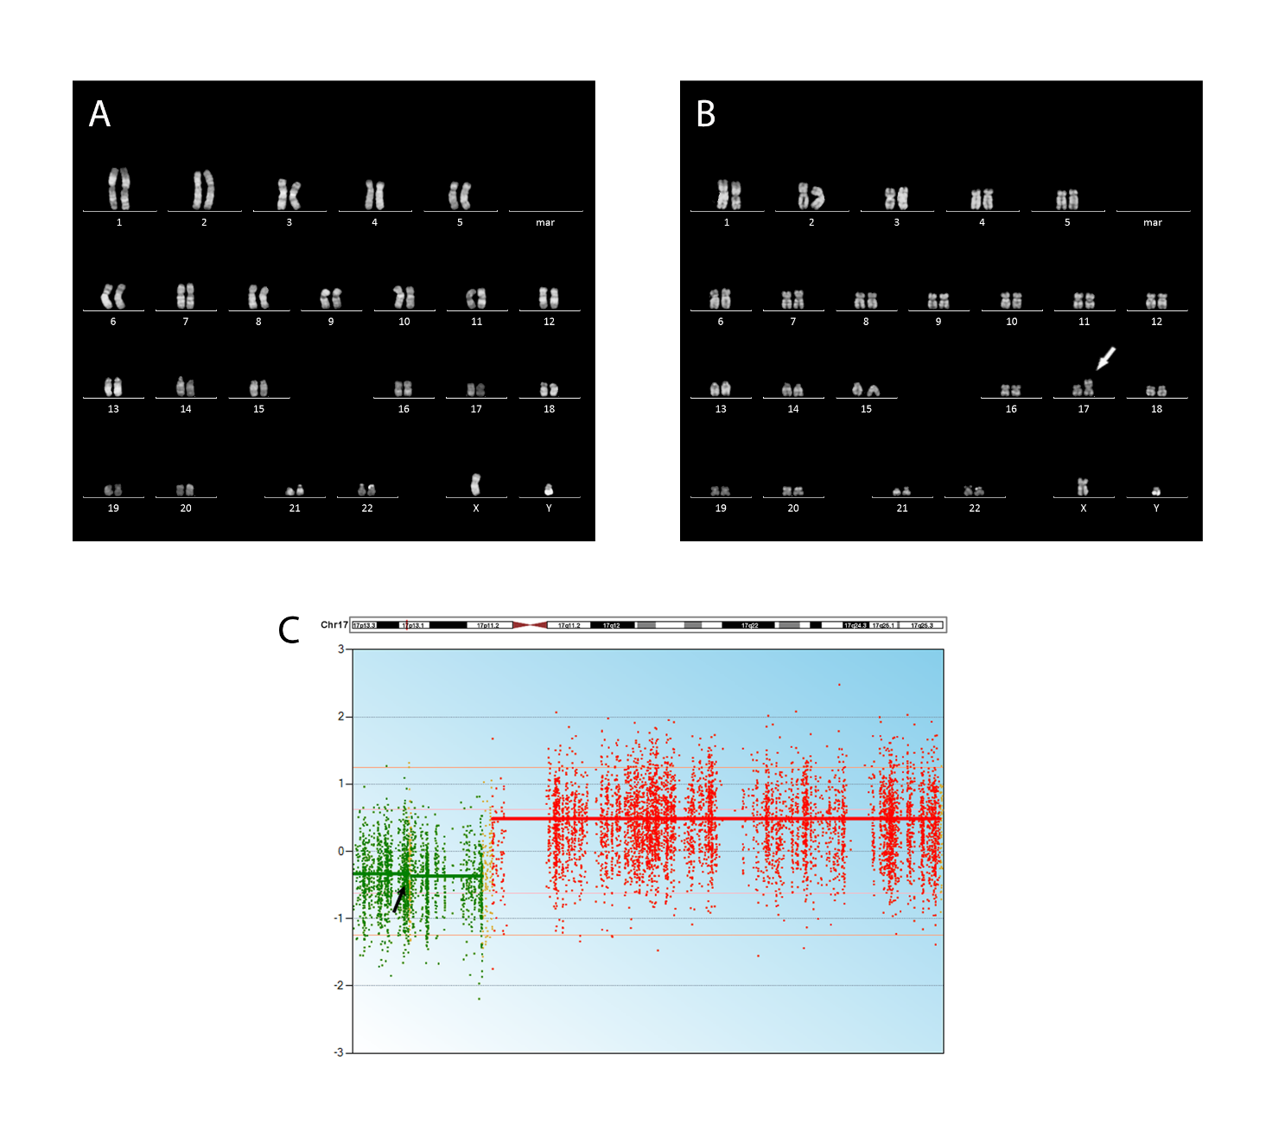

Supplementary Table 1: Table reporting the cancer-related genes used in the RNA-seq analysis. This list is obtained from the literature (Bailey M.H. et al. Comprehensive Characterization of Cancer Driver Genes and Mutations. Cell. 2018;173(2):371-385; Liu Y. et al. ONGene: A literature-based database for human oncogenes. J Genet Genomics. 2017;44(2):119-121; Zhao M. et al. TSGene: a web resource for tumor suppressor genes. Nucleic Acids Res. 2013;41(Database issue):D970-976; Zhao M. et al. TSGene 2.0: an updated literature-based knowledgebase for tumor suppressor genes. Nucleic Acids Res. 2016;44(D1):D1023-1031).
Supplementary Table 2: Clinical data of the aCML patients. WBCs=white blood cells; Hb=hemoglobin; PLTs=platelets; EOS=eosinophils; BAS=basophils; PB=peripheral blood; BM=bone marrow. The peripheral blood parameters refer to means.
Supplementary Table 3: Role of the mutated genes
Supplementary Table 4: Mutation profiling results of the aCML patient sample cohort (n=37).
Supplementary Table 5: Somatic variants identified by matched exome sequencing in atypical Chronic Myeloid Leukemia patient CMLPh-007.
Supplementary Table 6: Somatic variants identified by matched exome sequencing in atypical Chronic Myeloid Leukemia patient CMLPh-011.
Supplementary Table 7: Somatic variants identified by matched exome sequencing in atypical Chronic Myeloid Leukemia patient CMLPh-012.
Supplementary Table 8: Somatic variants identified by matched exome sequencing in atypical Chronic Myeloid Leukemia patient CMLPh-034.
Supplementary Table 9: Somatic variants identified by matched exome sequencing in atypical Chronic Myeloid Leukemia patient CMLPh-045.
Supplementary Table 10: Somatic variants identified by matched exome sequencing in atypical Chronic Myeloid Leukemia patient CMLPh-042.
Supplementary Table 11: Patients ID and related cluster assignments are listed in this table.
Supplementary Table 12: Table reporting the whole list of significant GO term resulting from our enrichment analysis.
Supplementary Table 13: Table reporting the whole list of significant pathways resulting from our enrichment analysis.
Supplementary Table 14: Roles of the top 4 differentially expressed genes.

