Supplementary Figures

Supplementary Figure S1: Schematic diagram of the DNA structure of a KMT2A wild-type (WT) and partial tandem duplication of the KMT2A gene. A) The boxes represent an exon, and the number above each box represents exon number. The KMT2A gene is composed of 36 exons, but for illustration, only the first 13 exons are displayed in the above diagram. The black small arrows indicate the location of the primers used for the analysis (adapted from Caligiuri et al., 1996). The grey boxes illustrate the exons that are duplicated in an e3-e9 KMT2A-PTD in the KMT2A gene. The PTD can also involve other exons of the KMT2A gene. B) Representative RT-PCR analyses KMT2A-PTD. The EOL1 cell line carries KMT2A-PTD and served as positive control (1H). The assay limit of detection was determined by diluting the EOL1 cell line (1:10 dilutions (1H-1D (100% - 0.01%)) in HL-60, a cell line without KMT2A-PTD.

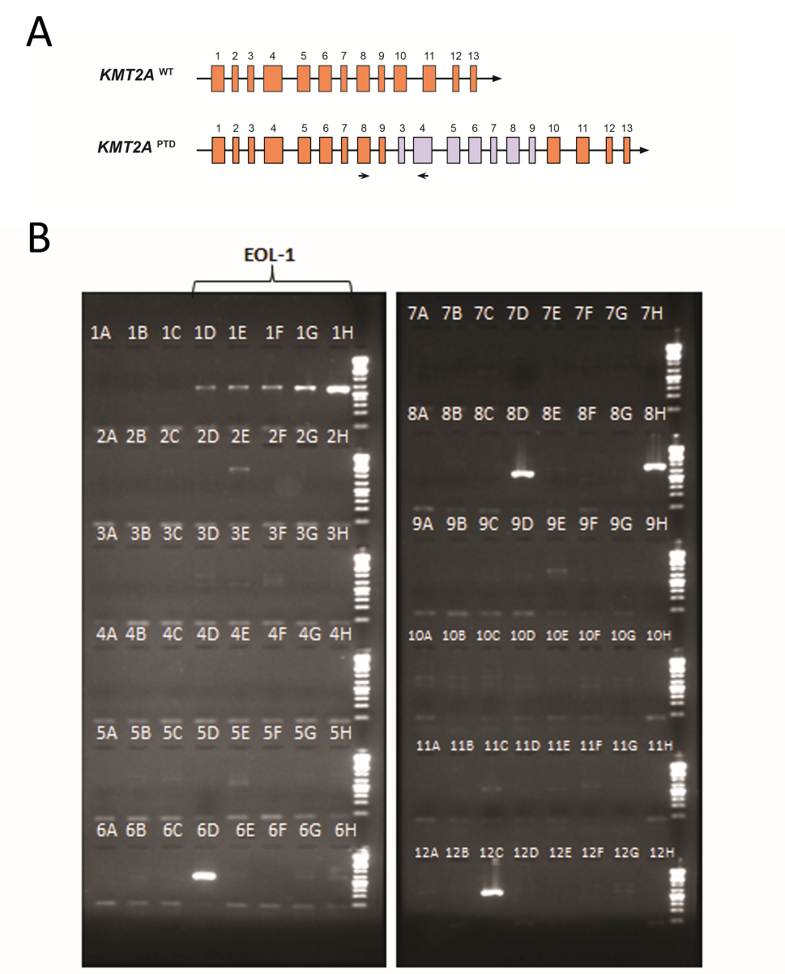
Supplementary Figure S2: KMT2A-PTD AML mutation frequency in study (KMT2A-PTD AML), validation cohort (KMT2A-PTD AML), AML reference cohort and t(11q23) AML. The frequencies of concurrent mutations in KMT2A-PTD AML study cohort (blue), KMT2A-PTD AML validation cohort (green), reference cohort (red) and t(11q23) (purple).

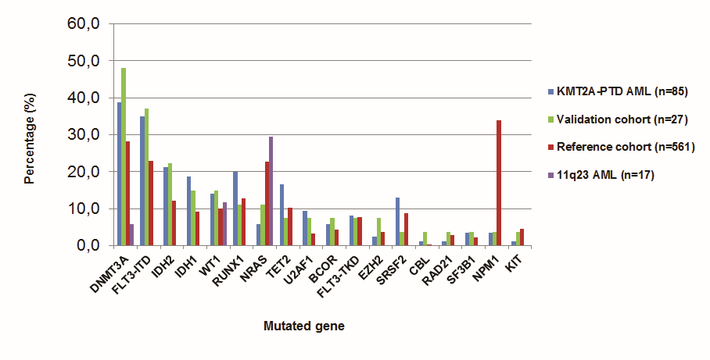
Supplementary Figure S3: Survival analysis KMT2A-PTD AML vs. KMT2A-WT AMLs. A) Kaplan-Meier graph OS of KMT2A-PTD AMLs (red) vs. KMT2A wild-type AML (black).

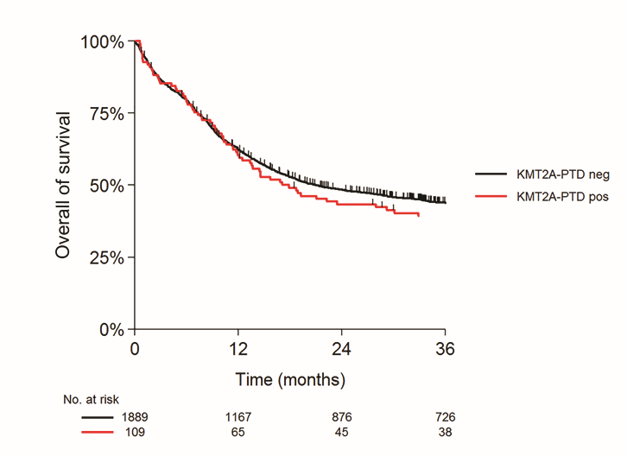
Supplementary Figure S4: Survival analysis of KMT2A wild-type cohort and concurrent mutations. KMT2A wild-type with and without DNMT3A mutations (p=0.99).

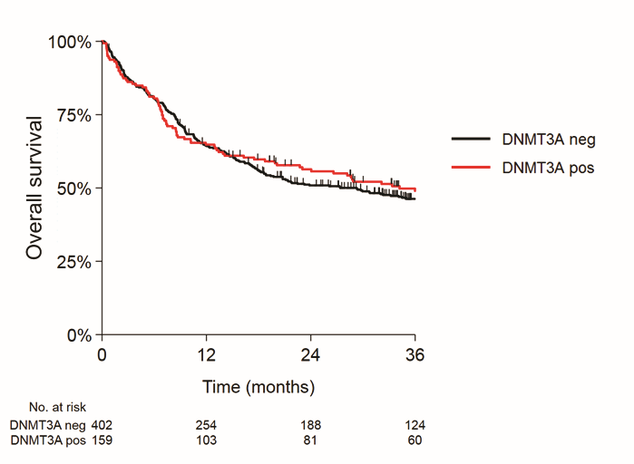
Supplementary Figure S5: Survival analysis of KMT2A wild-type cohort and concurrent mutations. KMT2A wild-type with and without NRAS mutations (p=0.044).

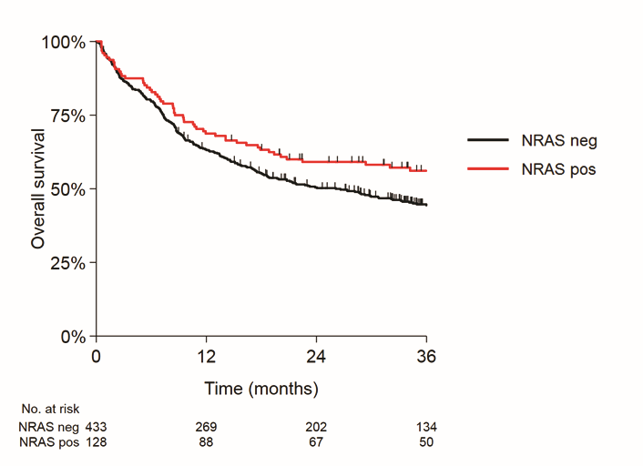
Supplementary Figure S6: Survival analysis of KMT2A-PTD validation cohort and concurrent mutations. KMT2A-PTD with and without DNMT3A mutations (p=0.0017).

