Supplementary Figure 1

Supplementary Figure 2: Analytical phenotype of the 4 biphenotypic MRD+ cases shown in Figure 4. First row: The two MRD subsets show different expression levels of CD56 and have kappa light chain restriction. Second row: Biphenotypic MRD+ case with a distinct CD56 phenotype but with lambda light chain restriction. Third row: Two different kappa clonal subsets with a distinct CD19 expression. Bottom row: The two clones show different levels of CD117 and CD27 and are both kappa light chain restricted.
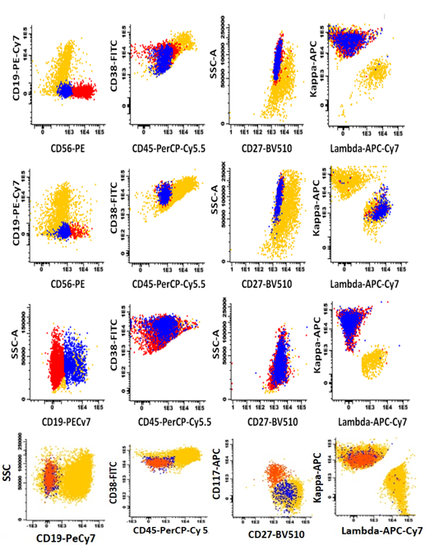
Supplementary Table 1. BM subset analysis in four patients turned MRD+ from initial MRD- status in sequential MRD testing
Bone Marrow subset | Patient #8 |  | Patient #32 |  | Patient #46 |  | Patient #47
 | MRD-  1st evaluation | MRD+  Re-evaluation | MRD-  1st evaluation | MRD+  Re-evaluation | MRD-  1st evaluation | MRD+  Re-evaluation | MRD-  1st evaluation | MRD+  Re-evaluation
Erythroblasts | 0.97† | 2.21 | 1.24 | 3.34 | 3.14 | 4.97 | 2.87 | 2.94
Erythroid progenitors | 0.04 | 0.04 | 0.08 | 0.24 | 0.16 | 0.15 | 0.05 | 0.05
T cells | 1.73 | 2.06 | 3.61 | 0.94 | 11.87 | 8.92 | 3.80 | 5.42
NK cells | 0.43 | 0.44 | 1.46 | 0.33 | 4.64 | 2.53 | 2.07 | 2.04
B cells (total) | 3.80 | 2.13 | 0.15 | 0.21 | 2.52 | 2.24 | 0.81 | 0.65
Naïve B cells | 2.79 | 1.74 | 0.04 | 0.04 | 1.90 | 1.47 | 0.38 | 0.29
Memory B cells | 0.89 | 0.86 | 0.09 | 0.04 | 0.53 | 0.54 | 0.33 | 0.26
B-cell precursors | 0.07 | 0.02 | 0.002 | 0.13 | 0.05 | 0.17 | 0.06 | 0.05
Myeloid precursors | 0.19 | 0.06 | 0.15 | 0.11 | 0.27 | 0.62 | 0.85 | 0.23
Monocytes | 3.64 | 7.34 | 6.02 | 1.90 | 4.08 | 7.85 | 5.84 | 7.98
Neutrophils | 77.5 | 77.9 | 74.46 | 85.77 | 56.81 | 59.16 | 73.94 | 70.69
Basophils | 0.02 | 0.02 | 0.16 | 0.05 | 0.07 | 0.22 | 0.34 | 0.14
Eosinophils | 0.21 | 0.12 | 0.007 | 0.005 | 0.17 | 0.08 | 0.22 | 0.23
Mast cells | 0.002 | 0.006 | 0.005 | 0.014 | 0.07 | 0.02 | 0.01 | 0.01
†All values in the table show percentages (%) of total bone marrow nucleated cells

Supplementary Table 2. Most significant reports evaluating MRD frequencies in independent MM patient cohorts
Study | Setting | Method | LOD | Frequency of CR | MRD+ in total patients (%) | MRD+/patients in CR (%)
San Miguel et al, 2002 | CT vs ASCT | 4-color MFC | 10⁻⁴ | 39/87 | 64/87 (73.6%) | 20/39 (51.3%)
Rawstron et al, 2002 | ASCT | 3-color MFC | 10⁻⁴ | 33/45 | 19/45 (42.2%) | 9/33 (27.3%)
Paiva et al, 2008 | ASCT | 4-color MFC | 10⁻⁴ | 147/295 | 170/295 (57.6%) | 53/147 (36.1%)
Roussel et al, 2014 | ASCT | 7-color MFC | 10⁻⁵ | 18/31 | 10/31 (32.3%) | NA
Rawstron et al, 2015 | ASCT | 6-color MFC | 10⁻⁴ | 214/394 | 148/394 (37.6%) | 31/214 (14.5%)
Paiva et al, 2016 | Elderly | 4-color & 8-color MFC | 10⁻⁵ | 81/162 | 108/162 (66.7%) | NA
Attal et al, 2017 | RVD | 7-color MFC | 10⁻⁴ | 169/350 | NA | 94/265* (35.5%)
 | RVD+SCT |  |  | 205/350 |  | 58/278* (20.9%)
Fukumoto et al, 2015 | CR | 4-6 color MFC | 10⁻⁴ | 78/78 | - | 44/78 (56.4%)
Paiva et al, 2015 | relapsed MM, CR | 4-color MFC | 10⁻⁴ | 52/52 | - | 28/52 (53.8%)
Flores-Montero et al, 2017 | VGPR or CR | 8-color conv. flow | 10⁻⁴-10⁻⁵ | NA | - | 37/110 (33.6%)
 |  | 8-color NGF | 10⁻⁵-10⁻⁶ | NA | - | 52/110 (47.3%)
Cumulative |  |  |  |  | 519/1014 (47.8%) | 426/1326 (32.1%)
*CR or VGPR

