Supplemental Digital Content
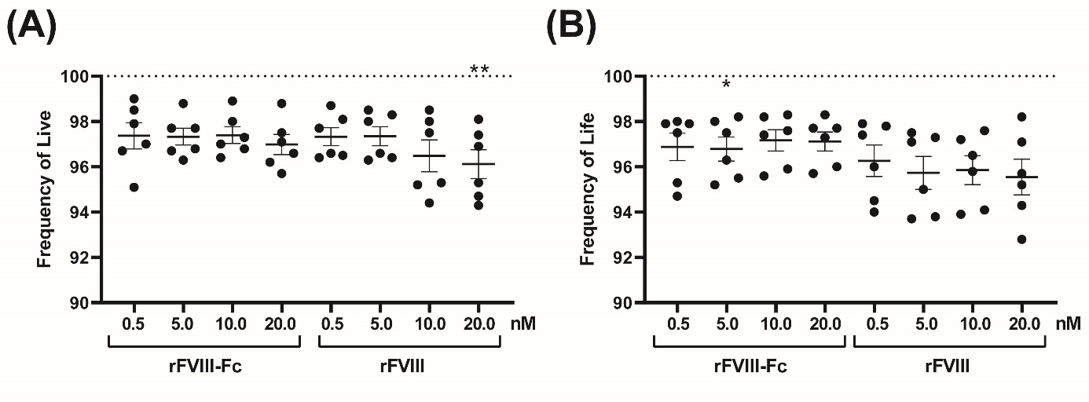
SDC, Figure 1. Effect of rFVIII-Fc and rFVIII on moDC cell viability. MoDC’s were cultivated at 0.5, 5, 10 and 20 nM of rFVIII-Fc and rFVIII for 3 h and then left untreated (A) or challenged additionally with 1 µg/ml LPS for additional 20 h (B). PBS-treated cells served as a control. Data are presented as mean percentage of cell viability ± SEM with each dot representing one donor. Data of each concentration were analysed using one-way ANOVA followed by Dunnett’s Multiple Comparison test relative to cells treated with PBS (*p ≤ 0.05).

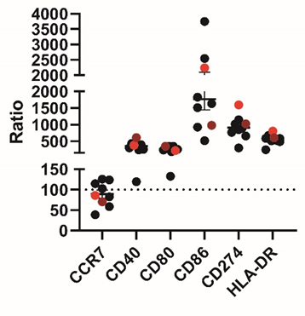
SDC, Figure 2. Effect of LPS on the expression of maturation markers on moDC’s. MoDC’s were cultivated with 1 µg/ml LPS. PBS-treated cells served as a control. Expression of CCR7, CD40, CD80, CD86, CD274 and HLA-DR was determined by flow cytometry on viable, single cells. Data are presented as mean percentage of change in MFI of LPS-stimulated cells over MFI of PBS-stimulated cells ± SEM with each dot representing one donor. The surface expression of the two high responders are highlighted in light and dark red.
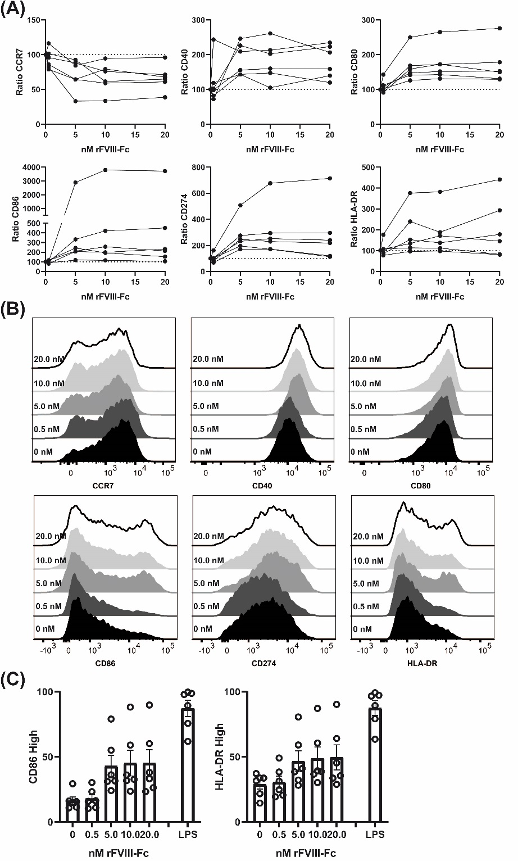
SDC, Figure 3. Dose-dependent response of rFVIII-Fc on the expression of activation markers. MoDC’s were cultivated with 0.5, 5, 10 and 20 nM rFVIII-Fc. PBS-treated cells served as a control. Expression of CCR7, CD40, CD80, CD86, CD274 and HLA-DR was determined by flow cytometry on viable, single cells. (A) Summary of the changes in surface expression of moDC’s obtained from six healthy donors treated with rFVIII-Fc. Data are presented as mean percentage of change in MFI of FVIII-stimulated cells over MFI of PBS-stimulated cells ± SEM depending on the rFVIII-Fc concentration with each line presenting one donor. (B) Displayed are representative histograms of one donor treated with different concentrations of rFVIII-Fc (grey to white filled) or PBS (black filled). (C) Percentage of the CD86 high and HLA-DR high expressing cell population amongst the rFVIII-Fc-treated cells. Data are presented as mean percentage of the CD86 high or HLA-DR high population ± SEM with each dot representing one donor. Data of each concentration were analysed using one-way ANOVA followed by Dunnett’s Multiple Comparison test relative to cells treated with no rFVIII-Fc (*p ≤ 0.05, **p ≤ 0.01, ***p ≤ 0.001). LPS-treated cells served as positive control.
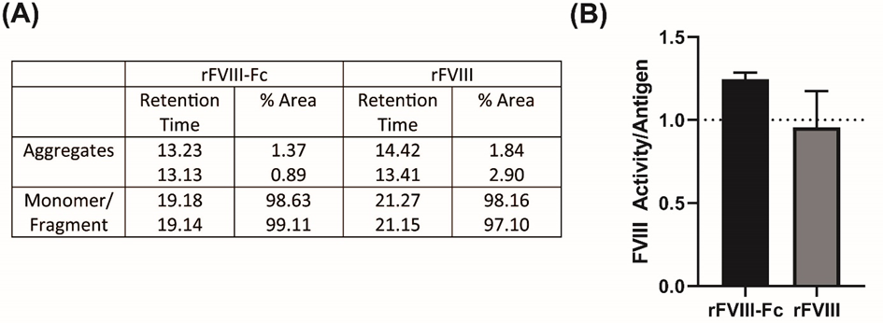
SDC, Figure 4. Analysis of two batches of rFVIII-Fc and rFVIII. (A) SEC analysis was performed on 6 µg rFVIII-Fc or rFVIII after storage at -80°C with a Superdex 200 Increase 10/300 GL (30x10 mm, 8.6 µm particle size) column (GE Healthcare) at 0.56 ml/min with the respective formulation buffer and absorbance was monitored at 280 nm. Displayed is the retention time and the % area of the respective peak for each analysed batch. (B) Ratio of FVIII protein activity to FVIII antigen. FVIII activity and FVIII antigen amount of rFVIII-Fc and rFVIII of two batches was determined via FVIII chromogenic assay or FVIII ELISA, respectively. Displayed is mean of the ratio of FVIII antigen to activity ± SEM.

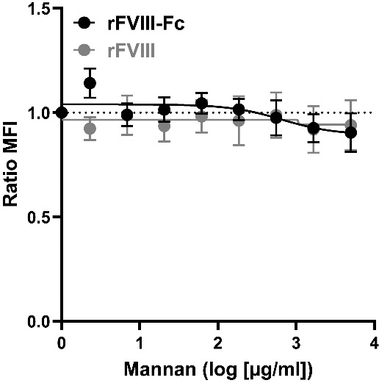
SDC, Figure 5. Effect of Mannan on rFVIII-Fc binding to moDC’s. MoDC’s were incubated with increasing concentrations of mannan in the presence of 10 nM rFVIII-Fc (black line) or rFVIII and binding of FVIII was detected by flow cytometry using a biotin-labelled FVIII-specific nanobody, followed by an incubation with a fluorophore-labelled streptavidin. Data are presented as mean change in MFI of rFVIII/rFVIII-Fc and mannan-treated cells over MFI of rFVIII/rFVIII-Fc-treated cells ± SEM. Data are obtained from three experiments with three donors.

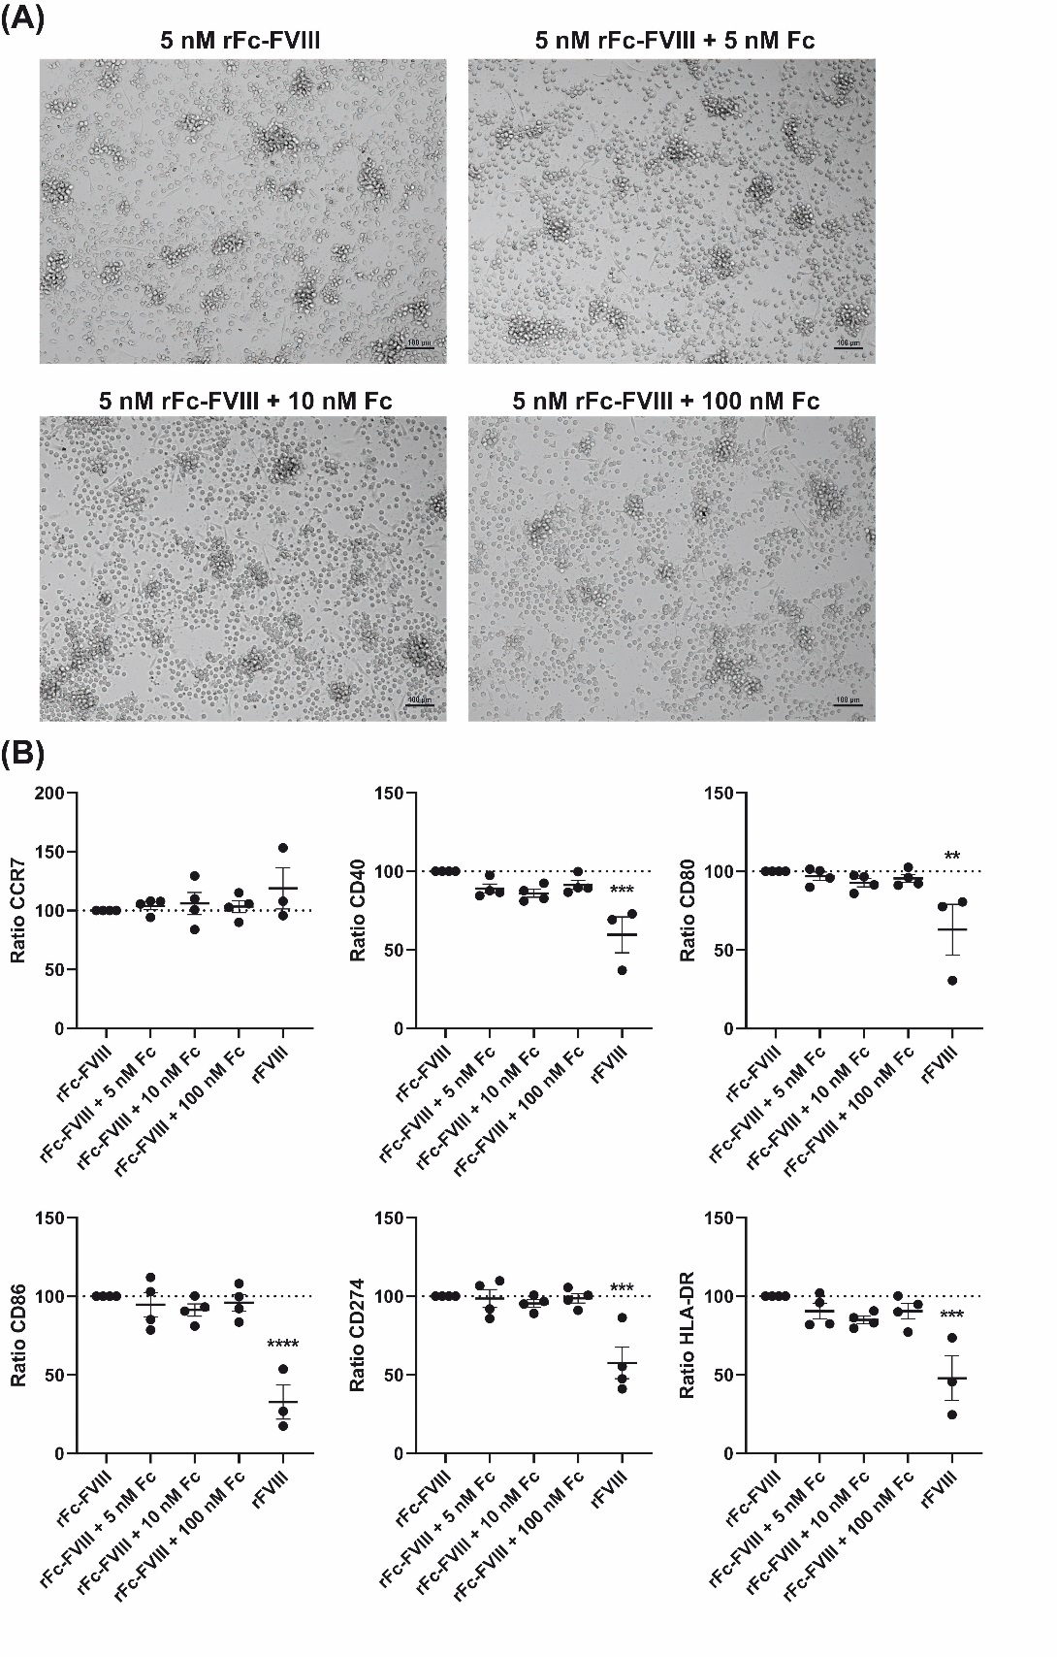
SDC, Figure 6. Effect of human Fc IgG1 on rFVIII-Fc-induced cell activation. MoDC’s were pre-incubated for 1 h with 5, 10 or 100 nM human IgG1 Fc followed by the addition of 5 nM rFVIII-Fc and an incubation for 23 h. (A) Images were taken 23 h post treatment with the Axio Observer Z1 microscope using a 100-fold magnification. Displayed are images from one representative donor. (B) Expression of CCR7, CD40, CD80, CD86, CD274 and HLA-DR was determined by flow cytometry on viable, single cells. Data are presented as mean percentage of change in MFI of Fc+rFVIII-Fc-stimulated cells over MFI of rFVIII-Fc-stimulated cells ± SEM with each dot representing one donor. Data of each concentration were analysed using one-way ANOVA followed by Dunnett’s Multiple Comparison test relative to cells treated with rFVIII-Fc (**p ≤ 0.01, ***p ≤ 0.001, ****p ≤ 0.0001).

