Supplement A1

Materials and Methods: Instructions for ddPCR set-up and analysis

ddPCR REACTION SET-UP

In the Pre-PCR zone, prepare the 20X primer and probe mix and the ddPCR reaction mix. One ddPCR master mix is created for each assay to perform 3 replicates per sample, as shown below. Prepare the ddPCR mix for a volume increased by 10% (for one replicate: 22μl instead of 20μl) to be sure to have enough reaction mix volume for each replicate, and not to risk the generation of air bubbles into the DG8 cartridges, when loading the samples. Dispense the reaction mix in one well, based on the number of technical replicates needed. (i.e for 1 replicate 16.5μl and for 3 replicates 49.5μl of mix).
In the DNA zone, load the amount of gDNA (500ng/μl) depending on the number of planned replicates per well (i.e for 1 replicate 16.5μl of mix add 5.5μl of gDNA, for 3 replicates 49.5μl (16.5x3) of mix add 16.5μl (5.5x3) of gDNA). To ensure that the gDNA is thoroughly mixed: vortex, spin-down and then pipet the sample few times before add the gDNA to the mix. Seal carefully the plate or the strips with optical adhesive film or caps, mix and spin down briefly. From this well, 20μl of mix will be taken for, droplet generation, for each replicate.
Proceed with droplets generation, loading 20μl of reaction mix and 60-70μl of droplet generation oil into the proper DG8 cartridge wells.
Is recommended to:
a) load the 20μl of ddPCR mix in to the DG8 cartridge using a multichannel pipet with filtered tips;
b) pay attention when removing the DG8 gasket and always remove it from the NTC, or BC well position, to the positive control sample;
c) always load the ddPCR reaction mix into the cartridge before the oil;
d) transfer the 40μl of droplets/well to the hard-shell, high-profile, 96-well semi-skirted PCR plates using a multichannel pipet with no filter tips and immediately seal the wells with a scotch tape;
e) load the technical replicates in different DG8 cartridges to avoid losing a full sample reaction, due to a technical error that might happen during pipetting or failing during the droplet generation procedure;
f) remove carefully, any bubble created into the DG8 cartridge “sample” well during sample loading. If necessary use a tip previously slightly soaked into the droplet generation oil.

Example of ddPCR reaction Mix:
Reagents | 1 Reaction (µl)
2X ddPCR Supermix for Probes (No dUTP) | 11
20X Target Primers/Probe mix | 1,1
Enzyme digestion (HINFI (2U/ µl)) or denaturation (optional) | 1,1
H2O (volume must be adjust if the enzyme is used) | 4,4
TOT mix | 16,5
Amount of input gDNA (100 ng/μl) | 5,5
TOT | 22
MIX for 1 replicate | 16,5 µl
gDNA (100 ng for target, 20 ng for housekeeping) | 5,5 µl
MIX for 3 replicates | 49,5 µl
gDNA (100 ng for target, 20 ng for housekeeping) | 16,5 µl
Total Volume loaded for droplet generation | 20 µl
Total amount of droplets mix | 40 µl

How to prepare 20X Target Primers/Probe mix
Example 1: Primers (500nM) / Probe(200nM) mix (50μl):
38 μl H20 + 2 μl PROBE (100pm/μl) + 5 μl EACH PRIMER (100 pm/μl).
Example 2: Primers (300nM) / Probe(100nM) mix (50μl):
10 μl H20 + 20 μl PROBE (5pm/μl) + 10 μl EACH PRIMER (30 pm/μl).

Thermal protocol:

95°C x 10 ‘

94 °C x 30’’
x 40 cycles
TM °C x 1’

98° C x 10 ’

MRD Plate set-up :

1) Each analysis must include:
- 2 replicates of diagnostic gDNA 1E-01 or 10 ng
- 3 replicates of each FU samples (500 ng)
- at least 6 replicates with a transcript-negative (Buffy coat (PBMC) from 5 to 10 subjects)
(the new proposed guidelines fixed the number of replicates for PBMC negative controls to 3 and does not recommend use of cell line DNA)
- at least 2 replicates with no template control (NTC)

Analysis:
- Only replicates with more (>=) than 9000 droplets can be considered for analysis.
- The threshold must be established manually. The threshold should be set below the positive control cloud and as close as possible to the background signal.
- For consensus primers and probe assay (i.e. BCL2/MBR) a single threshold must be set referring to the positive control, however for those samples presenting unaligned amplitude signal, a sample specific threshold can be set.
- In case of positive events in NTC or PBMC, verify the consistency of the amplification signal by checking the presence of positive droplets in channel 2 (ch2). If signal in ch2 (green) is detected, this represents non-specific amplification (false positive signal) and must be excluded from the analysis (see software guide). Channel 2 must be checked for all samples.

Results definition:
- MRD positive: those samples that have a merge of events >=3 within the triplicates (a).
- MRD negative: those samples that have all negative replicates (with no events) or replicates with a merge of 1 event in at least duplicate analysis.
- MRD BQL: those samples that have a merge of 2 events within the replicates.

- if only two replicates are available, due to technical reasons or because of insufficient DNA, the sample can be considered as evaluable.

ANALYTICAL PROCEDURE

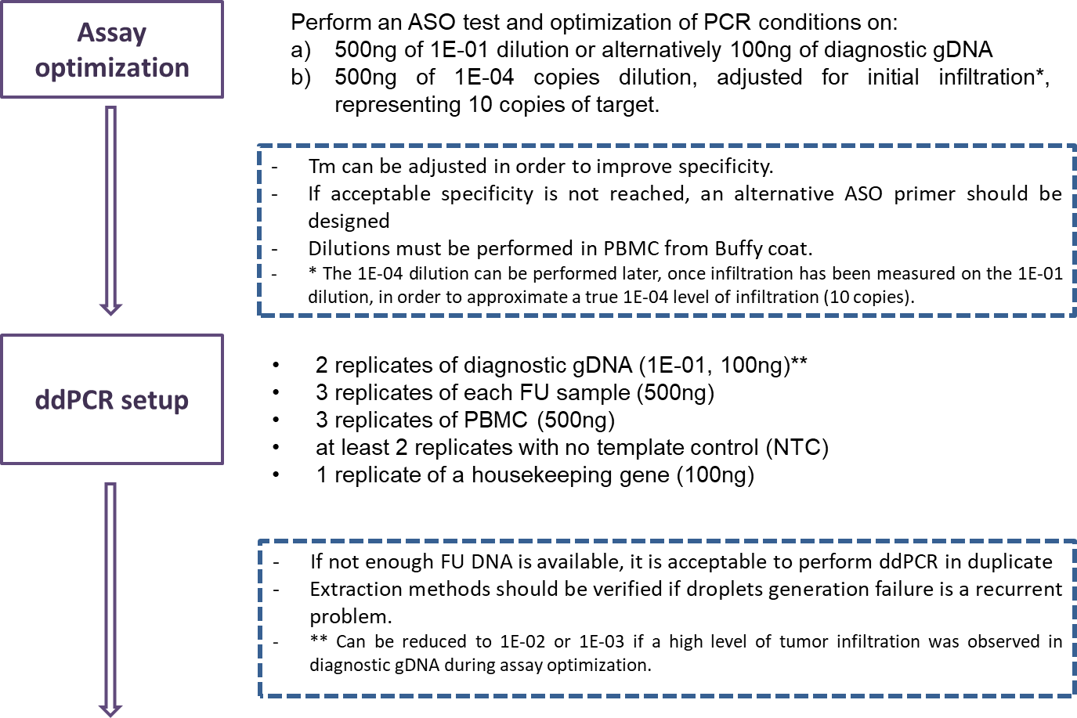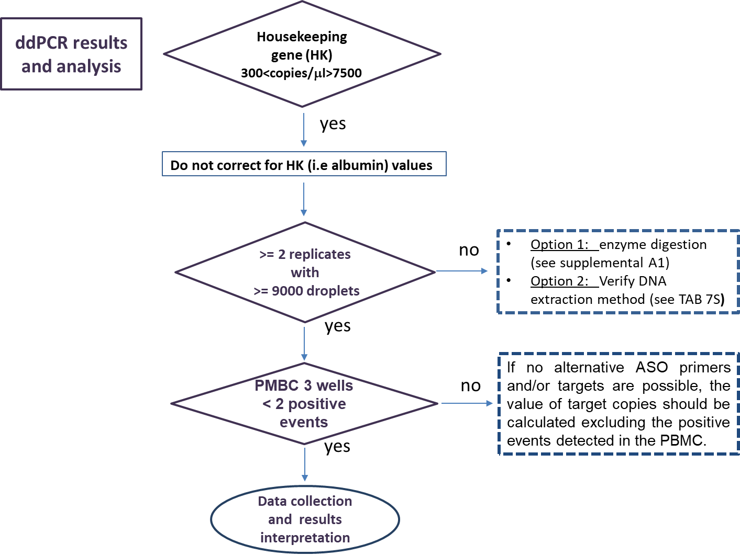Supplement A2: Sub-optimal ddPCR results: how to calculate sample target copies in case of PBMC positivity in replicates

For those patients in which positive events are observed within the PBMC replicates, the consistency of the amplification signal must be checked by excluding the presence of positive droplets in the alternative fluorescent channel (ch2 or the green signal). If a signal in ch2 (in the same position as ch1) is detected, this represents non-specific amplification (false positive signal) and must be excluded from the analysis. If PMBC wells present ≥ 2 positive events and no alternative approaches with other ASO primers and/or targets are possible, the value of target copies should be calculated by excluding the positive events detected in the PBMC based on the following formula:

SAMPLE COPIES CORRECTED FOR PBMC =
SAMPLE COPIES/ n replicates - PBMC COPIES/n replicates

Where:

SAMPLE COPIES= Mean of copies/µl (calculated by the QuantaSoft) in all replicates x 20 µl

Represents the absolute number of target copies per sample (500 ng of DNA) in 20 µl of reaction.

Another way to calculate the Total observed copies per sample (TC-S) is:

TC-S = {[LN (SAMPLE-TOTAL DROPLETS) – LN (SAMPLE-NEGATIVE DROPLETS)] x SAMPLE-TOTAL DROPLETS} / n replicates

and per PBMC (TC-PBMC) is:

TC-PBMC= {[LN (PBMC-TOTAL DROPLETS) – LN (PBMC-NEGATIVE DROPLETS)] x PBMC-TOTAL DROPLETS} /n replicates

This means that if

SAMPLE COPIES : TC-S = PBMC COPIES (X) : TC-PBMC

we can calculate the Total observed copies per PBMC as:

PBMC COPIES (X) = SAMPLE COPIES * (TC-PBMC / TC-S)

SAMPLE COPIES CORRECTED FOR PBMC= SAMPLE COPIES/ n replicates - PBMC COPIES/ n replicates

Definitions:
SAMPLES-TOTAL DROPLETS: sum of all droplets (in all replicates) for the target.
PMBC-TOTAL DROPLETS: sum of all droplets (in all replicates) for the PBMC.
SAMPLE-NEGATIVE DROPLETS : SAMPLES-TOTAL DROPLETS subtracted by POSITIVE EVENTS detected in the target wells.
PBMC-NEGATIVE DROPLETS : PBMC-TOTAL DROPLETS subtracted by all POSITIVE EVENTS detected in the PBMC wells.

