Supplementary material
A Study of Safety and Efficacy of Nivolumab and Bendamustine (NB) in Patients With Relapsed/Refractory Hodgkin Lymphoma After Failure Of Nivolumab Monotherapy.

Kirill V. Lepik, Natalia B. Mikhailova, Elena V. Kondakova, Yuri R. Zalyalov, Liudmila V. Fedorova, Luibov A. Tsvetkova, Polina V. Kotselyabina, Evgeniya S. Borzenkova, Elena V. Babenko, Marina O. Popova, Elena I. Darskaya, Vadim V. Baykov, Ivan S. Moiseev, Boris V. Afanasyev.

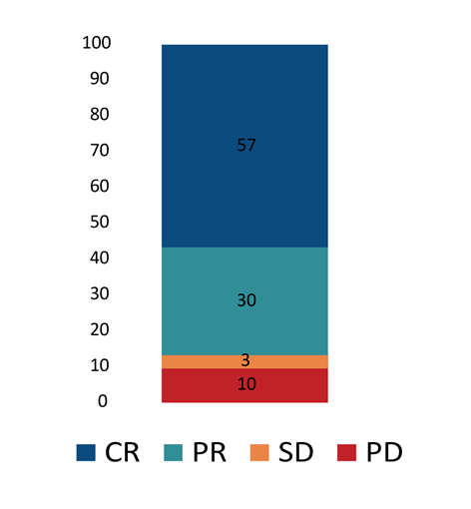
Figure 1S. Best overall response during nivolumab bendamustine combined therapy

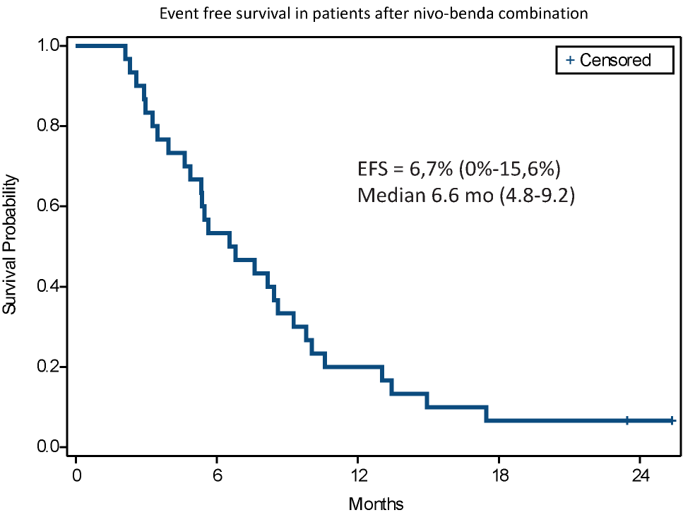
Figure 2S. Event-free survival after nivolumab-bendamustine combination according.

Table 1S. The influence of clinical factors on PFS after nivolumab-bendamustine treatment
Grouping variable | Median PFS in strata  (HR for Cox regression) | Significance level*
Age | 1.022 | 0.3477
BMI | 1.949 | 0.5509
Best response to nivolumab bendamustine combination  (across all groups) | CR: 10.6 mo (95% CI, 6.1-17.5)  PR: 9.3 mo (95% CI, 5.5-12.0)  SD: Not reached (95% CI, NR-NR)  PD: 2.1 (95% CI, NR-NR)  IR: Not reached (95% CI, NR-NR) | 0.0001
Best response to Nivolumab monotherapy | CR: 14.2 mo (95% CI, 9.8-NR)  PR/SD/IR: 13.0 mo (95% CI, 8.2-NR)  PD: 5.9 mo (95% CI, 2.1-9.3) | 0.0230
B-symptoms at study start | Yes: Not reached (95% CI, 9.3-NR)  No: 10.2 (95% CI, 7.6-13.2) | 0.4739
Consolidation of response achieved with combination, other than alloHSCT  (no landmark) | Yes: 9.8 mo (95% CI, 5.0-14.2)  No: 10.6 mo (95% CI, 7.6-17.5) | 0.3716
Gender | Male: 9.8 mo (95% CI, 6.1-14.2)  Female: 10.6 mo (95% CI, 5.5-NR) | 0.6479
Histological variant | NS: 11.2 mo (95% CI, 6.8-14.9)  MC: 7.1 mo (95% CI, 4.6-17.5)  LD: 8.4 mo (95% CI, 7.6-9.3)  LR: NR (95% CI, 14.2-NR) | 0.2580
Nivolumab bendamustine as bridge to alloHSCT  (no landmark) | Yes: Not reached (95% CI 5.5-NR)  No: 9.8 mo (95% CI, 7.6-13.0) | 0.0189
Number of prior therapy lines | 1.107 | 0.3335
Progression as BOR to nivolumab monotherapy | Yes: 5.9 mo (95% CI, 2.1-9.3)  No: 13.1 mo (95% CI, 8.6-NR) | 0.0063
Primary chemoresistance | Yes: 11.3 mo (95% CI, 5.5-17.5)  No: 9.8 mo (95% CI, 7.6-14.9) | 0.9841
Prior ASCT | Yes: 11.3 mo (95% CI, 5.6-NR)  No: 9.0 mo (95% CI, 6.1-13.2) | 0.4457
Prior bendamustine | Yes: 10.8 mo (95% CI, 6.8-17.5)  No: 9.9 mo (95% CI, 5.0-14.2) | 0.4849
Prior bendamustine refractory | Yes: 11.8 mo (95% CI, 4.6-NR)  No: 9.2 mo (95% CI, 5.5-14.9) | 0,1606
Prior BV | Yes: 10.9 mo (95% CI, 5.5-NR)  No: 10.2 mo (95% CI, 7.6-13.2) | 0.8155
Prior nivolumab combination | Yes: 9.5 mo (95% CI, 8.6-NR)  No: 11.2 mo (95% CI, 6.8-14.2) | 0.9379
Prior radiotherapy | Yes: 9.8 mo (95% CI, 6.8-13.2)  No: 12.4 mo (95% CI, 5.0-17.5) | 0.8839
Stage at study start | II: Not reached (95% CI, NR-NR)  III: Not reached (95% CI, NR-NR)  IV: 9.5 mo (95% CI, 6.8-13.2) | 0.4866
Status at study start | PR: 9.3 (95% CI, 6.1-NR)  SD: Not reached (95% CI NR-NR)  PD: 9.8 mo (95% CI, 5.6-14.2)  IR2: 13.2 mo (95% CI 4.6-17.5)  IR3: Not reached (95% CI NR-NR) | 0.9747
Time from prior nivolumab discontinuation to combo | 0.999 | 0,9352
Time from prior bendamustine discontinuation to combo | 1.000 | 0,8802
Tumor volume before combination | 1.000 | 0.0898

*PFS estimation with Kaplan-Mayer method with test of equality over strata (Log rank test) for nominal variable, Cox regression with analysis of Maximum Likelihood Estimates for interval variable

Figure 3S. Progression free survival after nivolumab-bendamustine combination according to anamnesis of prior bendamustine monotherapy.
Figure 4S. Progression free survival after nivolumab-bendamustine combination according to best overall response during therapy.

Table 2S. Next treatment after nivolumab-bendamustine treatment
Type of next additional treatment | N | (%)
Nivolumab monotherapy | 12 | 40%
Allogeneic SCT | 5 | 16,6%
Nivolumab-BV combination | 2 | 6,6%
Other nivolumab combination | 4 | 13,3%
BV monotherapy | 2 | 6,6%
Chemotherapy | 2 | 6,6%

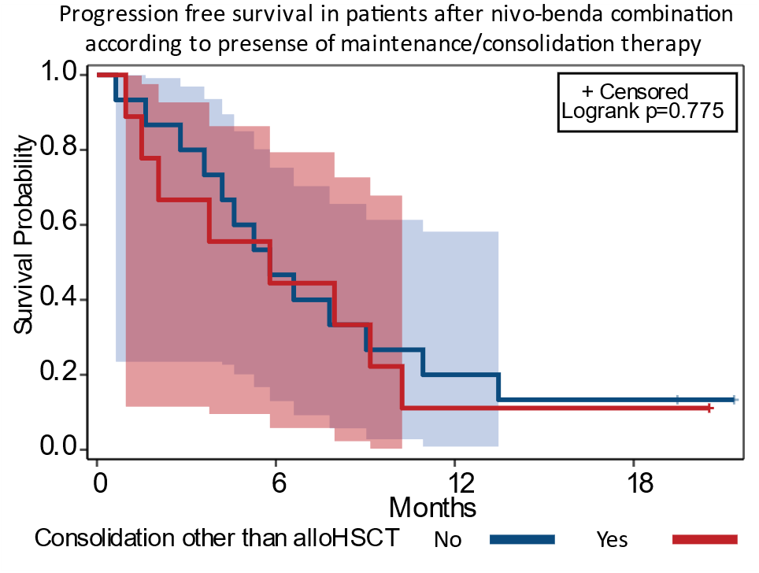
Figure 5S. Progression-free survival (PFS) in patients with response to nivolumab-bendamustine that received maintenance/consolidation therapy other than alloHSCT vs. other patients.

Table 3S. Structure of observed immune related adverse events

Type of irAE | irAE overall |  |  | irAE Gr 3-4 |  | irAE Gr 1-2
Any | 21 |  | 70,0% | 3 | 10,0% | 19 | 63,3%
Pyrexia | 11 |  | 36,7% | 0 | 0,0% | 11 | 36,7%
Pruritus | 10 | 33,3% |  | 0 | 0,0% | 10 | 33,3%
Rash | 3 | 10,0% |  | 0 | 0,0% | 3 | 10,0%
ALT increased | 3 | 10,0% |  | 0 | 0,0% | 3 | 10,0%
AST increased | 3 | 10,0% |  | 0 | 0,0% | 3 | 10,0%
Colitis | 2 | 6,7% |  | 1 | 3,3% | 1 | 3,3%
Infusion reaction | 1 | 3,3% |  | 1 | 3,3% | 0 | 0,0%
Uveitis | 1 | 3,3% |  | 1 | 3,3% | 0 | 0,0%

