Supplemental digital content

Supplemental Materials and Methods

Figure S1: Effect of mutagenesis of the Dmt1 3’IRE on Dmt1 transcription and IRP binding.

Figure S2: Terminal erythroid differentiation during early adulthood.

Figure S3: Iron metabolism parameters in female mice.

Figure S4: Expression of key iron metabolism molecules in the liver and spleen of adult mice.

Figure S5: Dmt1 mRNA expression in heart and kidney tissues.

Table S1: Inheritance of the Dmt1-IREKO allele.

Table S2: Body and organ weight parameters.

Table S3: Baseline hematological parameters in Dmt1^{IRE∆/∆} mice are globally normal.

Table S4: List of oligonucleotides and antibodies used in the study.

Supplemental References

Materials and Methods

Mice
Animals were housed under specific pathogen-free and light-, temperature- (21°C), and humidity (50-60% relative humidity)-controlled conditions. Food (containing around 200 ppm of iron) and water were available ad libitum. Littermates from Dmt1^{IRE+/∆} inter-crosses were analyzed. Blood was collected by cardiac puncture after deep anesthesia of the mice with a Ketamine/Xylazine mixture. For molecular analyses, mice were sacrificed by cervical dislocation to minimize protein and RNA degradation. Animal care, husbandry, and killing were performed according to national guidelines and were approved by an institutional review board headed by the local animal welfare officers.

Hematology and serum parameters
Blood profiles and hemoglobin content were determined using an ABC Vet apparatus (HORIBA ABX SAS, Montpellier, France). Serum was prepared using Z-gel containing microvettes (Sarstedt, Nümbrecht, Germany). Serum concentration of iron, ferritin and transferrin was determined at the “Centre de Recherche sur l’Inflammation” (Paris, France) using an Olympus 400 analyzer (Olympus, Tokyo, Japan). Hepcidin levels were measured using the Hepcidin Murine-Compete™ ELISA kit (Intrinsic Life Sciences, LaJolla, CA, USA).

Tissue iron levels
Tissues were dried and non-heme iron levels were measured using the bathophenanthroline method as described previously¹. Iron was stained on paraffin sections using Prussian blue, and pictures were acquired using a DM5000 microscope equipped with a DFC420C camera and a 10X objective. Images were processed using the Leica Application Suite (Leica Biosystems, Wetzlar, Germany).

DNA analyses
For Southern blotting, DNA was isolated by phenol/chloroform/isoamyl alcohol extraction after proteinase K digestion. The DNA was digested with NcoI, separated on an agarose gel, and transferred onto Hybond Nylon (GE Health Care Life Sciences, Freiburg, Germany) membranes. The membranes were UV crosslinked and hybridized with the P3’ probe in ULTRAHybTM solution (Fisher Scientific GmbH, Schwerte, Germany). The P3’ probe was obtained by PCR using the primers listed in Table S4 and was random labeled with [α-32P]dCTP using Ready-to-go™ DNA Labeling Beads (Sigma-Aldrich). Autoradiography was performed with a phosphor imager.

RNA analyses
qRT-PCR: Total RNA was extracted with TRIzol reagent (Life Technologies, Darmstadt, Germany), treated with DNase I to remove genomic DNA, and reverse transcribed using random primers and MultiScribe reverse transcriptase polymerase (Fisher Scientific GmbH) according to the manufacturer’s instructions. For each sample, RT reactions were performed in duplicate and the average of the duplicate was used for subsequent calculations. Real-time quantitative PCR was carried out on a CFX Real-Time PCR system (Bio-Rad, Munich, Germany) using SYBR Green and the following cycling parameters: denaturation, 95°C for 10 min, followed by 45 cycles of 15 s at 95°C, 15 s at 60°C and 15 s at 72° C. Semi-quantification was done using the ∆∆Ct-method. The primers used for qRT-PCR are listed in Table S4. Results are presented as relative mRNA expression (%) normalized to a housekeeping gene as indicated in figure legends. To selectively analyze Dmt1-IRE pre-mRNA levels, we used an intronic forward primer located 8 bp upstream of the splice acceptor of the exon containing the IRE; the reverse primer was located 5 bp downstream of the splice acceptor in the IRE containing exon that is used to generate the no IRE isoform (Table S4). For calibration, we used qPCR primers located in the last exon of the Actb pre-mRNA.
RT-PCR: Total RNA was reverse transcribed using the SuperScript™ III Reverse Transcriptase kit (Fisher Scientific GmbH) and an oligo-dT primer following the manufacturer’s instructions. The cDNA obtained was PCR amplified using the SequalPrep™ Long PCR Kit (Fisher Scientific GmbH) together with forward primers corresponding to exon 1A or 1B, respectively, and reverse oligonucleotides corresponding to either exon 16 (IRE isoform) or 17 (noIRE) and in both cases located near the polyA site (Table S4).
Electromobility shift assay:
The last 515 nucleotides of the coding region plus the first 1575 nucleotides of the 3’UTR of the Dmt1-IRE mRNA isoform were PCR amplified using total RNA from Dmt1^{IRE+/+} versus Dmt1^{IRE∆/∆} mice and the primers listed in Table S4. The cDNA obtained was sub-cloned into a blunt-end TOPO vector (Fisher Scientific GmbH) and served as template for in vitro synthesis of unlabeled RNA that was used in a non-radioactive competition electromobility shift assay as described previously².

Protein analysis.
For western blotting, mucosal scrapings from the duodenum were homogenized in ice-cold lysis buffer (10 mM Tris pH 8.0, 150 mM NaCl, 1 mM EDTA, 1% NP-40, 0.1% SDS) supplemented with protease inhibitors (100 mg/ml Pefabloc SC, 10 mg/ml Aprotinin, 1 mg/ml Leupeptin, 10 mg/ml E-64, 2 mg/ml Pepstatin), 100 mg/ml EDTA; all from Sigma-Aldrich Chemie GmbH, Munich, Germany) as described previously¹. Equal amounts of total protein were separated by SDS-PAGE and transferred onto PVDF membranes. The membranes were incubated with the antibodies listed in Table S4. Tissue immuno-staining was performed on paraffin sections using the AEC kit (Vector Lab Inc., Burlingame, CA). Pictures were acquired as described above for iron staining.

Polyribosome analysis
Polyribosome analysis was performed as described previously¹. Briefly, the duodenum was opened longitudinally and washed in ice-cold buffer A (40 mM HEPES pH 7.4, 100 mM KCl, 5 mM MgCl2, 2mM Na3-citrate) containing 300 µg/ml cycloheximide. The duodenal mucosa was scrapped off and homogenized in ice-cold buffer A complemented with 10 mM DTT, 500 U/ml Rnasin (Promega GmbH, Walldorf, Germany), and a complete EDTA-free protease inhibitor cocktail (Sigma-Aldrich Chemie GmbH). The homogenate was centrifuged at 5,000 × g for 20 min at 4°C. The supernatant was complemented with 1% Na deoxycholate and 1% Triton X-100 and resolved through a 12 ml 10-50% sucrose gradient at 39,000 rpm for 2 hr at 4°C in an SW40Ti rotor. 1 ml fractions were collected using a density gradient fractionation system (Teledyne Isco, Lincoln, NE). and RNA was extracted using phenol-chloroform. RNA fractions were pooled to generate samples corresponding to messenger ribonucleoprotein (mRNP) complexes, 80S, and light or heavy polysomes, respectively. The obtained RNA was used for qRT-PCR analysis as described above.

Flow cytometry analysis
To isolate total bone-marrow cells, the femurs were crushed in Iscove's Modified Dulbecco's Medium (Fisher Scientific GmbH) using a mortar and pestle, and cells were filtered through a 40 µM EasystrainerTM cell sieve (Greiner bio-one GmbH, Frickenhausen, Germany). 10⁷ cells were incubated for 20 minutes on ice with phyco-erythrin (PE)-conjugated anti-mouse/human CD44 (clone IM7) and PE/Cyanine7-conjugated anti-mouse TER119 (clone TER119) antibodies (both from Fisher Scientific GmbH) in PBS containing 2% Fetal Bovine Serum (FBS). After washing in PBS/FCS, the stained cells were analyzed using a LSRFortessa™ apparatus (BD Biosciences, Heidelberg, Germany) equipped with a 561 nm laser. Single cells were gated according to the forward scatter area (FSC-A) and side scatter area (SSC-A). The differentiation stages of TER119⁺ erythroid cells were discriminated based on CD44 expression and FSC-A^{3, 4}.

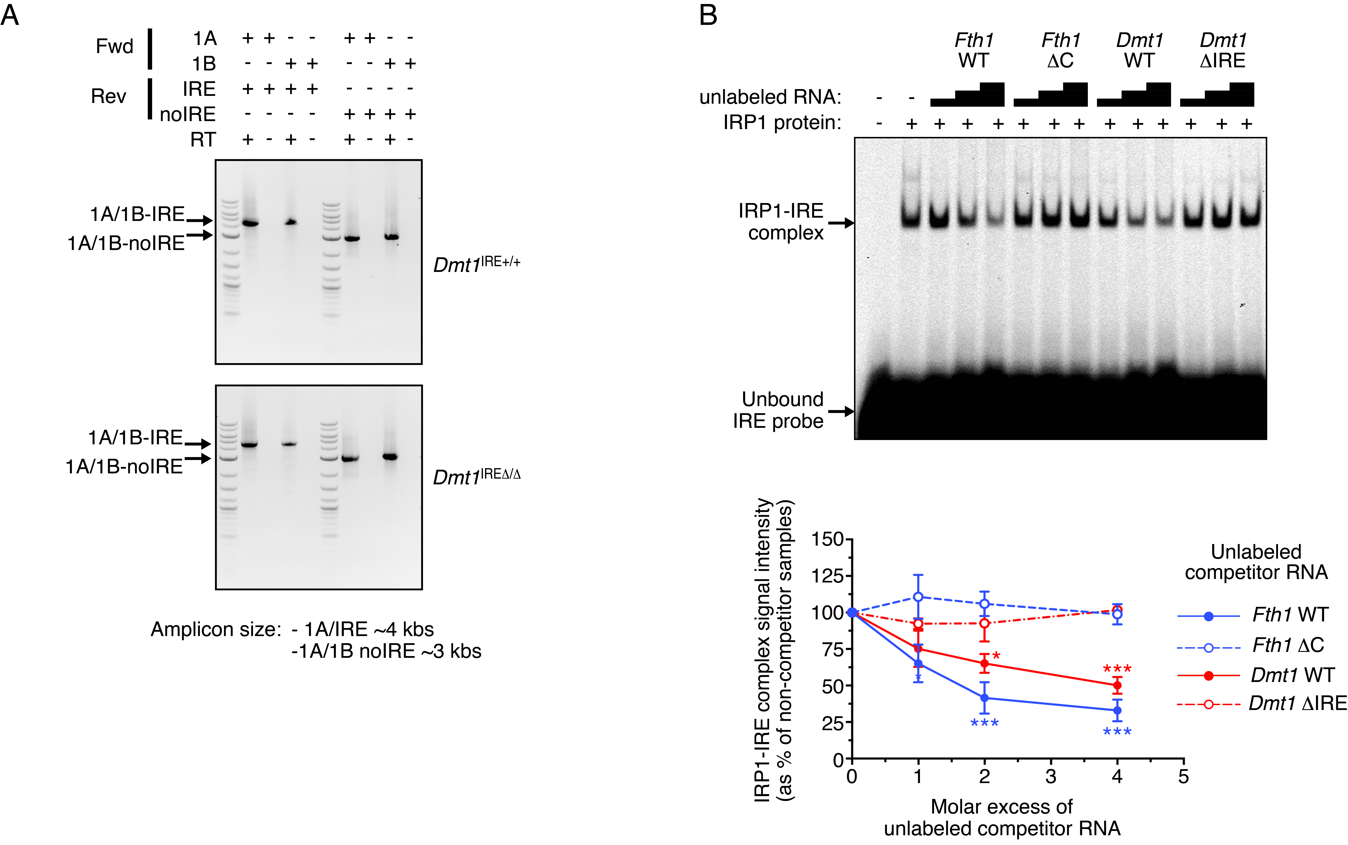

Supplemental Figure S1: Effect of mutagenesis of the Dmt1 3’IRE on Dmt1 transcription and IRP binding.
(A) To ascertain that mutagenesis of the Dmt1 3’IRE does not lead to overall alterations of transcript synthesis, we reverse transcribed total RNA from intestinal tissue using oligo-dT and PCR amplified all four Dmt1 isoforms using primers corresponding to the most distal parts of the RNA. Forward primers (Fwd) are located in exons 1A or 1B, respectively; reverse primers (Rev) correspond to either exon 16 (IRE) or 17 (noIRE), respectively, and in both cases are located near the polyA site (See Figure 1A and Supplemental Table S4). We obtained the amplicons of the expected size (as indicated) from both wild-type (top) and mutant (bottom) mice. Negative control reactions were performed omitting the reverse transcriptase (RT). The boundaries of the PCR products were partially sequenced to confirm the identity of the amplicons. (B) To ascertain that mutagenesis of the Dmt1 IRE effectively impairs IRP binding, the last 515 nucleotides of the coding region plus the first 1575 nucleotides of the 3’UTR of the Dmt1-IRE mRNA isoform were PCR amplified from Dmt1^{IRE+/+} versus Dmt1^{IRE∆/∆} mice (See primers in Supplemental Table S4). The cDNA obtained was sub-cloned and served as template for in vitro synthesis of unlabeled RNA used in a competition electromobility shift assay as described previously. Competitor transcripts corresponding to the full length Fth1 mRNA (Fth1 WT) versus a mutant version lacking the C residue in the IRE loop (Fth1 ΔC) were used as control to validate the assay. As expected, the unlabeled wild-type Fth1 mRNA competes for the interaction between recombinant purified IRP1 and a fluorescently labeled Fth1 IRE probe, whereas the mutant version does not. Similarly, the wild-type Dmt1 RNA (Dmt1 WT) competes efficiently, but not the RNA from Dmt1^{IRE∆/∆} mice (Dmt1 ΔIRE), confirming efficient disruption of the Dmt1 3’IRE. The graph displays the data as average ±SEM relative to the reaction without competitor (p: Student’s t-test; *: p<0.05; ***: p<0.001).

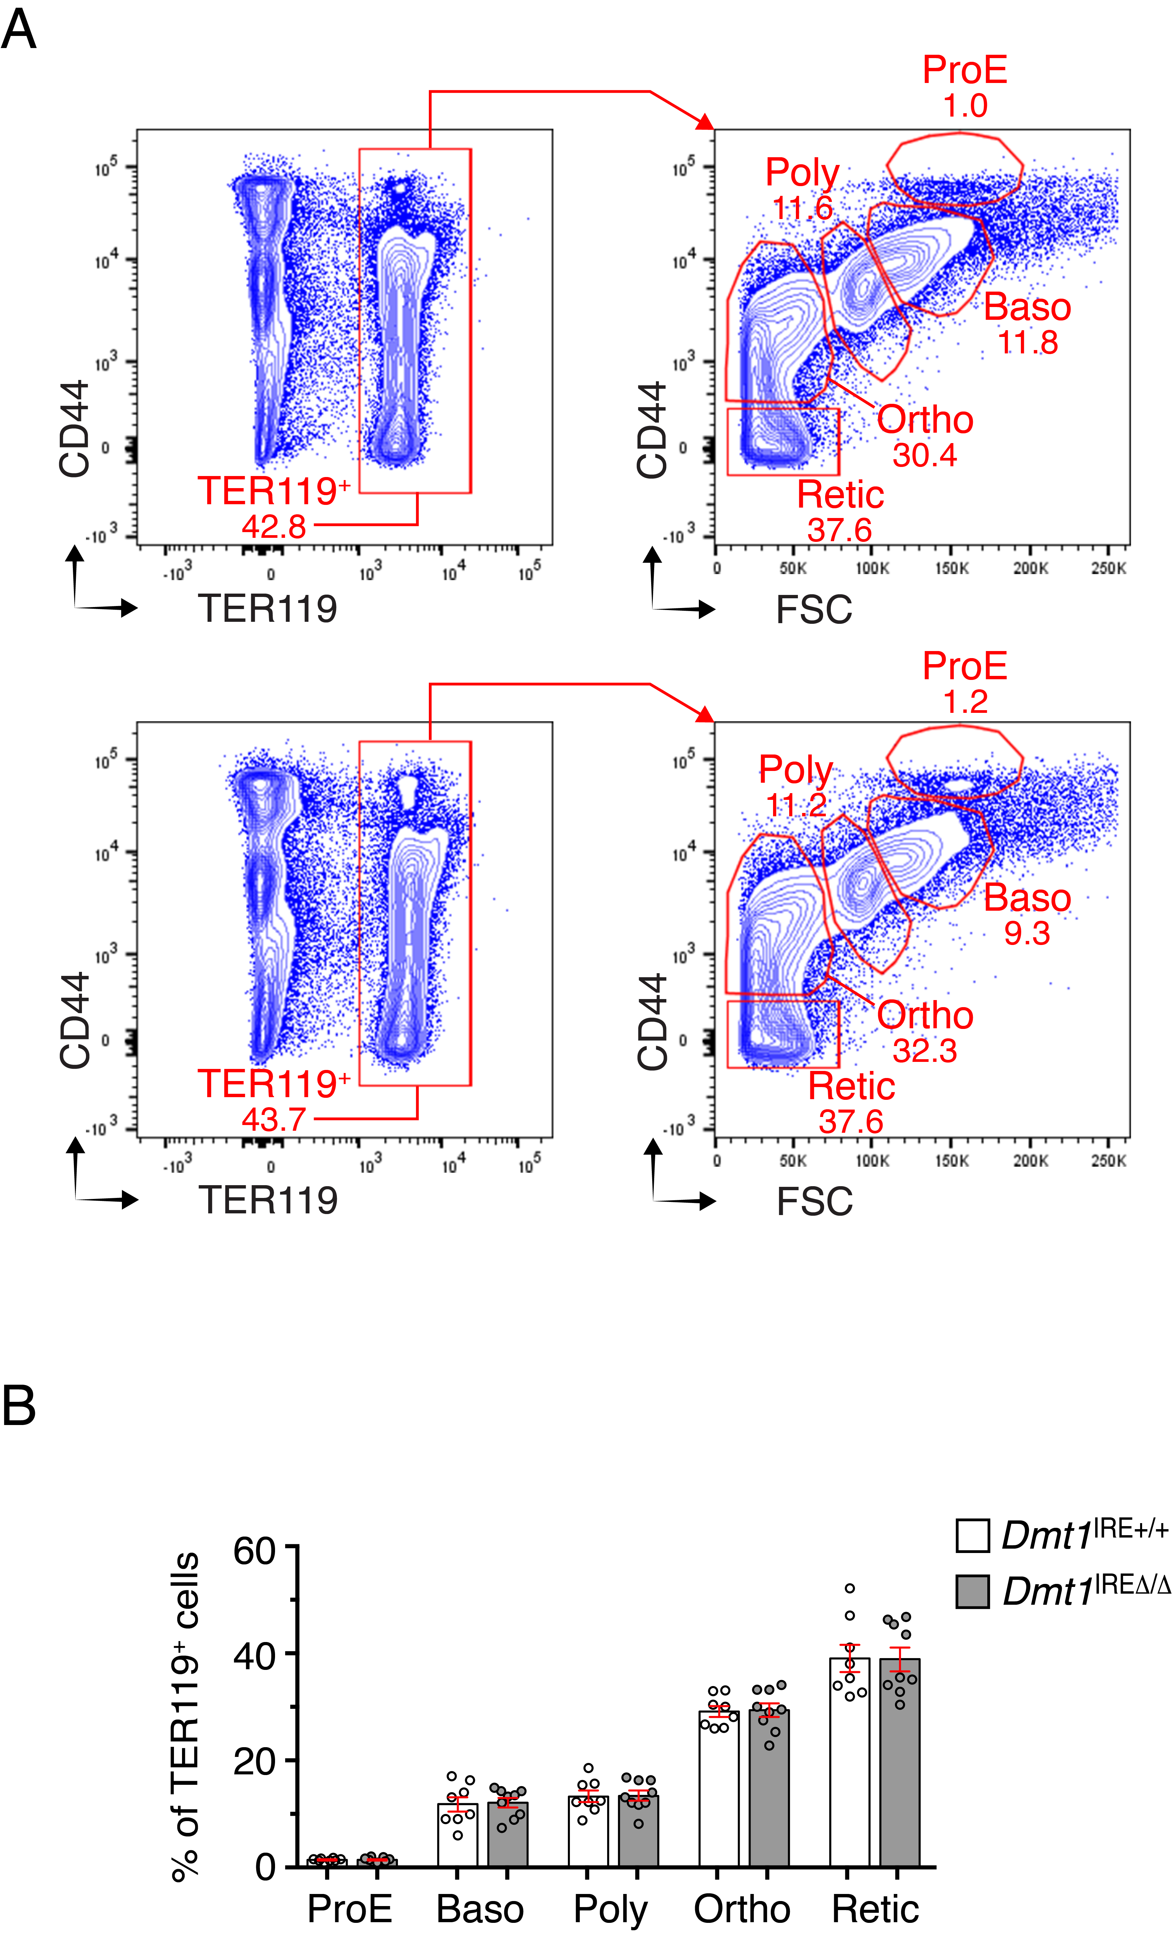

Supplemental Figure S2: Terminal erythroid differentiation during early adulthood.
(A) Representative flow cytometry profiles of bone marrow-derived erythroid progenitor cells from 3-month-old Dmt1^{IRE∆/∆} males versus wild-type littermates. Cells were co-stained with Ter119 and CD44. The graphs show the separation of Ter119⁺ cells (left panels) as a function of CD44 levels and cell size (forward scatter, FSC, right panels)^{3,4}. Distinct erythroid populations corresponding to pro-erythroblasts (proE) progressing to basophilic (Baso), polychromatic (Poly) and orthochromatic (Ortho) stages, and finally reticulocytes (Retic), are highlighted. (B) Relative quantification of the frequencies of each erythroid population (averages ± SEM, 8 to 9 mice per group). This analysis shows that mutagenesis of DMT1 3’IRE does not alter terminal erythroid differentiation in adult animals (Student’s t-test). This is in agreement with the notion that iron assimilation in erythroid cells is dependent on DMT1 isoforms encoded by mRNA variants lacking the 3’IRE⁵.

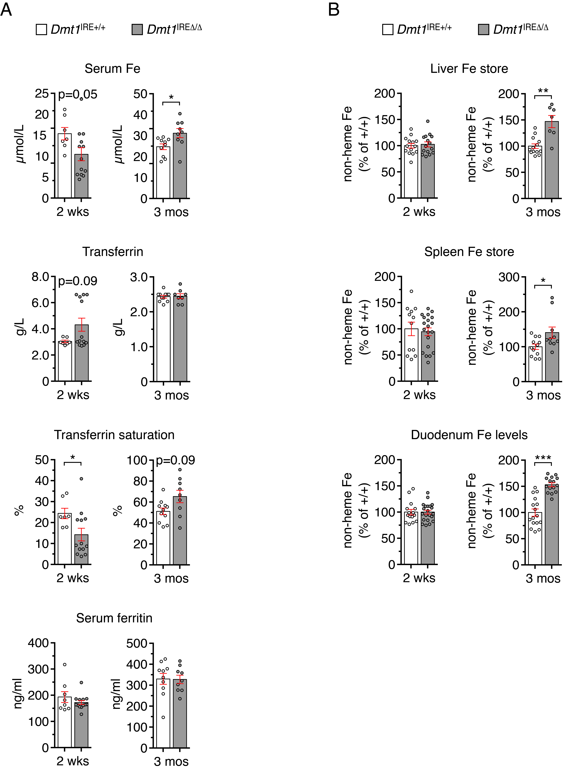

Supplemental Figure S3: Iron metabolism parameters in female mice
(A) Serum iron parameters were assessed in female mice during postnatal growth (2 weeks of age) or during early adulthood (3 months of age), respectively (7 to 13 mice per group). Similar to male mice (Figure 1C), Dmt1^{IRE∆/∆} female mice display a tendency towards decreased serum iron concentration and transferrin saturation during the suckling period (2 wks). On the opposite, they tend to have higher serum and transferrin saturation values during adulthood. Furthermore, the increase in serum iron levels is accompanied by a modest but significant augmentation of the liver and spleen iron stores (B) (10 to 21 mice per group), as observed in males (Figure 1D). Histograms display averages ± SEM. p: Student’s t-test (*: p<0.05; **: p<0.01; ***: p<0.001).

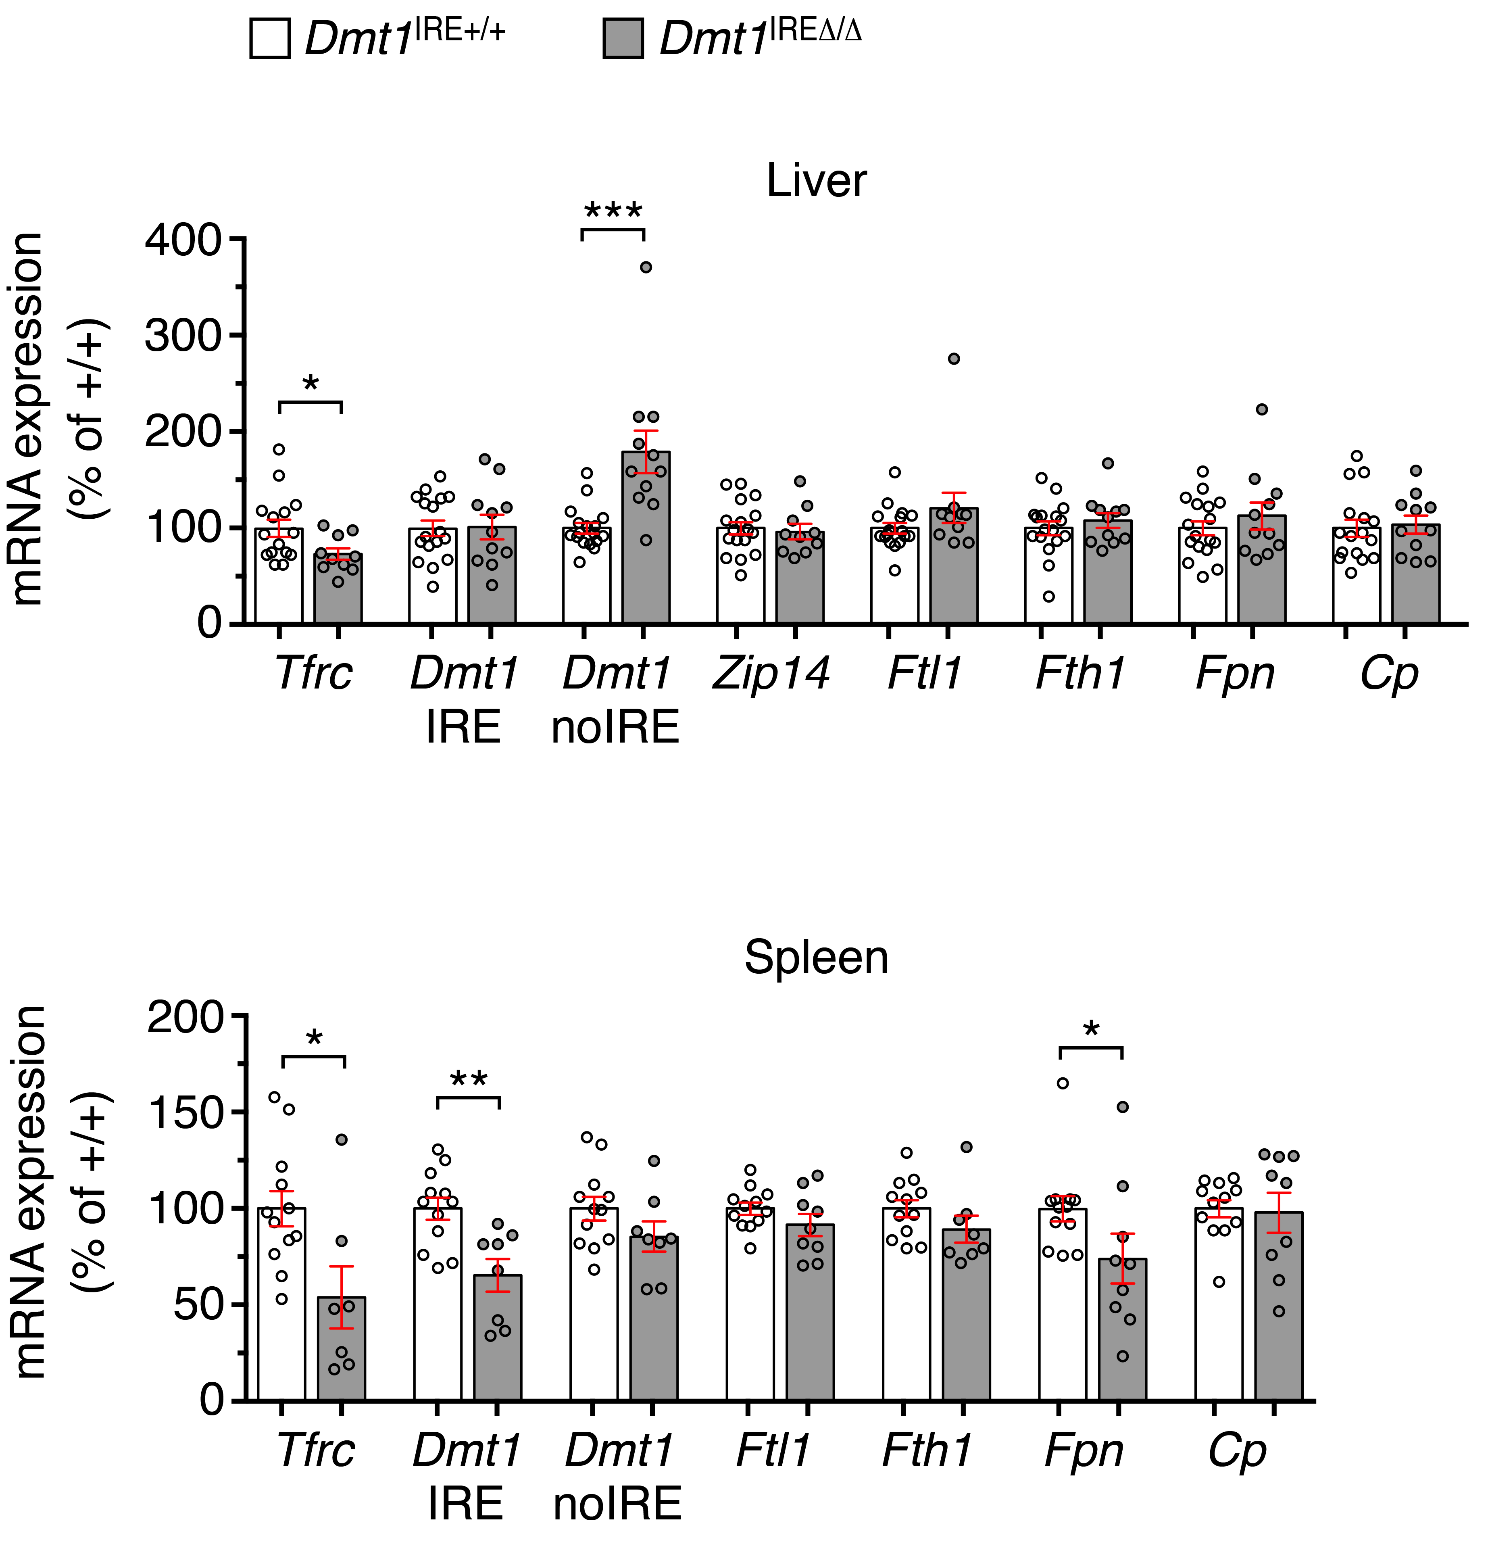

Supplemental Figure S4: Expression of key iron metabolism molecules in the liver and spleen of adult mice.
qPCR analysis of iron metabolism molecules in liver (top) and spleen (bottom) tissues of Dmt1^{IRE∆/∆} versus Dmt1^{IRE+/+} male mice at 3 months of age. Tfrc mRNA levels are reduced in liver, possibly as a response to hepatic iron loading. DMT1-IRE mRNA expression is unaltered, but Dmt1-noIRE mRNA levels are increased. Since DMT1-noIRE contributes to iron acquisition downstream of TFRC⁵ and Tfrc is downregulated in Dmt1^{IRE∆/∆} mice, hepatic iron accumulation unlikely results from stimulation of transferrin-bound iron uptake. Zip14 (a.k.a. Slc39a14), which mediates the uptake of non-transferrin bound iron in liver cells⁶, is unchanged. The mRNA levels of the ferritin-L (Ftl) and -H (Fth1) iron sequestration molecules are comparable between mutant and wildtype. Fpn and the ferroxidase ceruloplasmin (Cp), both required for cellular iron export^{7,8}, are unaltered. In spleen, iron accumulation cannot be explained by increased expression of iron import molecules, as both Tfrc and Dmt1-IRE are downregulated. We observed a mild reduction (~25%) of Fpn mRNA levels, which unlikely suffices to cause iron retention in splenic macrophages since 3-month-old mice lacking one Fpn allele display normal iron homeostasis parameters⁹. The Ftl and Fth1 mRNAs are unaffected. Overall these data suggest that enlargement of tissue iron stores in adult Dmt1^{IRE∆/∆} animals does not result from iron mismanagement in liver and spleen cells and is rather secondary to the increase in serum iron levels. Data are presented as average ±SEM relative to wild-type control after calibration to Actb (n= 7 to 17 mice per group). p: Student’s t-test (*: p<0.05; **: p<0.01; ***: p<0.001).

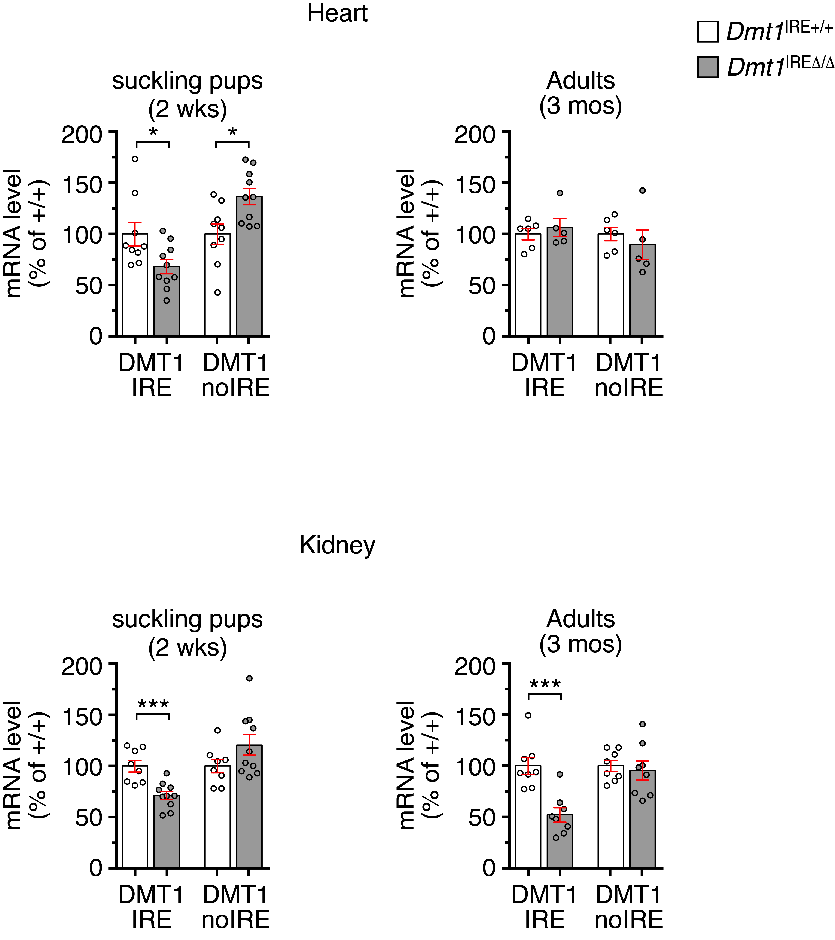

Supplemental Figure S5: Dmt1 mRNA expression in heart and kidney tissues during postnatal life and adulthood.
qPCR analysis of Dmt1 3’ mRNA variants in the heart (top) and kidney (bottom) of Dmt1^{IRE∆/∆} versus Dmt1^{IRE+/+} male mice at 2 weeks or at 3 months of age, respectively. In heart, we observe a mild but significant decrease in Dmt1-IRE mRNA expression in 2-week-old Dmt1^{IRE∆/∆} mice, associated with an opposite increase in the Dmt1 non-IRE mRNA levels. Similar to the duodenum, Dmt1 mRNA expression is unaltered when mice reach adulthood. In kidney, Dmt1-IRE mRNA expression is reduced both during postnatal growth and early adulthood, suggesting that the activity of 3’IRE of Dmt1 is not only age but also tissue dependent. Data are presented as average ±SEM relative to wild-type control after calibration to Actb (heart: 5 to 6 mice per group; kidney: 9 to 10 mice per group). p: Student’s t-test (*: p<0.05; ***: p<0.001).

Supplemental Table S1: Inheritance of the Dmt1^{IRE∆} allele.

 |  |  | Dmt1^{+/+} | Dmt1^{+/∆} | Dmt1∆/∆ | total | p value
Males
 | Observed |  | 59 | 103 | 61 | 223 | 0.51
 | Expected |  | 55.75 | 111.5 | 55.75
Females
 | Observed |  | 55 | 110 | 61 | 226 | 0.79
 | Expected |  | 56.5 | 113 | 56.5

Genotype distribution in the progeny from Dmt1^{+/∆} intercrosses (p value: Chi-square test)

Supplemental Table S2: Baseline hematological parameters in Dmt1^{IRE∆/∆} mice are globally normal.

 |  |  | 2 wks |  |  | 3 mos |  |  | 9 mos
 |  |  | Dmt1^{IRE+/+} | Dmt1^{IRE∆/∆} |  | Dmt1^{IRE+/+} | Dmt1^{IRE∆/∆} |  | Dmt1^{IRE+/+} | Dmt1^{IRE∆/∆}
Males |  |  | (n=8) | (n=18) |  | (n=11) | (n=21) |  | (n=16) | (n=12)
 | WBC (10⁹/L) |  | 3.7 ±0.5 | 3.5 ±0.2 |  | 4.5 ±0.3 | 4.4 ±0.3 |  | 3.2 ±0.2 | 3.8 ±0.3
 | RBC (10¹²/L) |  | 5.5 ±0.3 | 6.1 ±0.1 ** |  | 8.7 ±0.2 | 8.4 ±0.1 |  | 8.7 ±0.1 | 8.9 ±0.1
 | HGB  (g/L) |  | 10.6 ±0.2 | 11.2 ±0.2 |  | 15.2 ±0.3 | 15.2 ±0.1 |  | 14.8 ±0.2 | 15.2 ±0.2
 | HCT  (L/L) |  | 32.7±0.9 | 35.2 ±0.6 * |  | 46.6 ±0.8 | 45.8 ±0.4 |  | 46.3 ±0.5 | 47.4 ±0.7
 | MCV  (fL) |  | 59.1 ±0.9 | 57.6 ±0.5 |  | 53.8 ±0.7 | 54.4 ±0.4 |  | 53.4 ±0.5 | 53.1 ±0.7
 | MCHC  (pg/L) |  | 32.5 ±0.4 | 31.7 ±0.3 |  | 32.5 ±0.3 | 33.2 ±0.3 |  | 31.9 ±0.3 | 32.1 ±0.4
 | PLT  (10⁹/L) |  | 862 ±131 | 1026 ±41 |  | 1142 ±43 | 1127 ±53 |  | 1108 ±44 | 1126 ±48
Females |  |  | (n=11) | (n=11) |  | (n=13) | (n=11) |  | (n=9) | (n=10)
 | WBC (10⁹/L) |  | 4.0 ±0.3 | 3.9 ±0.2 |  | 4.5 ±0.2 | 4.5 ±0.5 |  | 4.5 ±0.5 | 4.6 ±0.4
 | RBC (10¹²/L) |  | 5.7 ±0.2 | 5.6 ±0.1 |  | 8.6 ±0.1 | 8.7 ±0.1 |  | 8.5 ±0.3 | 9.0 ±0.2
 | HGB  (g/L) |  | 11.0 ±0.3 | 10.7 ±0.2 |  | 15.3 ±0.3 | 15.8 ±0.2 |  | 14.3 ±0.3 | 14.8 ±0.3
 | HCT  (L/L) |  | 34.9 ±1.0 | 33.6 ±0.8 |  | 45.2 ±0.6 | 46.3 ±0.5 |  | 44.2 ±0.9 | 46.0 ±1.0
 | MCV  (fL) |  | 60.9 ±0.9 | 60.5 ±1.1 |  | 52.2 ±0.5 | 52.8 ±0.5 |  | 52.2 ±1.2 | 51.2 ±0.7
 | MCHC  (pg/L) |  | 31.7 ±0.4 | 31.8 ±0.3 |  | 33.9 ±0.5 | 34.2 ±0.4 |  | 32.3 ±0.3 | 32.3 ±0.2
 | PLT  (10⁹/L) |  | 1001 ±30 | 1119 ±33 * |  | 956 ±54 | 1007 ±76 |  | 1317 ±38 | 1401 ±32

Hematological parameters were assessed in both male (top) and female (bottom) mice at 2 weeks of age, during early adulthood (3 months of age) and during aging (9 months of age), using EDTA blood. Dmt1^{IRE∆/∆} mice display globally unchanged hematological parameters, with only a very mild and transient increase in red blood cell counts and hematocrit values in 2-week-old male pups. This shows that the 3’IRE of DMT1 is largely dispensable for normal erythropoiesis under standard laboratory conditions and is compatible with the notion that erythroid cells rely on the non-IRE isoform of DMT1 for the uptake of transferrin-bound iron. The fact that the mice do not display signs of iron deficiency anemia in spite of the reduction in serum iron levels might be an indication that the hypoferremia is only transient and/or compensated for by the erythropoietic system.
WBC: white blood cells; RBC: red blood cells; HGB: hemoglobin; HCT: hematocrit; MCV: mean corpuscular volume; MCHC: mean corpuscular hemoglobin concentration; PLT: platelets. Results are presented as means ± standard error. Sample size (n) is indicated.
* p<0.05; ** p<0.01; unpaired, two-tailed t-test.

Supplemental Table S3: Body and organ weight parameters

 |  |  | 2 wks |  |  | 3 mos |  |  | 9 mos
 |  |  | Dmt1^{IRE+/+} | Dmt1^{IRE∆/∆} |  | Dmt1^{IRE+/+} | Dmt1^{IRE∆/∆} |  | Dmt1^{IRE+/+} | Dmt1^{IRE∆/∆}
Body weight (g)
 | Males |  | 7.85 ±0.21  (n=18) | 8.63 ±0.20 *  (n=30) |  | 27.41 ±0.49  (n=38) | 27.37 ±0.46  (n=35) |  | 36.75 ±0.91  (n=22) | 36.97 ±0.75  (n=24)
 | Females |  | 8.11 ±0.25  (n=19) | 8.23 ±0.35  (n=13) |  | 22.20 ±0.36  (n=25) | 23.02 ±71  (n=18) |  | 32.49 ±1.02  (n=19) | 33.06 ±1.38  (n=16)
Spleen index
 | Males |  | 0.17 ±0.04  (n=23) | 0.17 ±0.01  (n=36) |  | 0.49 ±0.05  (n=17) | 0.50 ±0.01  (n=21) |  | 0.60 ±0.02  (n=21) | 0.61 ±0.03  (n=22)
 | Females |  | 0.10 ±0.01  (n=5) | 0.10 ±0.01  (n=7) |  | 0.44 ±0.01  (n=23) | 0.45 ±0.02  (n=16) |  | 0.55 ±0.02  (n=19) | 0.57 ±0.03  (n=16)
Liver index
 | Males |  | 0.42 ±0.02  (n=14) | 0.46 ±0.02  (n=15) |  | 1.96 ±0.05  (n=7) | 1.93 ±0.05  (n=12) |  | 2.34 ±0.10  (n=21) | 2.43 ±0.06  (n=22)
 | Females |  | 0.05 ±0.01  (n=5) | 0.05 ±0.01  (n=7) |  | 1.47 ±0.03  (n=24) | 1.53 ±0.06  (n=17) |  | 2.02 ±0.06  (n=19) | 2.09 ±0.08  (n=16)
Kidney index
 | Males |  | 0.25 ±0.01  (n=8) | 0.26 ±0.01  (n=6) |  | 1.03 ±0.03  (n=13) | 1.02 ±0.03  (n=17) |  | 1.27 ±0.02  (n=21) | 1.24 ±0.02  (n=22)
 | Females |  | 0.02 ±0.01  (n=5) | 0.02 ±0.01  (n=7) |  | 0.72 0.01  (n=15) | 0.76 ±0.03  (n=9) |  | 0.96 ±0.02  (n=19) | 0.97 ±0.03  (n=16)
Heart index
 | Males |  | n.d. | n.d. |  | 0.64 ±0.02  (n=9) | 0.67 ±0.03  (n=11) |  | 0.81 ±0.01  (n=20) | 0.79 ±0.02  (n=22)
 | Females |  | n.d. | n.d. |  | 0.50 ±0.01  (n=8) | 0.52 ±0.02  (n=5) |  | 0.66 ±0.03  (n=8) | 0.69 ±0.02  (n=6)

Body weight and organ weight were assessed in both male and female mice at 2 weeks of age, during early adult hood (3 months of age) and during aging (9 months of age). Organ index = $\sqrt{(organ weight)/(10 x body weight)}$.
The asterisk (*) corresponds to a p value <0.05 (unpaired, two-tailed t-test). The sample size is indicated (n). n.d.: not determined

Supplemental Table S4: Primers and antibodies used in the study

Oligonucleotides
Gene name | primer name | sequence (5’ to 3’) | purpose | note
Dmt1 (Slc11a2) | forward | tccttggcacttgcatactcac | Southern  blotting | generation of probe P3’, Figure 1C
 | reverse | aggtaacacgaaaggctaaggtg
 | exon 1A forward | AAGCCAAACCAGTCCTGCACC | RT-PCR | Analysis of Dmt1 mRNA isoforms, Supplemental Figure S1A
 | exon 1B forward | AGGGCAGGAGGTTGACTGG
 | exon 16 reverse | GTTCACTAAAGCCTCCTTGAAGC
 | exon 17 reverse | TCTGGTTGGGATTAAAGCAAAAACC
 | exon 12 forward | Acctattctggccagtttgtcatg | Cloning | DNA template for in vitro transcription of competitor RNA, Supplemental Figure S1B
 | exon 16 reverse | GGGGACAACTATTTCAGGTC
 | qPCR IRE forward | ATGTTGCCACCGCTGGTATC | qPCR | analysis of Dmt1 IRE mRNA isoforms, Figure 2 + Supplemental Figure S5
 | qPCR IRE reverse | AGCTAGGCCATGTGGCACTCT
 | qPCR noIRE forward | GCGGTCAGTCCCAGGCGGTACG | qPCR | analysis of Dmt1 noIRE mRNA isoforms, Figure 2 + Supplemental Figure S5
 | qPCR noIRE reverse | GTGGTGGCTGCAGTGGTTAGCG
 | Forward | ggagagtgacgactgtgttttg | qPCR | Analysis of Dmt1 IRE pre-mRNA, Figure 2C
 | reverse | tcagcaggactttcgagatg
Fpn (Slc40a1) | forward | GGGTGGATAAGAATGCCAGACTT | qPCR | Analysis of iron export molecules, Figure 2D
 | reverse | GTCAGGAGCTCATTCTTGTGTAGGA
Heph | forward | TCTATACATGCCCATTGGAGTTCT | qPCR | Analysis of iron export molecules in Figure 2E
 | reverse | TGGGATGTTCCACTGGTAAGT
Cybrd1 | forward | GAAAAGCTGTTCTTTGTCCTGAAAC | qPCR | Analysis of HIF2 targets, Figure 2F
 | reverse | GCCCAGCGTATTTGTAAAAACAC
Ccnd1 | forward | CATCCATGCGGAAAATCG | qPCR
 | reverse | GCGGGAAGACCTCCTCTT
Actb | forward | GGCCAGGATGGAGCCACCGATC | qPCR | qPCR standard
 | reverse | cagccattgctgacaggatgca
Actb Pre | forward | AAGCATCCTTAGCTTGGTGAG |  | Analysis of Actb pre-mRNA, Figure 2C
mRNA | reverse | TGCTGGGATTCCCCTTAAAC
Hepcidin (Hamp) | forward | CCTATCTCCATCAACAGAT | qPCR | Analysis of Hepcidin, Figure 1F
 | reverse | TGCAACAGATACCACACTG
Tfrc | forward | CCCATGACGTTGAATTGAACCT | qPCR | Analysis of iron molecules, Supplemental Figure S4
 | reverse | GTAGTCTCCACGAGCGGAATA
Zip14 (Slc39a14) | forward | TGGAACCCTCTACTCCAACG | qPCR
 | reverse | CTGAGGGTTGAAGCCAAAAG
Cp | forward | GAAAGGCAGCTTACTTGCTGA | qPCR
 | reverse | TCAAACACTGTGGGAAACAAGT
Fth1 | forward | TGGAACTGCACAAACTGGCTACT | qPCR
 | reverse | ATGGATTTCACCTGTTCACTCAGATAA
Ftl | forward | CGTGGATCTGTGTCTTGCTTCA | qPCR
 | reverse | GCGAAGAGACGGTGCAGACT
Antibodies
protein  (host) | supplier | concentration | purpose | note
DMT1 (rabbit) | Self-generated  against antigen: MVLDPEEKIPDDGASGDHGDSC | 1/500 | western blotting | reacts with all DMT1 protein isoforms
 |  | 1/400 | immuno-staining
FPN  (rabbit) | alpha-diagnostics | 1/300 | western blotting | affinity purified antibody
ACTB  (mouse) | Sigma-Aldrich | 1/5000 | western blotting | clone AC-15
TER119  (rat) | Fisher Scientific GmbH | 1/300 | Flow cytometry | Clone TER119, coupled to Cyanine7/Phycoerythrin
CD44  (rat) | Fisher Scientific GmbH | 1/300 | Flow cytometry | Clone IM7, coupled to Phycoerythrin

Supplemental References

1 Galy B, Ferring-Appel D, Becker C, et al. Iron regulatory proteins control a mucosal block to intestinal iron absorption. Cell Rep. 2013; 3:844.

2 Luscieti S, Tolle G, Aranda J et al. Novel mutations in the ferritin-L iron-responsive element that only mildly impair IRP binding cause hereditary hyperferritinaemia cataract syndrome. Orphanet J. Rare Dis. 2013; 8, 30.

3 Chen K, Liu J, Heck S, Chasis JA, An X, Mohandas N. Resolving the distinct stages in erythroid differentiation based on dynamic changes in membrane protein expression during erythropoiesis. Proc Natl Acad Sci U S A. 2009; 106:17413.

4 Casarrubea D, Viatte L, Hallas T, et al. Abnormal body iron distribution and erythropoiesis in a novel mouse model with inducible gain of iron regulatory protein (IRP)-1 function. J. Mol. Med. (Berl). 2013; 91(7):871.

5 Shawki A, Knight PB, Maliken BD, Niespodzany EJ, Mackenzie B. H(+)-coupled divalent metal-ion transporter-1: functional properties, physiological roles and therapeutics. Curr. Top. Membr. 2012; 70:169.

6 Jenkitkasemwong S, Wang CY, Coffey R, et al. SLC39A14 Is Required for the Development of Hepatocellular Iron Overload in Murine Models of Hereditary Hemochromatosis. Cell Metab. 2015; 22(1):138.

7 Drakesmith H, Nemeth E, Ganz T. Ironing out Ferroportin. Cell Metab. 2015; 22(5):777.

8 Muckenthaler MU, Rivella S, Hentze MW, Galy B. A Red Carpet for Iron Metabolism. Cell. 2017; 168(3):344.

9 Donovan A, Lima CA, Pinkus JL, et al. The iron exporter ferroportin/Slc40a1 is essential for iron homeostasis. Cell Metab. 2005; 1(3):191.

