**Supplementary Figure 1. Sample holder A) without lid and B) with lid.**

**A) Without lid**

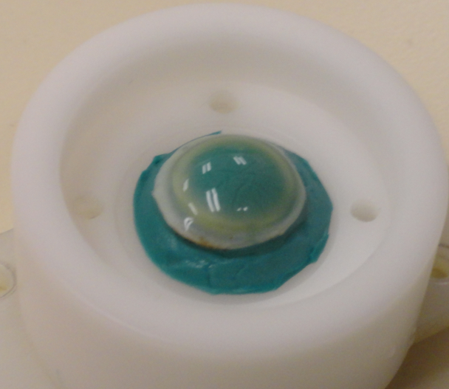

**B) With lid**

