Supplementary Figure 2. Aging effect on A) corneal tissue and B) a contact lens (ACUVUE® OASYS®, Johnson & Johnson VisionCare, Inc.) for 1-50 cycles at 2 mN Normal force.
- Corneal tissue
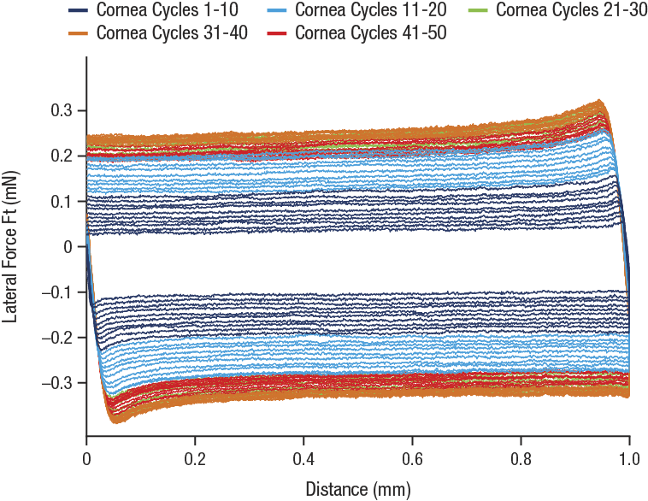
- Contact lens
