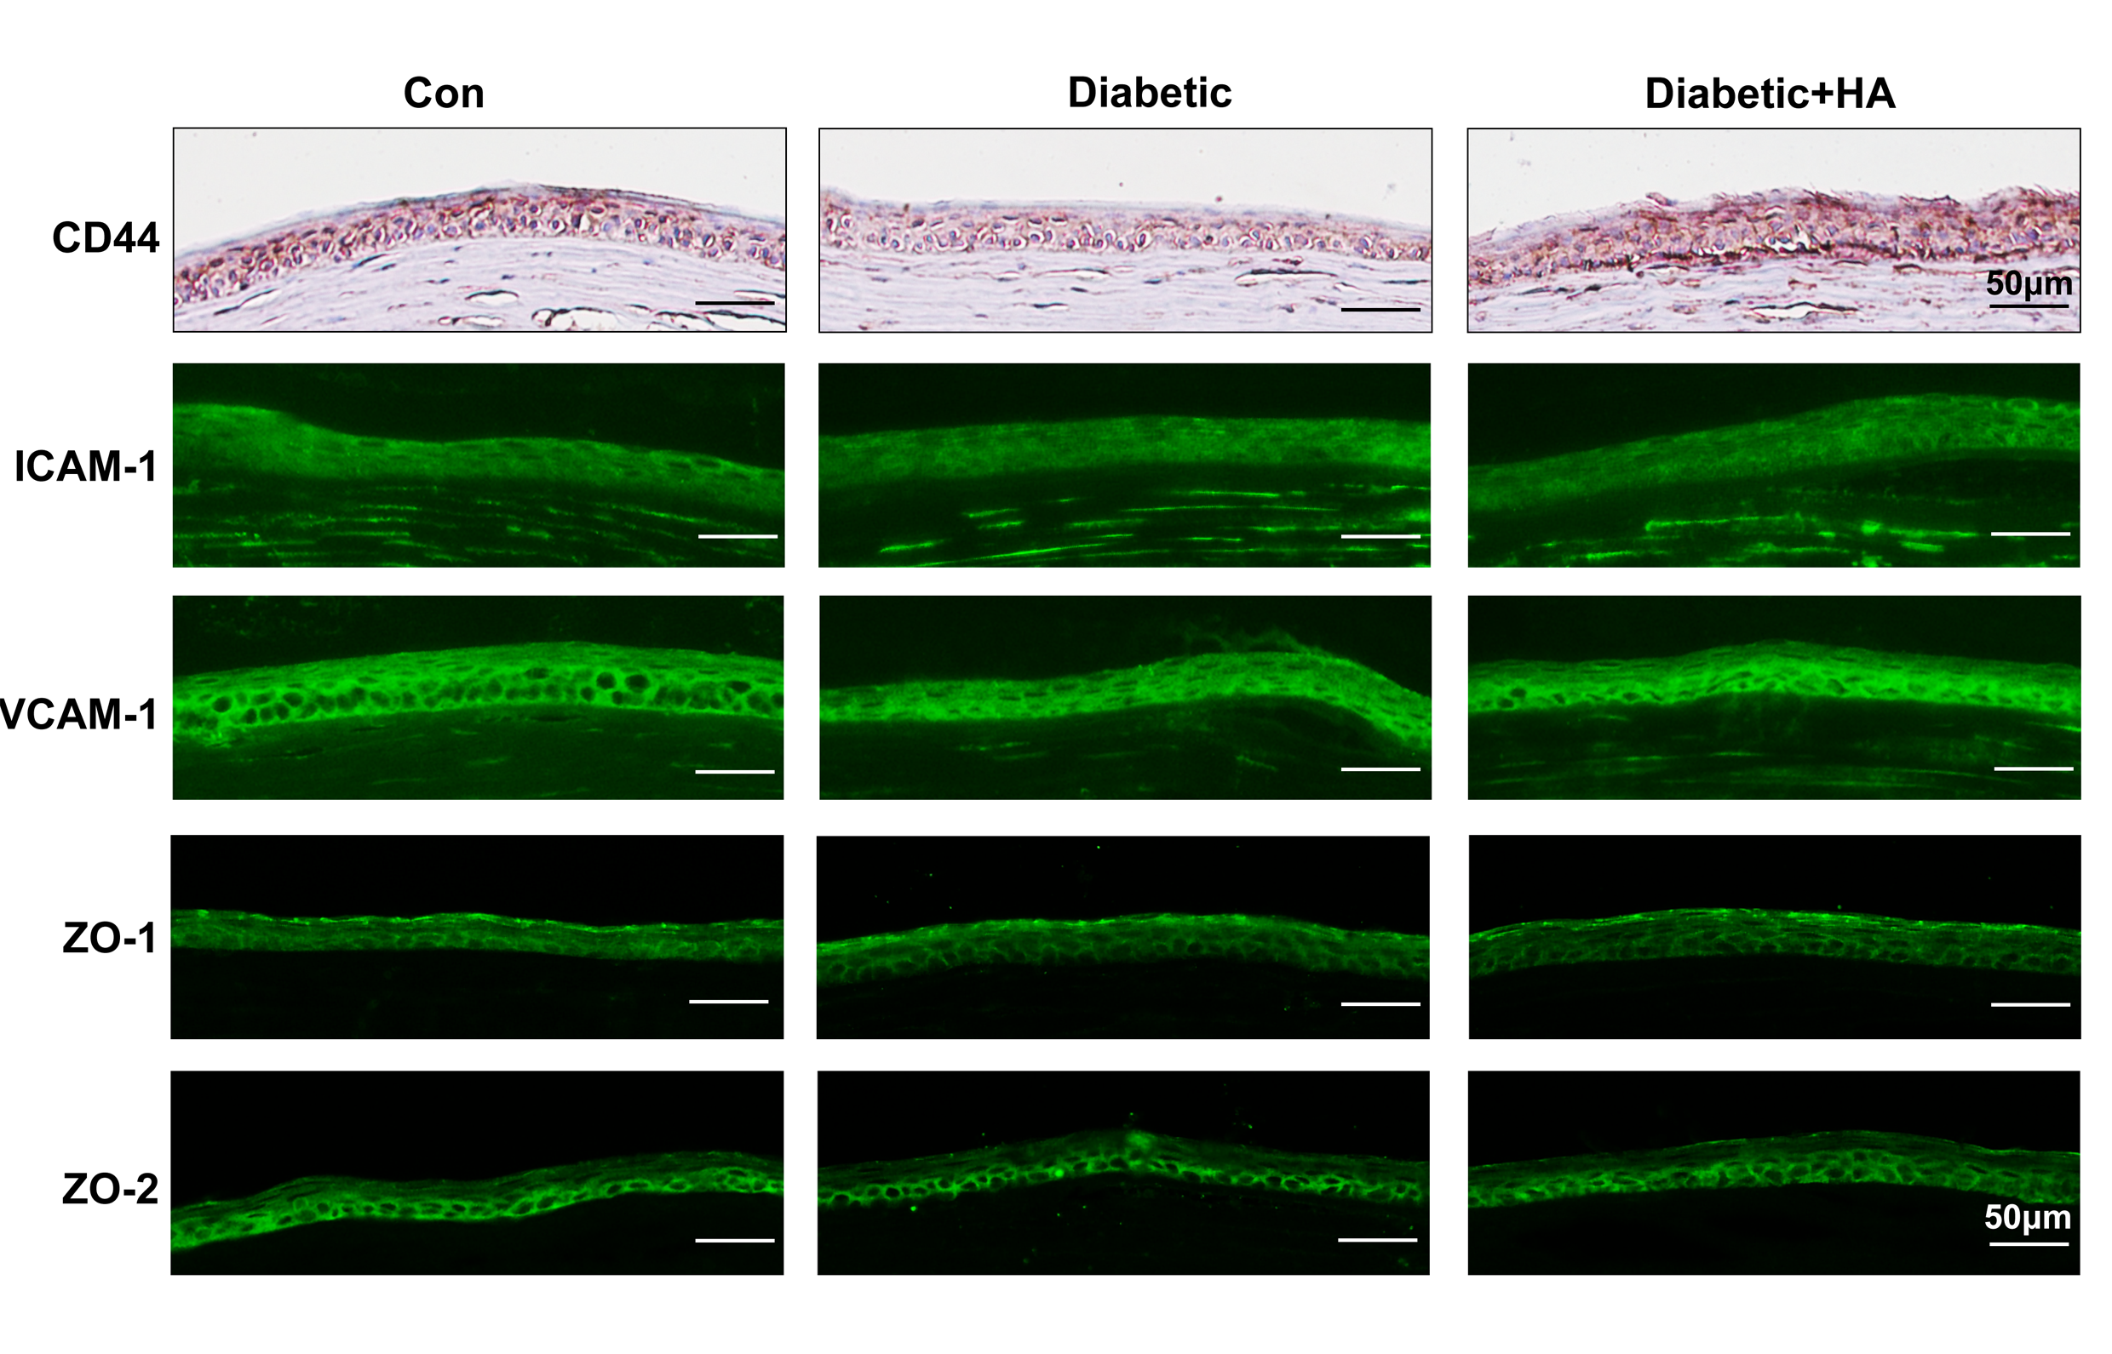

Supplemental Figure 1. HA main receptor CD44 exhibited more intense staining in 0.3% HA-treated diabetic mice, while either cell adhesion molecules (ICAM-1 and VCAM-1) or tight junction markers (ZO-1 and ZO-2) appeared no obvious changes after the HA treatment.

