SUPPLEMENTAL DIGITAL CONTENT 1 : VaHI user guidelines

Table of contents:
1. Getting started 2
2. User types 2
3. Languages 2
4. Information for administrators 3
4.1. Login 3
4.2. Upload photographs 3
4.3 Add eyes 5
4.4. Positioning of the grid 8
4.5. Add users 9
4.6. Export data 11
5. Information for graders 12
5.1. Login to VaHI 12
5.2. Start grading 12

Getting started
The VaHI tool is designed to meet the need for a precise grading system in limbal stem cell disease. It’s build as an easily accessible application for both clinicians and researchers. The software itself is web-based and users can access it online at https://vahi.eu.

Before getting started with the software, a Vahi instance needs to be created. In this way, groups can have their own tool that can be accessed by their administrators and users. Instructions on how to do so — along with the Vahi source code — are available at https://github.com/vahicode. Ideally, this is performed by an IT expert since some computer programming knowledge is required to install the software. This person is hereafter called the ‘Technical Administrator’.

User types
Once the VaHI instance is created, the program can be accessed at https://vahi.eu. There are two user types that have access: Administrators’ and ‘Users’. Each of these user types have assigned different roles:
Administrators: can add pictures into the system and place the grids on the eyes. Administrators can also create Users. Administrators are created by the technical administrator.
User: The single role of the user is to grade the eyes.
The guidelines for each user type are further explained in this document.

Languages
The system is provided in English, French and Dutch, and the desired language can be selected at the upper right corner of the webpage, prior or after login (red arrow).

Information for administrators

4.1. Login
Administrators have a username and password, which is created/provided by the Technical Administrator. To access VaHI as an administrator in your web-browser, go to the following login page: www.vahi.eu/admin. Enter your authorized username and password, and then click ‘Login’.

4.2. Upload photographs
Photographs can be uploaded by clicking on ‘Add pictures’ on the dropdown menu on the upper right corner of the page.
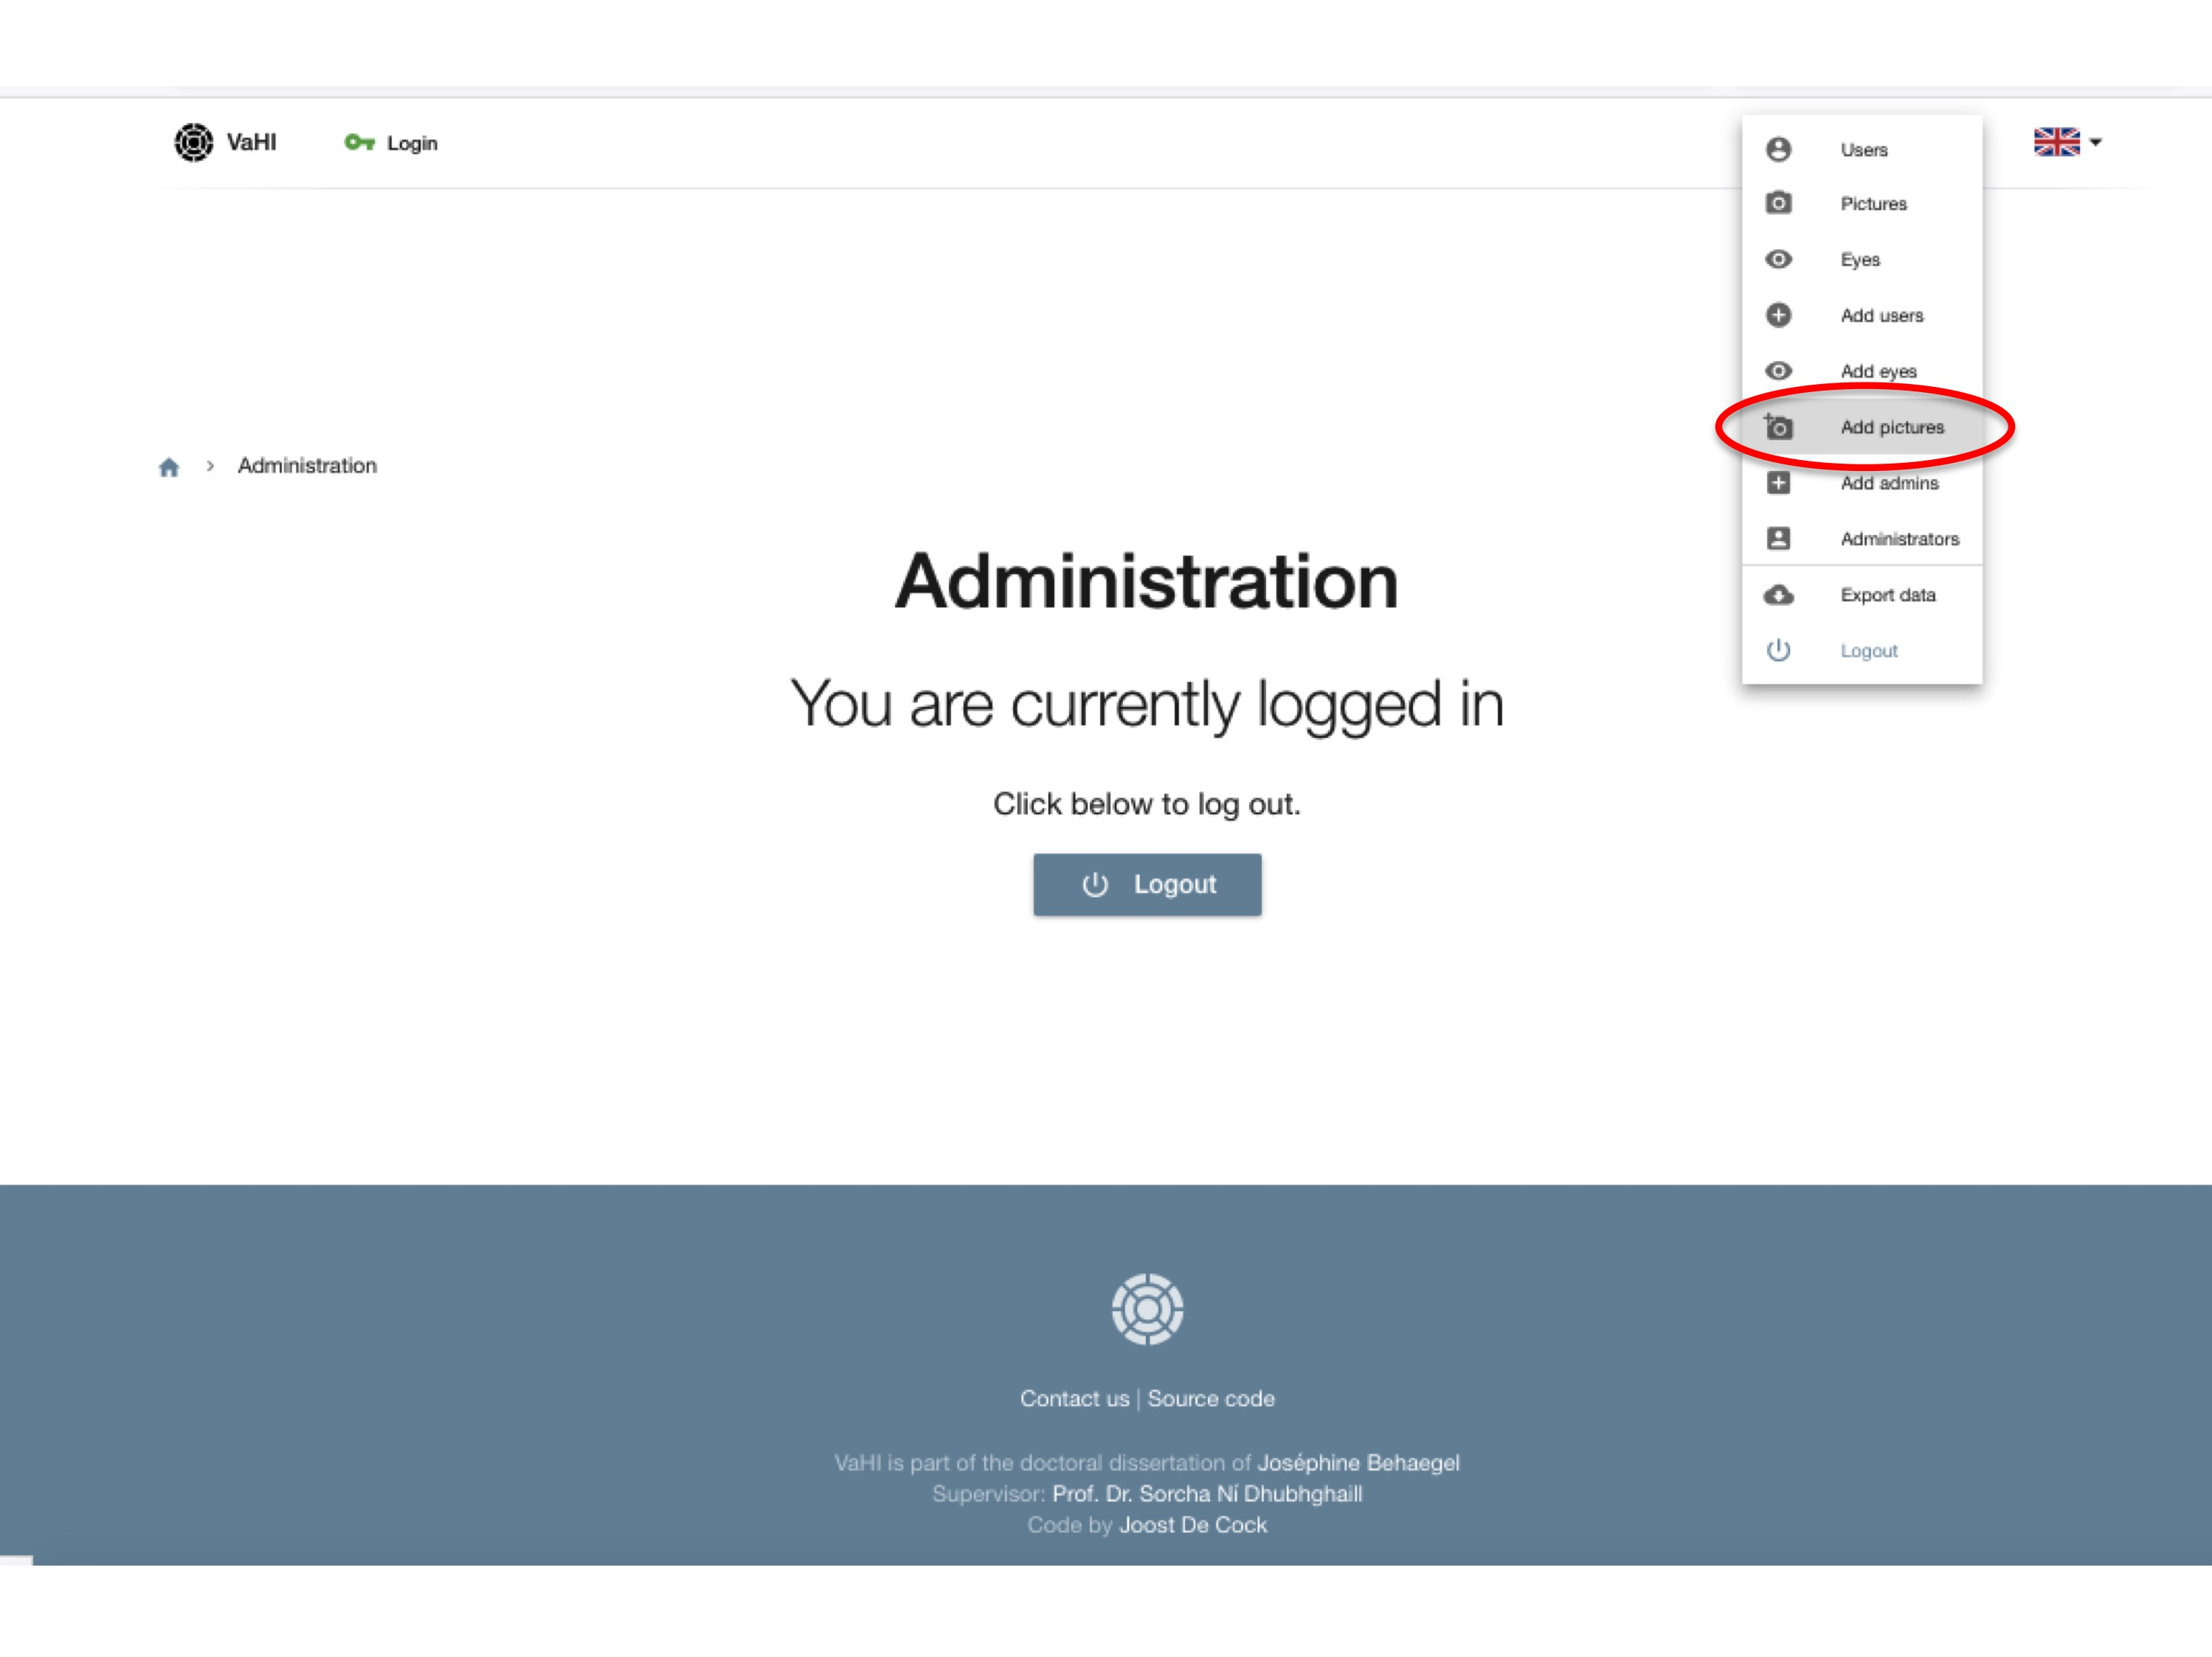
Next, photographs can be added by selecting your file, or by dragging and dropping the files. Then press ‘Start upload’. If uploading was successful, a green check mark will appear.
Ideally, a photograph under white light and under cobalt blue light should be placed here. You can also choose to add just one photograph, or to add other photographs later on.

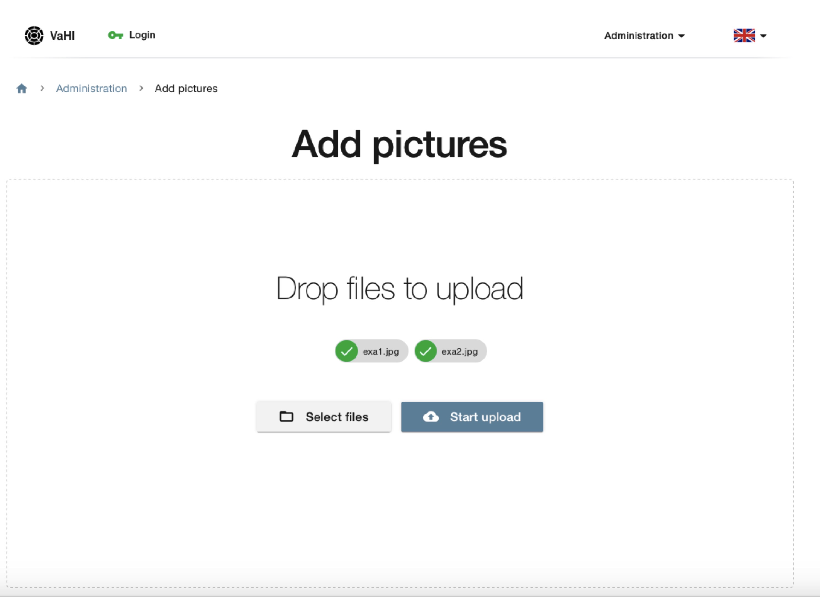

4.3 Add eyes
This part explains how multiple photographs of the same eye can be linked to one another, how an eye for integrity rating can be selected, and how eyes can activated or inactivated.
First, add one or more eyes by selecting ‘Add eyes’ on the dropdown menu of the right upper corner.
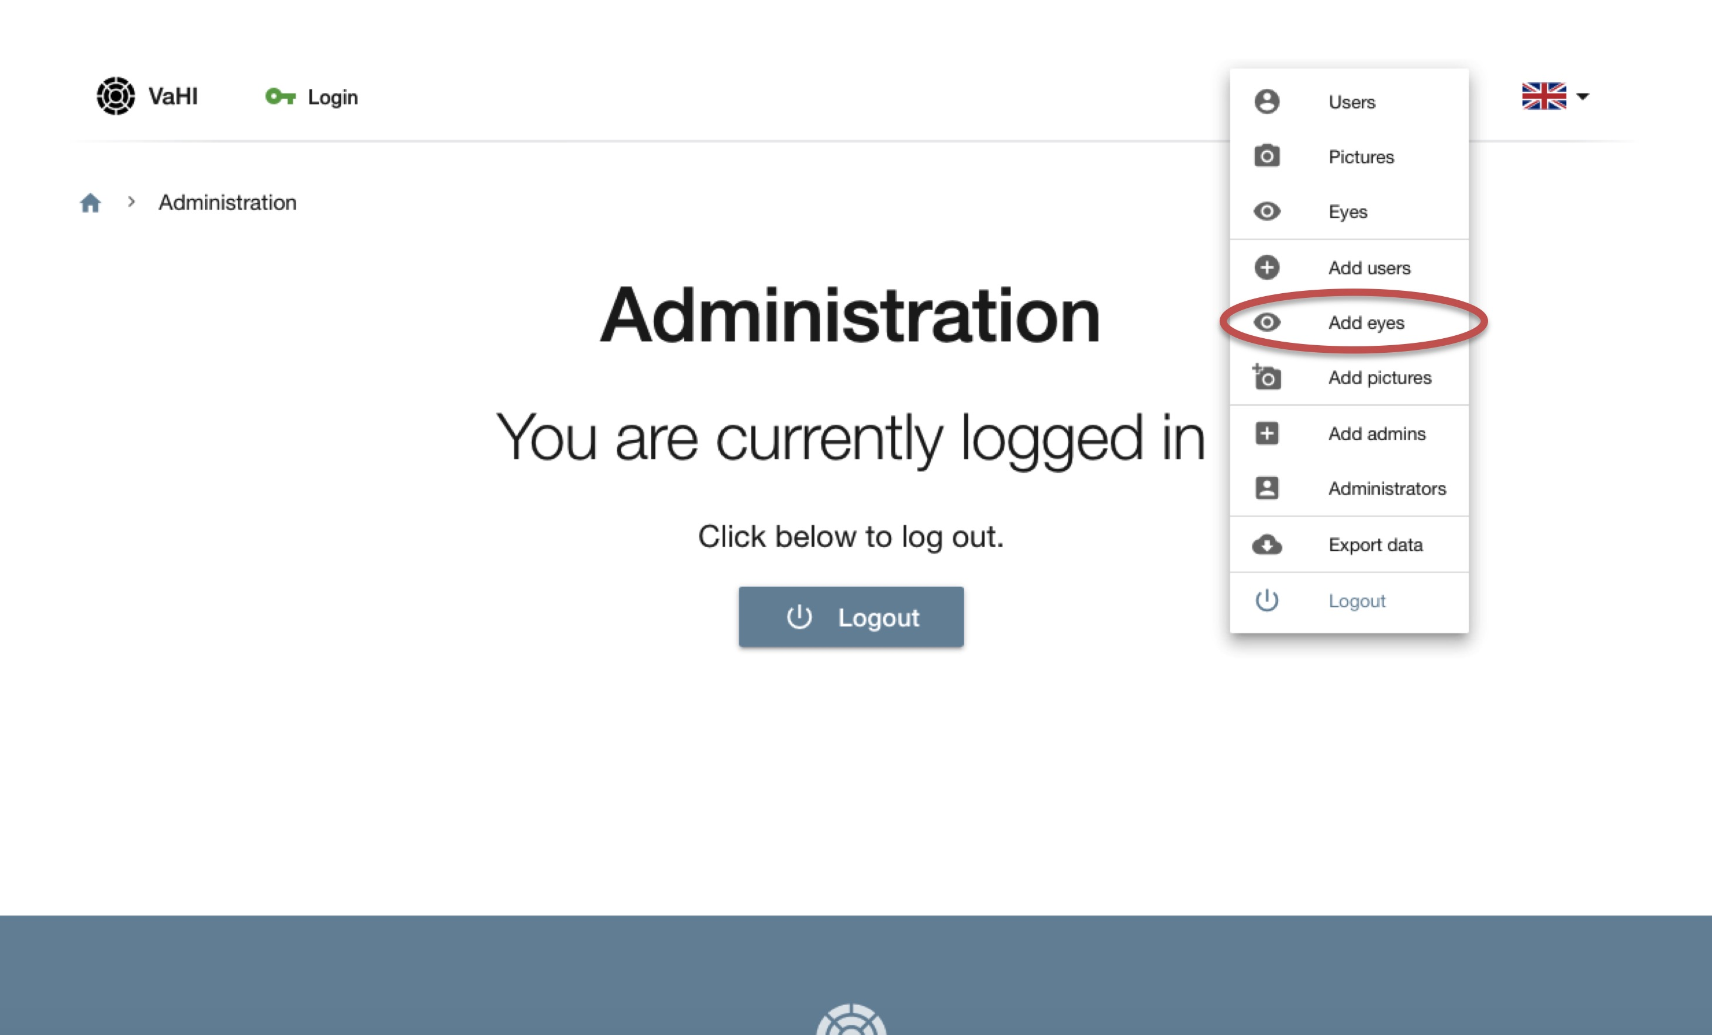

4.3.1. Add pictures to an eye
Now, select one or more pictures that correspond to the same eye. The picture is selected if it has a green check mark. Then click on ‘Add eye with selected pictures’ (pink bar).

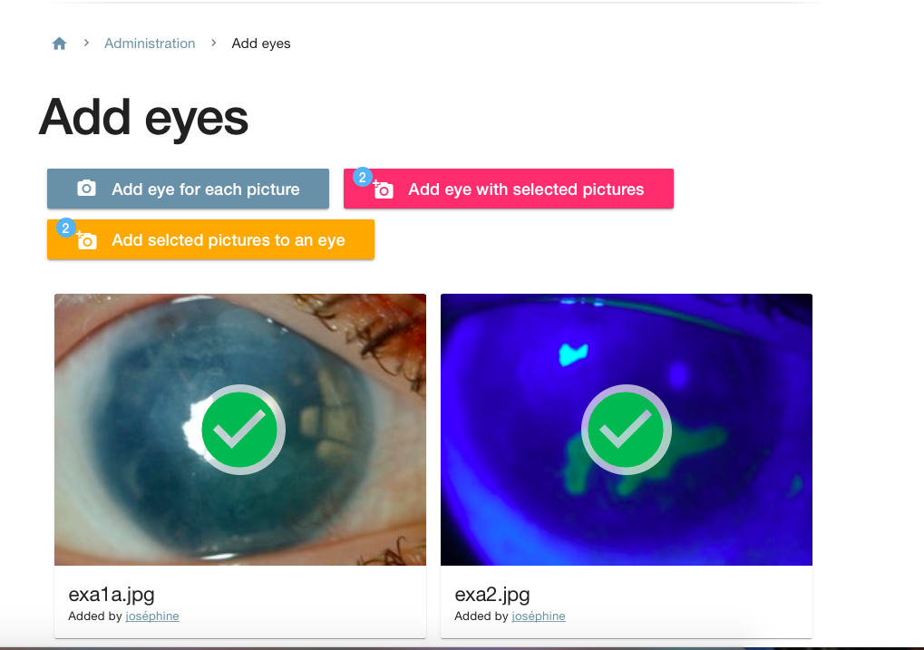

Now you are automatically directed to the overview page.
Click on the number of the eye on the overview page for activating an eye and for selecting the picture for integrity rating. (Number 73 in this example, red arrow)
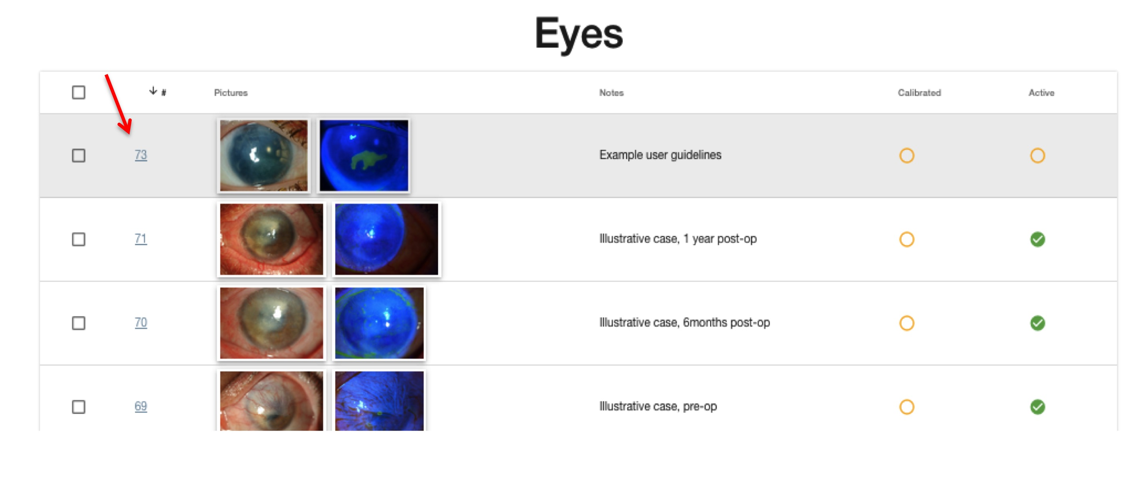

You are then directed to pictures of the same eye. Select here the picture for integrity rating by simply clicking on the photograph (red arrow). If there is no picture for integrity rating, don’t click any picture.
On the same page you can choose to place the eye on ‘active’ (eye will be presented to the users for grading) or ‘non-active’ (eye will not be presented to the users for grading, but remains in the system) (blue arrow). Finally, you may also choose to add a note to the eye (green arrow). Click on save. You will be directed to the overview page again.

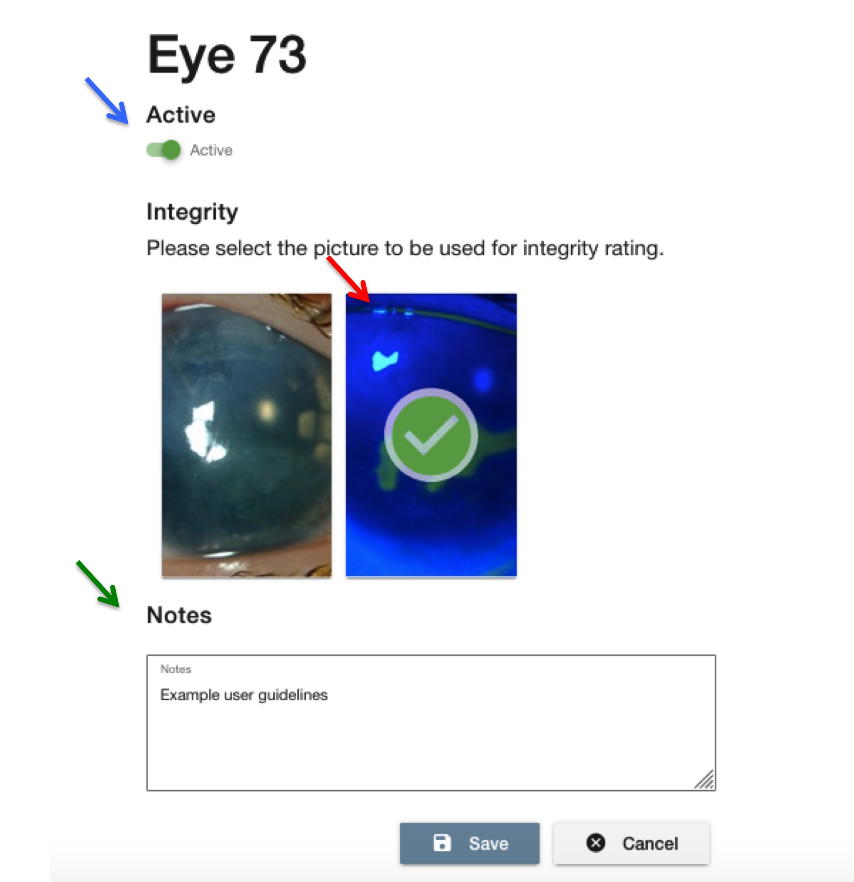

4.3.2. Add another picture to an eye
If you want to add another picture to an eye on a later moment, upload the picture as described above under 4.2, then go to ‘Add eye’ on the dropdown menu, and finally press ‘add selected picture to an eye’ (yellow bar).

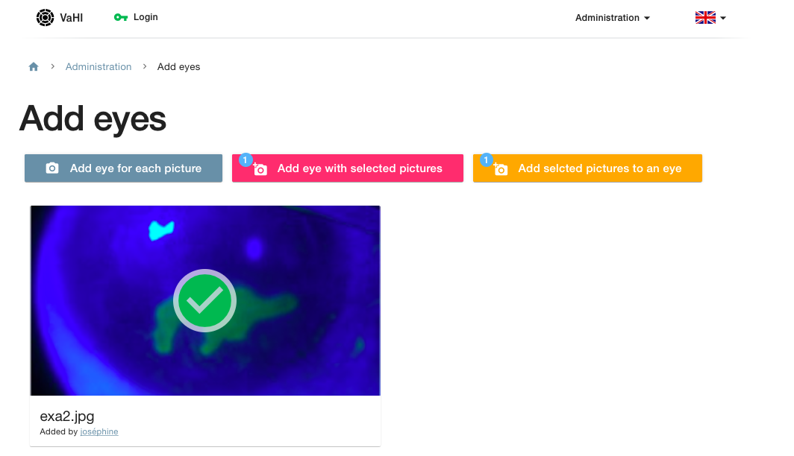

Now, an overview of all eyes is presented. Select the eye you want to link the picture with. The most recently uploaded photographs are placed at the bottom of the list. Click on ‘Add selected picture to an eye’.
For your information: In this illustration, a photograph under cobalt blue light is linked to an eye. However, you also have the possibility to add additional pictures (under white light) of the same eye, in case multiple pictures are needed for example to cover all zones for grading.

4.4. Positioning of the grid
This part explains how a grid can be positioned manually onto a photograph.
First, click on the desired photograph on the overview page (red arrow).

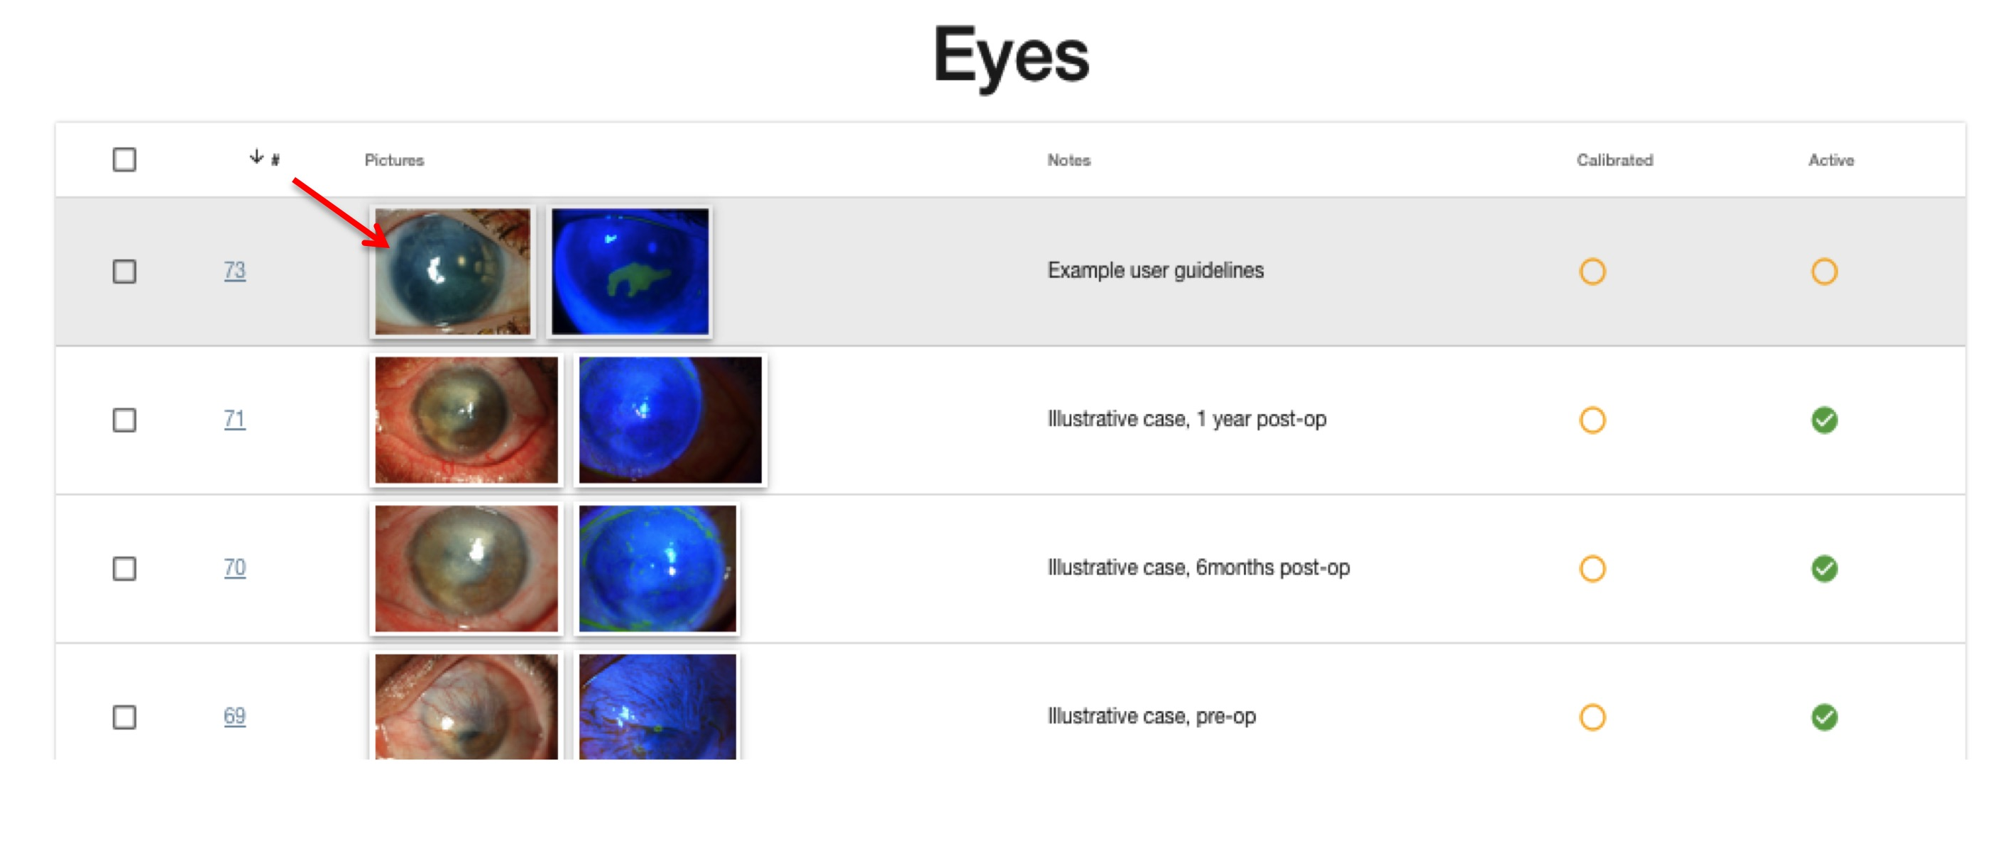

Now you’re redirected to the page where a grid can be positioned onto the eye.
First, position the grid into the center of the photograph. The grid itself can be moved by clicking and dragging the grid to the correct position. The size of the grid can be reduced or enlarged using the horizontal slide bar above the photograph, until the outer circle delineates the corneal limbus (blue arrow).
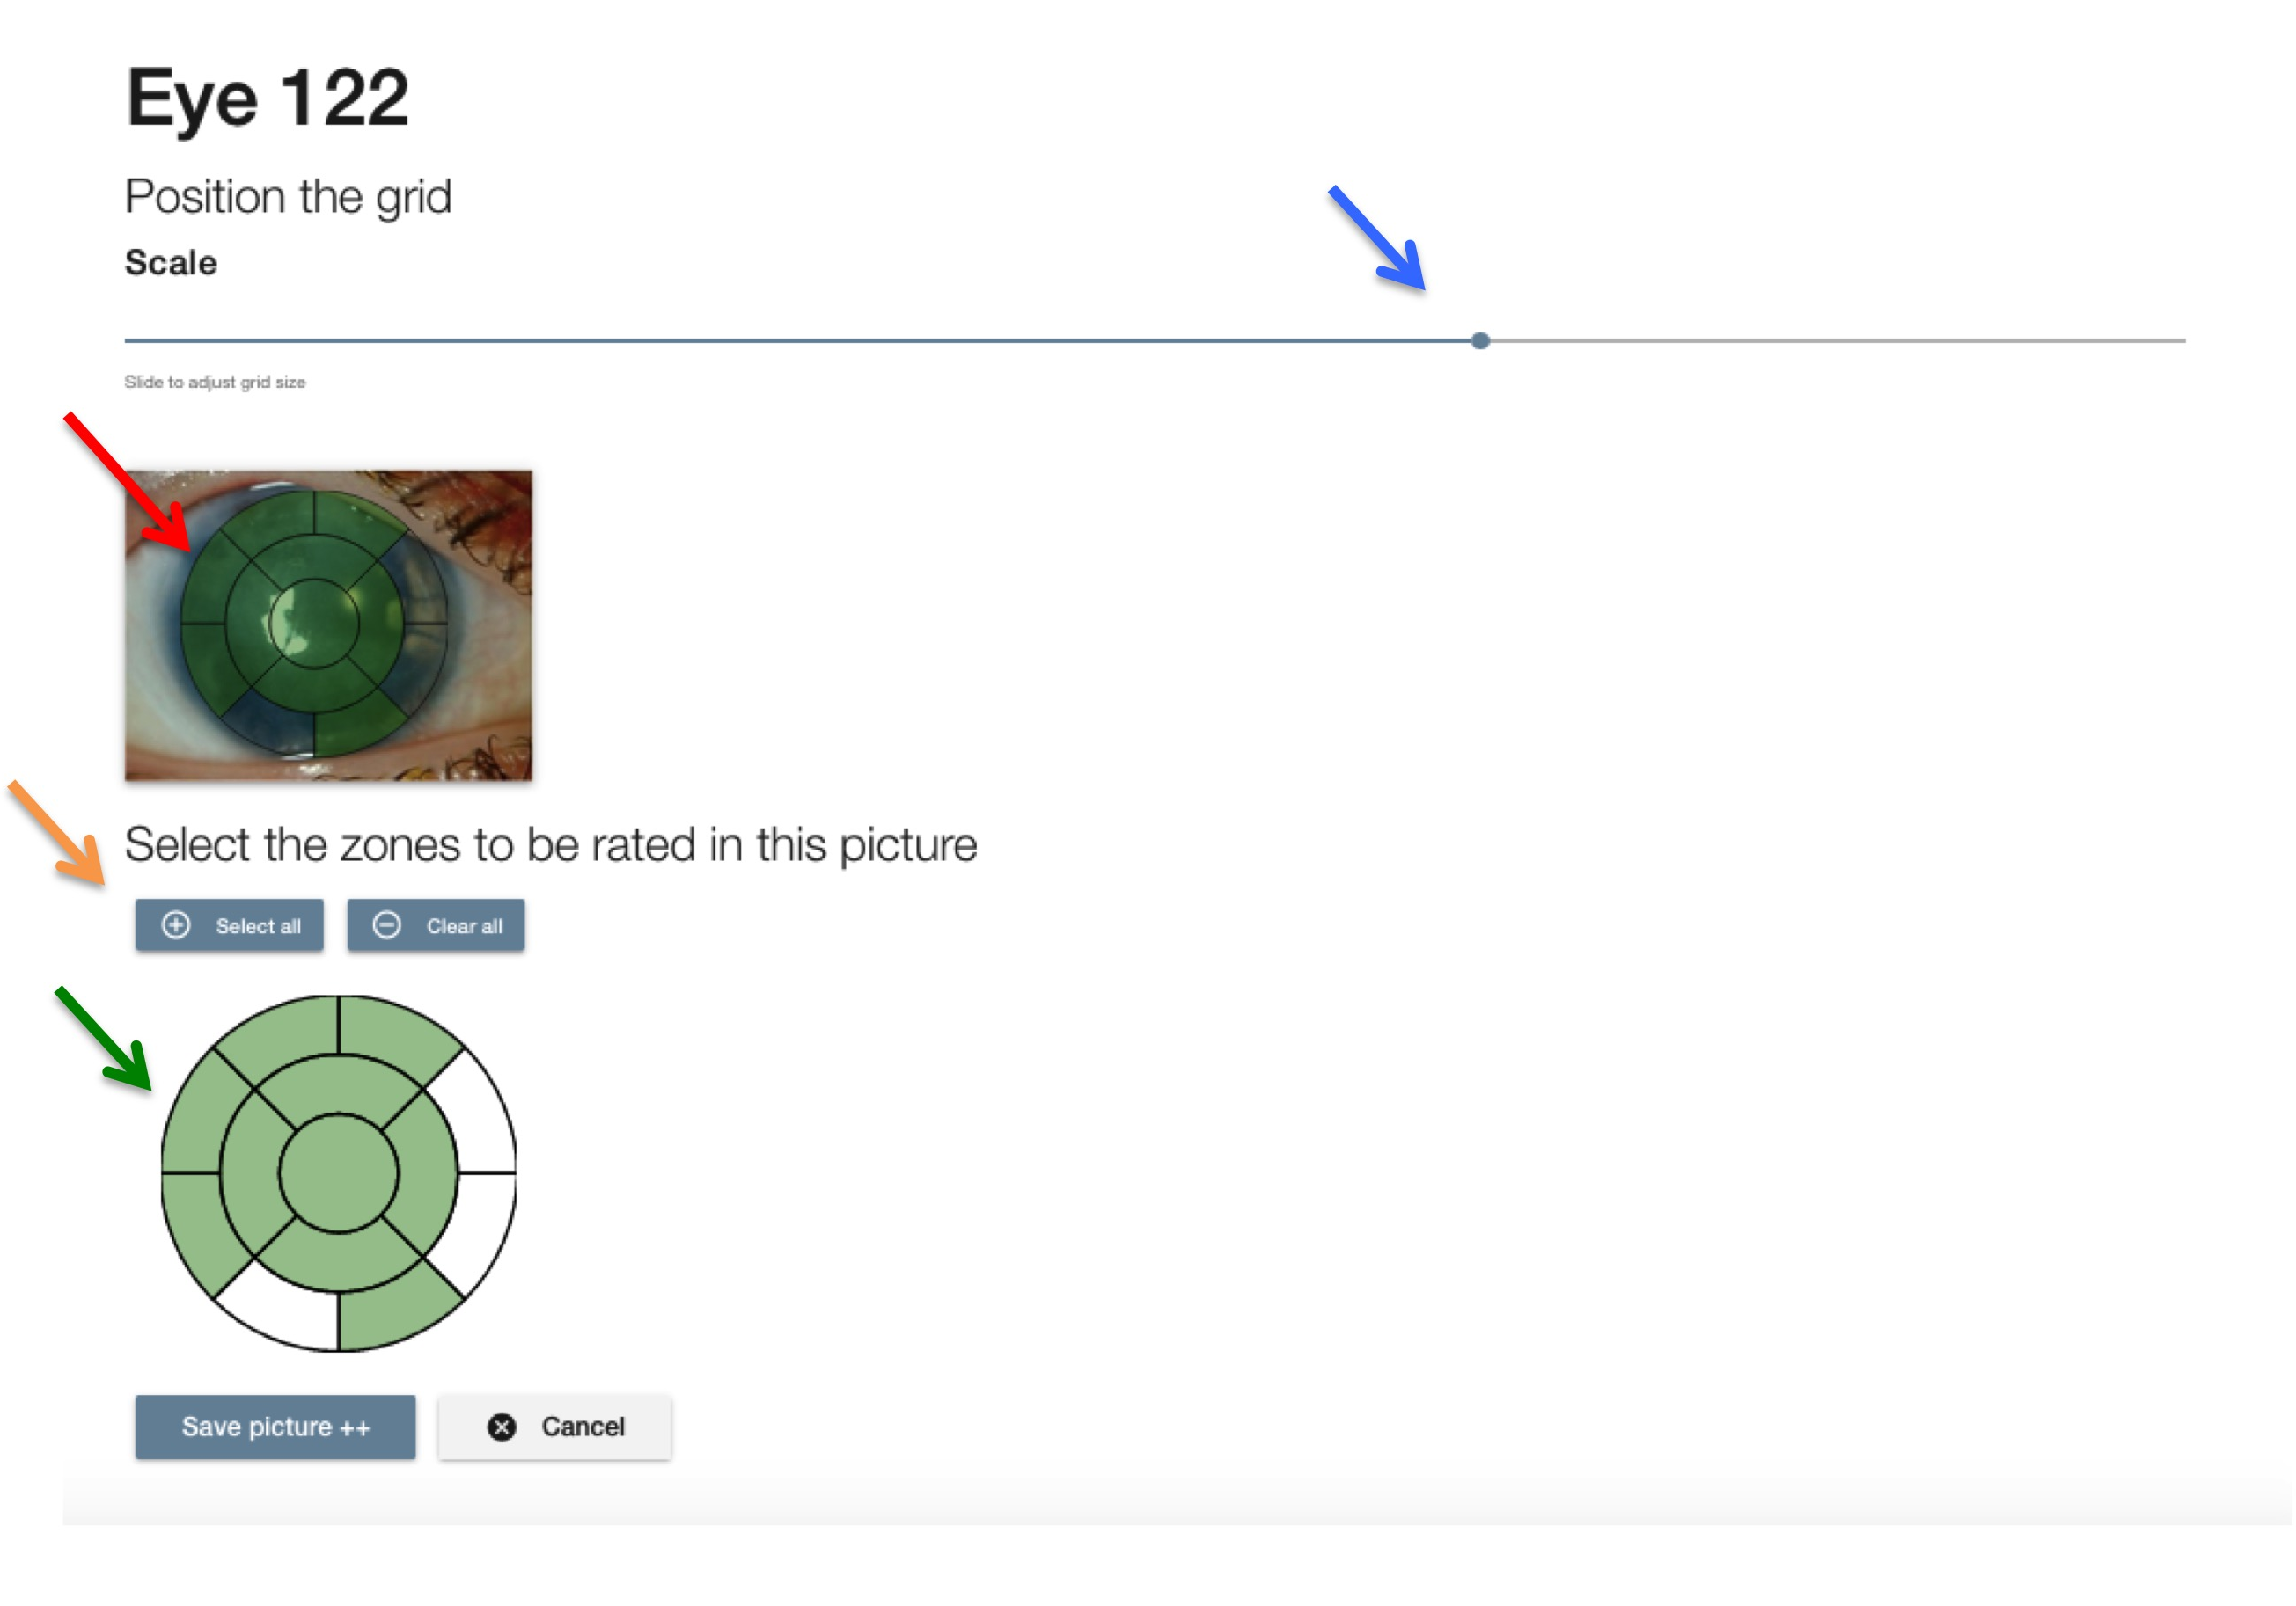
Next, select the zones that should be graded. Click on ‘Select all’ if all zones should be graded. Zones that are unable to grade (e.g. because the eyelid covers a part of the cornea), can be deselected by clicking on the grid underneath the photograph. A white zone indicates a grid that is not gradable, while the green zones indicate a zone that can be graded (green arrow). In the figure, 3 of the zones are deselected for illustrative purposes.
To save the changes, click ‘Save picture’. The position of the grid is saved and you will be redirected to the overview page.

Add the above-mentioned steps for all of your pictures you want to grade.

4.5. Add users
Go to the dropdown menu of the right upper corner and select ‘Add users’.
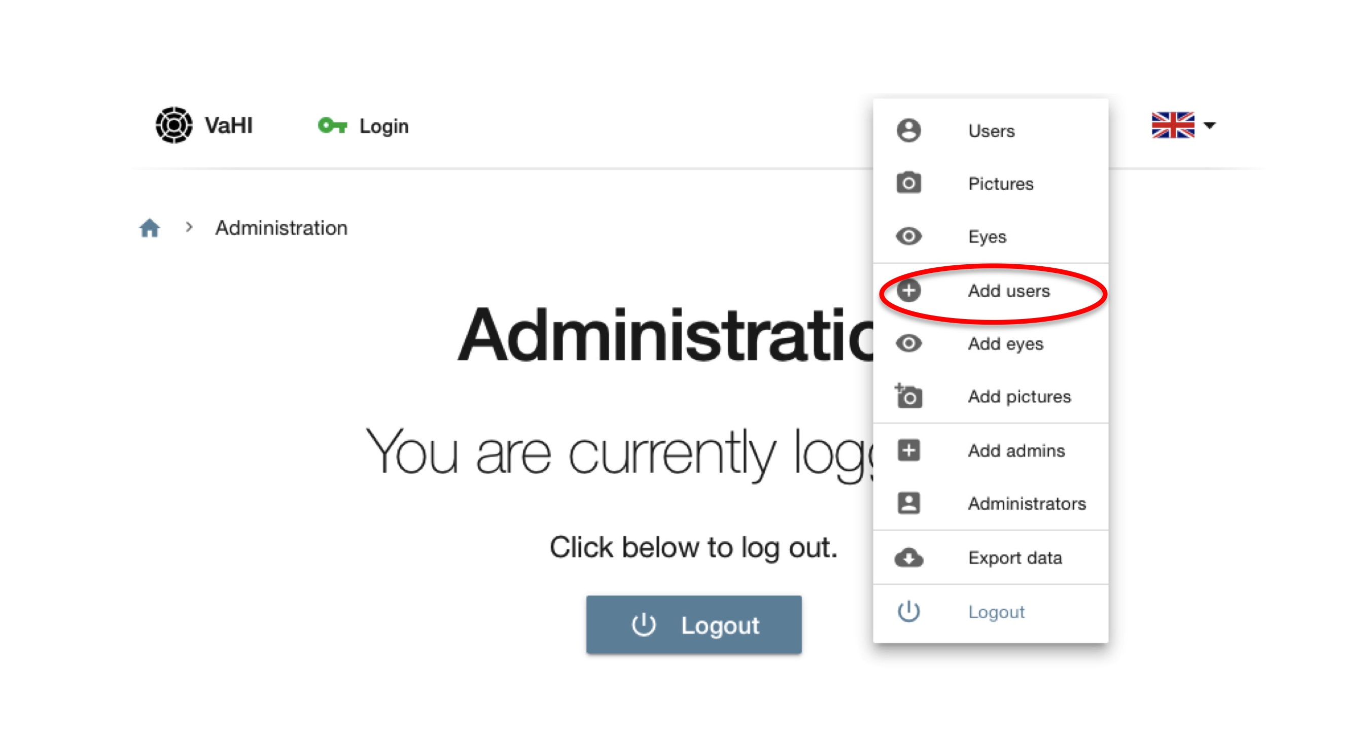

Now, choose the number of users you want to add. It’s not possible to store names, usernames or email addresses, but you can add 'notes' to every user to keep them apart.
Click on ‘Add users’.

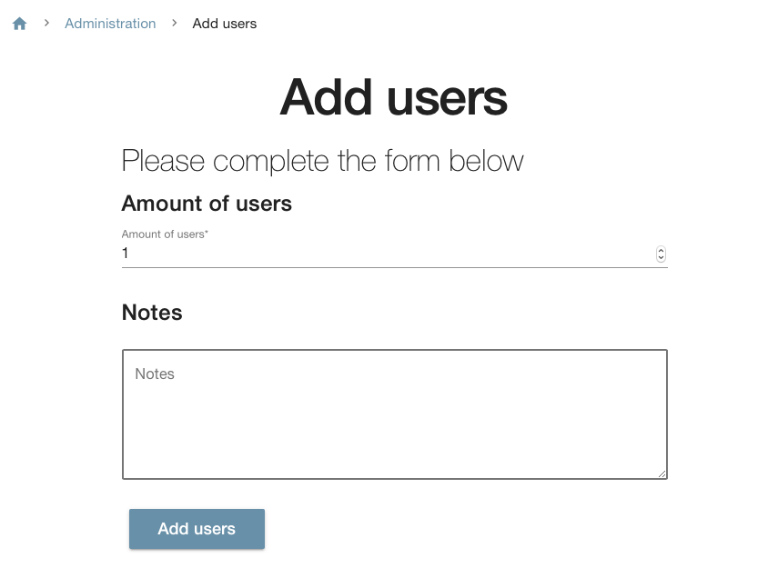

You will no be directed to the overview page of the users.
Here, an overview is presented with the number of the user (orange arrow), their invite code (blue arrow), the notes (red arrow), if they the user is active or not (green check bar), the last login of the user, and by which administrator the user was added.

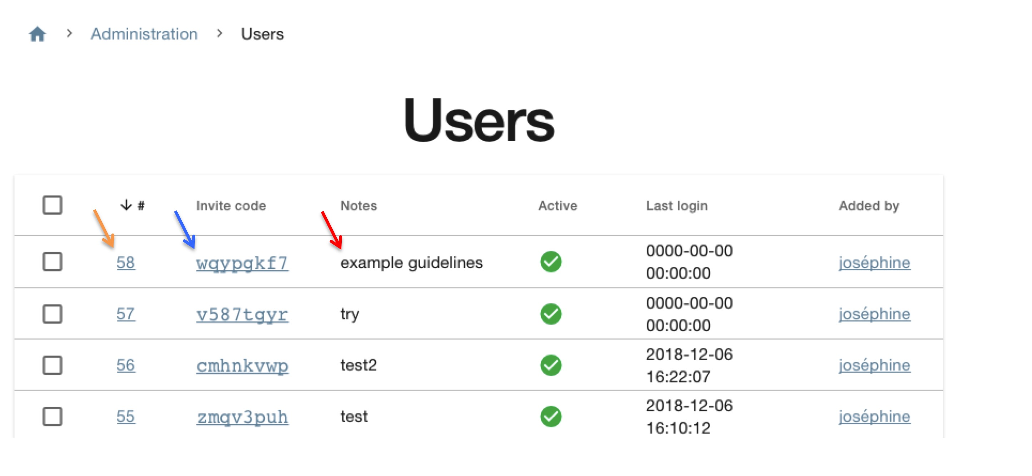

On this page you may additionally (i) delete a user, (ii) activate a user or (iii) deactivate a user by first selecting the user, and then clicking the desired button: ‘Delete’ (red), ‘Activate’ (green) or ‘Deactivate’ (orange).

As administrator, you need to provide the invite code to the user. This invite code is the login of the user. We advise to keep a logbook including names and numbers of the users.

4.6. Export data
Data can be exported by selecting ‘Export data’ on the dropdown menu of the right upper corner.

Click on ‘Export data’. Then click ‘Download’. An excel file will be downloaded, containing all grading scores sorted by user, an overview of the users, an overview of the eyes and an overview of the administrators.

Information for graders

5.1. Login to VaHI
To access VaHI you need to have a login code from your administrator. Once received, go to the login page of the VaHI web, and enter username and password.
If you just want to try it out and you don’t have a username and password: click on ‘login here’ under ‘Can I try Vahi’. Use ‘vahi’ as your invite code. Start grading.

5.2. Start grading

5.2.1. Vascularisation
For grading, click manually onto the zone. The score will appear automatically. Click until the desired score is presented into the zone. A colour (green for 0, yellow for 1, orange for 2 and red for 3) delineates the graded zone. Grade all zones, then click on ‘Rate haze’ to proceed to the next grading.
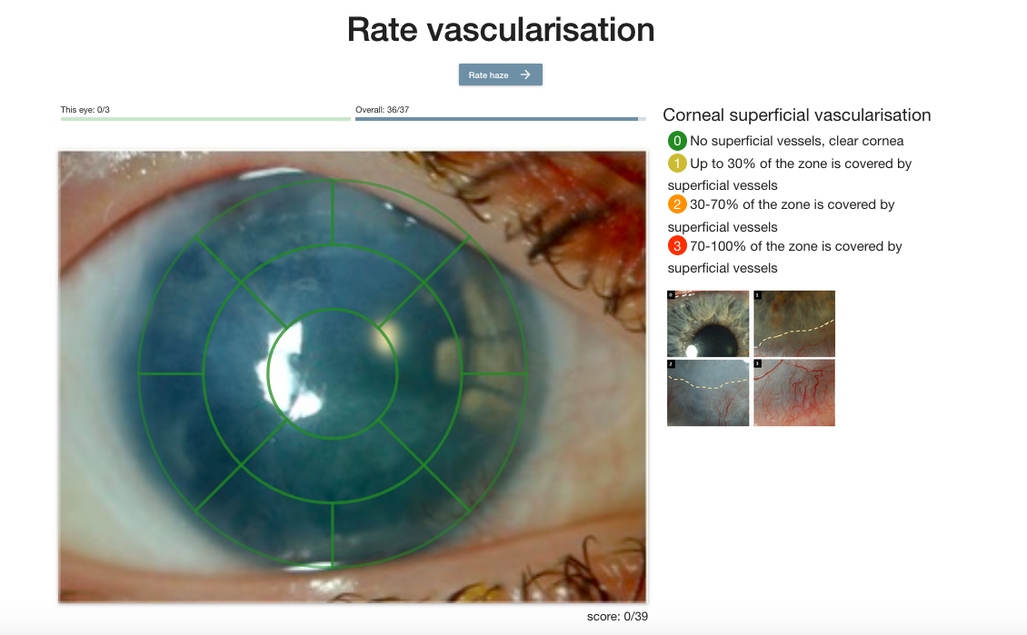

5.2.2. Haze
For rating the parameter ‘Corneal haze’, proceed in the same way as described under vascularisation.

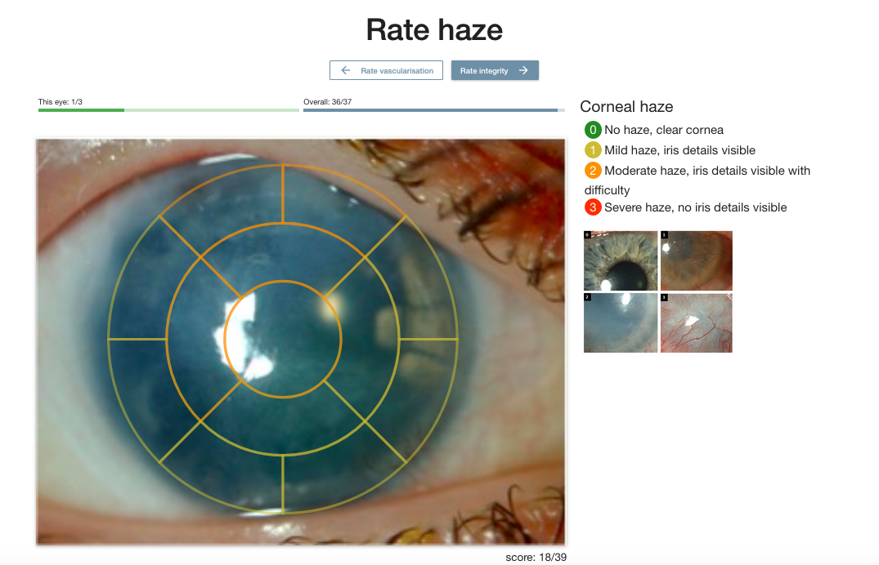

5.2.3. Integrity
Next, click on ‘Rate integrity’ for grading of the last parameter. Select the grade and click on ‘Save ratings’. All scores will be saved.

