**A**

**D**

**C**

**B**

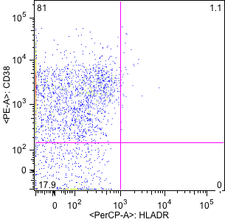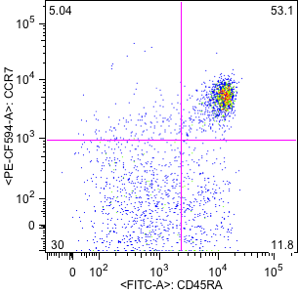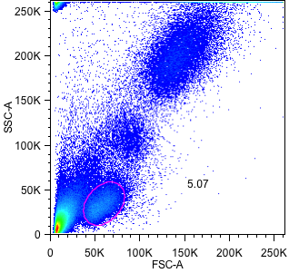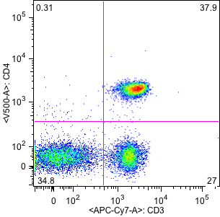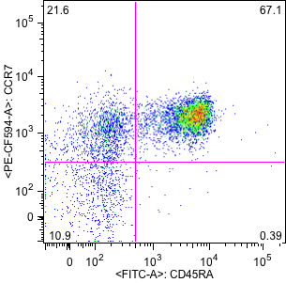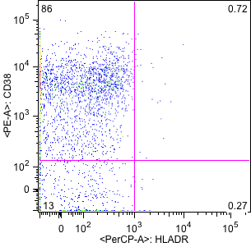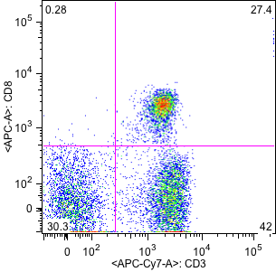

**Supplemental Digital Content 2.** Demarcation of CD4+ and CD8+ T cells, maturation subsets and HLA-DR+CD38+ expression. A: Lymphocyte demarcation. B: Separation of CD4+ and CD8+ T lymphocytes. C: CD4+ T cell maturation subsets: Naive (CCR7+CD45RA+), Central Memory (CCR7+CD45RA-), Effector Memory (CCR7-CD45RA-) and Effector (CCR7-CD45RA+) and HLA-DR+CD38+ expression. D: CD8+ T cell maturation subsets: Naive (CCR7+CD45RA+), Central Memory (CCR7+CD45RA-), Effector Memory (CCR7-CD45RA-) and Effector (CCR7-CD45RA+) and HLA-DR+CD38+ expression