**Supplemental Digital Content 3.** PD-1 expression analysis in CD4+ T cells and maturation subsets. A: Lymphocyte demarcation. B: Separation of CD4+ T lymphocytes. C: Mean Fluorescence Intensity PD-1 expression. D: Total % PD-1 expression on CD4+ T cells. E: PD-1 expression on CD4+ T lymphocyte maturation subsets: Naive (CCR7+CD45RA+), Central Memory (CCR7+CD45RA-), Effector Memory (CCR7-CD45RA-) and Effector (CCR7-CD45RA+).

**B**

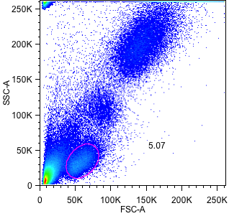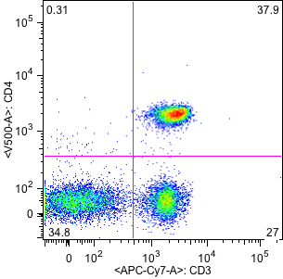

Central Memory

Naive

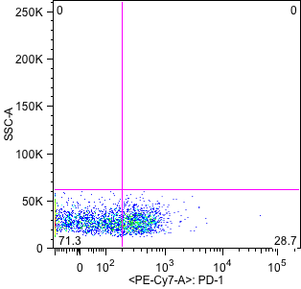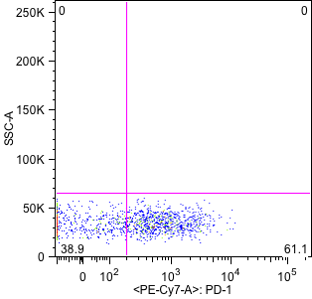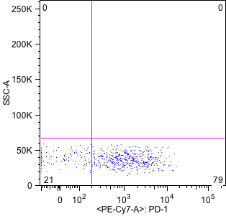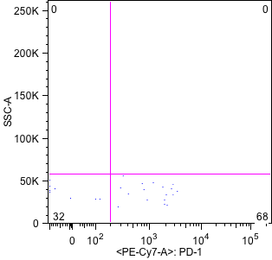

Effector Memory

Effector

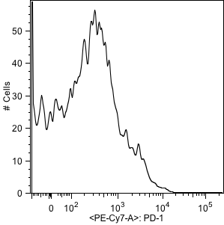

**A**

**C**

**D**

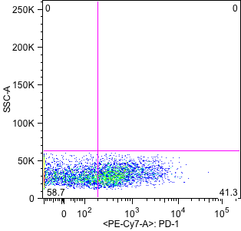

**E**