**E**

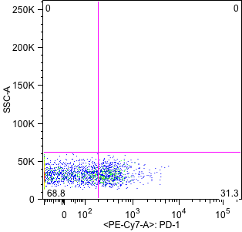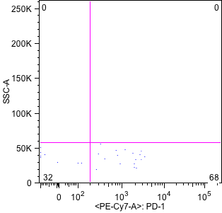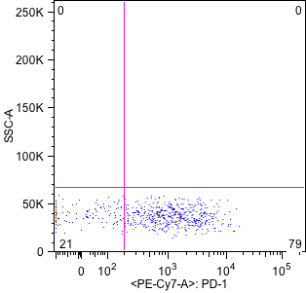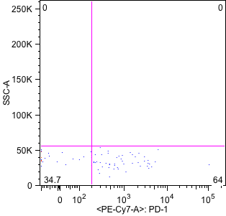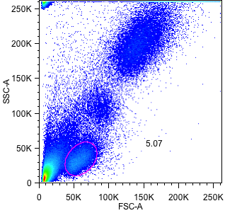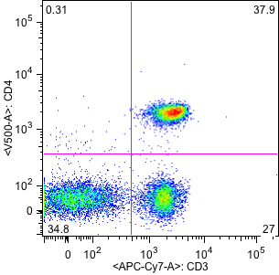

Naive

Central Memory

Effector Memory

Effector

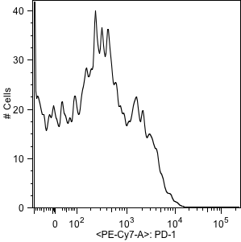

**A**

**B**

**C**

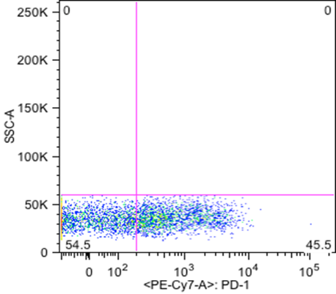

**D**

**Supplemental Digital Content 4.** PD-1 expression analysis in CD4- T cells and maturation subsets. A: Lymphocyte demarcation. B: Separation of CD4- T lymphocytes. C: Mean Fluorescence Intensity PD-1 expression. D: Total % PD-1 expression on CD4- T cells. E: PD-1 expression on CD4- T lymphocyte maturation subsets: Naive (CCR7+CD45RA+), Central Memory (CCR7+CD45RA-), Effector Memory (CCR7-CD45RA-) and Effector (CCR7-CD45RA+).