Figure, Supplemental Digital Content 3. Annual rate of clinic visits for diarrhea in children < 5 years old, provinces of Peru
2005  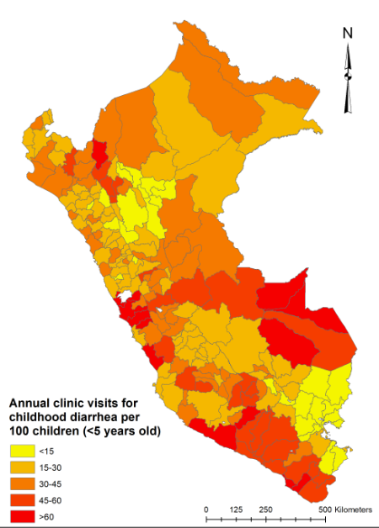 | 2015  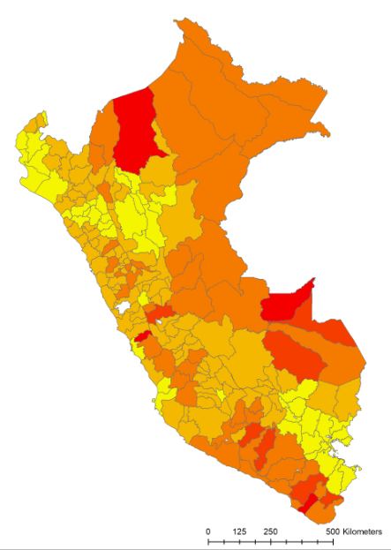
Provincial-level rates of clinic visits for childhood diarrhea displayed for first and last years of the study. There was a strong El Niño event in the second half of 2015. Moderate/strong El Niño events were associated with a higher rate of clinic visits for childhood diarrhea. In the study period (2005-2015), the annual rate of clinic visits for childhood diarrhea was lowest in the year 2014.

