Figure, Supplemental Digital Content 4. Percentage of infants who received both doses of rotavirus vaccine (RV1), Peru, 2008-2015
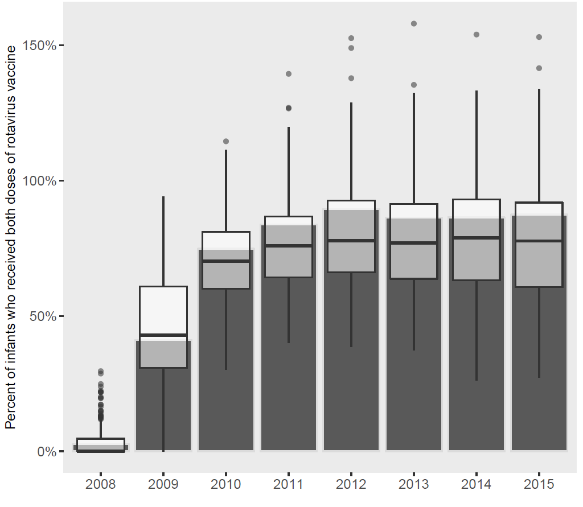
Shaded bars reflect national estimates; boxplots (with outlier points) are province-level estimates. The percentage of infants vaccinated is calculated as the total number of second doses of rotavirus vaccine administered, divided by the estimated infant (<12 months) population. Estimates exceed 100% when the count of second vaccine doses exceeded the estimated infant population, which may have resulted from an overcount of vaccine doses administered, or an underestimated infant population. Infant population estimates are Ministry of Health-derived estimates based on the 2007 Peruvian national census and other administrative data.

