Figure, Supplemental Digital Content 6. Association between province-level piped water access and percentage of infants receiving a second dose of the rotavirus vaccine (RV1), provinces of Peru (N=194), 2012
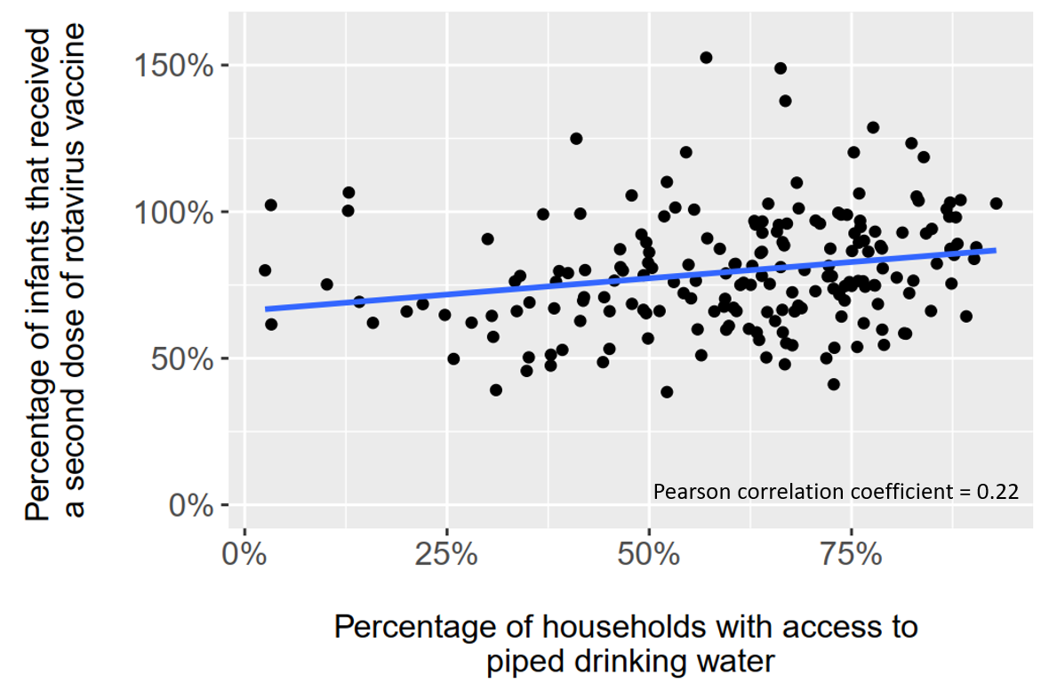
A single year of data was assessed because both variables considered increased over time (i.e., both were correlated with year). The year 2012 was chosen arbitrarily as a data point in the middle of the rotavirus vaccine era. The percentage of households with access to piped drinking water is defined as the percentage of households in a province using piped water (piped either inside of, or outside of the home, but within the building area) as the primary drinking water source. The percentage of infants vaccinated was calculated as the total number of second doses of rotavirus vaccine administered in each province, divided by the estimated infant (<12 months) population. Estimates exceed 100% when the count of second vaccine doses exceeded the estimated infant population, which may have resulted from an overcount of vaccine doses administered, or an underestimated infant population. Infant population estimates are Ministry of Health-derived estimates based on the 2007 Peruvian national census and other administrative data. The Pearson correlation coefficient is 0.22 (p =0.002).

