Figure, Supplemental Digital Content 7. Association between province-level sewerage access and percentage of infants receiving a second dose of the rotavirus vaccine (RV1), provinces of Peru (N=194), 2012
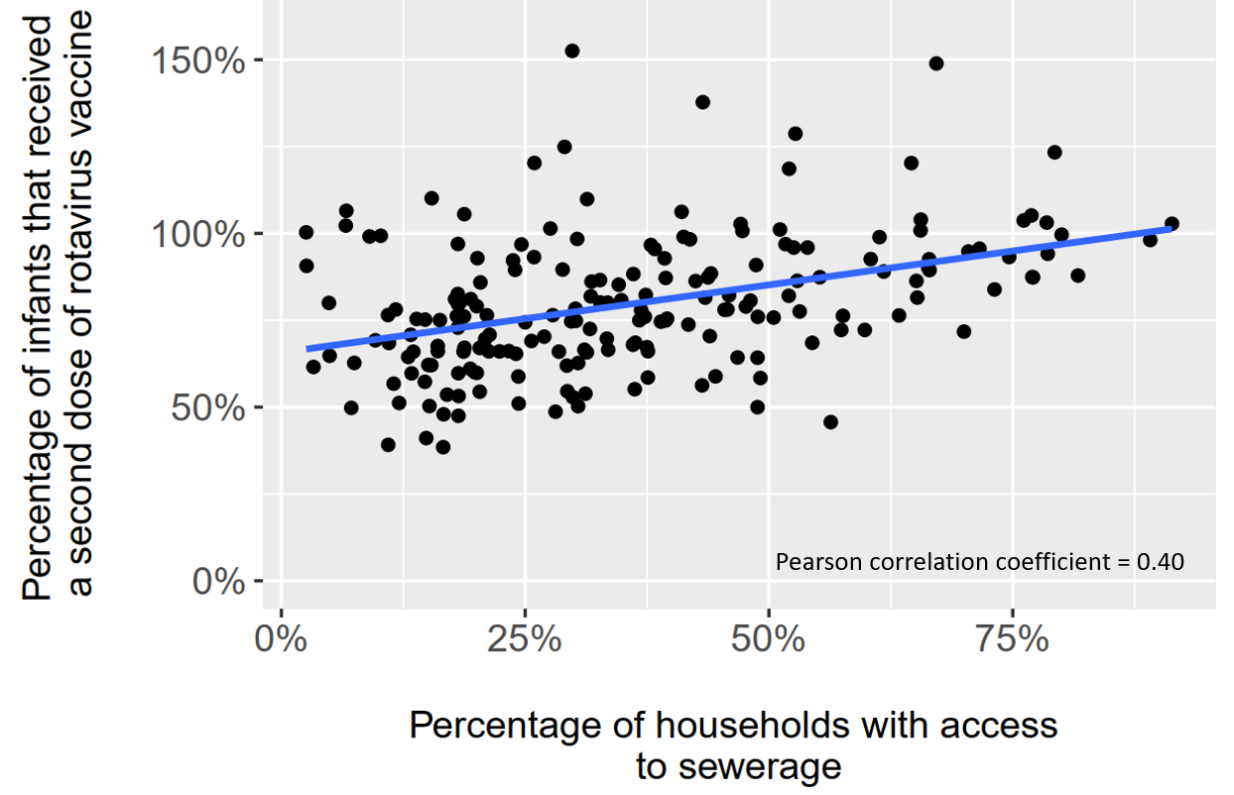
A single year of data was assessed because both variables considered increased over time (i.e., both were correlated with year). The year 2012 was chosen arbitrarily as a data point in the middle of the rotavirus vaccine era. The percentage of households with access to sewerage is defined as the percentage of households in a province for which the method of excreta disposal is a toilet connected to the sewerage system. The percentage of infants vaccinated was calculated as the total number of second doses of rotavirus vaccine administered in each province, divided by the estimated infant (<12 months) population. Estimates exceed 100% when the count of second vaccine doses exceeded the estimated infant population, which may have resulted from an overcount of vaccine doses administered, or an underestimated infant population. Infant population estimates are Ministry of Health-derived estimates based on the 2007 Peruvian national census and other administrative data. The Pearson correlation coefficient is 0.40 (p<0.001).

