Supplemental Digital Content 1. Use of Tdap vaccination during pregnancy and delivery in Medicaid (MAX) and IBM Marketscan from 2010-2015.

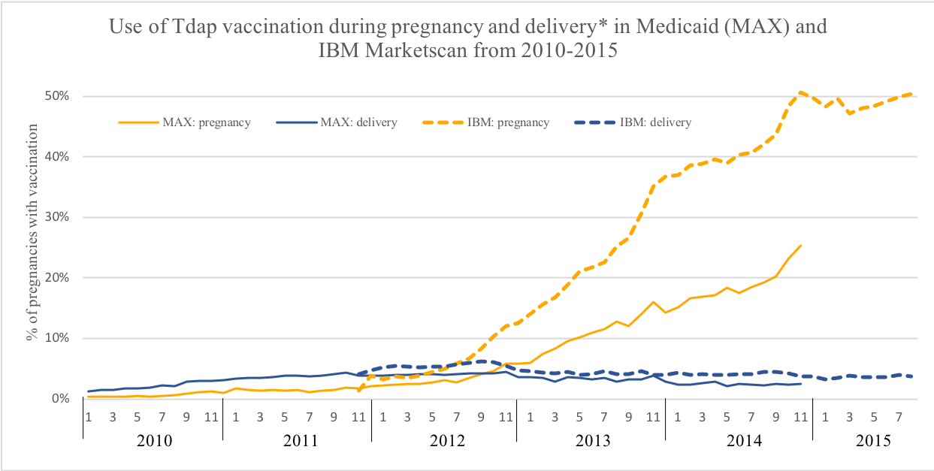
*Delivery period defined as one day before delivery through 7 days after delivery.

