Supplemental Digital Content (SDC)
CONTENTS
- SDC-1:Model inputs
- SDC-2: Model Calibration
- SDC-3: Sensitivity analysis
- SDC-4: Results over 25- and 100-Year Time Horizon
- REFERENCES FOR SDC

SDC-1:Model inputs

Table 1: Swiss Model Inputs
Parameters | Values
 | <15 years of age |  |  |  | 15–44 years of age |  | 45–65 years of age |  |  |  | ≥65 years
Percentage of cases requiring outpatient visits¹ | 40% |  |  |  | 90%
Number of outpatient visits per case¹ | 1.13 |  |  |  | 1.42
Cost per outpatient visit* | CHF 45.00
Percentage of outpatient cases requiring Rx or OTC drug¹ | 5% |  |  |  | 50%
Mean cost of Rx and OTC drugs for outpatients¹ | CHF 38.45 |  |  |  | CHF 162.80
Percentage of outpatient cases requiring diagnostic testing¹ | 2.5%
Estimated mean cost of diagnostic tests per case¹ | CHF 26.00
Percentage of cases requiring hospitalization¹** | 0.156% |  |  |  | 3.3%
Mean duration of hospitalization in days² | 3.44 |  |  |  | 4.86 |  | 12.57 |  |  |  | 17
Mean cost per hospital day^{2,3} | CHF 1781 |  |  |  | CHF 1142 |  | CHF 761 |  |  |  | CHF 982
Mean days lost from work due to varicella (outpatient)¹ | 0.32 (for caregiver) |  |  |  | 2.56 |  | 2.56 |  |  |  | 0
Mean days lost from work due to varicella (inpatient)² | 3.44 (for caregiver) |  |  |  | 4.86 |  | 12.57 |  |  |  | 0
Mean costs per workday missed¹ | CHF 267.00
Additional risk of febrile seizures for MMRV-MSD compared to MMR⁴ | 1 case per 2600 doses
Cost to treat a single episode of febrile seizures | CHF 6411.90 per case
HZ incidence per 1,000 population⁵ | 0-4y:  0.4 | 5-9y:  0.8 |  | 10-39y:  1.2 |  | 40-49y:  2.13 |  | 50-59y:  3.06 | 60-69y:  4.14 | 70:79y:  5.99 |  | 80:89y:  7.48 | 90+:  8.17
% of HZ cases that developed post-herpetic neuralgia⁶ | 0-4y:  0% |  | 5-14Y:  1 % |  | 15-44y: 4% |  | 45-64y:11% |  |  |  | 65y+: 31%
Mean cost per case of Herpes zoster (uncomplicated)⁶ | CHF 491.11 until age 69 years then CHF 534.74 for ≥ 70 years
Mean cost per case of Herpes zoster (complicated with postherpetic neuralgia [PHN])⁶ | CHF 858.02 until age 69 years then CHF 1214.03 for ≥ 70 years
Mean Days lost from work due to HZ⁵ |  |  |  |  | <18 yrs |  | 18-64 yrs |  |  |  | 65+ yrs
 | Uncomplicated case |  |  |  | 0.0 |  | 0.3 |  |  |  | 0.3
 | HZ with PHN |  |  |  | 0.0 |  | 1.9 |  |  |  | 1.9
Abbreviations: CHF = Swiss franc; OTC = over-the-counter; Rx = medical prescription.
* Expert opinion; ** calculated based on the proportion of complications and hospitalizations thereof as described in Banz et al¹

SDC-2: Model Calibration
Model calibration was achieved using the output from the force of mortality calculation and several sources of data on pre-vaccination varicella prevalence in Switzerland.⁷⁻⁹ It was necessary to combine data from multiple sources, as no single publication contained a complete picture of seroprevalence as broken down by age, which is fundamental to calibrating the underlying dynamic transmission model,¹⁰ and is central to other approaches to estimating varicella incidence from seroprevalence rates.^{8,11} In order to merge the data sets, we combined them in a single data set, assuming that the reported seroprevalence of each age group was applied at the midpoint of the age group. We then smoothed the data by fitting a simple curve to the data using Mathematica’s NonlinearModelFit routine, which implements the Nelder-Mead method.¹² The functional form we fit was
$$0.976 e^{-a/δ_{n}}+\left(1-\frac{Γ\left(1+b, c a\right)}{Γ\left(1+b\right)}\right)$$
Here $a$ is age, and we are fitting the parameters $δ_{n}$, which is the duration of natural immunity, as well as $b$ and $c$. The term in brackets is effectively the cumulative distribution function of the Gamma distribution with shape parameters of $b-1$ and $1/c$. We assume (as in the model) that maternal immunity decays exponentially, and the coefficient 0.976 is an estimate of how many Swiss children are born with maternal immunity, based on the seroprevalence data in Bollaerts et al. (2017)⁸ and the smoothed fertility data. The curve fit is shown plotted against the data in Figure 1.

Figure 1. Linear Model of Seroprevalence by Age
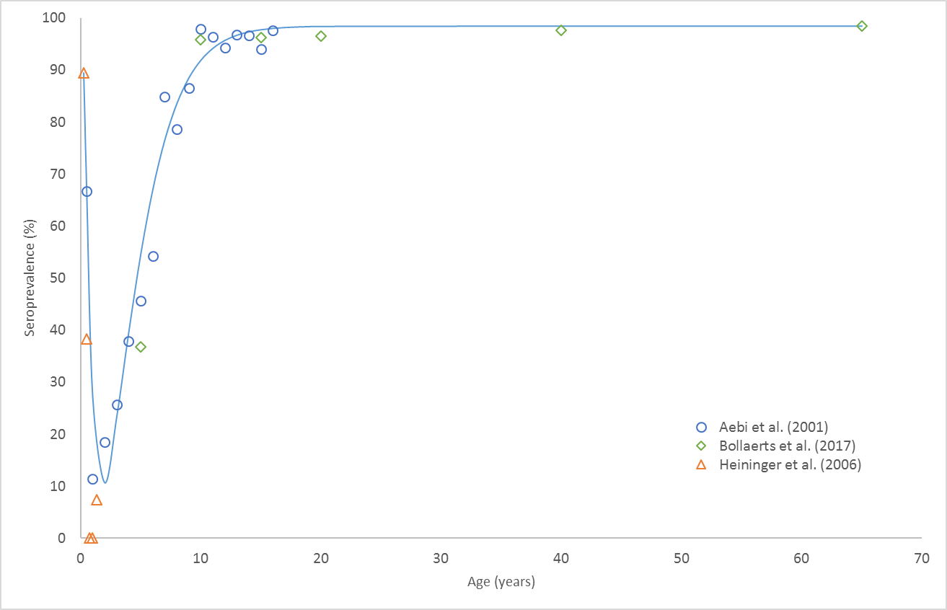
The value of $δ_{n}$ was 4.6 months, close to the model default value of 6 months.^{8,13}
Once we had a smoothed data set, we could find the implied force of infection the model would require to produce that seroprevalence curve, and from there estimate the age-specific susceptibilities that would give rise to that force of infection assuming an empirically known contact matrix for Switzerland.¹⁴ The resulting seroprevalence in the model is plotted against the data from Bollaerts et al. (2017)⁸ in Figure 2.

Figure 2. Model Seroprevalence Calibration
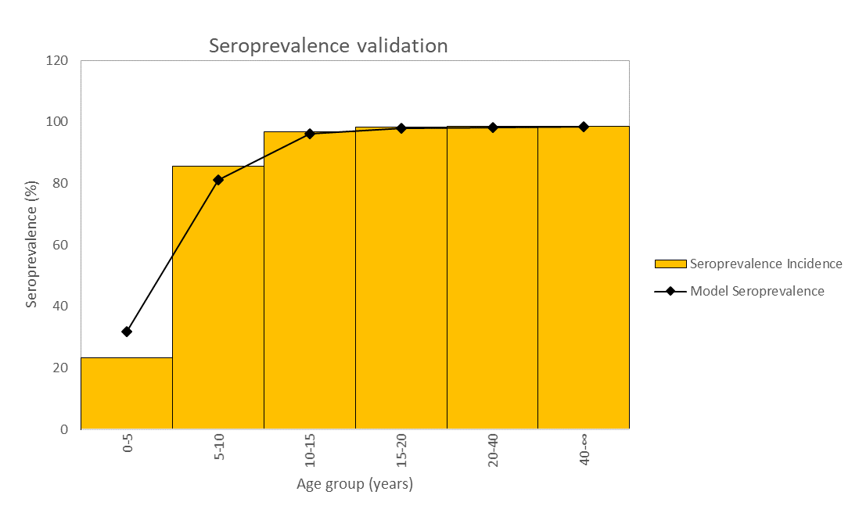

SDC-3: Sensitivity analysis

Table 2: Tabulated Results for One-Way Sensitivity Analysis (for Fig 1 in manuscript)
The low and high ICERs from the one-way sensitivity analysis for the three UVV strategies compared to BC1 and BC2 are shown below.
BC1 | ICERs
 | Low | High
UVV-S
Dose 2 vaccination coverage | 25,672 | 25,540
Catch-up coverage | 25,524 | 25,691
Percent of cases requiring hospitalization or outpatient visit | 26,045 | 25,169
Dose 1 vaccination coverage | 25,814 | 25,328
Cost of work day lost | 26,807 | 24,407
Work days lost | 27,023 | 24,190
MMRV-MSD price | 18,180 | 33,034
UVV-M
Dose 2 vaccination coverage | 25,072 | 24,907
Catch-up coverage | 24,904 | 25,078
Dose 1 vaccination coverage | 25,187 | 24,735
Percent of cases requiring hospitalization or outpatient visit | 25,435 | 24,545
Cost of work day lost | 26,211 | 23,770
Work days lost | 26,428 | 23,552
MMRV-MSD price | 17,671 | 32,310
UVV-L
Catch-up coverage | 28,941 | 29,146
Dose 2 vaccination coverage | 28,923 | 29,161
Dose 1 vaccination coverage | 29,293 | 28,807
Percent of cases requiring hospitalization or outpatient visit | 29,505 | 28,581
Cost of work day lost | 30,291 | 27,795
Work days lost | 30,533 | 27,553
MMRV-MSD price | 25,201 | 32,885
BC2 | ICERs
 | Low | High
UVV-S
Dose 2 vaccination coverage | 26,317 | 26,165
Catch-up coverage | 26,152 | 26,335
Percent of cases requiring hospitalization or outpatient visit | 26,670 | 25,809
Dose 1 vaccination coverage | 26,458 | 25,946
Cost of work day lost | 27,403 | 25,075
Work days lost | 27,636 | 24,843
MMRV-MSD price | 18,758 | 33,721
UVV-M
Dose 2 vaccination coverage | 25,637 | 25,448
Catch-up coverage | 25,450 | 25,641
Percent of cases requiring hospitalization or outpatient visit | 25,980 | 25,102
Dose 1 vaccination coverage | 25,749 | 25,272
Cost of work day lost | 26,728 | 24,354
Work days lost | 26,962 | 24,121
MMRV-MSD price | 18,181 | 32,901
UVV-L
Catch-up coverage | 30,015 | 30,243
Dose 2 vaccination coverage | 29,993 | 30,261
Percent of cases requiring hospitalization or outpatient visit | 30,583 | 29,666
Dose 1 vaccination coverage | 30,377 | 29,896
Cost of work day lost | 31,342 | 28,907
Work days lost | 31,603 | 28,645
MMRV-MSD price | 26,692 | 33,556

Probabilistic sensitivity analysis (PSA)
ICER scatter plots and cost-effectiveness acceptability curves (CEACs) from the PSA are presented in Figure C1 and C2. The mean for the generated ICERs are slightly lower than for the base-case, and the ICER scatter plots show a considerable amount of dispersion along the QALY axis. Both phenomena are due to the high variability in the base-case, and the correspondingly long tail of lower coverages sampled. Very high vaccine coverage rates are often subject to diminishing returns, as incremental improvements deliver doses to people who already benefit from a substantial degree of herd protection.

Table 3: PSA Parameter Distributions
Parameter | Distribution
Workdays lost | <15 years old | 15 or older
Outpatient treatment | Gamma Distribution [96.04, 0.0033] | Gamma Distribution [96.04, 0.0267]
Inpatient treatment | Gamma Distribution [96.04, 0.0512] | Gamma Distribution [96.04, 0.0764]
Cost per lost workday | Log Normal Distribution [5.582, 0.102]
Cases requiring hospitalization | <15 years old | 15 or older
 | Beta Distribution [95.88, 61290] | Beta Distribution [92.83, 2720]
Primary coverage | Beta Distribution [75.87, 3.993]
Booster coverage | Beta Distribution [79.93, 4.440]
MMRV-MSD price | Log Normal Distribution [4.245, 0.1018]
Catch-up coverage | Beta Distribution [491, 231]
Catch-up booster coverage | Beta Distribution [998, 1854]

Figure 3.Probabilistic Sensitivity Analysis Showing the ICER Scatter Plots and Cost-Effectiveness Acceptability Curves for UVV Compared to BC1 (orange circles and lines refer to mean values)
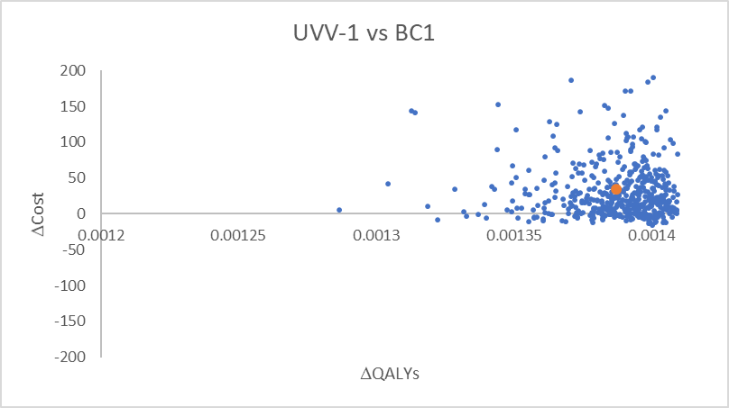 | 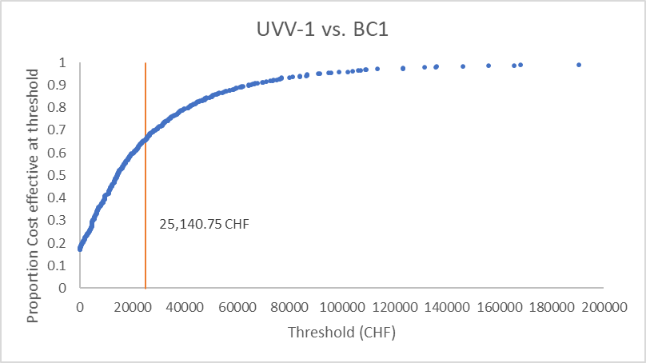
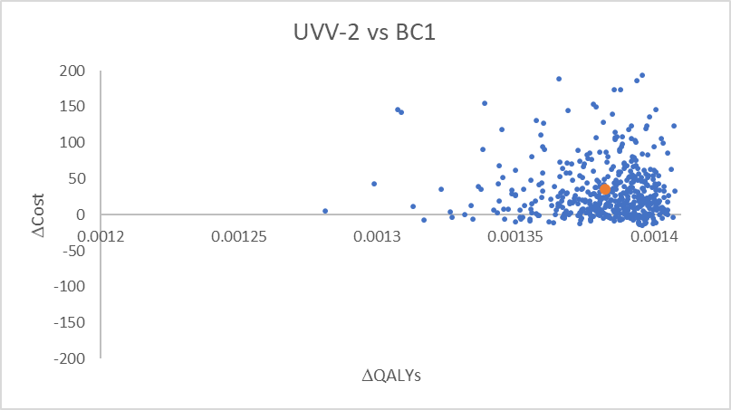 | 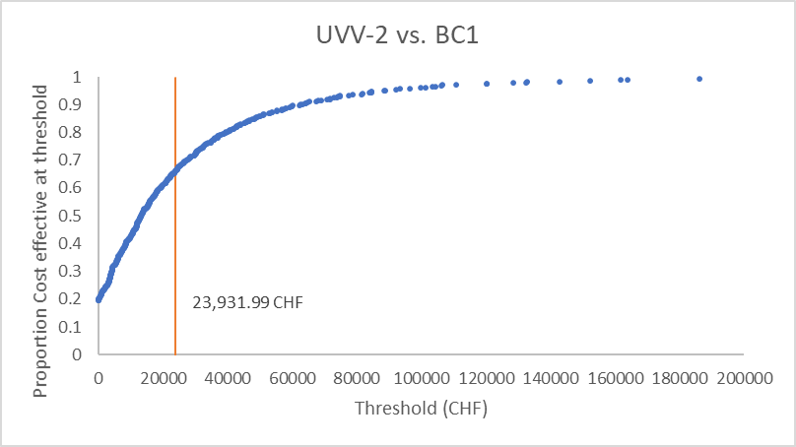
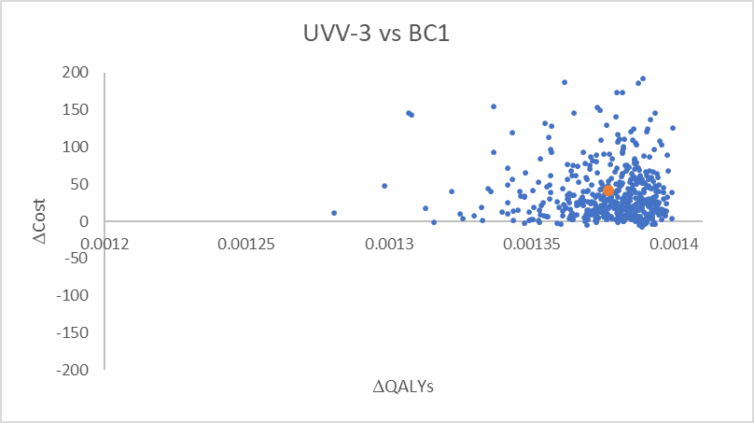 | 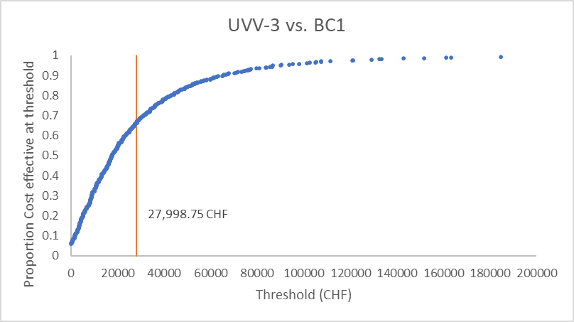

Figure 4. Probabilistic Sensitivity Analysis Showing the ICER Scatter Plots and Cost-Effectiveness Acceptability Curves for UVV Compared to BC1 (orange circles and lines refer to mean values)
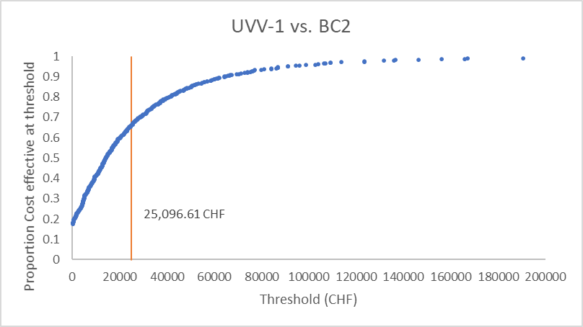 | 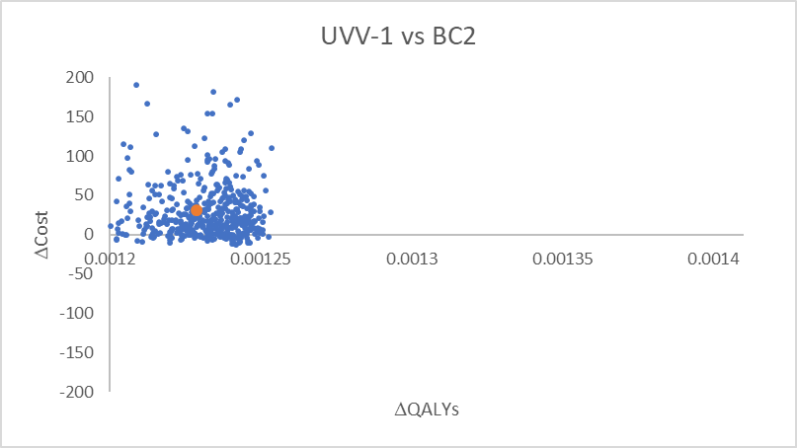
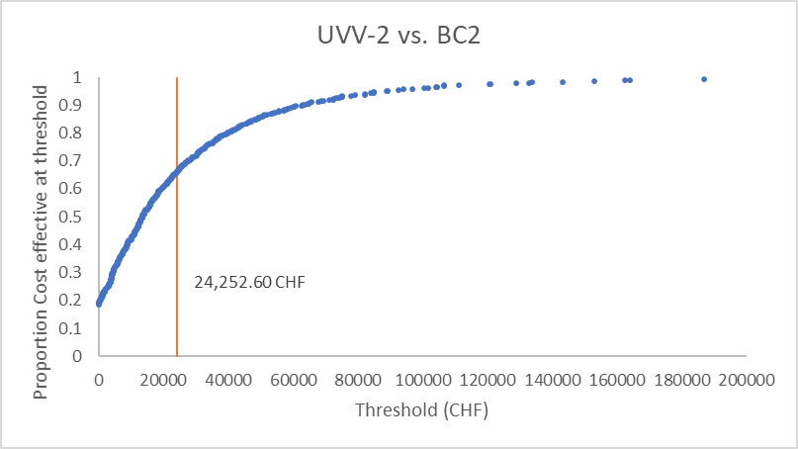 | 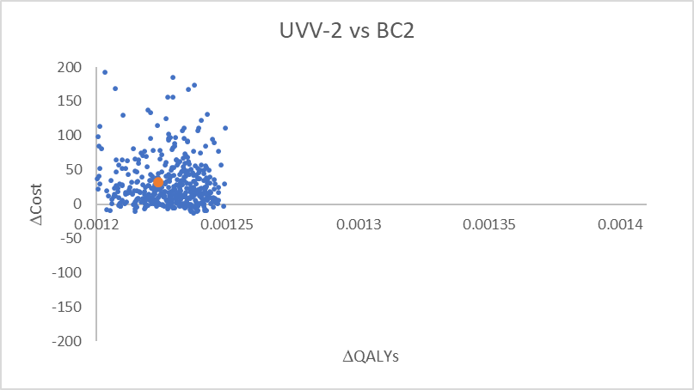
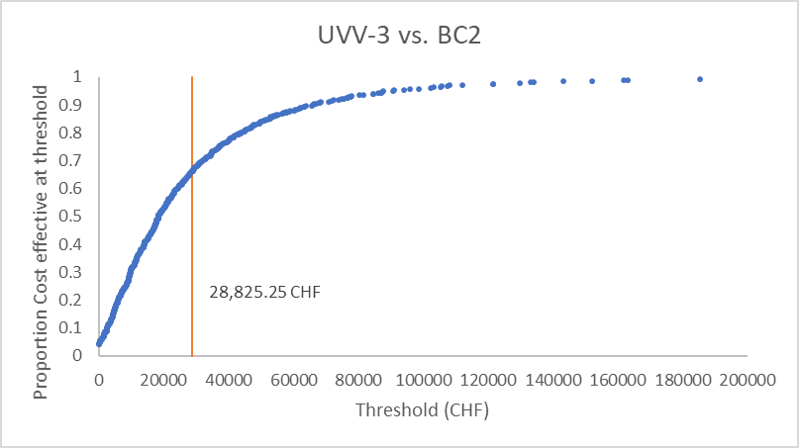 | 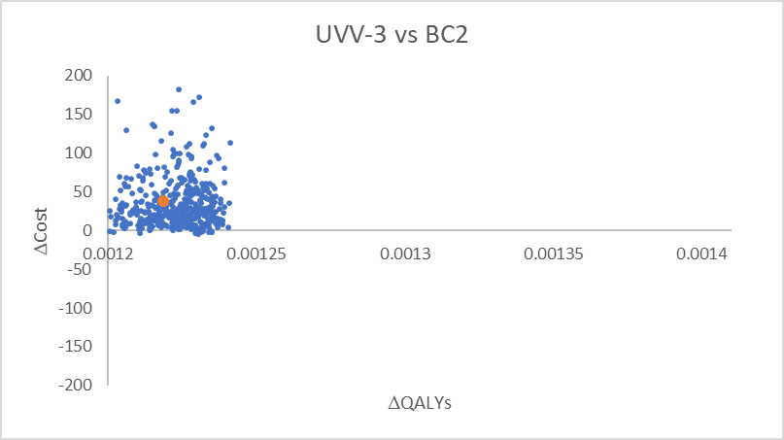

SDC-4: Results over 25- and 100-Year Time Horizon
The results in the table below are the costs, QALYs and ICERs from the two cost perspectives over 25-year and 100-year time horizons.

Table 4: 25-year and 100-year societal costs
25 years Societal
 | Costs | QALYs | ΔCosts | ΔQALYs | ICER
BC1 | 20.17 CHF | -0.0012 | None | None | None
BC2 | 22.53 CHF | -0.0011 | None | None | None
UVV-1 Vs BC1 | 44.45 CHF | -0.0004 | 24.28 CHF | 0.0009 | 28,005.52 CHF
UVV-2 Vs BC1 | 43.76 CHF | -0.0003 | 23.59 CHF | 0.0009 | 26,979.07 CHF
UVV-3 Vs BC1 | 46.63 CHF | -0.0003 | 26.47 CHF | 0.0009 | 30,279.53 CHF
UVV-1 Vs BC2 | 44.45 CHF | -0.0004 | 21.92 CHF | 0.0008 | 28,553.55 CHF
UVV-2 Vs BC2 | 43.76 CHF | -0.0003 | 21.23 CHF | 0.0008 | 27,390.40 CHF
UVV-3 Vs BC2 | 46.63 CHF | -0.0003 | 24.11 CHF | 0.0008 | 31,113.79 CHF
100 years Societal
 | Costs | QALYs | ΔCosts | ΔQALYs | ICER
BC1 | 36.41 CHF | -0.0022 | None | None | None
BC2 | 40.64 CHF | -0.0020 | None | None | None
UVV-1 Vs BC1 | 80.56 CHF | -0.0004 | 44.15 CHF | 0.0018 | 24,952.55 CHF
UVV-2 Vs BC1 | 79.59 CHF | -0.0004 | 43.19 CHF | 0.0018 | 24,291.79 CHF
UVV-3 Vs BC1 | 85.99 CHF | -0.0004 | 49.58 CHF | 0.0018 | 27,862.82 CHF
UVV-1 Vs BC2 | 80.56 CHF | -0.0004 | 39.92 CHF | 0.0016 | 25,344.55 CHF
UVV-2 Vs BC2 | 79.59 CHF | -0.0004 | 38.96 CHF | 0.0016 | 24,600.63 CHF
UVV-3 Vs BC2 | 85.99 CHF | -0.0004 | 45.35 CHF | 0.0016 | 28,608.92 CHF

Table 5: 25-year and 100-year payer costs
25 years Payer
 | Costs | QALYs | ΔCosts | ΔQALYs | ICER
BC1 | 9.11 CHF | -0.0012 | None | None | None
BC2 | 12.24 CHF | -0.0011 | None | None | None
UVV-1 Vs BC1 | 39.03 CHF | -0.0004 | 29.92 CHF | 0.0009 | 34,506.59 CHF
UVV-2 Vs BC1 | 38.43 CHF | -0.0003 | 29.32 CHF | 0.0009 | 33,529.19 CHF
UVV-3 Vs BC1 | 41.24 CHF | -0.0003 | 32.13 CHF | 0.0009 | 36,760.94 CHF
UVV-1 Vs BC2 | 39.03 CHF | -0.0004 | 26.79 CHF | 0.0008 | 34,896.70 CHF
UVV-2 Vs BC2 | 38.43 CHF | -0.0003 | 26.20 CHF | 0.0008 | 33,790.41 CHF
UVV-3 Vs BC2 | 41.24 CHF | -0.0003 | 29.01 CHF | 0.0008 | 37,436.21 CHF
100 years Payer
 | Costs | QALYs | ΔCosts | ΔQALYs | ICER
BC1 | 16.47 CHF | -0.0022 | None | None | None
BC2 | 22.12 CHF | -0.0020 | None | None | None
UVV-1 Vs BC1 | 70.64 CHF | -0.0004 | 54.17 CHF | 0.0018 | 30,616.01 CHF
UVV-2 Vs BC1 | 69.90 CHF | -0.0004 | 53.43 CHF | 0.0018 | 30,053.46 CHF
UVV-3 Vs BC1 | 76.53 CHF | -0.0004 | 60.06 CHF | 0.0018 | 33,750.73 CHF
UVV-1 Vs BC2 | 70.64 CHF | -0.0004 | 48.52 CHF | 0.0016 | 30,802.45 CHF
UVV-2 Vs BC2 | 69.90 CHF | -0.0004 | 47.78 CHF | 0.0016 | 30,169.89 CHF
UVV-3 Vs BC2 | 76.53 CHF | -0.0004 | 54.41 CHF | 0.0016 | 34,320.10 CHF

References
- Banz K, Iseli A, Aebi C, Brunner M, Schmutz AM, Heininger U. Economic evaluation of varicella vaccination in Swiss children and adolescents. Hum Vaccin. 2009;5(12):847-857.
- Federal Office of Public Health. Medical statistics of the hospitals: number of cases and average length of stay (DAD) according to age group and diagnosis code. Federal Office of Public Health. https://www.bfs.admin.ch/bfs/de/home/statistiken/gesundheit/gesundheitswesen/spitaeler/patienten-hospitalisierungen.assetdetail.6406957.html. Published 2017. Accessed2020.
- SwissDRGOnline Grouper. Individual case grouper. SwissDRGOnline Grouper. https://grouper.swissdrg.org/swissdrg/single?locale=de. Published 2020. Accessed2020.
- Jacobsen SJ, Ackerson BK, Sy LS, et al. Observational safety study of febrile convulsion following first dose MMRV vaccination in a managed care setting. Vaccine. 2009;27(34):4656-4661.
- Szucs TD, Kressig RW, Papageorgiou M, et al. Economic evaluation of a vaccine for the prevention of herpes zoster and post-herpetic neuralgia in older adults in Switzerland. Hum Vaccine. 2011;7(7):749-756.
- Brisson M, Edmunds WJ. Varicella vaccination in England and Wales: cost-utility analysis. Arch Dis Child. 2003;88(10):862-869.
- Aebi C, Fischer K, Gorgievski M, Matter L, Muhlemann K. Age-specific seroprevalence to varicella-zoster virus: study in Swiss children and analysis of European data. Vaccine. 2001;19(23-24):3097-3103.
- Bollaerts K, Riera-Montes M, Heininger U, et al. A systematic review of varicella seroprevalence in European countries before universal childhood immunization: deriving incidence from seroprevalence data. Epidemiol Infect. 2017;145(13):2666-2677.
- Heininger U, Desgrandchamps D, Schaad UB. Seroprevalence of Varicella-Zoster virus IgG antibodies in Swiss children during the first 16 months of age. Vaccine. 2006;24(16):3258-3260.
- Wolfson LJ, Daniels VJ, Pillsbury M, et al. Cost-effectiveness analysis of universal varicella vaccination in Turkey using a dynamic transmission model. PLoS One. 2019;14(8):e0220921.
- Riera-Montes M, Bollaerts K, Heininger U, et al. Estimation of the burden of varicella in Europe before the introduction of universal childhood immunization. BMC Infect Dis. 2017;17(1):353.
- Nelder JA, Mead R. A Simplex Method for Function Minimization. The Computer Journal. 1965;7(4):308-313.
- Schuette MC, Hethcote HW. Modeling the effects of varicella vaccination programs on the incidence of chickenpox and shingles. Bull Math Biol. 1999;61(6):1031-1064.
- Prem K, Cook AR, Jit M. Projecting social contact matrices in 152 countries using contact surveys and demographic data. PLoS Comput Biol. 2017;13(9):e1005697.

